
VoxBank Business Plan

Student’s Name: NIRANJAN MOUNE PUTTANNA
Student’s Number: 25050531
Word Count: 3385

Table of Contents
1. Service 1
1.1 Core Features and Technical Architecture 1
1.2 Problem Identification 1
1.3 Value Proposition and Target Audience 1
1.4 Unique Selling Point (USP) 2
1.5 Business Objectives for the Year Ahead 2
2. Market and Competitor Research 3
2.1 Overall Fintech Market Overview 3
2.2 PESTEL Analysis 4
2.3 Situational Analysis: Porter’s Five Forces 6
2.4 Geographic Potential and Trends 6
2.5 Main Competitors 7
3. Resource Plan 8
3.1 Human Capital and Expertise 8
3.2 Physical Infrastructure and Equipment 8
3.3 Externally Sourced Resources 9
4. Marketing Strategy 9
4.1 Integrated Marketing Mix 9
4.2 Revenue and Market Share Targets 10
5. Cash flow forecasting 10
5.1 Cash inflows for the next 5 years 10
5.2 Cash outflows 10
5.3 Post-Year-5 Cash Flows 11
6. Financing Strategy 11
6.1 Initial Capital Acquisition 11
6.2 Mitigation of Cash Flow Deficits 11
7. Regulatory Risk Assessment 12
7.1 Regulatory Hurdles 12
7.2 Mitigation and Overcoming Threats 12
8. Business Plan Evaluation 13
8.1 Strengths of the Business Plan 13
8.2 Weaknesses of the Business Plan 13
8.3 Key Risks and Impact 14
8.4 Contingency Plans 14
8.5 Literature on Business Planning 15
References 17
Appendices 22
Appendix A: Porter's Five Forces Analysis 22
Force 1: Threat of New Entrants (Moderate) 23
Force 2: Bargaining Power of Buyers (High) 23
Force 3: Threat of Substitutes (Low to Moderate) 24
Force 4: Bargaining Power of Suppliers (Moderate) 25
Force 5: Competitive Rivalry (Moderate) 25
Appendix B: SWOT Analysis 27
Strengths 27
Weaknesses 28
Opportunities 29
Threats 30
Appendix C 31
APPENDIX D: PESTEL Analysis for VoxBank 34

List of Figures
Figure 1: Voice AI in Financial Services 4
Figure 2: Active 30-day account rates by region 5
Figure 3: Porter's Five Forces applied to VoxBank 20
Figure 4: SWOT Analysis for VoxBank 25
Figure 5: Annual operational cash inflows (Years 1–5) 29
Figure 6: Annual operational cash outflows (Years 1–5) 30
Figure 7: Net cash flow summary and post-Year-5 projections 32

List of Tables
Table 1: Annual operational cash inflows (Years 1–5) 31
Table 2: Annual operational cash outflows (Years 1–5) 31
Table 3: Net cash flow summary and post-Year-5 projections 33
Table 4: PESTEL Analysis for VoxBank 34

1. Service

1.1 Core Features and Technical Architecture
VoxBank is a B2B, white-label Software-as-a-Service (SaaS) application that integrates conversational artificial intelligence programs directly into the existing banking infrastructure via secure Open Banking Application Programming Interfaces (APIs). The system is based on modern Natural Language Processing (NLP) aimed at complex, contextural intent recognition (Bhatia and Khetarpaul, 2025). Moreover, it uses advanced voice authentication by biometric measures, examining exclusive vocal tract frequencies to verify user identity in real-time, enabling safe substitution of dangerous passwords and PINs.

1.2 Problem Identification
Systematic exclusion of demographics with low digital literacy, physical disability, or visual impairments affects the use of standard digital banking to reduce demographic and behavioural disparities actively. In turn, according to Vision Empower (2024), the failure to meet accessibility standards limits the independence of users. Moreover, in fast-growing emerging markets, traditional text-intensive interfaces are a structural challenge to unbanked populations, deterred to seek independent financial management (Peprah et al., 2023). Therefore, these continuous exclusion gaps need a shift to voice-first financial technology that places more emphasis on inclusive design so that every user, irrespective of their physical or technical abilities, can have access.

1.3 Value Proposition and Target Audience
VoxBank provides a highly accessible financial tool that is inclusive. The main target audience includes financial institutions and mobile money providers who want to transform into a digital form of operation cheaply. This target audience is carefully chosen as by forming strategic partnerships with Fintech vendors, the traditional institutions not only avoid the cost, preventive and complexities of building proprietary infrastructure but also acquire customer-focused agile innovations (World Economic Forum, 2025). With the help of VoxBank, these institutions can bring immeasurable value to the secondary audience of marginalised retail customers and enable them to conduct smooth financial operations via natural speech. Most importantly, it enables banks to comfortably comply with the rigorous accessibility policies, including the FCA Consumer Duty.

1.4 Unique Selling Point (USP)
The uniqueness of VoxBank is its white-label, institution-agnostic structure and comprehensive multilingual coverage (fifteen languages and regional dialects). VoxBank offers a plug-and-play, scalable voice layer with real-time, AI-powered fraud detection, unlike proprietary bank-specific assistants. With this distinctive architecture, branded voice banking can be rolled out by any financial institution instantly without the affordable internal development expenses (Bejar et al., 2023).

1.5 Business Objectives for the Year Ahead
The strategic goals of VoxBank for the twelve months are:
- To successfully execute pilot API integrations with three mid-tier financial institutions across the UK and Sub-Saharan Africa; second
- To attain full ISO 27001 certification to validate our biometric security architecture.
- To seamlessly process over 500,000 authenticated voice-initiated transactions, establishing a robust foundation for subsequent global scaling.

2. Market and Competitor Research

2.1 Overall Fintech Market Overview
The transformation in the global financial technology arena is unprecedented, with much of it being spearheaded by agentic and automated conversational solutions. As a result, the voice banking business has become a very profitable industry. According to recent empirical forecasts, consumer expenditure in electronic commerce tools grows at 16.6 per cent in the initial 4 months after introducing voice assistants (Sun et al., 2025). This growth is mostly driven by escalating consumer demand towards the availability of convenient digital means of transaction. Voice-activated systems are an important and inclusive solution to the traditional banking infrastructure needs when it cannot serve the visually impaired demographic. Figure 1 depicts a mere example of a quick trend in the industry with AI voice in the financial services featuring a growth of up to $10 billion as of 2026 (Deshpande, 2026). Furthermore, the adoption of Natural Language Processing enhances the efficacy of transactions to a great degree, thus establishing institutional trust on a global scale. Finally, any bank that uses voice AI will always provide a smoother, more personalised experience, leading to sustainable growth (Devidas, 2025).
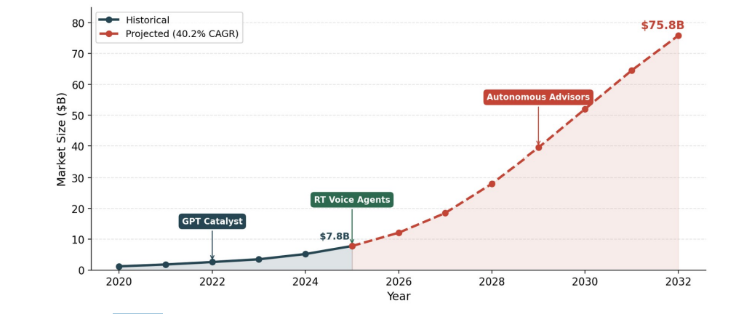
Figure 1: Voice AI in Financial Services
Source: Deshpande (2026)

2.2 PESTEL Analysis
VoxBank's external environment is influenced by a complicated interaction of political, economic, social, technological, environmental and legal (PESTEL) factors as shown in Appendix D Table 4. Politically, with growing government interest in financial inclusion in both the United Kingdom and Sub-Saharan Africa, a conducive policy atmosphere surrounding inclusive fintech solutions will arise. Institutional readiness to adopt Open Banking frameworks and digital transformation is further supplemented by state assistance in these cases (World Bank, 2022; World Economic Forum, 2025).
On the economic front, there is good growth potential in increased mobile money penetration and digital economy growth in emerging economies. There is also evidence of a continuous increase in digital financial activity, which is increasingly so in mobile-led economies (GSMA, 2026). Nonetheless, institutional investment capacity in the short-term might be limited by the pressures of inflation and currency volatility in some of the Sub-Saharan regions. Nevertheless, the long-term fintech investment trends are still favourable as they are driven by the imperative of cost-efficiency and the advantages of scale (Wamba et al., 2020).
On the social front, increasing awareness regarding both accessibility and inclusion greatly enhances the applicability of a voice-first solution by VoxBank. Demographic audiences like visually impaired, ageing cultures, and low literacy users are increasingly being identified as underserved markets, making the intuitiveness of financial interfaces (Vision Empower, 2024; Onyango, 2026). This is in line with bigger trends that show systemic obstacles of traditional digital banking interfaces (Peprah et al., 2023).
Conversational banking solutions have a solid enabler base in the technological trends of fast-developing artificial intelligence, Natural Language Processing, and biometric authentication (Bhatia and Khetarpaul, 2025). However, technology obsolescence poses a threat as well, and each new advancement results in the need to invest in system improvement and model optimisation (Jain et al., 2023).
Less direct, yet more and more environmental, considerations also apply as cloud-based infrastructural providers are under pressure to diminish carbon footprints. The aspect of VoxBank using scalable cloud solutions fits in the larger sustainability changes of the digital infrastructure and the effective use of resources (Nicoletti, 2021).
Strict data protection laws, such as GDPR and developing data sovereignty legislations, are a limitation as well as an opportunity in legal terms. Regulation makes operations more complex yet builds trust and credibility with institutional clients. There will also be regulatory progress in biometric authentication and anti-money laundering systems, which will greatly influence the deployment strategies (World Bank, 2022; Sahay et al., 2020).

2.3 Situational Analysis: Porter’s Five Forces
The dynamic competitive environment is reflected in a situational analysis, which uses the five forces of Porter. The threat of New Entrants is average because there are technical barriers to proprietary development of NLP and regulatory compliance barriers. The need to have a smooth, white-labeled integration and proven ROI by the financial institutions makes the Bargaining Power of Buyers high. The threat of Substitutes is low to moderate due to the differentiation of VoxBank as accessibility-oriented, but indirect competition exists with the general-purpose voice platforms. The supplier power and the competitive rivalry are both moderate, with dependency on the cloud infrastructure providers and rivalry with established core banking vendors. Each force and its strategic implications are broken down in detail in Appendix A, Figure 3.

2.4 Geographic Potential and Trends
The developed countries are steadily embracing conversational finance, but the potential is enormous in such emerging markets as India and Sub-Saharan Africa. The recent findings indicate that the proportion of voice assistants used by the financial services sector is 68.3 per cent in varied populations, including India (Chaturvedi and Vijaykarthigeyan, 2025). A strong digital backbone contributes to this transformation; according to Figure 2, the rate of mobile money activity in the world over thirty days came to 25.7 per cent in 2025 (GSMA, 2026). Likewise, in Sub-Saharan Africa, blind people are facing systemic barriers when using standard digital platforms (Onyango, 2026). The implementation of multilingual, voice-first systems enables institutions to avoid legacy infrastructure altogether.
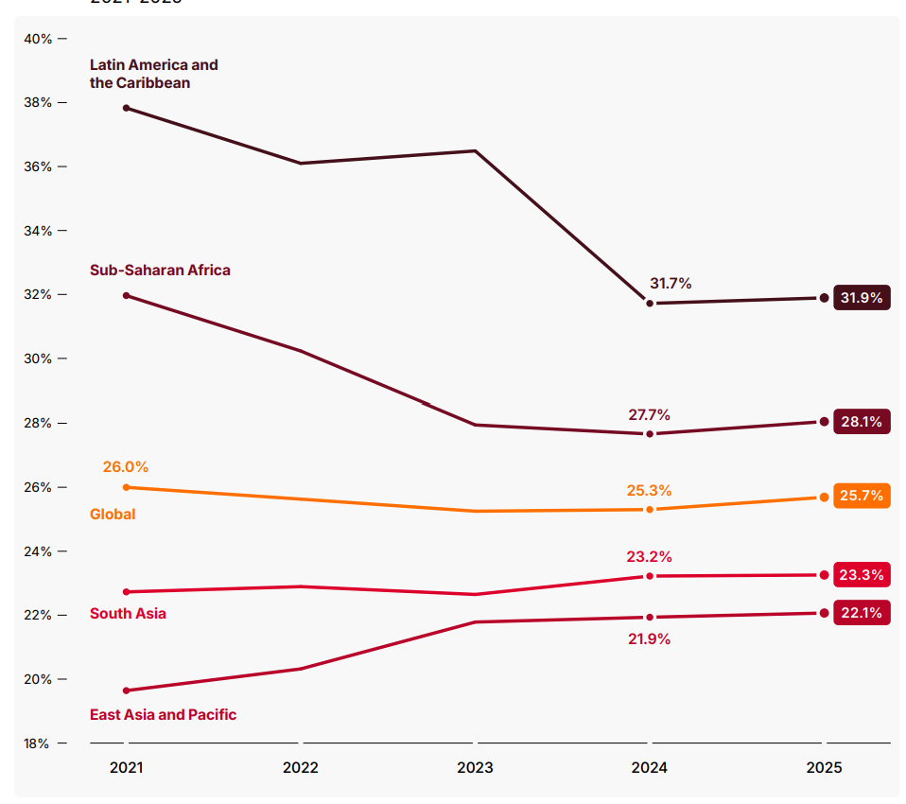
Figure 2: Active 30-day account rates by region
Source: GSMA (2026)

2.5 Main Competitors
VoxBank is competitive in an environment that is filled with established companies with core infrastructural capabilities. Mambu offers an independent lending engine assembly on a cloud native platform (Gartner Peer Insights, 2026). In addition, SDK.finance provides white-label solutions to deploy wallets quickly (SDK.finance, 2026). Moreover, Temenos has an international range of retail banking capabilities (Temenos, 2026). Nonetheless, the specialised plug-and-play voice layer of VoxBank fills a significant accessibility gap, positioning it differently in the markets underserved and with high growth rates in the international markets. In order to integrate these competitive strengths and weaknesses and internal strengths and weaknesses, a SWOT analysis has been developed fully. This analyses the strategic strengths, weaknesses, opportunities, and threats of VoxBank relative to the positioning of the bank in the market as observed in Appendix B, Figure 4.

3. Resource Plan

3.1 Human Capital and Expertise
A strategic distribution of resources is needed to make VoxBank a concept into a working SaaS platform. Human capital needs are concentrated on a highly skilled, small team of twelve professionals, which is lean. This consists of four full-stack developers, who will be experts in API integration, two AI/NLP engineers to refine the model, and two cybersecurity experts to monitor biometric encryption. According to the World Bank (2022), the effectiveness of digital financial services requires the presence of a highly skilled workforce with high technical skills and specialised knowledge of regulations that will be able to inspire consumer confidence.

3.2 Physical Infrastructure and Equipment
About physical infrastructure, a hybrid operational model is employed. This necessitates a collaborative office of about 1,000 square feet and is situated in a technology hub, with a core strategy and with remote-first practices in software development. Key equipment comprises workstations, biometric testing equipment, and encrypted mobile devices to ensure quality assurance.

3.3 Externally Sourced Resources
Much dependence is involved on externally sourced resources to ensure agile operations and security. Amazon Web Services (AWS) helps with the required cloud computing and server hosting with the help of dedicated financial services frameworks to satisfy data residency (AWS, 2026). Moreover, the scalability of Fintechs operations is much greater due to the possibility of using cloud-based infrastructure and third-party technical services that do not require a large amount of starting capital (Wamba et al., 2020). The outsourced architecture enables the company to concentrate on the proprietary voice-layer intellectual property and remain secured by the industry leaders on the infrastructure (Nicoletti, 2021).

4. Marketing Strategy

4.1 Integrated Marketing Mix
VoxBank uses a B2B product-led growth approach, which makes it an inclusive voice layer to financial institutions. In line with this, branding highlights reliance and greater access by a simple identity, which insinuates security. In addition, the product works in a white-label model, which can be well integrated into client applications. Besides this, it is cloud-based, location-agnostic, and focuses on the distribution, initially in the United Kingdom and Sub-Saharan Africa. On the same note, the pricing is based on a value tier model that integrates integration fees and transaction charges. As a result, the focus of promotion lies on thought leadership and fintech events, which facilitates Papadopoulos (2022) on institutional engagement and credibility.

4.2 Revenue and Market Share Targets
The initial target is to achieve 2 per cent of the East African mobile money integration market within 18 months. Besides, VoxBank expects to break even by the close of Year 2 with 500,000 monthly transactions. Thus, attainment of growth lies in collaborating with mid-tier banks to achieve scale. According to Gomber et al. (2018), platform scalability and network effects are key to achieving critical mass in digital finance.

5. Cash flow forecasting

5.1 Cash inflows for the next 5 years
As shown in Appendix C, Table 1 and Figure 5, the estimated cash inflows expected by VoxBank exhibit a gradual increase, with the company projecting an inflow of 380,000 in the first year, followed by 9,600,000 in the fifth year as the institution's growth gains momentum through institutional partnerships. Moreover, integration fees, recurrent SaaS licensing, and transaction fees are sources of revenue. As a result, scaling of client adoption supports the growth.

5.2 Cash outflows
The increase in operational cash outflows is expected to progress to a level of £1,140,000 in Year 1 to 6,240,000 in Year 5 due to planned growth as indicated in Appendix C, Table 2, and Figure 6. Specifically, employment increase, cost of cloud infrastructure, and constant research spending stimulate spending. Further, the largest portion is personnel, including AWS hosting, compliance and marketing. Consequently, there must be rigorous cost control.

5.3 Post-Year-5 Cash Flows
After Year 5, VoxBank expects to get inflows of more than £14,000,000 per year, on top of a client base of more than sixty institutions, as indicated in Table 3 and Figure 7. Moreover, transactions monthly would most likely exceed ten million, which will enhance the stability of the revenues. With the stabilising infrastructure cost, the operating margin will be around thirty-five per cent. As a result, net annual cash flows could be as high as £5,000,000, which will sustain the global growth.

6. Financing Strategy

6.1 Initial Capital Acquisition
Voxbank will seek to use a dual-funding strategy in order to enable it to meet the major investment expenses of £1,140,000. The first step is finding Seed Venture Capital of £500,000, aimed at Fintech-centric companies, putting social impact and inclusivity as a priority. This is complimented with government-sponsored innovation grants and founder interest to complete API development. Block et al. (2021) observe that early-stage Fintechs are starting to depend on specialised venture capital more to bridge the so-called valuation gap between transitioning from a prototype and market integration. Such a combination is warranted to provide enough liquidity to guarantee some basic technical staffing and technology.

6.2 Mitigation of Cash Flow Deficits
According to the analysis of Year 1, there is an estimated cash flow shortage of £760,000 related to high initial expenditure on research and development (R&D) and infrastructure. In order to address this shortcoming, a convertible loan note approach will be used in the business, whereby the initial investors will have a chance to convert debt into equity during the Series A round. Also, it will have a revolving credit facility that will take care of variances in operations. Cumming and Schwienbacher (2018) state that high-growth Fintech startups must have hybrid financing tools such as convertible notes to remain afloat at least as they grow to a break-even point. Such organised funding makes sure that VoxBank is not under liquidation in its sensitive initial stages of development.

7. Regulatory Risk Assessment

7.1 Regulatory Hurdles
The regulatory environment under which VoxBank operates is intricate; the prioritization of data protection and financial integrity measures. The major risks are the strict Anti-Money Laundering (AML) regulations and the absence of uniform laws on privacy worldwide. To balance innovation, consumer protection, and financial stability, proportional regulation is needed to adapt digital finance as suggested by the World Bank (2022). Such provisions offer a huge legal challenge to international expansion.

7.2 Mitigation and Overcoming Threats
The business is mitigating these threats through the integration of automated biometric verification into its voice-layer so that the design can be accepted as compliance-by-design. Also, VoxBank tests features in regulatory sandboxes where they are supervised by authorities. The active interaction with the authorities will enable the company to make compliance a strategic asset. As Sahay et al. (2020) note, it is essential to develop effective regulatory frameworks to reduce the threats of digital marginalisation and guarantee system security. This would reduce the friction of the law and enhance trust in underserved industries, and turn legal challenges into a competitive edge.

8. Business Plan Evaluation

8.1 Strengths of the Business Plan
The foundation and strength of the VoxBank business plan lies in the conscious correspondence to the Resource-Based View of the firm. The plan creates a base of a sustainable competitive advantage by making proprietary voice layer technology and massive dialect support rare, inimitable and non-substitutable resources (Liu, 2025). As a result, the long-term defensibility is enhanced by the value of these idiosyncratic assets, which competitors cannot easily imitate. Moreover, the plan shows good market consciousness in terms of high levels of segmentation and clear targeting of new market segments and underserved populations, especially in the emerging markets. Besides these, formal business planning alleviates information asymmetry between the venture and external stakeholders, thus making it easier to acquire venture capital (ERC, 2025). Hence, it serves as a strategy guide as well as a legitimising process that conveys competence and readiness of managerial discipline.

8.2 Weaknesses of the Business Plan
Although these strengths exist, the plan has a fatal weakness in its dependence on long-term financial forecasting in a highly volatile technological environment. In particular, the nature of fintech markets is dominated by swift innovation, changes in regulations, and changing consumer behaviour, which all render the use of fixed projections unreliable. To remain viable in their ventures, entrepreneurs are excellent integrators of formal planning with dynamic approaches, as Alshibani et al. (2025) suggest. Nonetheless, over-reliance on predetermined forecasts can impose less flexibility and responsiveness. This is the planning fallacy, in which elaborate anticipations limit the capacity to act in the face of uncertainty (Bai, Wu and Chetty, 2026). Therefore, when financial assumptions are too inflexible, it can reduce the ability of VoxBank to pivot when responding to new opportunities or disruptions in the technology environment, or when new competitors emerge in the market.

8.3 Key Risks and Impact
There are two major threats affecting the business that can have a major impact on its strategic direction and financial results. To begin with, the issue of technological obsolescence is one of the burning challenges since the rate of progress towards technologies of artificial intelligence and voice recognition is high. As the competitors build a better-developed capability, the core offering of VoxBank can become irrelevant, which lets it lose market share and destroy its value proposition. Jain et al. (2023) state that this type of obsolescence is both endemic and systematic to fintech ecosystems. Second, rejection in the market poses a considerable risk to adoption. Unless financial institutions are more concerned with existing digital interfaces or end users are willing to use biometric authentication because of the lack of trust, the estimated level of transactions might never be realised. This, in turn, would have a direct impact on revenue collection, stability in its financial status, and its long-term viability (Jain et al., 2023).

8.4 Contingency Plans
In order to reduce these risks, VoxBank will apply Agile Methodology principles and the concept of continuous integration in the development lifecycle (Alshibani et al., 2025). This helps in the continuous improvement of the product and quick adaptation to any new technological progress. Moreover, the company will embrace an effective logic of low cost loss by focusing on limited experimentation as compared to massive commitment (Bai, Wu and Chetty, 2026). In line with this, VoxBank will deploy small-scale pilot programmes with the chosen regional financial institutions prior to large-scale rollout. This will not only decrease financial exposure but it will also create practical insights that can be used to optimise the product functionality and user experience. Moreover, the pilots will assist in trust building among the institutional partners and the provision of credible data about performance, which will fortify the business case of expansion in competitive markets.

8.5 Literature on Business Planning
The advocates of formal business planning believe that it improves cognition structuring and thus facilitates entrepreneurs to articulate goals and focus on the successful coordination of strategies. Moreover, it aids in the effective distribution of resources and coordinated decision-making within the functions of organisations. ERC (2025) finds that when ventures are planned in an orderly fashion, they have higher probabilities of survival due to directions/goals being put in place that can be measured. It also enhances external credibility through effective communication of strategic intent to stakeholders and investors, thus paving the way to finance and partnering possibilities.
However, according to the critics, the dogmatism with business plans can decrease the flexibility in uncertain and quickly changing contexts. In dynamic industries like fintech, inflexible planning can limit flexibility to new opportunities and threats. Alshibani et al. (2025) emphasise that future entrepreneurial success is a combination of planning and agility. On the same note, the theory of effectuation stresses the importance of flexible, non-predictive strategies in the face of uncertainty as more effective, while questioning the classical approaches to planning (Bai, Wu and Chetty, 2026).

References
Alshibani, S.M., Tarabashkina, L., Lindsay, N., Reed, G.A. and Ramadani, V. (2025) 'From creation to growth: Examining agile and business planning for sustained ventures', International Journal of Entrepreneurial Behaviour & Research, 31(9). Available at: https://doi.org/10.1108/IJEBR-12-2024-1468 (Accessed: 23 April 2026).
AWS (2026) Cloud Computing for Financial Services. Available at: https://aws.amazon.com/financial-services/ (Accessed: 23 April 2026).
Bai, W., Wu, J. and Chetty, S. (2026) 'The impact of effectuation on international diversity and performance of SMEs', Journal of Business Research, 205. Available at: https://doi.org/10.1016/S0148296325006903 (Accessed: 23 April 2026).
Bejar, P., Gracia, M., Hellwig, K. and Loukoianova, E. (2023) Is FinTech Eating the Bank's Lunch?, IMF Working Paper No. 2023/239. Washington, DC: International Monetary Fund. Available at: https://www.imf.org/-/media/files/publications/wp/2023/english/wpiea2023239-print-pdf.pdf (Accessed: 23 April 2026).
Bhatia, M.S. and Khetarpaul, S. (2025) 'AI-enhanced bilingual banking assistant', Scientific Reports, 15(1). Available at: https://doi.org/10.1038/s41598-025-22569-z (Accessed: 23 April 2026).
Block, J.H., Fisch, C. and Diegel, W. (2024) 'Schumpeterian entrepreneurial digital identity and funding from venture capital firms', The Journal of Technology Transfer, 49(1). Available at: https://doi.org/10.1007/s10961-022-09973-7 (Accessed: 23 April 2026).
Chaturvedi, S. and Vijaykarthigeyan, K.T. (2025) 'Voice Search and AI Assistants: Changing The Way Consumers Discover Financial Products', International Journal of Accounting and Economics Studies, 12(SI-1). Available at: https://doi.org/10.14419/jzatrq05 (Accessed: 23 April 2026).
Cumming, D.J. and Schwienbacher, A. (2021) 'Fintech venture capital', in The Routledge handbook of FinTech. London: Routledge. Available at: https://www.taylorfrancis.com/chapters/edit/10.4324/9780429292903-3/fintech-venture-capital-douglas-cumming-armin-schwienbacher (Accessed: 23 April 2026).
Deshpande, A. (2026) 'Voice AI in Financial Services: Sector Growth Dynamics, Mathematical Foundations, and Model Tooling Challenges', SSRN. Available at: https://papers.ssrn.com/sol3/papers.cfm?abstract_id=6189980 (Accessed: 23 April 2026).
Devidas, S. (2025) 'Voice UX in Banking: Designing Conversational AI for Financial Assistants', International Journal of Leading Research Publication, 6(6). Available at: https://doi.org/10.70528/IJLRP.v6.i7.1687 (Accessed: 23 April 2026).
ERC (2025) Small Business Planning is Sticky but neither a Universal Practice nor a Guaranteed Path to Success, ERC Research Paper No 121. Available at: https://www.enterpriseresearch.ac.uk/publications/small-business-planning-is-sticky-but-neither-a-universal-practice-nor-a-guaranteed-path-to-success/ (Accessed: 23 April 2026).
Gartner Peer Insights (2026) Mambu Cloud Banking Platform Reviews & Ratings. Available at: https://www.gartner.com/reviews/product/mambu-cloud-banking-platform (Accessed: 23 April 2026).
Gomber, P., Kauffman, R.J., Parker, C. and Weber, B.W. (2018) 'On the Fintech Revolution: Interpreting the Forces of Innovation, Disruption, and Transformation in Financial Services', Journal of Management Information Systems, 35(1). Available at: https://doi.org/10.1080/07421222.2018.1440766 (Accessed: 23 April 2026).
GSMA (2026) The State of the Industry Report on Mobile Money 2026. Available at: https://www.gsma.com/sotir/wp-content/plugins/plugin_gsma_sotir/reports/The-State-of-the-Industry-Report-2026_English.pdf (Accessed: 23 April 2026).
Jain, R., Kumar, S., Sood, K., Grima, S. and Rupeika-Apoga, R. (2023) 'A systematic literature review of the risk landscape in fintech', Risks, 11(2). Available at: https://doi.org/10.3390/risks11020036 (Accessed: 23 April 2026).
Liu, S. (2025) 'Green management promotes long-term business competitive advantage through the resource-based view', Total Quality Management & Business Excellence. Available at: https://doi.org/10.1080/14783363.2025.2499142 (Accessed: 23 April 2026).
Nicoletti, B. (2021) 'Future of Banking 5.0', in Banking 5.0: How Fintech Will Change Traditional Banks in the 'New Normal' Post Pandemic. Cham: Palgrave Macmillan. Available at: https://link.springer.com/chapter/10.1007/978-3-030-75871-4_15 (Accessed: 23 April 2026).
Onyango, J. (2026) 'An Assessment of the Legal and Regulatory Framework on Fintech Inclusion for Visually Impaired Persons in Kenya', Strathmore University Law Review, 8(1). Available at: https://su-plus.strathmore.edu/server/api/core/bitstreams/8992a3f0-31ce-4967-ab62-6a907816317d/content (Accessed: 23 April 2026).
Papadopoulos, G. (2022) 'The Role of Marketing in the Fintech Ecosystem', in Chiu, I.H. and Deipenbrock, G. (eds) The Routledge Handbook of Financial Technology and Law. London: Routledge. Available at: https://www.routledge.com/Routledge-Handbook-of-Financial-Technology-and-Law/Chiu-Deipenbrock/p/book/9780367726553 (Accessed: 23 April 2026).
Peprah, J.A., Avorkpo, E.A. and Kulu, E. (2023) 'People With Disabilities and Access to Financial Services: Evidence From Ghana', International Journal of Economics, Commerce and Management, 11(4). Available at: https://doi.org/10.1111/rsp3.12643 (Accessed: 23 April 2026).
Sahay, R. et al. (2020) *The Promise of Fintech: Financial Inclusion in the Post-COVID-19 Era*. Washington, DC: International Monetary Fund. Available at: https://www.imf.org/en/publications/departmental-papers-policy-papers/issues/2020/06/29/the-promise-of-fintech-financial-inclusion-in-the-post-covid-19-era-48623 (Accessed: 23 April 2026).
SDK.finance (2026) Top Digital Banking Software Providers in 2026: A Comparative Study. Available at: https://sdk.finance/blog/top-digital-banking-software-providers/ (Accessed: 23 April 2026).
Sun, C., Shi, Z., Liu, X. and Ghose, A. (2025) 'The Effect of Voice AI on Digital Commerce', Information Systems Research. Available at: https://doi.org/10.1287/isre.2022.0140 (Accessed: 23 April 2026).
Technavio (2026) *AI in Fintech Market Growth Analysis - Size and Forecast 2026-2030*. London: Technavio Research. Available at: https://www.technavio.com/report/ai-in-fintech-market-industry-analysis (Accessed: 23 April 2026).
Temenos (2026) *Temenos delivers strong FY-25 results and raises FY-28 targets*. Geneva: Temenos AG. Available at: https://www.temenos.com/wp-content/uploads/2026/02/temenos-announces-q4-25-results-pr-22tw4tk10.pdf (Accessed: 23 April 2026).
Vision Empower (2024) Landscape Mapping of the Visual Disability Sector in India: Stakeholder Perspectives and Recommendations for Action. Bangalore: Vision Empower. Available at: https://visionempowertrust.org/arc/wp-content/uploads/Landscape-Mapping-Report_Vision-Empower_2025.pdf (Accessed: 23 April 2026).
Wamba, S.F., Bawack, R.E., Guthrie, C., Queiroz, M.M. and Estrada, A.F. (2020) 'Are we preparing for a good AI society? A multidisciplinary review of AI across domains', International Journal of Information Management, 55. Available at: https://doi.org/10.1016/j.techfore.2020.120482 (Accessed: 23 April 2026).
World Bank (2022) Fintech and the Future of Finance Flagship Report. Washington, DC: World Bank Group. Available at: https://documents1.worldbank.org/curated/en/099450005162250110/pdf/P17300600228b70070914b0b5edf26e2f9f.pdf (Accessed: 23 April 2026).
World Economic Forum (2025) The Future of Global Fintech: From Rapid Expansion to Sustainable Growth. 2nd edn. Available at: https://reports.weforum.org/docs/WEF_Future_of_Global_Fintech_Second_Edition_2025.pdf (Accessed: 23 April 2026).

Appendices

Appendix A: Porter's Five Forces Analysis
The analysis below uses the Five Forces framework developed by Porter to determine the effectiveness of the competitive environment in which VoxBank can be found. The intensity of each force is evaluated and assessed in relation to its strategic implications for the positioning of VoxBank in the white-label voice AI banking platform.
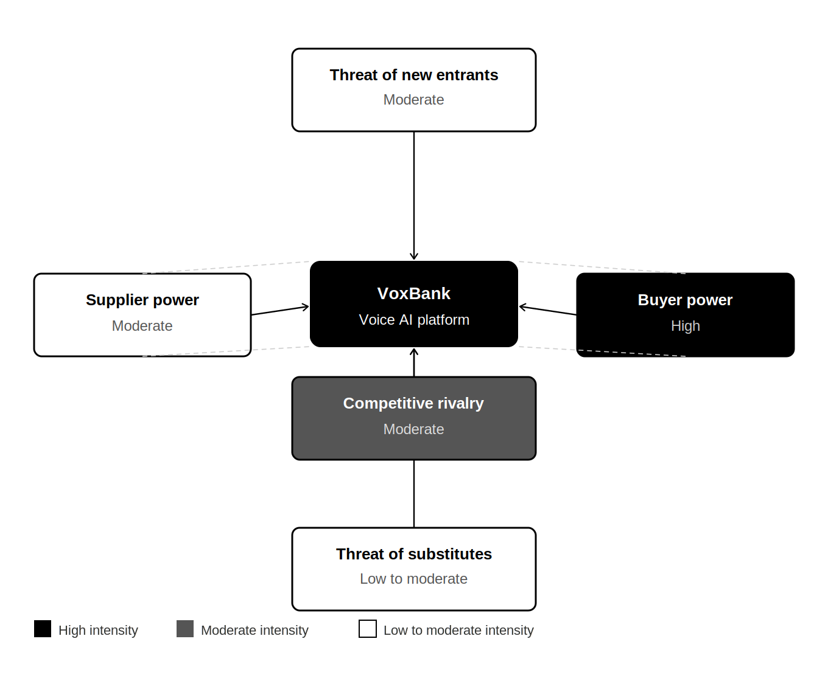
Figure 3: Porter's Five Forces applied to VoxBank

Force 1: Threat of New Entrants (Moderate)
The voice AI banking business has substantial barriers to entry due to the profound technical complexity. Creating banking-grade NLP with contextual intent recognition across fifteen languages and regional variations requires heavy research and development, expert machine learning skills and extensive training data (Bhatia and Khetarpaul, 2025). Biometric voice authentication also creates an additional level of complexity as it demands the level of clinical-grade accuracy to comply with financial regulatory requirements. The further compliance costs include compliance obligations, especially those related to data sovereignty, GDPR, and FCA Consumer Duty, which smaller entrants may not be able to afford (World Bank, 2022).
Nevertheless, the danger is not insignificant. Massive tech giants like Google, Amazon, and Microsoft already have an initial infrastructure in place in terms of voice AI and cloud distribution networks, so their possible interest in white-label fintech voice offering could proceed at a fast pace (Wamba et al., 2020). Moreover, the increase in the number of open-source NLP frameworks and inexpensive cloud computing has reduced the ground-level experimentation cost (AWS, 2026). In the case of VoxBank, the protection measure would be more investment in access-based differentiation, multilingual richness, and institutional switching costs by profound API integrations, which a generic technology platform cannot fail to imitate in a short time.

Force 2: Bargaining Power of Buyers (High)
The most significant customers of VoxBank, such as middle-level banks, mobile money operators, and fintech providers, are enjoying strong bargaining power. These organisations are able to rank a number of possible partners. Temenos and Mambu (exclusively the core banking solutions) are already increasing their digital functionality (Gartner Peer Insights, 2026; Temenos, 2026), whereas more traditionally big players can stick with in-house development. Vendor lock-in is also incredibly sensitive to buyers and, thus, they favour more flexible, API-based integrations that do not fetishise optionality to switch (World Economic Forum, 2025).
Banking privileges need to have strict SLA assurances, regulatory accreditation like ISO 27001, which VoxBank is in the habit of seeking and a record of reliability in the conduct of its transactions before entering into infrastructure-level contracts (World Bank, 2022). This power is partially reduced by the white-label model because VoxBank would be an invisible enabler, but not a competing branded product, generating fewer controversies and risks in the eyes of buyers. Nevertheless, pricing pressures will probably continue, and VoxBank will need to keep presenting tangible ROI, be it cost-cutting, compliance assurance, or customer acquisition, in underserved markets, to keep contract renewals afloat.

Force 3: Threat of Substitutes (Low to Moderate)
There are a few direct functional replacements of available, voice-first banking infrastructure. VoxBank would be inherently useful to the population with low digital literacy, as well as visually impaired users, which would naturally exclude both groups from the usage chart, which is exactly what VoxBank was created for (Peprah, Avorkpo and Kulu, 2023). This forms a structural distinction, which makes it resistant to direct substitution.
There are two risk vectors in the moderate qualifier. To start with, general-purpose voice assistants like Amazon Alexa, Google Assistant, and Apple Siri are adding more financial services capabilities (Wamba et al., 2020). This could make them indirect substitutes in case banks implement these services, as the major banks have them as extensions rather than the implementation of orthodox solutions. Second, human-assisted banking, such as agent networks and USSD-based banking, will continue to be a consistent alternative in emerging markets, especially in Sub-Saharan Africa, where infrastructure and device access may inhibit the use of voice AI (GSMA, 2026). The mobile-first architecture and regional dialect support of VoxBank to some extent address this risk.

Force 4: Bargaining Power of Suppliers (Moderate)
VoxBank will be using cloud infrastructure services providers like Amazon Web Services, Google Cloud, and Azure as its primary suppliers, third-party vendors of NLP and biometric technologies, and Open Banking API vendors. Hyperscale cloud provision is a moderately dependent market with three large players that control the market, and switching costs are high in the cloud provision market (AWS, 2026). Likewise, in case VoxBank uses licensed speech recognition models or biometric verification engines of a specialist supplier, then the supplier will have pricing power.
Competitive hyperscale providers partially offset this power by vigorously pursuing enterprise fintech clients with preferential pricing and compliance certifications (AWS, 2026). VoxBank can also minimise supplier risk through the development of proprietary model layers, multi-cloud strategy, and negotiating volume-based commitments as transaction throughput grows to the 500,000-transaction goal during Year 1.

Force 5: Competitive Rivalry (Moderate)
Although the direct competitors providing a combined accessibility-based, white-label voice banking layer, and with a multilingual adaptable voice interface are scarce, indirect competition is not irrelevant. Competitors like Mambu, SDK.finance, and Temenos all vie for the same institutional budgets with their wider core banking and digital transformation suites being seen as a complete alternative (SDK.finance, 2026; Temenos, 2026). Nevertheless, they have immature or no voice reach services, which implies that competition within the niche of VoxBank is rather limited.
The moderate rating is also a reflection of the comparatively low maturity of the voice banking market, in which the category creation processes mitigate a zero-sum game. With voice AI transitioning into regular operational infrastructure and the market maturing, the intensity of rivalry will become even more substantial (Technavio, 2026), and the first-mover incorporation of the institutions and regulators is likely to become critically important in terms of the ability to be defended in the long term.

Appendix B: SWOT Analysis
The given SWOT analysis is a critique of the internal strengths of VoxBank and its external environment, which present a systematic basis for the strategic priorities in Section 2.2.
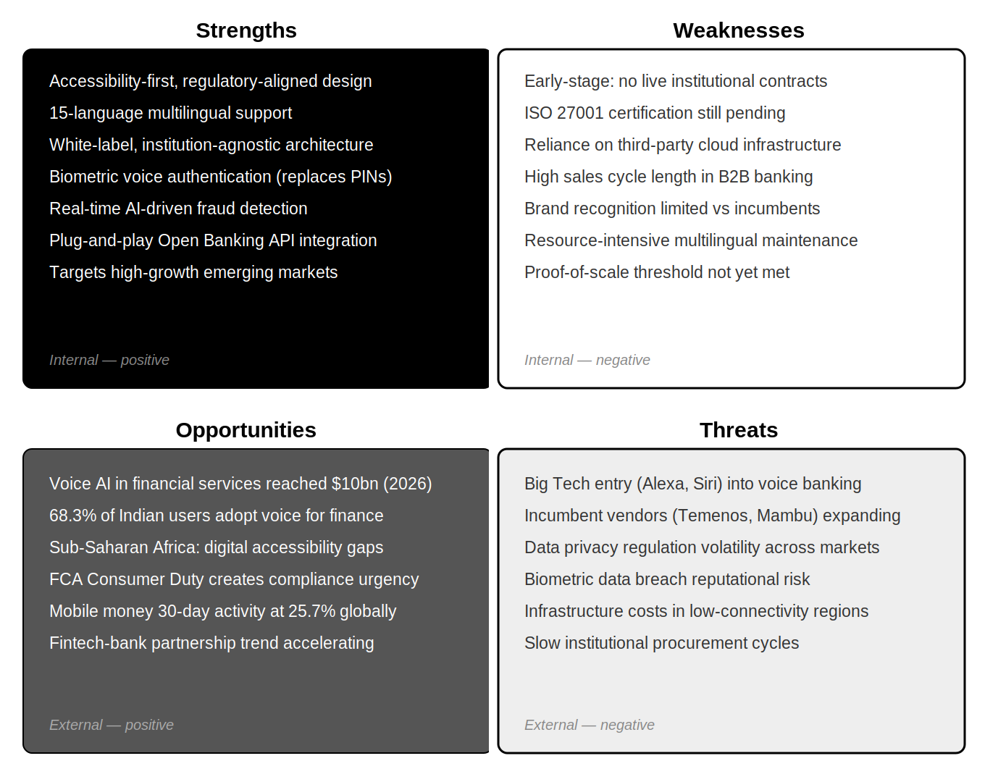
Figure 4: SWOT Analysis for VoxBank

Strengths
One of the strengths that VoxBank can defend best is its custom-built accessibility architecture. Competitors provide voice as an optional service overlaid on general-purpose platforms; VoxBank is designed with access to financial services based on inclusive, voice-first access. This practice supports the new regulatory requirements, like the FCA Consumer Duty, and global accessibility requirements (World Bank, 2022). This congruence is a business asset as opposed to an ethical stance. VoxBank can be used as a compliance solution by institutions that are at risk of compliance issues, thus reducing the sales justification cycle.
The white-label, institution-agnostic nature of the platform is a second key asset of the platform. VoxBank does not pose a threat to brand sovereignty because it does not act as a branded product but as an invisible layer over which banks would otherwise be reluctant to grant third-party access to consumers (World Economic Forum, 2025). The fact that fifteen languages, even including regional dialects, are supported further sets it apart as an improvement on the minimalist English-language voice banking solutions and allows reaching high-growth markets in Sub-Saharan Africa and South Asia not prioritised by competitors (Chaturvedi and Vijaykarthigeyan, 2025). Moreover, real-time AI fraud detection and biometric voice authentication tackle two of the most pressing issues in the risk of third-party infrastructure that financial institutions are concerned about when assessing a third-party infrastructure (Jain et al., 2023).

Weaknesses
The biggest threat facing VoxBank at this point in its life cycle is the pre-revenue and pre-certification position. It does not have the social evidence, such as case studies, volumes of transactions, and reference clients, that risk-averse financial institutions usually need before making the commitment of infrastructure-level involvement (Cumming and Schwienbacher, 2021). A quasi-prerequisite to most banking procurement teams is the ISO 27001 certification, which is being implemented. It is not present as such, thus restricting the addressable pipeline of VoxBank to those institutions that would take on conditional or pilot deals.
The platform has operational vulnerabilities inherent in its architecture as well. The reliance on third-party hyperscale-based cloud infrastructure exposes costs and resilience (AWS, 2026), and continuous and resource-intensive updating and growing of a fifteen-language NLP corpus. Besides this, the present market placement of VoxBank relies much on how the founders and the team are able to manoeuvre through protracted and convoluted business-to-business sales processes in highly regulated establishments. This limitation on capacity can limit the speed of pipelines in the short run.

Opportunities
The macroenvironment is highly conducive. Voice AI services in financial services have reached a high of 10 billion dollars in 2026 (Deshpande, 2026), and the adoption by consumers is on a rising trend in the targeted geographies. India, as an example, has 68.3 per cent of diverse-population users of voice assistants in accessing financial services (Chaturvedi and Vijaykarthigeyan, 2025), and global mobile money 30-day activity has hit 25.7 per cent in 2025 (GSMA, 2026). All these numbers indicate the current hidden demand, and not a future projection that is likely to happen, but are closely related to the requirements that the product offered by VoxBank is created to solve.
In Sub-Saharan Africa, there is an accessibility disparity that affects visually impaired people who use conventional digital platforms, which is not tackled significantly by the current providers, making it an underserved niche (Onyango, 2026). Meanwhile, the rapidly growing dynamics of strategic collaboration between banks and fintech institutions, imposed by expensive development of proprietary infrastructure systems, place VoxBank at the heart of a comparatively open institutional network (Gomber et al., 2018). The FCA Consumer Duty regulation also provides a demand stimulative catalyst of compliance in the United Kingdom market, which can reduce otherwise long institutional procurement cycles.

Threats
Competitive encroachment by big and well-capitalised competitors is the major strategic threat. Big technology companies already have the voice AI infrastructure, brand trust, and distribution ventures needed to scale and integrate the capabilities of financial services (Wamba et al., 2020). They have a prospect to grow into white-label or direct voice-enabled banking services, which can largely transform the competitive market. Existing vendors of core banking, like Temenos and Mambu, which already hold the confidence of target institutions, could also include voice accessibility modules to bridge the feature gap, especially when VoxBank develops indications of market preparedness (Temenos, 2026).
The volatility of regulations in the markets that VoxBank plans to operate in is another structural threat. Concerns on the storage of biometric data, cross-country data sovereignty and AI liability may result in considerable compliance costs or limit deployment models in critical jurisdictional areas (World Bank, 2022). A biometric breach of data at any point would have dire reputational consequences, given that the data of authentication is included (Jain et al., 2023). Moreover, structural bottlenecks continuing to affect prediction in cash flow in banking institutions have been the institutional procurement cycle, particularly for an early-stage platform, which relies on pilot milestones being met within a twelve-month timeframe (World Economic Forum, 2025).

Appendix C
Table 1: Annual operational cash inflows (Years 1–5)
Revenue stream | Year 1 | Year 2 | Year 3 | Year 4 | Year 5
Integration/setup fees | £150,000 | £250,000 | £420,000 | £650,000 | £910,000
SaaS licensing (monthly) | £108,000 | £768,000 | £1,800,000 | £3,600,000 | £6,384,000
Per-transaction fees | £25,000 | £300,000 | £720,000 | £1,440,000 | £2,100,000
Premium support & maintenance | £18,000 | £102,000 | £110,000 | £110,000 | £206,000
Total cash inflows | £301,000 | £1,420,000 | £3,050,000 | £5,800,000 | £9,600,000

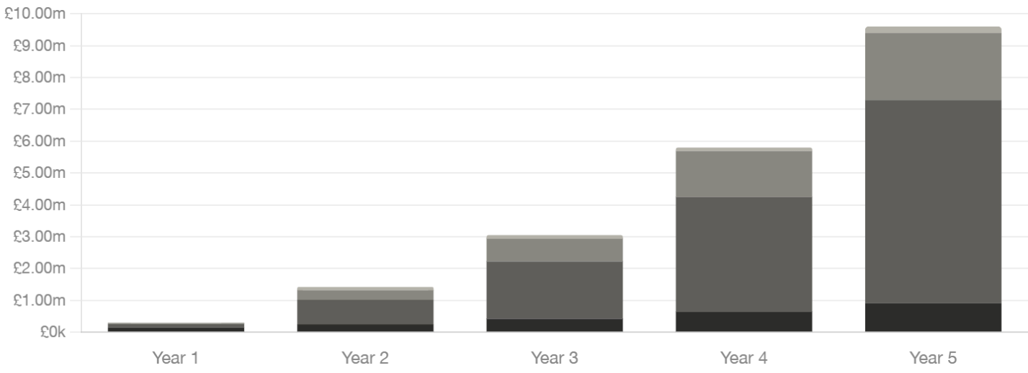
Figure 5: Annual operational cash inflows (Years 1–5)
Table 2: Annual operational cash outflows (Years 1–5)

Cost category | Year 1 | Year 2 | Year 3 | Year 4 | Year 5
Personnel & salaries | £780,000 | £936,000 | £1,170,000 | £1,560,000 | £2,184,000
Cloud infrastructure (AWS) | £80,000 | £150,000 | £300,000 | £560,000 | £900,000
R&D & product development | £120,000 | £130,000 | £300,000 | £620,000 | £1,040,000
Office & facilities | £60,000 | £64,000 | £70,000 | £80,000 | £90,000
Sales, marketing & events | £40,000 | £60,000 | £200,000 | £560,000 | £1,200,000
Legal, compliance & certification | £50,000 | £30,000 | £80,000 | £100,000 | £130,000
Equipment & hardware | £60,000 | £20,000 | £60,000 | £80,000 | £110,000
Miscellaneous & contingency | £30,000 | £0 | £120,000 | £400,000 | £586,000
Total cash outflows | £1,220,000 | £1,390,000 | £2,300,000 | £3,960,000 | £6,240,000

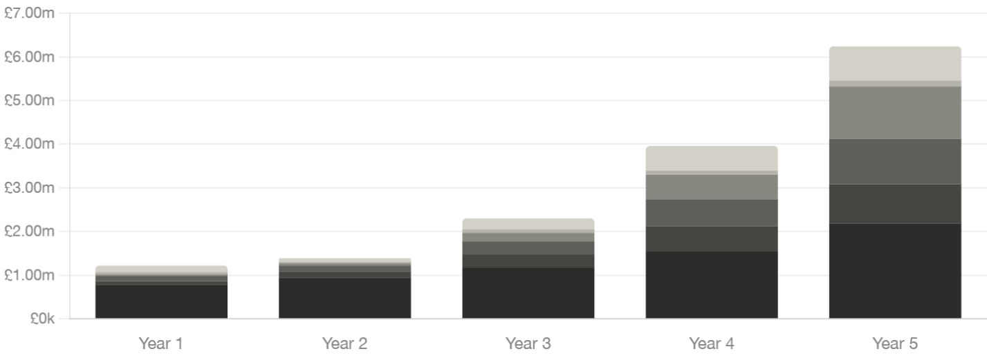
Figure 6: Annual operational cash outflows (Years 1–5)

Table 3: Net cash flow summary and post-Year-5 projections
Year 1 | Year 2 | Year 3 | Year 4 | Year 5 | Year 6+
Total inflows | £301,000 | £1,420,000 | £3,050,000 | £5,800,000 | £9,600,000 | >£14,000,000
Total outflows | £1,220,000 | £1,390,000 | £2,300,000 | £3,960,000 | £6,240,000 | ~£9,000,000
Net cash flow | -£919,000 | +£30,000 | +£750,000 | +£1,840,000 | +£3,360,000 | ~£5,000,000
Cumulative net cash flow | -£919,000 | -£889,000 | -£139,000 | +£1,701,000 | +£5,061,000 | Sustained surplus
Institutions served (approx.) | 3 | 8 | 15 | 25 | 38 | 60+
Est. monthly transactions | ~40,000 | ~500,000 | ~1.5m | ~3m | ~5m | >10m

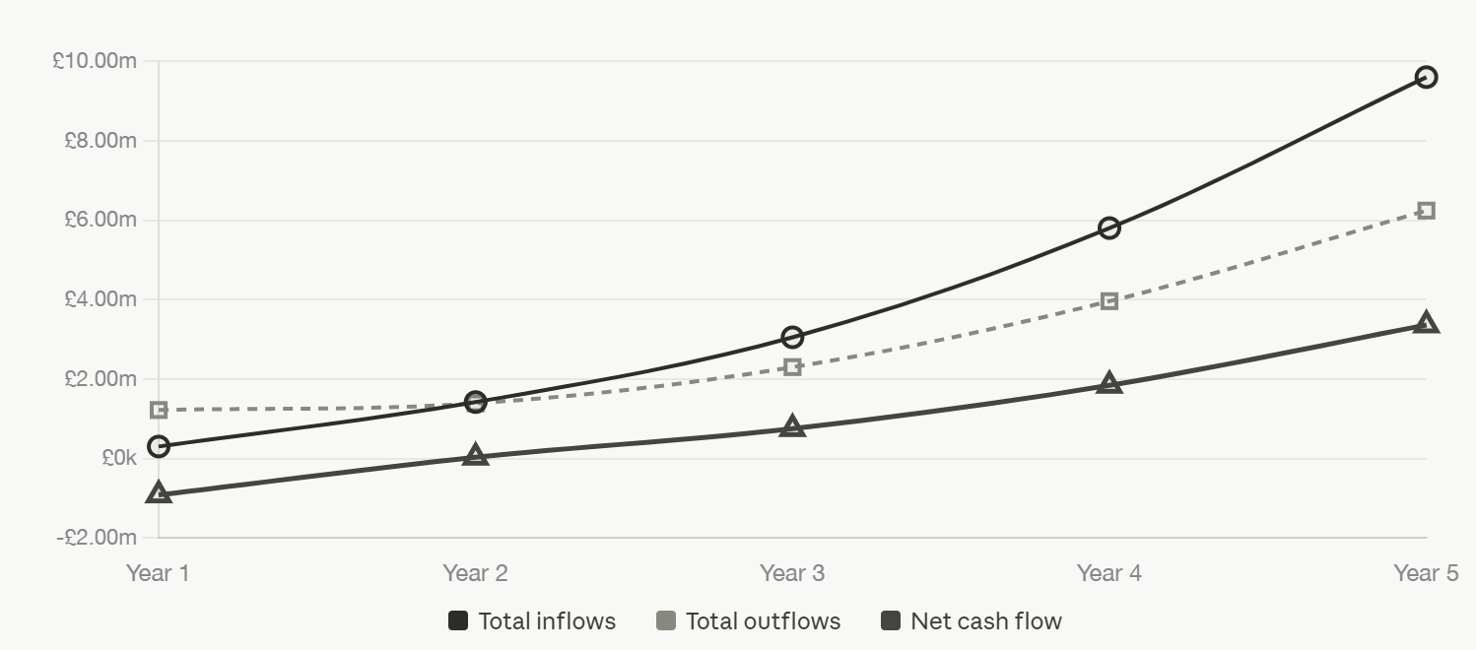
Figure 7: Net cash flow summary and post-Year-5 projections

APPENDIX D: PESTEL Analysis for VoxBank
Table 4: PESTEL Analysis for VoxBank
Factor | Key Drivers | Analysis | Strategic Implications for VoxBank
Political | Government support for financial inclusion (UK, Sub-Saharan Africa); Open Banking policies; Digital economy strategies | Governments are increasingly prioritising inclusive financial systems and digital transformation. Regulatory encouragement of Open Banking ecosystems facilitates third-party innovation. However, political instability in some Sub-Saharan regions may affect policy consistency and investment confidence. | VoxBank can align with national financial inclusion agendas to strengthen institutional partnerships. Entering politically stable markets first reduces risk. Engagement with policymakers and participation in regulatory sandboxes enhances legitimacy.
Economic | Growth of mobile money markets; Fintech investment trends; Inflation and currency volatility; Cost pressures on banks | Emerging markets show strong digital financial growth, particularly in mobile-led economies. However, macroeconomic instability, including inflation and fluctuating exchange rates, may limit institutional spending capacity in the short term. | VoxBank’s SaaS model offers cost efficiency, making it attractive during economic uncertainty. Pricing strategies may need localisation. Diversifying across regions mitigates exposure to economic shocks.
Social | Financial exclusion; Low digital literacy; Ageing populations; Accessibility awareness | Large segments of the population remain underserved due to literacy, disability, or lack of digital skills. There is increasing societal emphasis on inclusivity and equitable access to services. Trust in biometric systems varies across demographics. | VoxBank’s voice-first interface directly addresses inclusion gaps, creating strong differentiation. User education and trust-building measures will be critical for adoption. Multilingual capability strengthens market penetration.
Technological | Advances in AI, NLP, and voice recognition; Biometric authentication; Cloud computing; Cybersecurity risks | Rapid technological progress enables highly accurate conversational interfaces and secure authentication. However, the pace of innovation increases the risk of obsolescence. Dependence on cloud infrastructure introduces third-party risk. | Continuous R&D investment is essential to maintain competitiveness. Strategic partnerships with cloud providers enhance scalability. Strong cybersecurity architecture is critical to maintaining trust and regulatory compliance.
Environmental | Energy consumption of cloud infrastructure; ESG expectations; Sustainable digital operations | While fintech has a relatively low physical footprint, large-scale cloud computing contributes to energy usage. Stakeholders increasingly expect environmentally responsible digital operations. | VoxBank can leverage cloud providers with strong sustainability credentials. Positioning as a low-carbon digital solution may enhance brand value, particularly with ESG-conscious institutional clients.
Legal | Data protection regulations (such as GDPR), AML/KYC requirements, Biometric data laws, and Cross-border data restrictions | The regulatory landscape is stringent and fragmented across jurisdictions. Compliance with data privacy and financial regulations is mandatory but complex. Biometric data usage is particularly sensitive and highly regulated. | Compliance-by-design architecture is essential. Achieving certifications such as ISO 27001 strengthens credibility. Legal complexity may slow expansion, but it also creates barriers to entry for competitors, benefiting VoxBank in the long term.

THANK YOU

