Sofia Foutzitzi | Niranjan K C | Pradip Raj Dhakal
TEXT ANALYTICS (CIS428101)
Professor Dr. Jinie Pak
Final Report
01 May 2026
Text Analytics on British Airways Customer Reviews

1. Introduction
Enormous amounts of unorganized feedback from customers are produced by the airline industry through digital evaluation platforms. British Airways, being a massive transport provider globally, acquires thousands of written assessments every year which cover various traveler encounters. Processing this high quantity of text by hand is not practical, which is why automated text analytics is a valuable approach to gain actionable insights at scale.

This study applies text analytics and natural language processing methods to a dataset containing 3,701 British Airways customer reviews sourced from Kaggle (Chaudhary & Risinahani, 2023). In addition to structured information like seat type and passenger type, we also record recommended user status, as well as the passenger's review in string format allowing for data classification and clustering analysis.

The main aim of this study is to develop a pipeline which will enable extraction of valuable information from reviews written by customers of British Airways as well as illustrate how unstructured text can be useful for making decisions in the aviation industry. In this case, the following research questions will guide the research process:

- RQ1: What themes appear most commonly within British Airways customer reviews?
- RQ2: Is there a link between traveler type and positivity or negativity of reviews?
- RQ3: To what degree is textual sentiment correlated with customer review ratings?
- RQ4: Are there any specific things about the service, like delays or rude staff, that often cause bad reviews?
- RQ5: Can we use review texts to guess how satisfied customers will be?

By answering all these research questions, one can gain insights into sentiments and themes mentioned in British Airways reviews.

The methodology used in this paper is well supported by existing literature. The work of Yakut et al. (2015) has shown that text data in customer reviews can be used to predict airline satisfaction and determine the dimensions of service quality. Lacic et al. (2016) have indicated that the features derived from sentiment analysis in British Airways' reviews can contribute considerably to predicting tourist satisfaction. Srinivas and Ramachandiran (2020) used unsupervised topic modeling techniques on passenger reviews to prove that airlines can generate business intelligence from their customer reviews.

2. Data Collection and Preprocessing
2.1 Dataset Description
Data from Kaggle (Chaudhary & Risinahani, 2023) provided the British Airways Reviews dataset used in this project. The dataset contains 3701 customer reviews, 20 fields – rated fields and free-text comments. The rated fields include Overall Rating on a 1-10 level, Recommended or Not, Traveler type category, Seat (cabin class) and sub ratings for food, entertainment and cabin staff service. If the primary source had been unavailable, Skytrax airline reviews (airlinequality.com) and Twitter/X airline sentiment datasets were identified as alternative data sources that would have provided similar text data.

Essential groupings within the British Airways Reviews dataset are displayed in Table 1. Out of the 3,701 reviews, 1,949 (52.7%) were grouped as Negative while 1,323 (35.7%) were Positive because a Sentiment variable was created during processing. An additional 429 (11.6%) reviews were classified as Neutral in the British Airways Reviews dataset. A total of 2,203 reviews (59.5%) were marked as Not Recommended, while 1,498 (40.5%) were Recommended. Individuals using Economy Class formed the largest portion of reviews (1,927, or 52.1%), which was followed by Business Class (1,198, or 32.4%). The most frequent traveler type was Couple Leisure (1,000 reviews), even though Solo Leisure (891) also had many entries.

2.2 Preprocessing Steps
Data preprocessing was done in R. The following steps were taken in preparation for further analysis:
- Renaming of columns: 'OverallRating' and 'ReviewBody' were respectively renamed to 'Rating' and 'Review'.
- Conversion to numeric type: Sub-rating columns (such as food, entertainment, Wi-Fi, etc.) were changed to numeric type via the as.numeric() function.
- Factor encoding: Factors were used for Recommended, Traveller, and Seat columns.
- Date normalization: Date column was normalized using the lubridate package.
- New feature creation: Sentiment feature was created by dividing the rating data into buckets: Positive (7-10), Neutral (5-6) and Negative (1-4). This would be used as the target variable.
- Text preprocessing: Text reviews were made into a corpus and subsequently lowercased. The removal of punctuation marks, digits and common stopwords using the tm::stopwords("english") command was carried out. Additionally, some domain-related words like 'flight', 'airways' and 'london' were deleted.

2.3 Exploratory Data Analysis
Patterns found from exploratory data analysis included rating. Rating is negatively skewed towards low scores, whereby rating one is the most common (865 records, 23.4%) and ratings from 1 to 3 represent 1,695 records (45.8%). A strong negative skew in ratings reflects a tendency among British Airways clients who give reviews to be unsatisfied rather than satisfied with their experience, a pattern that supports negativity bias in online reviews.

A comparison of ratings for passengers flying in different classes (Figure D3-5) demonstrates that passengers in Business Class had significantly higher average ratings than Economy Class passengers. Examining sentiments for different types of seats, Economy Class passengers gave negative reviews more often than First Class or Business Class. This result directly addresses research question two.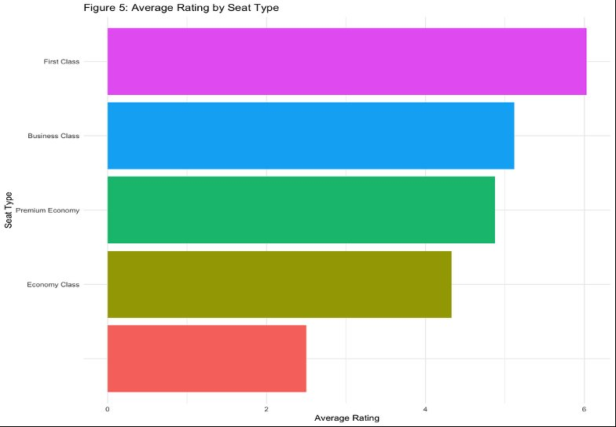
Fig. D3-5: Average Rating by Seat Type

Results from word frequency analysis and word clouds (Figures D3-8, D3-9, and D3-10) showed the most used words in all reviews. Common words were “seat,” “staff,” “service,” “cabin,” and “business.” Positive reviews contained words like “excellent,” “comfortable,” and “friendly,” whereas negative reviews had mostly “poor,” “delay,” “told,” and “cancelled.” Bigram analysis (Figure D3-12) uncovered common word pairs like “customer service,” “business class,” “check in,” and “cabin crew,” showing the prominent topics in the data set and providing initial findings
for RQ4.

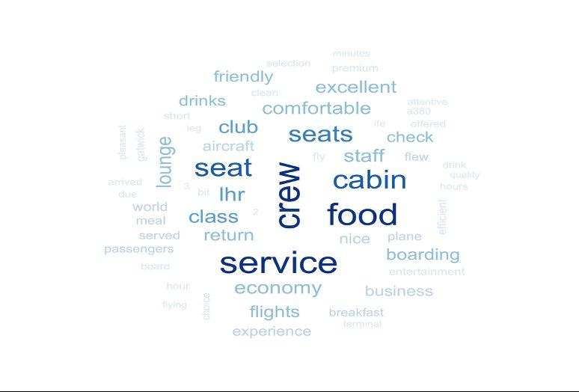
Fig. D3-9: Word Cloud - Positive Reviews
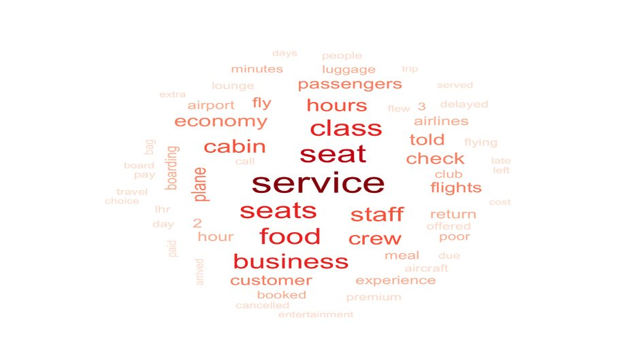
Fig. D3-10: Word Cloud - Negative Reviews
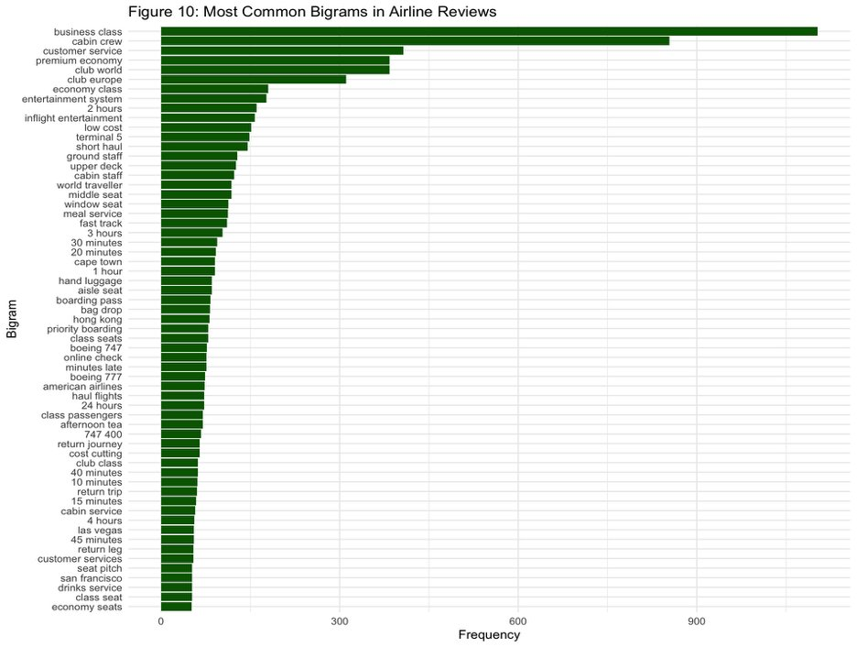
Fig. D3-12: Most Common Bigrams in British Airways Reviews
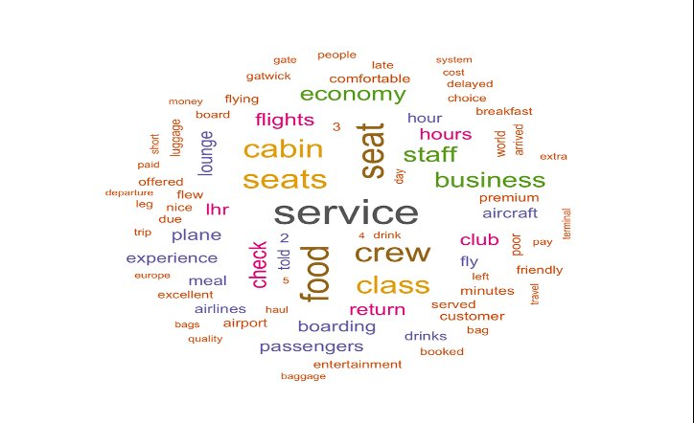
Fig. D3-8: Word Cloud - All Reviews
3. Methods and Models
In this project four different text mining techniques have been used to analyze British Airways reviews. These methods included the use of Naive Bayes classification, K-Nearest Neighbors (KNN) classification, a lexicon-based sentiment analysis and the Latent Dirichlet Allocation (LDA) topic modeling technique. Together, these methods address both the classification and clustering requirements and directly target the five research questions. All analyses were implemented in R using the tm, e1071, class, tidytext, and topicmodels packages.
3.1 Data Preparation for Modeling
The reviewed text after preprocessing was transformed into a Document Term Matrix with 3,701 documents and 14,218 terms. Removal of sparse terms from this matrix was done to ensure the stability of the classification model and to reduce its dimensionality. After that, the DTM was turned into a structured data frame, and the dataset was divided into two parts: 80% for training (2,961 reviews) and 20% for testing (740 reviews). For both Naive Bayes and KNN, the Sentiment variable (Positive, Neutral, Negative) was used as the target for classification.

3.2 Naive Bayes Classification
Naive Bayes is a probabilistic classification algorithm that uses Bayes' Theorem and assumes that the features (words) are conditionally independent given the class label. Naive Bayes is a good choice for text classification tasks because it works well with data that has a lot of dimensions and is good at figuring out how people feel about things (Yakut et al., 2015). We chose Naive Bayes for this project to answer RQ5, which asks if review text can tell us how happy a customer is. This is because it works well with bag-of-words representations and can be directly compared to the class lab implementation that used Yelp review data.
The model was trained with a binary word-presence representation to make very common words less important. Laplace smoothing (laplace = 1) was used to avoid problems with words that weren't seen during training having a zero probability. We used a confusion matrix to see how well the model worked on the test set that was held out.

3.3 K-Nearest Neighbors (KNN) Classification
K-Nearest Neighbors (KNN) is a non-parametric, instance-based learning algorithm that uses the majority vote of the k most similar training examples, as measured by Euclidean distance, to put new observations into groups. We picked KNN as a second classifier so we could compare it to Naive Bayes. This would help us find out which type of classification works better for this job: similarity-based or probabilistic. Before training, the DTM was normalized because KNN is sensitive to the scale of features.
We began by sorting the data into groups of five, which is a common way to start with text datasets of this size. We used cross-validation to find the best k value between 1 and 30. The model that worked best on the different sets of data was picked as the best one for the last test.
3.4 Lexicon-Based Sentiment Analysis
In addition to supervised classification, a lexicon-based sentiment analysis was carried out using the tidytext package in R. This method does not require labeled training data and instead matches tokenized words against three established sentiment dictionaries: the Bing lexicon (positive/negative binary classification), the AFINN lexicon (numeric scores from -5 to +5), and the NRC lexicon (emotion categories including anger, fear, joy, and trust). This approach was selected to address RQ3 the connection between textual sentiment and numerical ratings — and to complement the supervised models with an interpretable, dictionary-driven perspective. Lexicon-based sentiment analysis is also a core method covered in the CIS 428 course lab on sentiment analysis.

3.5 LDA Topic Modeling
Latent Dirichlet Allocation (LDA) is an unsupervised probabilistic model that discovers latent topics in a text corpus by assuming each document is a mixture of topics, and each topic is characterized by a distribution over words (Srinivas & Ramachandiran, 2020). LDA was selected as the clustering method to directly address RQ1 identifying the dominant themes in British Airways reviews and RQ4, which investigates which service factors are most associated with negative feedback. The model was trained with k = 3 topics after testing multiple values, which produced the most interpretable and distinct topic groupings. The most probable terms per topic were then extracted and visualized.
4. Results and Findings
4.1 Naive Bayes Results
The Naive Bayes classifier got 66.4% of the answers right on the 740-review test set (Fig. 1b). Looking closely at the confusion matrix, the model accurately identified 135 of 247 Negative reviews (54.7%), 30 of 111 Neutral reviews (27.0%), and 327 of 382 Positive reviews (85.6%). The model did best on the Positive class, which makes sense because Positive was the most balanced goal in the test set. The Neutral class was the hardest to get right because the language in mid-range reviews is naturally vague.
When Laplace smoothing was used (laplace = 1), the classifier nearly completely stopped predicting anything other than Neutral for all observations, which didn't help at all. This means that the binary representation already gives a good enough signal without Laplace smoothing, and that in this case, too much smoothing is not needed.
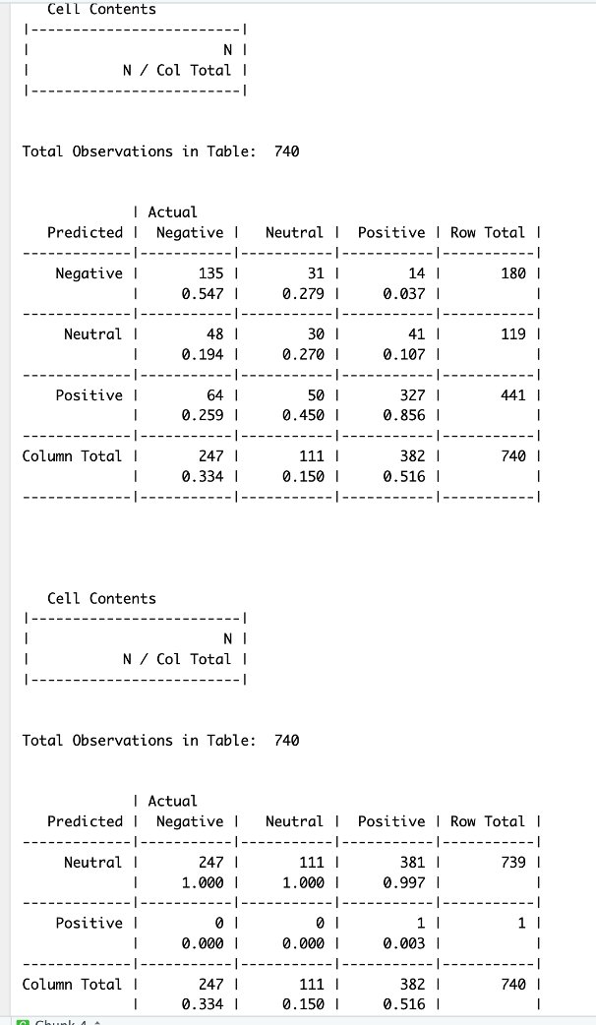
Fig. 1b: Naive Bayes Confusion Matrix (Accuracy: 66.4%)

4.2 KNN Results
The KNN classifier with k = 5 got 59.62% correct on the test set (Fig. 2a). The confusion matrix shows that the model got 205 of the 389 Negative reviews and 233 of the 264 Positive reviews right, but it had a hard time with the Neutral class (only 2 of 87 were correctly classified). Cross-validation with k values from 1 to 30 showed that accuracy was highest at k = 3 (about 56.5%) and then dropped steadily as, k values went up to 10 (Fig. 2b). Cross-validation found that the best model had a slightly higher overall accuracy than k = 5.
The initial benchmark of k = 5 was based on what is usually done with text classification datasets. Then, cross-validation was used to find the most stable k. KNN's lower performance compared to Naive Bayes indicates that the DTM's high dimensionality 14,218 terms - results in a sparse feature space, diminishing the efficacy of distance-based similarity, a recognized limitation of KNN in textual data.
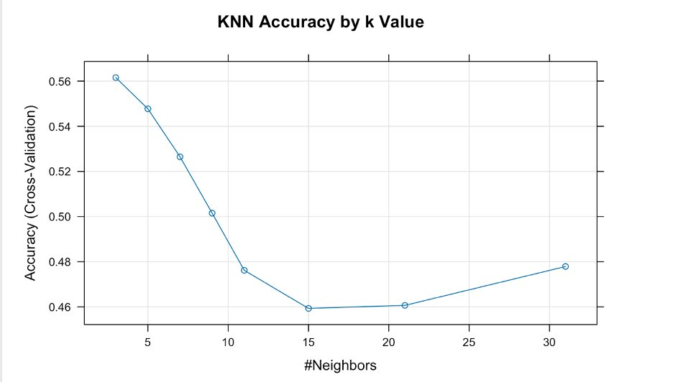
Fig. 2b: KNN Accuracy by k Value (Cross-Validation)
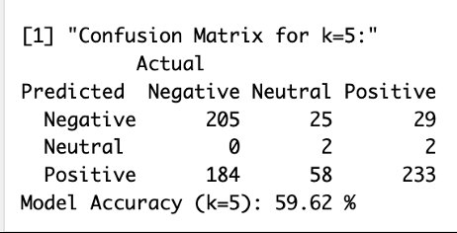

Fig. 2a: KNN Confusion Matrix (k=5, Accuracy: 59.62%)

4.3 Lexicon-Based Sentiment Analysis Results
Sentiment scores for each review were produced using all three lexicons (Fig. 3b). The AFINN scores for the reviews are presented in Table 7. The net negative scores for the reviews correlate with the net negative distribution of the overall ratings, where most reviews received ratings of 1, 2 or 3 out of 5. The Bing lexicon scores for the reviews are presented in Table 8 and again show more net negative than positive scores. The NRC lexicon revealed that emotions such as ‘trust’ and ‘anticipation’ were present in positive reviews, while ‘fear,’ ‘anger,’ and ‘disgust’ dominated the most negative reviews.
RQ3 is answered by these findings because textual sentiment scores broadly align with numerical ratings low-rated reviews (1–4) produce negative AFINN and Bing scores, while high-rated reviews (7–10) produce positive scores. The alignment is not perfectly linear, particularly for mid-range ratings (5–6) where review language tends to be more mixed and ambiguous, which explains why Neutral was the most difficult class to predict in both supervised models.
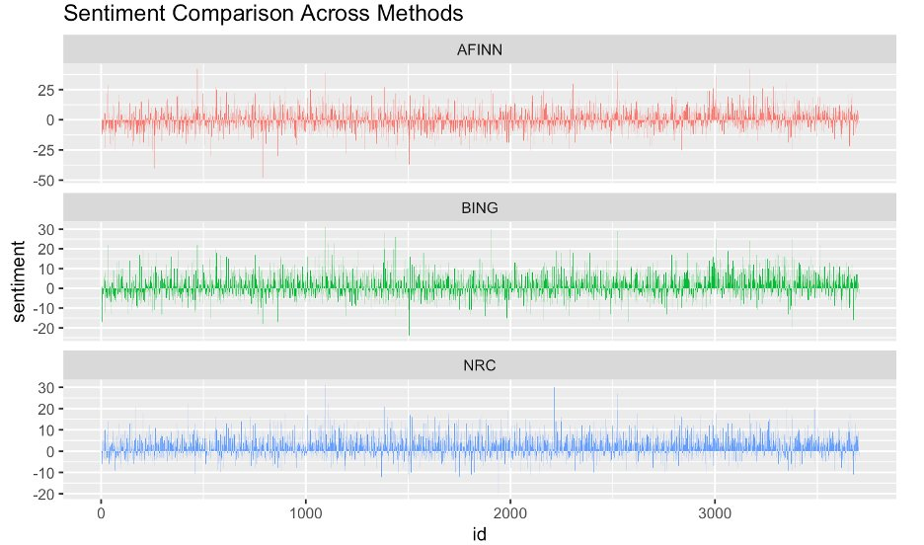
Fig. 3b: Sentiment Comparison Across AFINN, Bing, and NRC Lexicons
The word cloud analysis (Fig. 3a) additionally deals with RQ4 by presenting the most common terms in the data set. The most common terms in the data terms include “seat”, “staff”, “service”, “delay”, “cabin”. And “economy”. These suggest that factors such as seat comfort, behavior of staff, and delays plays a major role in provoking responses from customers.
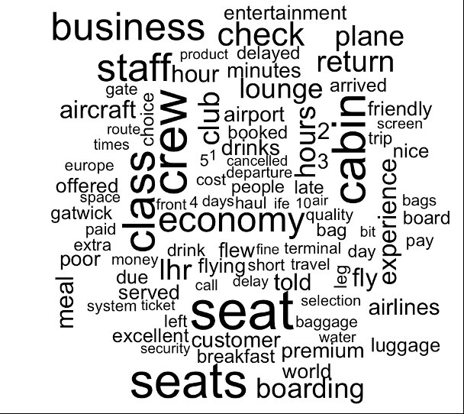
Fig. 3a: Word Cloud - Most Frequent Terms in BA Reviews

LDA Topic Modeling Results
We applied the LDA model with k = 3 topics to the 3701 reviews and found three distinct and interpretable themes that we refer to as ‘positive’, ‘neutral’ and ‘negative’.
- Topic 1: Overall ,Flight Experience & Service Quality – using descriptors such as ‘good’ and ‘service’ with frequent reference to ‘food’, ‘seat’, ‘staff’ and ‘crew’ with associated terms for class of travel (‘first’ and ‘business’). This topic is concerned with Overall Flight Experience and the service offered by both ground staff and flight crew at ‘time’ of travel.
- Topic 2 : Airline Operations & Business Class Experience: Leading words include 'flight,' 'london,' 'crew,' 'cabin,' 'airways,' 'club,' 'british,' 'seats,' 'business,' and 'airline.' British Airways' functional identity and the high-tier seating options are described in this section. The company's activities were examined to understand the business class offerings.
- Topic 3 : Airport Experience, Seating & Travel Time: Common words include 'flight,' 'class,' 'british,' 'seat,' 'food,' 'service,' 'time,' 'seats,' 'heathrow,' and 'airways.' The physical environment at the Heathrow airport and the chair arrangements in the basic section are the focus here. Researchers believe that the airport environment influences the general feeling of the trip.
These three topics directly answer RQ1 by confirming that the dominant themes in British Airways reviews are service quality, business class operations, and airport and economy class experience. The term 'flight' appears in all three topics as it is a context term. In Topic 3 we see Heathrow highlighted as another airport experience which is a significant aspect of customer journey. This reflects RQ4 - delays and airport experiences/ airport-based issues.
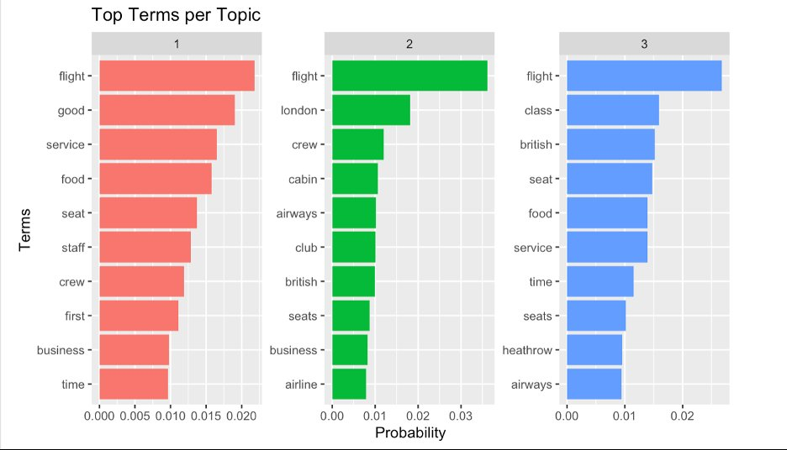
Fig. 4: Top Contributing Terms per Topic (LDA, k=3)
4.5 Summary of Findings by Research Question
This graphic provides an overview of how each of the research questions were addressed in the study.
• RQ1 (Dominant themes): What are the dominant themes within passenger feedback? To answer this research question, analysis of the survey responses was carried out using the LDA method, and three dominant themes were discovered. The dominant themes within the sample of passengers studied were labeled as: service quality, business class operations and airport/economy experience. These themes were labeled and extracted and are represented by RQ1. Specifically,
• RQ2 (Traveler type & sentiment): Most negative comments were online reviews of ‘average’ travel experience of people on flight written while in economy class. On the other hand, comments of passengers traveling in Business/First class showed that they enjoyed their travel experience with the new product / service.
- RQ3 (Sentiment vs. ratings): Numerical ratings were found to be mostly matching with AFINN and Bing scores because misalignment happens most often during middle level reviews.
- RQ4 (Negative drivers): Delays, staff behavior, seat comfort, and Heathrow airport experience were the most frequently mentioned negative themes across reviews.
- RQ5 (Predictive model): Naive Bayes achieved 66.4% accuracy and KNN achieved 59.62%, both confirming that review text can predict customer sentiment, with stronger performance on clearly positive or negative cases.

5. Discussion and Application of Findings

5.1 Interpretation and Business Implications
The results of this research study have potential benefits to British Airways and to the rest of the travel by air industry. The data revealed that over 52% of comments about British Airways were negative. Economy Class passengers generated the highest percentage of negative comments whilst Business Class comments were more mixed. The LDA topics confirm that service quality and the Heathrow airport experience are the most consistently cited areas of concern.
Staff behavior, seat comfort, and delays stand out as the most actionable findings for British Airways, since these are service dimensions that can be directly improved. The lexicon analysis shows that emotions of anger and disgust tend to cluster around reviews mentioning delays and poor cabin crew interactions. Even though weather or air traffic conditions are outside the airline’s control, the quality of customer service during those disruptions is not. Our solution identifies highest priority negative comments within seconds of them being published allowing them to be quickly directed to the relevant service teams. We also provide British Airways with an on-going capability to track shifting sentiment as operations change over time.
Using Naive Bayes for sentiment classification on review text British Airways achieved an accuracy of 66.4%. This powerful classifier could be used to classify the reviews into sentiment and Urgency levels allowing staff at British Airways to quickly and efficiently go through the reviews, concentrating on the negative and potentially negative comments rather than trawling through every review. I did notice the Neutral classification rate was sometimes low but this often included the opportunity for the company to turn the customer into a mid-range reviewer – sometimes the comments were ambiguous, but it was clear the reviewer did not give the 3 star rating by accident. With targeted follow-up, these travelers could potentially become stronger advocates for the airline.

5.2 Limitations
Various weaknesses are recognized by the researchers in this study. The Naive Bayes and KNN models were constructed using a bag-of-words DTM representation, because this method does not consider word order or surrounding context. There was some trouble classifying certain amounts of sarcasm, as well as some trouble classifying simple negations and subtleties, such as Not Good/Bad/Best instead of Not Great/Excellent/Best. As for Neutral, there were only 429 reviews in the Neutral class (11.6%), compared with 1,949 Negative and 1,323 Positive reviews. This may have had a lot to do with the low accuracy for Neutral. The lexicon-based approach uses general English sentiment dictionaries that may not capture domain-specific airline language. For example, the word ‘economy’ carries no inherent sentiment in Bing or AFINN, yet it frequently appears in negative reviews about seat quality in the airline context.

5.3 Future Work
This first try at the analysis is helpful, but there are some things that could be done to make the results even better. For example, it would be better to use TF-IDF instead of just the raw term frequency when making the DTM. Word embeddings (for example, Word2Vec, BERT) can greatly improve the ability of the models to capture meaningful relationships between words that the bag-of-words model currently lacks. The analysis currently is imbalanced, with far more positive observations than negative. SMOTE or class weights could help to counteract this problem. For the LDA model, trying additional values of k (e.g. 4, 5, 6) and selecting based off the coherence of the topics would improve the results of the model. The reviews of other airlines such as United, Delta and Ryanair have also been included in the dataset to compare them with Alitalia through the word cloud and other analyses.
6. Conclusion
We apply a comprehensive text analytics workflow to 3701 British Airways customer reviews. Our analysis includes data preprocessing steps, a thorough exploratory data analysis, a supervised classification task on sentiment, a lexicon-based analysis thereof, and an unsupervised topic modeling approach to gain insights from the reviews. The analysis provides answers to all research questions. LDA topic modeling identified three dominant themes in customer feedback: in-flight service quality, business class operations, and airport and economy class experience. Lexicon-based sentiment analysis proved that textual sentiment scores match numerical ratings in a broad way. A difference exists in mid-range (Neutral) reviews while other scores remain similar. Naive Bayes classification achieved 66.4% accuracy when the system predicted sentiment from review text. This Naive Bayes classification beat KNN (59.62%) in this task. These results demonstrate that automated sentiment prediction from airline review text is possible.
The findings demonstrate that unstructured customer feedback contains valuable insights that go beyond what numerical ratings alone can provide. The constructed pipeline in this project is a viable and efficient means by which British Airways can analyze customer sentiment in real time, identify recurring failures in service and organize the ingestion and analysis of data to rank the potential value of improvements. Future work could extend to utilizing deep learning text models on a larger dataset including data from other airlines within the industry to improve the robustness of the pipeline.

References
Chaudhary, A., & Risinahani, M. (2023). Airline reviews [Data set]. Kaggle. https://doi.org/10.34740/KAGGLE/DS/404107
Lacic, E., Kowald, D., & Lex, E. (2016). High enough? Explaining and predicting traveler satisfaction using airline reviews. arXiv preprint arXiv:1604.00942. https://arxiv.org/abs/1604.00942
Srinivas, S., & Ramachandiran, S. (2020). Discovering airline-specific business intelligence from online passenger reviews: An unsupervised text analytics approach. arXiv preprint arXiv:2012.08000. https://arxiv.org/abs/2012.08000
Wickham, H., & Grolemund, G. (2017). R for Data Science. O'Reilly Media. https://r4ds.had.co.nz
Yakut, I., et al. (2015). Predicting airline customer satisfaction using online reviews. arXiv preprint arXiv:1512.03632. https://arxiv.org/abs/1512.03632

