Niranjan K C
Professor Dr. McGuire
CIS468
13 February 2026
Assignment 1: Exploratory Data Analysis on Credit Card Approval
1. Introduction & Background
Exploratory Data Analysis (EDA) is an important first step in building any kind of predictive or statistical model. The purpose of this project is to learn more about how a credit card approval dataset is structured, how the data is spread out, and how the different pieces of data are related to each other. We can discover patterns that may help explain how acceptance decisions are spread out across candidates by looking at both numerical and categorical parameters.
There are 690 credit card applications in this dataset, and each one has 16 different properties.
This dataset consists of 690 credit card applications with 16 different attributes. For this research, I used five primary variables to represent both financial and categorical characteristics:
- Debt (numeric – primary attribute)
- Income (numeric)
- Credit Score (numeric)
- Industry (categorical)
- Approved (categorical – binary outcome)
The main purpose of this study is to talk about how these variables are spread out and look at how they might be related to each other.
2. Data and Methods

Dataset Overview
There are 690 observations in the dataset. The response variable, Approved, tells you if a credit application was approved (1) or not (0). To make it easier to see and understand, I turned this variable into factor labels: Approved and Not Approved.
Three numeric variables were examined for distributional properties:
- Debt
- Income
- Credit Score
Two categorical variables were analyzed:
- Industry
- Approved

Methods Used
All analysis was conducted in R using the ggplot2 library for visualization.
For numeric variables, I calculated:
- Minimum and maximum values
- Mean and median
- Variance and standard deviation
- Pearson’s skewness coefficient
Histograms were used to assess distribution shape, and boxplots were used to identify outliers.
For categorical variables, bar charts were created to examine frequency distributions.
For relationships between variables:
- A scatter plot with regression line was used to explore the relationship between Income and Debt.
- A boxplot grouped by approval status was used to compare debt distributions between approved and denied applicants.
- A side-by-side bar chart was used to examine approval outcomes across industries.
- Pearson correlation was calculated for Income and Debt.

Methods Considered but Not Used
- A Normal Q-Q plot was considered to formally assess normality for the financial variables. However, after observing the histograms and skewness coefficients, it was clear that the distributions were strongly non-normal. Including Q-Q plots would not have added meaningful insight beyond what was already visible.
- I also considered using Z-score standardization to detect outliers numerically. However, because the financial variables are heavily skewed and contain extreme values, boxplots were preferred. Boxplots are more appropriate for skewed financial data because they rely on interquartile range rather than assumptions of normality.

Key Assumptions of Major Methods
The linear regression line in the scatter plot assumes:
- A linear relationship between variables
- Independence of observations
- Homoscedasticity (constant variance)
Given the extremely skewed income distribution and visible clustering near zero income values, these assumptions are only partially satisfied. Therefore, the regression line should be interpreted cautiously and only as a descriptive trend.
Correlation analysis assumes:
- Linear relationship
- Continuous variables
- Absence of strong outliers
Because of the extreme income values (including 100,000), correlation may be influenced by outliers. The weak correlation observed supports this limitation.

Generative AI Disclosure
I used Google Gemini to help organize the R code and improve the clarity of written explanations. All statistical decisions, interpretations, and analysis were performed independently by me.

3. Results

3.1 Univariate Analysis – Debt (Primary Attribute)
Debt ranges from 0 to 28. The mean debt is 4.76, while the median is 2.75, indicating a noticeable difference between central tendency measures.
The Pearson skewness coefficient is 1.21, which confirms a right-skewed distribution.
The histogram shows that most applicants have relatively low debt, but a small number carry substantially higher debt amounts. The boxplot shows that there is more than one outlier on the higher end. This means that the "average" debt doesn't really show what a typical application is like, as extreme values make the mean higher.
Figure 1: Distribution of Debt (Histogram)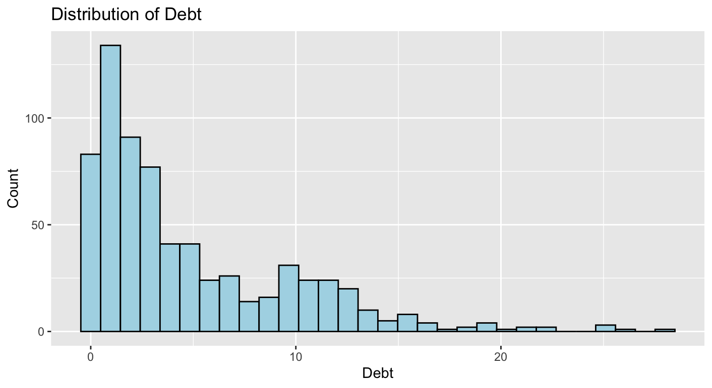
Figure 1 shows that most applicants have rather low levels of debt, with most of it being below 5. But the distribution has a long right tail that goes all the way to 28, which shows that there are candidates with very significant debt. This visual proof backs up the calculated skewness value of 1.21, which shows that the distribution is positively skewed.
Figure 2: Debt Distribution by Approval Status
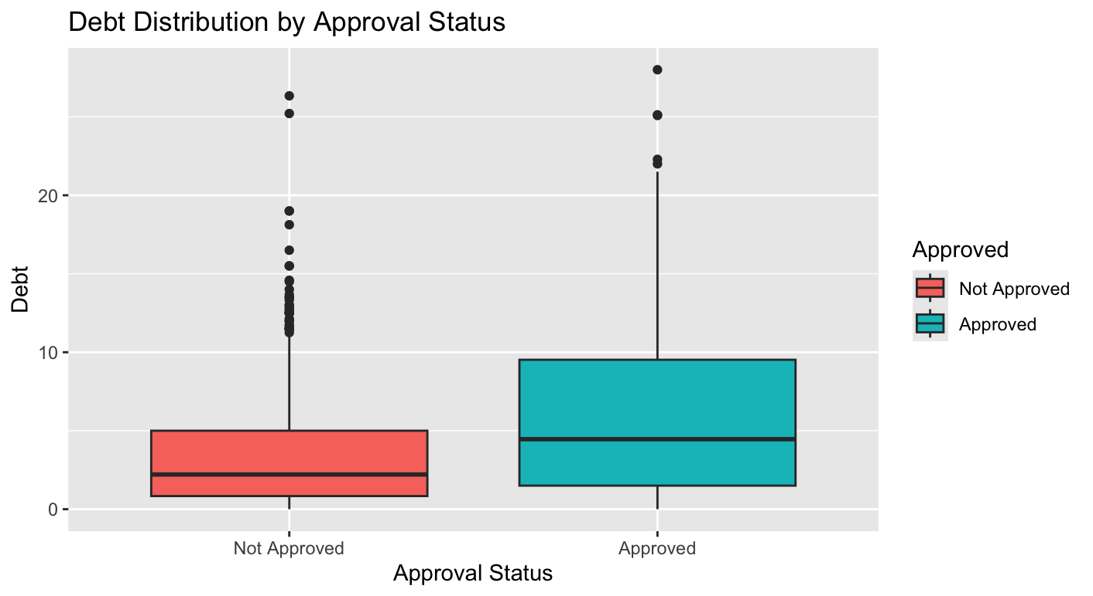

Figure 2 demonstrates that the amount of debt is very similar for both approved and refused applications. Even while approved candidates tend to have slightly lower median debt, both categories have people with a lot of debt.

3.2 Income and Credit Score
Income displays extreme variability. While the median income is 5, the maximum income is 100,000, and the standard deviation exceeds 5,200. This indicates that most applicants report very low-income values, with a few extremely large outliers creating a long right tail.
This distribution can be described as heavily right-skewed and possibly zero-inflated.
Credit Score is also very skewed. The median is 0, which means that more than half of the people who applied have a credit score of 0 in this dataset. The distribution indicates that a significant number of applicants either had no documented credit history or have limited credit information accessible.
Figure 3: Distribution of Income using histogram
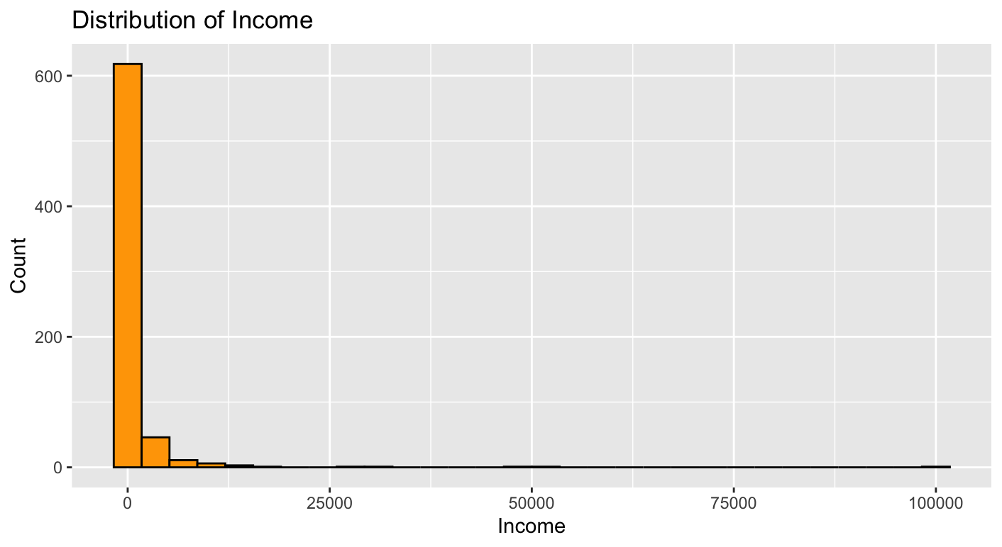
Income is heavily right-skewed. Most applicants report very low-income values, while a small number show extremely high income. These extreme values stretch the distribution and make the mean much higher than the median.
Figure 4: Distribution of Credit Score using histogram
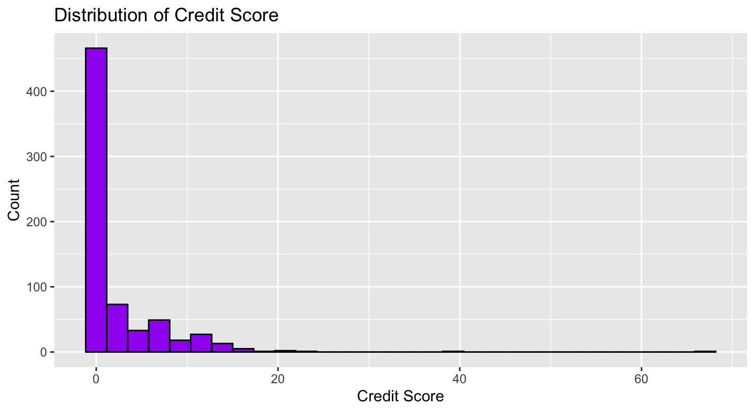
Credit scores are also skewed to the right, with most applicants having very low or no credit ratings. There is a lengthy right tail because only a few applicants have higher values. This indicates that many people in the dataset have a short credit history.
3.3 Categorical Analysis – Industry and Approval
There are 14 categories in the Industry variable. Energy is the most common industry in this dataset, with 146 applicants.
Regarding approval outcomes:
- 383 applicants (55.5%) were Not Approved
- 307 applicants (44.5%) were Approved
This indicates that slightly more than half of the applications were denied.
The side-by-side bar chart shows that approval rates vary by industry. Some industries appear to have relatively higher approval counts compared to others, suggesting that industry type may play a role in credit decisions.
Figure 5: Distribution of Approval Status using Bar Plot
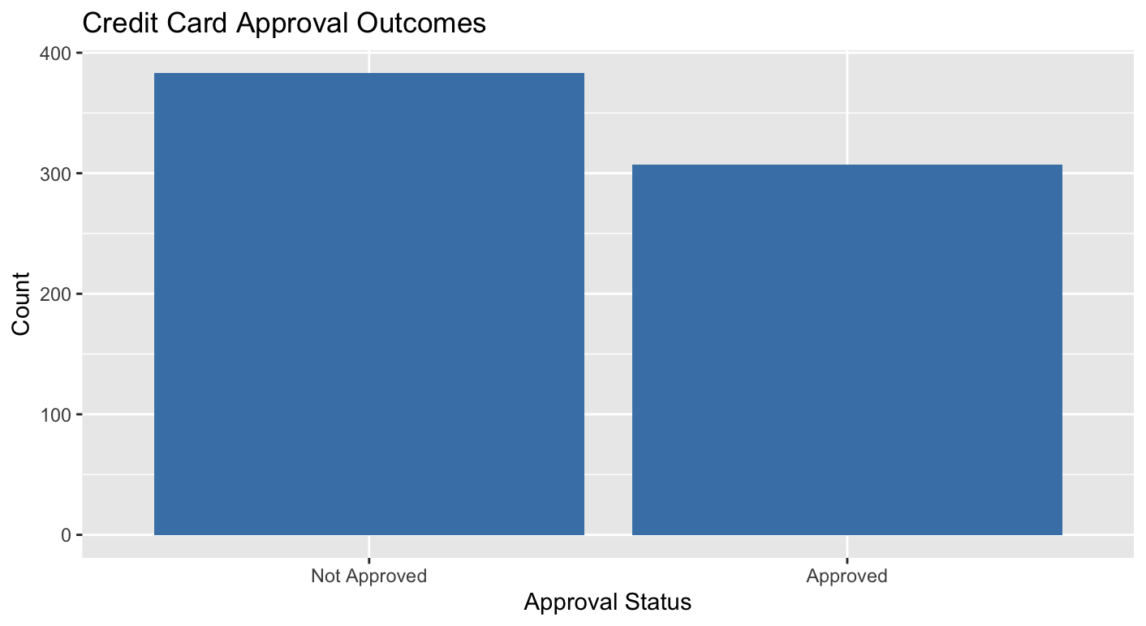
Figure 5 shows the overall approval outcomes in the dataset. Slightly more applicants were not approved (383) compared to those who were approved (307). This shows that approval was rather selective, since more than half of the applications were turned down.
Figure 6: Distribution of Industry using Bar Plot
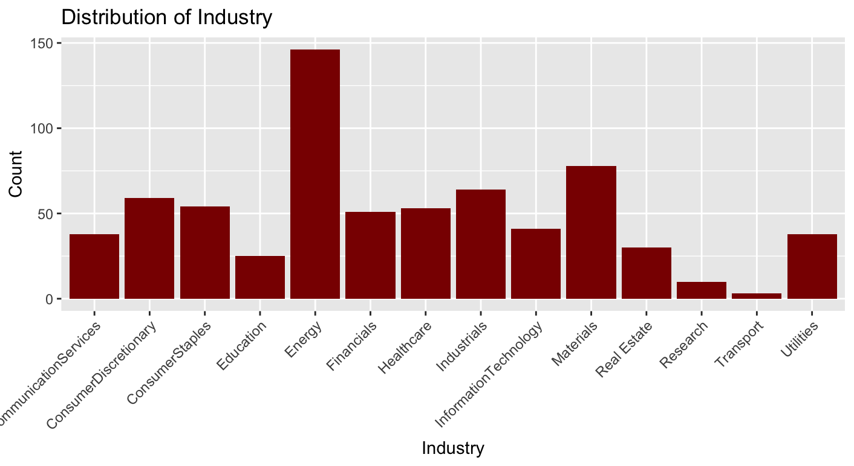

This bar chart in Figure 6 illustrates how many people applied for jobs in each industry. The Energy industry has the most applicants, while Research and Transport have the least. This means that some industries are better represented in the dataset than others.

3.4 Bivariate Relationships

Income vs Debt
The scatter plot of Income and Debt shows a weak positive relationship. The correlation coefficient is 0.123, which means that there is almost no linear relationship.
This means that in this dataset, having a greater income doesn't really mean that you will have debt. The regression line goes up a little, but the data points are spread out a lot, thus the association is weak.
Figure 7: Exploring relationships between numeric variables (Income vs Debt)
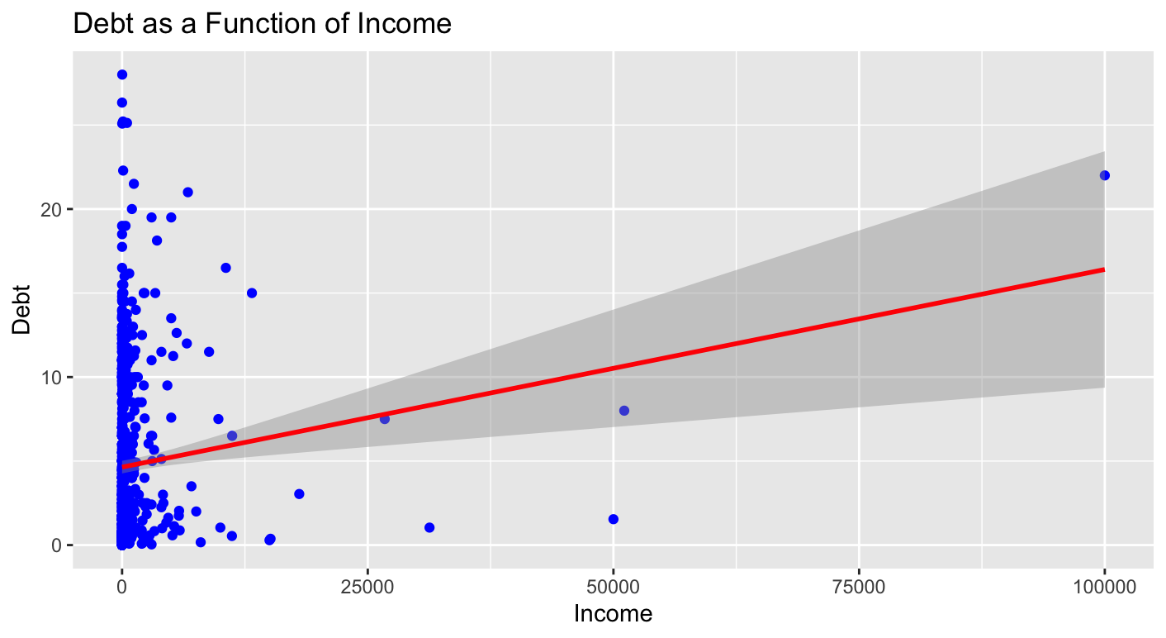

Figure 7 shows how income and debt are related. The regression line goes up a little, but the data points are spread out a lot. The correlation coefficient (0.123) shows that the association is quite weak. In this dataset, income does not significantly predict debt levels.

Debt vs Approval Status
The boxplot that compares Debt by Approval Status indicates that there is a lot of overlap between applicants who were approved and those who were not.
Even while rejected applicants appeared to have slightly more debt on average, the distributions overlap a lot. This indicates that debt alone does not sufficient to explain approval decisions. Other variables must contribute to the outcome.
Figure 8: Exploring relationships between numeric vs categorical variables (Debt vs Approval Status)

The boxplot shows a lot of overlap between approved and denied applicants. Although there is a slight difference in median debt, both groups include high-debt outliers. This suggests that debt alone does not determine approval decisions.

Industry vs Approval
The side-by-side bar chart indicates that approval rates vary by industry. Some industries have a very even ratio of approvals to denials, while others have a more uneven one.
This suggests that industry classification might affect the likelihood of acceptance, although additional statistical modeling is necessary to validate significance.
Figure 9: Exploring relationships between categorical variables (Industry vs Approved Status)

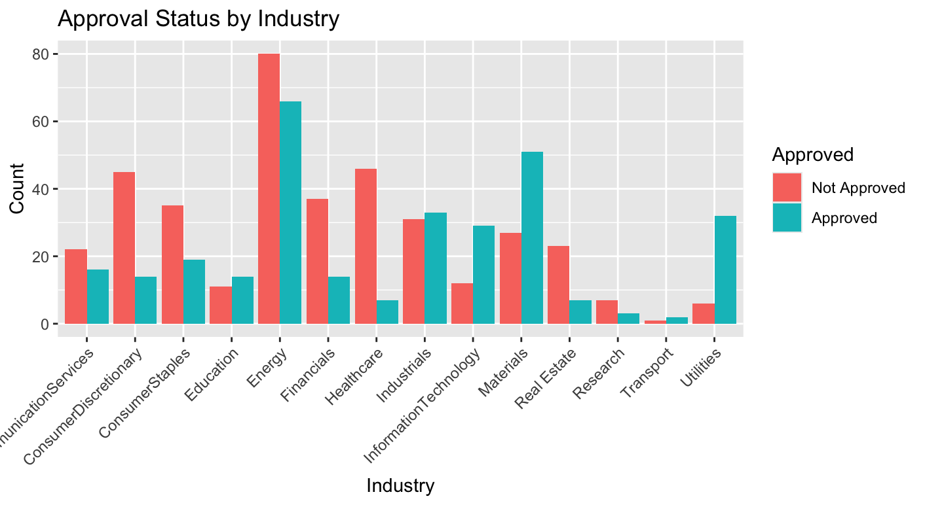

It seems that approval rates differ from one industry to the next. Some fields have more approvals than denials, while others have the opposite pattern. This implies that the type of industry may influence approval outcomes, although more research is needed to statistically validate this correlation.

4. Conclusion
This exploratory analysis shows that the credit card approval dataset contains strongly non-normal financial variables with significant right-skewness and extreme outliers.
Key findings include:
- Debt and Income are heavily right-skewed.
- Mean values do not represent typical applicants due to extreme outliers.
- Income and Debt have very weak correlation.
- Debt distributions overlap heavily between approval categories.
- Approval outcomes vary by industry.

In general, this means that loan approval choices probably don't depend on just one financial factor. Instead, they probably come from a mix of different things about the applicants.
Future modeling studies need to use robust statistical techniques or modifications to deal with skewed distributions and outlier data.

Work Cited
Kaggle. (n.d.). Credit card approval dataset. https://www.kaggle.com/datasets/samuelcortinhas/credit-card-approval-clean-data

