The National Aquarium Smart Tablet Project Report
ITEC 411
Oluwanifemi Jobi-fele, Onyinyechi Inyamah, Niranjan K C, Assam Khan, Adamah Jackson

Executive Summary
The aim of this project is to enhance the visitor experience at The National Aquarium in Baltimore, MD, through the development of a "smart" tablet. This initiative was proposed by the executive director after she overheard a couple of young children pestering their father with question after question about the animals. He was only able to answer a few of their questions and expressed a wish that there was a way he could answer his daughters' queries. The project focuses on integrating technology to provide guests with interactive and informative content that deepens their understanding of the exhibits. The primary objective is to offer users a seamless way to engage with the Aquarium’s educational resources, helping them navigate exhibits, answer questions, and explore areas of interest. Ultimately, the goal is to elevate the overall experience, making it both enjoyable and educational for all visitors.
Scope
The project will involve the design and deployment of rugged, user-friendly tablets that can withstand daily use in a public environment. These tablets will need to provide detailed information about the exhibits, animals, and facility, using a combination of voice, text, graphics, and possibly video. The system will integrate with the existing Aquarium database to ensure accuracy and provide real-time information to visitors. Additionally, the tablets may include an optional link to the Aquarium's store database to suggest relevant products for purchase based on visitor queries.
Time
The project timeline spans approximately 25 weeks, beginning with a 2-week initiation phase to define the project scope and align with stakeholders. The planning phase will last 4 weeks, during which the project charter, work breakdown structure, and procurement plan will be created. A 4-week procurement phase will follow, involving the issuance of an RFP and vendor selection. The design and development phase, lasting 8 weeks, will focus on software development, hardware procurement, and system integration. Testing will take place over 4 weeks to ensure functionality and user experience, followed by a 2-week deployment phase for tablet installation, staff training, and system handover. The project will conclude with a 1-week closure phase for final reviews and documentation.
Cost
The estimated cost for the project will cover hardware, software development, system integration, and procurement services, with additional considerations for testing, training, and contingency. The hardware costs will include the procurement of durable tablets, which are expected to cost approximately $300 per unit, with the total cost dependent on the number of tablets required. Software development will account for the development of the tablet application, including design, user interface, and database integration, with an estimated cost of $50,000. System integration services for linking the tablet software with the Aquarium’s existing educational and store databases will be approximately $20,000. Additionally, there will be costs for testing, training, and project management, along with a contingency budget for unforeseen expenses. The total cost of the project is projected to be in the range of $120,000 to $150,000, depending on final vendor pricing and scope adjustments.

Procurement
The procurement process begins with a thorough needs assessment, where a company might determine that it requires new software to enhance project management efficiency. After identifying these requirements, the next step is market research, where the team explores various software vendors such as Asana, Trello, and Microsoft Project to compare features and pricing. Once potential suppliers are identified, an RFP is issued, outlining the specific needs, such as integration capabilities and user support. For instance, if the company values user-friendly interfaces, this would be a critical criterion in the RFP. After receiving proposals, the evaluation phase assesses each vendor against criteria like cost-effectiveness, customer reviews, and the ability to provide training. For example, if one vendor offers a comprehensive training program while another does not, this could significantly influence the decision. Once a vendor is selected, contract negotiations follow to finalize terms, including pricing and service level agreements. The company would then issue a purchase order to formalize the agreement. Throughout the order fulfillment phase, communication is key to ensure timely delivery of the software. Upon receiving the software, a quality assurance check is conducted to verify that it meets the specified requirements, such as functionality and performance. Finally, after processing payment, the procurement team conducts a review of the entire process to identify strengths and areas for improvement, ensuring that future procurements are even more efficient and aligned with company goals.
Project Charter
Project Title: Smart Tablet Solution for the National Aquarium
Project Start Date: March 28, 2025
Projected Finish Date: September 25,2025
Budget Information: Estimated project cost: $120,000 to $150,000

Project Manager:
Oluwanifemi Jobi-fele
Mobile: 433433433
E-mail: ojobife1@sudents.towson.edu

Project Objectives:
The objective of this project is to develop and deploy durable, user-friendly smart tablets for the National Aquarium in Baltimore. The tablets will provide visitors with real-time, interactive information about the exhibits, animals, and the Aquarium’s facility. The goal is to improve the visitor experience by making educational content easily accessible while navigating the exhibits.

Main Project Success Criteria:
The main project success criteria include the successful procurement of durable tablets and software within the specified budget, seamless integration with the Aquarium’s existing educational and store databases, and positive user feedback regarding the tablets' ease of use and effectiveness. Additionally, the project will be considered successful if the tablets are deployed on schedule, with all stakeholders, including staff and visitors, properly trained. Ultimately, the project’s success will be measured by its completion on time, within budget, and meeting the desired quality standards.

Approach:
The project will follow a structured approach, beginning with a needs assessment to define the requirements for the tablets and software. After completing market research, the team will issue an RFP to potential vendors. The vendor selection process will be based on factors like cost, quality, and technical capability. Once selected, the team will procure the hardware and software, followed by testing and training. The final phase will involve deployment and quality assurance checks to ensure the tablets meet all specifications.
Roles and Responsibilities

Role | Name | Organization/  Position | Contact Information
Project Manager | Oluwanifemi jobi-fele | IT DEPARTMENT | 453-433-3333
Procurement Specialist | Inyamah, Onyinyechi | IT DEPARTMENT | 223-222-1134
Technical Expert / Project Planner | Khan, Assam | IT DEPARTMENT | 987-567-4433
Resource and Scheduling Lead | K C,Niranjan | IT DEPARTMENT | 233-344-6766
Cost and Project Close-Out Lead | Jackson, Adamah | IT DEPARTMENT | 967-453-3444

Discussion of the project team and skill set needed
The success of the procurement process depends on the collaboration of a well-rounded team with diverse skills. Each team member's expertise plays a crucial role in ensuring that procurement decisions are well-informed, strategic, and aligned with the project’s goals. This is how the skills of each team member contribute to the project, particularly the procurement process:
Project Manager:
The project manager oversees the entire project and ensures that the procurement process aligns with the project's scope, timeline, and budget. They also lead the decision-making process, ensuring the team stays focused on the project's objectives while making informed procurement decisions based on the team's input.
Key skills required include:
- Leadership and Management: The ability to coordinate team members, set clear goals, and ensure that all project phases are executed on time.
- Project Planning: Expertise in creating a comprehensive project plan that includes procurement activities and milestones.
- Risk Management: Identifying potential risks in the procurement process and developing strategies to mitigate them.
- Communication: Ensuring clear communication between the team, stakeholders, and vendors to align expectations and keep everyone informed.
Procurement Specialist:
The procurement specialist is responsible for managing the procurement process, including issuing the Request for Proposal (RFP), evaluating vendor proposals, and selecting the best vendors. Skills needed for this role include:
- Vendor Management: The ability to identify, evaluate, and select vendors that offer the best value for the project’s needs.
- Contract Negotiation: Skilled in negotiating terms that ensure the project stays within budget and meets the required quality standards.
- Procurement Best Practices: Knowledge of procurement strategies and the ability to draft comprehensive RFPs that clearly define project requirements and evaluation criteria.
- Market Research: Conducting thorough research to compare vendors and identify the most suitable solutions for the project’s needs.
Technical Expert / Project Planner:
The Technical Expert / Project Planner is responsible for evaluating the technical specifications of the tablet and software solutions, ensuring that the selected vendors meet the project’s technical requirements. Key skills for this role include:
- Systems Integration: Understanding the technical requirements of integrating tablet hardware with the Aquarium's existing educational and store databases.
- Technology Evaluation: Evaluating vendor proposals based on their technical capability to meet the project's needs, such as system compatibility and scalability.
- Project Planning: Expertise in developing the project’s scope and work breakdown structure (WBS), defining all project activities and deliverables.
The Technical Expert / Project Planner contributes to the procurement decision by ensuring that the selected hardware and software solutions meet the project’s technical standards and functional needs.
Resource and Scheduling Lead:
The Resource and Scheduling Lead is responsible for managing the resources and schedule required for the project, ensuring that the procurement process stays on track. Required skills for this role include:
- Resource Allocation: Expertise in managing and allocating resources efficiently to meet project demands.
- Project Scheduling: Proficiency in creating detailed project timelines and ensuring that procurement activities are completed on time.
- Time Management: The ability to monitor and control the project schedule to ensure that the procurement process does not cause delays.
The Resource and Scheduling Lead ensures that the procurement activities align with the project schedule, helping the team stay on track and ensuring timely delivery of procured goods and services.
Cost and Project Close-Out Lead:
The Cost and Project Close-Out Lead is responsible for managing the project’s financials, ensuring that the procurement stays within the defined budget. This role also involves overseeing the closure phase of the project. Required skills include:
- Cost Estimation and Budgeting: Expertise in estimating procurement costs and ensuring that the project remains within budget.
- Financial Analysis: Reviewing vendor proposals to assess the financial impact and ensure the best value for money.
- Risk and Financial Management: Identifying potential cost overruns and working with the team to ensure the project stays financially viable.
- Project Close-Out: Managing the final stages of the project, ensuring that all contracts are closed, and all deliverables are met.
The Cost and Project Close-Out Lead ensures that the procurement decisions align with the project’s financial constraints and that the project is completed within the agreed-upon budget.
Request for Proposal (RFP)
Development of Smart Tablets for Visitor Engagement
National Aquarium, Baltimore, MD
1. Introduction
The National Aquarium in Baltimore, MD, is seeking proposals for the development and deployment of a smart tablet system to enhance visitor engagement. These tablets will be strategically placed at exhibits to provide interactive and educational content, improving the visitor experience. This initiative aligns with the Aquarium’s mission to inspire conservation of the world’s aquatic treasures through innovative technology.
2. Project Background and Objectives
This project was inspired by a visitor interaction where a father struggled to answer his children's questions about the animals. To address this need, the smart tablet system will:
- Provide voice search functionality for easy access to information.
- Offer interactive maps to assist visitors in navigating exhibits.
- Support multilingual access for a diverse audience.
- Enable image search to identify animals and provide related information.
- Integrate with the Aquarium’s education and store databases, suggesting relevant purchases when visitors inquire about exhibit-related items.
3. Scope of Work
The project will involve the design and deployment of rugged, user-friendly tablets that can withstand daily use in a public environment. These tablets will need to provide detailed information about the exhibits, animals, and facility, using a combination of voice, text, graphics, and possibly video. The system will integrate with the existing Aquarium database to ensure accuracy and provide real-time information to visitors. Additionally, the tablets may include an optional link to the Aquarium's store database to suggest relevant products for purchase based on visitor queries. The vendor will be responsible for:
- Designing and developing the tablet interface with a user-friendly experience.
- Deploying 250 Android-based tablets at designated exhibit locations.
- Ensuring real-time Wi-Fi connectivity for up-to-date navigation and educational resources.
- Implementing voice-enabled assistance to improve accessibility.
- Integrating with existing Aquarium databases for seamless information retrieval.
- Providing ongoing support and maintenance (specific security and maintenance protocols to be determined).
4. Technical Requirements
- Operating System: Android.
- Connectivity: Wi-Fi-enabled for real-time updates.
- Hardware: Vendor must recommend appropriate tablet specifications.
- Software Integration: Must interface with the Aquarium’s educational and retail systems. (Asana, Trello, and Microsoft Project in consideration)
- User Accessibility: Voice-enabled and multilingual support required.
5. Project Timeline
The project timeline spans approximately 25 weeks, including:
- Weeks 1-2: Initiation phase to define project scope and align with stakeholders.
- Weeks 3-6: Planning phase to create the project charter, work breakdown structure, and procurement plan.
- Weeks 7-10: Procurement phase, involving the issuance of the RFP and vendor selection.
- Weeks 11-18: Design and development phase focused on software development, hardware procurement, and system integration.
- Weeks 19-22: Testing phase to ensure functionality and user experience.
- Weeks 23-24: Deployment phase for tablet installation, staff training, and system handover.
- Week 25: Closure phase for final reviews and documentation.
6. Budget
The estimated cost for the project will cover hardware, software development, system integration, and procurement services, with additional considerations for testing, training, and contingency.
- Hardware: Tablets are expected to cost approximately $300 per unit, with a total of 250 units.
- Software Development: Estimated at $50,000, including design, user interface, and database integration.
- System Integration: Approximately $20,000 for linking the tablet software with the Aquarium’s existing educational and store databases.
- Additional Costs: Include testing, training, project management, and a contingency budget.
- Total Estimated Budget: $120,000 - $150,000, depending on final vendor pricing and scope adjustments.
7. Vendor Qualifications
Interested vendors must:
- Demonstrate expertise in interactive technology and mobile development.
- Have experience in museums or educational technology projects.
- Provide examples of similar projects with references.
- Detail their approach to ongoing support and system updates.
8. Proposal Submission Requirements
Proposals should include:
- Company background and relevant experience.
- Project approach and methodology.
- Technical specifications and proposed solutions.
- Cost breakdown and budget justification.
- Proposed timeline and implementation plan.
9. Evaluation Criteria
Proposals will be evaluated based on:
- Technical feasibility and innovation (30%)
- Vendor experience and qualifications (25%)
- Cost-effectiveness (20%)
- Scalability and future expansion potential (15%)
- Support and maintenance plan (10%)
10. Submission Deadline and Contact Information:
All proposals must be submitted by May 26th, 2025, to oinyama1@students.towson.edu. For questions regarding the RFP, please contact Onyinyechi Inyamah at 223-222-1134.
Detailed Project Plan
Project Scope
By the end of the project, we should have 250 units of rugged, durable, user-friendly tablets. These tablets would have detailed information of the different animals of the Aquarium, being linked to its database. It would also supply the user with visual information such as graphics, and videos pertaining the wildlife as well as accessibility features such as text-to-speech and multilingual capabilities. The tablets will be connected over Wi-Fi to access the database and store page in real time with an algorithm that would suggest products for the user to buy based on activity. The tablets should be fast enough to allow for fast retrieval of information to retain interest. Software integration may include the likes of Asana, Trello, or Microsoft Project.
TASK LIST
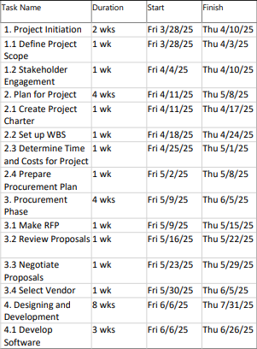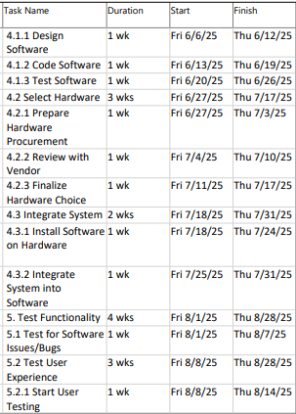
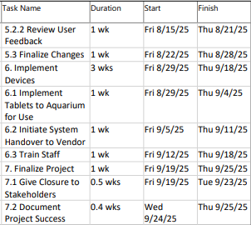
Work Breakdown Structure

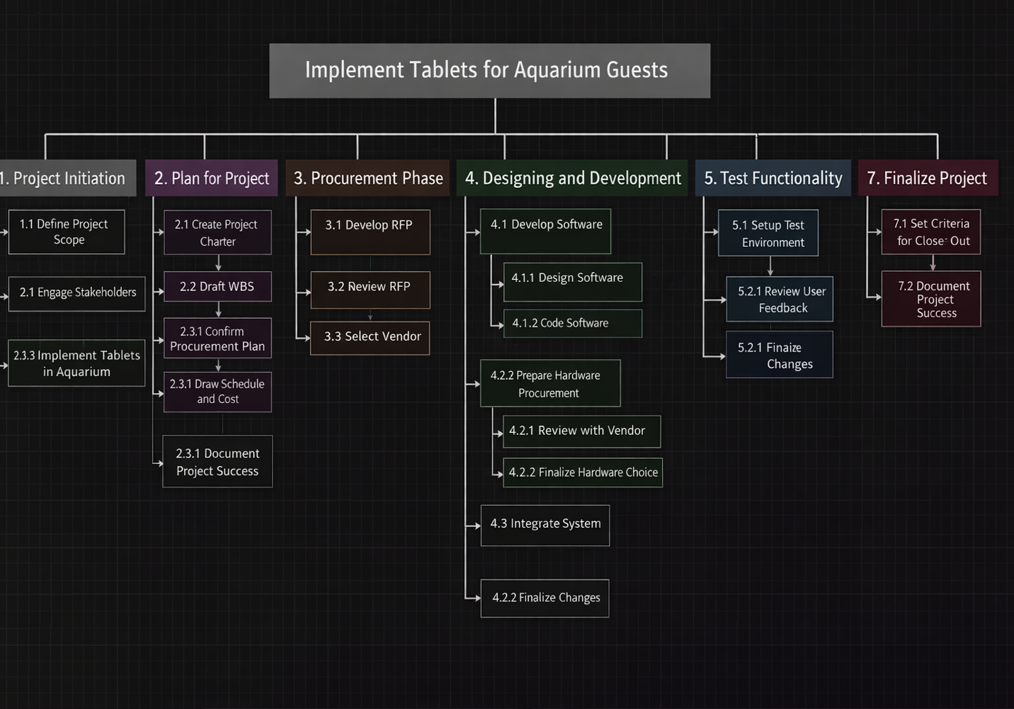
Discussion of Project Activities
- Project Initiation
1.1 Define Project Scope
This is where the general scope statement is defined for the project as expectations are set.
1.2 Stakeholder Engagement
Stakeholders are then included in the discussion for initiating the project as the scope may be reviewed if needed.
- Plan for Project
2.1 Create Project Charter
This serves as an outline for the project overall and where responsibilities are assigned. Goals and milestones should be made clear here.
2.2 Set up WBS
The Work Breakdown Structure is set up to break down all tasks into the smallest deliverables that can be recorded to document the project’s completion.
2.3 Determine Time and Costs for Project
Resources such as time and budget are estimated here to gauge how the project should be handled.
2.4 Prepare Procurement Plan
Planning for the procurement begins as terms are established.
- Procurement Phase
3.1 Make RFP
The scope of the project and the terms for service are presented to vendors to set the standards for a proposal.
3.2 Review Proposals
Different proposals from potential vendors are looked at with aspects such as experience, and pricing are considered.
3.3 Negotiate Proposals
After viewing different proposals, counteroffers are made in relation to experience and services.
3.4 Select Vendor
After considering all other bids into account, a vendor with the most promise for their pricing is selected and a statement of work is made.
- Designing and Development
4.1 Develop Software
4.1.1 Design Software
The vendor is given time to create concept software designed for the tablets.
4.1.2 Code Software
The software goes from the conceptual phase to logical as the vendor begins coding. This would be the general layout for the tablets.
4.1.3 Test Software
The software is then tested for its compatibility on a tablet, ensuring there are no complications.
4.2 Select Hardware
4.2.1 Prepare Hardware Procurement
Hardware is requested from the vendor with reasonable specs yet affordable pricing. The tablets should have all the features such as Wi-Fi and fast retrieval time.
4.2.2 Review with Vendor
The hardware selected by the vendor is assessed to see if it fits the criteria. If not, other tablets are looked at.
4.2.3 Finalize Hardware Choice
Once the best tablet has been determined, 250 units are then ordered and shipped to the Aquarium
4.3 Integrate Systems
4.3.1 Install Software on Hardware
The software is then installed on all devices. Any potential problems with the tablets are last dealt with here as they are configured with the appropriate settings.
4.3.2 Integrate System into Software
The database is then accessed through the software on the tablets, and the connection is monitored and tested.
- Test Functionality
5.1 Test for Software Issues/Bugs
The tablets are thoroughly tested for any bugs or issues and then fixed accordingly.
5.2 Test User Experience
5.2.1 Start User Testing
A selected group is asked to navigate through the tablet and try the different features such as access to the database or store page. Other features such as the text-to-speech and other languages are tested.
5.2.2 Review User Feedback
The selected group then provides feedback on the different features the tablets have to offer along with its performance. Notes are made on what stood out the most and the least.
5.2.3 Finalize Changes
The feedback is then taken into consideration along with any issues in the last round of changes.
Network Diagram
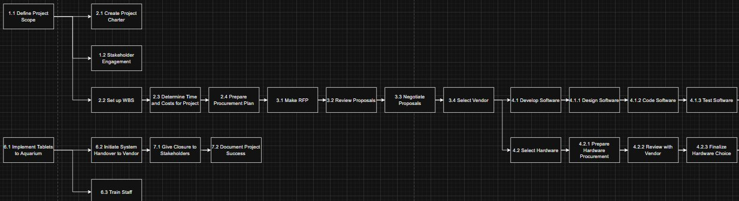
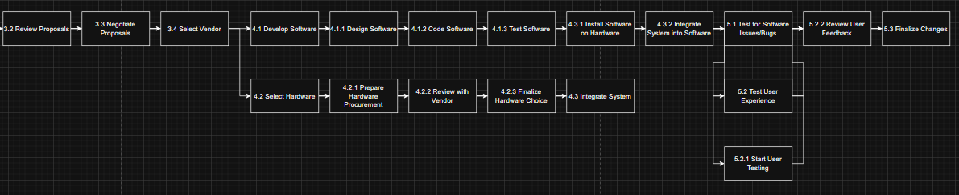

Responsibility Matrix
The following table shows a simplified version of the task responsibilities for each major phase of the project. It avoids technical RACI terms and instead identifies which team member is primarily responsible for each task. Clear role assignment helps ensure accountability and smooth project execution.
Task | Femi (PM) | Onyinyechi (Procurement) | Assam (Tech Lead) | Niranjan (Scheduling) | Adamah (Cost/Close-Out)
Define Scope | A | I | R | C | I
Develop RFP | I | A/R | C | I | I
Vendor Selection | C | A/R | C | C | I
Project Planning | A | C | R | R | I
Software/Hardware Integration | I | C | A/R | C | I
Schedule Development | I | I | C | A/R | I
Cost Estimation | I | I | C | C | A/R
Testing and QA | A | C | R | C | I
Deployment | A | C | R | R | C
Training | A | C | C | R | I
Project Closure | I | I | I | C | A/R

Note on the RACI Chart (For All Team Members – FYP Awareness)
In this project, we used the RACI matrix to clearly define team responsibilities. RACI stands for:
R – Responsible: Person who does the task
A – Accountable: Person who ensures the task is completed and approves the outcome
C – Consulted: Person who gives advice or expert input
I – Informed: Person who needs to stay updated on progress
Using the RACI model helps us:
- Avoid confusion about who’s doing what
- Make sure each task has clear ownership
- Improve communication and accountability across the team

Discussion of All Resources Required
The successful completion of this project depends on access to the following resources:
- Human Resources
- Project Manager (Femi): Oversees full lifecycle and aligns with objectives.
- Procurement Specialist (Onyinyechi): Handles RFP, vendor evaluations.
- Technical Expert / Planner (Assam): Manages tech integration, scope breakdown.
- Resource Scheduler (Niranjan): Ensures schedule alignment and timely task execution.
- Cost/Close-Out Lead (Adamah): Manages budget, financials, and closure tasks.
- Hardware Resources
- 250 rugged Android tablets ($300 each)
- Charging stations and potential Wi-Fi upgrades
- Software Resources
- Custom tablet app with voice/text/multilingual features
- Database integration with Aquarium’s systems
- PM tools like Asana, Trello, MS Project
- External Services
- Software vendor, maintenance and security provider
- Training for staff

Project Schedule with Time Estimates
The following schedule outlines the key phases, and time estimates over the 25-week project duration:
Phase | Tasks | Duration | Time Frame
Initiation | Define scope, team alignment | 14 days | Mar 28 – Apr 11
Planning | Project charter, WBS, procurement plan | 28 days | Apr 11 – May 09
Procurement | Issue RFP, evaluate vendors, sign contracts | 28 days | May 09 – Jun 06
Design & Development | UI/UX design, software build, tablet purchase | 56 days | Jun 06 – Aug 01
Testing | Functional and user testing | 28 days | Aug 01 – Aug 29
Deployment | Install tablets, train staff, launch | 14 days | Aug 29 – Sep 12
Closure | Final checks, report, handoff | 7 days | Sep 12 – Sep 19

Cost Table with Estimates for All Activities and Overall Project
Activity | Estimated Cost
Hardware (250 tablets @ $300 each) | $75,000
Software Development | $50,000
System Integration | $20,000
Testing & Quality Assurance | $5,000
Staff Training | $3,000
Project Management | $7,000
Contingency | $10,000
Total Estimated Cost | $170,000 (Max)
Budget Range | $120,000 – $150,000

The Gantt chart below provides a visual representation of the project timeline:
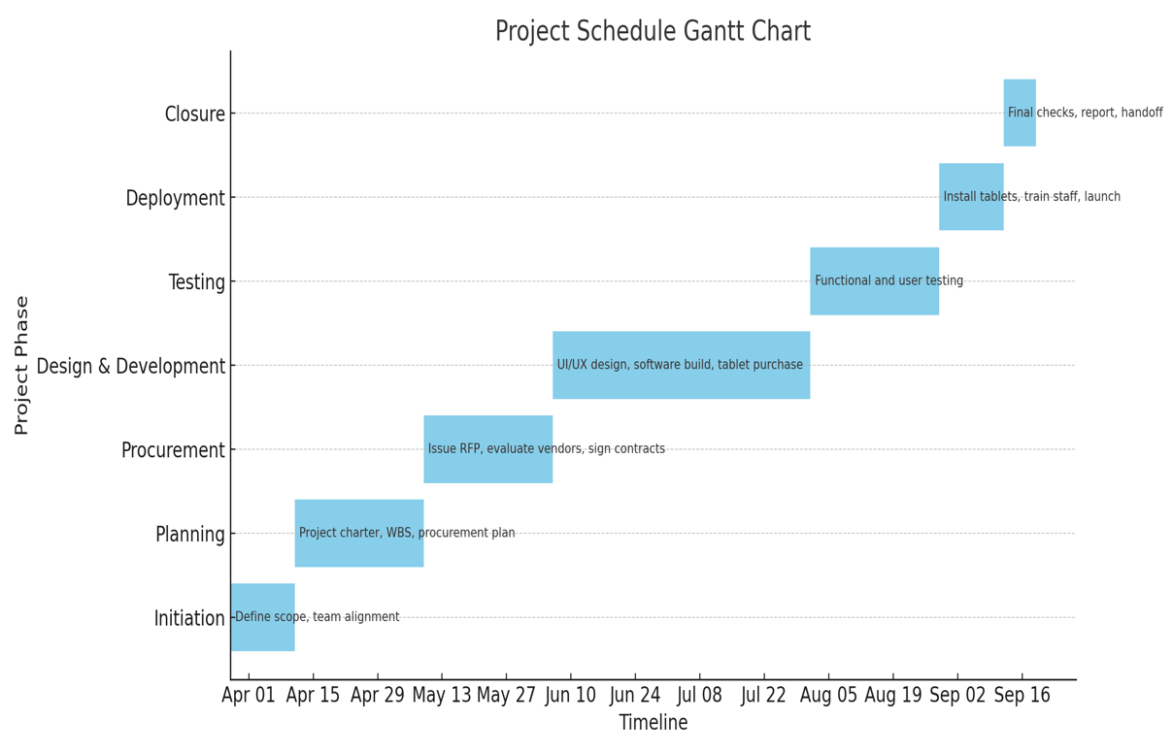

Critical Task List and Discussion of the Project’s Critical Path
Critical Tasks (Tasks that directly impact the completion date):
Define Scope and Stakeholder Engagement
Create Project Charter and WBS
Issue and Evaluate RFP
Vendor Selection and Contract Finalization
Software Design and Development
Hardware Procurement
System Integration
Testing and User Feedback
Deployment and Staff Training
Project Closure and Handover
Critical Path Explanation
The Critical Path includes all activities that must be completed on time to avoid delaying the project. These span from scope definition to final handover, particularly tasks in the Design & Development, Testing, and Deployment phases. For example, delays in tablet procurement or software development would push back integration and deployment, impacting the final deadline.
6. Implement Devices
6.1 Implement Tablets to Aquarium
Tablets are put in place at the Aquarium where guests can be given but are also secured. Charging stations are mapped out across the Aquarium for before, during, or after use.
6.2 Initiate System Handover to Vendor
The vendor gets control of the system for maintenance and oversight.
6.3 Train Staff
All employees on the floor are given proper training in handling the devices including device collection, distribution to guests, and processing payment information. Basic troubleshooting is also taught for guests' convenience.

Discussion of the Activities Needed to Close-Out the Project
To properly close out the project, the following activities are needed:
Final System Handover: Control of the installed and tested system is officially transferred to the vendor for ongoing maintenance and support.
Staff Training Completion: All relevant staff are trained in device usage, distribution, troubleshooting, and customer support.
Stakeholder Reporting: Project outcomes are formally reported to key stakeholders, summarizing milestones, deliverables, and budget usage.
Documentation and Archiving: Final documentation including lessons learned, project summaries, vendor contracts, and usage reports are compiled and archived.
Contract Closure: All outstanding contracts and procurement agreements are reviewed and formally closed.
Post-Implementation Review: A brief evaluation is conducted to assess what went well, what didn’t, and how future projects can be improved.
Conclusion
The Smart Tablet Project at the National Aquarium in Baltimore has officially reached its completion and is ready for handover to relevant stakeholders. A final report detailing the project outcomes, system features, and deployment success has been prepared and presented to executive sponsors, IT management, and educational staff. The 250 rugged Android tablets are now fully integrated into the aquarium’s infrastructure, offering real-time database access, educational content, and multilingual support. With all objectives met and deliverables accepted, the project is formally closed, and ownership of the system is transferred to the operations and maintenance teams for ongoing support and updates. This project successfully delivered an innovative and interactive learning solution within the planned 25-week timeline. Key accomplishments include on-time procurement and deployment, successful system testing, and staff training. The estimated cost of $120,000 to $150,000 was effectively managed through structured budgeting and procurement via a competitive RFP process. The use of RACI charts and strong communication helped ensure clarity in roles and accountability. Lessons learned include the importance of early stakeholder engagement, detailed planning during the procurement phase, and proactive risk management to handle technical and schedule-related issues. While there were minor setbacks during hardware configuration and initial testing, these were resolved quickly due to agile development practices and collaborative problem-solving.
In summary, the Smart Tablet Project stands as a model of applying technology to enhance public education, meeting both functional and experiential goals. The insights gained will inform and improve future technology initiatives within the organization.

