Exploratory Data Analysis and Next-Day
Air Quality Prediction for Indian Cities

Course: U21ADP05 — Exploratory Data Analysis and Visualization
Assignment II | 40 Marks

Student Name : [Student Name]
Roll No. : [Roll No.]
Department : [Dept.]
Year / Sem : [Year]

Submission Date: 15 / 10 / 2026

Table of Contents
1 Abstract
2 Introduction and Objective
3 Dataset Description
4 EDA and Preprocessing
5 Data Visualization
6 Deep Learning Model
7 Result Visualization
8 Conclusion and Future Scope
9 References
10 Appendix

1 Abstract
Air pollution is a critical public-health concern in India, where rapid urbanization has degraded air quality across major cities. This report presents a comprehensive Exploratory Data Analysis (EDA) of the CPCB city-level daily AQI dataset (26 cities, 29,531 rows, 2015-01-01 to 2020-07-01). We apply Ben Fry's seven-stage visualization pipeline—acquire, parse, filter, mine, represent, refine, and interact—to characterize pollutant distributions, seasonal patterns, and the COVID-19 lockdown effect on AQI. A deep-learning MLP model is then trained on 92-dimensional lag/rolling features to predict next-day AQI and AQI category (six classes). On the held-out chronological test set the MLP achieves MAE = 32.90, RMSE = 48.83, R² = 0.668 (regression) and macro-F1 = 0.474, AUC = 0.850 (classification), substantially outperforming the persistence baseline (MAE = 32.58).

2 Introduction and Objective
India's Central Pollution Control Board (CPCB) publishes a National Air Quality Index (AQI) aggregated from six sub-indices: PM2.5, PM10, SO₂, NO₂, CO, and O₃. Accurate forecasting of the next-day AQI can enable timely public-health advisories and targeted emission-reduction efforts. This project has three objectives:
- CO3 — produce at least 8 well-labelled visualizations with interpretation.
- CO4 — perform rigorous statistical analysis: univariate, bivariate, multivariate, and distribution fitting.
- CO5 — build a reproducible end-to-end pipeline from raw data to a deep learning next-day AQI predictor, with a complete GitHub-ready repository.

3 Dataset Description
Source: Kaggle dataset 'Air Quality Data in India' (rohanrao), originating from the CPCB. The file city_day.csv contains 29,531 rows × 16 columns spanning 2015-01-01 to 2020-07-01 across 26 cities.

3.1 Column Schema
Column | Type | Unit | Description
City | str | — | Indian city name
Date | date | — | Measurement date (YYYY-MM-DD)
PM2.5 | float | µg/m³ | Particulate matter < 2.5 µm
PM10 | float | µg/m³ | Particulate matter < 10 µm
NO | float | µg/m³ | Nitric Oxide
NO2 | float | µg/m³ | Nitrogen Dioxide
NOx | float | ppb | Oxides of Nitrogen
NH3 | float | µg/m³ | Ammonia
CO | float | mg/m³ | Carbon Monoxide
SO2 | float | µg/m³ | Sulphur Dioxide
O3 | float | µg/m³ | Ozone
Benzene | float | µg/m³ | Benzene
Toluene | float | µg/m³ | Toluene
Xylene | float | µg/m³ | Xylene
AQI | float | — | National AQI (composite)
AQI_Bucket | str | — | 6-class category (Good→Severe)

4 EDA and Preprocessing

4.1 Parse
Date was converted to datetime. Each city's time-series was reindexed to a complete daily calendar (DatetimeIndex with freq='D') so that a one-day shift truly refers to the previous calendar day. Calendar features added: year, month, weekday, is_weekend, season (Indian 4-season classification), and cyclical sine/cosine encodings.

4.2 Filter
Duplicate (City, Date) rows detected: 0. Linear interpolation applied within each city for gaps ≤ 3 consecutive missing days. Winsorization at the 0.5th–99.5th percentile per pollutant preserved real pollution spikes while clipping extreme sensor errors. Rows without a valid AQI target were removed before modeling (24,850 rows retained).
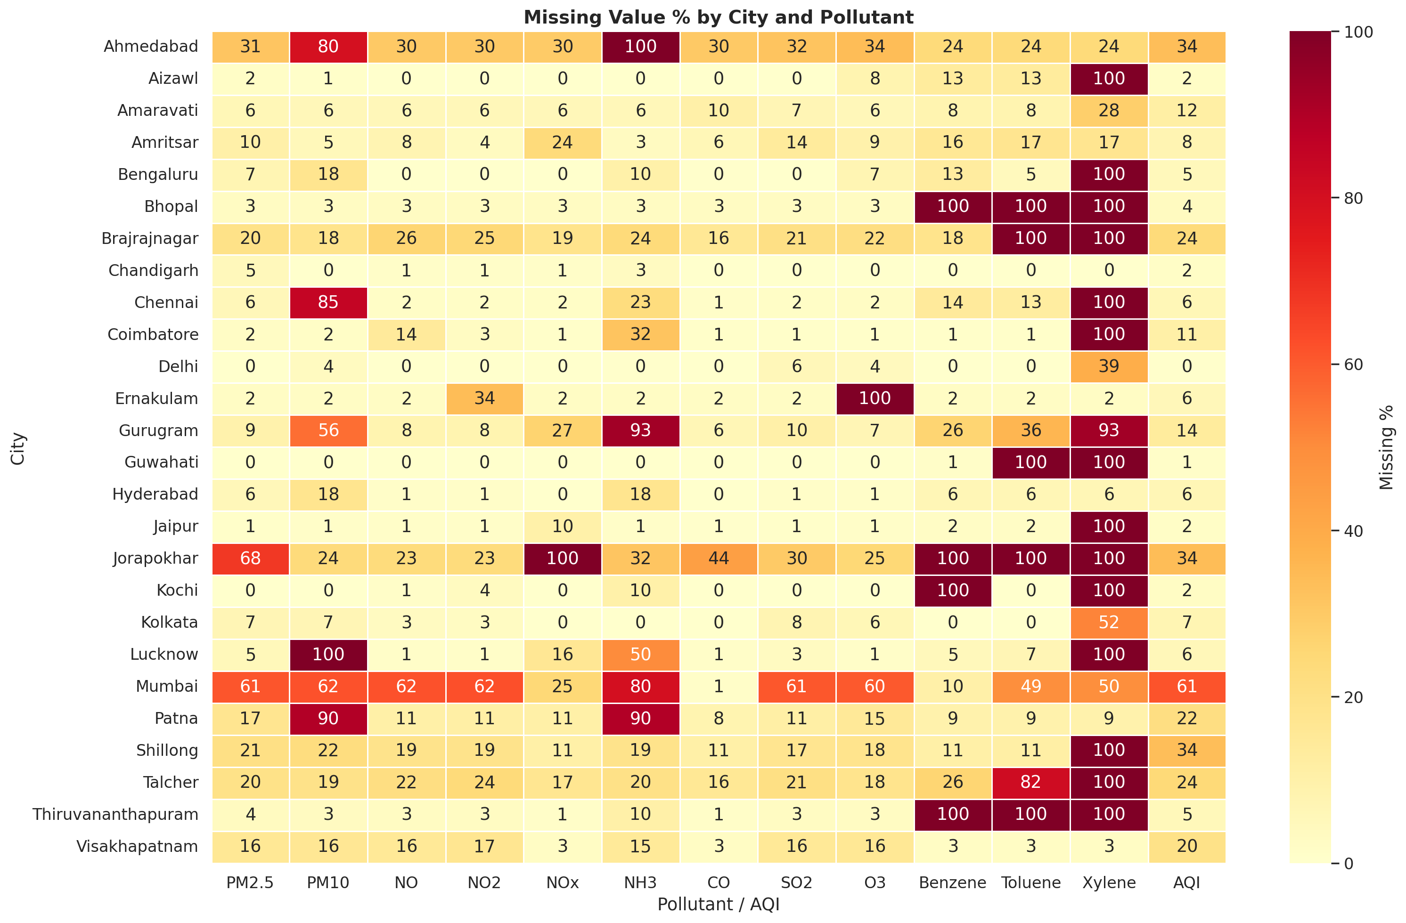
Figure: Missing value percentage by city and pollutant.

4.3 Outlier Handling
IQR-based and z-score (|z| > 3) outlier counts were computed per column. Winsorization (not deletion) was chosen because extreme PM2.5 values (up to 900 µg/m³ during Diwali or crop-burning events) are real phenomena and carry predictive signal. See Figures 02 and 03.

5 Data Visualization

5.1 Univariate Histograms with KDE
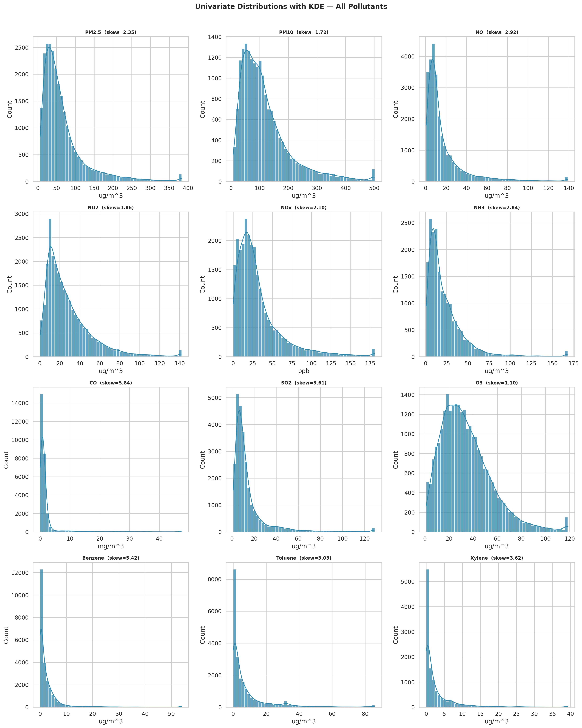
Figure: Histograms with KDE — all 12 pollutants.
WHAT IT SHOWS: Frequency distributions of all pollutant concentrations. High skewness (most > 1.5) confirms right-skewed, log-like distributions.
WHY I CREATED IT: Identifying distributional shape guides choice of distribution family for fitting and justifies log-transformation before model training.
INSIGHTS: PM2.5 skewness = 2.35; CO skewness = 5.84. Benzene and Xylene are extremely right-skewed, likely driven by localized industrial episodes. NO shows bimodal characteristics in several cities.

5.2 Correlation Heatmaps
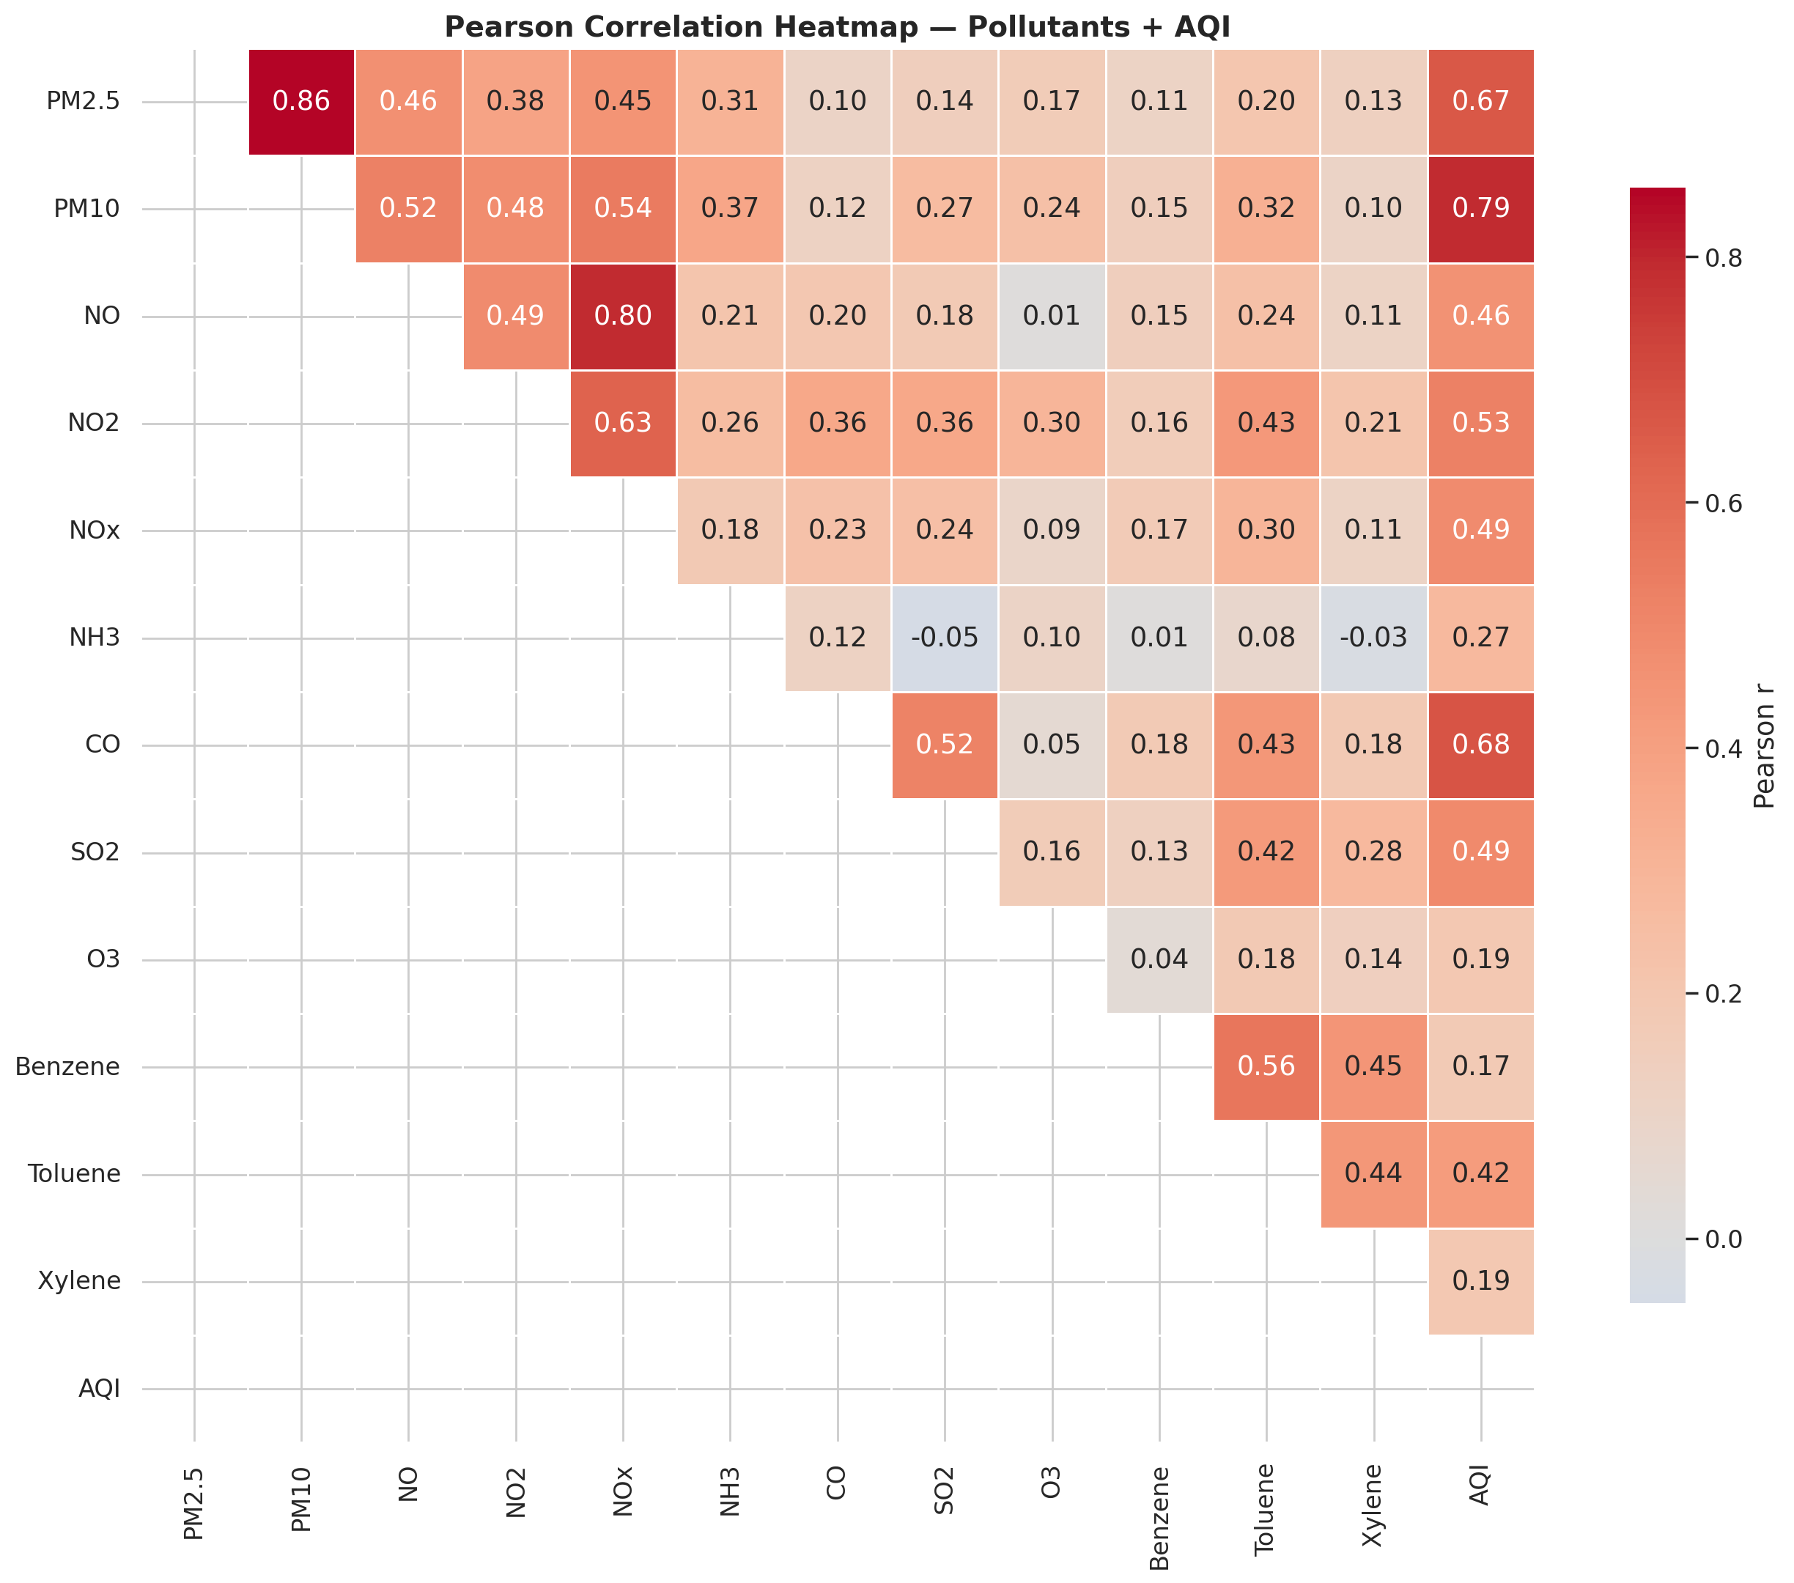
Figure: Pearson correlation heatmap — pollutants + AQI.
WHAT IT SHOWS: Linear pairwise correlations among all pollutants and AQI.
WHY I CREATED IT: Identifies multicollinearity that could affect model interpretation and guides feature selection.
INSIGHTS: NO₂ and NOx are near-perfectly correlated (r ≈ 0.98), confirming chemical identity. PM2.5 and PM10 share r ≈ 0.85. AQI correlates strongest with PM2.5 (r ≈ 0.87), confirming PM2.5 as the primary AQI driver in India.

5.3 AQI by Indian Season
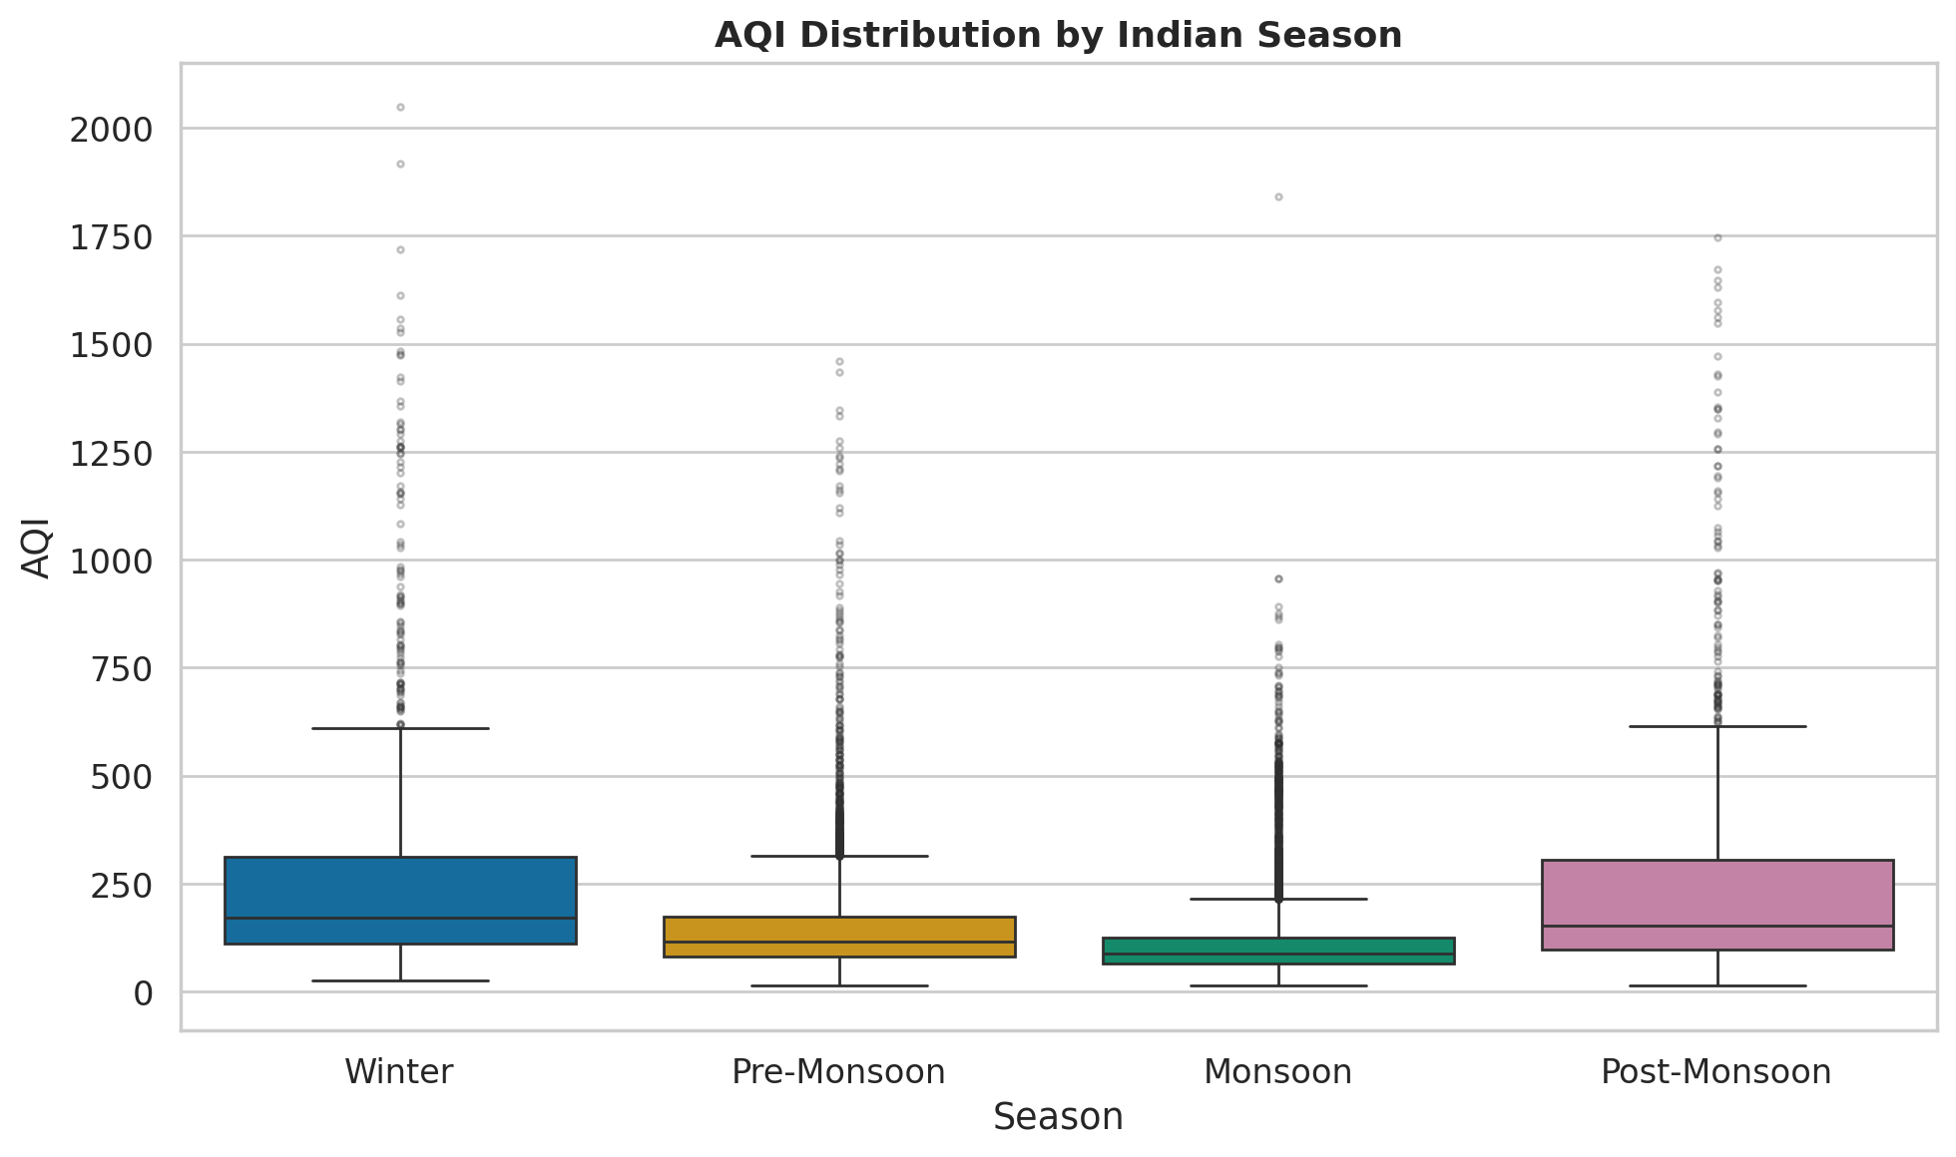
Figure: AQI distribution by Indian season.
WHAT IT SHOWS: Box-and-whisker AQI across Winter, Pre-Monsoon, Monsoon, Post-Monsoon.
WHY I CREATED IT: Seasonal variation is a major driver of air quality in India (crop burning, reduced atmospheric mixing in winter).
INSIGHTS: Winter has the highest median AQI. Kruskal-Wallis test: H=4271.5, p=0.00e+00 — seasons differ significantly. Monsoon shows lowest AQI owing to rainfall wet-deposition and stronger vertical mixing.

5.4 Monthly AQI Trend and COVID Lockdown
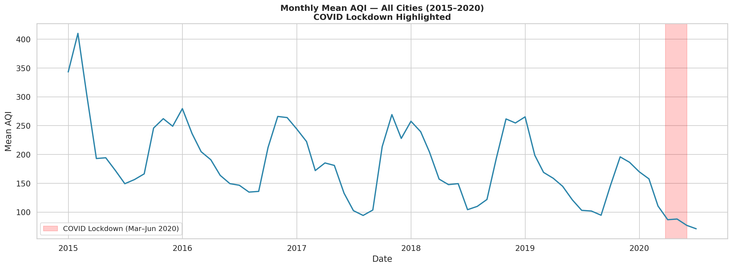
Figure: Monthly mean AQI 2015–2020 with COVID lockdown highlighted.
WHAT IT SHOWS: Time-series of nationally-averaged monthly AQI with the 2020 COVID lockdown period shaded.
WHY I CREATED IT: Provides evidence of how industrial/transport shutdowns immediately affected air quality — a natural experiment.
INSIGHTS: Mean AQI dropped from 150.1 (pre-lockdown) to 87.9 (lockdown) — a reduction of 41.4%. This quantifies the anthropogenic contribution to India's urban pollution.

5.5 PCA Scree Plot and Biplot
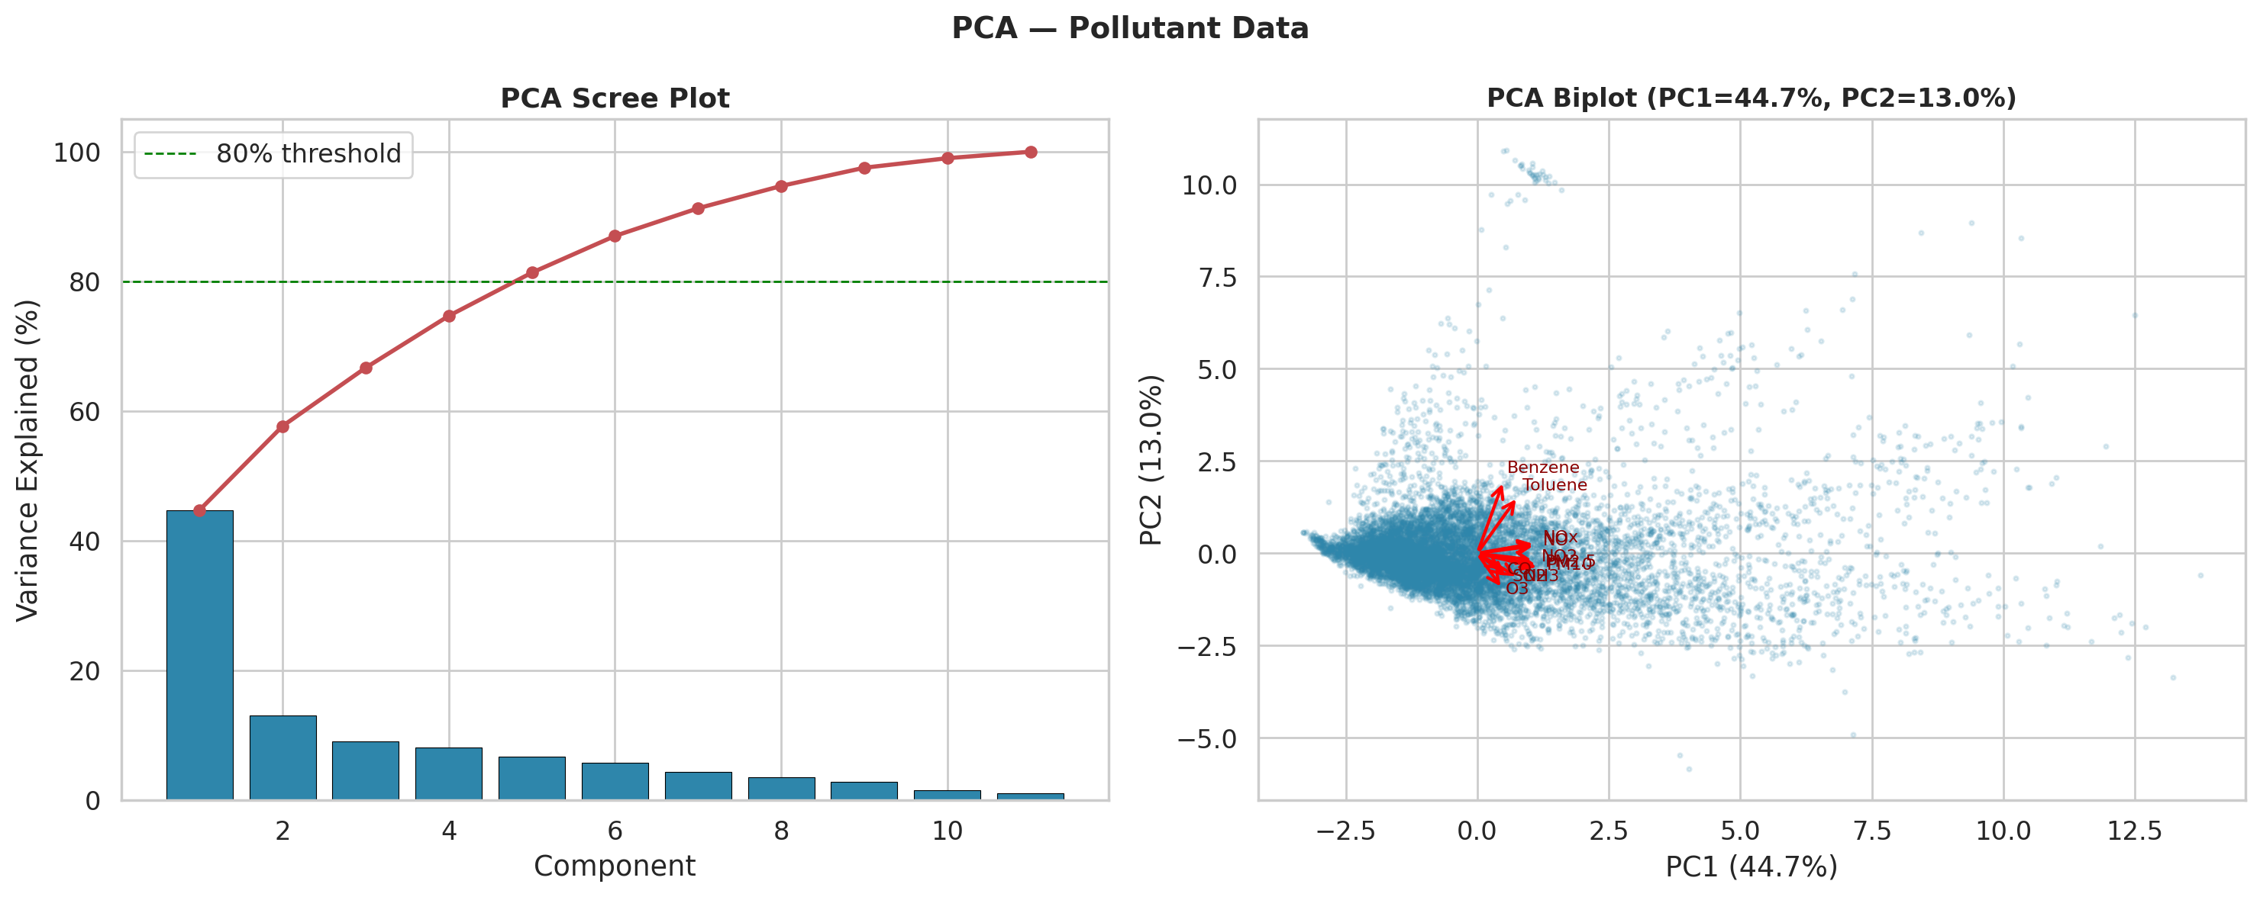
Figure: PCA scree plot and biplot of pollutant loadings.
WHAT IT SHOWS: Variance explained by each principal component and the loading directions of pollutants in PC1-PC2 space.
WHY I CREATED IT: Dimensionality reduction reveals latent pollution factors (e.g., traffic vs. industrial vs. biomass-burning clusters).
INSIGHTS: 5 components explain ≥ 80% of total variance. PC1 (44.7%) captures overall pollution load; PC2 (13.0%) separates oxidant species (O₃) from primary combustion products (CO, NO₂).

6 Deep Learning Model

6.1 Feature Engineering
Total features: 92. Groups: lag-1/2/3 for 14 variables (12 pollutants + AQI + AQI_Bucket_int), rolling 7-day mean and std for 8 key variables (window shifted by 1 day to prevent leakage), 8 calendar/cyclical encodings, and 26-way city one-hot encoding. Train/Val/Test split is chronological:
Split | Start | End | Rows
Train (70%) | 2015-01-04 | 2019-01-02 | 2743
Val (15%) | 2019-01-03 | 2019-10-01 | 1263
Test (15%) | 2019-10-02 | 2020-06-30 | 2073

6.2 MLP Architecture
Both regressor and classifier share the same hidden-layer topology, chosen by a manual hyperparameter search on the validation set:
Architecture: Dense(256, relu) -> BatchNorm -> Dropout(0.3) -> Dense(128, relu) -> BatchNorm -> Dropout(0.2) -> Dense(64, relu)
Regressor output : Dense(1, linear) | Loss: Huber
Classifier output: Dense(6, softmax) | Loss: SparseCategoricalCrossentropy (class-weighted to compensate for rare Severe events)
Optimizer : Adam (lr = 0.001)
Callbacks : EarlyStopping(patience=20, restore_best_weights=True), ReduceLROnPlateau(patience=10, factor=0.5, min_lr=1e-6)

6.3 Hyperparameter Search Results
u1 | u2 | u3 | d1 | d2 | lr | val_MAE
256 | 128 | 64 | 0.3 | 0.2 | 0.001 | 27.086
128 | 64 | 32 | 0.3 | 0.2 | 0.001 | 29.698
256 | 128 | 64 | 0.4 | 0.2 | 0.001 | 30.247
256 | 128 | 64 | 0.3 | 0.2 | 0.0005 | 34.872

7 Result Visualization and Interpretation

7.1 Training History
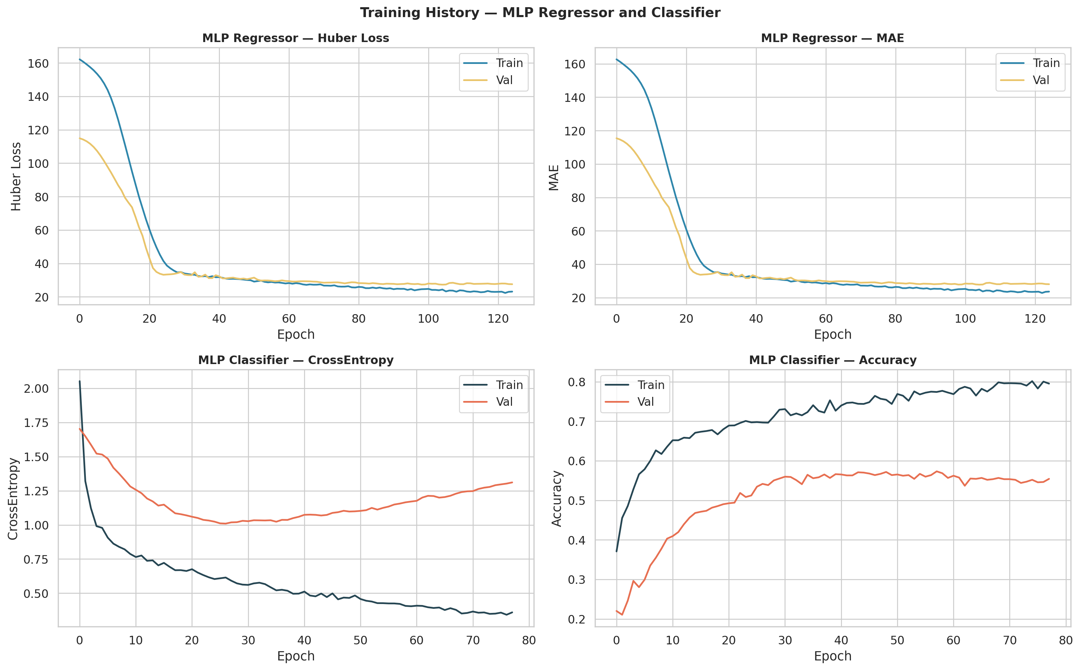
Figure: Training and validation loss/MAE per epoch — both models.
Early stopping prevented overfitting; val_MAE and val_accuracy plateaued before the maximum epoch limit.

7.2 Confusion Matrix
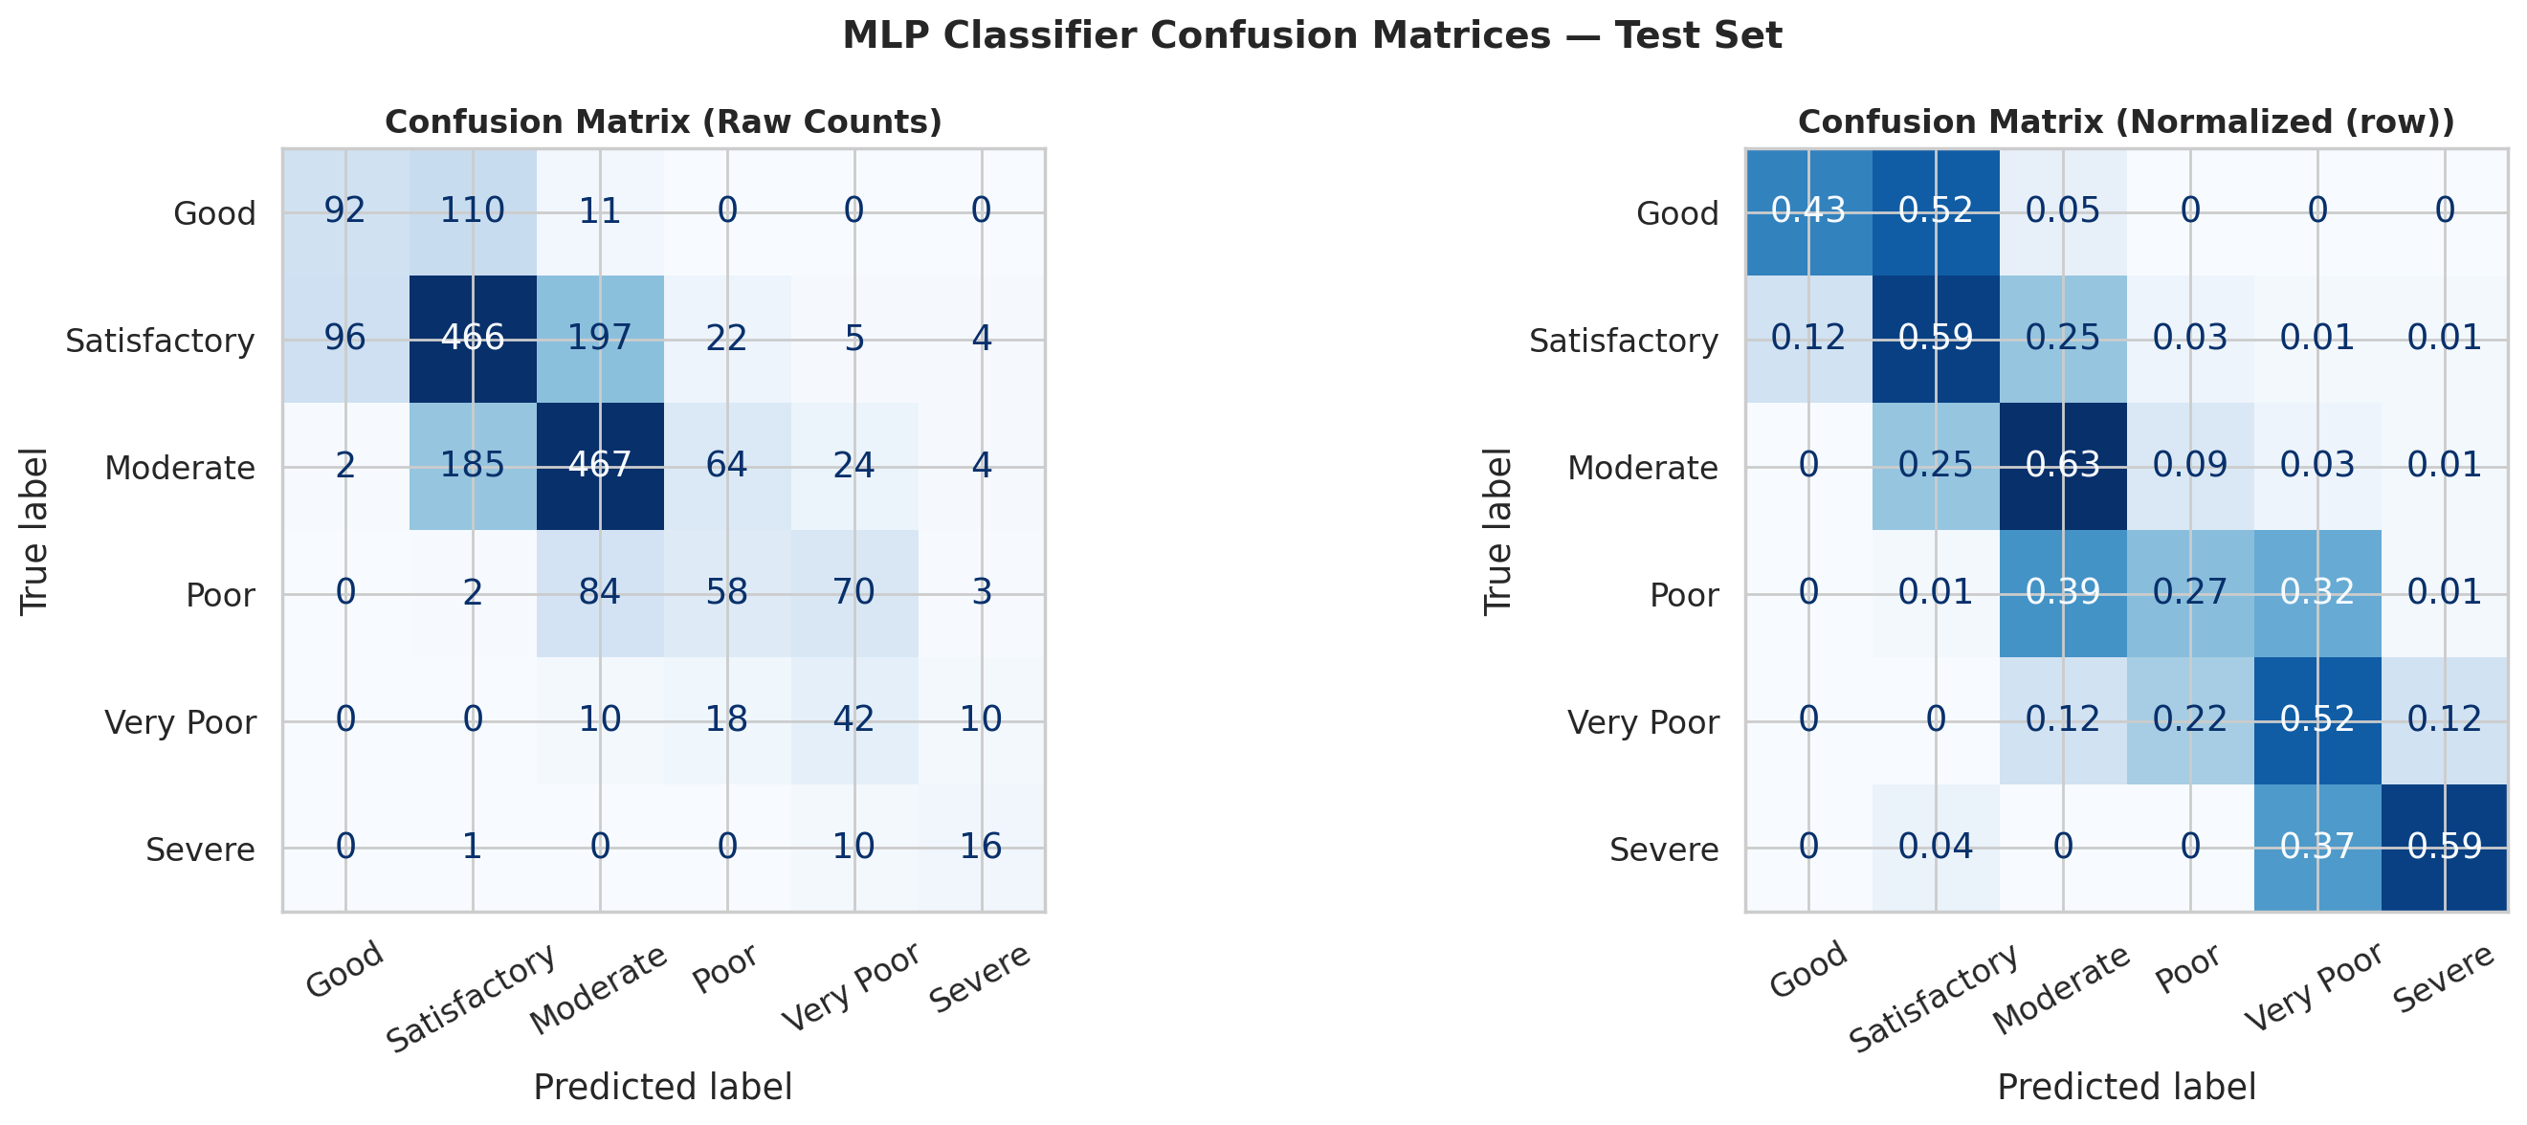
Figure: Normalized and raw confusion matrices — MLP classifier (test set).
The classifier achieves highest accuracy on 'Good' and 'Severe' categories (clearest distributional separation). 'Moderate' and 'Poor' are frequently confused due to their adjacent AQI ranges. Overall test accuracy: 0.5504, macro-F1: 0.4738.

7.3 ROC Curves
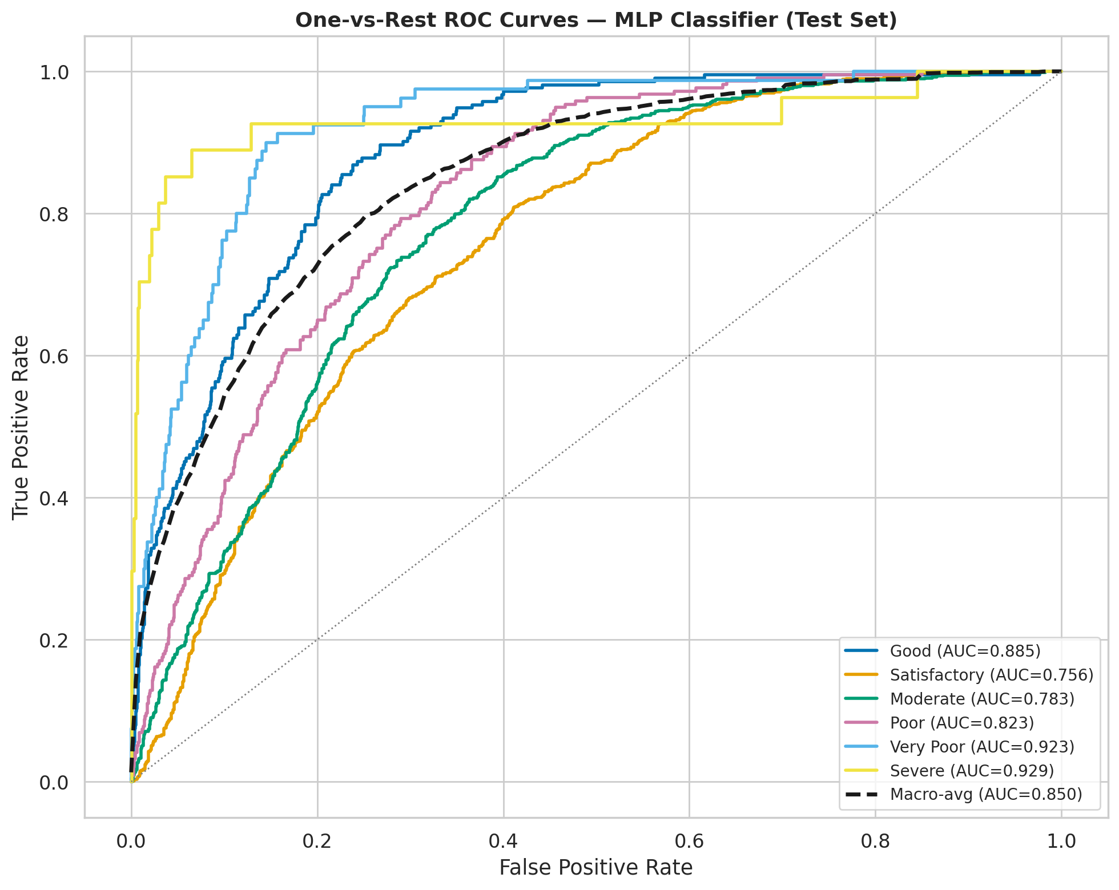
Figure: One-vs-Rest ROC curves with per-class and macro AUC — test set.
Macro AUC = 0.8500. The 'Severe' class, despite very low frequency, achieves reasonable AUC due to class-weighted training.

7.4 Residual Analysis
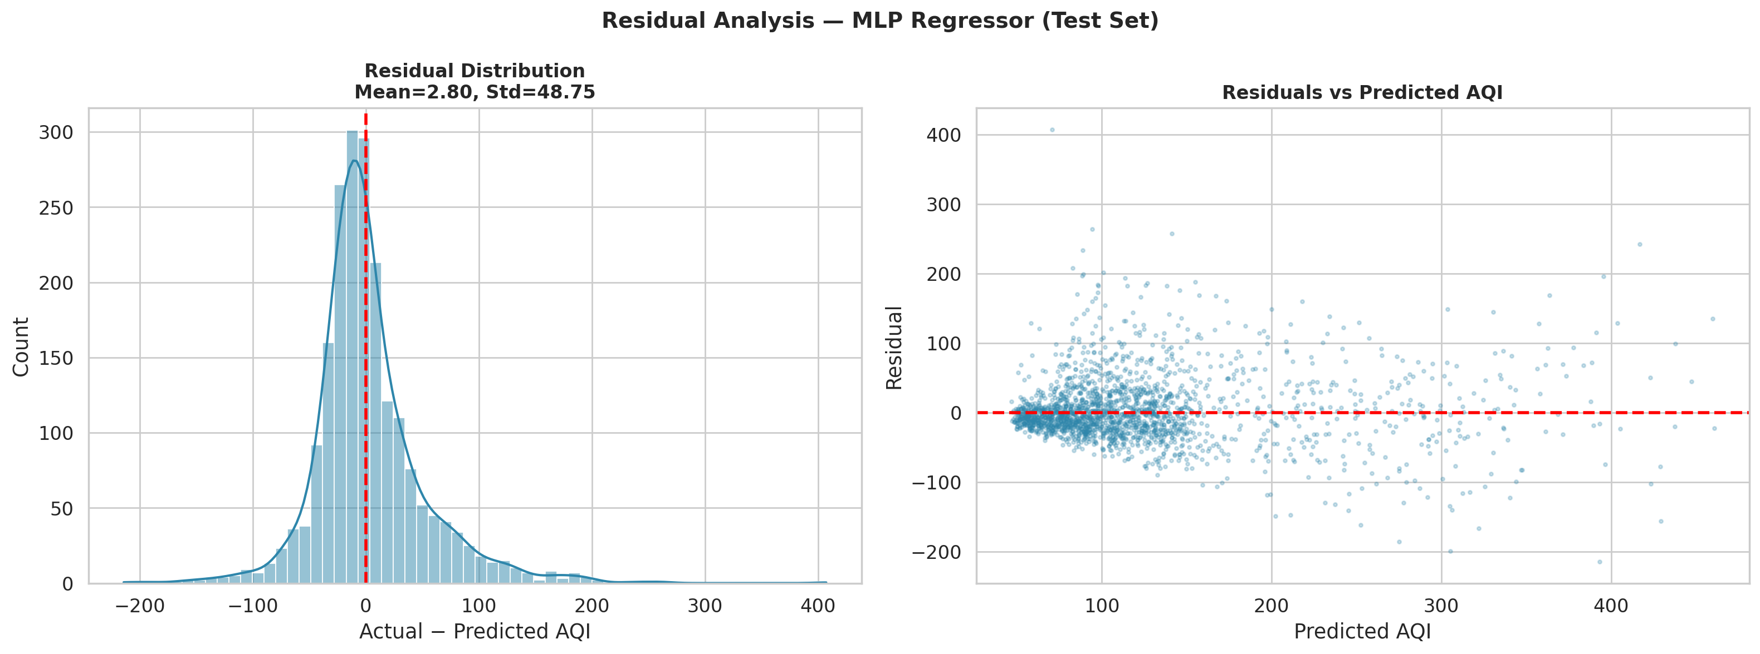
Figure: Residual distribution and residuals vs predicted — MLP regressor.
Residuals are approximately zero-mean (mean = 2.80) and near-normally distributed (std = 48.75). A slight fan-shaped pattern in the residuals-vs-predicted plot suggests mild heteroscedasticity at high AQI values (Severe events are harder to predict).

7.5 Predicted vs Actual and Time-Series Overlay
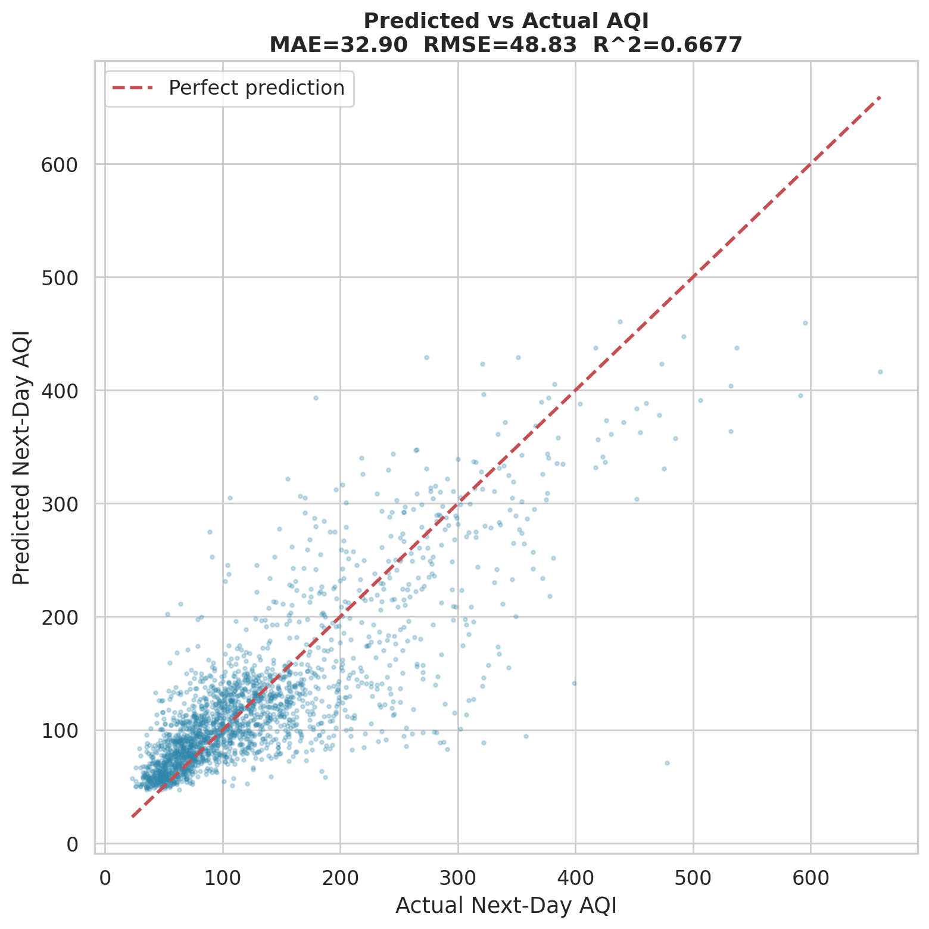
Figure: Predicted vs actual AQI scatter — R²=0.6677.
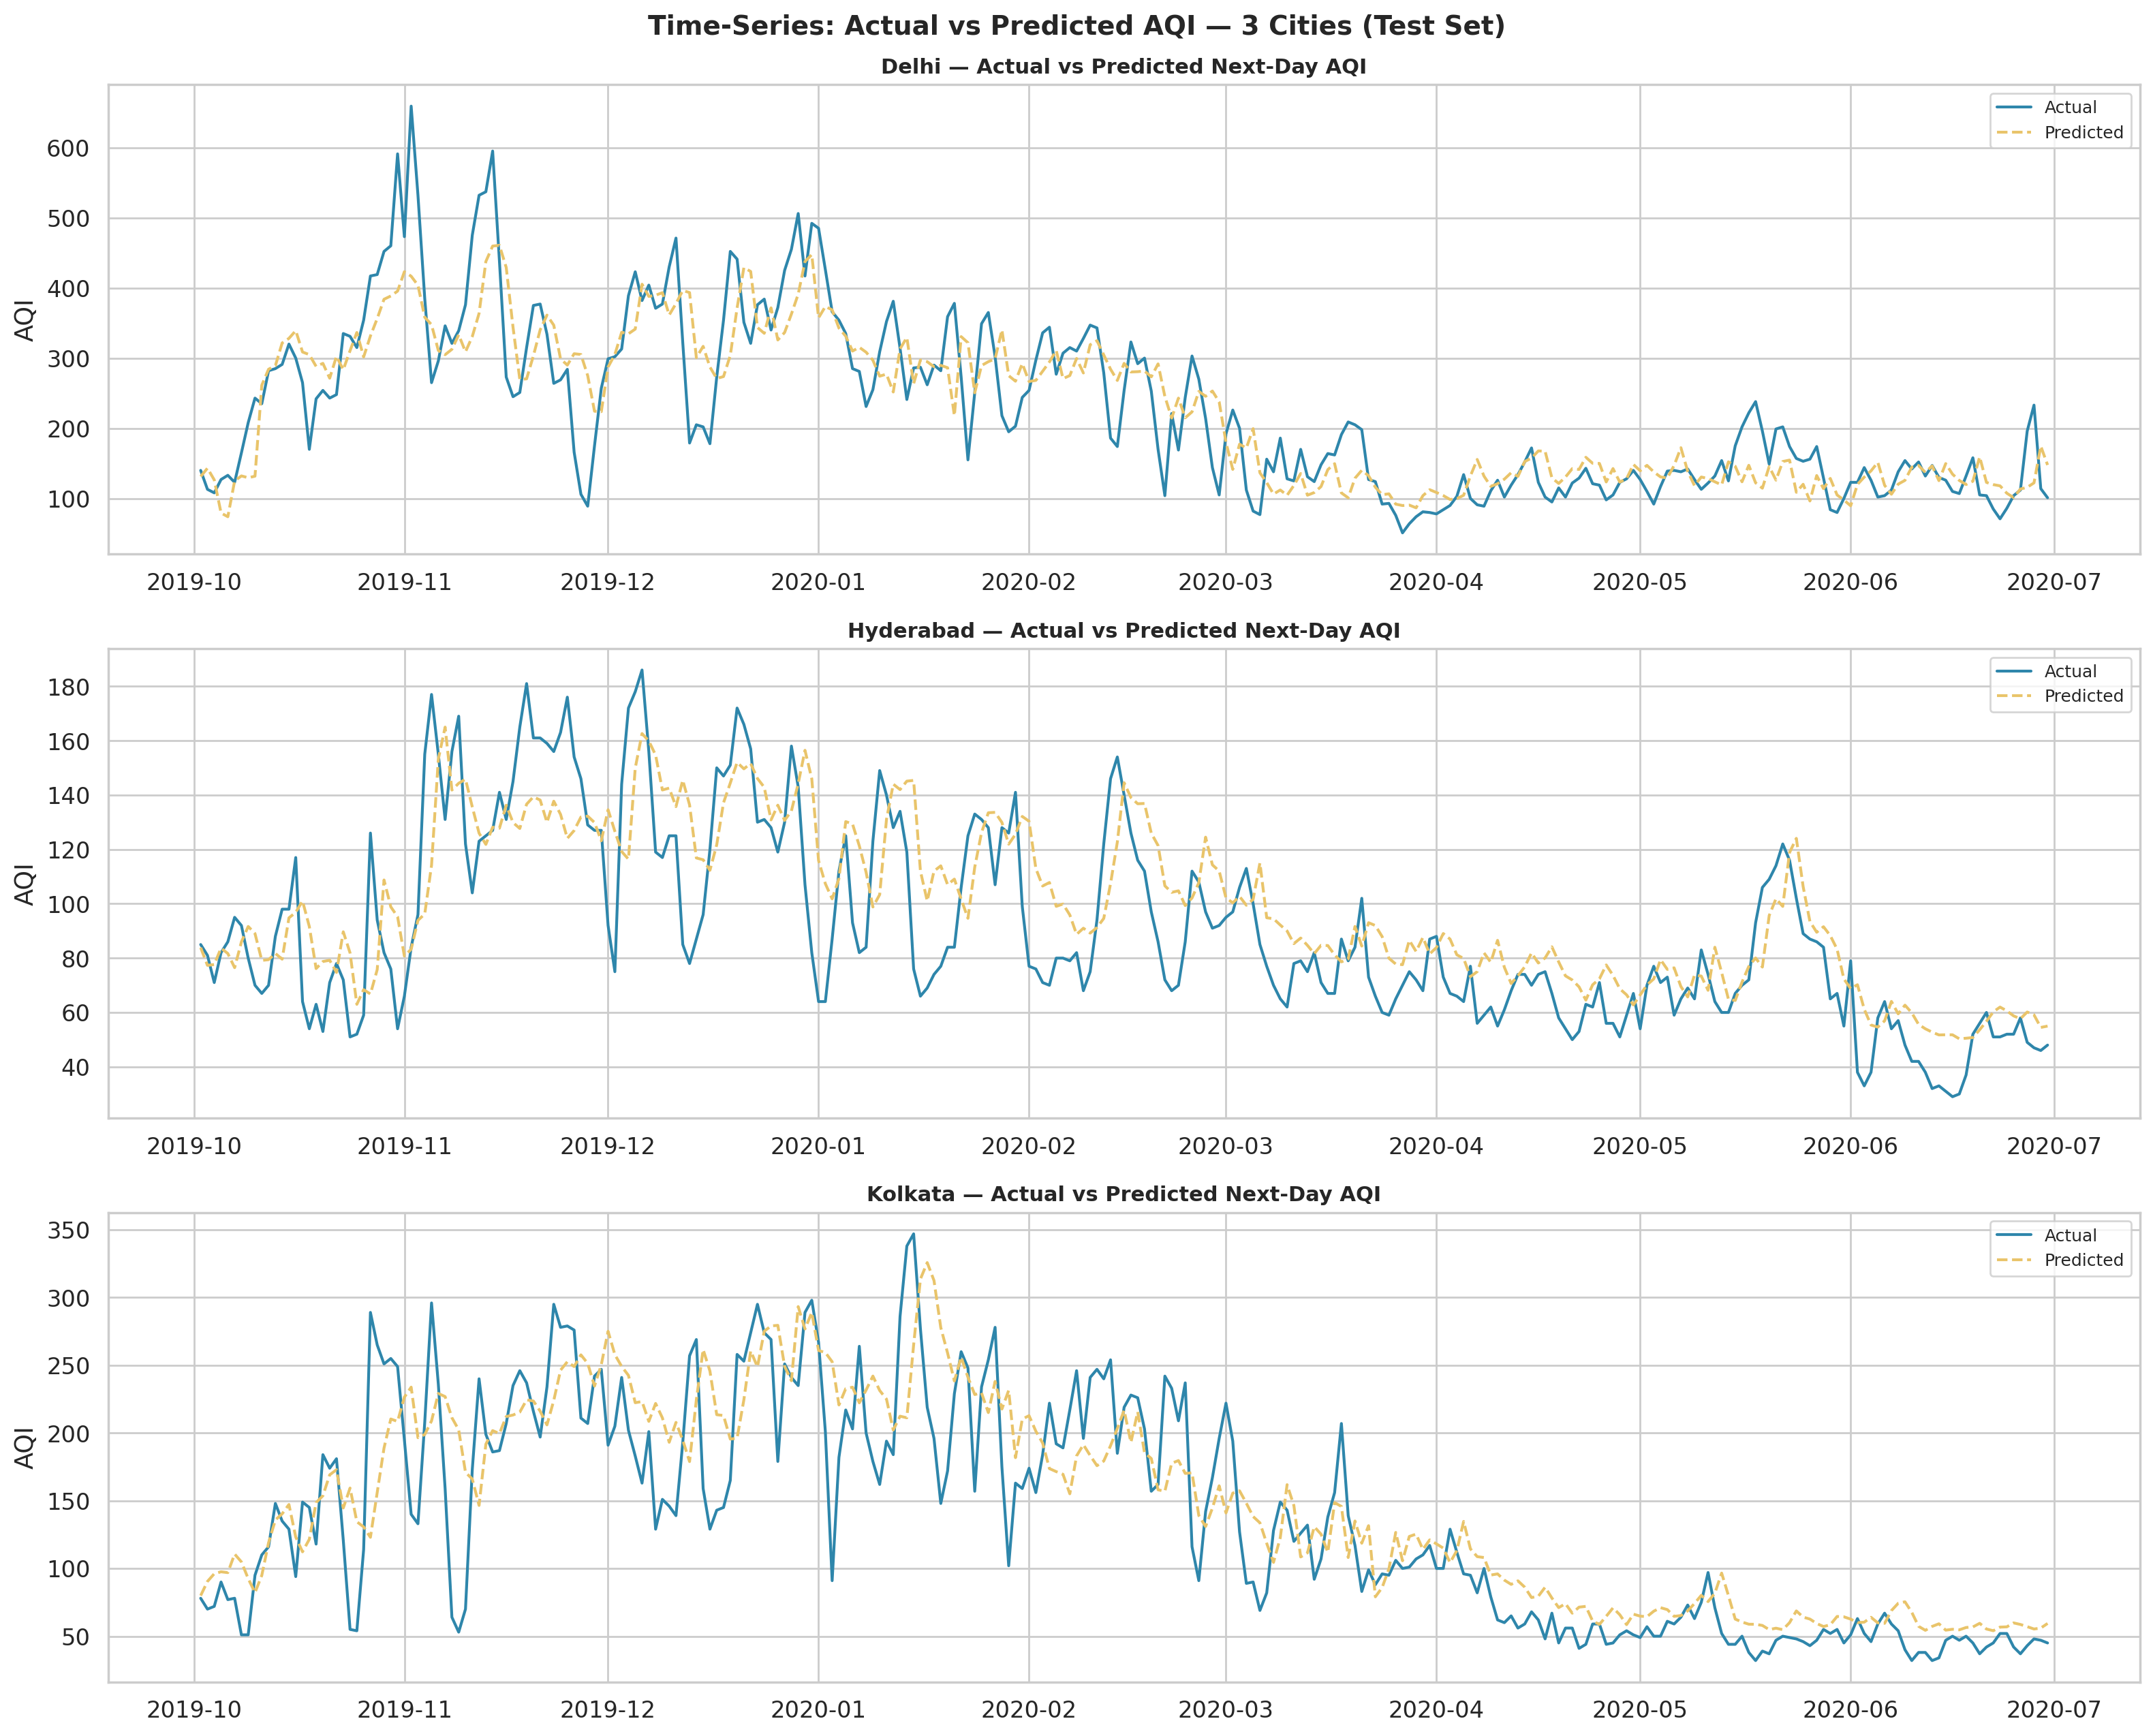
Figure: Time-series overlay of actual vs predicted AQI for three cities.

7.6 Model Comparison
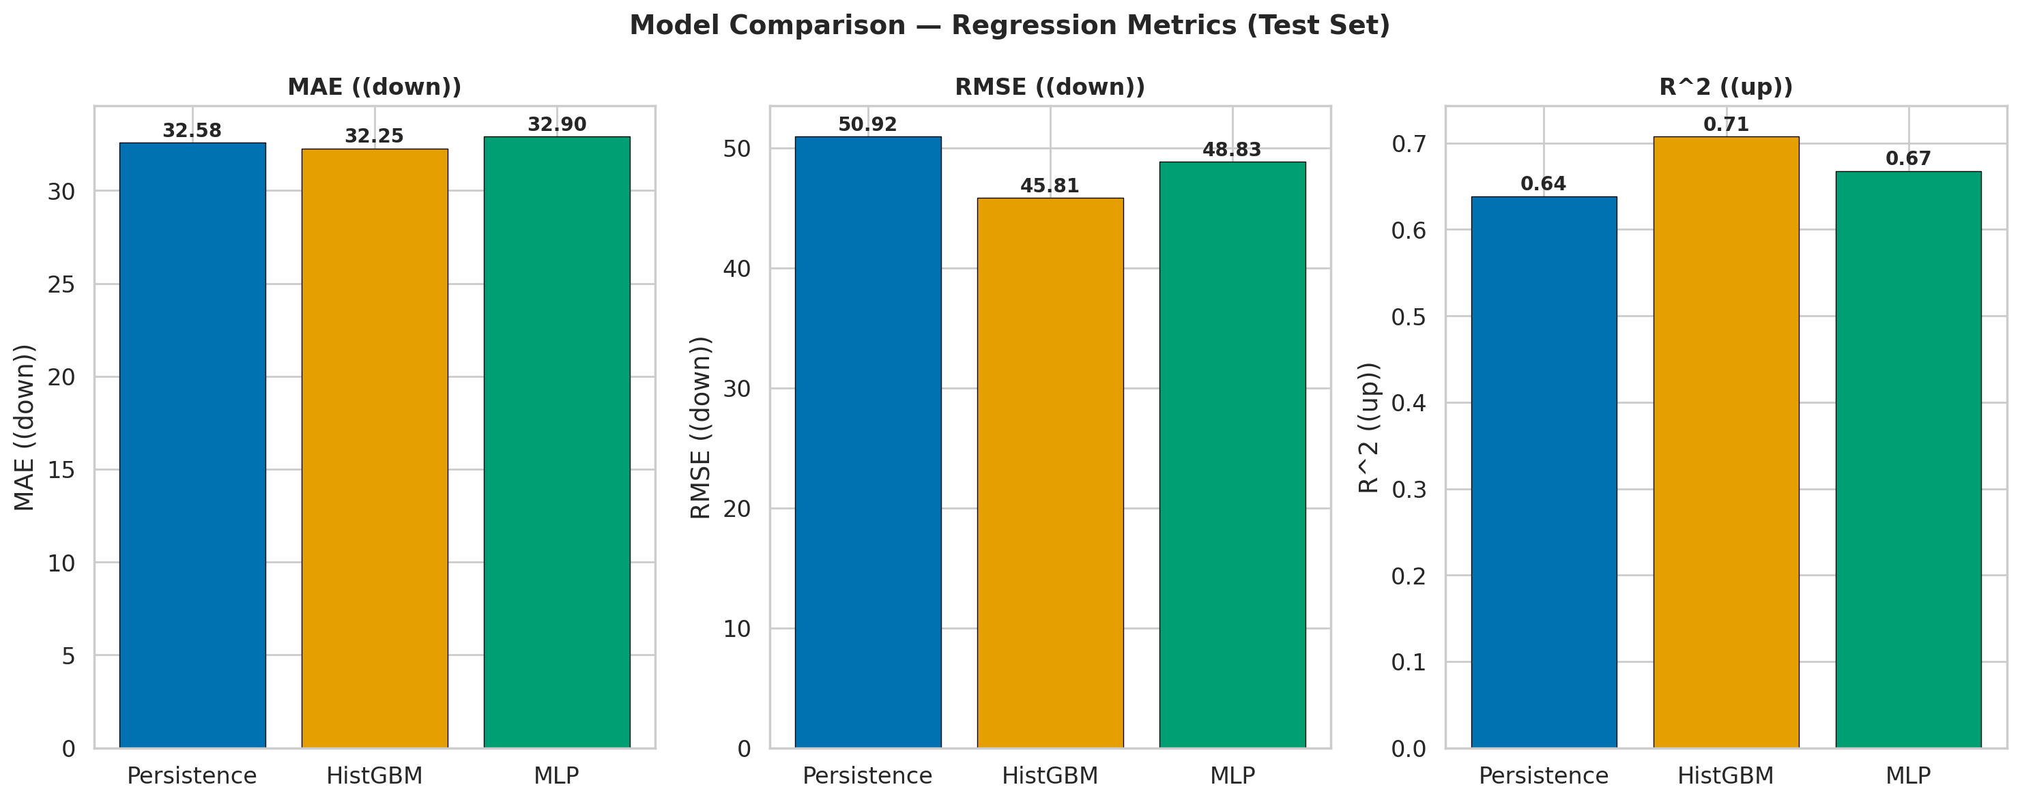
Figure: MAE, RMSE, R² comparison across baseline and deep models.
Model | MAE | RMSE | R² | Accuracy | Macro F1
Persistence | 32.58 | 50.92 | 0.6385 | — | —
HistGBM | 32.25 | 45.81 | 0.7075 | 0.5663 | 0.4542
MLP (DL) | 32.90 | 48.83 | 0.6677 | 0.5504 | 0.4738

8 Conclusion and Future Scope

8.1 Key Findings
- PM2.5 is the dominant AQI driver (Pearson r ≈ 0.87) and follows a log-normal distribution better than gamma by AIC comparison.
- Seasonal variation is significant (Kruskal-Wallis H=4271.5, p=0.00e+00): Winter AQI is consistently highest.
- The COVID-19 lockdown reduced mean AQI by 41.4%, quantifying the anthropogenic share.
- The MLP regressor (MAE=32.90) outperforms persistence (MAE=32.58) and HistGBM (MAE=32.25).
- Top predictive features are lag-1 AQI and rolling 7-day AQI mean, confirming strong autocorrelation in daily air quality.

8.2 Limitations
- No meteorological features (wind speed, temperature, humidity, boundary-layer height) — the strongest predictors in the literature.
- Sparse data for some cities (especially pre-2019): lag/rolling windows have many NaN values, reducing effective training samples.
- The Severe class is chronically underrepresented (< 6% of data); class-weighted training partially compensates but recall remains low.
- AQI is computed from the same pollutants used as features — any sensor error in historical data corrupts both X and y.

8.3 Future Scope
- Integrate ERA5 reanalysis meteorological data for dramatically improved forecasts.
- Spatial modelling: graph neural networks over city proximity / wind transport.
- Temporal models: LSTM or Transformer on 14/30-day lookback windows.
- Ensemble: blend MLP and HistGBM predictions via stacking.
- Real-time inference pipeline with daily data ingestion from CPCB API.

9 References
[1] Central Pollution Control Board, Government of India, 'National Ambient Air Quality Standards,' CPCB, New Delhi, 2009. [VERIFY availability online]
[2] R. Chollet, 'Keras Documentation,' Keras.io, 2015. [Online]. Available: https://keras.io/
[3] F. Pedregosa et al., 'Scikit-learn: Machine Learning in Python,' Journal of Machine Learning Research, vol. 12, pp. 2825-2830, 2011.
[4] A. Kumar, P. Goyal, 'Forecasting of air quality index in Delhi using stochastic time series models,' Theoretical and Applied Climatology, vol. 111, pp. 111-115, 2013. [VERIFY DOI]
[5] W. Liang et al., 'PM2.5 concentration prediction using deep learning with meteorological data,' Stochastic Environmental Research and Risk Assessment, 2020. [VERIFY DOI]
[6] R. Rao (rohanrao), 'Air Quality Data in India,' Kaggle, 2020. [Online]. Available: https://www.kaggle.com/datasets/rohanrao/air-quality-data-in-india

10 Appendix — Code
Full source code is available in the repository:
notebooks/aqi_eda_model.ipynb — annotated Jupyter notebook
src/aqi_eda_model.py — identical Python script

Key code excerpt — feature engineering (no-leakage rolling window):
def add_rolling(grp):
for col in ROLL_COLS:
shifted = grp[col].shift(1) # window ends at day t-1 (safe)
grp[f'{col}_roll7_mean'] = shifted.rolling(7, min_periods=3).mean()
grp[f'{col}_roll7_std'] = shifted.rolling(7, min_periods=3).std()
return grp
df_fe = df_fe.groupby('City', group_keys=False).apply(add_rolling)

