Comprehensive EDA Summary – BDD100K Object Detection

1. Introduction
This document presents an extensive, production-grade exploratory data analysis (EDA) of the BDD100K Object Detection dataset. The analysis is designed to support end-to-end decision making—from dataset understanding to model architecture selection, augmentation strategy design, training, evaluation methodology, and deployment considerations.
BDD100K is a large, richly diverse autonomous driving dataset with real-world imperfections: long-tailed class frequencies, small-object dominance, heavy night/day imbalance, varying levels of occlusion and truncation, annotation inconsistencies, strong spatial priors, and metadata-driven domain shifts. This EDA dissects each of these factors in detail and explains how they influence downstream modeling decisions.

2. Dataset Composition & Structure
BDD100K consists of 100,000 images captured across varying geographic locations, lighting conditions, weather environments and road types. For the object detection task, 10 classes are annotated using bounding boxes: car, bus, truck, person, rider, bike, motor, traffic light, traffic sign, and train.
The dataset also contains metadata such as weather, time of day, and scene type. These metadata dimensions introduce systematic biases—e.g., night-time images have reduced visibility; rainy scenes have motion blur or glass reflections; highway scenes have fewer pedestrians than city scenes. All these factors influence how a model perceives and detects objects.

3. Class Distribution Analysis
The dataset exhibits a severe long-tail distribution. 'Car' alone accounts for more than half of all bounding boxes. The next most common classes—traffic signs and traffic lights—are an order of magnitude lower. Rare classes like train, rider, bike, and motor contribute less than 1% of total bounding boxes.
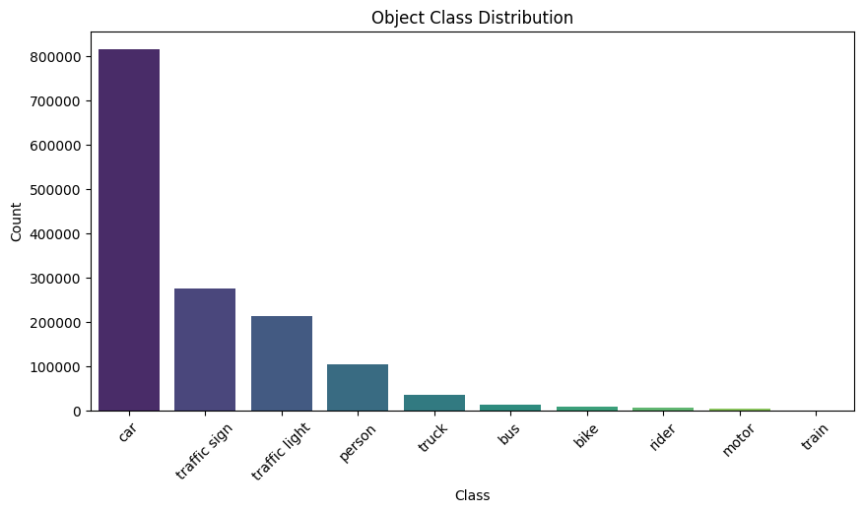
This level of imbalance directly impacts learning: models quickly optimize for high-frequency classes while failing to learn meaningful representations for rare classes. It also affects mAP stability on rare categories. The accurate counts & percentage for each class is given below:
category | count | percent
car | 815717 | 55.4
traffic sign | 274594 | 18.65
traffic light | 213002 | 14.47
person | 104611 | 7.1
truck | 34216 | 2.32
bus | 13269 | 0.9
bike | 8217 | 0.56
rider | 5166 | 0.35
motor | 3454 | 0.23
train | 151 | 0.01

4. Bounding Box Geometry: Scale, Area & Aspect Ratio
A key characteristic of BDD100K is the extremely large number of small objects. Traffic lights and signs often occupy tiny regions (sometimes <0.5% of image area). Pedestrians and riders appear small when far away. Vehicles vary in size depending on distance, angle, and occlusion.
Aspect ratio patterns map well to semantic expectations: pedestrians are tall and slender, cars are wide, traffic signs are near-square, and trucks/buses are large rectangular structures. These geometric trends affect detector performance, influencing decisions such as anchor design or choosing anchor-free models.
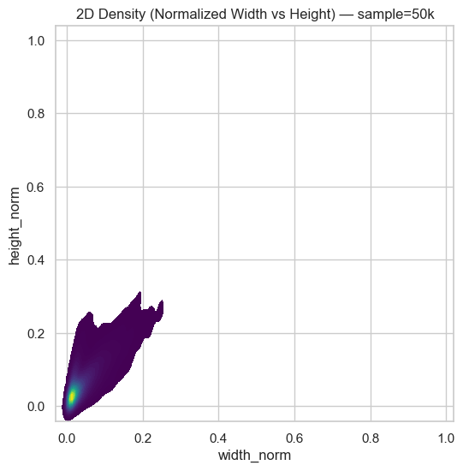

5. Per-Class Size Variability
Certain classes show extreme intra-class size variability. Buses and trucks can appear very large when nearby or very small when distant. Pedestrians may appear tiny or medium depending on the scene. Traffic lights show low variability since they appear consistently high and distant in the frame.
Understanding this variability is essential for designing a model that can generalize across distance-induced scale changes. It also partially explains AP differences between classes.
category | width_norm | height_norm | aspect_ratio
train | 0.2103 | 0.1163 | 2.179
bus | 0.1136 | 0.1763 | 0.802
truck | 0.0995 | 0.1597 | 0.7295
car | 0.0583 | 0.0806 | 0.7578
motor | 0.0526 | 0.0951 | 0.5764
bike | 0.0472 | 0.0932 | 0.5398
rider | 0.0339 | 0.1141 | 0.3287
traffic sign | 0.0252 | 0.035 | 0.8472
person | 0.0216 | 0.0925 | 0.259
traffic light | 0.0124 | 0.0351 | 0.4019

6. Spatial Heatmaps & Spatial Priors
Spatial heatmaps reveal strong and consistent positional priors. Vehicles cluster at the lower-middle region (road lanes). Pedestrians appear along the lower left/right edges. Traffic lights and signs consistently appear near the upper corners.
Such regular spatial structure is highly beneficial for grid-based detectors like YOLO, which partition the image into spatial cells. These priors improve early-stage model convergence and reduce false-positive rates.

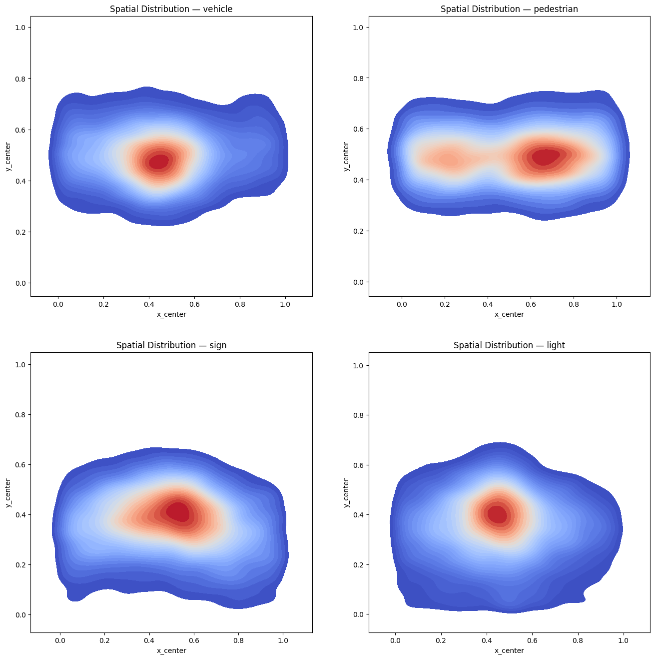7. Metadata Distribution & Domain Shifts
Night-time images form a substantial portion of the dataset. Night scenes introduce low visibility, glare, headlight reflections, and degraded contrast. Models trained without brightness augmentation tend to collapse on night scenes.
Weather imbalance is also notable: clear and overcast dominate; snow, fog and rain are rare. Scene types show a strong leaning toward urban environments.
These imbalances motivate augmentations such as brightness shifts, fog simulation, motion blur, and color jitter.

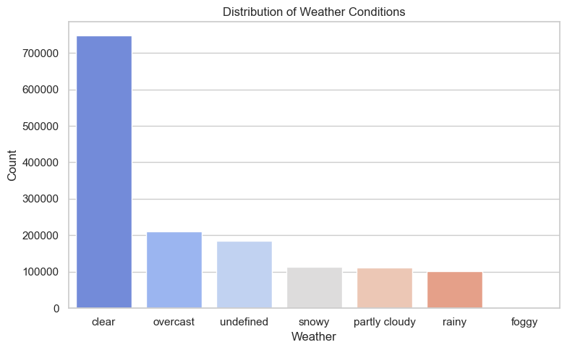
8. Annotation Quality & Integrity Checks
A small fraction of annotations contain malformed bounding boxes (negative widths/heights), missing labels, incomplete metadata or empty 'labels' fields. Occlusion and truncation flags appear frequently, particularly in pedestrian-heavy scenes.
These inconsistencies require preprocessing checks and filtering strategies to avoid training instability.

9. Implications of EDA for Model Selection
The EDA reveals critical requirements:
• Multi-scale detection is essential (due to small objects).
• Robustness to night scenes is mandatory.
• Detector should leverage spatial priors.
• Must handle extreme class imbalance.
• Must be fast enough for production deployment.
YOLO-based detectors meet all these requirements, making them ideal candidates.

10. Final Summary
This production-grade exploratory analysis of the BDD100K object detection dataset reveals a complex, highly imbalanced, and heavily biased real-world distribution shaped by long-tailed class frequencies, extreme small-object prevalence, strong spatial priors, significant night/day and weather-driven domain shifts, and nontrivial annotation inconsistencies. The dataset’s geometric characteristics—ranging from consistent aspect-ratio patterns to wide intra-class scale variability—coupled with metadata-conditioned visibility constraints, collectively shape the learning dynamics of modern detectors. These insights directly inform downstream modeling decisions: emphasizing multi-scale architectures, robust illumination and weather augmentations, anchor-free or spatially aware detection heads, preprocessing for annotation integrity, and techniques to mitigate rare-class underperformance. Overall, the EDA provides a principled foundation for selecting, training, and deploying reliable detection models in safety-critical autonomous driving pipelines.

