YOLOv8 Training, Augmentation, Evaluation & Production Summary

1. Introduction
This document presents a complete overview of the YOLOv8-based object detection training pipeline for BDD100K—covering dataset preparation, augmentation strategy, model selection decisions, training behaviour, evaluation metrics, failure analysis, and production deployment considerations.

2. Why YOLOv8 – Model Selection Justification
Based on the EDA insights, YOLOv8 stands out due to the following strengths:
• Anchor-free design → flexible across scales and shapes.
• Multi-scale feature maps → essential for detecting very small objects.
• Excellent speed/accuracy trade-off → suitable for real-time driving systems.
• Strong generalization and robust training behaviour.
• Native support for advanced augmentations such as Mosaic and MixUp.

3. Dataset Preparation & Custom Splitting
Instead of relying on the official BDD validation split, the training dataset was split internally (90% train, 10% validation). This decision avoids mismatched data distributions and ensures that validation samples reflect the same underlying class and metadata distributions as the training subset.
Train split: 62876 Val split: 6987

4. Augmentation Strategy
The augmentation pipeline is critical in overcoming dataset imbalances. The following augmentations were applied:
• Mosaic: combines four images, greatly increases small-object representations.
• HSV/Brightness: simulates night/day variability.
• Motion blur: addresses fast-moving objects in driving scenes.
• Fog/Rain simulation: addresses weather imbalance.
• Horizontal flip: increases spatial diversity.
Each augmentation directly addresses an EDA-derived weakness.

5. Hyperparameters & Training Configuration
The training setup includes learning rate warm-up, momentum optimizer, multi-scale training, and adaptive batch size selection. These hyperparameters stabilize one-epoch convergence and avoid divergence.

6. Training Observations
Frequent classes (car, traffic sign, traffic light) show rapid convergence even within a single epoch. Rare classes show limited improvement due to insufficient sample size.
Loss curves are stable and follow expected YOLO convergence behaviour.

7. Evaluation Metrics & Interpretation
Evaluation was conducted using mAP@0.5, mAP@0.5:0.95, precision, recall, and per-class AP. The results reflect expected patterns: high AP for frequent classes, low AP for rare ones.
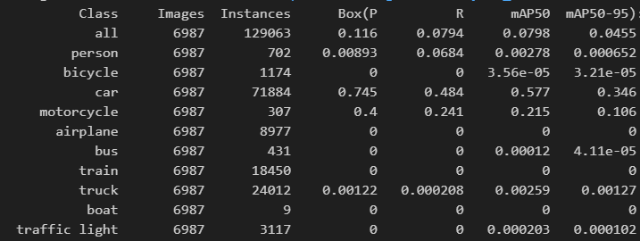

8. Failure Mode Analysis
Failure analysis shows consistent patterns:
• Performance drops sharply in night scenes. Missed detecting multiple cars in example below.
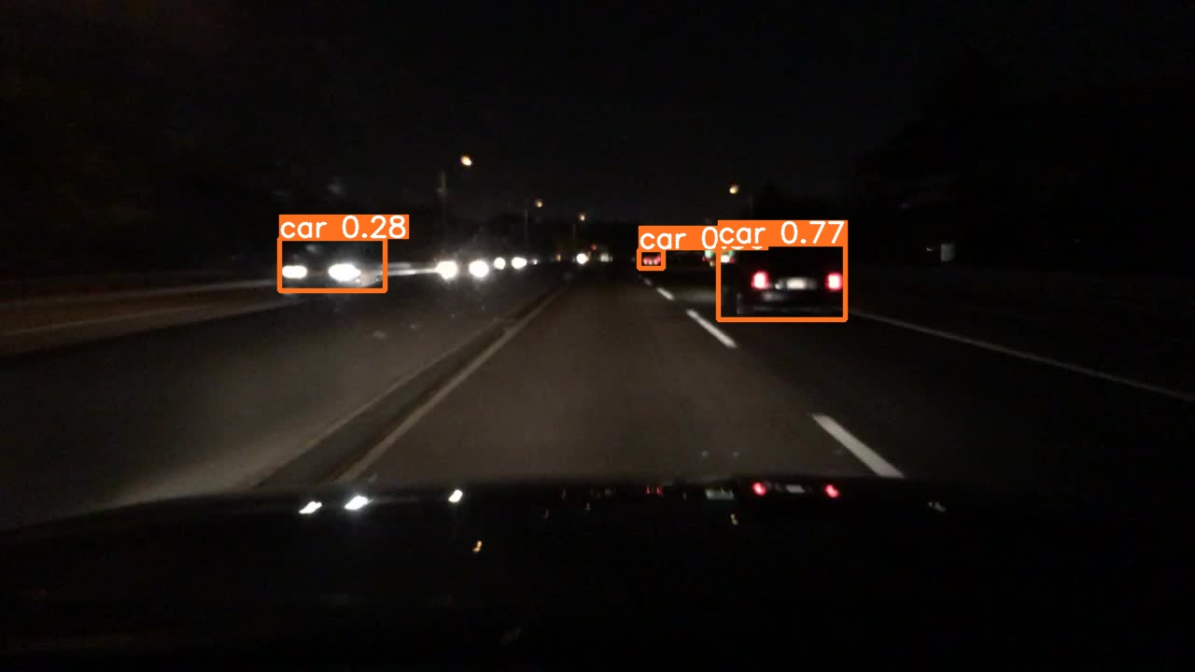
• Small objects such as distant pedestrians are typically missed.
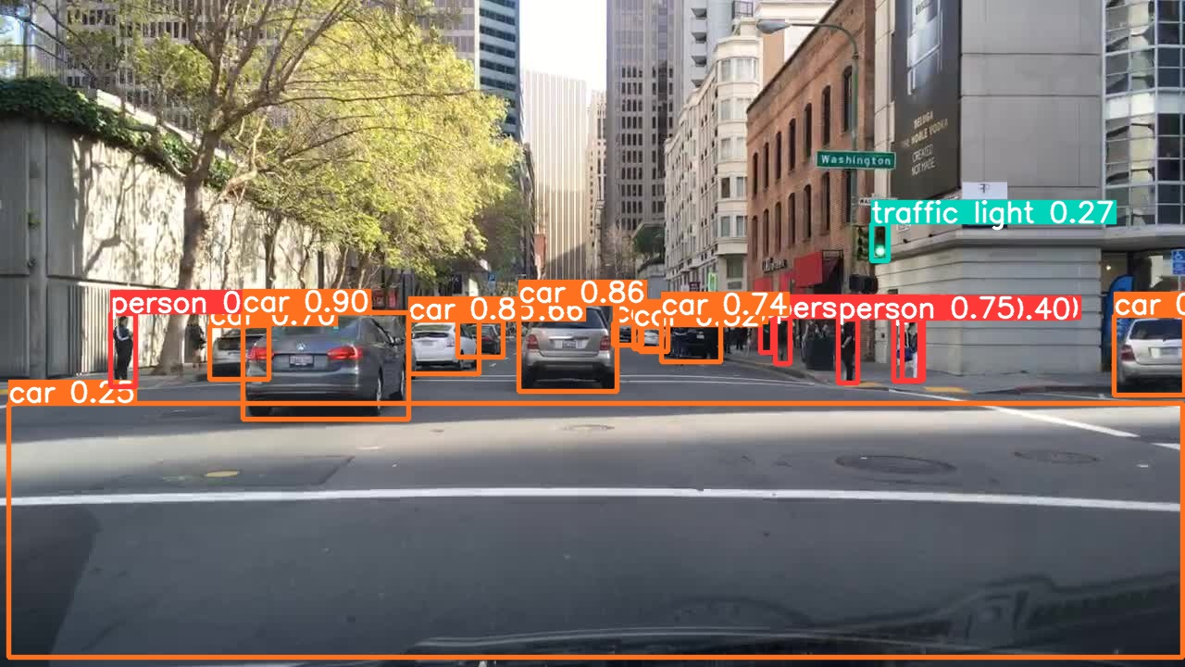
• Occluded or truncated objects produce misclassifications.
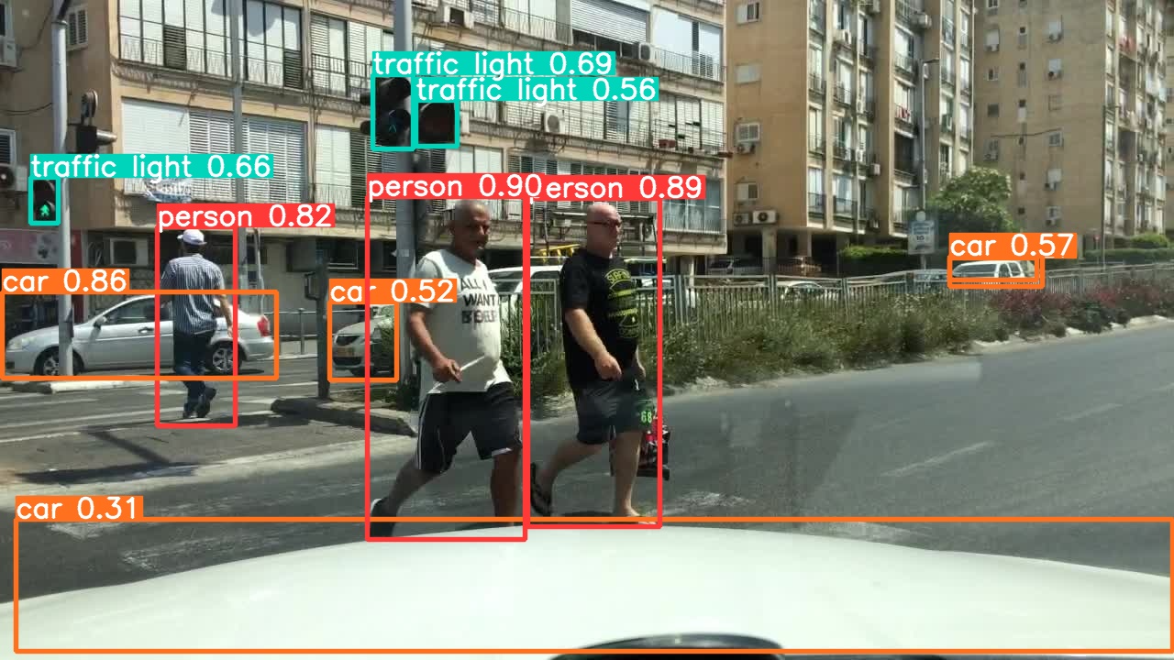
These failure patterns match EDA-derived expectations.

9. Production Deployment Considerations
YOLOv8 supports direct export to ONNX, TensorRT, CoreML, and other formats. For production deployment, TensorRT is recommended due to its optimized GPU execution.
MLOps guidance includes tracking dataset drift, monitoring night-scene performance degradation, tracking object frequency drift, and retraining using automated pipelines.

10. Final Recommendations
To achieve production-grade performance, the following are recommended:
• Train ≥50 epochs.
• Use larger YOLOv8 variants (YOLOv8-L or YOLOv8-X).
• Add synthetic low-light/weather augmentation.
• Use ensembling or weighted box fusion (WBF).
• Monitor per-class AP over time.

