**EX.No:** 2 **Name:** Niranjana S

**Date:18/08/20 Reg.No:312217205059**

**MakeFile Command**

**Code:**

**adjust.c**

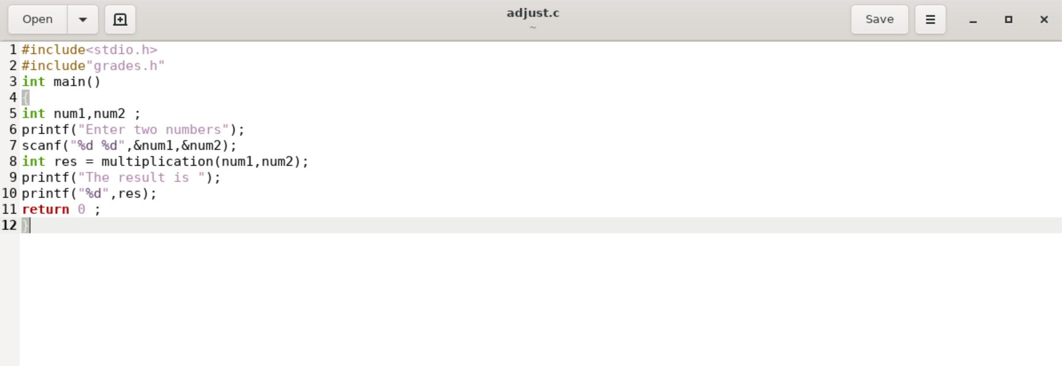

**grades.h**

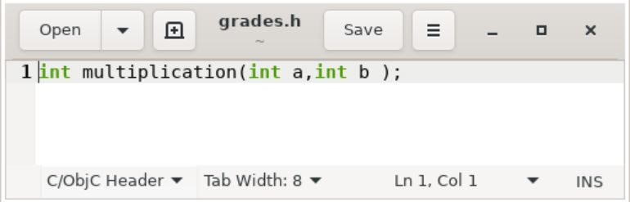

**grades.c**

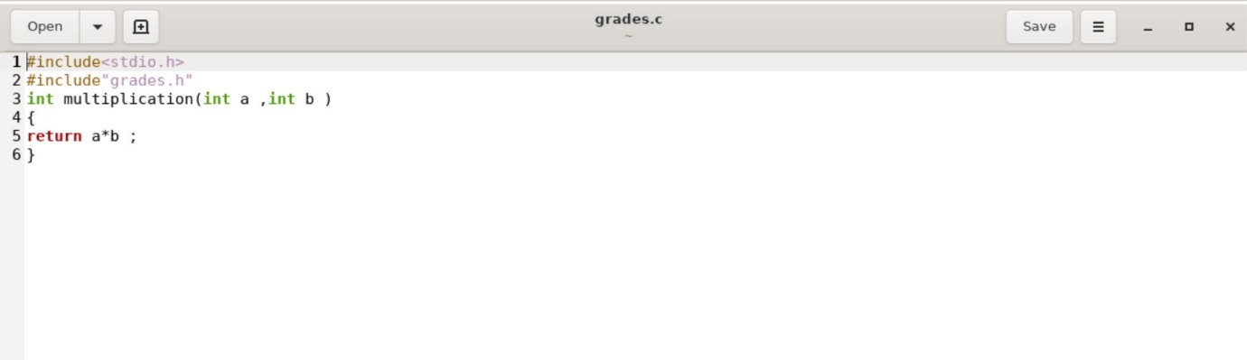

**Makefile**

all:

compile:

gcc grades.c adjust.c -o hello

**Output:**

