Hi! When I read through the Allocation - Load SSAP code, I found a section where it looks like the 3 excluded codes are “hard-coded” (if I am reading it correctly). I think this defeats the purpose of having a flag, meaning that if an additional code needed to be excluded in the future, we would have to update the code again. For my testing, I commented out that part of the code, and ran the process and got the expected results. I had updated the load data with a “new” program code, by changing an existing code to a code that did not exist in the data nor in the dimension in GFS Dev. I have validated that the new code was added, and that the existing exclude flags remained when I ran the load process. Please review the attached testing and let me know if my assumption about the code change is incorrect.

This is the code as it originally was when I started my test today:
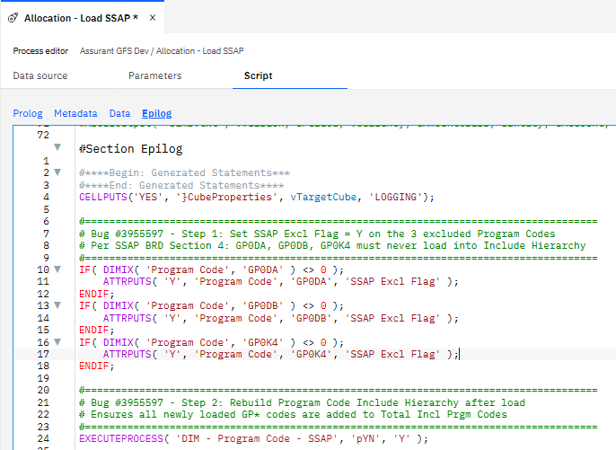

This is the section that I commented out for my test, and I think is not needed:
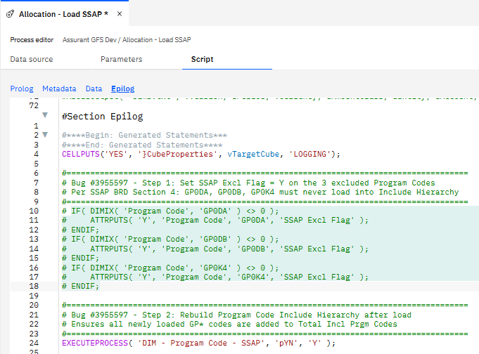

Thank you,

