Tribhuvan University
Faculty of Humanities and Social Sciences
"CAR RENTAL SYSTEM"
A PROJECT REPORT
Submitted to
Department of Computer Application
Reliance College
In partial fulfillment of the requirements for the Bachelor in Computer Application
Submitted by:
Niranjan Kafle
(Registration Number: [Registration Number])
Under the Supervision of
Riwaj Bhurtel
July, 2026

Tribhuvan University
Faculty of Humanities and Social Sciences
Reliance College

SUPERVISOR'S RECOMMENDATION
I hereby recommend that this project prepared under my supervision by Niranjan Kafle (Registration Number: [Registration Number]) entitled “CAR RENTAL SYSTEM” be accepted as fulfilling the requirement for the partial fulfillment of the degree of Bachelor in Computer Application. To the best of my knowledge, this is an original piece of work carried out under my guidance and has not been submitted elsewhere for the award of any degree.

....................................................

SIGNATURE
Riwaj Bhurtel

SUPERVISOR
Department of Computer Application
Reliance College

Tribhuvan University
Faculty of Humanities and Social Sciences
Reliance College

LETTER OF APPROVAL
This is to certify that this project prepared by Niranjan Kafle (T.U Registration Number: [Registration Number]) entitled “CAR RENTAL SYSTEM” has been examined and is submitted for evaluation by the Department of Computer Application, Reliance College, in partial fulfillment of the requirements for the degree of Bachelor in Computer Application. This project report has not been submitted for any other degree and is forwarded for evaluation.

.................................................... | ....................................................
Riwaj Bhurtel  Supervisor | Internal Examiner

....................................................
External Examiner

ABSTRACT
Car Rental System is a web-based car rental booking and fleet management platform designed to streamline the process of listing, discovering, and booking rental vehicles online. The system replaces the manual, phone-call-driven booking process traditionally used by small and mid-sized car rental businesses with a self-service portal that lets customers browse the available fleet, filter vehicles by brand, fuel type, seating capacity and price, check real-time availability for a chosen date range, and complete a booking with online payment.
The platform is built on a PHP and MySQL stack and is organised into two cooperating modules: a customer-facing portal for registration, search, booking, testimonials and account management, and an administrative back office for managing vehicles, brands, bookings, offers, testimonials and customer enquiries. A weighted greedy algorithm ranks the available fleet against the customer's stated preferences (vehicle type, fuel type, brand and budget) to recommend the best-fitting cars first, and an AI-powered chatbot, backed by an OpenRouter large-language-model with function-calling tools, assists visitors with vehicle search, booking questions and account queries in natural language. Online payment is processed through the Khalti payment gateway.
The system was analysed and designed using standard software engineering artefacts — use-case diagrams, data-flow diagrams, an entity-relationship schema and a system architecture diagram — and was implemented incrementally, with each module unit-tested against a documented set of test cases before integration. The resulting system demonstrates that a well-scoped, algorithmically assisted booking platform can materially reduce the manual overhead of running a car rental business while giving customers a faster and more transparent booking experience.
Keywords: Car Rental System, Vehicle Booking, Greedy Algorithm, AI Chatbot, PHP, MySQL, Khalti Payment Gateway, Role-Based Access Control.

ACKNOWLEDGEMENT
I would like to express my sincere gratitude to Tribhuvan University and the Department of Computer Application, Reliance College, for providing me with the opportunity and the platform to undertake this project as part of the Bachelor in Computer Application programme.
I am deeply grateful to my supervisor, Riwaj Bhurtel, for the continuous guidance, valuable feedback and encouragement provided throughout the analysis, design, implementation and testing of this project, “CAR RENTAL SYSTEM”. Their insights were instrumental in shaping the direction of this work.
I would also like to thank the faculty members of the Department of Computer Application for their support throughout the course of study, and my family, friends and classmates for their patience, motivation and constructive suggestions during the development of this project.
Finally, any errors or shortcomings that remain in this report are entirely my own.

Yours Sincerely,
Niranjan Kafle
(Registration Number: [Registration Number])

TABLE OF CONTENTS
Right-click and choose "Update Field" to build this list.

LIST OF FIGURES
Right-click and choose "Update Field" to build this list.

LIST OF TABLES
Right-click and choose "Update Field" to build this list.

ABBREVIATIONS
Abbreviation | Full Form
API | Application Programming Interface
BCA | Bachelor in Computer Application
CSS | Cascading Style Sheets
DFD | Data Flow Diagram
ER | Entity Relationship
HTML | Hyper Text Markup Language
HTTP | Hyper Text Transfer Protocol
JSON | JavaScript Object Notation
LLM | Large Language Model
PDO | PHP Data Objects
PHP | Hypertext Preprocessor
RBAC | Role-Based Access Control
SQL | Structured Query Language
TU | Tribhuvan University
UI/UX | User Interface / User Experience
URL | Uniform Resource Locator

CHAPTER 1: INTRODUCTION

1.1 Introduction
The rental car industry has traditionally relied on phone calls, walk-in counters and manually maintained spreadsheets to track vehicle availability, bookings and customer records. This approach does not scale well: staff must manually cross-check dates against a fleet list to confirm availability, customers cannot compare vehicles or prices without contacting the business directly, and there is no self-service way to view, modify or cancel a booking once it has been made.
The Car Rental System is a full-stack web application that digitises this entire workflow. It gives customers a public storefront where they can browse the fleet, filter vehicles by brand, fuel type, seating capacity and daily rate, check live availability for a chosen pickup and return date, and complete a booking online with payment through the Khalti payment gateway. On the other side, administrators are given a dedicated back-office panel to manage the vehicle inventory, brands, bookings, promotional offers, customer testimonials and contact enquiries from a single dashboard.
Beyond basic CRUD-style booking management, the system layers two pieces of applied algorithmic logic on top of the core workflow: a weighted greedy recommendation algorithm that ranks the available fleet against a customer's stated preferences, and an AI chatbot, backed by a large language model through the OpenRouter API, that can answer natural-language questions, search the fleet and even place a booking on the customer's behalf through a set of guarded function-calling tools.

1.2 Problem Statement
Small and mid-sized car rental businesses typically cannot afford (or do not need) a large enterprise fleet-management suite, and end up running their booking process manually. This creates several concrete problems that this project sets out to address:
- Vehicle availability is tracked manually, which makes double-booking of the same vehicle for overlapping dates a real risk.
- Customers have no way to browse, filter or compare the available fleet before contacting the business, which lengthens the booking cycle.
- There is no self-service way for a customer to view their booking history, cancel a booking, or update their account details.
- Administrators lack a single dashboard to manage vehicles, brands, offers, testimonials and customer enquiries — these are often spread across spreadsheets, messaging apps and paper records.
- First-time visitors often have basic questions (pricing, fuel type, how booking works) that would otherwise require a phone call or a wait for a reply to be answered.

1.3 Objective
The broad objective of this project is to design and implement a web-based car rental booking and fleet-management platform. The specific objectives are:
- To develop a public-facing portal where customers can register, browse the vehicle fleet, search and filter by brand/fuel type/price, and view detailed information for each vehicle.
- To implement a date-range-aware booking workflow that prevents a vehicle from being double-booked for overlapping dates, integrated with the Khalti online payment gateway.
- To build an administrative back office for managing vehicles, brands, bookings, promotional offers, testimonials and contact-us enquiries.
- To design and implement a greedy algorithm that scores and ranks available vehicles against a customer's stated preferences (vehicle type, fuel type, brand, seating and budget).
- To integrate an AI-powered chatbot capable of answering customer questions and performing guarded actions (search, booking) through function calling against a large language model.

1.4 Scope and Limitation
Scope:
- Customer registration, login and profile/account management.
- Vehicle catalogue with search, keyword/brand/fuel-type filtering and pagination.
- Date-range booking with availability checking, checkout and Khalti payment integration.
- Customer testimonial submission and a public contact/enquiry form.
- An AI chatbot for search, FAQ and guarded booking assistance.
- A role-based administrative panel for vehicles, brands, bookings, offers and testimonials.
Limitation:
- The system is scoped to a single rental branch/location and does not model multi-branch fleet transfers.
- Payment is integrated with a single gateway (Khalti); other gateways are not implemented.
- The recommendation algorithm is a deterministic weighted greedy scorer rather than a learned (machine-learning-based) recommender.
- The chatbot's knowledge is limited to the information exposed through its tool definitions and does not have access to information outside the platform's database.

1.5 Development Methodology
The project was developed using an incremental development model. Rather than attempting to design the complete system up-front, the system was decomposed into independently deliverable increments — public browsing and search, customer authentication, the booking and payment workflow, the administrative panel, the greedy recommendation engine, and finally the AI chatbot — with each increment analysed, designed, implemented and tested before the next one began. This allowed core booking functionality to be validated early, while later increments (recommendation and chatbot) were layered on top of a already-working booking pipeline.
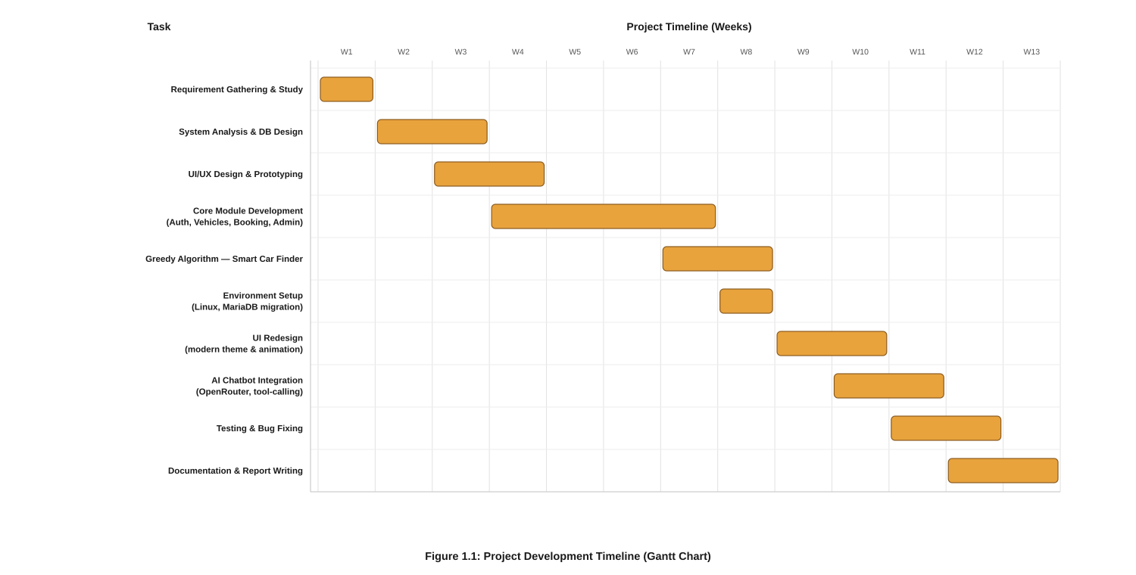
Figure 3. 1: Project Schedule (Gantt Chart)

1.6 Report Organization
This report is organised into five chapters:
- Chapter 1 (Introduction) presents the motivation, problem statement, objectives, scope and development methodology of the project.
- Chapter 2 (Background Study and Literature Review) discusses the domain background and reviews related systems and techniques.
- Chapter 3 (System Analysis and Design) covers requirement analysis, feasibility analysis, the use-case, data-flow and architectural diagrams, database schema design, the interface design of every major screen, and the algorithms used by the system.
- Chapter 4 (Implementation and Testing) describes the tools and technologies used, module-level implementation details, and the test cases used to verify each feature.
- Chapter 5 (Conclusion and Future Recommendations) presents a critical analysis of the finished system, its limitations, and directions for future work.

CHAPTER 2: BACKGROUND STUDY AND LITERATURE REVIEW

2.1 Background Study
Vehicle rental is a well-established service industry, but a large share of small and independent operators still coordinate bookings manually — over the phone, through messaging apps, or with a walk-in counter and a paper or spreadsheet-based booking register. This is workable at low volume, but breaks down as the fleet and customer base grow: it is easy to lose track of which vehicle is booked for which date range, difficult to give customers an accurate, real-time picture of what is actually available, and time-consuming to manually reconcile payments against bookings.
A web-based booking platform addresses these problems directly. Vehicle availability becomes a query against a single source of truth (the bookings table) rather than something staff have to remember or look up; customers can self-serve — browsing, filtering and booking without waiting for a reply; and the business gets a searchable, auditable record of every booking, payment and customer enquiry. This project studies that transition for the specific case of a car rental business, and additionally explores how a lightweight recommendation algorithm and a conversational AI assistant can further reduce the friction of finding and booking the right vehicle.

2.2 Literature Review
Commercial car-sharing and rental platforms such as Turo, Zoomcar and the booking modules of major rental chains popularised the now-familiar pattern of browsing a vehicle catalogue, filtering by category/price/fuel type, and checking a calendar of availability before paying online. These platforms informed the core user flow adopted in this project — catalogue, filter, date-range availability check, checkout — while this project keeps the implementation intentionally smaller in scope and self-hosted, suited to a single-branch rental business rather than a multi-vendor marketplace.
On the algorithmic side, greedy algorithms are a standard technique in resource-allocation and scheduling problems where a good-enough, locally-optimal choice at each step is acceptable in exchange for a simple, fast and deterministic decision procedure — as opposed to globally optimal but far more expensive approaches such as integer programming or learned ranking models. This project applies that idea to vehicle recommendation: rather than solving a combinatorial optimisation problem over the whole fleet, each available vehicle is scored independently against the customer's stated preferences (vehicle-type weight, fuel-type preference, brand preference and budget fit), and the highest-scoring vehicles are greedily selected as the top recommendations. This is appropriate here because recommendations must be computed on every search request, in real time, over a modestly sized fleet.
On the conversational side, the emergence of large language models with function/tool-calling support (as exposed through APIs such as OpenRouter) has made it practical to add a natural-language assistant to a web application without training a custom model: the model is given a fixed set of callable tools (searching cars, fetching car details, checking login state, creating a booking) and decides when to call them based on the conversation, while the application code — not the model — continues to enforce access control on any tool that touches booking or account data. This project's chatbot follows that pattern, which is increasingly common in customer-support and e-commerce assistants.

CHAPTER 3: SYSTEM ANALYSIS AND DESIGN

3.1 System Analysis

3.1.1 Requirement Analysis

Functional Requirements
- Vehicle Catalogue: display the full fleet with brand, fuel type, seating capacity, model year and price-per-day; allow keyword, brand and fuel-type based search with pagination.
- Booking Management: let a logged-in customer pick a vehicle and a pickup/return date range, verify the vehicle is not already booked for an overlapping date range, and record the booking.
- Online Payment: route the checkout amount through the Khalti payment gateway and record the transaction result against the booking.
- Account Management: registration, login, profile editing and password update for customers.
- My Bookings: let a customer view their booking history and its current status.
- Testimonial Management: let a customer submit a testimonial, and let an administrator approve or reject it before it appears publicly.
- Contact / Inquiry Management: a public contact form that stores enquiries for admin follow-up.
- Chatbot Support: a conversational assistant that can answer questions, search the fleet and place a booking for a logged-in visitor.
- Admin Panel: CRUD management of vehicles, brands, bookings, offers, testimonials, contact enquiries and registered users, from a single dashboard.
- Smart Vehicle Recommendation: score and rank the available fleet against a customer's stated preferences using the greedy recommendation algorithm.

Non-Functional Requirements
- Usability: a clean, responsive interface that works across desktop and mobile screen sizes.
- Security: passwords are never stored or transmitted in plain text without hashing, all database access uses parameterised (PDO prepared statement) queries to prevent SQL injection, and every chatbot tool that touches booking or account data re-checks the visitor's session server-side rather than trusting the language model's judgement.
- Compatibility: the system runs on any standards-compliant browser and on a standard PHP/MySQL hosting stack without special server extensions.
- Performance: fleet search, filtering and the greedy scoring pass must complete quickly enough to run synchronously on every search request.

3.1.2 Use-Case Diagram
The system recognises two actors: the Customer (an unregistered visitor or a registered user of the public portal) and the Administrator (the operator of the back office). Figure 3.1 shows the principal use cases each actor participates in.
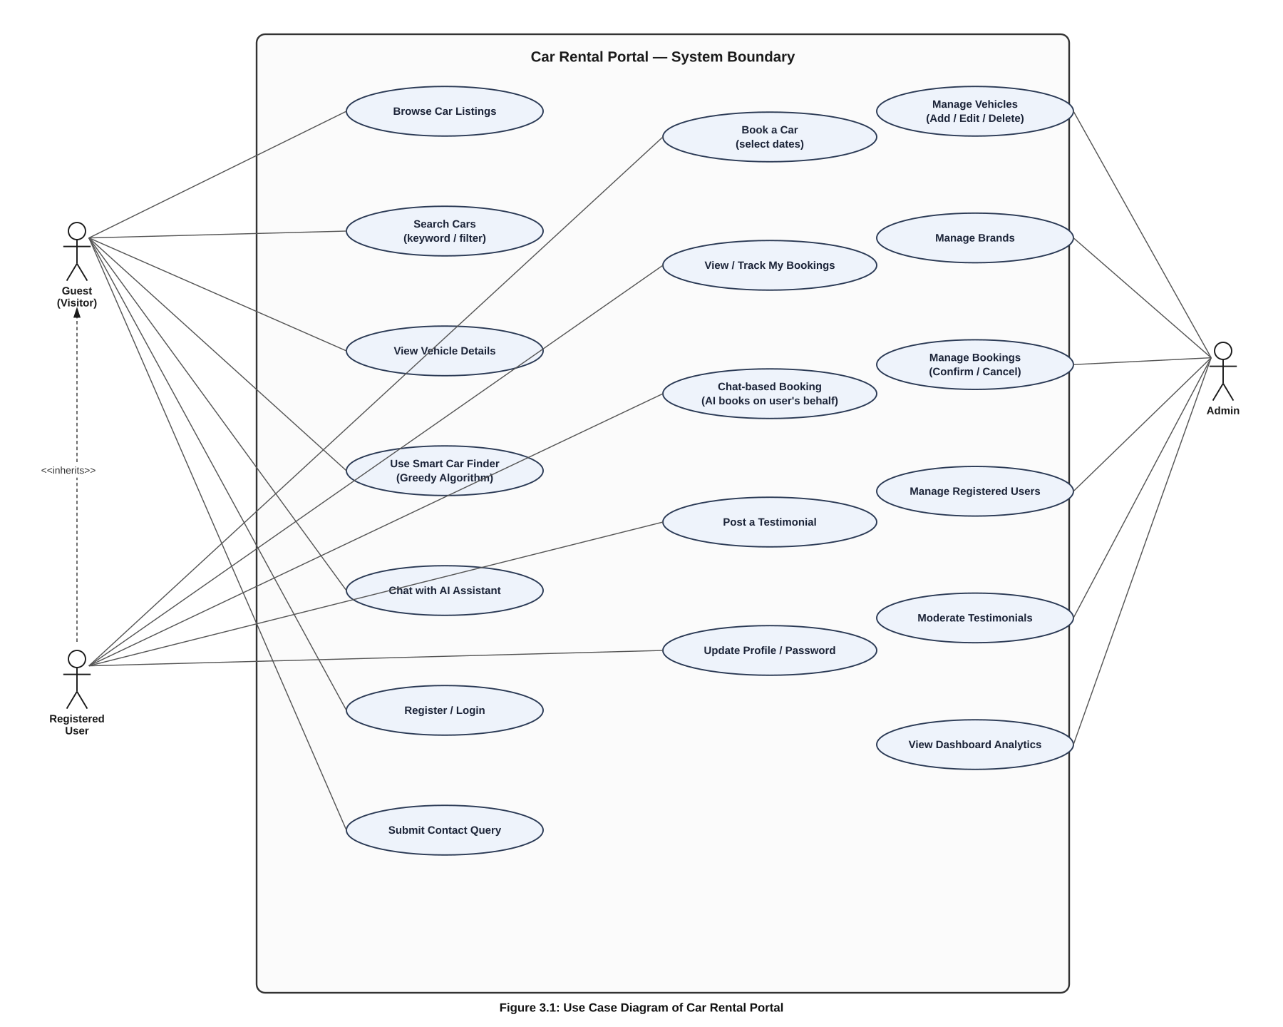
Figure 3. 1: Use Case Diagram

Customer Use Cases
- Register / Login / Update profile and password.
- Browse and search the vehicle catalogue; use the smart finder to get ranked recommendations.
- View vehicle details and check availability for a date range.
- Book a vehicle and pay online through Khalti.
- View "My Bookings" and past booking status.
- Submit a testimonial and a contact / enquiry message.
- Chat with the AI assistant for search help, FAQs and guided booking.

Administrator Use Cases
- Log in to the admin dashboard.
- Add, edit, delete and view vehicles and vehicle brands.
- View and manage new, confirmed and cancelled bookings.
- Manage promotional offers.
- Approve or reject customer testimonials.
- View and respond to contact / enquiry submissions and manage registered users.

3.1.3 Feasibility Analysis

Technical Feasibility
The system is built entirely on the open-source PHP/MySQL stack (with a small amount of JavaScript and Bootstrap on the front end), technologies that are freely available, well documented and already familiar from the BCA curriculum. The Khalti and OpenRouter integrations are both plain HTTPS/JSON APIs reachable with PHP's cURL extension, requiring no specialised infrastructure. The project is therefore technically feasible to build and deploy on standard shared or VPS hosting.

Economic Feasibility
All software used — PHP, MySQL, and the code editor/IDE — is free and open-source, and Khalti's merchant integration and OpenRouter's pay-per-use API pricing keep running costs proportional to actual usage rather than requiring a large upfront licence fee. The system is therefore economically feasible for a small rental business to adopt.

Schedule Feasibility
The incremental development plan shown in the Gantt chart in Section 1.5 allocates the project across analysis, module-by-module implementation and testing within the semester timeline, making the schedule realistic given the scope defined in Section 1.4.

3.1.4 Data Modeling (Process Modeling)
Data flow diagrams (DFDs) were used to model how information moves between the customer, the administrator and the system's data stores. Figure 3.2 gives the context-level (Level 0) view of the whole system as a single process, and Figure 3.3 decomposes that process into its main sub-processes for Level 1.
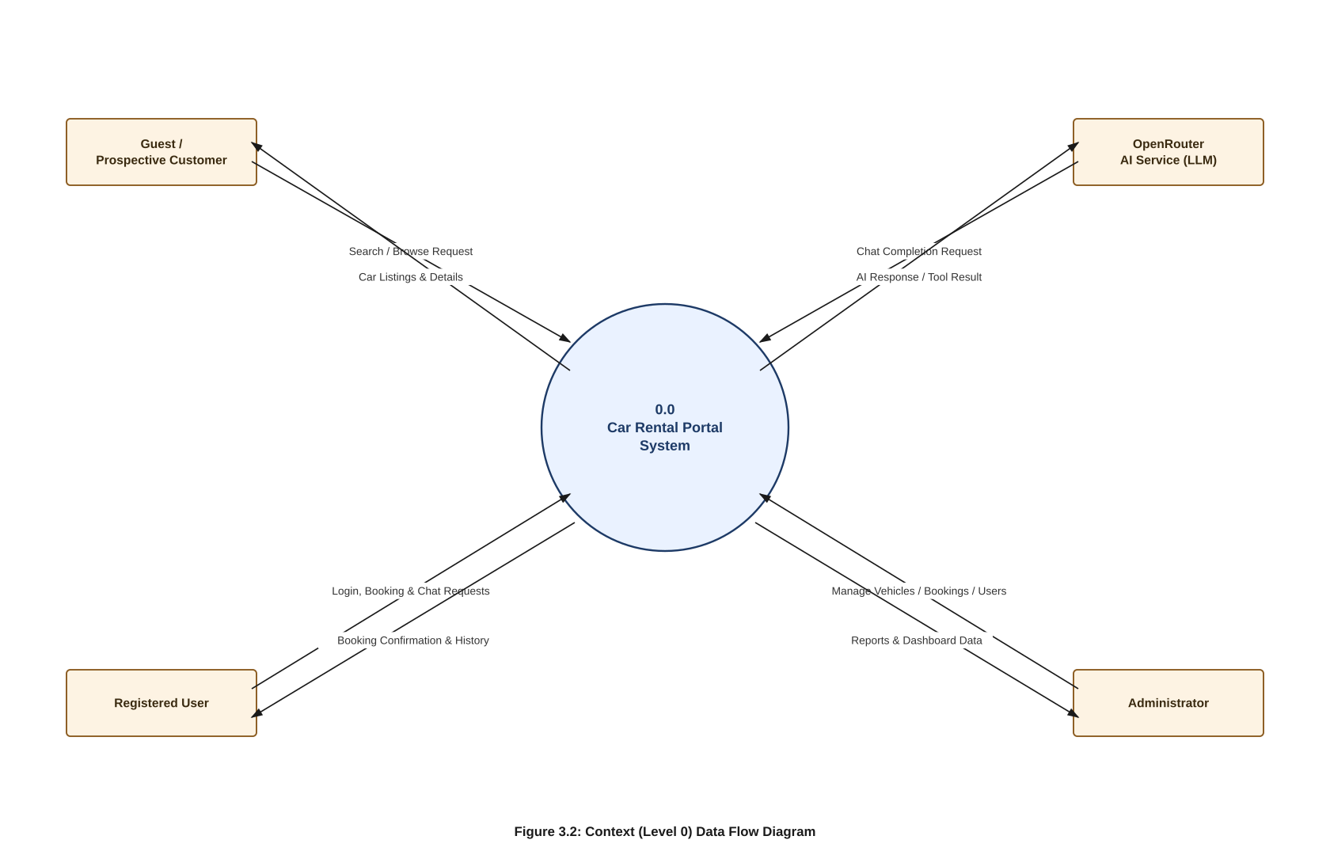
Figure 3. 1: Level-0 Data Flow Diagram
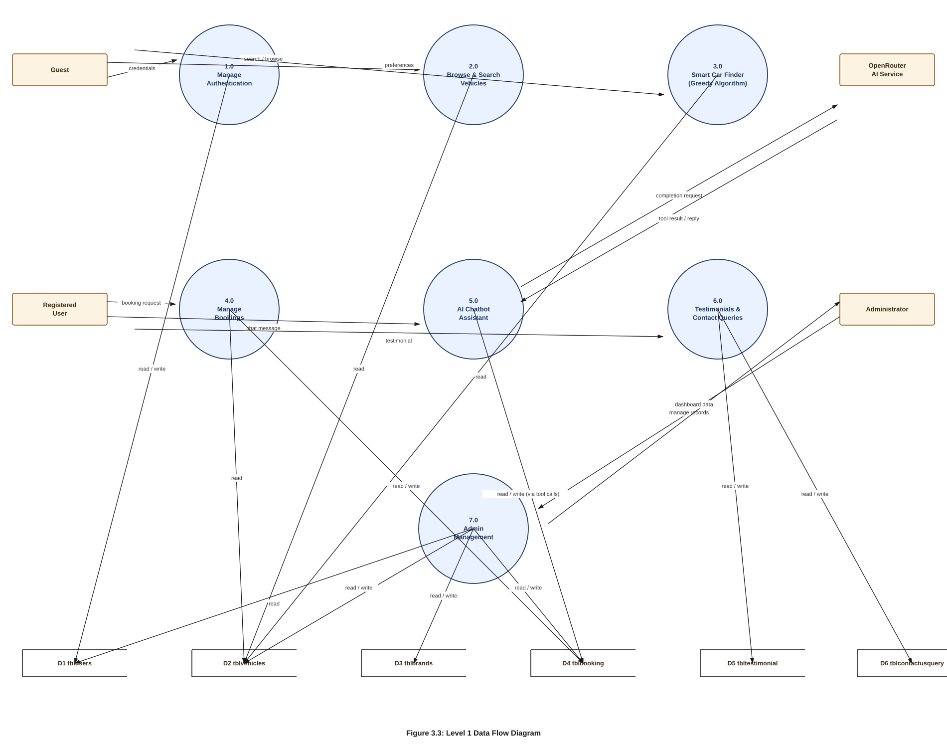
Figure 3. 1: Level-1 Data Flow Diagram

3.2 System Design

3.2.1 Architecture Design
The system follows a classic three-tier web architecture. The presentation tier is server-rendered PHP with Bootstrap and JavaScript for interactivity; the application tier is a set of PHP controllers/scripts implementing authentication, booking, the greedy recommendation engine and the chatbot's tool-calling logic; and the data tier is a MySQL database accessed exclusively through PDO prepared statements. The chatbot module additionally calls out to the OpenRouter API for language-model inference, and the checkout flow calls out to the Khalti API for payment processing, both over HTTPS.
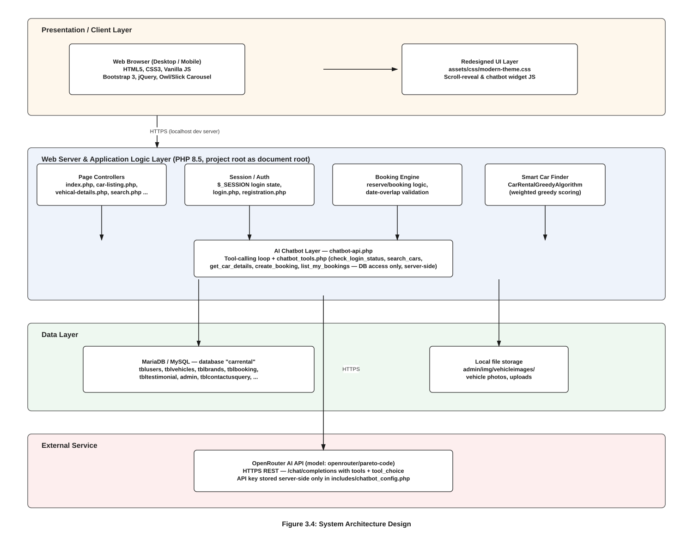
Figure 3. 1: System Architecture Design

3.2.2 Database Schema Design
The database is normalised around ten tables. Figure 3.5 shows the schema and the relationships between them.
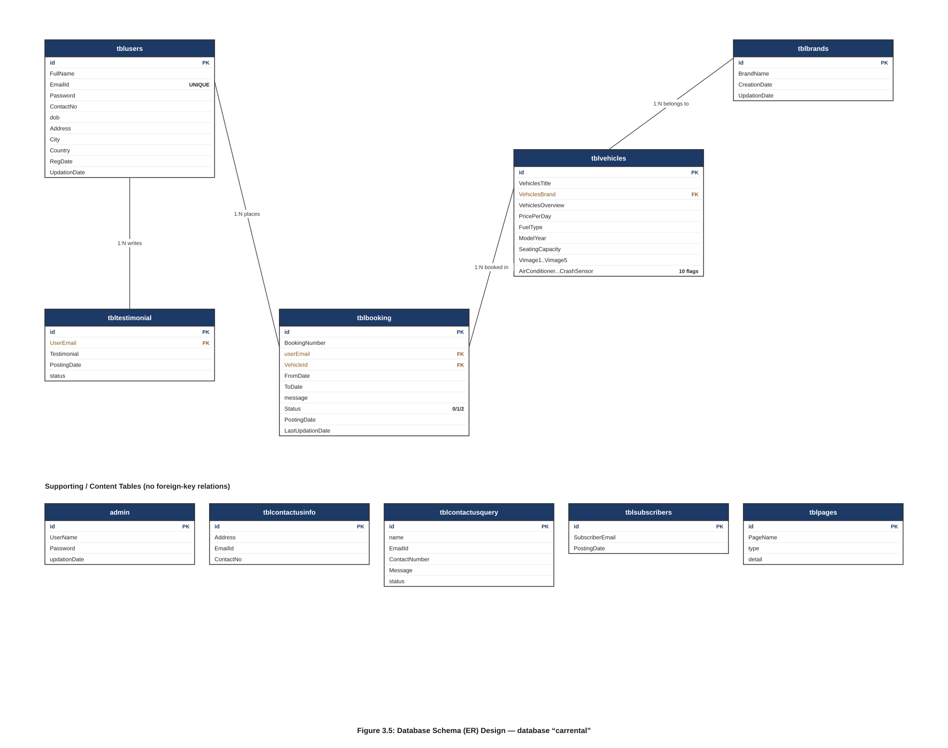
Figure 3. 1: Database Schema Design
Table | Purpose
admin | Administrator login credentials for the back-office panel.
tblusers | Registered customer accounts (name, email, password, contact and address details).
tblvehicles | The vehicle fleet: title, brand, overview, price per day, fuel type, model year, seating capacity, feature flags (air conditioner, power door locks, etc.) and up to five images per vehicle.
tblbrands | Vehicle brand/manufacturer master list, referenced by tblvehicles.
tblbooking | Booking records linking a customer email and a vehicle to a from/to date range, a status flag, and an optional message.
tblcontactusquery | Enquiry messages submitted through the public Contact Us form.
tblcontactusinfo | The rental business's own published address, email and phone number.
tbltestimonial | Customer testimonials pending or approved for public display.
tblsubscribers | Newsletter/subscriber email addresses.
tblpages | Editable static content pages (e.g. About Us) managed from the admin panel.

3.2.3 Interface Design (UI/UX)
The following figures show the implemented interface for each major screen of the customer portal and the admin panel.
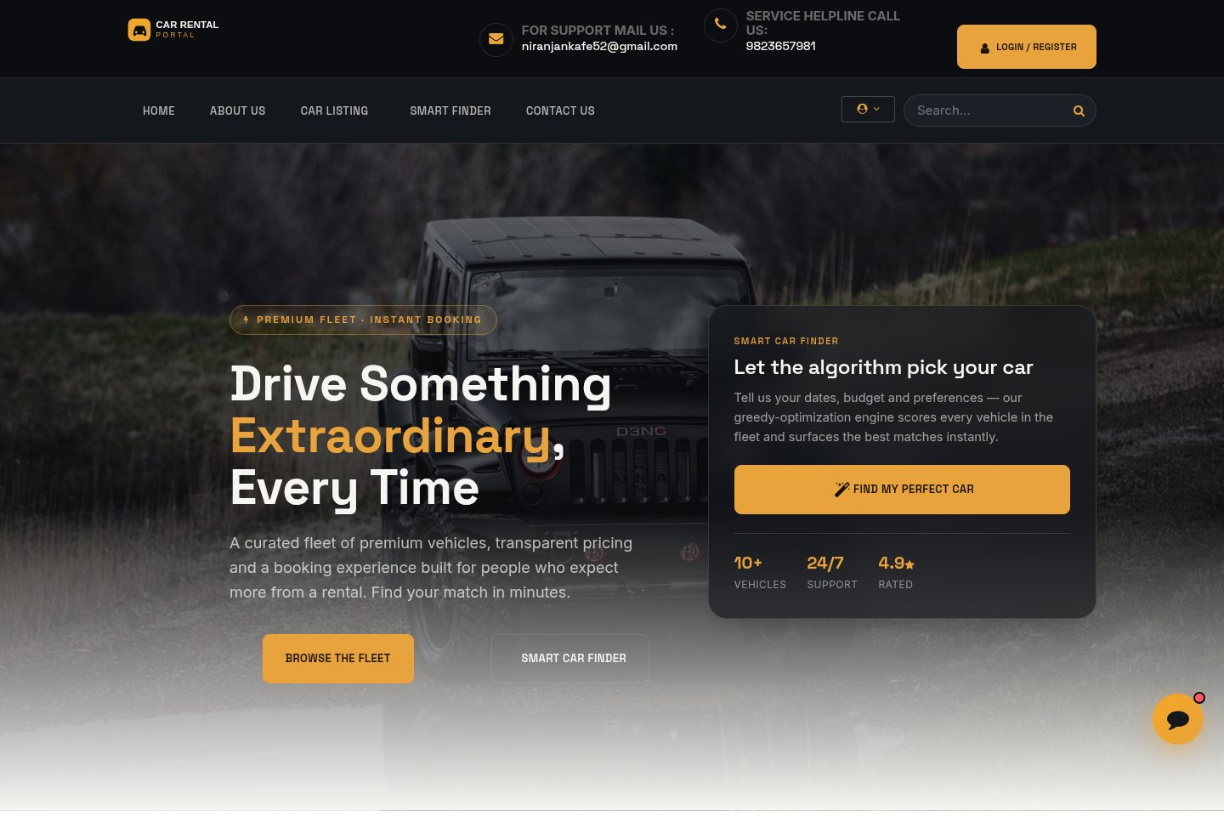
Figure 3. 1: User Home Page
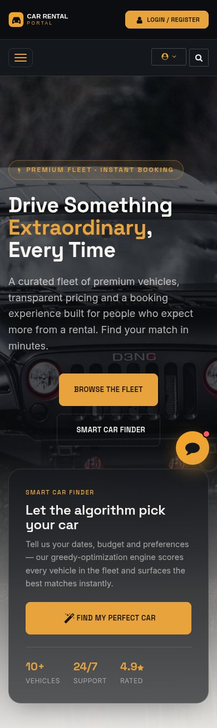
Figure 3. 1: User Home Page (Mobile View)
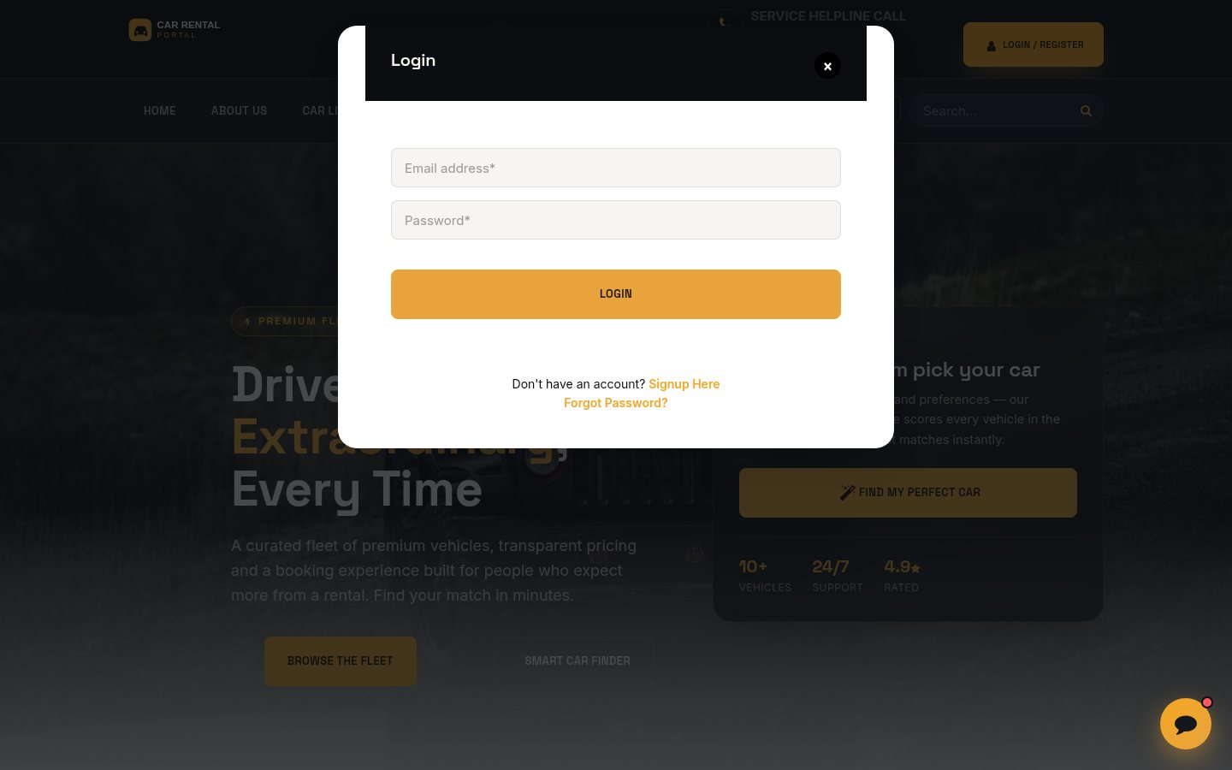
Figure 3. 1: Login
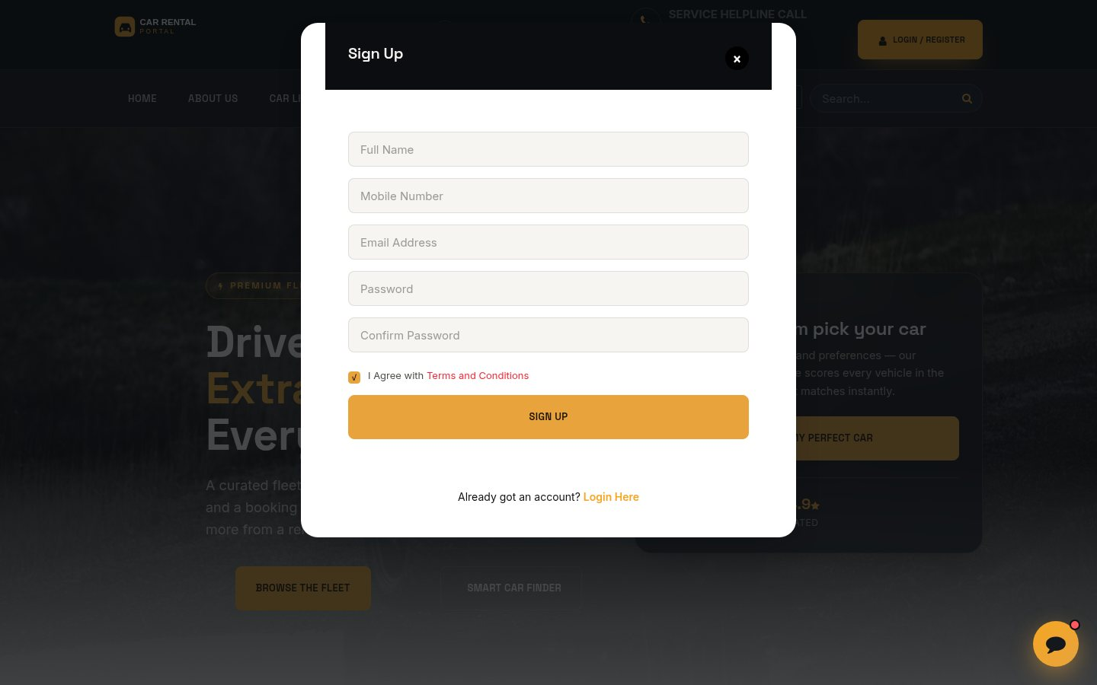
Figure 3. 1: Register
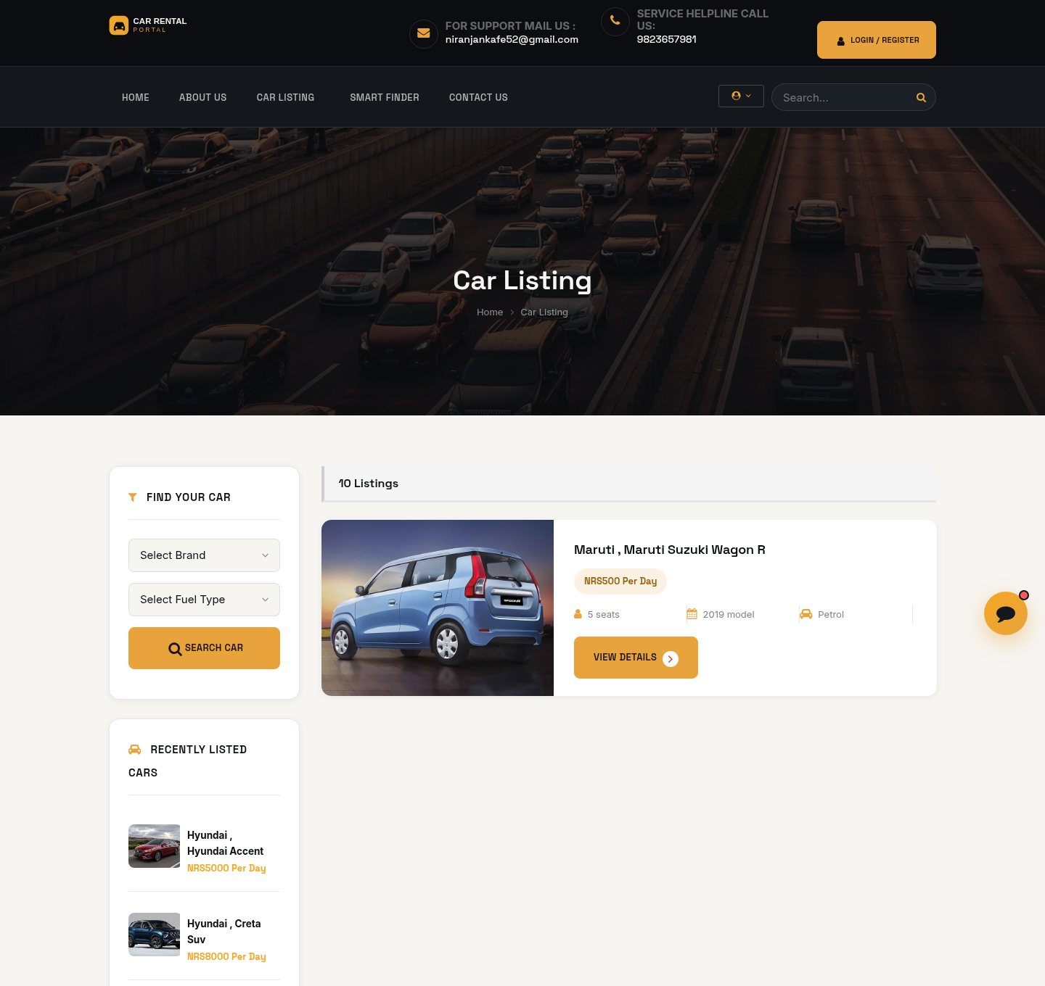
Figure 3. 1: Vehicle Listing Page
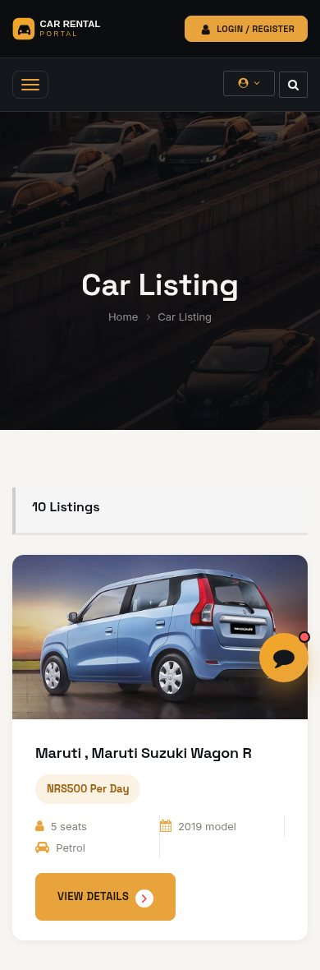
Figure 3. 1: Vehicle Listing Page (Mobile View)
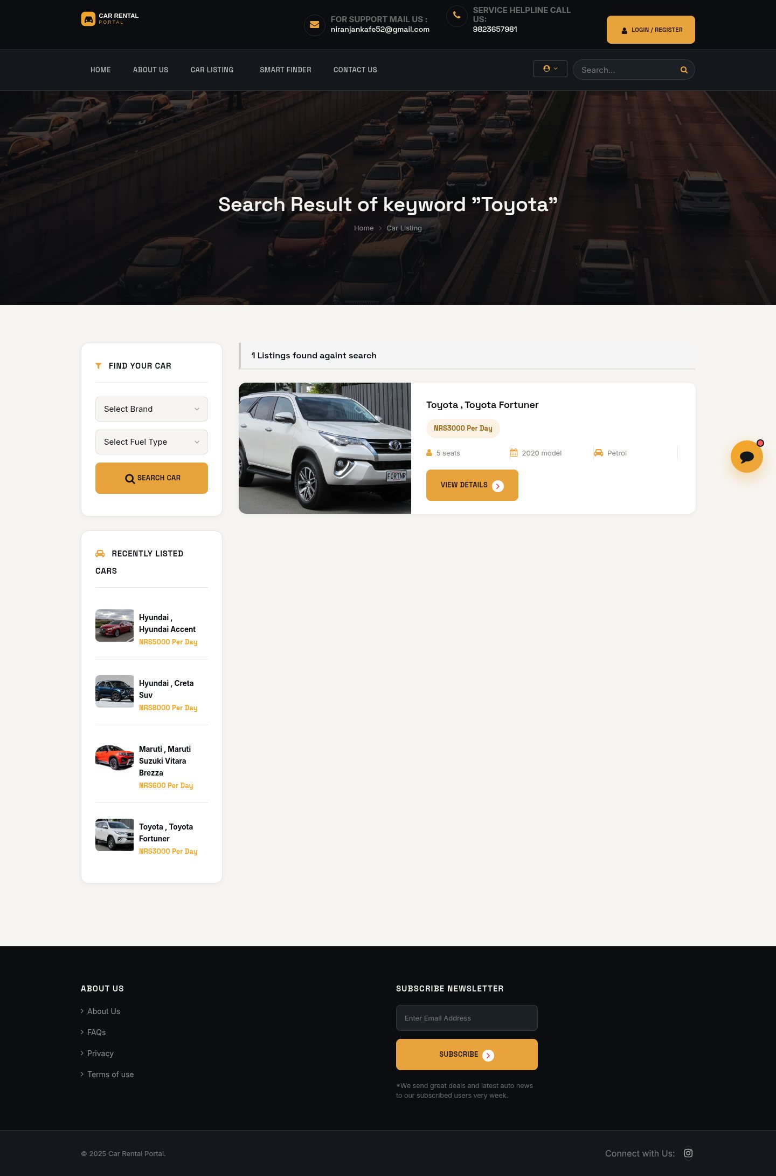
Figure 3. 1: Search Results Page
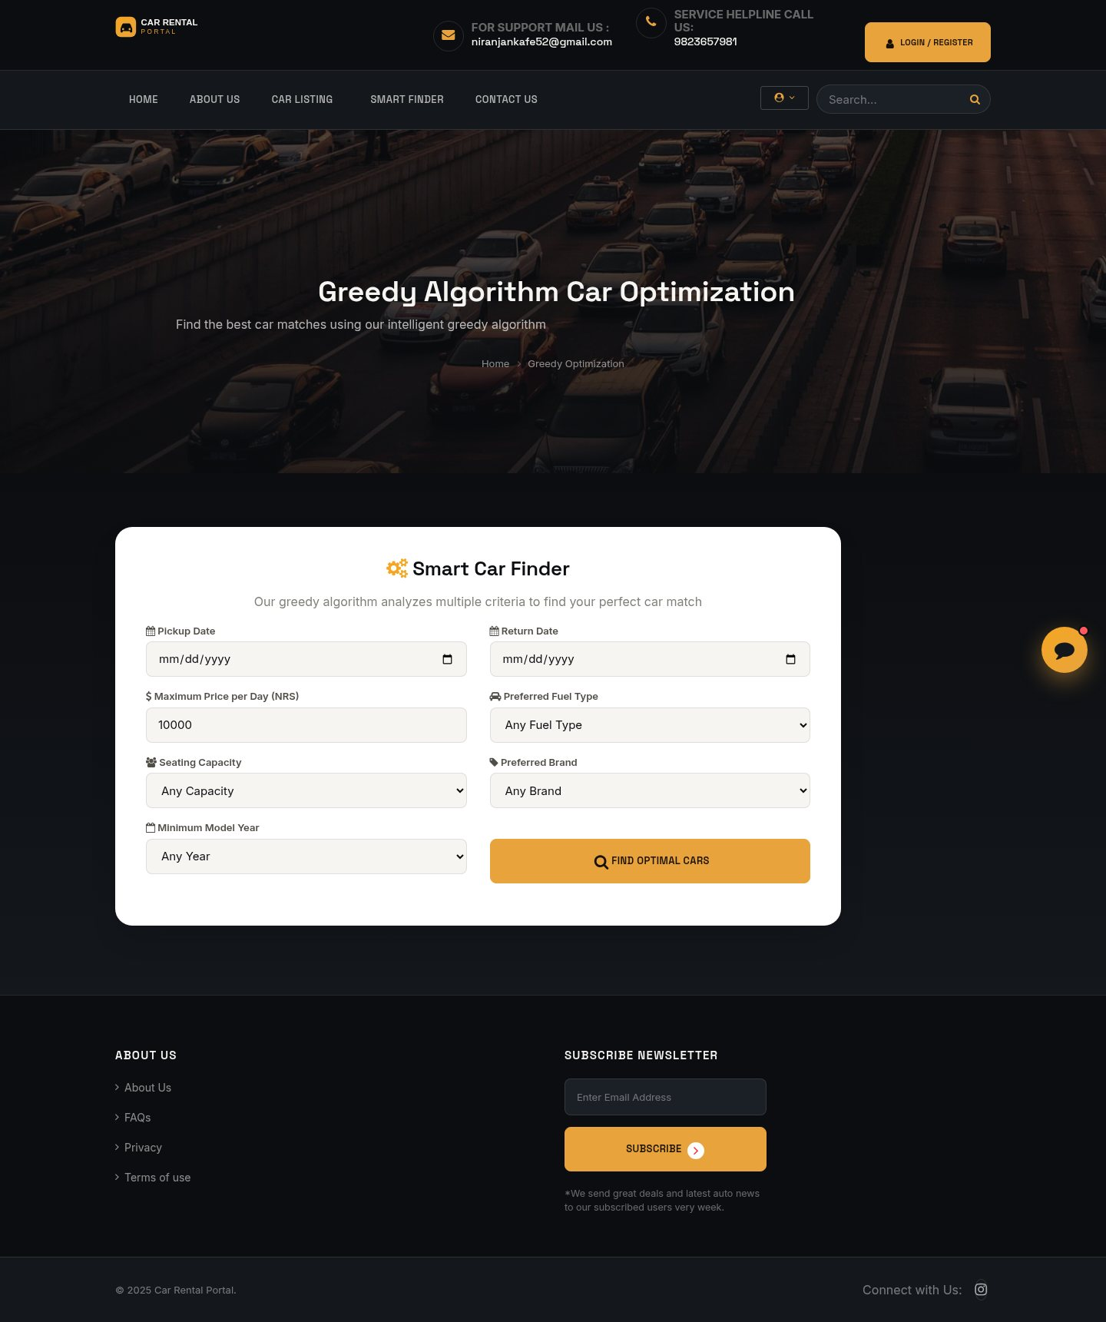
Figure 3. 1: Smart Car Finder (Greedy Recommendation)
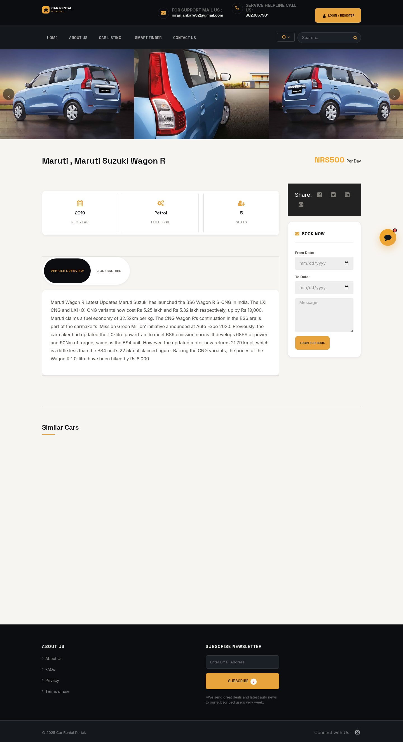
Figure 3. 1: Vehicle Details Page
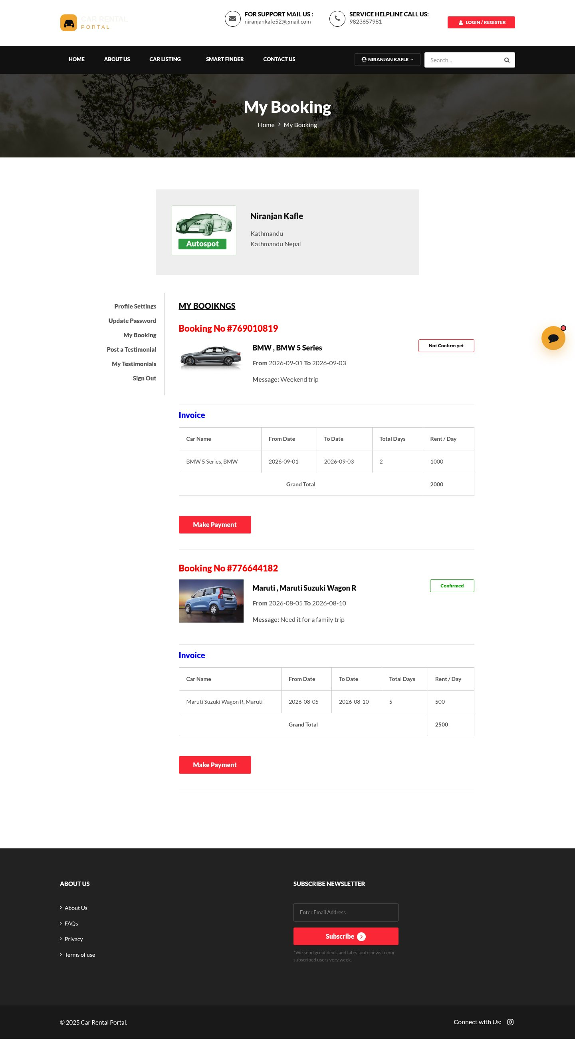
Figure 3. 1: My Bookings Page
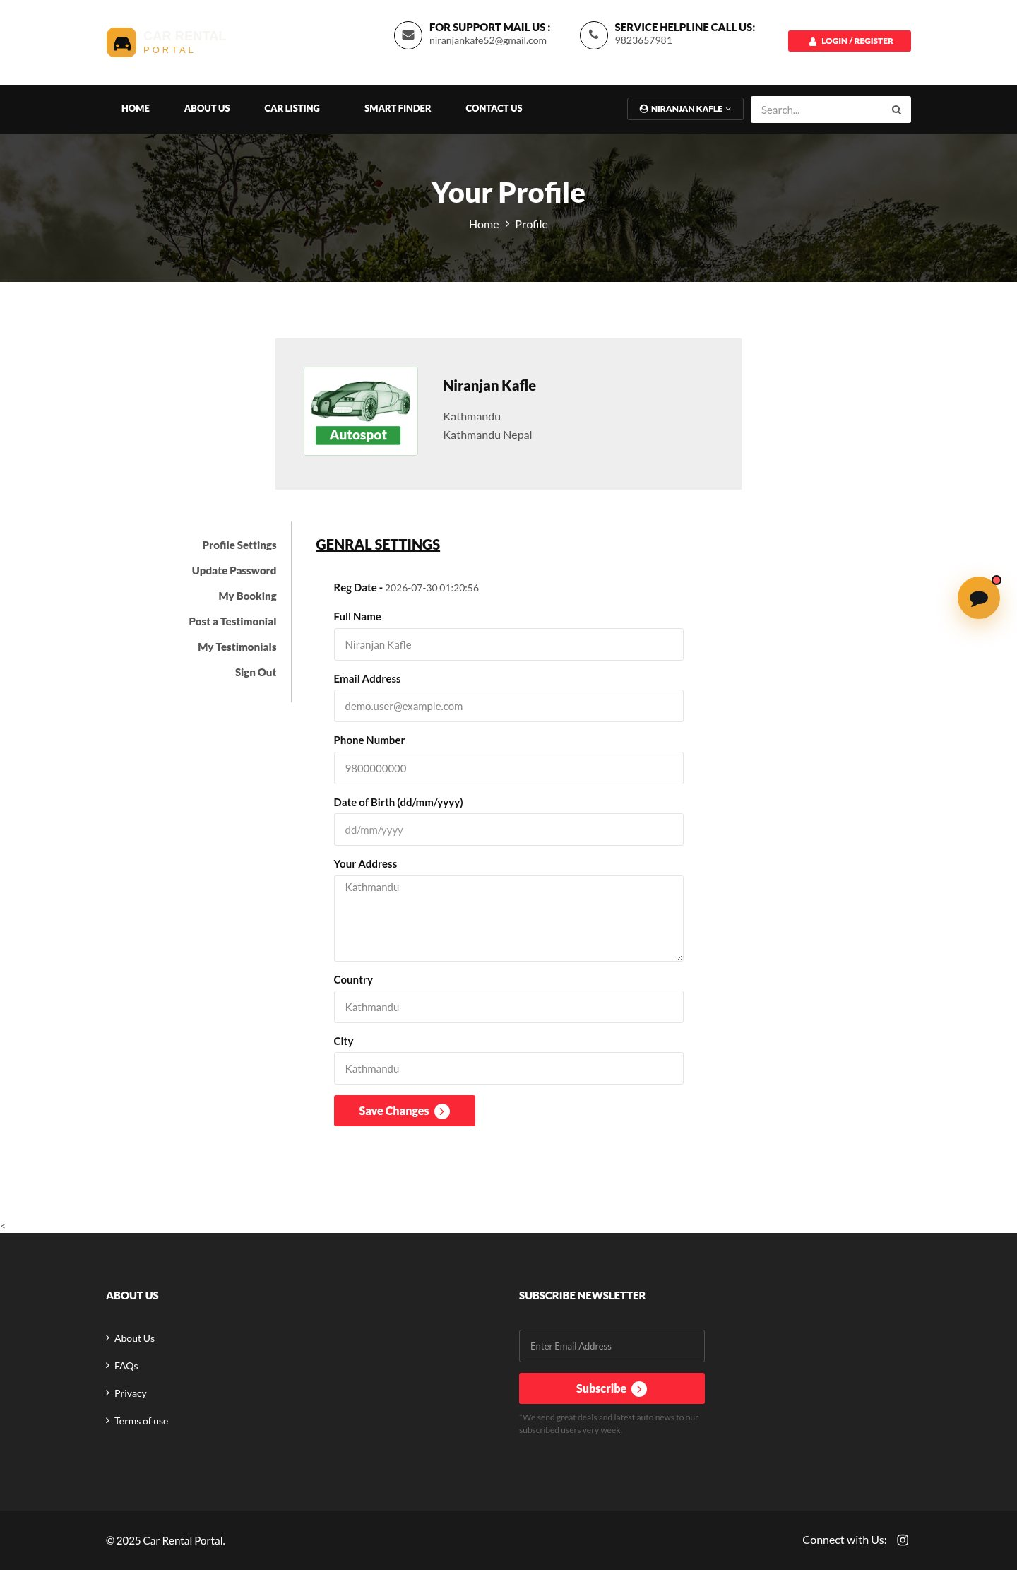
Figure 3. 1: Account Details Page
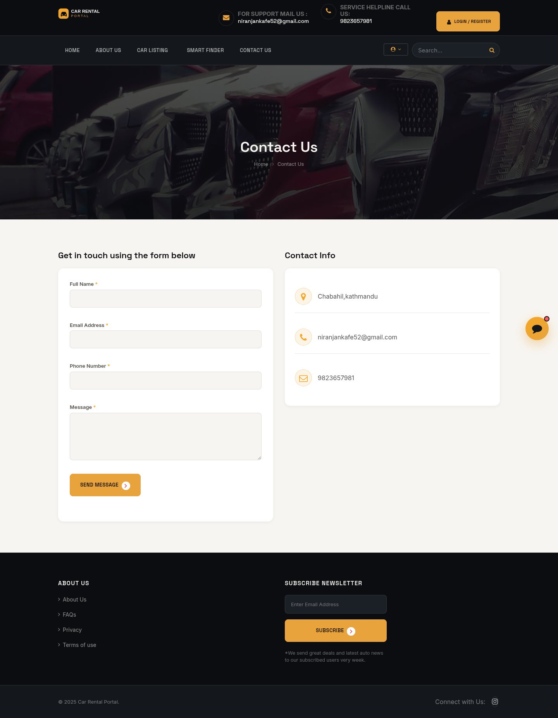
Figure 3. 1: Contact Us Page
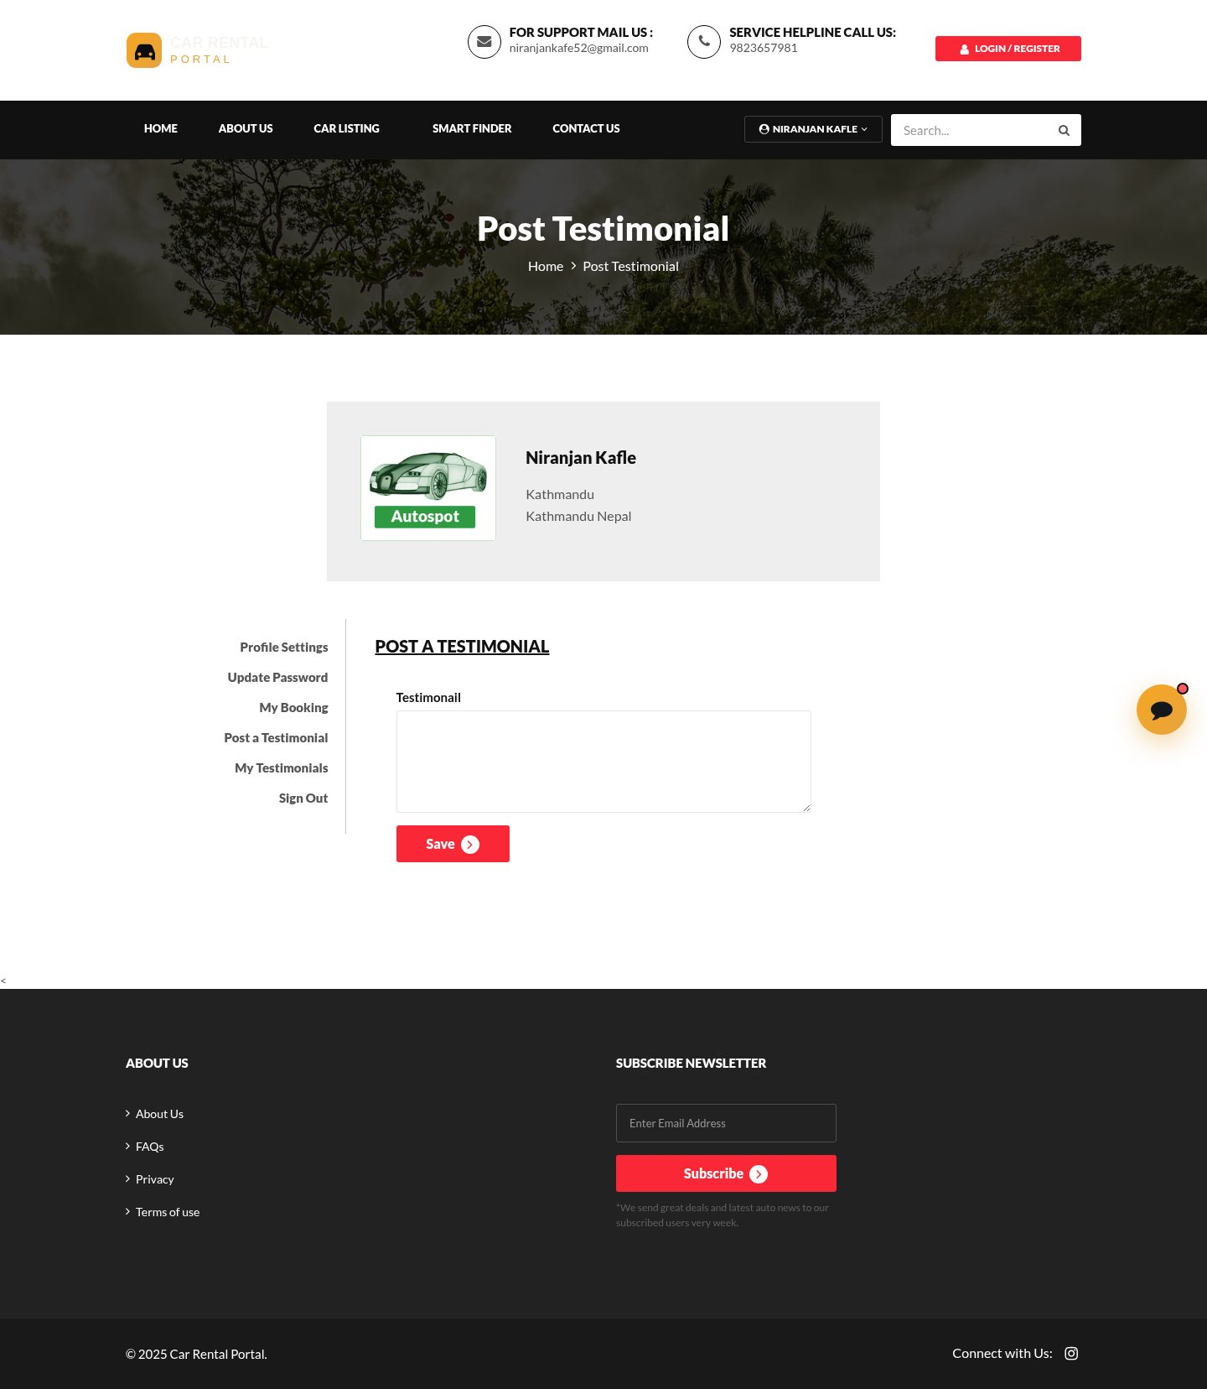
Figure 3. 1: Post Testimonial Page
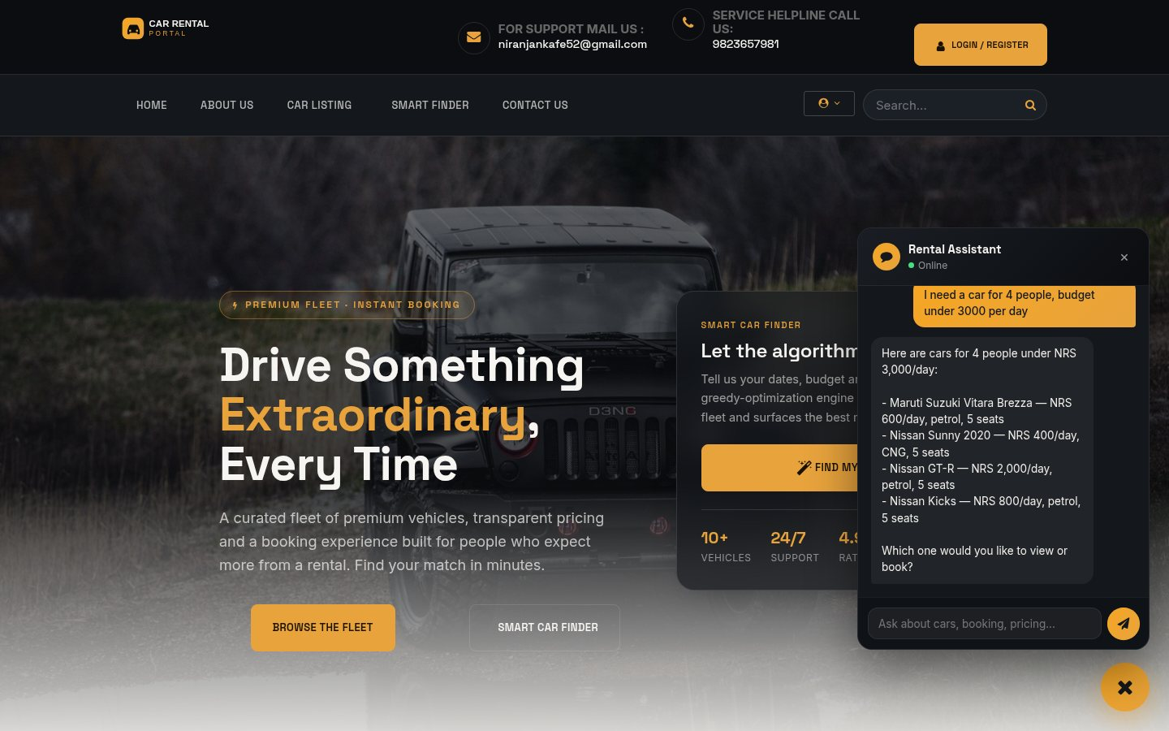
Figure 3. 1: AI Chatbot Widget
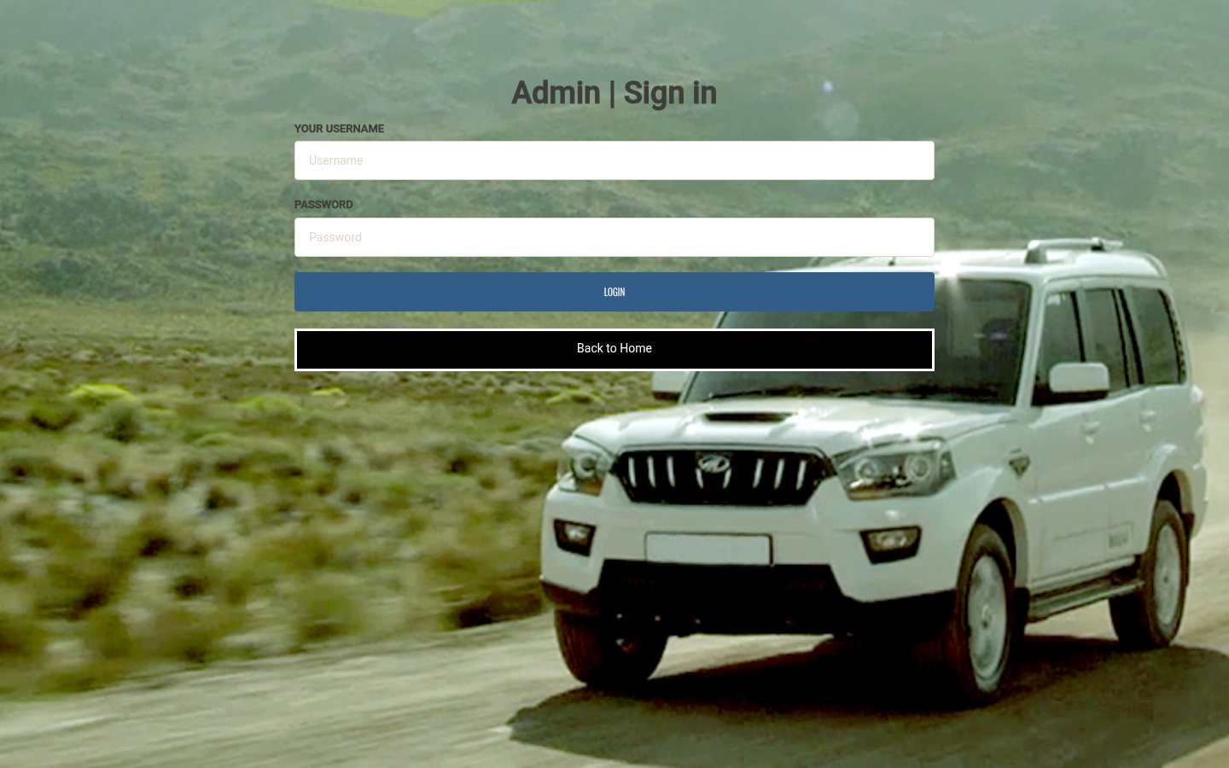
Figure 3. 1: Admin Login
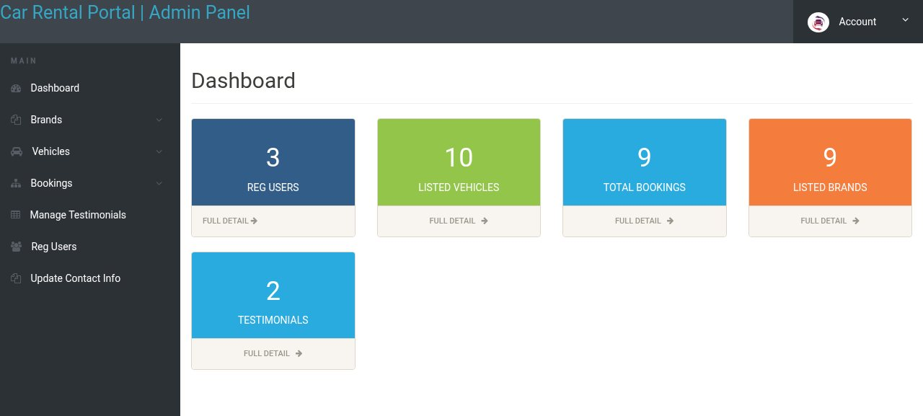
Figure 3. 1: Admin Dashboard
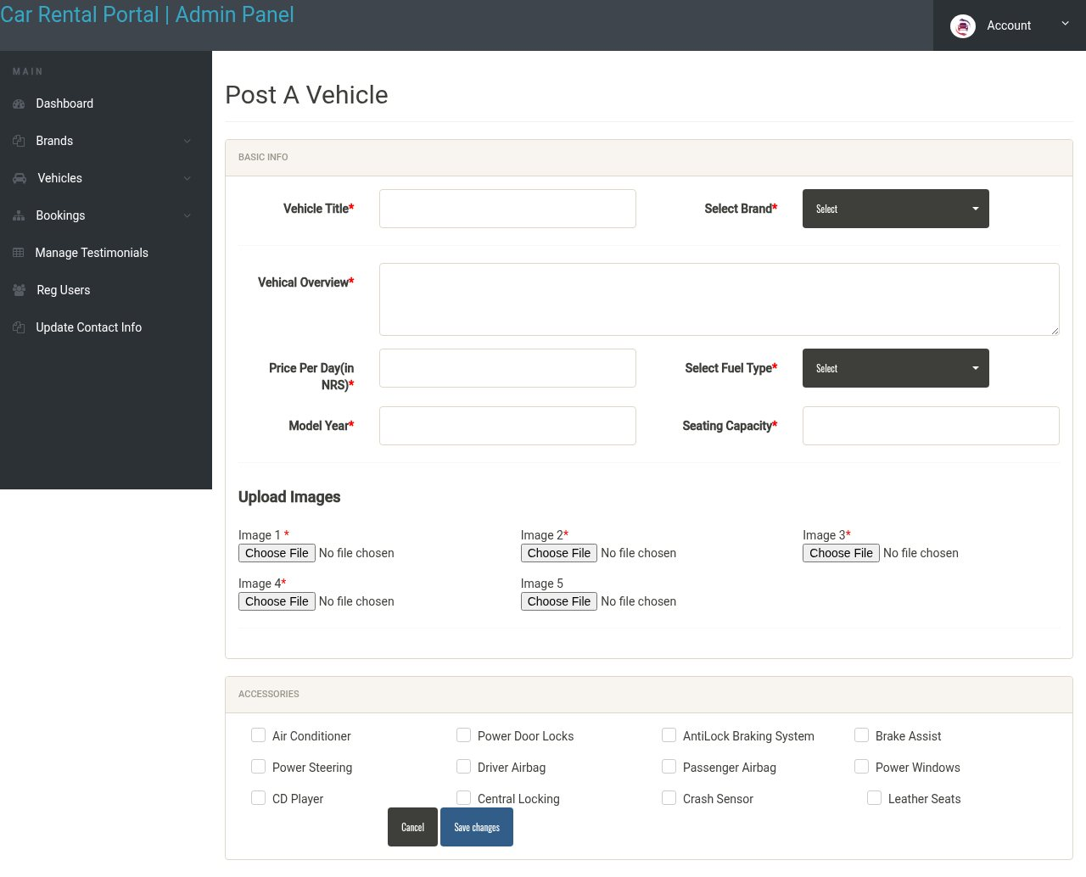
Figure 3. 1: Admin: Add Vehicle
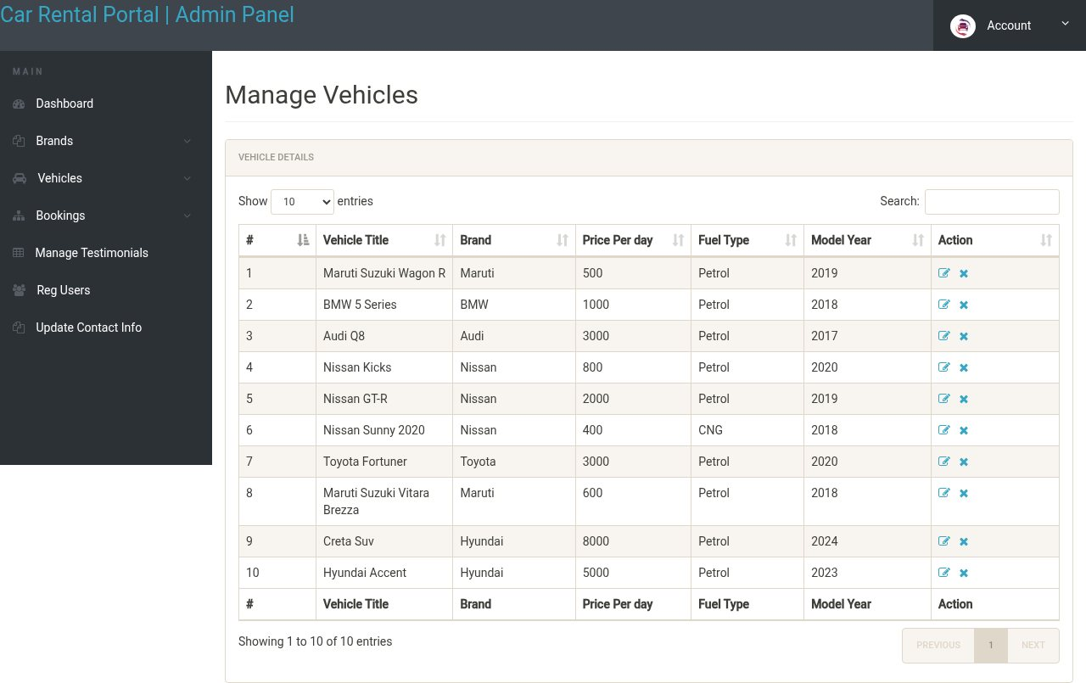
Figure 3. 1: Admin: Manage Vehicles
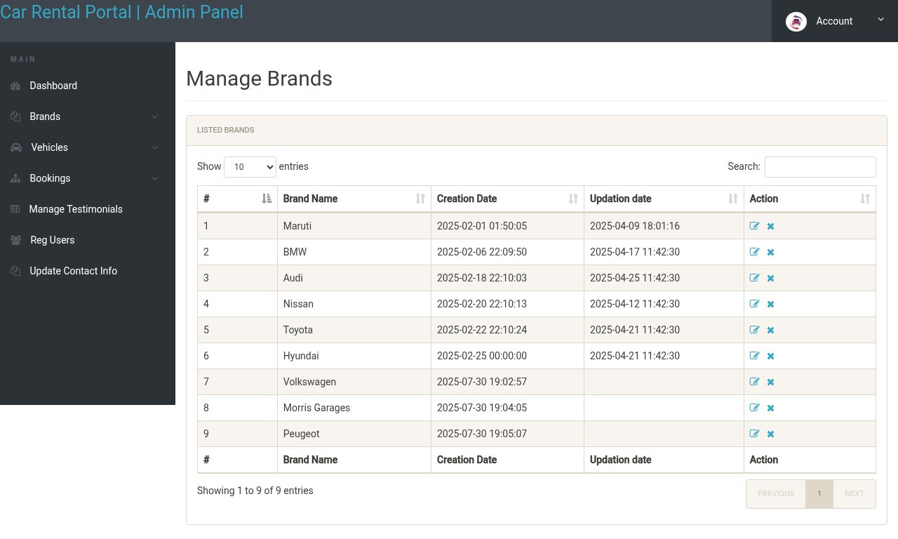
Figure 3. 1: Admin: Manage Brands
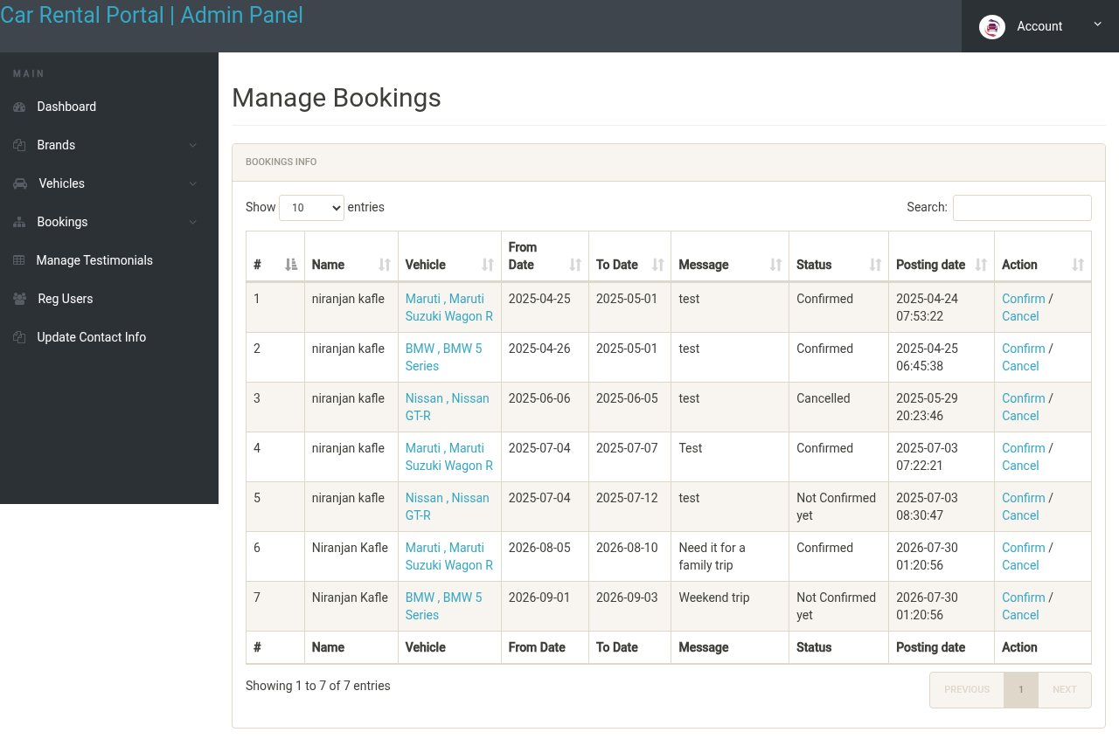
Figure 3. 1: Admin: Manage Bookings
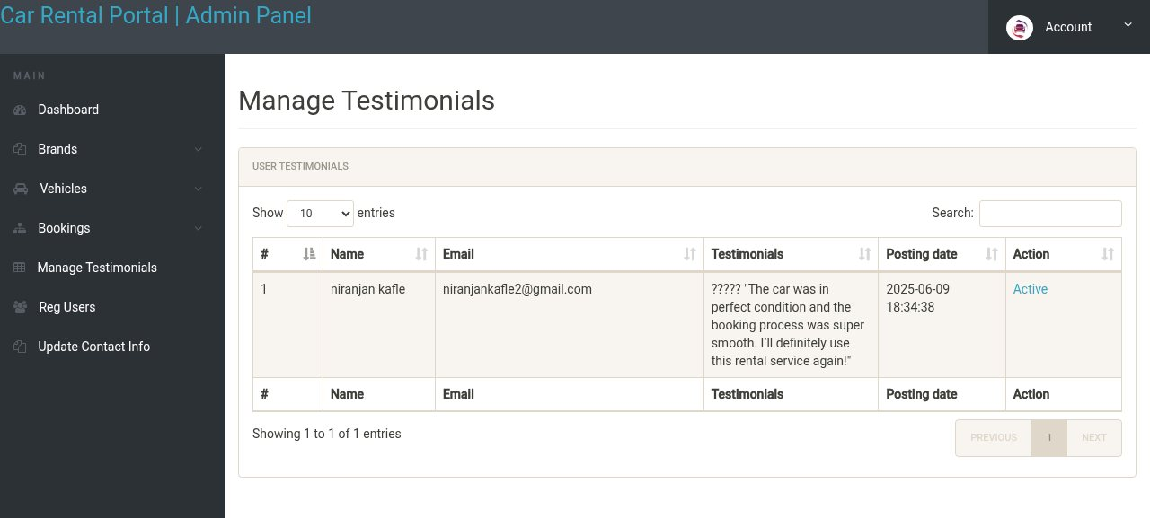
Figure 3. 1: Admin: Manage Testimonials
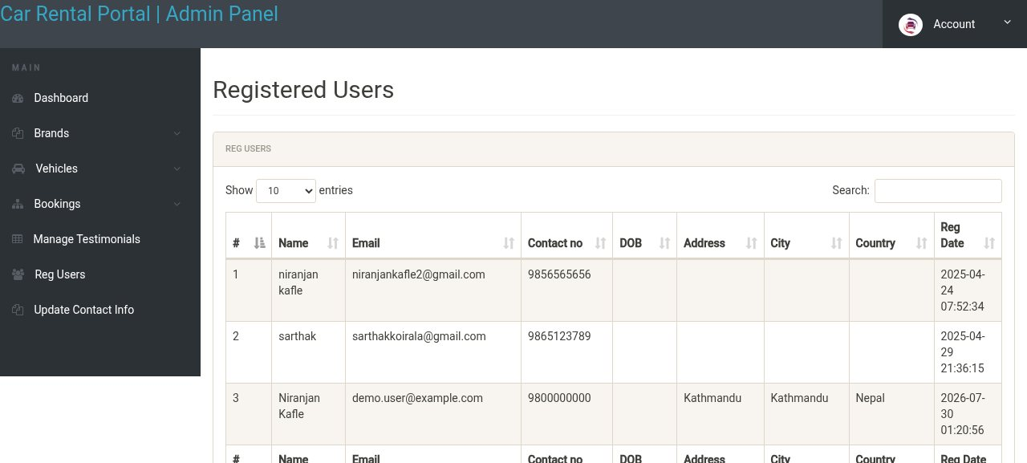
Figure 3. 1: Admin: Registered Users

3.2.4 Algorithm

Greedy Vehicle Recommendation Algorithm
The smart finder ranks the fleet with a weighted greedy scoring function. For a given search, the system first filters out every vehicle already booked for an overlapping date range, then scores each remaining vehicle independently against the customer's stated preferences, and finally makes the greedy choice of always returning the highest-scoring vehicles first — rather than searching for a globally optimal combination, which would be unnecessary for a single-vehicle booking.
function findOptimalCars(criteria, fromDate, toDate):
available = getAvailableCars(fromDate, toDate) // excludes overlapping bookings
for each car in available:
score = 0
score += vehicleTypeWeight(car.type) // SUV/Sedan/Luxury/... weight
score += fuelPreferenceScore(car.fuelType, criteria)
score += brandPreferenceScore(car.brand, criteria)
score += budgetFitScore(car.pricePerDay, criteria.budget)
score += seatingMatchScore(car.seats, criteria.seats)
car.total_score = score
sort available by total_score descending // greedy: best-first
return top 10 of available

How it works:
- Availability is checked first with a date-overlap query against tblbooking, so an already-booked vehicle is never recommended.
- Each remaining vehicle accumulates a score from independent weighted factors — vehicle-type weight, a fuel-type preference multiplier, a brand preference multiplier, and how closely the price and seating match the customer's stated budget and party size.
- The greedy step is the sort-and-take-the-best: the algorithm never backtracks or reconsiders a lower-scoring vehicle once a higher-scoring one is available, which keeps the recommendation pass O(n log n) over the available fleet and fast enough to run on every request.
Example: for a customer requesting an SUV, Petrol fuel and a budget around NRS 8,000/day, a Hyundai Creta (SUV, Petrol, NRS 8,000/day) scores higher than a Maruti Suzuki Wagon R (Hatchback, Petrol, NRS 500/day) even though the Wagon R is cheaper, because the vehicle-type and budget-fit terms dominate the score for this query.

Chatbot Support Algorithm
The AI chatbot is implemented as a tool-calling conversation loop against an OpenRouter-hosted large language model. The model is not given direct database access; instead it is offered a fixed set of callable tools — check_login_status, search_cars, get_car_details and create_booking among others — and the PHP backend executes the tool the model asks for, enforcing the visitor's actual session state itself rather than trusting anything the model claims about who is logged in.
loop:
response = OpenRouter.chat(history, systemPrompt, tools=chatbotToolDefinitions())
if response.requests_tool_call:
for each tool_call in response.tool_calls:
result = executeTool(tool_call.name, tool_call.arguments) // server enforces auth here
history.append(tool_call, result)
continue // let the model see the tool result and respond again
else:
return response.message // final natural-language reply to the visitor

It works by:
- Maintaining the running conversation in the PHP session (chatbot_history) so the model has context across turns.
- Calling check_login_status before any booking-related tool, and refusing create_booking server-side if the session is not actually authenticated — the model's own belief about login state is never trusted for access control.
- Exposing search_cars and get_car_details as read-only tools so the assistant can answer fleet questions directly from the live database instead of guessing.
Example: a visitor asks "do you have any electric cars under 6000 a day?" — the model calls search_cars with the keyword "electric", receives the matching rows including price, and replies with the matches actually in the database rather than a hallucinated answer.

Search, Filtering, and Pagination
The vehicle catalogue supports free-text keyword search plus brand and fuel-type filters, all translated into a single parameterised SQL query with WHERE/LIKE and equality clauses, combined with LIMIT/OFFSET for pagination so that only one page of results is fetched per request.
It works by:
- Building the WHERE clause incrementally from whichever filters the customer actually supplied, so an empty filter is simply omitted rather than matched against a wildcard.
- Joining tblvehicles against tblbrands so brand name, rather than the internal brand id, is shown and searched.
- Applying LIMIT/OFFSET last, after filtering, so pagination always operates over the already-narrowed result set.
Example: searching "Hyundai" with fuel type "Petrol" produces a WHERE clause matching the brand name and fuel type together, returning only Hyundai petrol vehicles, ten per page.

CHAPTER 4: IMPLEMENTATION AND TESTING

4.1 Implementation

4.1.1 CASE Tools
- Visual Studio Code — primary code editor for PHP, JavaScript, HTML and CSS.
- XAMPP (Apache + MySQL + PHP) — local development and hosting environment.
- phpMyAdmin — database administration and inspection of the carrental schema.
- Git and GitHub — version control and source management.
- Postman — manual endpoint testing for the JSON APIs (chatbot-api.php, greedy-api.php).
- Google Chrome DevTools — front-end debugging and responsive/mobile-layout testing.

4.1.2 Programming Language

PHP
PHP is used for all server-side logic: routing, authentication, session management, the booking workflow, the greedy recommendation engine, the chatbot's tool-calling loop, and all database access through the PDO extension with parameterised queries.

HTML, CSS, Bootstrap and JavaScript
The presentation layer uses server-rendered HTML templated by PHP, styled with CSS and the Bootstrap framework for a responsive, mobile-friendly grid, and progressively enhanced with JavaScript for client-side interactivity such as the date-range picker, the chatbot widget and AJAX form submissions (e.g. live email-availability checking on registration).

SQL
SQL (via MySQL) defines and queries the ten-table relational schema described in Section 3.2.2, including the availability-overlap query that underpins both booking and the greedy recommendation engine.

4.1.3 Database Platform
MySQL is used as the relational database engine, accessed exclusively through PHP's PDO layer. PDO's prepared statements bind every user-supplied value as a parameter rather than concatenating it into the SQL string, which is the project's primary defence against SQL injection.

4.1.4 Implementation Details of Modules

Authentication Module
Handles registration, login, logout and password updates for both customers (tblusers) and administrators (admin), with a live AJAX email-availability check (check_availability.php) during registration.

Vehicle Catalogue Module
Lists the fleet from tblvehicles joined with tblbrands, and implements keyword/brand/fuel-type search with pagination (search.php, search-carresult.php, car-listing.php).

Booking Module
Validates a requested date range against tblbooking to prevent double-booking, creates the booking record, and hands off to the payment module (reserve.php, my-booking.php).

Payment Module
Initiates and confirms a Khalti epayment transaction for a booking's total amount (initiate_payment.php, return_url.php, message.php).

Smart Finder / Recommendation Module
Implements the weighted greedy scoring algorithm described in Section 3.2.4 to rank the available fleet against customer-submitted preferences (greedy-form.php, greedy-api.php, greedy_algorithm.php).

Chatbot Module
Runs the tool-calling conversation loop against the OpenRouter API, exposing guarded tools for searching cars, fetching car details, checking login state and creating a booking (chatbot-api.php, includes/chatbot_tools.php, includes/chatbot_config.php).

Testimonial Module
Lets a logged-in customer submit a testimonial for admin approval before public display (post-testimonial.php, my-testimonials.php).

Contact / Enquiry Module
Stores public contact-form submissions for admin follow-up (contact-us.php).

Admin Module
A role-gated back office (admin/) for managing vehicles, brands, bookings, offers, testimonials, contact enquiries and registered users.

4.2 Testing
Each module was tested manually against a documented set of test cases before being integrated with the rest of the system. Every table below records the input payload used, the expected result, the actual observed result, a pass/fail verdict, and a pointer to the corresponding screenshot evidence in the Appendix.
Table 4. 1: Login Test Cases
S.N. | Payload | Expected Result | Actual Result | Result | Appendix
1 | Email: (blank), Password: (blank) | Please fill out this field. | Please fill out this field. | Pass | Appendix 1
2 | Email: unregistered@test.com, Password: wrongpass | Invalid email or password. | Invalid email or password shown. | Pass | Appendix 2
3 | Email: registered user, Password: correct password | User is logged in and redirected to home. | User logged in and redirected to home page. | Pass | Appendix 3

Table 4. 1: Register Test Cases
S.N. | Payload | Expected Result | Actual Result | Result | Appendix
1 | Email already registered | Email already exists — Register button disabled. | "Email already exists" shown, submit disabled. | Pass | Appendix 4
2 | Valid new email, all fields completed | Account created and user redirected to login. | Account created successfully. | Pass | Appendix 5
3 | Password and Confirm Password mismatch | Passwords do not match. | Validation error shown, form not submitted. | Pass | Appendix 6

Table 4. 1: Vehicle Search and Booking Test Cases
S.N. | Payload | Expected Result | Actual Result | Result | Appendix
1 | Search keyword: "Hyundai", Fuel: Petrol | Only Hyundai petrol vehicles listed. | Only Hyundai petrol vehicles listed. | Pass | Appendix 7
2 | Book vehicle for dates overlapping an existing booking | Booking rejected — vehicle unavailable for the selected dates. | Booking rejected with an availability error. | Pass | Appendix 8
3 | Book vehicle for a free date range while logged in | Booking created and user proceeds to checkout/payment. | Booking created, redirected to payment. | Pass | Appendix 9

Table 4. 1: Smart Finder (Greedy Recommendation) Test Cases
S.N. | Payload | Expected Result | Actual Result | Result | Appendix
1 | Preferences: SUV, Petrol, budget ~NRS 8,000/day | Higher-scoring SUVs ranked above cheaper non-matching vehicle types. | SUV matches ranked first. | Pass | Appendix 10
2 | No vehicles available for the chosen dates | Empty recommendation list returned gracefully. | Empty list shown with a friendly message. | Pass | Appendix 11

Table 4. 1: My Bookings Test Cases
S.N. | Payload | Expected Result | Actual Result | Result | Appendix
1 | Logged-in user with existing bookings opens My Bookings | All of the user's bookings are listed with correct status and invoice totals. | Bookings listed correctly with invoice totals. | Pass | Appendix 12
2 | User with no bookings opens My Bookings | An empty state is shown instead of an error. | Empty state shown. | Pass | Appendix 13

Table 4. 1: Contact Us and Chatbot Test Cases
S.N. | Payload | Expected Result | Actual Result | Result | Appendix
1 | Contact form submitted with all required fields | Enquiry saved and visible to the admin. | Enquiry saved successfully. | Pass | Appendix 14
2 | Chatbot asked to book a car while not logged in | Chatbot asks the visitor to log in before booking; create_booking is not executed. | Chatbot correctly requested login before booking. | Pass | Appendix 15
3 | Chatbot asked "what electric cars do you have" | Chatbot calls search_cars and replies with actual matching vehicles from the database. | Correct matches returned from the live catalogue. | Pass | Appendix 16

Table 4. 1: Admin Vehicle and Brand Management Test Cases
S.N. | Payload | Expected Result | Actual Result | Result | Appendix
1 | Admin adds a new vehicle with all required fields | Vehicle saved and immediately visible in the public catalogue. | Vehicle added and visible in listing. | Pass | Appendix 17
2 | Admin edits an existing vehicle's price per day | Updated price reflected on the public vehicle details page. | Price updated correctly. | Pass | Appendix 18
3 | Admin adds a new brand | Brand appears in the brand filter/dropdown. | Brand appears in filter list. | Pass | Appendix 19

Table 4. 1: Admin Booking and Testimonial Management Test Cases
S.N. | Payload | Expected Result | Actual Result | Result | Appendix
1 | Admin opens Manage Bookings | New, confirmed and cancelled bookings are listed with correct status. | Bookings listed with correct status. | Pass | Appendix 20
2 | Admin approves a pending testimonial | Testimonial becomes visible on the public site. | Testimonial shown publicly after approval. | Pass | Appendix 21
3 | Admin rejects a pending testimonial | Testimonial is not shown on the public site. | Testimonial hidden from public view. | Pass | Appendix 22

CHAPTER 5: CONCLUSION AND FUTURE RECOMMENDATIONS

5.1 Critical Analysis
The finished system meets the objectives set out in Chapter 1: it replaces a manual, phone-driven booking process with a self-service portal, prevents double-booking through a date-overlap check enforced at the database layer, integrates real online payment through Khalti, and adds two pieces of applied intelligence — the greedy recommendation engine and the tool-calling chatbot — that go beyond a plain CRUD booking system. Keeping access control (login checks) enforced server-side rather than delegated to the chatbot's own judgement proved to be an important design decision, since it means the AI-facing surface of the system cannot be tricked into bypassing authentication.
At the same time, the greedy scoring weights (vehicle type, fuel, brand, budget) are currently fixed constants rather than values learned from real booking outcomes, so the quality of a recommendation depends on how well those hand-chosen weights actually reflect customer behaviour — a limitation acknowledged below rather than something the current system measures.

5.2 Conclusion
Car Rental System demonstrates that a small, well-scoped web application built on a conventional PHP/MySQL stack can meaningfully reduce the manual overhead of running a car rental business, while a lightweight greedy recommendation algorithm and a guarded, tool-calling AI chatbot can add real value on top of a standard booking workflow without requiring a large machine-learning infrastructure. The project reinforced practical skills in requirement analysis, relational database design, secure server-side development, and integrating third-party APIs (Khalti and OpenRouter) into a production-style workflow.

5.3 Limitations
- Single rental branch and single payment gateway, as scoped in Section 1.4.
- The recommendation algorithm uses fixed, hand-tuned weights rather than weights learned from historical booking data.
- No automated test suite; testing in Chapter 4 was performed manually against documented test cases.
- The chatbot's knowledge is limited to what its tool definitions expose and does not cover queries outside the platform's own data.

5.4 Future Enhancements
- Support multiple rental branches and inter-branch vehicle transfers.
- Add further payment gateways (e.g. eSewa, card payments) alongside Khalti.
- Replace the fixed greedy weights with a model trained on historical booking and rating data.
- Add automated unit and integration tests around the booking-overlap and greedy-scoring logic.
- Extend the chatbot with tools for booking modification/cancellation and richer multi-turn itinerary planning.

REFERENCES
- Sommerville, I. (2011). Software Engineering (9th ed.). Pearson Education.
- Pressman, R. S., & Maxim, B. R. (2014). Software Engineering: A Practitioner's Approach (8th ed.). McGraw-Hill Education.
- Elmasri, R., & Navathe, S. B. (2015). Fundamentals of Database Systems (7th ed.). Pearson.
- PHP Documentation Group. PHP Manual. Retrieved from https://www.php.net/manual/en/
- Oracle Corporation. MySQL 8.0 Reference Manual. Retrieved from https://dev.mysql.com/doc/
- Khalti Digital Wallet. Khalti ePayment API Documentation. Retrieved from https://docs.khalti.com/
- OpenRouter. OpenRouter API Documentation — Chat Completions and Tool Calling. Retrieved from https://openrouter.ai/docs
- Bootstrap Team. Bootstrap 5 Documentation. Retrieved from https://getbootstrap.com/docs/
- Cormen, T. H., Leiserson, C. E., Rivest, R. L., & Stein, C. (2009). Introduction to Algorithms (3rd ed.). MIT Press. (Greedy algorithms, Chapter 16.)

APPENDIX
This appendix collects screenshot evidence for the test cases documented in Section 4.2, numbered to match the "Appendix" column of each test-case table.

Appendix 1: Login — validation on empty fields


Appendix 2: Login — invalid credentials


Appendix 3: Login — successful login (account session)


Appendix 4: Register — email already exists


Appendix 5: Register — successful registration


Appendix 6: Register — password mismatch validation


Appendix 7: Vehicle search — brand/fuel-type filter results


Appendix 8: Booking — rejected for an overlapping date range


Appendix 9: Booking — created successfully


Appendix 10: Smart Finder — ranked recommendation results


Appendix 11: Smart Finder — no vehicles available


Appendix 12: My Bookings — booking history with invoice totals


Appendix 13: My Bookings — empty state


Appendix 14: Contact Us — enquiry submitted


Appendix 15: Chatbot — login required before booking


Appendix 16: Chatbot — vehicle search reply


Appendix 17: Admin — vehicle added


Appendix 18: Admin — vehicle price updated


Appendix 19: Admin — brand added


Appendix 20: Admin — bookings managed


Appendix 21: Admin — testimonial approved


Appendix 22: Admin — testimonial rejected


