

Tribhuvan University
Faculty of Humanities and Social Sciences

“BYTESTAY”

A PROJECT REPORT
Submitted to

Department of Computer Application Reliance College

In partial fulfillment of the requirements for the Bachelor in Computer Application

Submitted by:
Nishant Bikram Diyali
(Registration Number: 6-2-522-96-2021)

Under the Supervision of
Riwaj Bhurtal

April, 2026



Tribhuvan University
Faculty of Humanities and Social Sciences Reliance college

SUPERVISOR’S RECOMMENDATION
I hereby recommend that this project prepared under my supervision by Nishant Bikam Diyali (T.U Exam Roll No.: Registration Number: 6-2-522-96-2021) entitled “Bytestay” in partial fulfillment of the requirements for the degree of Bachelor of Computer Application is recommended for the final evaluation.

SIGNATURE

Riwaj Bhurtel

SUPERVISOR

Reliance College


Tribhuvan University
Faculty of Humanities and Social Sciences Reliance college

LETTER OF APPROVAL
This is to certify that this project prepared by Nishant Bikram Diyali (T.U Registration Number:6-2-522-96-2021) entitled “Bytestay” in partial fulfillment of the requirements for the degree of Bachelor in Computer Application has been evaluated. In our opinion, it is satisfactory in the scope and quality of a project for the required degree.
Riwaj Bhurtel  Supervisor  Reliance College, Kathmandu | Buddhi Nath Kapali  Lecturer/Program Coordinator-BCA Reliance College, Kathmandu
Internal Examiner | External Examiner

ABSTRACT

Bytestay is a modern, web-based hotel management and room booking system designed to streamline hotel operations while providing customers with a seamless, self-service booking experience. Traditional hotel management often relies on disparate tools for reservations, inventory tracking, customer relationship management, and reporting, leading to inefficiencies, data inconsistencies, and poor coordination between staff and guests. Bytestay addresses these challenges by integrating all essential hospitality management functions into a single, unified platform built around role-based access control, ensuring that customers, staff, and administrators each interact with the system through interfaces tailored to their specific needs and permissions.
The system enables customers to search for available rooms, view ongoing offers and promotions, book accommodations in real time, and track and manage their bookings and profiles with ease. For hotel administrators, Bytestay provides comprehensive control over room inventory, booking management, customer records, promotional offers, and staff/user administration, along with a dashboard analytics module that delivers actionable insights into occupancy rates, booking trends, and revenue performance. Automated email notifications keep customers informed at key stages of their booking journey, while an integrated AI-powered chatbot enhances customer support by delivering instant assistance for common queries and booking-related concerns.
By combining real-time inventory control, robust administrative tools, and intelligent automation within a single cohesive system, Bytestay improves operational efficiency, reduces manual overhead, minimizes booking errors, and enhances the overall guest experience. The proposed system demonstrates how modern web technologies can be leveraged to modernize hotel management workflows and meet the evolving expectations of the hospitality industry.
Keywords: Hotel Management System, Room Booking, Role-Based Access Control, Real-Time Booking, Room Inventory Management, Customer Relationship Management, Dashboard Analytics, Email Notification System, AI Chatbot, Web-Based Application.

ACKNOWLEDGEMENT
In this accomplishment, we would like to express our special gratitude to all our teachers and most importantly our supervisor Mr. Riwaj Bhurtel, without his guidance and feedback it wouldn’t have been possible to work on this project.

In addition, we extend our sincere thanks to our friends, and senior guardians for their direct/indirect contribution to this project and for helping us to bring this project into existence. We will be always looking forward to hearing the comments. Suggestions for further improvement will be highly solicited.

Your Obediently

Nishant Bikram Diyali

TABLE OF CONTENT

SUPERVISOR’S RECOMMENDATION ii
LETTER OF APPROVAL iii
ABSTRACT iv
ACKNOWLEDGEMENT v
TABLE OF CONTENT vi
LIST OF FIGURES viii
LIST OF TABLES ix
ABBREVIATIONS x
CHAPTER1: INTRODUCTION 1
  - Introduction 1
  - Problem Statement 1
  - Objective 2
  - Scope and Limitation 2
  - Development Methodology 3
  - Report Organization 3
CHAPATER 2: BACKGROUND STUDY AND LITERATURE REVIEW 5
  - Background Study 5
  - Literature Review 5
CHAPTER 3: SYSTEM ANALYSIS AND DESIGN 7
  - System Analysis 7
    - Requirement Analysis 7
    - Feasibility Analysis 10
    - Data modeling 12
    - Process Modeling 15
  - System Design 17
    - Architecture Design 17
    - Database Schema Design 18
    - Interface design (UI/UX) 19
    - Physical-DFD 35
  - Algorithm 36
CHAPTER 4: IMPLEMENTATION AND TESTING 38
  - Implementation 38
    - CASE Tools 38
    - Implementation Details of Modules 39
  - Testing 40
    - Test Cases for Unit Testing 40
CHAPTER 5: CONCLUSION AND FUTURE RECOMMENDATIONS 46
  - Critical Analysis 46
  - Conclusion 47
  - Limitations 48
  - Future Enhancements 48
REFERENCES 50

Appendixes

LIST OF FIGURES
Figure 1.1 Agile Methodology 3
Figure 3.1 Use Case Diagram 9
Figure 3.2 Gantt Chart 11
Figure 3.3 Gantt Chart 11
Figure 3.4 Level-0 Diagram 15
Figure 3.5 Level-1 DFD Diagram 16
Figure 3.6 Architecture Design 17
Figure 3.7 Database Schema Design 18
Figure 3.8 Login Page 19
Figure 3.9 Register Page 20
Figure 3.10 Home Page 21
Figure 3.11 About Us 22
Figure 3.12 Room Listing Page 23
Figure 3.13 Booking Page 24
Figure 3.14 Check Out 25
Figure 3.15 Confirmation page 26
Figure 3.16 My Bookings Page 27
Figure 3.17 Account details page 28
Figure 3.18 Admin Dashboard 29
Figure 3.19 Room Add Page 30
Figure 3.20 Room Manage Page 31
Figure 3.21 Add Offer Page 32
Figure 3.22 Manage Offer Page 33
Figure 3.23 Booking Management Page 34
Figure 3.24 Physical DFD 35

LIST OF TABLES
Table 4.1: Login Test Cases 40
Table 4.2: Register Test Cases 40
Table 4.3: Room Booking Cases 41
Table 4.4: User Contact Cases 41
Table 4.5: My Bookings Cases 42
Table 4.6: Admin Offer Management Cases 43
Table 4.7: Admin Room Management Cases 44
Table 4.8: Admin Booking Management Cases 45

ABBREVIATIONS

API | Application Programming Interface
CI/CD | Continuous Integration / Continuous Deployment
JWT | JSON Web Token
ORM | Object-Relational Mapping.
REST | Representational State Transfer
SQL | Structured Query Language
UI | User Interface
UX | User Experience

CHAPTER1: INTRODUCTION

Introduction
In today's fast-evolving hospitality industry, travelers seek not only seamless booking experiences but also secure data handling and reliable accommodation options [1]. Bytestay stands out as a comprehensive hotel and booking management system focused exclusively on delivering exceptional guest experiences and efficient hotel operations. It offers a distinctive combination of specialized features, user-friendly design, and robust security measures [2].
At its core, Bytestay is designed for both hotel administrators and guests — a platform where guests are interested in detailed room specifications, pricing transparency, and real-time booking tracking [3]. The platform offers precise filtering options and a robust search mechanism, distinguishing it from generic booking platforms. Additionally, Bytestay is committed to data integrity, utilizing state-of-the-art encryption methods to protect user information. It employs modern web technologies, including C# and ASP.NET Core Web API for back-end development, along with Svelte 5, SvelteKit, and TypeScript for a dynamic front-end experience [2]. The system's approach to security is proactive as well: by integrating JWT-based authentication, Bytestay ensures that every transaction is safeguarded and user data remains confidential. This commitment to security is essential not only for compliance with global standards but also for building trust with customers, encouraging repeat engagement and fostering a loyal user base [1].
Bytestay is not merely a booking website — it is a specialized platform built around the intricacies of the hospitality market [2]. The system is thoughtfully designed to empower users with an intuitive navigation experience that makes exploring room offerings effortless. With real-time filtering options, travelers can easily refine their search to find precisely what they need. This seamless booking experience enhances convenience while bringing modern hospitality technology within easy reach, helping users stay ahead in a fast-paced digital world [3]. With a strong emphasis on customer satisfaction and operational excellence, Bytestay is set to transform how hotels manage their operations and how guests book their stays online [1].

Problem Statement
Many current hotel booking and management systems are too general and fail to meet the specific needs of both hotel operators and guests. Some of them are below:
Lack of detailed room information: Many current platforms offer only basic information about rooms, lacking detailed insights into room conditions, amenities, views, bed types, and specifications. This insufficiency makes it difficult for guests to evaluate the quality and suitability of accommodation.
a) Inefficient search and filtering capabilities: Basic search features are common, but they often lack advanced filtering options. This limitation compels users to manually sift through countless rooms to find the one that meets their specific criteria (e.g., price range, capacity, view type, amenities).
b) Lack of real-time booking status tracking: In many existing systems, guests and staff cannot easily track booking statuses in real-time. Without instant updates on booking confirmations, check-in/check-out times, and cancellations, both parties face uncertainty and potential double-bookings.
c) Limited role-based access control: Many hotel management systems often lack proper role-based access, leading to unauthorized data security risks, where staff may access administrative features beyond their responsibilities, and guests may view sensitive information.
d) Inadequate notification and personalized communication: In many existing systems, communication between hotels and guests is limited. Without automated status updates, personalized offers, and timely reminders are often missing, affecting the overall guest experience and hotel operational efficiency.).

Objective
The primary objectives of the Bytestay project are as follows:

- Implement Search and Filtering: Integrate comprehensive search and filtering functionalities to enable users to narrow down rooms based on multiple criteria (e.g., price range, capacity, view type, amenities, room name searching, pagination).
- Role-Based Access Control: Implement secure role-based access control (Admin, Staff, Customer) to ensure proper data security and restrict unauthorized access to sensitive features.
- Email Notifications: Develop automated email notification system for booking status updates, confirmation, check-in/check-out reminders, and cancellations, enhancing guest communication.
- Improve Navigation and User Experience: Design a user-friendly, intuitive interface to ensure seamless browsing, smooth booking process, and efficient hotel management experience.
- Dashboard Analytics: Implement comprehensive dashboard analytics for administrators to monitor bookings, occupancy rates, revenue, and other key performance indicators.

Scope and Limitation
As the demand for convenient and reliable hotel booking continues to rise, Bytestay provides a seamless online booking experience for guests seeking accommodation, while also offering efficient hotel management tools for administrators and staff. The platform features a clean, user-friendly interface that allows customers to easily browse, filter, and book rooms across various categories, with detailed room information, including specifications, amenities, and high-quality images, enabling guests to make informed booking decisions. Bytestay also implements a robust email notification system that sends personalized updates based on booking status changes, along with a comprehensive filtering system for available rooms and special offers. Additionally, the project includes an intuitive administrative dashboard, allowing hotel owners and staff to efficiently manage rooms, bookings, offers, users, gallery content, and customer inquiries. Ultimately, Bytestay aims to simplify the hotel booking and management experience while providing business owners with the tools they need to effectively manage their hotel operations.
However, the current implementation is subject to certain limitations. It does not include online payment processing integration, meaning bookings are confirmed without a built-in payment gateway. The AI chatbot, powered by Ollama, requires local deployment and may not be available in all environments. Furthermore, the system does not currently support multi-hotel chain management, as it is designed specifically for single-hotel operations, and real-time room availability is based solely on internal database records rather than integration with external hotel Property Management Systems (PMS).

Development Methodology
The Bytestay project follows an Agile methodology, using an iterative, sprint-based approach well-suited to web development projects that require continuous improvement. Development is broken into small, manageable sprints, allowing for faster releases and the ability to incorporate feedback from hotel staff and guests as requirements evolve.
This approach is particularly effective for a hotel management system, where core features like booking management, room inventory control, and email notifications benefit from early testing and validation. By delivering working software at the end of each sprint, Agile ensures Bytestay adapts to real-world needs while maintaining high standards of quality and reliability.
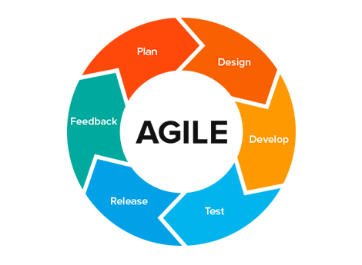

Figure 1.1 Agile Methodology

Report Organization
Chapter 1: The report starts with the introduction of Bytestay and its process, followed by problem statements in the current system with the objectives of this project. This chapter also includes the scopes and limitations of this project.
Chapter 2: This part of the report analyzes the existing system in brief.

Chapter 3: This chapter discusses system analysis and design along with its feasibility status. Data modeling and process modeling are explained in this chapter. The system design is discussed with the help of database schema design, process design, and user interface design.

Chapter 4: Chapter 4 explains the tools that are used on this project’s front end and back end. Along with it, all the CASE tools and modules of the project are explained here. Testing parts like unit testing and system testing are also explained within this chapter.
Chapter 5: This chapter of the report discusses the conclusion of how the project is continued, its findings, and many more. In the same chapter, the recommendations and future enhancements are also discussed.

CHAPATER 2: BACKGROUND STUDY AND LITERATURE REVIEW

Background Study
The rapid growth of travel and tourism technology has transformed how consumers book accommodations, particularly in the hospitality sector with advancements in technology and greater internet accessibility, online hotel booking has become increasingly popular and convenient. The demand for quality hotel stays, such as well-equipped rooms and unique experiences, has surged in recent years due to their essential role in both leisure and business travel [1].
Despite the substantial growth of [6], providing an optimal booking experience still presents several challenges. Many platforms struggle with limited room information, inefficient search and filtering systems, and poorly designed user interfaces. As the hospitality market becomes increasingly competitive, it is essential for hotel management platforms to deliver a seamless, secure, and personalized booking experience for customers [7].
This study focuses on the development of Bytestay, a hotel and booking management platform [6] designed to offer rooms, dining options, and unique experiences. The primary objective is to tackle the challenges faced by both customers and hotel staff in existing systems. Bytestay will incorporate features that enhance room discovery, and provide detailed room and experience information. By implementing advanced features such as offer management and a user-friendly interface, Bytestay aims to improve the overall booking experience [8] and simplify management processes for users.

Literature Review
The travel and hospitality technology landscape has seen exponential growth over the last decade, with platforms evolving to meet the demands of both travelers and accommodation providers. Today’s travelers expect a seamless, efficient, and personalized booking experience, particularly in the hospitality sector where room amenities, location, and reviews play a crucial role in booking decisions.
Booking.com – Booking.com [9] is a leading online travel agency that enables individuals and businesses to book accommodations, flights, and other travel services. Founded in 1996, Booking.com has rapidly become one of the most popular travel platforms worldwide. The company's business model is centered around providing a user-friendly platform for finding and booking accommodations. It offers a variety of tools and features, including customizable search filters, secure payment options, and real-time availability updates, to help users effectively plan their travels. Booking.com has also been at the forefront of technological innovation in the hospitality industry. It has introduced features such as mobile booking apps, personalized recommendations, and integrations with popular travel tools to enhance the booking experience for customers. The impact of Booking.com on the hospitality industry has been significant, empowering hotels of all sizes to reach a global audience. Its intuitive interface and robust features make it a popular choice for both travelers and accommodation providers.
Airbnb – Airbnb [10] is an online marketplace specializing in short-term rentals, vacation homes, and unique accommodations. Founded in 2008, Airbnb has grown to become one of the largest platforms for alternative accommodations in the world. Airbnb's business model revolves around offering a wide selection of unique stays at competitive prices to travelers seeking authentic experiences. The company focuses on providing a user-friendly booking experience, with features such as detailed property descriptions, customer reviews, and host profiles. Airbnb has embraced technological innovation to enhance the booking experience for its customers. The company has invested in features such as mobile check-in, personalized property recommendations, and a streamlined booking process. Airbnb has had a significant impact on the short-term rental and hospitality industries. The company's unique offerings and wide selection have made it a popular choice among travelers seeking authentic and flexible accommodations.

CHAPTER 3: SYSTEM ANALYSIS AND DESIGN

System Analysis
Bytestay is a web-based hotel and booking management platform designed to offer customers a seamless booking experience while optimizing property management for hotel staff and administrators. Built using ASP.NET Core Web API [11] and SvelteKit, Bytestay ensures modularity, scalability, and maintainability.
Customers benefit from a comprehensive room catalog with detailed descriptions, amenities, pricing, and high-quality images, all organized for easy navigation. Advanced search and filtering features help users quickly find their desired rooms, while special offers, packages, and a gallery showcasing the property's amenities further enhance the booking experience.
Hotel staff and administrators are supported by an intuitive dashboard for managing rooms, offers, bookings, and gallery items, with real-time booking tracking that allows administrators to monitor and update customer bookings as they happen. The platform is further enhanced by an AI-powered chatbot for customer support, automated email notifications for booking status updates, and inquiry management — all aimed at improving service quality and customer satisfaction.

Requirement Analysis
For the Bytestay hotel and booking management platform, it is essential to define both functional and non-functional requirements to ensure a smooth user experience. Functional requirements include features such as user registration, room search, booking tracking, and administrative management for rooms and bookings. Non-functional requirements focus on system performance, emphasizing aspects like fast load times, data privacy, and high availability. The platform should be mobile-friendly, reliable, and scalable to accommodate growing user demands while providing an efficient and seamless booking experience for all users.

Functional requirements:
        - User Registration & Authentication:
Users must be able to create an account, log in, and manage their profiles. The system supports three user roles: Admin, Staff, and Customer.

Room Catalog:
Display rooms with detailed descriptions, amenities, pricing, and high-quality images. Users should be able to filter rooms by price, availability, number of people, etc.

Booking Management:
Users can search for available rooms by check-in/check-out dates, make bookings, and view/manage their bookings. Users receive booking confirmations and status update emails. Admin/Staff should be able to manage booking statuses (Pending, Confirmed, Checked In, Checked Out, Cancelled).

Search & Filtering:
Users should be able to search for rooms by keywords or amenities. Use of advanced search filters (date range, price, number of guests) for better user experience.

Offer Management:
Admin/Staff can create and manage special offers that apply to specific rooms.

Gallery Management:
Admin/Staff can upload and manage gallery images showcasing the property’s amenities, rooms, and experiences.

Inquiry Management:
Users can submit inquiries through the contact form, and Admin/Staff can manage and respond to inquiries.

Chatbot Support:
Users can interact with an AI-powered chatbot for quick assistance.

Non-Functional Requirements:
        - Performance:
The website should load smoothly to ensure an optimal user experience.

Usability:
The website should be intuitive and user-friendly for visitors with various levels of online booking experience. Ensure that navigation is easy and the design is responsive for both mobile and desktop users.

Security:
Data encryption for customer information. Secure authentication protocols (JWT) to protect user accounts.

Compatibility:
The website should be compatible with major browsers like Chrome, Firefox, and Edge.

Use-Case Diagram
A use case diagram is a visual representation of how different users interact with a system to achieve specific tasks. It helps capture functional requirements and understand user-system interactions. This use case diagram represents a Bytestay system, where three types of users (Admin, Staff, and Customer) interact with various functionalities.

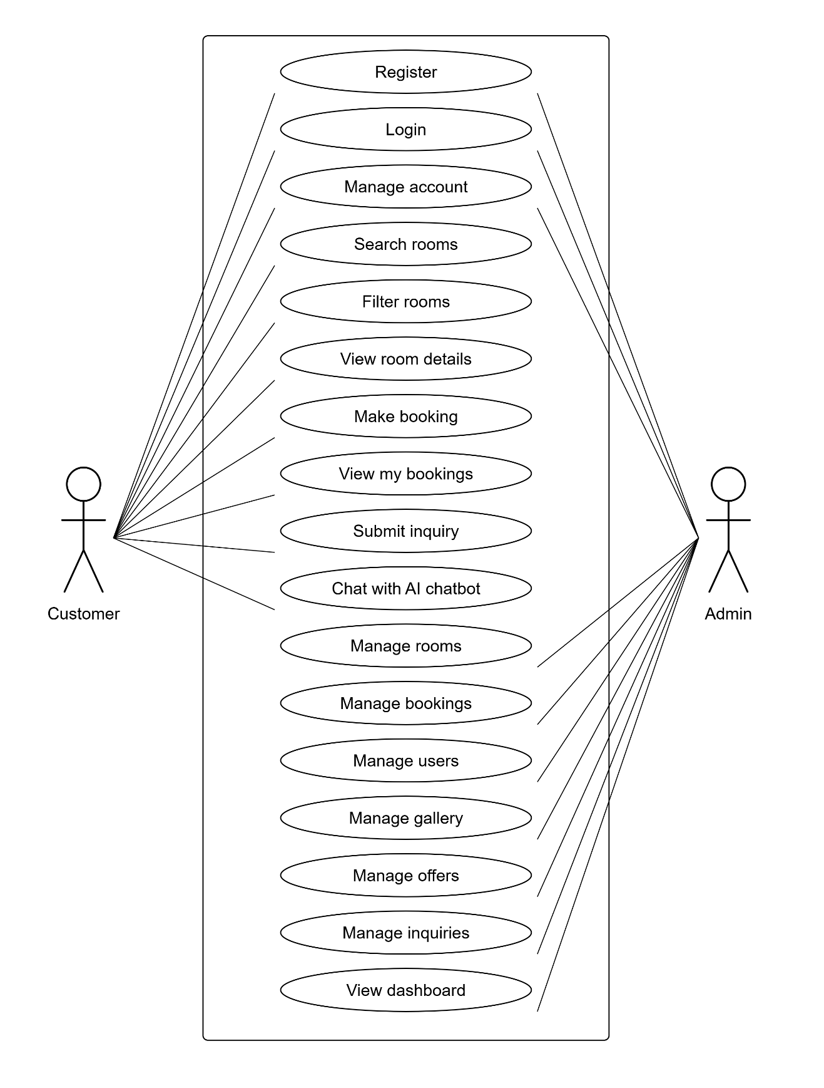

Figure 2.1 Use Case Diagram

Actors in the System:

- Admin: The administrator has full control over the system and can manage rooms, offers, users, bookings, gallery items, inquiries, and view the dashboard.
- Staff: Staff members can manage bookings (view, update status, delete), view the gallery, and assist with daily hotel operations.

Admin Functionalities:
The admin can perform the following tasks:
  - User Management: Register new staff members and view all system users.
  - Room Management: Create, update, delete, and view all rooms.
  - Offer Management: Create, update, delete, and view special offers (including which rooms they apply to).
  - Booking Management: View all bookings, update booking statuses, and delete bookings.
  - Gallery Management: Upload and delete gallery items (images of the hotel, rooms, amenities, etc.).
  - Inquiry Management: View, filter, update status, and delete customer inquiries.
  - Dashboard Access: View dashboard statistics (overview of bookings, revenue, occupancy, etc.).

Staff Functionalities:
The Staff can perform the following tasks:
- Booking Management: View all bookings, update booking statuses, and delete bookings.
- Gallery Management: View gallery items.

Customer Functionalities:
  - Room Browsing: View all available rooms and their details (amenities, price, capacity, etc.).
  - Booking: Make bookings as a guest or registered user.
  - View Bookings: View their own booking history.
  - Inquiry Submission: Submit inquiries via the contact form.
  - Chatbot Interaction : Chat with the AI-powered chatbot for assistance.

Feasibility Analysis
A feasibility study assesses all factors of a project, including legal, economic, technical, and scheduling considerations, to determine its viability.

Technical Feasibility
The technical feasibility of Bytestay is robust. The platform will utilize SvelteKit, Svelte, TypeScript, HTML, and CSS for a responsive, modern frontend, and ASP.NET Core Web API with C# (.NET 8) for a secure, scalable backend. Data will be managed using PostgreSQL with Dapper ORM for efficient database access, and email notifications will be handled via MailKit/MimeKit over SMTP. An AI-powered chatbot can optionally be integrated using Ollama. These technologies are all mature, well-documented, and widely adopted, ensuring a reliable and maintainable platform that provides users with a seamless booking experience.

Economic Feasibility
Bytestay is a hotel booking management system that is financially viable because it requires minimal hardware and infrastructure. The main necessities for development are a computer system and an internet connection, with standard tools like Visual Studio 2022 (Community Edition, free), VS Code, and Docker (all free and widely available). The platform can be hosted on affordable cloud providers (e.g., Azure, AWS, DigitalOcean) or on a dedicated server, offering flexibility in terms of cost and scalability. The use of open-source technologies (PostgreSQL, SvelteKit, Dapper) further reduces licensing costs.

Schedule Feasibility
The project timeline is achievable, as the integration of SvelteKit, TypeScript, C#, ASP.NET Core Web API, and PostgreSQL allows for efficient development and fast deployment. The separation of concerns (frontend/backend API/database) enables parallel development by different team members, and containerization with Docker Compose simplifies environment setup and deployment. This guarantees that the platform can be launched within a reasonable timeframe while upholding high-quality standards.

- Gantt Chart
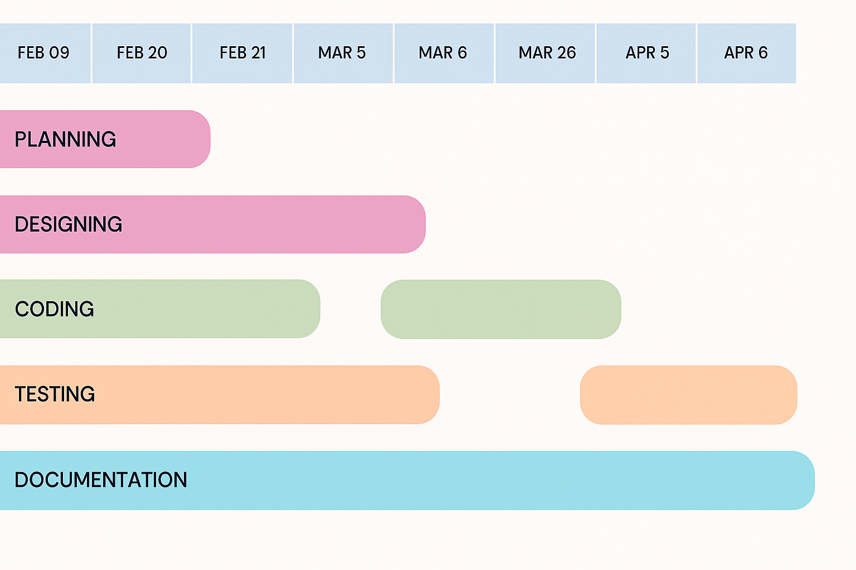

Figure 3.2 Gantt Chart

Data modeling
      - ER Diagram
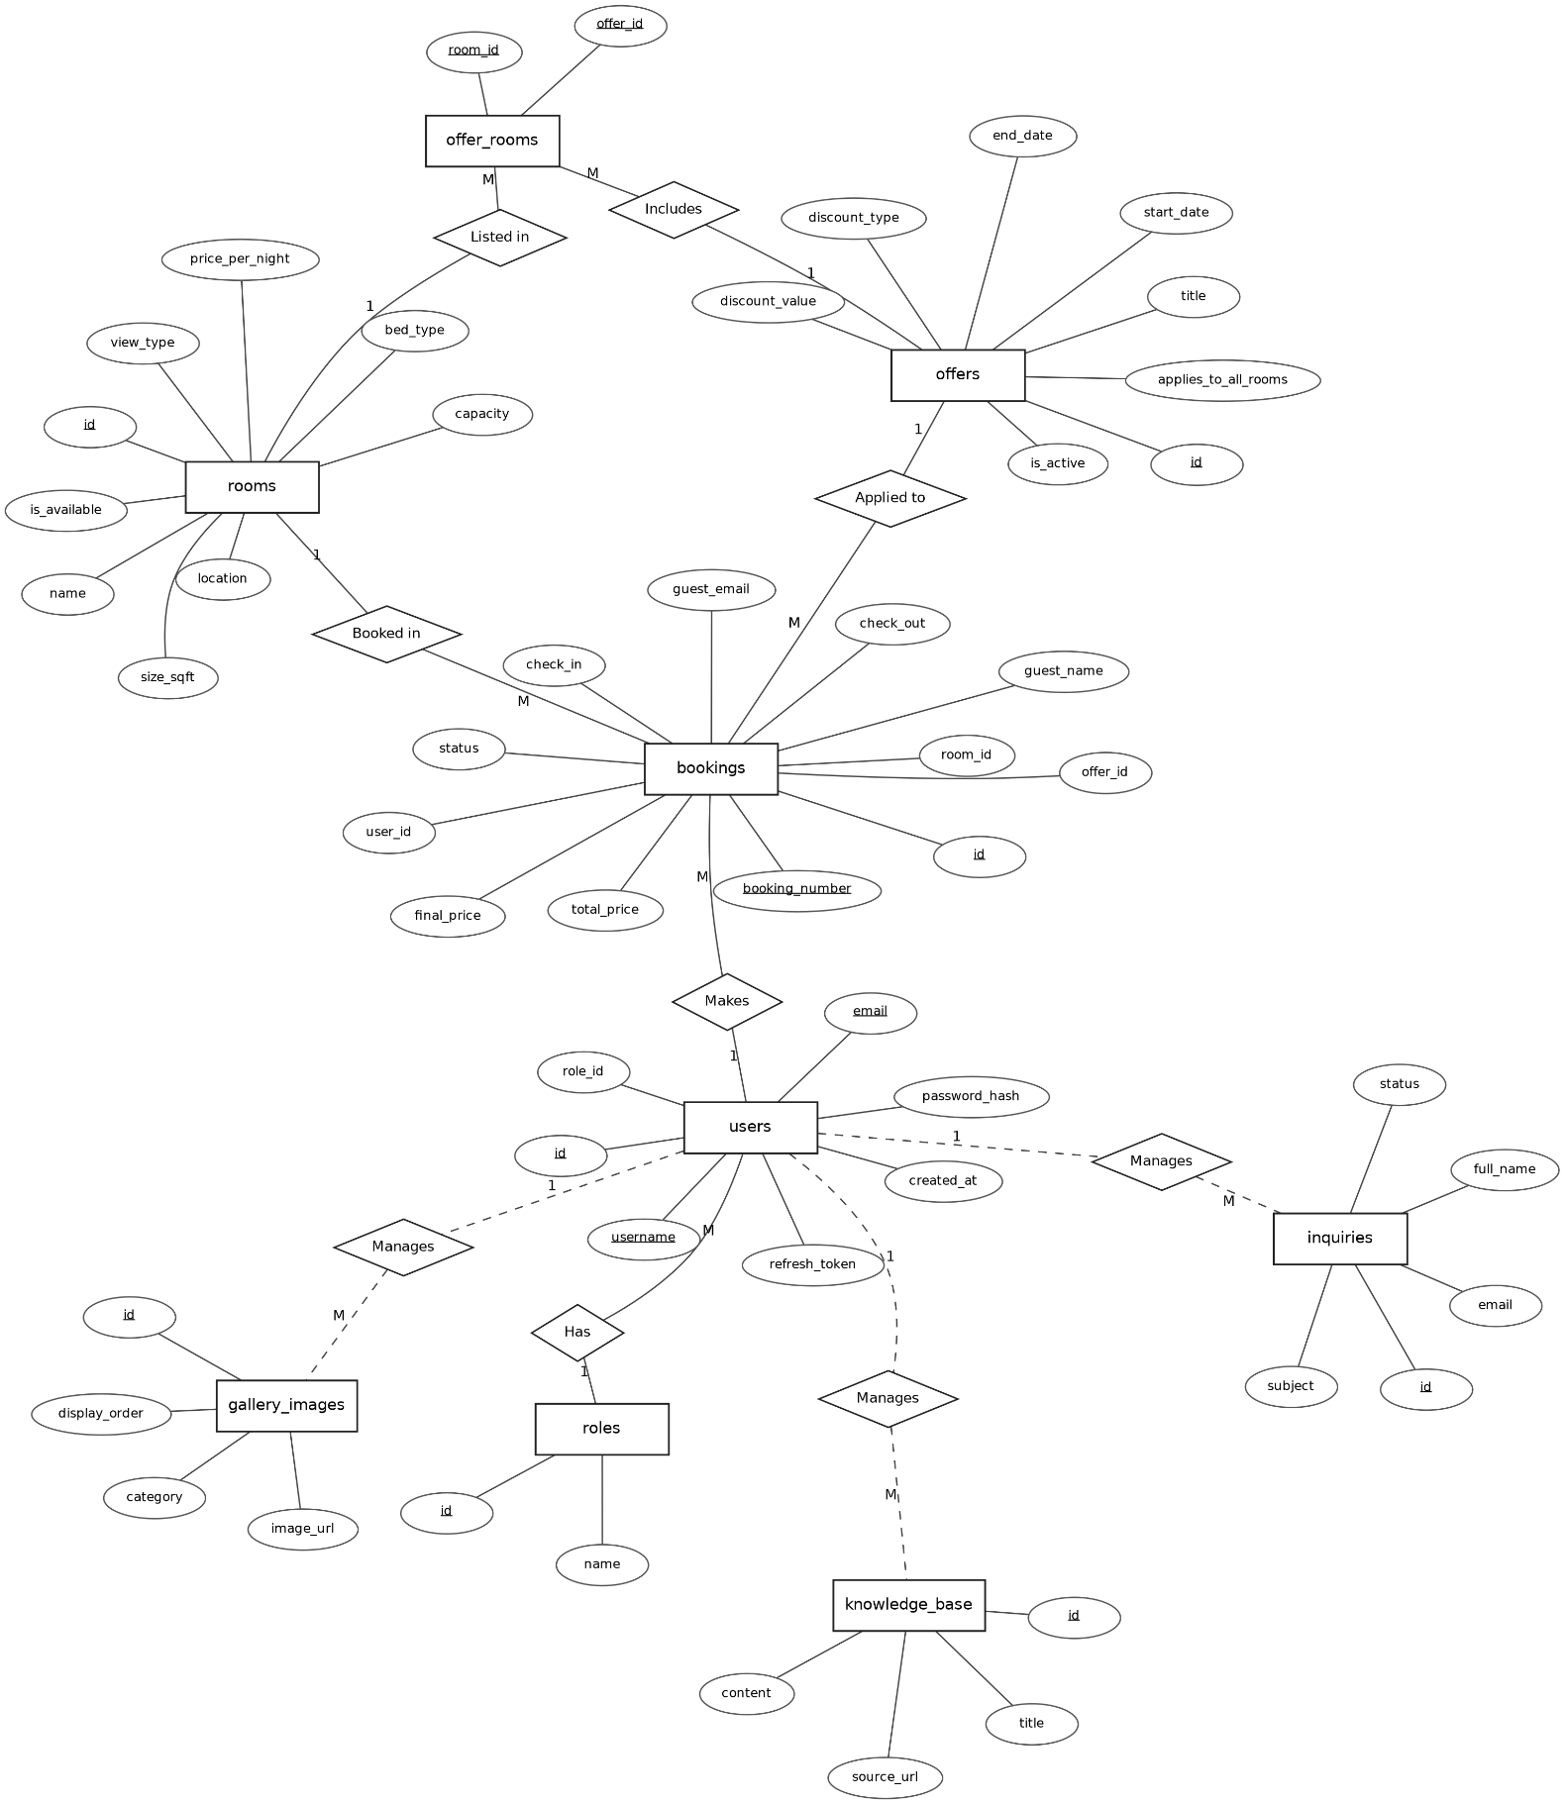

Figure 3.3 ER-Diagram

In the E-R Diagram (Entity-Relationship Diagram) for Bytestay, we can see 9 entities, each with their respective attributes and relationships. The ER diagram helps visualize the data within the hotel booking system. Below are the entities along with their cardinality in relation to other entities.
- Admin/Staff (Users with Role "Admin" or "Staff"): The admin and staff of the Bytestay hotel booking system are responsible for managing rooms, offers, bookings, gallery items, inquiries, and other staff members. Their tasks include adding, updating, and deleting rooms/offers, as well as viewing statistics on the dashboard. Additionally, they manage booking statuses (confirming, checking in/out, canceling) and responding to customer inquiries. They also have access to manage user accounts and gallery images.
- Customer (User with Role "Customer") or Guest: When a customer accesses the Bytestay website's main page, they see a list of available rooms, gallery images, and special offers. If the user is logged in, they can view their booking history and make bookings without re-entering their details. After browsing, the user can select a room, enter their stay dates, and complete a booking. During this phase, the system saves the booking information in the bookings table, including guest details, pricing, and status.
- Roles: The roles table stores a list of user roles, including "Admin", "Staff", and "Customer", identified by their ID and name. Each user is assigned exactly one role, which determines their access permissions to different parts of the system (e.g., only admins can manage other users).
- Rooms: The system consists of rooms that include a name, price per night, capacity, location, description, amenities, images, bed type, and size. Admin manages the list of rooms, ensuring proper maintenance (adding, updating, deleting, setting availability). Users can access room details to view prices, amenities, and images. Rooms are the core entity that bookings are tied to, with a one-to-many relationship with bookings.
- Offers: The offers table stores special promotions and discounts. Each offer has a title, description, discount type (percent or fixed), discount value, start/end dates, active status, and whether it applies to all rooms or specific ones. Offers are managed by admins and can be applied to bookings to reduce the final price.
- Offer Rooms: This junction table maintains a many-to-many relationship between offers and rooms for offers that don't apply to all rooms. It links an offer_id to a room_id, allowing admins to specify exactly which rooms an offer is valid for
- Bookings: The bookings table stores all booking information, including a unique booking number, room ID, guest details (name, email, phone, country), check-in/check-out dates, pricing (total, discount, final), number of people, and status (Pending, Confirmed, Checked In, Checked Out, Cancelled). Bookings can be made by registered users (linked via user_id) or guests (without a user_id). Admins and staff can update booking statuses, which triggers email notifications to guest.
- Gallery Images: The gallery_images table stores images of the hotel, rooms, dining, experiences, and other amenities. Each image has a URL, alt text, category, display order, and creation date. Admins can add/delete gallery images, and all users can view them on the website.
- Inquiries: In the inquiries table, when a user provides their full name, email, phone number, subject, and message, they send feedback or questions related to bookings, the hotel, or any issues. Admins can view this information in the admin dashboard, filter inquiries by status (New, Read, Replied, Closed), and update their statuses as they are addressed.
- Knowledge Base: The knowledge_base table stores articles and information that power the AI chatbot. Each entry has a title, content, source URL, source type, and creation/update dates. This helps the chatbot answer user questions about the hotel, bookings, amenities, etc.

Process Modeling
      - Level-0 Diagram
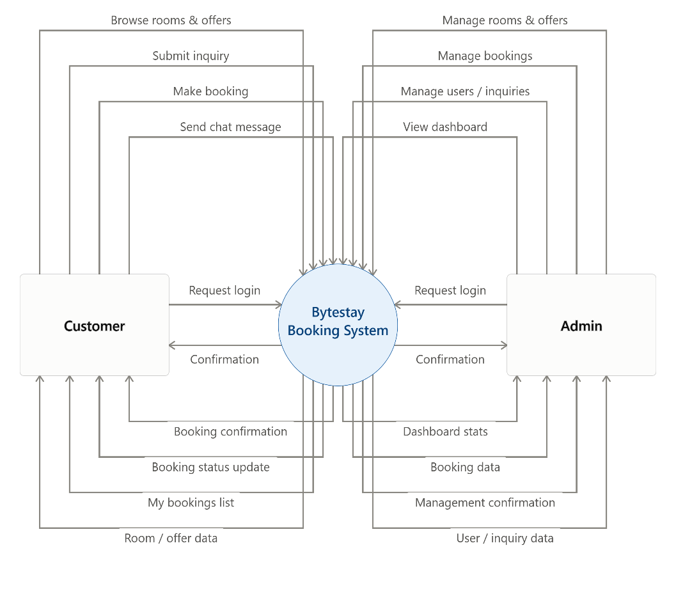

Figure 3.4 Level-0 Diagram
The Level-0 diagram for the Bytestay project identifies three main entities: Administration, Staff, and Customer.
The Administration entity is responsible for logging into the admin section of the website. In this section, it can manage, update, and delete rooms, offers, and gallery images. Additionally, the administration can manage users and staff, view and manage bookings, view inquiries submitted through the contact section, and monitor dashboard statistics for key system metrics. It also has access to the list of bookings and can manage their statuses, transitioning them from pending to confirmed to checked in to checked out, and can cancel bookings as needed.
Staff can view the list of bookings and update their statuses (e.g., check-in, check-out), and view gallery images. Customers can access lists of rooms, offers, and gallery images. They can make bookings for rooms, view and manage their own bookings, submit inquiries through the contact section, and chat with the AI chatbot which retrieves information from the knowledge base. Additionally, the system sends email notifications for booking confirmations and status updates

Level-1 Diagram
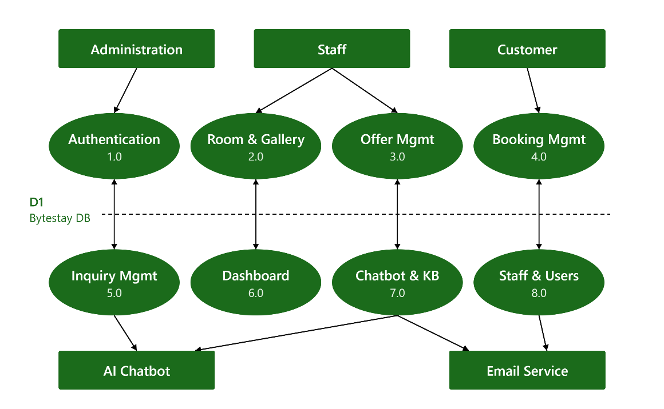

Figure 3.5 Level-1 DFD Diagram

The diagram illustrates a Level 1 Data Flow Diagram that showcases the relationships among various components of the Bytestay system. It clarifies how data flows between different entities and processes, as well as where data is stored and retrieved. The diagram features seven main processes:
- Room and Offer Management: This process is managed by the Administration, who is responsible for inserting, updating, and deleting rooms, offers, and gallery images. The rooms, offers, and gallery images added by the Administration will be visible to Customers on the main website.
- Booking Processing: From the Customer side, this process allows guests to make bookings for rooms. The Administration will update and manage the booking system as needed, and Staff can view and update booking statuses.
- My Bookings Module: In this module, Customers can view and manage their own bookings.

- Dashboard Analytics: This function provides the Administration with key statistics and analytics about the system.
- Account Management: process manages user accounts and their associated data, handling login and registration for Administration, Staff, and Customers.
- Chatbot & Knowledge Base: This module handles Customer interactions with the AI chatbot, retrieving information from the knowledge base.
- Inquiry Management: This process allows Customers to submit inquiries, and Administration to view them.

The three main entities involved in this system are Administration, Staff, and Customer.

System Design

Architecture Design
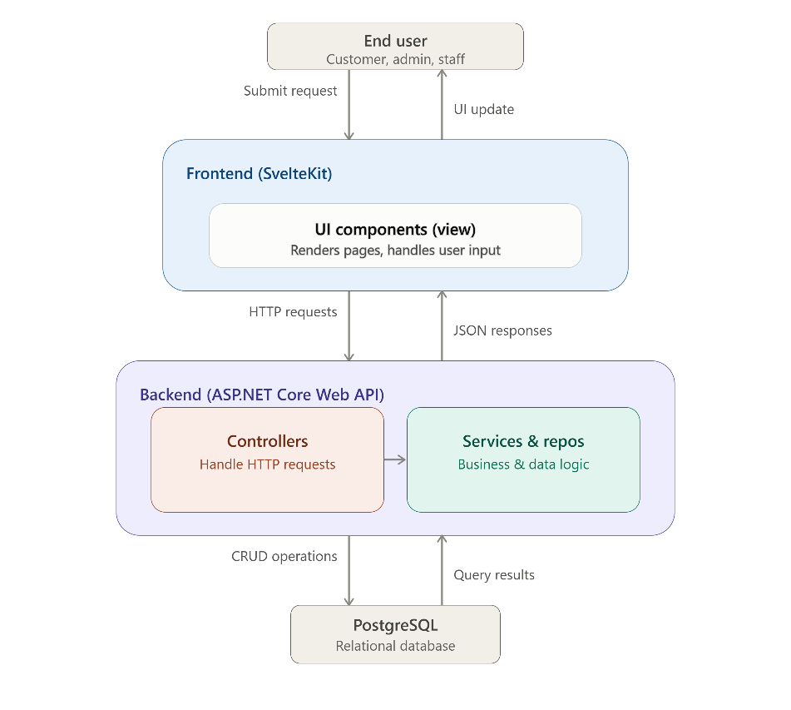

Figure 3.6 Architecture Design

The diagram illustrates the Model-View-Controller (MVC) architecture adapted for the Bytestay hotel booking system, a framework commonly used in web development that shows how different components work together to handle user interactions.
In this architecture, the Frontend (SvelteKit) UI Components (View) allow users (Customer, Admin, Staff) to submit requests. These requests are sent as HTTP requests to the Backend (ASP.NET Core Web API) Controllers, which are responsible for managing the flow of requests and determining the appropriate response. The Controllers interact with the Services & Repositories (Model), which oversee the application's data logic and communicate with the PostgreSQL Database to retrieve, update, or manipulatedata.
Once the Model processes the data, it sends the results back to the Controllers. The Controllers then pass this data as JSON responses to the View (SvelteKit UI Components), which is in charge of visually presenting the information to the user. Finally, the View generates the user-facing UI updates that are sent back to the End User. This architecture promotes a clear separation of responsibilities between data management, application logic, and presentation, resulting in an application that is more organized, maintainable, and scalable.

Database Schema Design
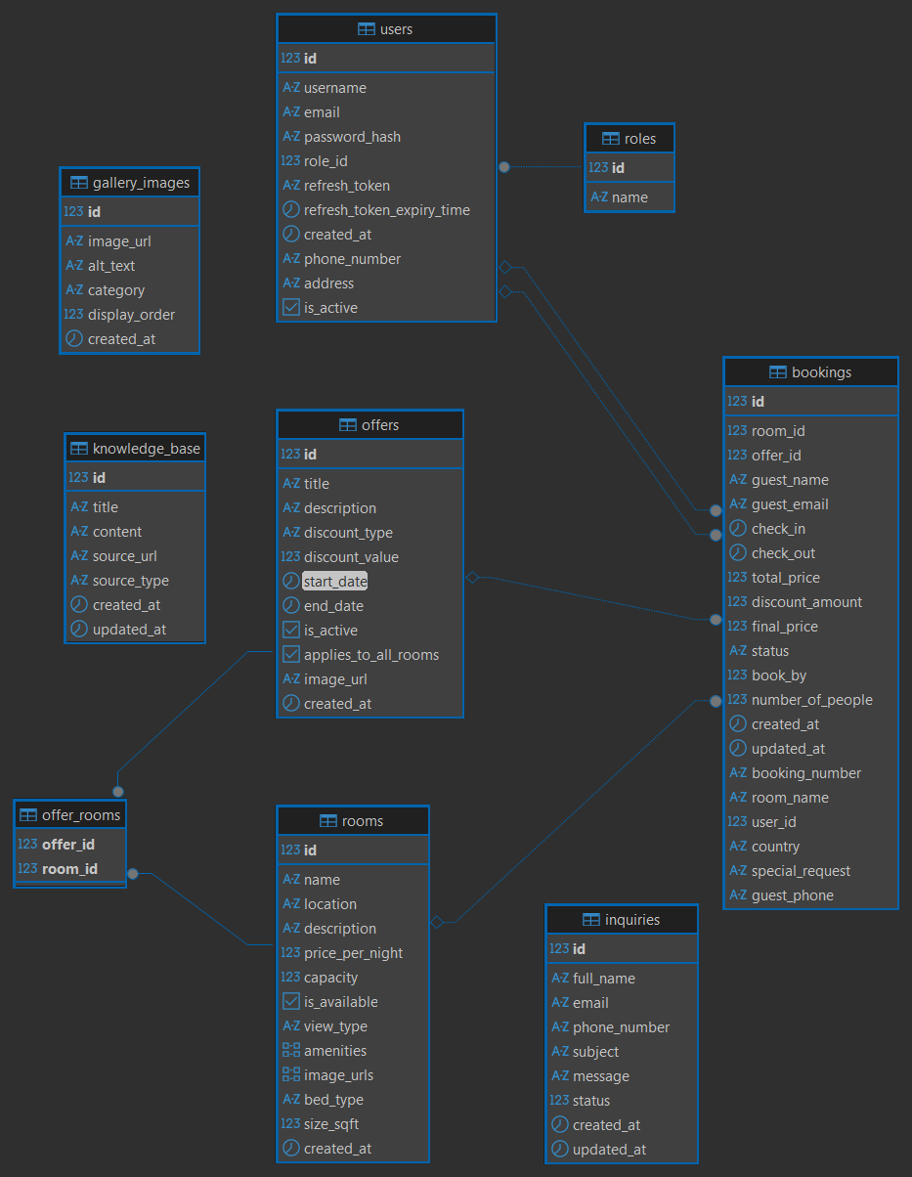
Figure 3.7 Database Schema Design

In the Bytestay Database Schema Diagram, there are 9 tables. One of the tables is the "roles" table, which stores the names of different roles such as "admin", "staff", and "customer". In the "users" table, both the IDs of the role and the users are stored for authorization purposes, along with user details like username, email, password hash, refresh token, and created timestamp.
When customers browse rooms and offers, they can view images and details of rooms (such as name, location, description, price per night, capacity, view type, amenities, image URLs, bed type, and size) and offers (such as title, description, discount type, discount value, start and end dates, active status, and applicable rooms).
When a customer books a room, the booking details are stored in the "bookings" table, which includes booking number, room ID, room name, offer ID, user ID, guest details (name, email, phone, country), special request, check-in and check-out dates, total price, discount amount, final price, status, number of people, and created/updated timestamps. The "offer_rooms" table is a junction table that stores the relationships between offers and the rooms they apply to.
Additionally, in the "inquiries" table, users can submit inquiries or feedback with details like full name, email, phone number, subject, message, status, and created/updated timestamps. The "gallery_images" table stores images for the website with image URL, alt text, category, display order, and created timestamp. The "knowledge_base" table stores content for the AI chatbot with title, content, source URL, source type, and created/updated timestamps.

Interface design (UI/UX)

- Login

Figure 3.8 Login Page
In the login process, both the admin and the user access the same login page, where they need to provide their email address and password. The "Remember Me" option will store a session cookie in the browser, allowing the user to remain logged in without having to

enter their credentials again. If the login is successful for an admin, they will be directed to the admin dashboard; otherwise, they will be directed to the user dashboard.
- Register

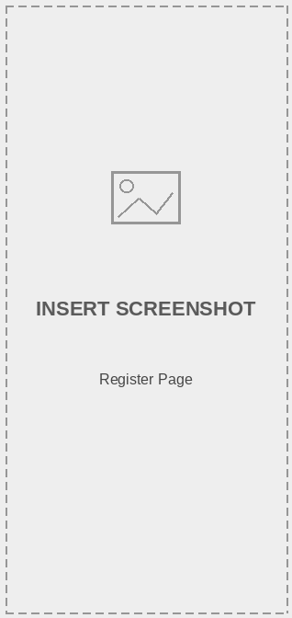

Figure 3.9 Register Page

During the registration process, the user visits the Registration page, where they must provide their name, email address, password, and confirm password. Once the email and password are submitted, the user will be registered and will not have access to the admin page; instead, they will be directed to the main user interface.

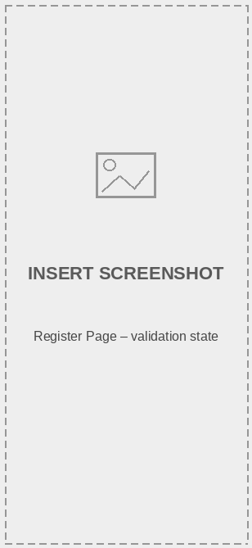
User Home Page

Figure 3.10 Home Page

The home page of the website is user-focused. At the top, there’s a header with navigation options: Home (main interface), Rooms (browse available rooms), My Bookings (redirects logged-in users to their booking history), About (website purpose), and Contact (feedback and inquiry form). The page features a room highlights slider, a list of current offers and promotions, recently added rooms, and a section for featured accommodations.

About Us Page


Figure 3.11 About Us

Our "About Us" section provides details about the company's story, including the mission behind its creation, the vision we are striving for, and a description of what our company is about.

Room Listing Page
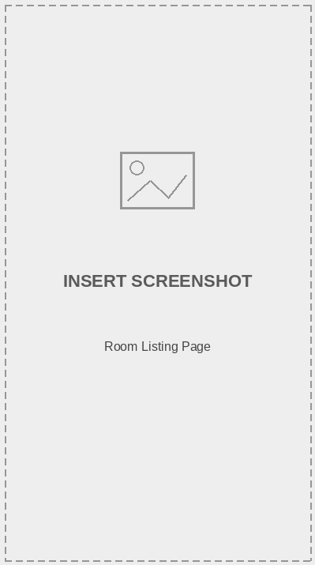

Figure 3.12 Room Listing Page

In the room listing section, users have access to various search tools, including filters for room type and amenities that help them find rooms that fit their needs. Users can set a minimum price (min) and a maximum price (max) for the rooms they are interested in, along with check-in and check-out dates, while the right side showcases the available rooms.
By default, the rooms are sorted based on availability and popularity. The rooms are arranged in a row format, where selecting 2 will display 2 rows, and selecting 3 will display 3 rows. Pagination is located at the end of the room listings, just before the footer.

Booking Page
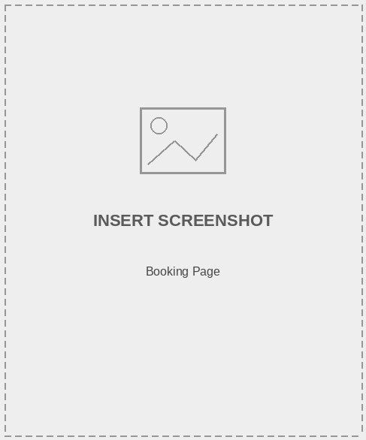

Figure 3.13 Booking Page

On the booking page, users can review the room they have selected along with their chosen check-in and check-out dates. They can update the number of guests and nights, and the page displays the subtotal price based on the length of stay. Additionally, users have the option to apply any available offer. The page also shows the total price for the booking. Finally, there is a "Proceed to Checkout" button to complete the reservation.

Check Out
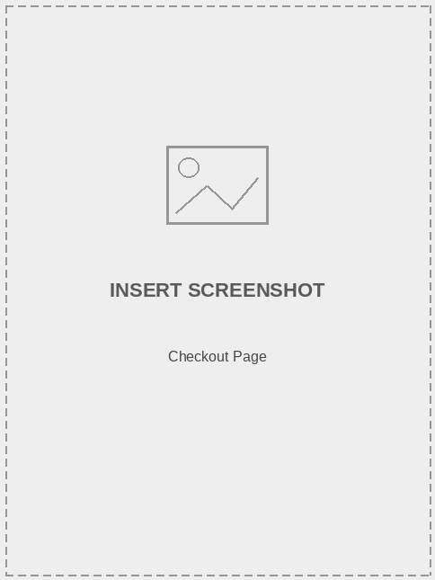

Figure 3.14 Check Out

During the checkout process, users need to provide their contact and guest details. If their account already has saved details, the system will automatically show this information, allowing them to make changes as needed. The booking subtotal will be displayed, along with available payment options, which include pay-at-hotel or online payment.

Confirmation page
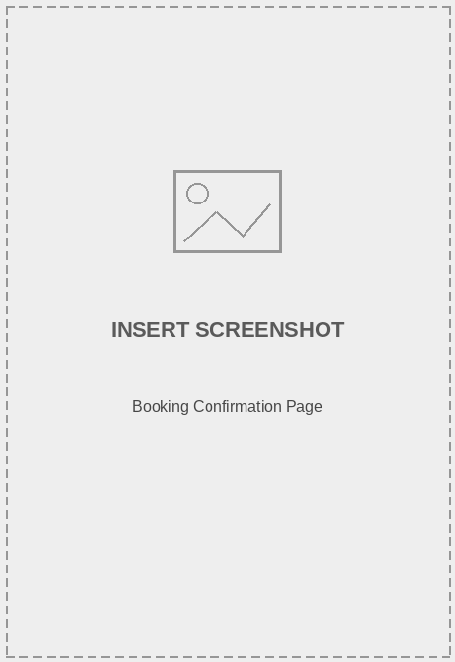

Figure 3.15 Confirmation page

Once the user places a booking, they will receive a confirmation that includes the booking date, check-in/check-out dates, total amount, and payment method. For further details, they can view the booking specifics in the booking details section. An automated confirmation email is also sent to the guest at this stage.

My Bookings Page


Figure 3.16 My Bookings Page

Here, the user can view a table listing their bookings. The table includes the following information for each booking: guest name, phone number, room booked, total amount, booking date, check-in and check-out dates, booking status, and an option to view further details about each booking.

Account details
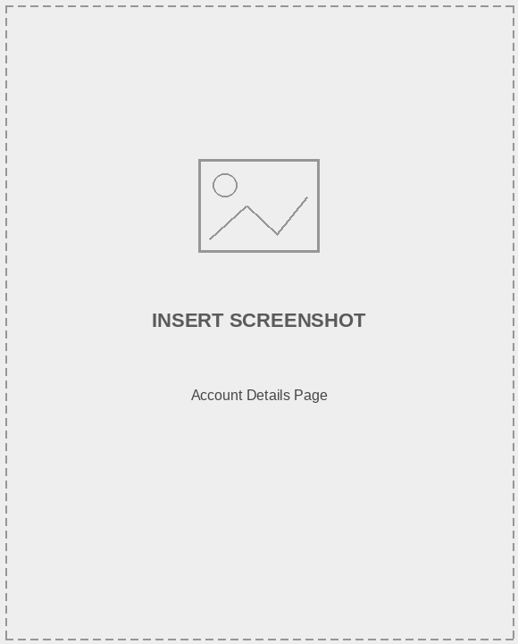
Figure 3.17 Account details page

Users can update their account details, which include their full name, phone number, email, and address, without needing to input their password as they are already logged in. To change the password, however, users must provide their old password, along with the new password and a confirmation of the new password.

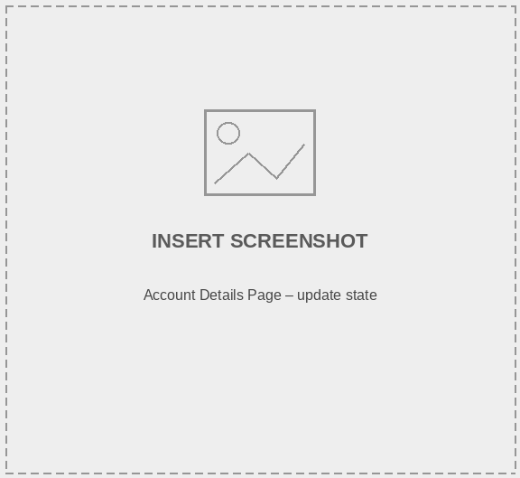
Admin Dashboard

Figure 3.18 Admin Dashboard

In the admin dashboard, the admin user has access to the main home page. By default, this page displays dashboard analytics covering rooms, offers, and bookings, along with key statistics such as occupancy rate, booking trends, and revenue performance. The admin can add, update, and delete rooms and offers, while the bookings section is updated as reservations come in. Additionally, there is an inquiry section that shows a list of customer inquiries submitted through the contact form.
In the user management area, the admin is responsible for overseeing user accounts. In the settings section, users can modify their own account details, including their name, address, phone number, and password.

Room Add
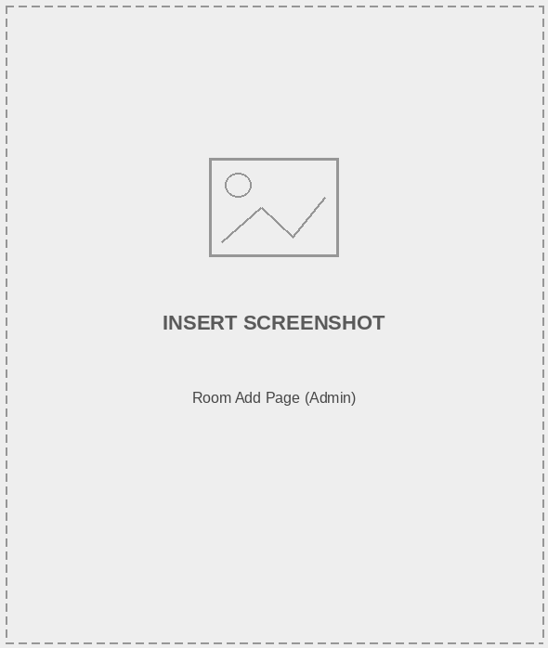

Figure 3.19 Room Add Page

On the admin side of the website, the admin user can add a new room by setting the room name/number, room type, and price per night, and selecting the amenities available for that room. Additionally, room specifications such as capacity and description should be provided, along with images of the

room. The admin needs to upload images labeled 1, 2, and 3 for each room they are adding.

Room Manage
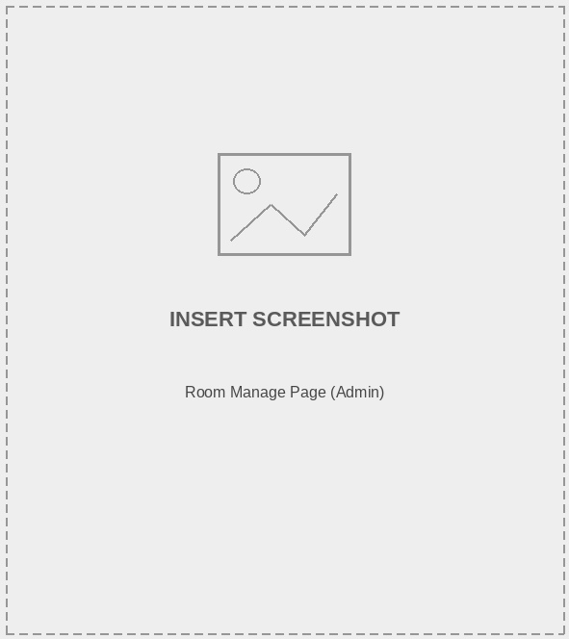
Figure 3.20 Room Manage Page

On the room management page, the admin user will be able to view a list of rooms. There is a search feature available to help find specific rooms that they want to manage. The admin can update, delete, and manage the rooms as needed.

In the room list table, the following details are displayed: room name/number, room type, price per night, and a single image of the room. Each entry also includes an icon of a pencil for editing and updating the room, as well as a trash can icon for deleting rooms that are no longer needed.

Offer Add


Figure 3.21 Add Offer Page

The admin can create promotional offers to inform guests about ongoing discounts and packages. In this process, admin users provide the offer name, description, discount details, applicable rooms, and a relevant offer image.

Offer Manage
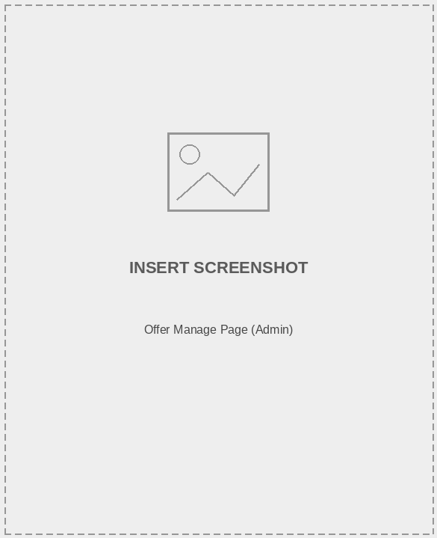
Figure 3.22 Manage Offer Page

In the "Manage Offers" section, you will find a list of offers that includes an image, name, discount details, and the room(s) associated with each offer. The pen icon allows you to manage

the offer by updating its details and image. The trash can icon will remove the selected offer.

Admin Booking Management
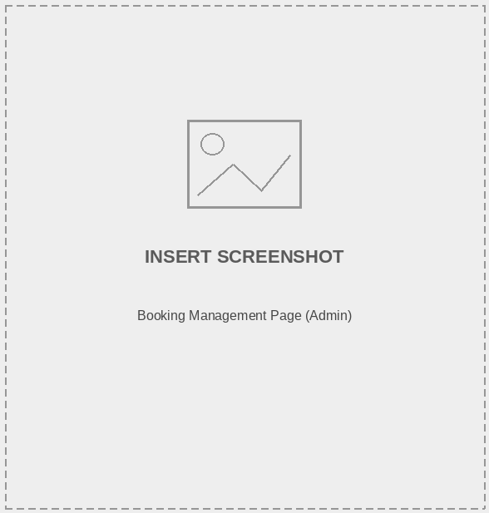

Figure 3.23 Booking Management Page

On the Bookings page, the admin manages guest bookings, including updating the booking status. This page displays a list of bookings, which consists of the guest’s name, phone number, room booked, total amount, booking status, booking date, and the check-in/check-out dates. There is also an action option to view further details about each booking.

Physical-DFD
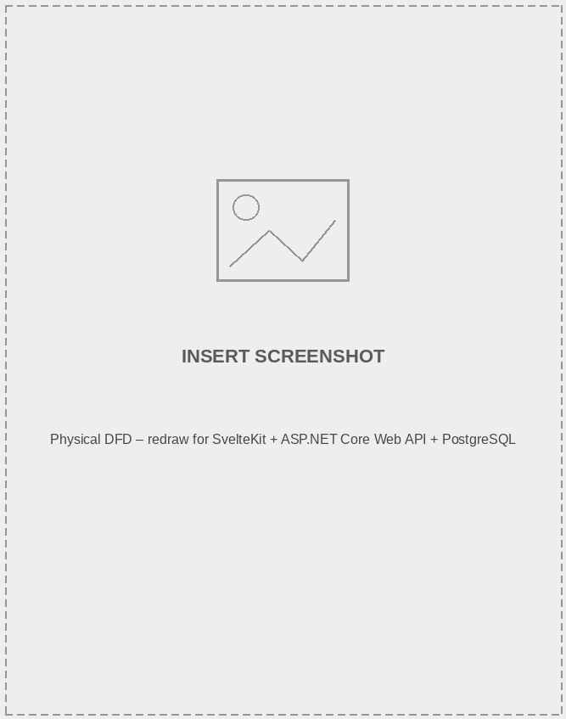

Figure 3.24 Physical DFD

Algorithm

Room Availability Algorithm

The room availability algorithm checks whether a selected room is free for a guest’s chosen check-in and check-out dates before a booking is confirmed. It works by:
      - Querying existing bookings for the selected room within the requested date range.
      - Checking for any overlap between the requested check-in/check-out dates and existing confirmed bookings.
      - Marking the room as unavailable for those dates if an overlap is found, and prompting the guest to choose different dates or another room.
      - Confirming availability and allowing the booking to proceed to checkout if no conflict is found.

How it works:
      - When a guest selects check-in and check-out dates for a room, the system queries the bookings table for that room.
      - If any existing booking’s date range intersects with the requested range, the room is flagged as unavailable.
      - Once a booking is confirmed, a new booking record is created, which is then considered in future availability checks for that room.

Example:
If a guest tries to book Room 101 from June 10 to June 12, but another guest already holds a confirmed booking for Room 101 from June 11 to June 13, the system detects the overlap and prevents the double booking.

Chatbot Support Algorithm

The AI-powered chatbot, built using Ollama, provides guests with instant answers to common queries such as room availability, pricing, and hotel policies.

It works by:

      - Accepting a guest’s natural-language question through the chat widget on the website.
      - Passing the query, along with relevant context (such as room and offer data), to the Ollama-hosted language model.
      - Generating a relevant response based on the query and the available hotel information.

How it works:

      - The chat widget sends the guest’s message to the backend chatbot endpoint.
      - The backend forwards the message to the Ollama model, optionally along with recent room/offer data for context.
      - The generated response is returned to the guest in real time within the chat widget.

Example:
A guest asking "Do you have any rooms available this weekend?" receives an instant response from the chatbot summarizing currently available rooms and any active offers, without needing to speak to hotel staff.

Search, Filtering, and Pagination

The search and filtering functionality allows guests to efficiently locate rooms by combining keyword search with specific filter criteria such as room type, amenities, and price range.

It works by:

      - Allowing users to search by room name or description keywords using partial match techniques (e.g., Contains or SQL ILIKE in PostgreSQL).
      - Enabling filtering by room type and amenities, where users can select one or more criteria to narrow down room results.
      - Supporting price range filtering, where users specify a minimum and maximum price per night to view only rooms within their budget.
      - Handling combined conditions, meaning users can search for a room name and simultaneously apply type, amenity, price, and date-availability filters for more accurate results.

Example:
A user searching for "deluxe" can filter the results to show only "Deluxe Room" types priced between Rs. 3,000 and Rs. 6,000 per night, making it easier to find relevant rooms quickly.

CHAPTER 4: IMPLEMENTATION AND TESTING

Implementation

CASE Tools
      - Draw.io: Draw.io is a charting and diagramming tool owned by Seibert Media. You can use the automated layout tool or create a custom layout. We made different kinds of diagrams using this tool.
      - Microsoft Word: Microsoft created the word processor known as Microsoft Word. From the beginning of the project until its completion, we documented every step of the workflow using Microsoft Word.

Programming language
  - HTML: HTML is the standard markup language for creating and designing web documents. It uses tags to format text, images, and multimedia, defining the structure and layout of web pages, and enabling browsers to display content correctly for users to access and interact with online.
  - CSS: CSS styles how HTML or XML elements appear on webpages, controlling layout, colors, fonts, and spacing. It separates content from visual style, making design maintenance easier.
  - JavaScript: JavaScript (JS) is a client-side programming language for creating interactive websites. It runs in the user's browser, enabling manipulation of webpage content, user action responses, form validation, animations, and server interactions for data fetching or sending asynchronously.
  - C#: C# is a modern, object-oriented programming language created by Microsoft for developing a variety of applications, including web, desktop, and mobile platforms. It is frequently used in conjunction with the .NET framework to build robust and scalable software solutions. C# features strong typing, automatic memory management, and seamless integration with databases and web services.

TypeScript & SvelteKit:
TypeScript is a strongly-typed superset of JavaScript that compiles to plain JavaScript, adding static type checking to catch errors during development rather than at runtime.

SvelteKit is a full-stack application framework built on top of Svelte that provides file-based routing, server-side rendering, and API endpoint handling. Combined with Svelte’s compile-time reactivity, it enables a fast, lightweight, and highly interactive front-end experience for Bytestay.

Database Platforms
  - ASP.NET Core Web API: ASP.NET Core Web API is a cross-platform framework created by Microsoft for building HTTP-based backend services. Bytestay’s backend is structured around Controllers, Services, and Repositories, which promotes separation of concerns and simplifies testing and maintenance. It offers built-in support for routing, JWT-based authentication and authorization, dependency injection, and database integration via Dapper.
  - PostgreSQL: PostgreSQL is a powerful, open-source object-relational database management system known for its reliability, feature robustness, and performance. It offers strong support for complex queries, indexing, and data integrity through ACID-compliant transactions. Dapper, a lightweight micro-ORM for .NET, is used alongside PostgreSQL to map query results directly to C# objects, offering fine-grained control over SQL while avoiding the overhead of a full ORM.
In this project, PostgreSQL is used to store and manage critical hotel data, including user accounts, room inventory, bookings, offers, and inquiries. A PostgreSQL client such as pgAdmin supports efficient database administration, enabling smooth interaction between the ASP.NET Core Web API application and the database.

Implementation Details of Modules
- Admin Module: This module is designed to manage bookings, rooms, offers, and inquiries from the admin side of the system. To log into their account, the admin must provide valid credentials secured through JWT-based authentication. Once authenticated, the admin can manage room inventory, create and update promotional offers, review and update booking statuses, and respond to customer inquiries. Additionally, this module assists with managing staff and user accounts, and provides dashboard analytics covering occupancy, revenue, and booking trends.
- User Module: This module is designed to effectively manage room browsing, bookings, and customer support for guests using the system. Guests are welcomed with a home page that displays room highlights and current offers. From this page, they can browse available rooms, check availability for their desired dates, and make a booking as a guest or registered user. Additionally, the module allows guests to manage their booking history and account details, submit inquiries through the contact form, and get instant assistance through the AI-powered chatbot.

Testing

    - Test Cases for Unit Testing Table 4.1: Login Test Cases

S.N. | Payload | Expected Result | Actual Result | Result | Appendix
1 | Email: admin@admin.co m  Password:  Rember me: True | Please Fill out this Field. Or Wrong Email or password | Please Fill out this Field. Or Wrong Email or password | Pass | Appendix 1
2 | Email: admin@admin.co m  Password:1234  Rember me: True | logged in. Then, redirected to the admin dashboard. | logged in and redirected to the dashboard. | Pass | Appendix 2
3 | Email: User@gmail.com  Password: user1234  Rember me: True | logged in. Then, redirected to the Main Website. | logged in and redirected to the Main Website. | pass | Appendix 3

Table 4.2: Register Test Cases

S.N. | Payload | Expected Result | Actual Result | Result | Appendix
1 | Email: Password: Password: | Please Fill out this Field. Or Wrong Email or password | Please Fill out this Field. Or Wrong Email or  password | Pass | Appendix 4

 | Confirm Password:
2 | Email: User@gmail.com  Password: user1234  Confirm password:user123 4 | logged in. Then, redirected to the Main Website. | logged in and redirected to the Main Website. | pass | Appendix 3

Table 4.3: Room Booking Cases

S.N. | Payload | Expected Result | Actual Result | Result | Appendix
1 | User: Not Login  Room: Book Now | Directed to login/register page | Directed to login/register page | Pass | Appendix 5
2 | User: User12  Room: Book Now | Message: Room successfully added to your booking. | Message: Room successfully added to your booking. | pass | Appendix 6

Table 4.4: User Contact Cases

S.N. | Payload | Expected Result | Actual Result | Result | Appendix
1 | Name: Phone: Email: | Name, phone, email, and message are  required | Name, phone, email, and message are  required | Pass | Appendix 7

 | Message:
2 | Name: User12  Phone: 9123684934  Email: User12@gmail.c om  Message: Hello! | Message: Thank you! Your Message has been received! | Message: Thank you! Your Message has been received! | pass | Appendix 8

Table 4.5: My Bookings Cases

S.N. | Payload | Expected Result | Actual Result | Result | Appendix
1 | User: Not Login  Booking: Proceed to checkout | Directed to login/register page | Directed to login/register page | Pass | Appendix 5
2 | Name: User12 Phone: Address:  Option: Pay at hotel | Name, phone, and payment option are required. | Name, phone, and payment option are required. | pass | Appendix 9
3 | Name: User12  Phone: 9123456789  Address: Kathmandu  Option: Pay at hotel | Redirect to Booking confirmation page showing bill. | Redirect to Booking confirmation page showing bill. | pass | Appendix 10

4 | On cancel request on pending booking | Message: Your booking has been canceled successfully. | Message: Your booking has been canceled successfully. | Pass | 11

Table 4.6: Admin Offer Management Cases

S.N. | Payload | Expected Result | Actual Result | Result | Appendix
1 | Name: Not given  Image: offer1.png | The Name field is required | The Name field is required | Pass | Appendix12
2 | Name: Summer Sale Image: offer1.png | Redirect it to offers list | Redirect it to offers list | pass | Appendix 13
3 | Name: Summer Sale Image: offer1.png | Offer already exists! | Offer already exists! | pass | Appendix 14
4 | Option: Delete On Summer Sale offer | Message: Are you sure you want to delete this offer?  Then Redirected to Offers list | Then Redirected to Offers list | pass | Appendix 15
5 | Option: Update On Summer Sale to Name: Summer Sale 1 | Message: Offer Updated successfully! | Message: Offer Updated successfully! | pass | Appendix 16

Table 4.7: Admin Room Management Cases

S.N. | Payload | Expected Result | Actual Result | Result | Appendix
1 | Name: Not given Image1: room1.png Image2: Not given Image 3: Not given Amenities: Not given  Description: Not given | The field is required | The field is required | Pass | Appendix17
2 | Name: Deluxe Room Image1: room1.png Image2: room2.png Image 3: room3.png Amenities: WiFi, AC  Description: Deluxe room description | Redirect it to Room list  Message: Room added successfully! | Redirect it to Room list  Message: Room added successfully! | pass | Appendix 18
3 | Update Process to Name: Deluxe Room 1 Image1: room1.png Image2: room4.png Image 3: room3.png Amenities: WiFi, AC, TV  Description: Deluxe room description | Redirect it to the Room list  Message: Room Updated successfully! | Redirect it to the Room list  Message: Room Updated successfully! | pass | Appendix 19

4 | Option: Delete  On Deluxe Room | Message: Are you sure you want to delete this room?  Then redirected to room list | Then redirected to room list | pass | Appendix 20

Table 4.8: Admin Booking Management Cases

S.N. | Payload | Expected Result | Actual Result | Result | Appendix
1 | Booking Update Status pending to Status: Confirmed | Message: Successfully updated booking! | Message: Successfully updated booking! | Pass | Appendix 21
2 | On guest cancel booking request  Status: Cancelled | Message: Successfully updated booking! | Message: Successfully updated booking! | Pass | Appendix 22
3 | Booking Complete Status pending to Status: Confirmed | Message: Successfully updated booking! | Message: Successfully updated booking! | Pass | Appendix 21

CHAPTER 5: CONCLUSION AND FUTURE RECOMMENDATIONS

Critical Analysis
Bytestay is a comprehensive hotel management and room booking platform designed to provide a seamless, self-service booking experience for guests while giving hotel administrators and staff full control over rooms, bookings, offers, and customer communication. Its architecture focuses on scalability, security, real-time data consistency, and a smooth user experience across the customer, staff, and admin roles.
The frontend is built with Svelte 5, SvelteKit, and TypeScript, combined with HTML and CSS for structure and styling. SvelteKit’s compile-time reactivity and file-based routing produce a fast, lightweight, and responsive interface with minimal client-side overhead. Server-side rendering improves initial load performance, while TypeScript’s static typing helps catch errors during development. Challenges such as coordinating real-time room availability with a dynamic UI and maintaining consistent styling across devices are addressed through component-based design and careful state management.
The backend is developed using C# and ASP.NET Core Web API (.NET 8), following a layered architecture of Controllers, Services, and Repositories that separates request handling, business logic, and data access. This structure improves testability and maintainability, and makes it straightforward to extend the system with new features. Key backend capabilities include JWT-based authentication and role-based authorization for Admin, Staff, and Customer roles, room and offer management, real-time booking handling, dashboard analytics, and automated email notifications via MailKit/MimeKit over SMTP.
The application uses PostgreSQL as its relational database, accessed through the Dapper micro-ORM for efficient, fine-grained control over SQL queries. PostgreSQL manages core entities including users, rooms, bookings, offers, gallery images, and customer inquiries, with relationships enforced through foreign keys to maintain data integrity. This combination provides the reliability and query performance needed for real-time booking and availability checks.

By properly utilizing indexing and well-defined relationships between entities, the database remains optimized and responsive even as booking volume grows.
Security is a top priority. The system implements JWT-based authentication and role-based access control to ensure that customers, staff, and administrators only access functionality appropriate to their role. Password hashing, input validation, and HTTPS enforcement protect user data and booking information, while ASP.NET Core’s built-in protections help guard against common web threats such as Cross-Site Request Forgery (CSRF), Cross-Site Scripting (XSS), and SQL Injection. Containerizing the application with Docker Compose further ensures a consistent, reproducible deployment environment.
Agile methodology is utilized during development, allowing the team to plan, develop, test, and release new features in an iterative manner. Regular sprint cycles, code reviews, and continuous testing ensure that the platform evolves quickly and reliably. This approach enhances collaboration, speeds up development, and increases transparency throughout the project lifecycle.
Bytestay prioritizes delivering an exceptional user experience. Every element, from intuitive room browsing and real-time availability checks to secure checkout and instant chatbot assistance, is thoughtfully designed with the guest in mind. The admin system facilitates efficient management of rooms, offers, and bookings, while dashboard analytics help hotel staff track occupancy, revenue, and booking trends. Balancing a rich feature set with performance remains an ongoing focus as new capabilities, such as the AI-powered chatbot, continue to be refined.
In conclusion, Bytestay leverages modern web technologies — a Svelte/SvelteKit frontend, an ASP.NET Core Web API backend, and a PostgreSQL database — to create a scalable, secure, and efficient hotel booking experience. By adhering to best practices in coding, security, and agile development, Bytestay is well-positioned to modernize hotel operations and meet the evolving expectations of both guests and hotel staff.

Conclusion
In conclusion, Bytestay provides a robust and scalable solution for hotel management and room booking by utilizing technologies such as Svelte, SvelteKit, TypeScript, C#, ASP.NET Core Web API, and PostgreSQL. The platform is designed with a focus on performance, security, and user experience, ensuring smooth navigation, real-time booking accuracy, and reliable communication between guests, staff, and administrators.

While the current implementation supports the core hotel management workflow end-to-end, future growth will require ongoing optimization, infrastructure scaling, and feature enhancements. By proactively addressing technical challenges and adapting to evolving guest expectations, Bytestay is well-positioned to deliver a seamless, secure, and intelligent hotel booking experience in a competitive hospitality market.

Limitations
Despite the functional implementation of the Bytestay hotel booking platform, there are several limitations that need to be addressed for future improvement:
    - Scalability Constraints: The current system may face performance bottlenecks under high booking traffic or with a large volume of rooms and reservations, as it lacks advanced load balancing or distributed infrastructure.
    - UI Responsiveness: While the interface is functional, it may require further optimization for full responsiveness across all screen sizes, particularly on low-end mobile devices.
    - Performance Under Load: Without advanced caching mechanisms, page and availability-check load times may increase during peak booking periods.
    - Security Considerations: Although standard security practices are followed, potential risks remain, especially around refresh-token handling, password recovery mechanisms, and session management.
    - Chatbot Accuracy: As the AI-powered chatbot relies on a locally hosted language model via Ollama, its responses may occasionally be inaccurate or lack up-to-the-minute booking context without further tuning.

Future Enhancements
In the future, Bytestay plans to introduce several advanced features to enhance the guest experience and improve platform capabilities. This includes expanding the AI-powered chatbot to handle more complex booking modifications directly, and integrating online payment gateways for a fully self-service checkout experience.
To enhance guest convenience, we plan to introduce a loyalty and rewards program for returning guests, along with SMS notifications alongside the existing email notification system. Additionally,

we plan to launch a mobile application to streamline room browsing and booking management, while also providing app-exclusive offers.
For hotel administrators, we will introduce more advanced analytics and reporting tools, multi-property support, and integration with third-party travel and booking platforms. These enhancements will transform Bytestay into more than just a booking platform — it will evolve into a comprehensive hotel management ecosystem designed to meet the changing expectations of guests and the hospitality industry.

REFERENCES

[1] | D. Chaffey, "Digital Marketing," 2020. [Online]. Available: https://www.pearson.com/us/higher-education/program/Chaffey-Digital-Marketing- Strategy-Implementation-and-Practice-7th-Edition/PGM329452.html.
[2] | K. C. L. a. T. C. G. Laudon, "E-commerce 2021," 2020. [Online]. Available: https://www.pearson.com/us/higher-education/program/Laudon-E-Commerce-2021- Business-Technology-and-Society-16th-Edition/PGM332834.html.
[3] | J. Nielsen, "Designing Web Usability," 2000. [Online]. Available: https://www.amazon.com/Designing-Web-Usability-Practice- Simplicity/dp/0789723104.
[4] | S. Krug, "Don't Make Me Think, Revisited," 2014. [Online]. Available: https://www.amazon.com/Dont-Make-Think-Revisited-Usability/dp/0321965515.
[5] | W. Stallings, "Cryptography and Network Security," Pearson, 2017. [Online]. Available: https://www.pearson.com/us/higher-education/program/Stallings- Cryptography-and-Network-Security-Principles-and-Practice-7th- Edition/PGM334401.html.
[6] | A. Laukaitis, "The 9 Best Ecommerce Platforms to Consider for Your Online Store," Big Ecommerce, 12 06 2024. [Online]. Available: https://www.bigcommerce.com/articles/ecommerce/ecommerce-platforms/.
[7] | E. Artug, "5 ecommerce personalization trends to watch in 2025," conentful, 1 January 2024. [Online]. Available: https://www.contentful.com/blog/ecommerce- personalization-trends/.
[8] | B. Meyer, "20 ecommerce best practices to drive sales in 2025," omnisend, 4 Fed 2025. [Online]. Available: https://www.omnisend.com/blog/ecommerce-best- practices/.
[9] | C. Tweten, "The History of Shopify: Founders, Funders, and Timeline," zoko, 18 October 2022. [Online]. Available: https://www.zoko.io/post/history-of-shopify.
[10] | newegg, "About US," newegg, 01 04 2021. [Online]. Available: https://www.newegg.com/corporate/about.
[11] | I. E. Team, "What Is MVC With ASP.NET? (With Features and Advantages)," indeed,  5 June 2025. [Online]. Available: https://in.indeed.com/career-advice/career- development/what-is-mvc-with-asp-net.

[12] | indeed, "What Is a User Interface (UI)?," Indeed Editorial Team, 26 March 2025. [Online]. Available: https://www.indeed.com/career-advice/career-  development/user-interface.

Appendixes
Login:

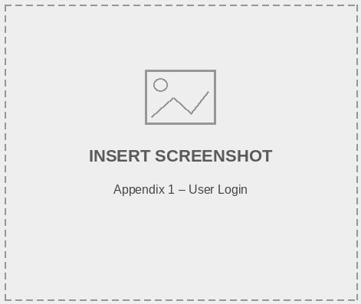
Appendix 1
Admin Login:
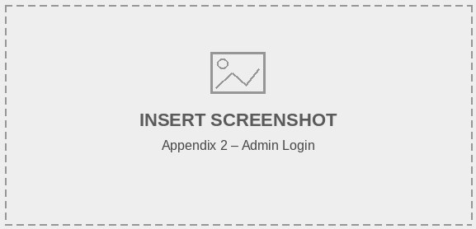

User Login:
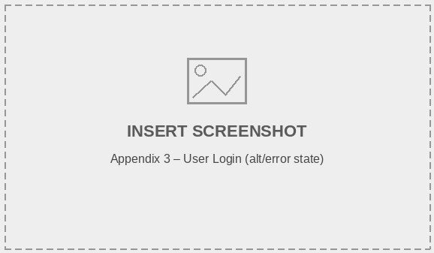
Appendix 3
Register: User Register:
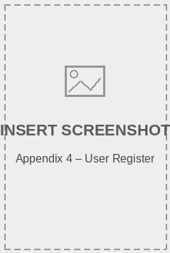

Select Room & Dates:

Redirect to login:

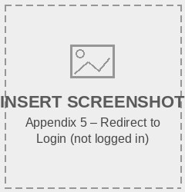

Appendix 5

Success Message:

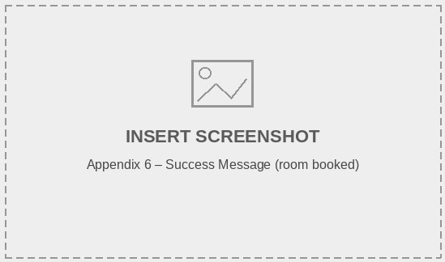

User Contact:
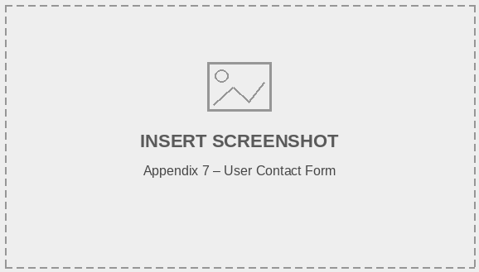

Appendix 7
Contact success:
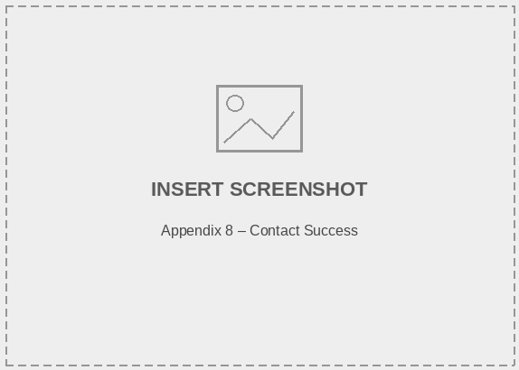

User Checkout:

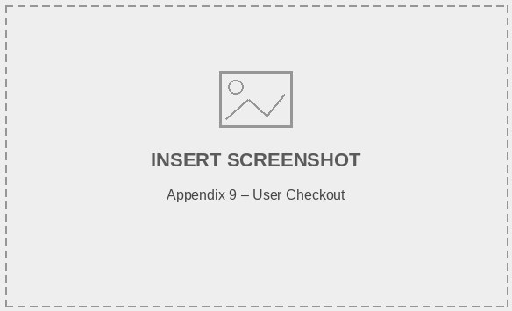
Appendix 9
User Booking Confirmation:
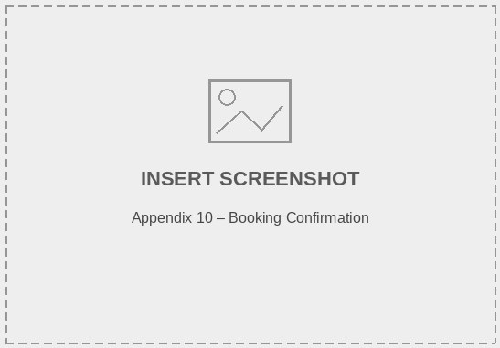

User booking cancel:
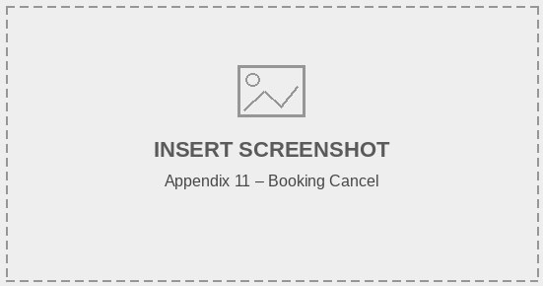

Appendix 11
Offer Add:
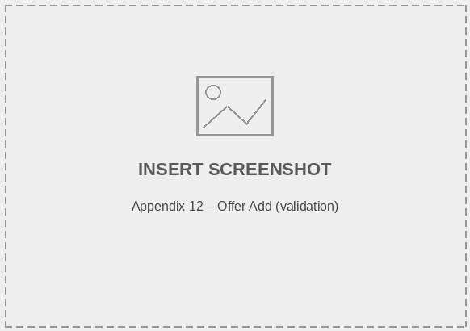

Offer List:
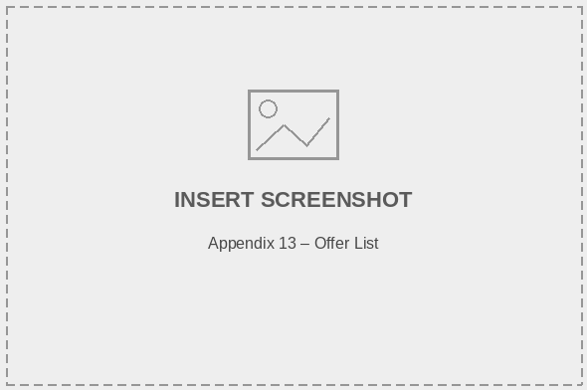

Appendix 13
Offer already exists:
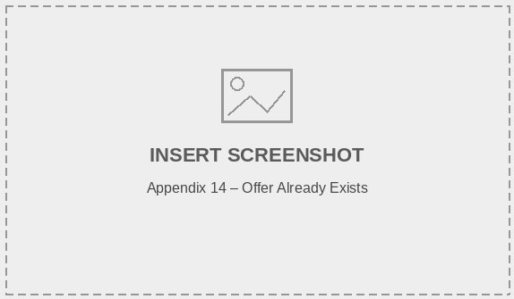

Offer Delete:
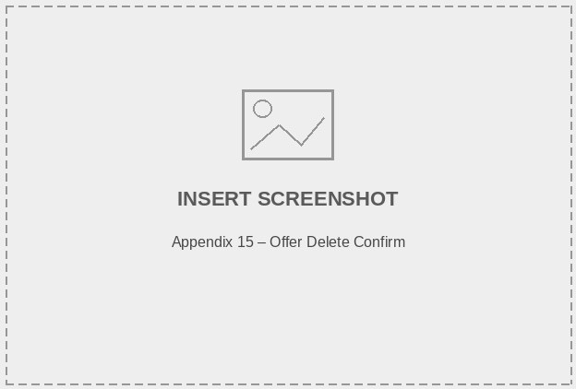

Appendix 15
Offer Update:
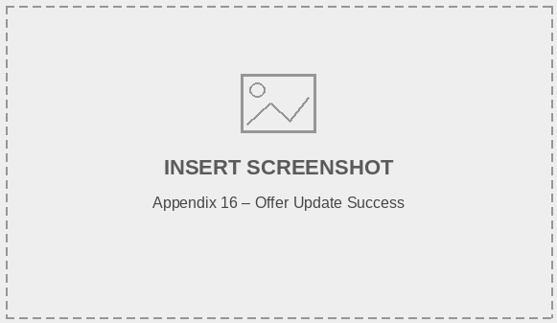

Room Add required:
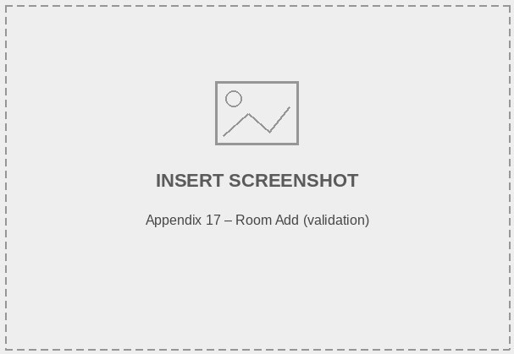

Appendix 17
Room add success:
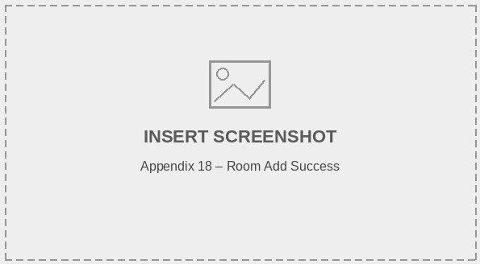

Room Update:
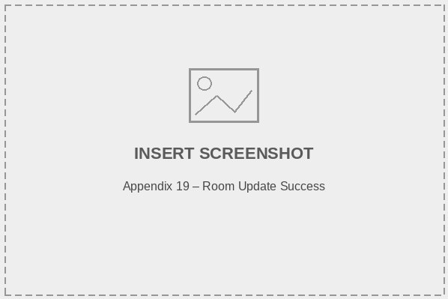

Appendix 19
Room Delete:
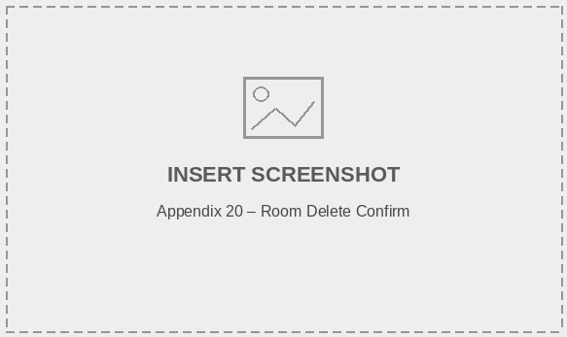

Booking Status update:
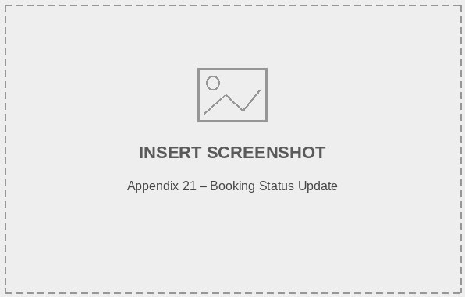

Appendix 21
Cancel Booking:
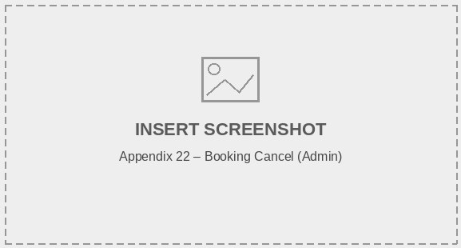
Appendix 22

