Name: Niranjan Telkikar

EID: nnt479

Semester: Fall 2025
Course: ECE445L

A) Objectives:
- In a few sentences, describe the purpose of the lab and the features of your alarm clock PCB.
The purpose of this lab is to design a PCB for an embedded system that acts as an analog signal generator. The purpose of this lab is to make sure that a PCB can be designed given the constraints of an enclosure as well. The purpose of this lab is also to learn how to create a BOM given the components on a PCB.

B) Hardware Design Deliverables:
Changelog:

Since checkout I have changed the following things:
      - Changed schematic to remove shunt diode and used 3.3 volts for reference voltage for DAC.
      - Removed one LED (now have one power LED and one LED connected to a digital GPIO pin)
      - Instead of using pad testpoints, I am now using the given jumper testpoints for SignalOUT and DACOUT.
      - For the oscilloscope, I am now using the 1*8 connector instead of test pads (for 8 digital pins).
      - I deleted three testpoints for 3.3, 3.7 and GND, since they were already included in the schematic.
      - For the design, test points are close to their respective circuits.
      - The digital oscilloscope pins are close to the chip.
      - The crystal oscillator is close to the chip and there are no power or ground traces under the oscillator.
      - There are no power or ground loops.
      - I went from using 75 vias to 35 vias due to more optimal placement of components.
      - Holes are aligned for the SERPAC 151 enclosure and I measured using the datasheet. The PCB size is the insert size for the SERPAC 151 enclosure taken from the datasheet.
      - Bypass capacitors are close to their IC’s.
      - To minimize traces, components in each circuit attached to each other are close together
      - Power, Ground, DACOUT, and SIGNALOUT all have traces that are 0.5mm while the other ones are 0.25mm.
      - Components were placed optimally by placing components close to each other to minimize trace length.

- Deliverable 1: Using KiCad, create a schematic for your design. Include a screenshot in the space below.
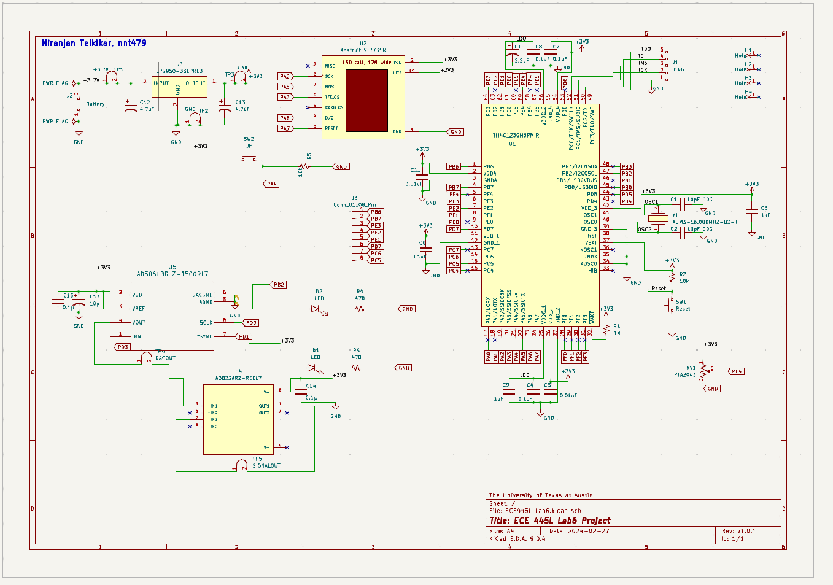
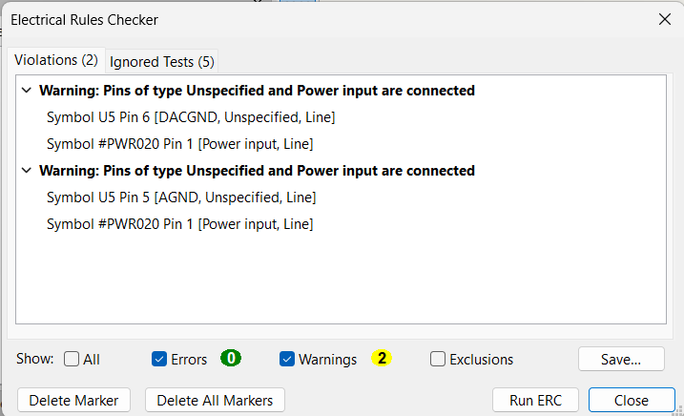

These two warnings are acceptable since this just involves the pin type that comes with the footprint and says that different types are connected. Since we know that the types being different are fine, these two warnings are acceptable. KiCad just shows these warnings because a pin is unspecified in the footprint.

- Deliverable 2: Using KiCad, create a Layout for your design. Include a screenshot in the space below.
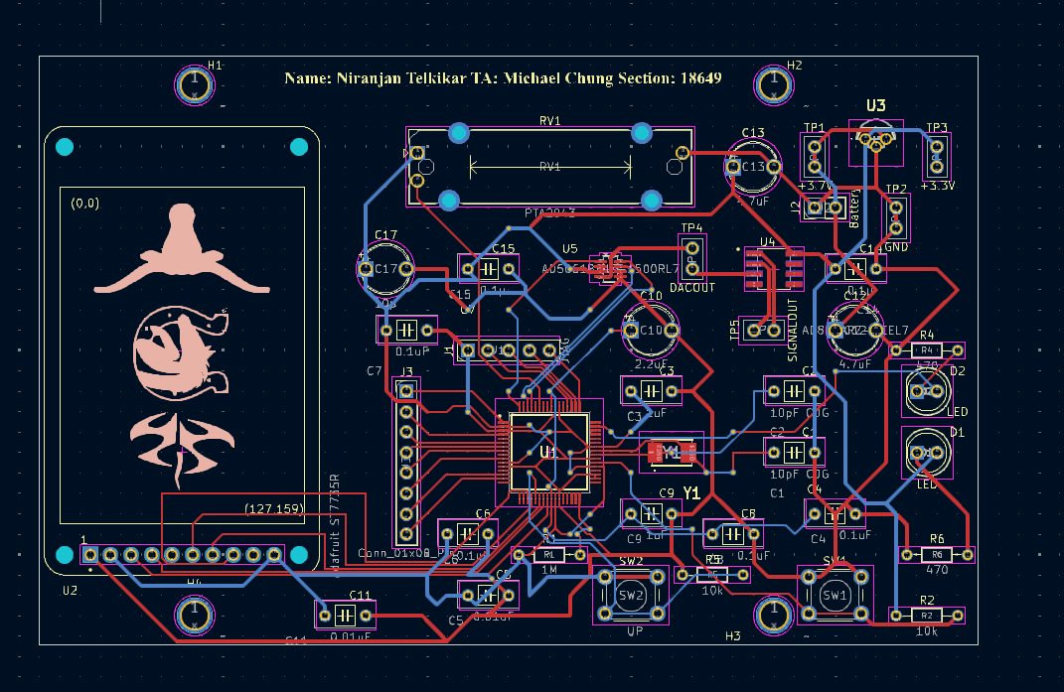
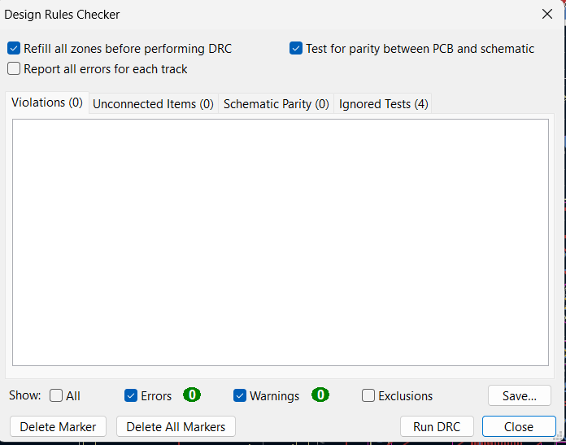

C) Software Design Deliverables:
- I have pushed my project to GitHub for grading (Check box if true). ☒
D) Measurement Data:
- Deliverable 3: Cardboard mockup of the PCB
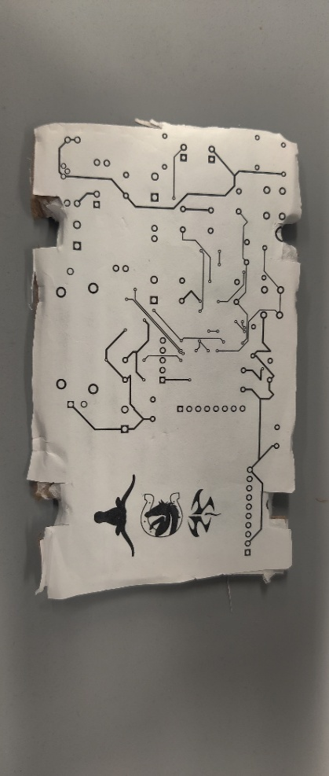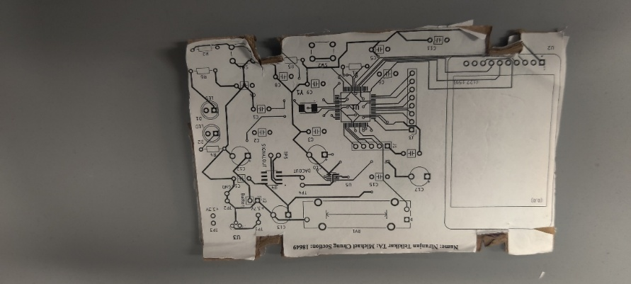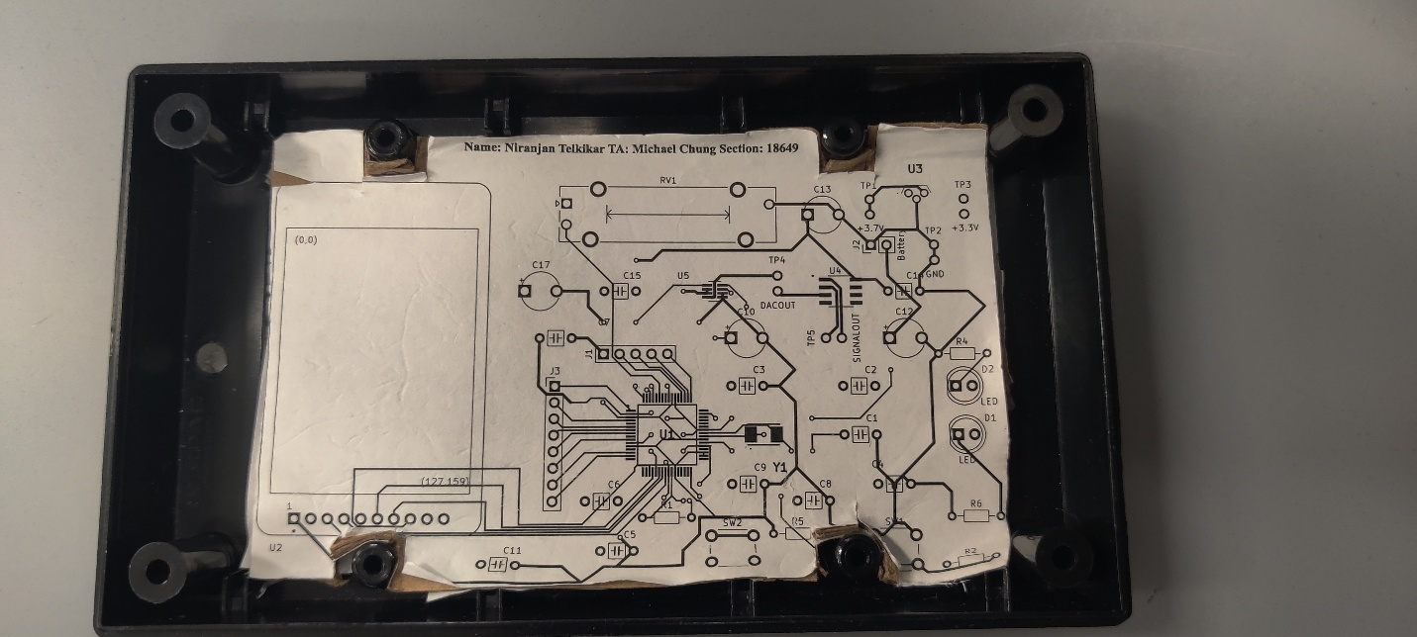

- Deliverable 4: I have updated the bill of materials (Check box if true). ☒

- Deliverable 5: Estimated current usage
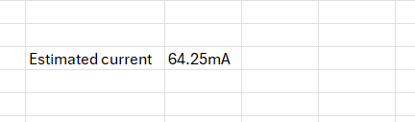
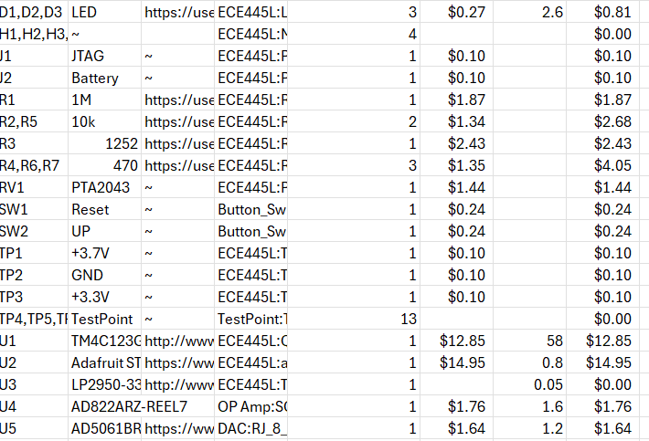
The estimated current is 64.25mA. It was estimated using the currents of the active components including the LEDs, TM4C, LP2950, AD822ARZ, AD506, and Adafruit ST775R LCD.
- Deliverable 6: JLC PCB Quote
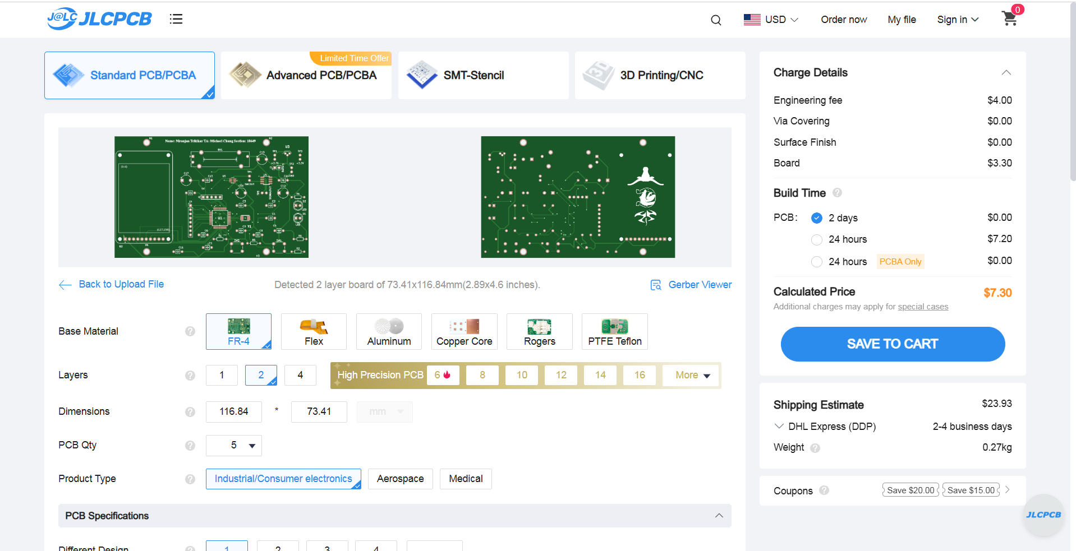
- Deliverable 7 (4 or 8pt EC): Custom Symbol and Footprint

E) Analysis and Discussion Questions:
- Estimate how long the system you created would run on the 2600mA battery.
The system consumes 64.25mA. The battery is 2600mAH. 2600mAH/64.25mA is approximately 40.5 hours.
- Estimate the power dissipated through the LDO regulator knowing the current draw from downstream components and voltage drop across the regulator.
The power dissipated through the LDO regulator is (3.7-3.3 V) *100mA of output current which is 0.04 watts.

- Examine the following excerpt from the datasheet for the MX1500 which has a nominal capacity of 2500mAh. Assuming you placed enough of these batteries in series to power your system, how long would the lifetime be? What happens to the lifetime of the battery when you double the current?
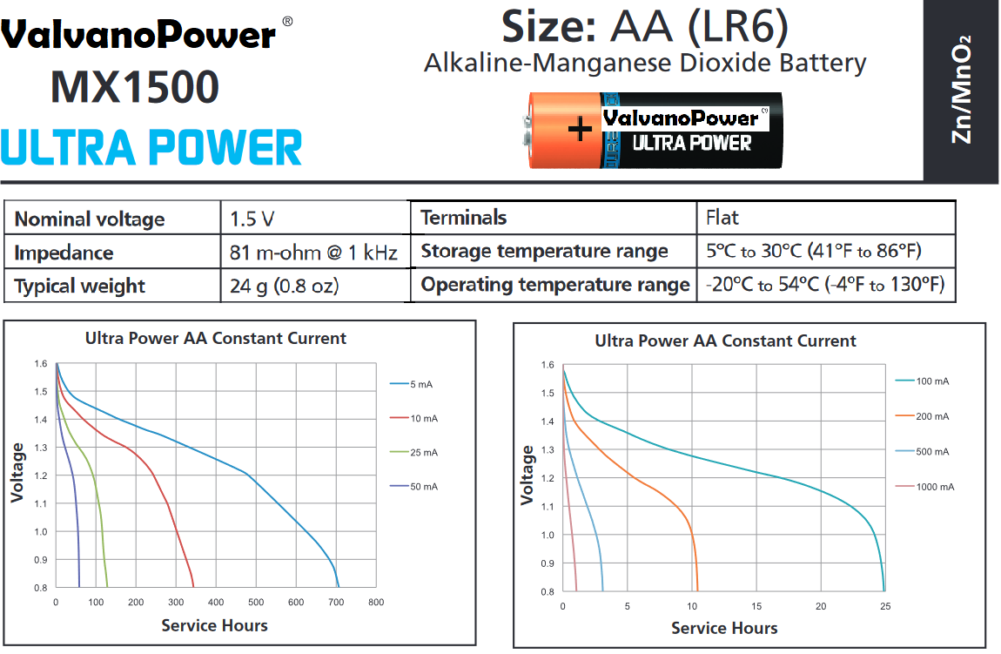

If we place two of these batteries, we will have 5000mAH/64.25mA or 77.8 hours of runtime. When you double the current, the lifespan of the battery decreases by half to (5000mAH/(64.25mA*2)) = 38.9 hours.
- Discuss the advantages and disadvantages of using an LDO versus a switching regulator.
The advantages of using an LDO (which is a type of linear regulator) rather than a switching regulator is the fact that an LDO does not have switching noise, the device size is smaller, and the circuit design is simpler (which are the properties of linear regulators). A disadvantage of using an LDO is the dissipation of heat for it to operate. Switching regulators are more prone to noise than LDO’s. Switching regulators are more power efficient than LDO’s, however.

