ECE 445L Lab 4E
IEE802.11 Wi-Fi communication, TCP, Web sockets, MQTT Publish-Subscribe, IoT
This laboratory assignment accompanies the book, Embedded Systems: Real-Time Interfacing to ARM Cortex M Microcontrollers, ISBN-13: 978-1463590154, by Jonathan W. Valvano, copyright © 2021.

Table of Contents
Table of Contents 1
Team Size 3
Goals 3
Review 3
Starter Files 3
Required Hardware 3
Lab Overview 3
Preparation 7
Procedure 10
ESP8266 Procedure 11
Web App Procedure 12
LaunchPad Procedure 16
Merge Lab 3 Code 18
Deliverable 1 19
Deliverable 2 20
Deliverable 3 20
Deliverable 4 20
Deliverable 5 20
Deliverable 6 (5pts Extra Credit) 20
Lab Checkout 21
Lab Report 21
Hint (A deep dive into MQTT) 22
Hint (Arduino Setup) 22
Steps: 22
Hint (MQTT Debugging) 25
Browser Debugging 25
Internet Traffic Analysis & Debug 26
Hint (Notable Project Files) 27
LaunchPad Starter Project 27
ESP8266 Starter Project 27
MQTT Web Application Starter Project 28

Team Size
The team size for this lab is 2.

Goals
- Implement a “smart object” that connects to a web application using a MQTT broker.
- Use the ESP8266 to interface between the internet and the TM4C123.
- Remotely control the clock developed in Lab 3 via the MQTT publish/subscribe interface.

Review
- ebook Chapter 4 or textbook Section 11.4 on IoT
- MQTT architecture (see Lab Overview)

Starter Files
- Starter project:
  - Lab 4 template provided on the GitHub Classroom repo.

Required Hardware
Parts | Datasheet | Price | Source (price source)
EK-TM4C123GXL | EK-TM4C123GXL datasheet | $16.99 | TI
Sitronix ST7735R Color LCD | ST7735R Driver datasheet | $19.95 | Adafruit
8Ω or 32Ω speaker | N/A | N/A | EER Checkout Desk
10kΩ resistor | N/A | N/A | EER Checkout Desk
1uF Tantalum Capacitor | N/A | N/A | EER Checkout Desk
Switches | N/A | N/A | EER Checkout Desk
IRLD120 MOSFET  or IRLD024 MOSFET | IRLD120 datasheet  IRLD024 datasheet | $1.88 | EER Checkout Desk  Or Mouser, Digikey
1N914 Diode | 1N914 datasheet | $0.10 | EER Checkout Desk,  Or Mouser
ESP8266-ESP01 | ESP8266 Datasheet | 3.50 | Get it from the TA’s
ESP01 breadboard adapter | N/A | N/A | Get it from the TA’s
ESP8266 Programmer |  | 10.99 | EER Checkout Desk
LM2937-3.3 Voltage Regulator or any 3.3V regulator | LM2937 Datasheet | 1.68 | EER Checkout Desk

Lab Overview
In this lab your team will create a “smart object” that connects to a MQTT Broker. This Broker will allow communication to a Web Application as shown below in Figure 4.1.
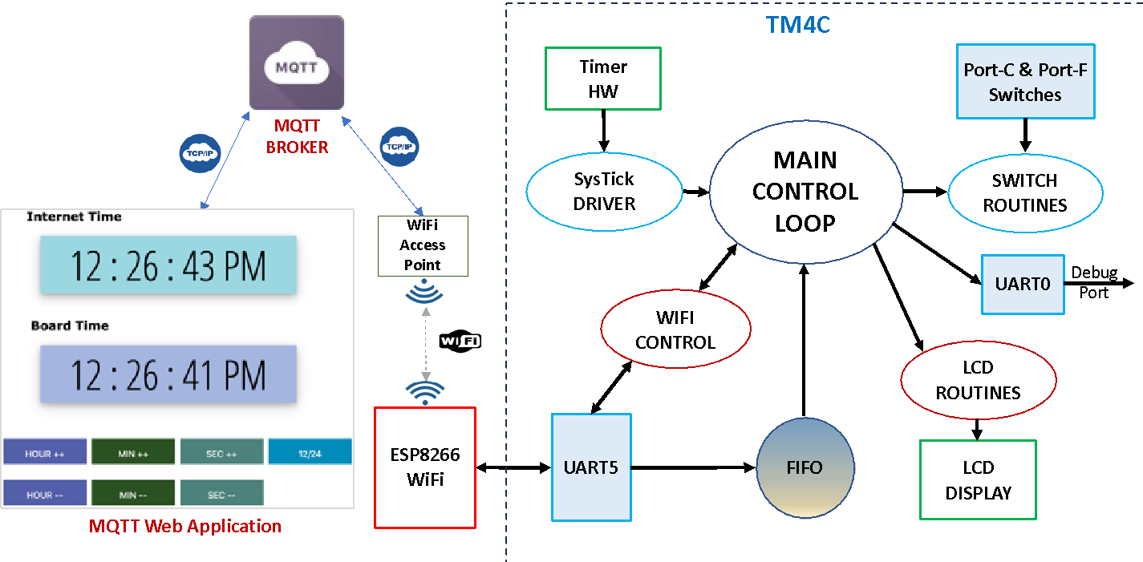
Figure 4.1: Lab 4 Data Flow Diagram
Your system will include:
- A PC or Phone running a MQTT Web App that you will develop using starter code we provide.
- A TM4C123 Launchpad running your Lab 3 software plus a UART peripheral that talks to the ESP8266 Wi-Fi module.
- An ESP8266 Wi-Fi module (Fig. 4.2) that is configured with starter net code built using Arduino.
- Existing hardware reused from Lab 3, including the display and any switches.
Your system will be able to:
- Have the phone or laptop running the MQTT Web App, displaying any changes in the TM4C’s state.
- Have the TM4C and its display respond to updates from the MQTT web application.
- Display the time including hour, minute and second as well as 7 control buttons: Hour++, Hour--, Minute++, Minute--, Second++, Second--, Toggle 12/24-hour display.
- A nice to have would be another display showing internet time as shown above in Figure 4.1. You can use this to determine the drift of the crystal on the TM4C.
- Measure an external sensor using the ADC (extra credit). Any external sensor and any interface method is okay (ADC, I2C, or SPI).
You are free to define the “look and feel” of your system if you meet the specifications listed above.
NOTE: You will need access to a wireless access point, configured with or without security to use the MQTT broker running in the EER. You may also use any online cloud brokers.
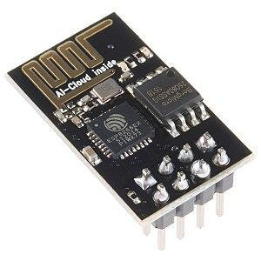
Wi-Fi is the name given to devices that communicate wirelessly employing the IEEE 802.11 standard. They typically operate in the 2.4 GHz Industrial-Scientific-Medical (ISM) unlicensed band that is shared with ZigBee (IEEE 802.15.4) and Bluetooth (IEEE 802.15.1) communications. The IEEE 802.11 standard describes how information is represented via radio frequency signals, i.e., the physical or PHY layer, and how communications are formatted and controlled, i.e., the media access control or MAC layer. Communication requirements beyond the PHY and MAC, e.g., flow control, error recovery, and routing, are handled at higher levels of the internet stack.
Figure 4.2: The ESP8266 WiFi module.
MQTT (which stands for nothing) is a message passing mechanism that uses a centralized broker (server) to receive published data and send the data to any number of subscribers as shown below in Figure 4.3.
Figure 4.3 MQTT Publish-Subscribe Model
Key points about MQTT:
- All clients can publish (broadcast) and subscribe (receive).
- Clients do not have addresses like in email systems; messages are not sent directly to clients.
- Clients become subscribers to “topic(s)” to get messages published to the broker about the “topic”.
- Messages are published to a broker about a particular “topic”. In this Lab all topics MUST begin with your EID. A topic example is rg7677/b2w/hour where:
  - rg7677 is the student EID,
  - b2w is a subtopic indicating that the message is from the LaunchPad board to the web application, and
  - hour is a sub-subtopic that is current hour on the board.
- The job of an MQTT broker is to collect and sort messages based on the “topic”, so that the broker can distribute messages to subscribers of the “topic”.
- There is no direct connection between a publisher and subscriber.
- MQTT brokers do NOT normally store messages. All messages are sent via TCP which guarantees delivery (vs UDP which does not).
- The publisher dictates the data format. The subscriber must know the format to decipher the data.
- You will be given suggested topics and data formats. You are free to generate your own.
- The only restriction is that all topics must begin with your EID, e.g., rg7677/b2w/hour.
- You have several options for MQTT brokers:
  - McDermott has set up a broker in the EER that you can use, tied to the following config:
    - IP address: 10.159.177.244 (IP subject to change due to DHCP)
    - Port: 9001
    - SSID: Utexas, Utexas-IoT
    - Password: will need one to connect to these Wi-Fi SSIDs
  - You can set up your own broker on a laptop or a server; an option is MOSQUITTO It is considered one of the best open-source MQTT brokers.
  - An online hosted MQTT broker: EMQX is a free public broker with no sign up that you can use instantly.
    - IP address/domain name: broker.emqx.io
    - Port: 8083 (for websockets, 1883 for TCP port)
    - The starter code has been set up with to talk to this broker so you can get running instantly.
Here are some useful MQTT tutorials and projects:
- http://www.steves-internet-guide.com/mqtt-works/
- http://www.steves-internet-guide.com/download/mqtt-study-guide/
- http://www.steves-internet-guide.com/mqtt-protocol-messages-overview/
- http://www.steves-internet-guide.com/into-mqtt-python-client/
- http://www.steves-internet-guide.com/mqtt-websockets/
- http://www.steves-internet-guide.com/using-javascript-mqtt-client-websockets/
- http://www.steves-internet-guide.com/mosquitto-broker/
- http://www.steves-internet-guide.com/install-mosquitto-broker/
- http://www.steves-internet-guide.com/mqtt-broker-testing/
- http://www.steves-internet-guide.com/monitoring-mqtt-brokers/
- MQTT on Arduino Project Hub

Preparation
Preparation is performed during or before the W/TH lab session.
- Software Review
  - Review the Lab 4 starter code provided in the GitHub classroom repository. There is a hint at the end of this document enumerating notable files in the project. There are three sets of software you should be familiar with which are listed below.
    - The LaunchPad starter project you expanded in Lab 3
    - The ESP8266 starter project, which performs the intermediate parsing and handshakes with the MQTT broker and LaunchPad (via UART)
    - The MQTT web application starter project which displays the data collected.
- ESP Software Setup
  - Demo to the TA that you can flash the ESP8266 Starter project successfully. A guide to installing the Arduino IDE and project dependencies can be found in the hints section at the end of this lab document. Be prepared to show the ESP interacting with the web interface.
  - You will need to checkout an ESP8266 programmer from the checkout counter if you intend to change the functionality of the ESP8266. The orientation of the ESP8266 is displayed on the programmer. You will burn up the ESP8266 if you install it in the other orientation. The programmer MUST be stored in the box as it is vulnerable to damage from electrostatic discharge (ESD). The programmer MUST be returned in working order and is only available for short-term checkout.
- MQTT API and communication scheme
  - Explain to your TA what MQTT topics you feel fit with your Alarm Clock Design from Lab3. MQTT Topics are key in communication between MQTT clients and brokers. Properly defining your MQTT Topics and the API regarding them is a crucial part of this lab. The ESP code has support for basic Clk_Mode, Hour, Minute, second topics and has corresponding API. You will extend this to support your additional features. The root topic is your eid.
  - Understand that in MQTT, a topic is a string that is a filter a MQTT broker uses for MQTT message delivery. The broker filters all clients according to their subscription and forwards the message to subscribers/clients. A publisher and subscriber can create MQTT topics. Here are some examples of MQTT topics:
    - EER/floor1/embeddedlabroom/temperature - This topic represents the temperature in the embedded lab room, which is part of floor 1, which is part of the EER.
    - USA/Texas/Austin/ManorGarage/car/1324/location - A topic structure which can be used to share the location of a specific car, in a specific garage in Austin, TX, USA.

- Hardware Setup
  - Be prepared to show your TA that you can assemble the hardware for this lab. Before leaving prep, you must collect all hardware needed to perform this lab as listed below:
    - TM4C123 Launch Pad
    - ST7735 TFT Screen
    - ESP01 AKA the ESP8266-ESP01 (Can use until 445L is finished if desired)
    - ESP01 breadboard adapter (please give this adapter back along with the ESP01)
  - Consider the following power circuit. The ESP8266 draws more current than the 3.3V regulator on the LaunchPad can provide. You must build a separate 3.3V regulator for the ESP01. This is done using the LM2937ET-3.3 linear regulator and two 4.7 µF tantalum bypass capacitors (see Figure 9.2 in the book and Figure 4.7 below). You must connect ALL grounds together or you WILL have a very bizarre circuit operation. You must NOT CONNECT 3V3 to the 3V3 output of the launchpad. As always, disconnect power before building this circuit. Verify 3V3 output before continuing.
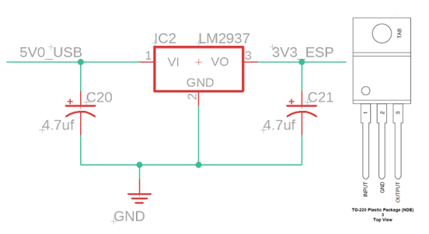
Figure 4.7: Regulator circuit using the LM2937 linear regulator. Please test this circuit before attaching to ESP8266.
  - Consider the interface between the ESP8266/ST7735 and the LaunchPad is shown below in Figures 4.4, 4.5, 4.6 and Table 4.1. The ESP8266 interface uses GPIO and UART ports on the LaunchPad. The ESP8266 interface uses UART5 running at 9600 bits/sec, 1 stop bit no parity, and no flow control (aka RTS/CTS). You can use PE3 for profiling the interface. The Port F LEDs and switches are used in the starter code, but you can repurpose these pins as needed for your Lab 4. NOTE: There are two different pinout numbering schemes for the ESP8266 on the web. The schematic in Figure 4.5 below uses the pinout numbering scheme in 4.4(B) below.
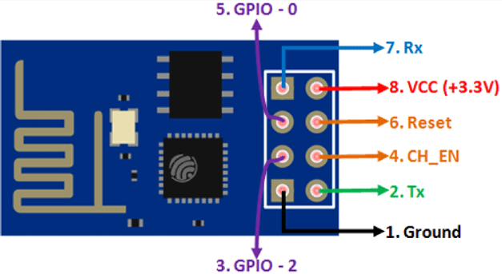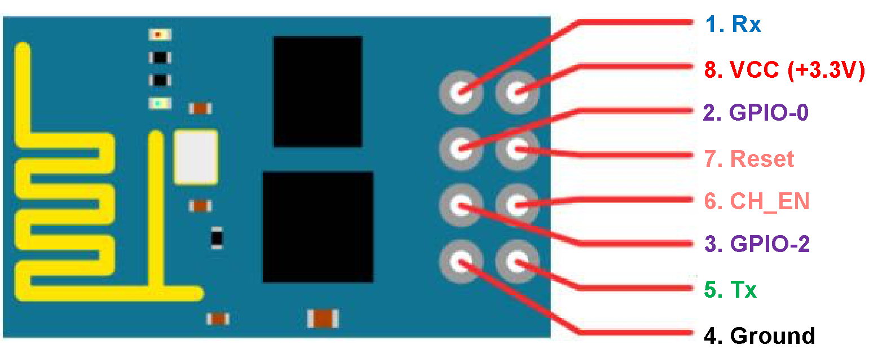
Figure 4.4A (Left) & 4.4B (Right): ESP 8266 Pinout numbering
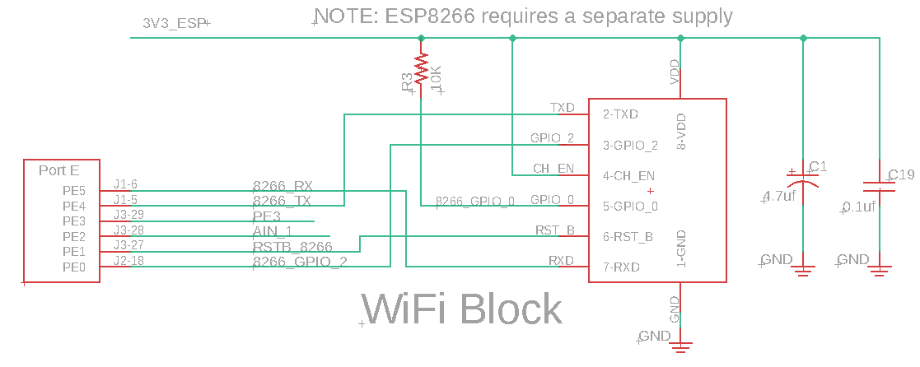
Figure 4.5: Detailed schematic of the ESP8266 interface. UART5 is used. The +3V3 supply for the ESP8266 is different from the regular LaunchPad +3.3V, see Figure 4.6. All grounds are connected together.
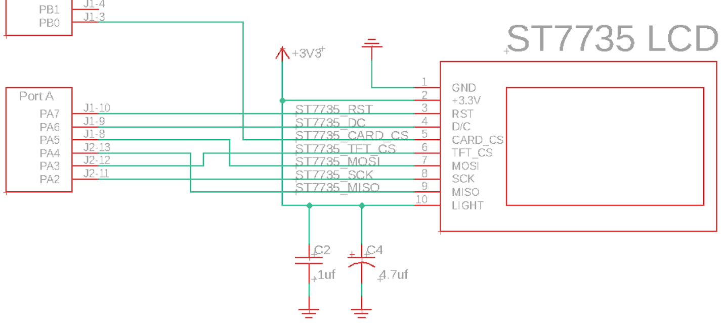
Figure 4.6: Detailed schematic of the ST7735 interface. The CARD_CS pin (pin 5) on the LCD is optional and needed only when the SDC card is being used. This 3.3V supply is the regular LaunchPad 3.3V.

Pin | Signal | Direction | Pin | Signal | Direction
P1.1 | VCC | POWER | P2.1 | GND | POWER
P1.2 | UNUSED | N/A | P2.2 | UNUSED | N/A
P1.3 | CARD_CS | OUT | P2.3 | ESP_RDY | IN
P1.4 | UNUSED | N/A | P2.4 | SWITCH | IN
P1.5 | UNUSED | N/A | P2.5 | ~RESET | IN
P1.6 | ESP_U5TX | OUT | P2.6 | UNUSED | N/A
P1.7 | ESP_U5RX | IN | P2.7 | UNUSED | N/A
P1.8 | TFT_MOSI | OUT | P2.8 | TFT_MISO | IN
P1.9 | TFT_DC | OUT | P2.9 | TFT_CS | OUT
P1.10 | TFT_RST | OUT | P2.10 | TFT_SCK | OUT
P3.1 | 5V0 | POWER | P4.1 | LED | OUT
P3.2 | GND | POWER | P4.2 | LED | OUT
P3.3 | TMP36_IN | IN | P4.3 | UNUSED | N/A
P3.4 | UNUSED | N/A | P4.4 | UNUSED | N/A
P3.5 | UNUSED | N/A | P4.5 | UNUSED | N/A
P3.6 | UNUSED | N/A | P4.6 | UNUSED | N/A
P3.7 | ESP_RSTB | OUT | P4.7 | UNUSED | N/A
P3.8 | UNUSED | N/A | P4.8 | UNUSED | N/A
P3.9 | DEBUG | OUT | P4.9 | UNUSED | N/A
P3.10 | LED | OUT | P4.10 | SWITCH | IN
Table 4.1. ESP8266, ST7735 and TMP36 connections to the TM4C123 LaunchPad.

Procedure
Procedure is performed during or before the W/TH lab session.
This lab has a lot of moving parts, so we suggest you perform the lab procedure in a specific order to minimize pain.
- Run the starter code for the ESP8266 and the Web App
- Communicate with the ESP8266 via your laptop’s serial terminal (Arduino IDE or Putty) and the web app console/monitor, seeing changes when topics are published or subscribed to.
- Read the code to get an understanding of the data flow between devices.
  - PC -> UART -> ESP -> WIFI -> MQTT Broker -> WIFI -> Web App
- Extend the system to the TM4C replacing the PC. View communications sent by the TM4C using a logic analyzer, PuTTY, or the ST7735 display.
  - Some code modifications may be required here. At this point students can split up the work, with one person working on the web interface and another on the TM4C.
- When the TM4C facing student has a working unit test that can send messages to the other student’s web interface, then do we encourage students to (1) extend the endpoint API to their desired specifications and (2) begin integrating Lab 3 into Lab 4.

ESP8266 Procedure
The ESP must be configured to connect to Wi-Fi. This can be done in two ways:
- Update the Arduino Sketch with your group’s EIDs (Line 46) (e.g. mjy358_abc123). By default, this will be xxx, and groups that do not change the EID may result in name collision with other groups.
- After flashing the device, you can then connect to the ESP via UART. The ESP will prompt the PC/TM4C to provide comma separated credentials, or to skip this and use the preloaded values via a newline/enter. An example of a credential string is shown in figure 4.8
  - Credential Format: EID, SSID, PASSWORD, MQTT_BROKER_IP_ADDRESS, PORT_NUMBER,

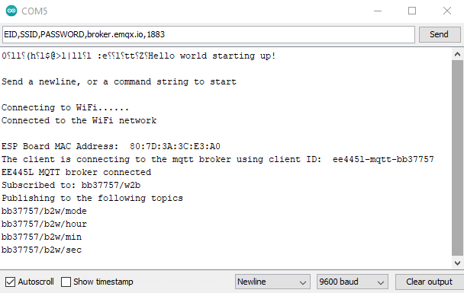
Figure 4.8. Serial Monitor.
Note that this UART interface is the same one that the TM4C will use to send data to the ESP8266. Thus, as a debugging measure, you can send premade messages to the ESP to confirm functionality of any changes you make to the Arduino code or Web app code.
At this stage, test that the ESP can receive messages sent to its subscribed topic. Additionally, send comma separated data to the ESP via UART to see how they show up in the published topics. Data sent to the ESP is split by commas, with the format of “Clock Mode, Hour, Minute, Second”. This data is then individually published to the topics listed in the serial monitor.
For this portion of the procedure, we ask that students do the following:
- Using the ESP8266 programmer, confirm that the ESP8266 can connect to a MQTT broker by manually sending commands using the serial port in the Arduino IDE.
- Come back to this later when you’ve verified that everything works. You will need to make changes to the ESP8266 MQTT driver if you want to modify subscription or publishing topics. Typically, you will want to change the topic names to suit your application. Here is what is in the example code where b2w means board-to-web and w2b means web-to-board.
- Note that the ESP software can be debugged using Arduino Serial.print() and Serial.println() functions:
// ----------------------------------------------------------------
// -------------- Publish topics --------------------------
//
const char *pub_mil = "/b2w/mil";
const char *pub_hour = "/b2w/hour";
const char *pub_min = "/b2w/min";
const char *pub_sec = "/b2w/sec";

// ----------------------------------------------------------------
// -------------- Subscribe topics ------------------------
//
char topic_w2b[20] = "/w2b";

Listing 4.2 Pub-Sub topics.

Web App Procedure
By default, the web app should connect to the EMQX server regardless of the network you are on (unless it is private and restricted to outgoing traffic).
Opening the index.html in the sw/web folder of your starter code on your web browser, you should see Figure 4.10. Pressing connect (even without a username and password) should connect you to the server. For a quick loopback test, you can subscribe and publish to the same topic, with some random message, and you should get a message received response.
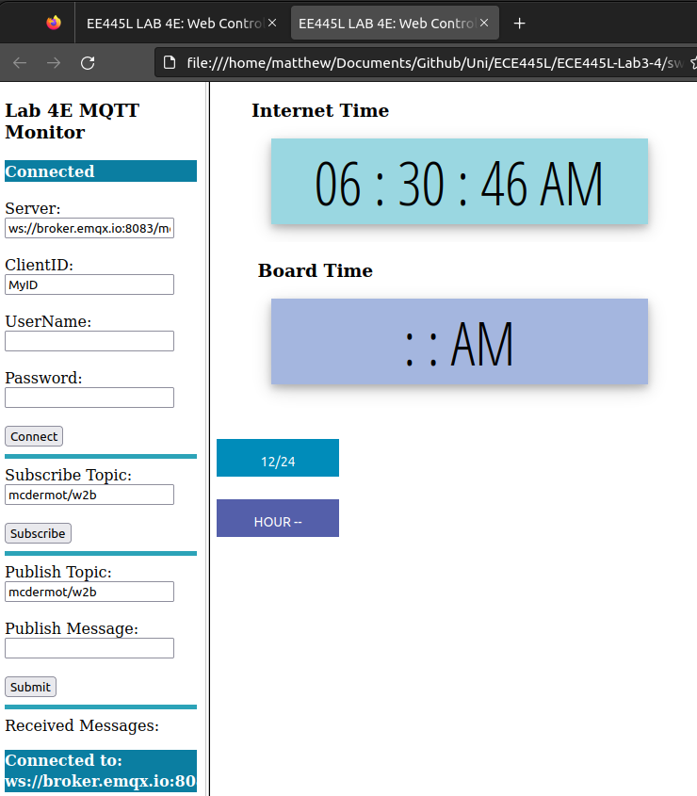
Figure 4.10: MQTT web app interface.
We also encourage you to download MQTTX (an all-in-one client toolbox that supports MacOS, Windows, and Linux), to also connect and send/receive messages between the ESP and the web app. This is like the Postman equivalent of HTTP and can be very useful for testing your web interface.
The application should be relatively straightforward to set up; just make sure you have the host and port set properly, and you should be able to connect as in Figure 4.11. You can add subscriptions in the center pane and publish to arbitrary topics on the bottom right console.

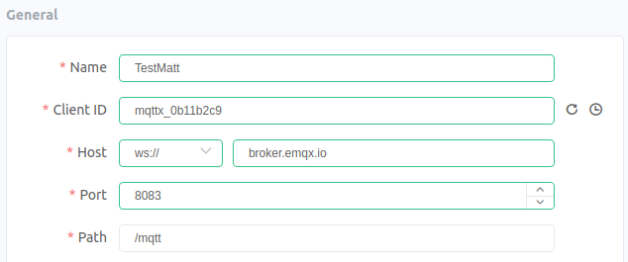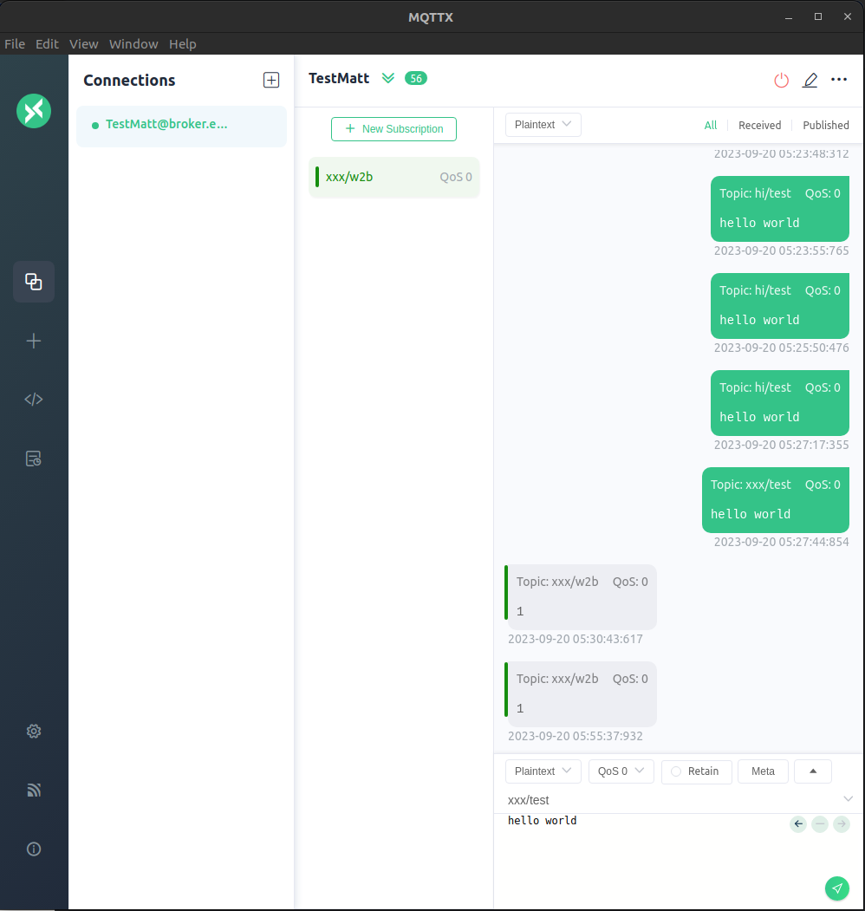
Figure 4.11. MQTTX interface.
Students who work on this portion of the lab, we suggest making a copy of this code so you can use it to continue debugging ESP8266 and TM4C functionality. With one set of code (the code you will keep), you will need to make the following modifications:
- Frames are used in this example. iFrames is now required for HTML5. Modify index.html to use iFrames for your Web Page design.
- Modify the default configuration values in mqtt_monitor.htm for your environment.
- Modify mqtt_app.htm to display the 7 command buttons. Add in a display for an ADC for extra credit (See w3schools for lots of HTML tutorials on adding buttons or displays, etc).
- Modify the default configuration values in clock_page.js for your environment.
- Modify the subscribe and publish variables in clock_page.js to comply with the data protocol that you have decided to use. Modify the following onConnect and onMessageArrived functions for handling more APIs.
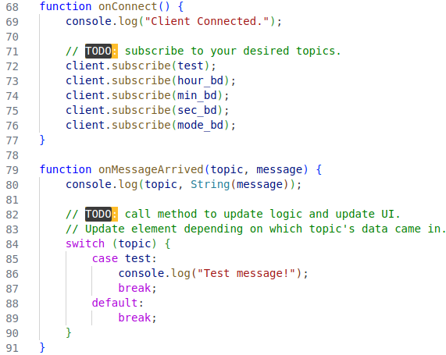
Listing 4.4. onConnect and onMessageArrived functions.

Functions to update the ESP (and the TM4C) are called from mqtt_app.htm. An example is one to toggle the MODE:
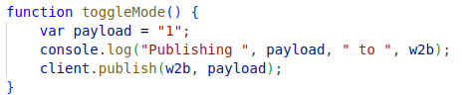
Listing 4.5. toggle_mode function.
Add additional functions that are needed for your design.

LaunchPad Procedure
The next step is to replace the human from the PC sending commands via the serial port with the TM4C. To validate that we get the same connection outputs from the ESP8266, we can use PuTTY (Windows only) to talk to the TM4C through the ICDI USB-UART debug chip via UART0. Reminder that this only work when the USB cable is plugged into the debug microUSB connector. The starter code uses 115200 bits/sec, 1 stop, no parity, and no flow control, which can be set in the connection properties for PuTTY.
You may also output the results on the ST7735 display. There are two #defines in esp8266.h you can select either one or the other, both or neither of the UART0 or the ST7735 LCD for debugging. DEBUG1 activates UART0 debugging and DEBUG3 activates ST7735 debugging. Use the Windows device manager to determine the COM port used to communication communicate with your LaunchPad (in Device Manager, click View -> Show hidden devices to view COM ports).
- You will need to debug the interface between the ESP8266 and the TM4C. The ESP8266 will assert the RDY flag once it is ready to accept commands from the TM4C. Make sure all debug messages from the ESP8266 are sent to the UART0 debug port.
The following code in the TM4C loops waiting for the flag:
while (!RDY) { // Wait for ESP8266 to indicate it is ready for programming data
#ifdef DEBUG1
UART0_OutString(".");
#endif
DelayWait10ms(30);
}
Listing 4.6. While loop on flag.
Reminder that the ESP8266 is expecting the following sequence of data to be sent to it after it asserts the RDY flag:

EID, SSID, PASSWORD, MQTT_BROKER_IP_ADDRESS, PORT_NUMBER,

Listing 4.7. Sequence input.
NOTE!!!! The sequence must be terminated with a comma and a NEWLINE (\n) as shown below:
char eid[32] = "your-EID-goes-here"; // Your EID goes here
char ssid[32] = "EE-IOT-Platform-03"; // WAP in the 445L Lab
char pass[32] = ""; // Get password from the TA
char mqtt_broker[16] = "10.159.177.244" // EER based broker
char mqtt_port[8] = "1883"; // TCP/IP MQTT port number

UART5_OutString(eid); // Student EID - Used for individualizing MQTT Topics
UART5_OutChar(',');
UART5_OutString(ssid); // Send WiFi SSID to ESP8266
UART5_OutChar(',');
UART5_OutString(pass); // Send WiFi Password to ESP8266
UART5_OutChar(',');
UART5_OutString(mqtt_broker); // Send IP address of MQTT Broker
UART5_OutChar(',');
UART5_OutString(mqtt_port); // Send MQTT port number
UART5_OutChar(','); // Extra comma needed for ESP8266 parser code
UART5_OutChar('\n'); // Send NewLine to indicate EOT

Listing 4.8. Arduino side UART capture and parsing.
- Once you can make a connection to the MQTT Broker you will need to confirm that you can subscribe to a topic and publish to a topic. Using the supplied MQTT Monitor (that your lab partner should have already gotten up and running), you will publish data to a topic that the TM4C has subscribed to. The TM4C will in turn republish the data to a different topic than the Monitor has subscribed to. This will confirm that the roundtrip from the TM4C -> Broker -> Monitor -> Broker -> TM4C is functioning.

- The next step is to set up the topics and data format between the TM4C and the WebApp. All topics MUST begin with your EID. A topic example is rg7677/b2w/hour where rg7677 is your EID and b2w is a subtopic indicating that the message is from the LaunchPad board to the Web Application and the hour is a sub-subtopic that is current hour on the board.
The topic implementation for the example code is:
// ----------------------------------------------------------------
// -------------- Publish topics --------------------------
//
const char *pub_mode = "<your_eid>/b2w/mode";
const char *pub_hour = "<your_eid>/b2w/hour";
const char *pub_min = "<your_eid>/b2w/min";
const char *pub_sec = "<your_eid>/b2w/sec";

// ----------------------------------------------------------------
// -------------- Subscribe topics ------------------------
//
char topic_w2b[20] = "<your_eid>/w2b";

Listing 4.9. Publish and subscribe topics.
The TM4C publishes four values once a second: HOUR, MIN, SEC & MODE. The values are sent to the ESP8266 in the following format: mode, hour, min, sec.
The ESP8266 converts the CSV stream into 4 topics as shown above and sends them to the Broker. The broker sends them to the Web Application which displays the time as shown below in Figure 4.12.
The Web Application publishes a single command to the TM4C since there isn’t a need to stack commands.
You can keep the same publish-subscribe topic format for this lab or modify it to be more efficient. For example, setup the TM4C to send out the number of seconds since midnight and have the Web App convert it to Hour:Min:Sec format while keeping the 12/24-hour mode active.
Figure 4.12. TM4C pub-sub command dataflow diagram.

Merge Lab 3 Code
Finally, you will need to merge your Lab 3 code with the program you just got up and running.
- Merge your Lab 3 code with the starter code.
You will find these five lines around line 35 in esp8266.c. Modify the lines of code for the environment you are working in.
char eid[32] = ""; // Your EID goes here
char ssid[32] = ""; // SSID for the WAP you are using
char pass[32] = ""; // Password for the access to the WAP
char mqtt_broker[32] = ""; // IP Address to your Broker
char mqtt_port[8] = "1883"; // Port for TCP/IP access to the Broker
Listing 4.10. Auth fields.
- Modify the following routine in MQTT.c.
void Parser(void) {
uint8_t cmd_num = atoi(w2b_cmd); // Need to convert ASCII command to integer
// ---- Command #1: Toggle MODE select
if(cmd_num == 0x1) {
if (MODE == 0x1) MODE =0x0;
else if (MODE == 0x0) MODE = 0x1; }
}

Listing 4.11. Command parser.
Modify the example code to parse commands from the Web App based on the data protocol that you have decided to use for the lab.
- The TM4C_to_MQTT routine in MQTT.c needs to be modified before it can be used.
void TM4C_to_MQTT (void) {
char msp[24] = "";
sprintf(msp, "%d", MODE);
sprintf(msp + strlen(msp),","); // Append data in CSV format
...
}

Listing 4.12. Output to ESP8266.
Modify the example code above to generate the correct data stream to the Web App based on the data protocol that you have decided to use for the lab. This
- Add calls to the corresponding initialization functions before interrupts are enabled.

Deliverable 1
Create a schematic or figure showing all external components connected to the TM4C123 board on KiCad. You do not need to show hardware components on the TM4C123 LaunchPad board. Your schematic should include at least the TM4C, The ST7735, the LDO, and the ESP.

Deliverable 2
Create a system call graph including all endpoints that you added for this lab. Your graph should show how time is updated, how time is displayed on the screen, and how data gets to the web interface.

Deliverable 3
Take screenshots in the debugger showing incoming data dumps, and jitter measurements. This data should be collected using your Lab 2 dump.c code. Specifically, you should use:
- Dump_Capture() to record some of the outgoing data (Such as what value of second is being sent) in the TM4C_to_MQTT() function calls.
- Jitter_Measure() to record the variance in timing of the MQTT_to_TM4C() function calls.

Deliverable 4
Take at least three pictures of the final alarm clock demonstrating the features of your system. These pictures should show that:
- The clock and the web interface show the same time after initialization. Use the MQTT monitor to show what data is coming in for the seconds.
- The unique features that you demonstrated in lab 3 are still present in the updated lab.

Deliverable 5
Characterize the voltage and current on the 3V3 and 5V0 lines.
- (In Lab) Disconnect the USB cable to the PC. If you have access to the lab bench supply, you can adjust the voltage output to +5V and connect it to VBUS on the LaunchPad. Verify 3.3V on the LaunchPad and 3.3V on the ESP8266. There should be between 40 and 200 mA of current on the 5V line, depending on what hardware you have connected and which software you are running. Take current measurements (both on 5V and on 3.3V to ESP8266) with
  - just the clock;
  - alarm on; and
  - during Wi-Fi communication.
- (Outside of Lab) Disconnect the USB cable to the PC. If you do NOT have access to the lab bench supply, you will remove the 2-pin jumper from the LaunchPad and connect a current meter between the pins. Reconnect the USB cable to the PC. Verify 3.3V on the LaunchPad and 3.3V on the ESP8266. There should be between 40 and 200 mA of current on the 5V line, depending on what hardware you have connected and which software you are running. Take current measurements (both on 5V and on 3.3V to ESP8266) with
  - just the clock;
  - alarm on; and
  - during Wi-Fi communication.
If you only have one current meter you can perform the experiment twice repeating the same conditions.
- Turn off power and remove the current meter(s). Connect the regulator output to the ESP8266 supply. Make sure the 2-pin jumper on the LaunchPad is connected and verify the regulator still works using a voltage measurement on the ESP8266 3.3V supply.
Document how you measured currents and report the current values (5V total and 3.3V to ESP8266) for (1) just the clock; (2) alarm on; and (3) during Wi-Fi.

Deliverable 6 (5pts Extra Credit)
Interface any sensor to the ADC of the TM4C and have it report on the web interface. The type of sensor and interface is not important. A valid solution will have a code that calibrates the sensors to real results and reports these results in a human readable format to the end user. This measurement must be sent to Web App and be displayed along with the time.
One example is a distance sensor. Here, the values read by the ADC when interface with an IR sensor are recorded for several points, then a function is created based on these measurements to report the distance.
Another example is a digital protractor. Use a potentiometer interfaced to the ADC. Measure several angles and ADC values, then create a function/map that is able to report the angle to which the potentiometer has been turned.

Lab Checkout
The lab checkout is performed during the M/T lab session.
Demonstrate that your system can control the Clock on the TM4C display data using the MQTT Web Application. Demonstrate that your system can read the sensor (extra credit) and time on the TM4C. Students should be able to display understanding of the data flow through the system and between the web interface.

Lab Report
The lab report shall be submitted by the Friday after the second lab section.
You should complete the Lab04EReport.docx file with your data and answers then submit the completed file to Canvas.

Hint (A deep dive into MQTT)
For a deep dive into the details of the MQTT protocol, there is a document in the “resources” folder of the lab starter code titled “MQTT and Lab 4.pdf”. This document has a detailed writeup and explanation of the MQTT protocol with examples of an implementation of it in an IOT system. Please refer to this resource to understand how the protocol works, as well as advice on how this is relevant to Lab 4.
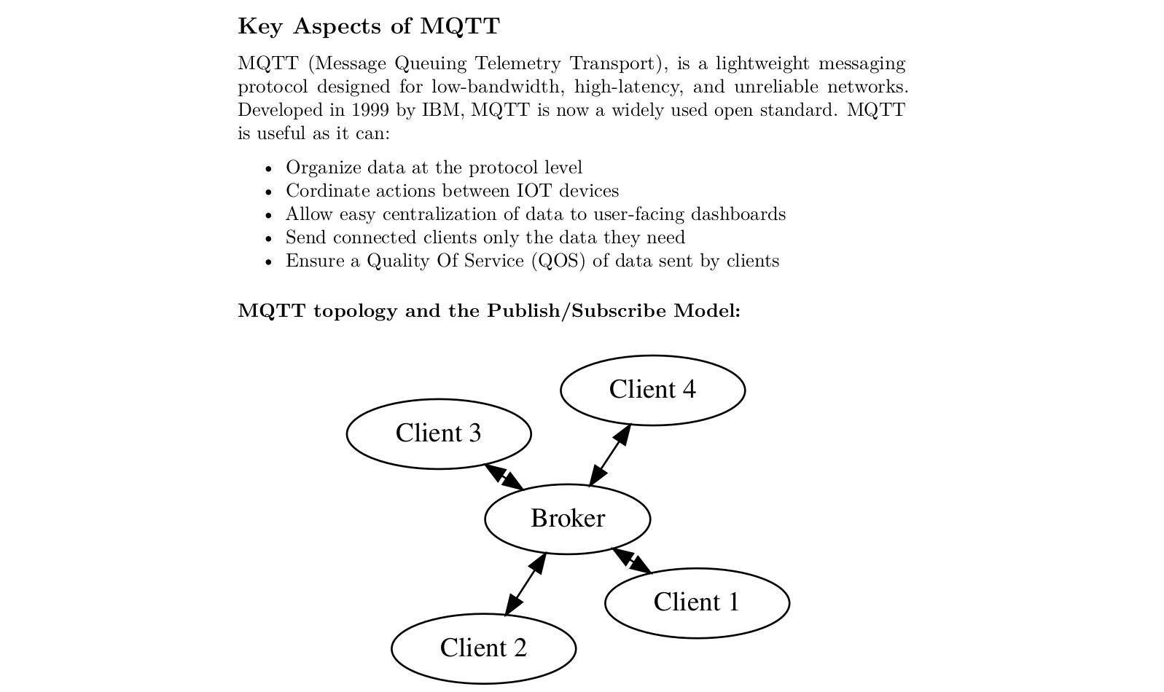
Figure 21: A screenshot of an excerpt from the MQTT writeup in the resource folder.

Hint (Arduino Setup)
To use the ESP8266-ESP01 for this class, you will need to install the Arduino IDE (preferably version 2.0) to flash the .ino file provided in the starter files using the Arduino IDE. You will need the following dependencies to program the ESP8266, which we will show how to install:
- Adding the ESP8266 boards to the board manager
- Adding the following libraries to the library manager:
  - PubSubClient by Nick O’Leary
  - Blynk by Volodymyr Shymanskyy including dependencies.

Steps:
- To program the ESP8266 via the programmer, you must have board support in the Arduino IDE. In the Arduino IDE, navigate to File-->Preferences. In the Additional board manager URL’s, add the following URL:
http://arduino.esp8266.com/stable/package_esp8266com_index.json
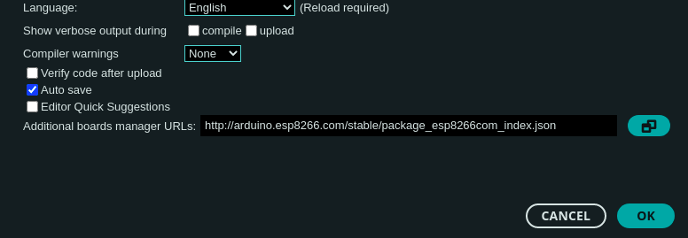
Figure 4.8: Adding Board Manager URL
- Open the Board Manager and search for “ESP8266”. If the previous step worked as it should, you should see the following package from ESP8266 Community. After installing, connect the programmer to your computer via USB and select the board as a Generic ESP8266 module.
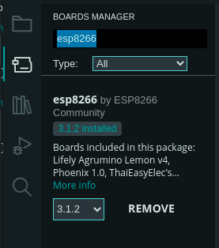
Figure 4.9: Installing the ESP8266 Board Packages
- Install the MQTT Drivers: In the library manager tab, search for “pubsubclient”, install the package called PubSubClient by Nick O’Leary.
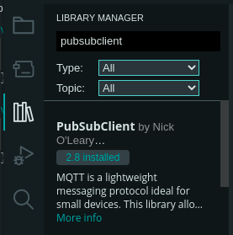
Figure 4.10: Installing MQTT Library
- Install the Blynk Driver: In the library manager tab, search for “Blynk”. Install the library titled Blynk by Volodymyr Shymanskyy.
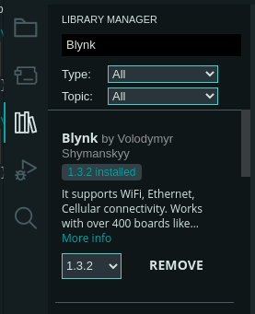
Figure 4.11: Installing Blynk Library
- To program the ESP, plug in the ESP into the programmer such that it is over the bent pins. Plug in the programmer, press the reset button on the programmer, then press D15 button twice to enter the ESP Bootloader. Within the Arduino IDE, press upload. If you are unable to connect to the board, your pins may be loose. If the board fails to program, try rebuilding and flashing this board as a NodeMCU board.

Hint (MQTT Debugging)
There are more advanced monitors (such as MQTT_Explorer) available if this homebrew tool is not adequate to debug an issue:
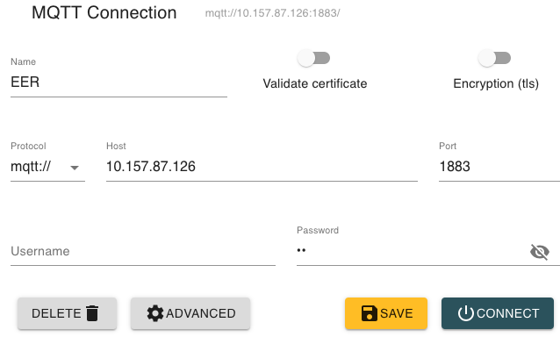
Figure 4.16. MQTT explorer.

Browser Debugging
Use the WEB browser to receive console messages from the HTML/JS code. Embed console.log messages in your code: console.log("Connection Lost: " + responseObject.errorMessage);
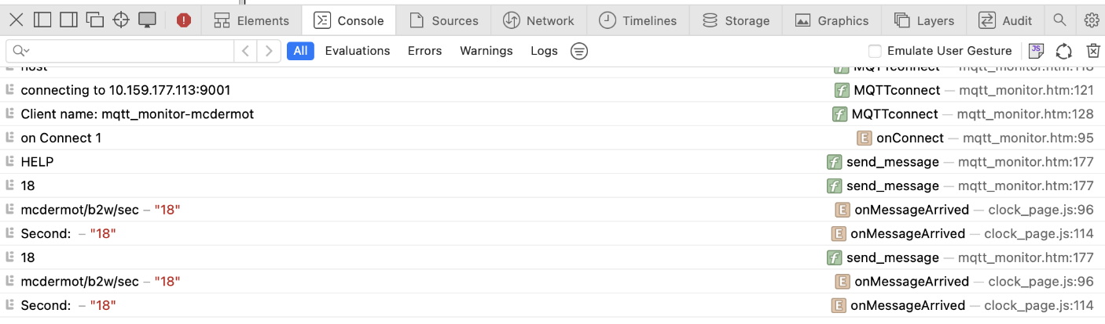
Figure 4.17. Browser console.

Internet Traffic Analysis & Debug
If the MQTT monitors are not able help debug an issue, the next step is to look at the internet traffic between the MQTT Broker and the Web App or the TM4C. You will need to use a TCP/IP analysis tool such as WireShark. You will need to know the IP address of the Broker the computer that is running the Web App. An example of a typical MQTT packet is shown below.
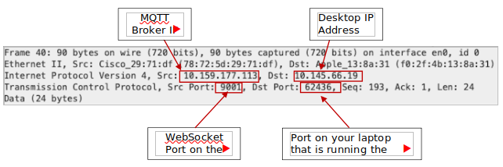
Figure 4.18. Wireshark frame.
The packet details are shown below. The subscribed data for this packet is “mcdermot/b2w/mode 0”.
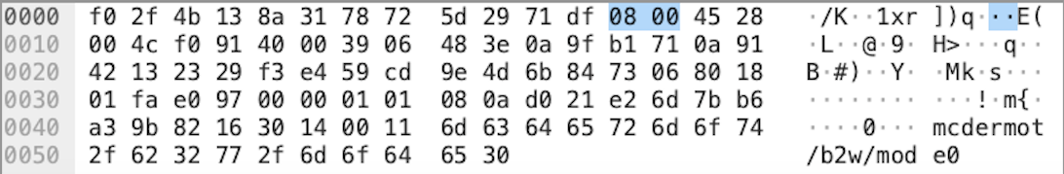
Figure 4.19. Hex packet data.
This corresponds to the subscription shown in the previous page.
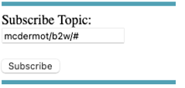
Figure 4.20 Associated topic.
Refer to these three web pages for more details on how to use WireShark.
- Installation - instructions are here
- WireShark - User Guide is here
- WireShark - YouTube tutorial is here

Hint (Notable Project Files)

LaunchPad Starter Project
The LaunchPad starter project contains the following modules:
- Lab4EMain.c is a very basic template containing some basic initialization of the various modules used for Lab 4. Incorporate your Lab3 into this file.
- MQTT.c contains the TM4C_to_MQTT and MQTT_to_TM4C routines. This code is used to bridge the TM4C123 board and the MQTT Web Application via the ESP8266 Wi-Fi board. You will be extending the W2B parser, TM4C_to_MQTT, and MQTT_to_TM4C routines to send/receive and interpret commands between the TM4C and the MQTT WebApp. We communicate with the ESP via UART5. UART2 is used for PC debugging to see that data is sent to the ESP via serial terminal on your PC.
- Timers:
  - Timer1 is used to check subscriber data from MQTT web app.
  - Timer5 is used to publish data to the MQTT web app.
  - If you use any of these timers for functionality in your Lab3, you will need to change those timers.
- Esp files
  - You are given two separate files to flash to the esp8266: esp8266_fifo.c and esp8266.c. These files will need to be merged in order to complete the lab. The file labeled esp8266_fifo.c implements a low level UART interface which is required to send data between the esp8266 and the TM4C. The implementation is interrupt driven and uses a FIFO to buffer data to and from the 8266. Similarly, esp8266.c implements the MQTT interface that enables communication between the esp8266 and the MQTT broker. By merging these files, you will create the bridge that allows messages sent over UART by the TM4C to be sent to the MQTT broker.
- MQTT.c contains the TM4C_to_MQTT and MQTT_to_TM4C routines.
- UART.c is an interface to PC for debugging (interrupt driven). Additionally, another UART channel is used to communicate with the esp8266.
- Timers.c contains code for the 3 system timers:
  - Timer0 is the 1ms (SysTick) PIT (Programmable Interval Timer).
  - Timer2 is the PIT that checks for subscriber data from MQTT Web App.
  - Timer5 is the PIT that publishes data to the MQTT Web App.

ESP8266 Starter Project
The ESP8266 contains a single starter file, ESP_to_MQTT_LAB_4E.ino. Observe the following:
- Declaration of variables for authentication, MQTT connection, publish and subscribe topics
- Routines for setting up WiFi that looks for auth data from the TM4C
- Routines for connecting to the MQTT broker and subscribing to a known topic (default is ‘/w2b’)
- Callback for receiving messages and sending it back to the TM4C
- Periodic function call to publish any available TM4C data to the MQTT broker.
You will want to modify the high-level data variables that store your relevant topics and topic values, as well as relevant publish calls in the function tm4c2mqtt.

MQTT Web Application Starter Project
The MQTT Web Application starter project contains the following modules:
- Index.html is the entrypoint for the web application. Open this in your web browser.
- clock_page.js is a JavaScript that handles the MQTT WebSocket. It talks to the MQTT broker and performs UI and data logic.
- mqtt_app.htm is the html script that displays the clocks and the buttons.
- mqtt_monitor.htm is a simple MQTT Monitor that will help with debugging.
You will want to modify clock_page.js and mqtt_app.htm for your application specifications.

