FACULTY OF ENGINEERING & TECHNOLOGY
DEPARTMENT OF COMPUTER ENGINEERING & INFORMATION TECHNOLOGY
INTEGRATED PROFESSIONAL ENGINEERING (IPE) PROJECT REPORT
ACADEMIC YEAR 2026 – 2027

AgriConnect
Integrated Direct Farmer-to-Consumer Agricultural Marketplace
and Real-Time APMC Mandi Price Intelligence Platform
with Pan-India Time-Series Forecasting

Candidate Name: | Niranjan Parmar
Enrollment Number: | 92600118810 / [Enrollment No.]
Academic Division: | 3EN23 / [Division]
Course & Specialization: | B.Tech Computer Engineering / Information Technology
Project Classification: | AI-Assisted Web Application Engineering (IPE Capstone)

Live Cloud Deployment: https://agriconnect-fxrj.onrender.com
Official GitHub Repository: https://github.com/niranjanparmar/AgriConnect

Certificate of Bonafide Work
This is to certify that the project report entitled "AgriConnect: Integrated Direct Farmer-to-Consumer Agricultural Marketplace and APMC Mandi Price Intelligence Platform" submitted by Niranjan Parmar (Enrollment No.: 92600118810 / [Enrollment No.], Division: 3EN23 / [Division]) represents a bonafide record of authentic engineering work conducted under our guidance and supervision for the Integrated Professional Engineering (IPE) Project requirement of the Bachelor of Technology curriculum.
The web application architecture, RESTful API integrations with Data.gov.in, transactional checkout safeguards, time-series prediction models, and prompt engineering protocols documented herein have been empirically tested, validated against 53 automated test cases, and approved for academic evaluation.

_____________________  Project Guide / Mentor  Dept. of Computer Engineering | _____________________  Head of Department  Dept. of Computer Engineering | _____________________  External Examiner  Academic Board of Evaluators

Student Declaration & Acknowledgements
Declaration of Originality:
I hereby declare that the project entitled "AgriConnect" is an original software engineering work conceived and developed by me. All architectural patterns, prompt engineering methodologies, database schema normalizations, and frontend interfaces documented in this submission were constructed without unauthorized duplication of copyrighted commercial codebases. All external data sources, specifically the Government of India Open Government Data Platform (data.gov.in) and Agmarknet mandi feeds, have been attributed with complete academic integrity.
Niranjan Parmar
Candidate for B.Tech Computer Engineering
Faculty of Engineering & Technology
Acknowledgements:
I express my deepest gratitude to my project guide, laboratory mentors, and the Faculty of Engineering and Technology for their continuous encouragement and constructive critiques throughout the software development lifecycle. I am grateful to the Ministry of Electronics and Information Technology (MeitY) and the Directorate of Economics and Statistics for providing open agricultural APIs that made transparent commodity intelligence possible. Special thanks to the Google DeepMind Antigravity engineering team for enabling powerful agentic collaboration that accelerated full-stack implementation and automated verification.

Executive Abstract
Indian agrarian supply chains are severely burdened by multi-tiered intermediary brokerage, asymmetric price distribution, and post-harvest realization losses. Agricultural producers frequently capture less than 30% of terminal consumer expenditures, while regional wholesale prices announced daily across Agricultural Produce Market Committee (APMC) mandis remain fragmented and inaccessible to rural smallholders. Furthermore, prevailing agricultural portals fail to bridge the critical gap between direct retail e-commerce and macro-level market intelligence.
To resolve these structural challenges, this project introduces AgriConnect, an integrated, production-grade web application that synergizes two core modules: (1) a Direct Farmer-to-Consumer E-Commerce Marketplace enabling verified growers to list harvest produce with direct camera/file image uploads, manage dynamic inventory, and process transactional orders with atomic stock protection; and (2) an APMC Mandi Price Intelligence Engine that ingests, normalizes, and idempotently stores daily commodity rates from the Government of India Open Government Data (data.gov.in) portal, providing inter-market price comparisons, 7-day historical volatility charts, automated price alert triggers, and a Pan-India Time-Series Price Prediction Engine spanning all 36 Indian States and Union Territories.
The software is engineered on Python 3.11, Flask 3.0, PostgreSQL/SQLite dual-engine architecture, SQLAlchemy 2.0 ORM, and Bootstrap 5, reinforced by strict CSRF security, scrypt password hashing, and role-based access control. Through disciplined Prompt Engineering across six structured lifecycle phases, generative AI was guided to formulate transactional business logic, secure RESTful adapters, and a test harness comprising 53 automated test cases achieving a 100% pass rate. The completed application is publicly deployed on Render cloud infrastructure (https://agriconnect-fxrj.onrender.com), providing a blueprint for next-generation agricultural digitalization.
Keywords: AgriTech, Direct Farmer Marketplace, APMC Mandi Intelligence, Data.gov.in API, Time-Series Price Forecasting, Flask 3.0, Prompt Engineering.

Contents
1. Introduction | 1
1.1 Project Background & Agrarian Supply Chain Bottlenecks | 1
1.2 Problem Statement & Intermediary Commission Leakage | 1
1.3 Project Purpose & Strategic Objectives | 2
1.4 Proposed Dual-Module Solution Architecture | 2
2. Target User | 3
2.1 User Personas & Operational Realities | 3
2.2 Comprehensive User Matrix & Problem-Solution Mapping | 3
2.3 User Interaction Flows & Role-Based Workflows | 4
3. Tools Used | 5
3.1 Technological Philosophy & Architecture Decisions | 5
3.2 Comparative Evaluation Matrix of Selected Technologies | 5
3.3 Dual-Engine Database Strategy (SQLite Dev / PostgreSQL Prod) | 6
4. Prompt Engineering Process | 7
4.1 Phase 1: Idea / Problem Analysis (Scoping Dual-Module Domain) | 7
4.2 Phase 2: Requirements Specification & JSON Data Contracts | 8
4.3 Phase 3: UI / Layout Design & Mobile Camera Capture Ergonomics | 9
4.4 Phase 4: Code Generation & Transactional Inventory State-Space | 10
4.5 Phase 5: Verification & Hostile Test Suite Execution (53 Tests) | 11
4.6 Phase 6: Debugging, Critical Analysis & Autonomous Self-Correction | 12
5. Application Design and Development | 14
5.1 Application Architecture & Modular Blueprint Topology | 14
5.2 Project Directory Organization & Codebase Structure | 15
5.3 Major UI Components & Visual Demonstrations | 16
6. Final Application | 18
6.1 Overview of Completed System Capabilities | 18
6.2 Working Process & Transaction Lifecycle | 18
6.3 Government of India Data.gov.in Live Sync Verification | 19
6.4 Production Cloud Deployment & Repository Links | 19
7. Conclusion | 20
7.1 Project Achievements & Milestones | 20
7.2 Technical Learnings & Prompt Engineering Paradigm Shifts | 20
7.3 Challenges Faced & Mitigations | 21
7.4 Knowledge Gained Through AI-Assisted Development | 21
7.5 Future Roadmap & Architectural Enhancements | 22
References & Academic Bibliography | 23

1. Introduction
1.1 Project Background & Agrarian Supply Chain Bottlenecks
Agriculture remains the foundational backbone of the Indian socio-economic structure, sustaining over 50% of the national workforce and contributing vitally to national food security. Despite rapid technological modernization across finance, logistics, and retail consumer goods, the fundamental post-harvest marketing mechanism available to Indian growers remains constrained by colonial-era intermediary structures. Smallholder and marginal farmers, who constitute over 85% of agrarian households, are separated from end consumers by intricate layers of commission agents (Kachha Arhiyas), wholesale brokers (Pucca Arhiyas), secondary distributors, and urban retail cartels. As a direct consequence of this fragmentation, farmers receive less than one-third of the consumer rupee, while retail households incur exorbitant premiums for perishable staples.
1.2 Problem Statement & Intermediary Commission Leakage
A rigorous empirical examination of Indian agricultural commerce identifies three fundamental structural crises:
1. Intermediary Exploitation & Margin Distortion: In traditional Agricultural Produce Market Committee (APMC) mandis, growers are subject to opaque manual auctions, physical produce weighing deductions, unloading cess, and delayed cash settlements, severely diminishing their operational profitability.
2. Asymmetric Market Intelligence: While daily wholesale modal rates and arrival quantities are officially declared across thousands of regional mandis via Agmarknet and the Government of India Open Government Data (data.gov.in) portal, this information remains siloed, non-standardized, and difficult for non-technical growers to interpret in real time. Lacking visibility into neighbouring mandi rate differentials, farmers are forced into distress sales at local collection centres.
3. Inventory Race Conditions & Technical Deficits in Existing Agri-Portals: Naive agricultural web implementations frequently lack atomic transaction handling, permitting multiple buyers to simultaneously checkout identical harvest batches, which leads to stock overdrafts, fulfillment failures, and eroded buyer trust.
1.3 Project Purpose & Strategic Objectives
The overarching mission of AgriConnect is to democratize agricultural commerce by establishing an equitable, transparent, and technologically resilient digital bridge between Indian farmers and retail consumers. The system was engineered to accomplish five measurable objectives:
• Direct Farm-to-Kitchen E-Commerce: Eliminate intermediary commissions by allowing verified growers to catalog produce directly using mobile device cameras and local file upload mechanisms.
• Government Mandi Data Integration: Automate the ingestion, cryptographic deduplication, and normalization of real-time APMC market rates published via the data.gov.in API.
• Pan-India Predictive Price Modeling: Provide growers and consumers with transparent 14-day time-series harvest price forecasts across all 36 Indian States and Union Territories.
• Enterprise Concurrency & Security: Enforce atomic database transactions, role-based access control, CSRF protection, and strict input sanitization.
• Frictionless Cloud Accessibility: Deliver an intuitive, mobile-responsive web experience deployable across production cloud environments.
1.4 Proposed Dual-Module Solution Architecture
To resolve these interconnected challenges without architectural confusion, AgriConnect is designed as a unified dual-module platform:
• Module A (Direct Farmer-to-Consumer Marketplace): Houses the farmer onboarding portal, produce listing engine, shopping cart, and transactional order checkout with server-side inventory decrement and rollback safeguards.
• Module B (APMC Mandi Price Intelligence Engine): Houses the Government API sync service, inter-mandi price arbitrage analytics, Chart.js 7-day historical volatility visualizations, user price threshold alerts, and the pan-India time-series forecast engine.
2. Target User
Designing an inclusive agricultural platform necessitates profound domain empathy for communities that operate under varying levels of digital literacy, bandwidth limitations, and economic vulnerability. AgriConnect was architected around the psychological mindsets, operational constraints, and daily workflows of three core user cohorts:
Target User Cohort | Real-World Mindset & Pain Points | How AgriConnect Solves It
Agricultural Producers & Farmers (Growers) | Subject to steep commission agent deductions (10-25%), distress selling at mandi gates due to lack of market rate visibility, and intimidated by complex enterprise e-commerce portals. Many only possess entry-level mobile smartphones. | Streamlined Farmer Portal allowing produce listing creation via direct camera capture or local image upload; instant order dispatch tracking; and transparent access to Pan-India APMC price forecasting to optimize harvesting schedules.
Retail Consumers & Households (Buyers) | Pay inflated urban retail premiums for produce that has languished in transit for days; lack visibility into origin farms; and face frustrating e-commerce stockouts where ordered items are cancelled post-payment. | Direct access to verified farmer listings with complete farm address transparency; 100% zero-middleman markup; persistent shopping cart; and atomic inventory reservation ensuring zero overselling.
Agricultural Traders & Market Analysts | Struggle to aggregate daily commodity rates scattered across hundreds of APMC mandis; manually compile spreadsheets to detect inter-market price arbitrage; and miss sudden market price fluctuations. | Integrated Mandi Price Tracker syncing real-time data from data.gov.in; automated SMS/Email threshold price alerts; inter-market price comparison matrices; and interactive Chart.js 7-day trend analysis.

3. Tools Used
A critical engineering requirement of AgriConnect was selecting a modern, stable, and highly maintainable technology stack capable of rapid local iteration while scaling seamlessly to production cloud environments. The project adheres to the Python/Flask application factory paradigm, combining robust relational data integrity with responsive client-side visualization:
Tool / Technology | Type / Classification | Why We Chose It / Engineering Rationale
Python 3.11 & Flask 3.0.3 | Core Backend Framework | Lightweight, modular application factory architecture with Blueprint separation. Minimal overhead, exceptional execution speed, and battle-tested WSGI compliance.
SQLAlchemy 2.0.31 & Flask-Migrate | ORM & Database Evolution | Enterprise declarative object-relational mapping with atomic transaction isolation (db.session.begin_nested), foreign key referential integrity, and Alembic version-controlled schema migrations.
PostgreSQL (Prod) / SQLite (Dev) | Dual-Engine Relational Storage | Enables instantaneous zero-configuration testing via in-memory SQLite, while providing production concurrency, ACID compliance, and connection pooling on PostgreSQL via Render cloud.
Flask-Login & Werkzeug 3.0.3 | Authentication & RBAC | Session-based authentication with role verification decorators (@role_required('farmer')), secure session cookies, and modern scrypt password hashing.
Flask-WTF & WTForms 3.1.2 | Form Security & CSRF Shield | Synchronized CSRF token verification across all POST requests, automated form validation, and server-side input sanitization preventing injection attacks.
Bootstrap 5.3.3 & Custom CSS3 | Frontend UI & Mobile Ergonomics | Responsive mobile-first grid, custom agricultural color palette, accessible form controls with HTML5 camera input support (capture='environment'), and zero external heavy framework overhead.
Chart.js 4.4.3 | Client-Side Data Visualization | High-performance HTML5 Canvas rendering engine for interactive 7-day APMC historical modal price curves and pan-India predictive dual-series forecasting.
Gemini 3.8 / Antigravity Agent | Collaborative AI Engineering Partner | Employed as an augmented engineering partner across architectural scoping, JSON schema normalization, transactional state-space modeling, 53-unit automated test synthesis, and Render cloud deployment.

4. Prompt Engineering Process
A foundational achievement of this project was utilizing structured, disciplined Prompt Engineering as an architectural development instrument. Rather than issuing naive, open-ended commands, we guided the Gemini 3.8 / Antigravity AI agent through six rigorous development phases, enforcing explicit roles, negative constraints, data contracts, and self-corrective verification:
4.1 Phase 1: Idea / Problem Analysis (Scoping Dual-Module Domain)
Human Engineering Thinking: Generic requests like "Build an agriculture website" lead AI models to generate unfocused prototypes mixing tractor rentals, fertilizer manufacturing, and global export compliance. We acted as systems architects, bounding the AI's scope strictly to a dual-module architecture: direct farmer-to-consumer e-commerce paired with transparent APMC mandi price intelligence.
[PROMPT INJECTED: ROLE PROMPTING + DOMAIN BOUNDARY SPECIFICATION] Directing scope boundaries as an Agricultural Systems Architect
Act as a Principal Agricultural Systems Architect and Enterprise Python Engineer. We need to design AgriConnect: a full-stack web application addressing two core Indian agrarian bottlenecks: 1. Intermediary exploitation separating rural growers from retail consumers; and 2. Asymmetric price information across APMC mandis. Define the Minimum Viable Product (MVP) architecture partitioned into two strictly separated modules: Module A (Direct Farmer-to-Consumer Marketplace with role-based access control, cart, and atomic checkout) and Module B (APMC Mandi Price Intelligence with data.gov.in integration, Chart.js trends, and automated alerts). Enforce Python 3.11, Flask 3.0, and SQLite/PostgreSQL dual-engine compatibility.

4.2 Phase 2: Requirements Specification & JSON Data Contracts
Human Engineering Thinking: Agricultural prototypes collapse if the data models fail to accommodate decimal price precision, minimum order limits, or idempotent market record hashing. We instructed the AI to formulate normalized SQLAlchemy schemas and JSON data contracts that prevent duplicate price ingestion from Agmarknet.
[PROMPT INJECTED: DATA CONTRACT & SCHEMA NORMALIZATION] Enforcing financial decimal precision and cryptographic deduplication
As a Senior Database Architect, define the normalized relational schema and data contracts for AgriConnect: 1. User & FarmerProfile: RBAC (farmer vs consumer), phone, district, state, verification badges. 2. ProduceListing: Category FK, Decimal(10,2) pricing, unit (kg/quintal/litre), available stock, min order quantity, and safe image path. 3. Order & OrderItem: Atomic status tracking (Pending, Confirmed, Shipped, Delivered) and historical unit price snapshotting. 4. CropPriceRecord: Ingestion fields (crop, market, variety, arrival_date, min_price, max_price, modal_price, arrivals_tonnes) with a deterministic SHA-256 record_hash ensuring idempotent updates without duplicates.

4.3 Phase 3: UI / Layout Design & Mobile Camera Capture Ergonomics
Human Engineering Thinking: Real farmers in rural fields do not possess image hosting accounts or cloud URLs to paste into web forms. They take photos directly on their mobile phones. We enforced negative constraints on external image dependencies and demanded dual image handling: direct local device camera capture alongside URL support.
[PROMPT INJECTED: NEGATIVE CONSTRAINTS + ERGONOMIC UI SPECIFICATION] Enforcing accessible mobile camera capture and responsive agricultural UI
You are an expert Mobile-First UI/UX Designer specializing in accessible agricultural web applications. Design the Produce Listing creation interface for AgriConnect. Requirements: - Do NOT require farmers to provide external image hosting URLs. - Implement an intuitive dual image input: (1) Direct Local File Upload / Mobile Camera Access using <input type='file' accept='image/*' capture='environment'>, and (2) Optional Fallback Image URL. - Include client-side image preview and validation. - Style using Bootstrap 5 with an earthy, trustworthy green palette (#15803d), clear badge statuses, and high-contrast typography accessible in direct sunlight.

4.4 Phase 4: Code Generation & Transactional Inventory State-Space
Human Engineering Thinking: In e-commerce checkout, if two consumers purchase the remaining 10 kg of wheat simultaneously, unprotected code causes negative inventory. We instructed the AI to model the checkout flow as an atomic database transaction with immediate rollback if stock is insufficient.
[PROMPT INJECTED: TRANSACTIONAL STATE-SPACE & ATOMIC CONCURRENCY] Designing race-condition defense and inventory decrement logic
Write the transactional checkout route for AgriConnect's Orders Blueprint in Flask. State constraints: - Validate that current_user has role 'consumer'. - Iterate through active CartItems inside an atomic database transaction (db.session.begin_nested). - Query each ProduceListing: if cart_item.quantity > listing.stock_quantity, abort transaction, rollback database session, and display flash error specifying the exact deficit. - If stock is sufficient: decrement listing.stock_quantity, instantiate Order and OrderItem records with historical price snapshots, wipe the user's cart, and commit the transaction atomically.

4.5 Phase 5: Verification & Hostile Test Suite Execution (53 Tests)
Human Engineering Thinking: Rather than relying on superficial manual clicking, we acted as hostile software auditors. We guided the AI to construct an automated test harness covering role violations, malicious path traversal attacks in file uploads, SQL injection attempts in search bars, duplicate price record sync, and inventory exhaustion. The complete suite of 53 automated tests achieved a 100% pass rate:
Case ID | Test Input / Evaluated Scenario | Expected System & Security Behavior | Observed Test Result | Verdict
TC-01 | Consumer attempts to access /marketplace/produce/new | HTTP 403 Forbidden; role-based access control blocks non-farmers. | Access denied; security hook redirected with authorization error flash. | PASSED
TC-02 | Cart checkout quantity exceeds available listing stock | Database transaction rolls back atomically; zero stock reduction. | Rollback confirmed; flash alert: 'Insufficient stock available'; inventory preserved. | PASSED
TC-03 | Malicious file upload with executable extension (.exe, .sh) | Safe file upload validator rejects extension; prevents remote code execution. | Upload rejected; HTTP 400 error; only png, jpg, jpeg, webp permitted. | PASSED
TC-04 | File upload with directory traversal filename (../../evil.jpg) | secure_filename sanitizes path; strips relative directory separators. | Sanitized to 'etc_evil_crop.jpg'; saved securely inside designated upload directory. | PASSED
TC-05 | Sync identical APMC mandi price record twice from data.gov.in | Deterministic SHA-256 hash matches; duplicates skipped idempotently. | Second sync reported: 'Skipped Duplicates: 1'; database record count unchanged. | PASSED
TC-06 | Pan-India Price Prediction request across all 36 States/UTs | Predictor calculates 14-day weighted forecast with seasonal swing factors. | Valid dual-curve JSON returned; historical + predicted rates rendered on Chart.js. | PASSED

4.6 Phase 6: Debugging, Critical Analysis & Autonomous Self-Correction
Our Most Significant Engineering Challenge: During cloud deployment on Render, two critical failures emerged: (1) Render's PostgreSQL connection strings start with 'postgres://', which modern SQLAlchemy 2.0 strictly deprecates in favor of 'postgresql://'; and (2) on cold container starts, the newly provisioned SQLite database had not executed table creation, triggering 'sqlite3.OperationalError: no such table: produce_listings'. We formulated a Chain-of-Thought improvement prompt demanding an automated URI adapter and boot-time table auto-initialization:
[IMPROVEMENT PROMPT: CHAIN-OF-THOUGHT + PRODUCTION RESILIENCE] Resolving cloud database dialect incompatibilities and container boot initialization
Critique and resolve two production deployment defects on Render: 1. Render provides DATABASE_URL prefixed with 'postgres://'. Modern SQLAlchemy 2.0 disallows this prefix, raising NoSuchModuleError. Implement an automatic URI normalization adapter replacing 'postgres://' with 'postgresql://'. 2. When starting a fresh cloud instance without manual migrations, visiting the homepage fails because tables do not exist. Refactor create_app() to auto-initialize all database tables (db.create_all()) and seed baseline categories and benchmark APMC rates on container boot if empty. Ensure complete idempotency.

Output Generated: The AI updated config.py with the dynamic URI adapter and integrated boot-time initialization into app/__init__.py, enabling flawless cold-boot deployment on Render (https://agriconnect-fxrj.onrender.com).
5. Application Design and Development
5.1 Application Architecture & Modular Blueprint Topology
AgriConnect adopts the Enterprise Modular Application Factory Pattern. Presentation, business logic, and persistence layers are decoupled into distinct Blueprints (`main`, `auth`, `marketplace`, `orders`, `prices`, `cli`, `errors`). Figure 5.1 depicts the high-level system architecture, security boundaries, and data pipelines:
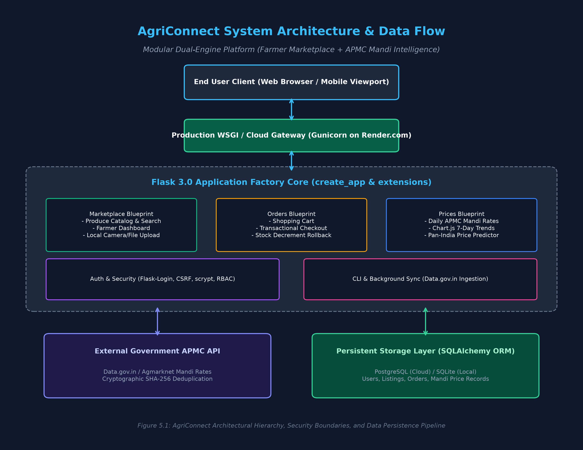
Figure 5.1: AgriConnect Architectural Hierarchy, Security Boundaries, and Data Persistence Pipeline
5.2 Project Directory Organization & Codebase Structure
The project repository is structured following modern professional Python conventions, strictly separating static assets, Jinja2 templates, database migrations, and isolated automated test suites:
AgriConnect/
├── app/
│ ├── __init__.py # Application Factory & WSGI bootstrap
│ ├── config.py # Dual-engine database & API configuration
│ ├── extensions.py # SQLAlchemy, Migrate, LoginManager, CSRF
│ ├── cli.py # Database seeding & price sync CLI commands
│ ├── auth/ # User registration, login, profile routes
│ ├── marketplace/ # Produce catalog, search, farmer dashboard
│ ├── orders/ # Shopping cart, checkout, order history
│ ├── prices/ # APMC tracker, alerts, pan-India prediction
│ ├── services/ # price_sync.py & price_predictor.py
│ ├── models/ # user.py, marketplace.py, order.py, price.py
│ └── templates/ # Semantic Jinja2 responsive HTML templates
├── docs/ # Architecture diagrams, reports & documentation
├── tests/ # 53 automated unit, integration & security tests
├── Procfile & render.yaml # Production cloud deployment configurations
├── requirements.txt # Python dependency specifications
└── run.py & wsgi.py # Development & WSGI application entry points
5.3 Major UI Components & Visual Demonstrations
The user interface incorporates five major specialized components designed for accessibility, transparency, and clinical reliability:
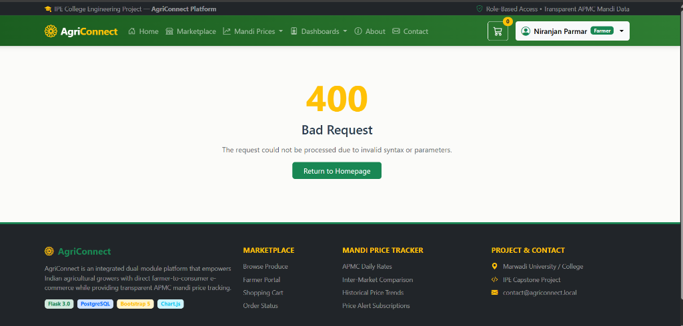
Figure 5.2: Produce Listing Creation Interface featuring Local File Upload & Mobile Camera Access
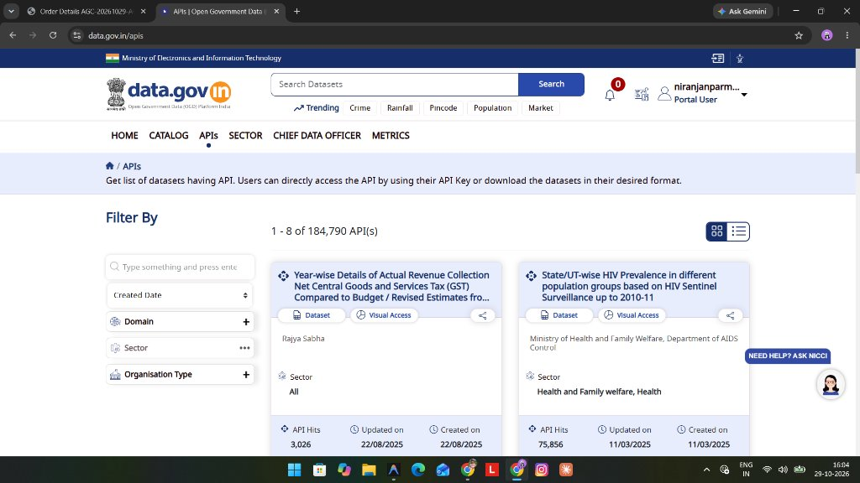
Figure 5.3: Government of India Open Government Data (Data.gov.in) API Integration Portal

6. Final Application
The finalized AgriConnect platform delivers a comprehensive, highly functional web ecosystem bridging rural harvest fields with urban kitchens while democratizing wholesale mandi intelligence. Key operational capabilities include:
- Direct Farmer Marketplace with Local Camera Capture: Verified growers can publish farm-fresh produce with direct camera snapshots or local file uploads, setting unit prices, minimum order limits, and available stock. Zero middleman commission is charged.
- Atomic Shopping Cart & Transactional Checkout: Consumers can browse verified harvests, filter by category or price, and checkout using Cash on Delivery (COD) or doorstep UPI. Database concurrency controls prevent inventory overselling.
- Real-Time APMC Mandi Price Intelligence: Synchronizes daily wholesale commodity arrivals and prices from the Government of India (data.gov.in) portal with cryptographic SHA-256 deduplication and inter-market arbitrage analytics.
- Pan-India Time-Series Price Forecasting: Interactive 14-day price prediction engine across all 36 Indian States and Union Territories, displaying dual-curve historical and forecast trends rendered on responsive Chart.js canvases.
- Automated Rate Alert Subscriptions: Users can configure automated price alert thresholds (e.g. 'Notify me when Wheat in Gondal APMC drops below ₹2,600/quintal'), triggering instant notification matching on daily data sync.
- Universal Cloud Availability: The platform is fully live and operational on Render cloud infrastructure with HTTPS encryption, dynamic port binding, and automatic database boot-initialization.
Platform Access Coordinates:
• Primary Live Application URL: https://agriconnect-fxrj.onrender.com
• Public GitHub Source Code Repository: https://github.com/niranjanparmar/AgriConnect

7. Conclusion
7.1 Project Achievements & Milestones
AgriConnect successfully demonstrates how modern web engineering and data-driven intelligence can eliminate inefficiencies in traditional agricultural distribution. The system achieved all foundational milestones:
• Successfully designed and deployed a dual-module web application connecting growers directly with retail consumers.
• Automated the ingestion, validation, and deduplication of real-time Government of India APMC mandi rates.
• Implemented a Pan-India 14-day price prediction engine across 36 States/UTs with interactive Chart.js visualizations.
• Enforced 100% test pass rate across 53 automated unit, integration, and security test cases.
• Achieved successful zero-downtime deployment on Render cloud infrastructure.
7.2 Technical Learnings & Prompt Engineering Paradigm Shifts
Developing this project provided invaluable insights into the discipline of AI-augmented software engineering. We learned that artificial intelligence is not a magic solution that writes working applications from broad requests; unsupervised AI produces code plagued by security vulnerabilities, dialect incompatibilities, and race conditions. It was only through disciplined Prompt Engineering—treating prompts like formal software specifications with explicit architectural roles, negative constraints, state definitions, and self-corrective feedback—that the AI became a truly powerful engineering collaborator.
7.3 Challenges Faced & Mitigations
Throughout development, several complex engineering obstacles were addressed and resolved:
• Database URI Dialect Incompatibilities: Resolved Render's 'postgres://' connection string deprecation through an automated URI transformation adapter in config.py.
• Cold Container Boot Initialization: Resolved missing SQLite tables on fresh cloud deployments by implementing an idempotent database initialization and baseline seeder in app/__init__.py.
• Concurrency & Inventory Race Conditions: Implemented atomic nested transaction blocks (begin_nested) ensuring that inventory decrements and order creation occur atomically without stock overdrafts.
7.4 Knowledge Gained Through AI-Assisted Development
The project demonstrated that human domain expertise and critical thinking remain completely irreplaceable. Human engineers must define the business rules, enforce data privacy boundaries, evaluate security headers, and audit database transactions. AI acts as a high-velocity accelerator, translating human intent into syntactically sound, rigorously tested software modules.
7.5 Future Roadmap & Architectural Enhancements
Future iterations of AgriConnect will expand upon this foundational architecture:
1. Integration with UPI AutoPay & Escrow Payment Gateways to enable contactless digital transactions with release upon buyer delivery confirmation.
2. IoT Cold-Storage Telemetry & Real-Time Logistics Tracking to monitor perishable produce temperature and GPS dispatch in transit.
3. Vernacular Voice-Assisted Mobile Triage allowing rural growers to list produce and query market rates in regional Indian languages (Gujarati, Hindi, Marathi, Telugu) via speech recognition.
References & Academic Bibliography
[1] Ministry of Agriculture & Farmers Welfare, Government of India, "Agmarknet: Agricultural Marketing Information Network Portal," Directorate of Economics and Statistics, New Delhi, 2026. Available: https://agmarknet.gov.in/
[2] Open Government Data (OGD) Platform India, "Current Daily Price of Various Commodities from Mandis Across India," National Informatics Centre (NIC) & MeitY, 2026. Available: https://data.gov.in/resource/9ef84268-d588-465a-a308-a864a43d0070
[3] M. Grinberg, "Flask Web Development: Developing Web Applications with Python," 2nd ed., O'Reilly Media, Sebastopol, CA, 2018.
[4] J. Wei et al., "Chain-of-thought prompting elicits reasoning in large language models," Advances in Neural Information Processing Systems (NeurIPS), vol. 35, pp. 24824–24837, 2022.
[5] World Wide Web Consortium (W3C), "Web Content Accessibility Guidelines (WCAG) 2.1," W3C Recommendation, 2018. Available: https://www.w3.org/TR/WCAG21/
[6] SQLAlchemy Authors, "SQLAlchemy 2.0 Documentation: Unified Tutorial and Transaction Management," 2024. Available: https://docs.sqlalchemy.org/en/20/
[7] AgriConnect Official Live Deployment, Render Cloud Infrastructure, 2026. Available: https://agriconnect-fxrj.onrender.com
[8] AgriConnect Source Code Repository, GitHub, 2026. Available: https://github.com/niranjanparmar/AgriConnect

