Scenario 1 – Amazon-style Electronics Store

Aim
To create an e-commerce homepage for an electronics store with product categories, a promotional banner, product cards, prices, and Add to Cart functionality.

Algorithm
- Start the program and create the basic HTML document structure.
- Set the page title and define CSS styles for the navigation bar, banner, product grid, product cards, images, and buttons.
- Create a navigation bar containing the store name and product categories such as Mobiles, Laptops, and Accessories.
- Create a promotional banner that displays a sale message or discount.
- Declare a JavaScript array containing at least six products and their prices.
- Create an empty container in the HTML where the product cards will be displayed.
- Use a JavaScript loop or array mapping method to read each product from the array.
- For each product, generate a card containing its image, product name, price, and Add to Cart button.
- Attach a click event to each Add to Cart button so that the selected product is identified.
- Display a confirmation message when a product is added, then open the page in a browser and test the buttons.

Source Code
<!DOCTYPE html>
<html>
<head>
<title>Electronics Store</title>
<style>
body{font-family:Arial;margin:0;background:#f5f5f5}
nav{background:#222;color:white;padding:18px}
nav a{color:white;margin:20px;text-decoration:none}
.banner{background:#2874f0;color:white;text-align:center;padding:35px}
.products{display:grid;grid-template-columns:repeat(3,1fr);gap:20px;padding:25px}
.card{background:white;padding:20px;text-align:center;border-radius:10px}
.card img{width:120px;height:100px;object-fit:contain}
button{background:#ff9f00;border:0;padding:10px 20px;cursor:pointer}
</style>
</head>
<body>
<nav><b>ElectroMart</b>
<a href="#">Mobiles</a><a href="#">Laptops</a><a href="#">Accessories</a></nav>
<div class="banner"><h1>Big Electronics Sale</h1><p>Up to 50% OFF</p></div>
<div class="products" id="products"></div>
<script>
const items=[
["Smartphone","₹20,000"],["Laptop","₹55,000"],["Headphones","₹2,500"],
["Smart Watch","₹3,500"],["Tablet","₹18,000"],["Bluetooth Speaker","₹2,000"]
];
document.getElementById("products").innerHTML=items.map(p=>`
<div class="card"><img src="https://via.placeholder.com/150" alt="Product">
<h3>${p[0]}</h3><p>${p[1]}</p>
<button onclick="alert('Added to cart: ${p[0]}')">Add to Cart</button></div>`).join("");
</script>
</body>
</html>

Output
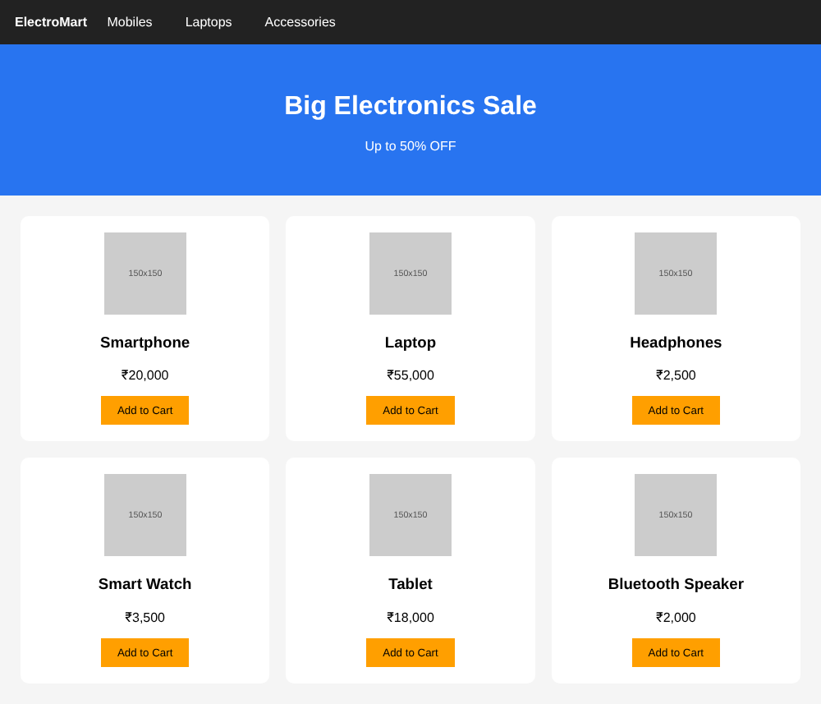
Output 1: Electronics store homepage with navigation bar, sale banner and six product cards
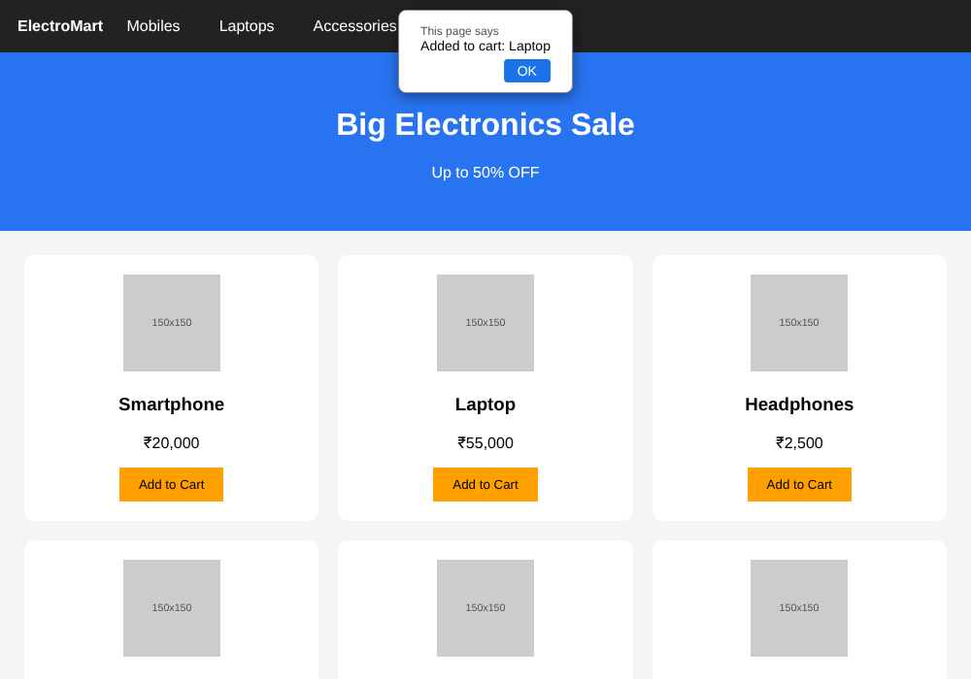
Output 2: Clicking "Add to Cart" on the Laptop card shows the confirmation message

Result
The homepage rendered with the navigation bar, sale banner and six product cards (image, name, price). Each Add to Cart button identified its product and displayed a confirmation message.

Scenario 2 – Zomato-style Food Ordering Site

Aim
To develop a restaurant listing webpage with restaurant search, cuisine filtering, ratings, and a menu showing dishes with prices.

Algorithm
- Start the program and create the HTML structure for the food-ordering page.
- Add a heading area with the website name and a short description.
- Create a search input to enter a restaurant name.
- Create a cuisine drop-down list with options such as Indian, Chinese, and Italian.
- Prepare a JavaScript array containing restaurant names, cuisine types, and ratings.
- Create a container to display the restaurant results.
- When the page loads, call a display function to show the available restaurants.
- Inside the function, read the search text and selected cuisine from the form controls.
- Filter the restaurant array by checking the name and cuisine conditions.
- Display a card for every matching restaurant with its cuisine, rating, and at least five menu dishes with prices.
- Call the display function whenever the search text or cuisine selection changes.
- Test the page using different restaurant names and cuisine selections.

Source Code
<!DOCTYPE html>
<html>
<head>
<title>Food Ordering</title>
<style>
body{font-family:Arial;background:#f5f5f5;margin:0}
header{background:#1976d2;color:white;padding:20px;text-align:center}
.controls{text-align:center;padding:20px}
input,select{padding:10px;margin:5px}
.card{background:white;padding:20px;margin:15px;border-radius:10px}
</style></head>
<body>
<header><h1>Food Hub</h1><p>Find your favourite restaurant</p></header>
<div class="controls">
<input id="search" placeholder="Search restaurant">
<select id="cuisine"><option value="">All Cuisine</option>
<option>Indian</option><option>Chinese</option><option>Italian</option></select>
</div>
<div id="restaurants"></div>
<script>
const data=[
{name:"Spice Garden",cuisine:"Indian",rating:4.5},
{name:"Chinese Wok",cuisine:"Chinese",rating:4.2},
{name:"Pizza House",cuisine:"Italian",rating:4.6},
{name:"South Kitchen",cuisine:"Indian",rating:4.3}
];
function display(){
const s=document.getElementById("search").value.toLowerCase();
const c=document.getElementById("cuisine").value;
document.getElementById("restaurants").innerHTML=data.filter(x=>
x.name.toLowerCase().includes(s)&&(!c||x.cuisine===c)).map(x=>`
<div class="card"><h2>${x.name}</h2><p>Cuisine: ${x.cuisine}</p>
<p>Rating: ${x.rating}</p><h3>Menu</h3>
<p>Biriyani - ₹180 | Fried Rice - ₹150 | Noodles - ₹140</p>
<p>Pizza - ₹250 | Ice Cream - ₹80</p></div>`).join("");
}
document.getElementById("search").addEventListener("input",display);
document.getElementById("cuisine").addEventListener("change",display);
display();
</script></body></html>

Output
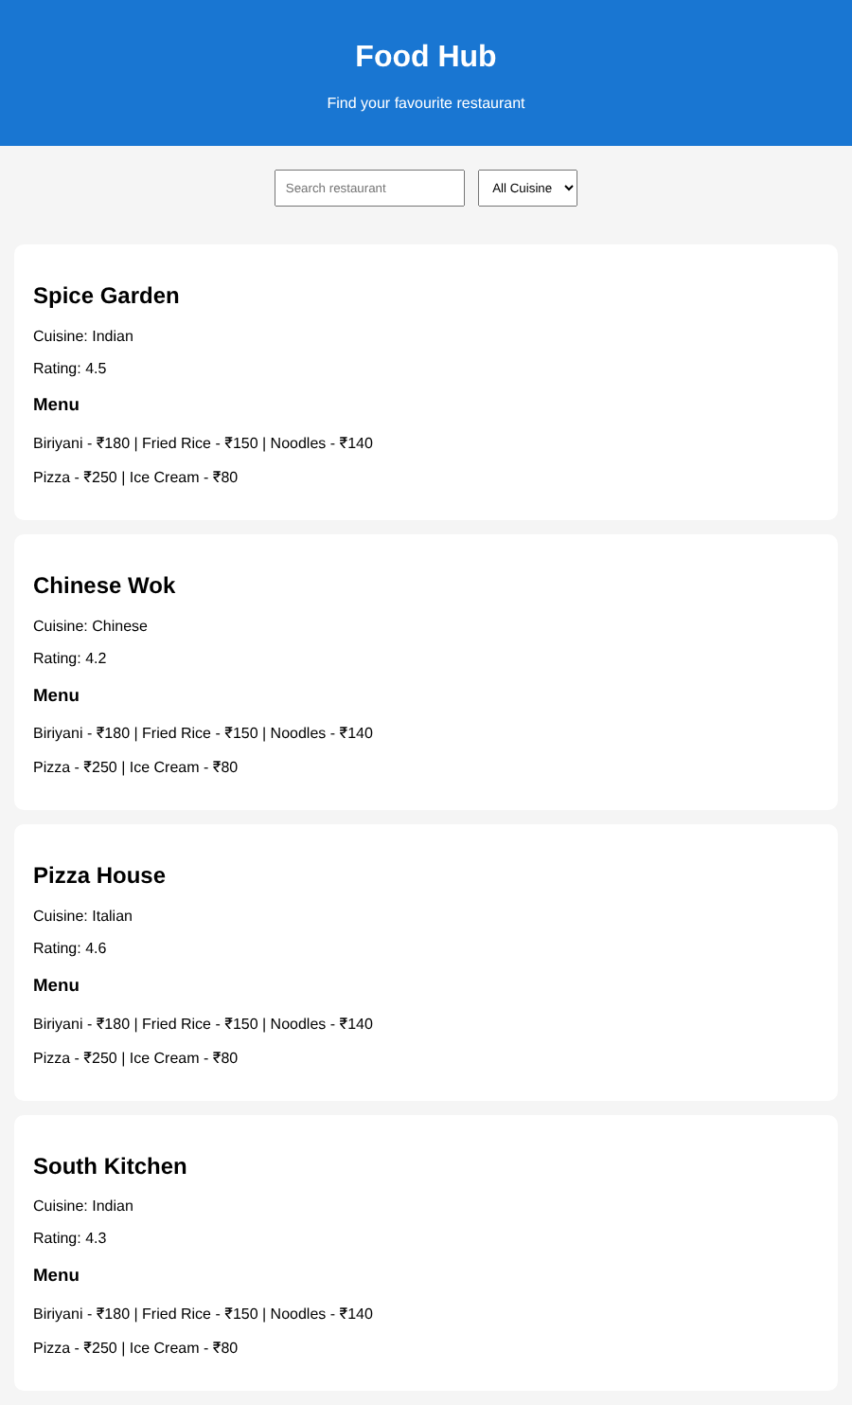
Output 1: All restaurants displayed on page load (no filter)
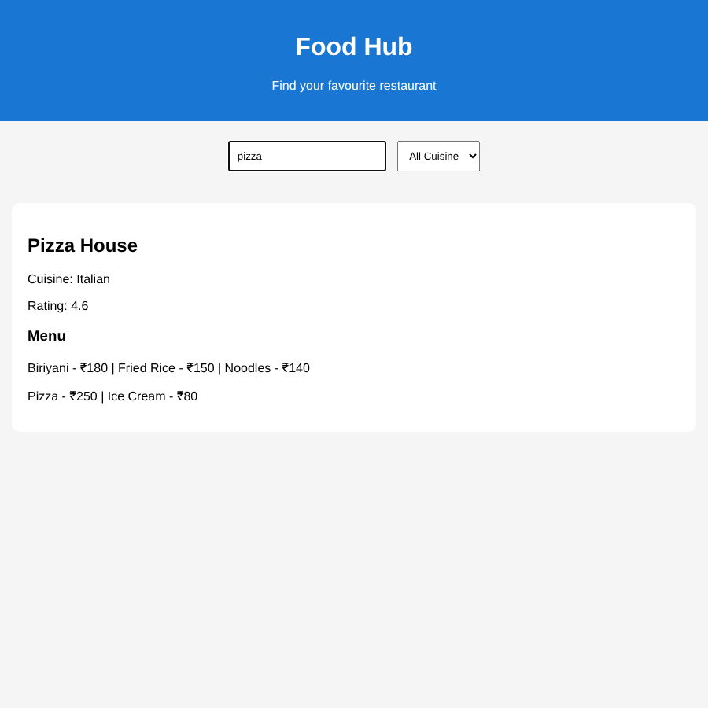
Output 2: Searching "pizza" shows only Pizza House
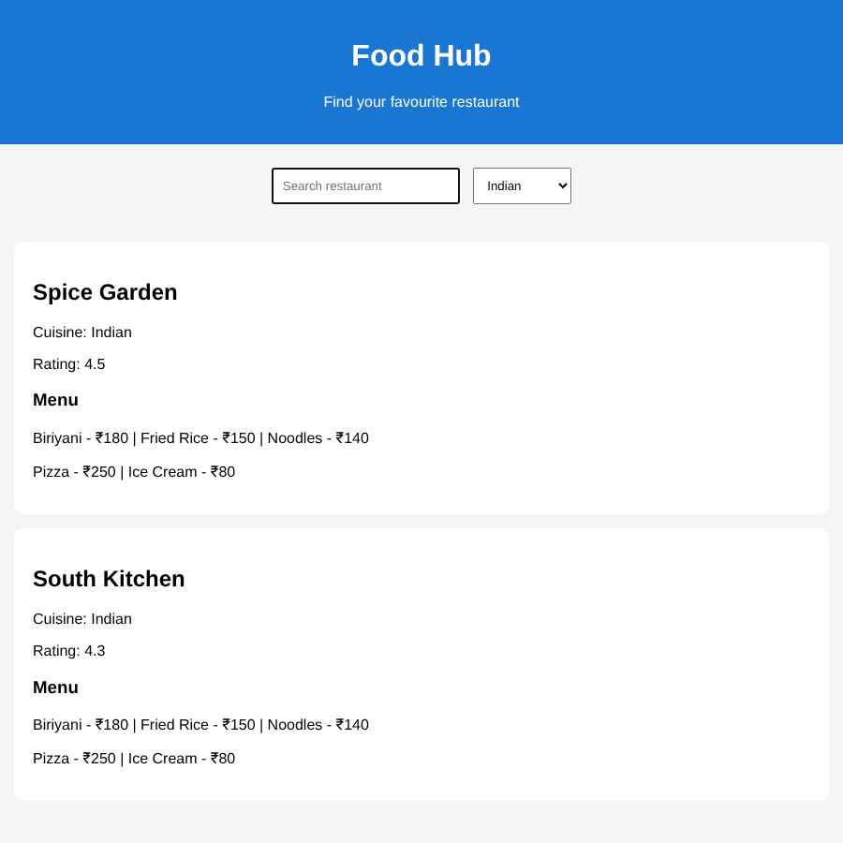
Output 3: Cuisine filter "Indian" shows Spice Garden and South Kitchen
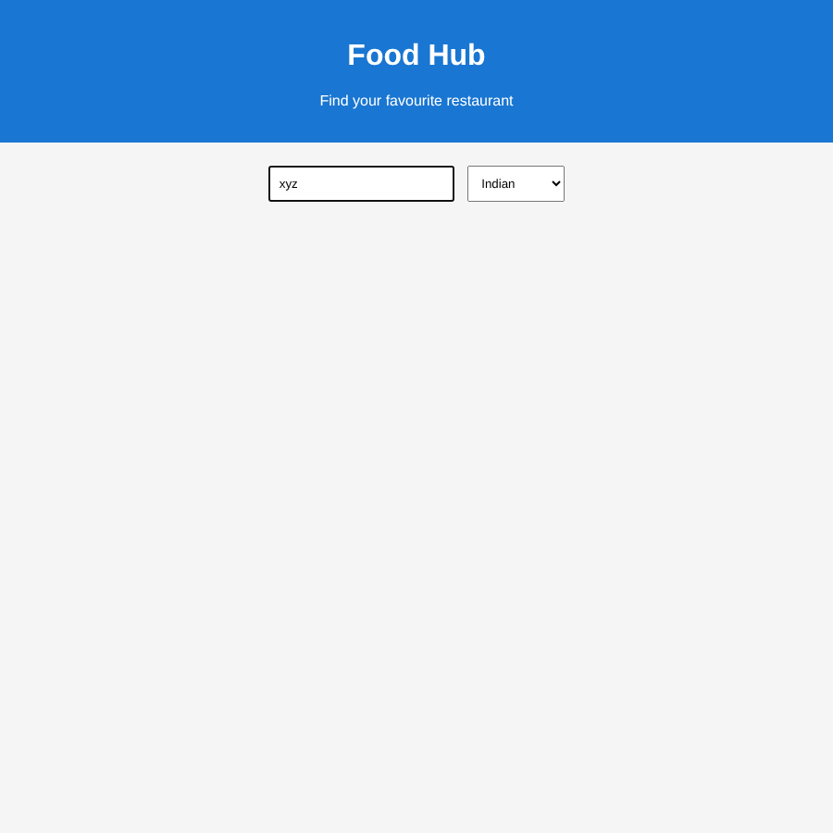
Output 4: A name with no match (xyz) shows no restaurants

Result
The page listed all restaurants on load, and the list updated instantly with the search text and cuisine selection. Non-matching searches showed no cards.

Scenario 3 – Myntra-style Fashion Portal

Aim
To create a user registration form with JavaScript validation for email, password, mobile number, and confirm password.

Algorithm
- Start the program and create an HTML registration form.
- Add input fields for the user's name, email address, mobile number, password, and confirm password.
- Set appropriate input types and required attributes for the form fields.
- Create a message area to show validation errors.
- When the user submits the form, call a JavaScript validation function.
- Read the values entered in all the input fields.
- Check the email address against a valid email pattern.
- Check that the password has at least eight characters, one digit, and one special character.
- Check that the mobile number contains exactly ten digits.
- Compare the password and confirm-password values to ensure they match.
- If any validation fails, show a suitable error message and stop submission.
- If all checks pass, display a registration success message.

Source Code
<!DOCTYPE html>
<html>
<head><title>Fashion Registration</title>
<style>
body{text-align:center;font-family:Arial;background:#f5f5f5}
form{background:white;width:330px;margin:40px auto;padding:25px;border-radius:10px}
input{box-sizing:border-box;display:block;width:100%;padding:10px;margin:10px 0}
button{padding:10px 30px;background:#ff3f6c;color:white;border:0}
#error{color:red}
</style></head>
<body>
<form onsubmit="return validate()">
<h2>Fashion Portal</h2>
<input id="name" placeholder="Name" required>
<input id="email" type="email" placeholder="Email" required>
<input id="mobile" placeholder="Mobile Number" required>
<input id="pass" type="password" placeholder="Password" required>
<input id="confirm" type="password" placeholder="Confirm Password" required>
<p id="error"></p><button type="submit">Register</button>
</form>
<script>
function validate(){
const email=document.getElementById("email").value.trim();
const mobile=document.getElementById("mobile").value.trim();
const pass=document.getElementById("pass").value;
const confirm=document.getElementById("confirm").value;
const error=document.getElementById("error");
if(!/^[^\s@]+@[^\s@]+\.[^\s@]+$/.test(email)){
error.textContent="Enter a valid email";return false;}
if(!/^(?=.*\d)(?=.*[^A-Za-z0-9]).{8,}$/.test(pass)){
error.textContent="Password needs 8 characters, a number and a special character";return false;}
if(!/^\d{10}$/.test(mobile)){
error.textContent="Enter a valid 10-digit mobile number";return false;}
if(pass!==confirm){error.textContent="Passwords do not match";return false;}
alert("Registration successful");return false;
}
</script></body></html>

Output
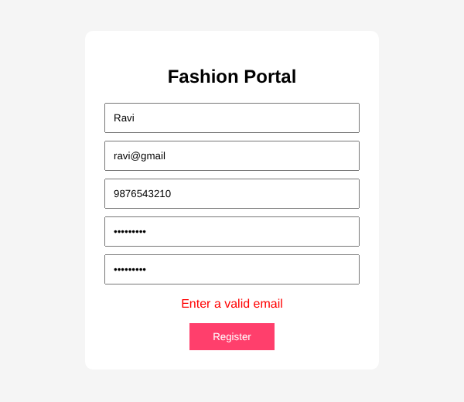
Output 1: Invalid email (ravi@gmail) shows an error
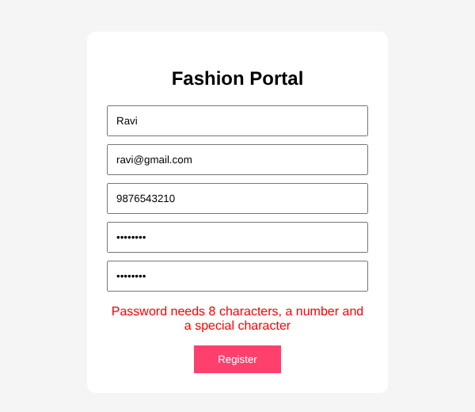
Output 2: Weak password (no digit/special character) shows an error
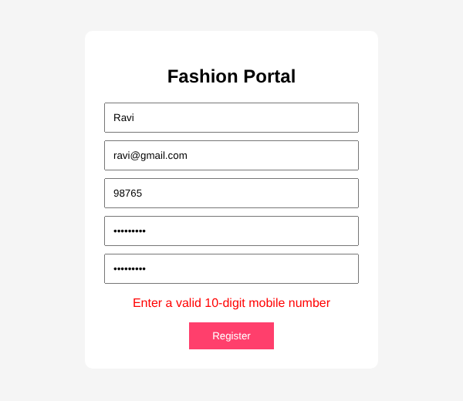
Output 3: Mobile number with fewer than 10 digits shows an error
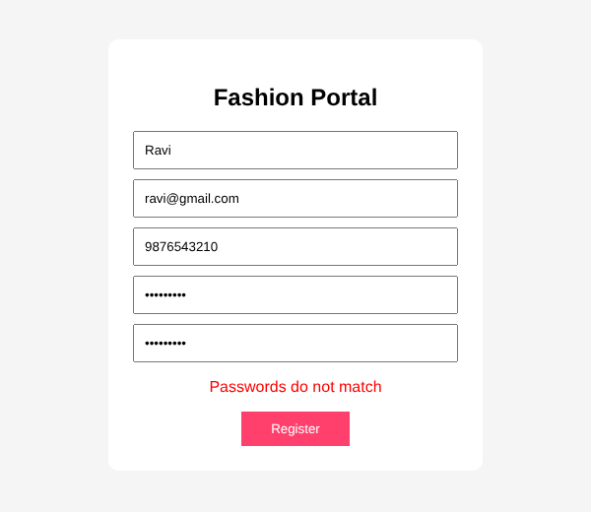
Output 4: Mismatched confirm password shows an error
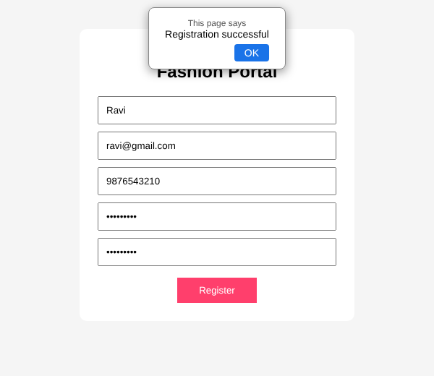
Output 5: All inputs valid - "Registration successful" message

Result
Each invalid input (email, weak password, short mobile number, mismatched passwords) was rejected with a suitable error message; valid data displayed 'Registration successful'.

Scenario 4 – BookMyShow-style Ticket Booking

Aim
To create a PHP movie-ticket booking form that validates show timing and seat number, prevents duplicate seat selection within the session, and generates a booking ID.

Algorithm
- Start the PHP program and call session_start() to enable session storage.
- Initialize a session array to store seat numbers already booked during the current session.
- Create an HTML form with a show-time selector and a seat-number field.
- When the form is submitted, read the selected show time and seat number.
- Check that the show time belongs to the list of valid show times.
- Check that the seat number is within the allowed range of 1 to 100.
- Search the session's booked-seat array to see whether that seat has already been booked.
- If the input is invalid or the seat is already booked, prepare an appropriate error message.
- If the seat is available, add its number to the session array.
- Generate a unique booking ID for the successful booking.
- Display the booking ID, selected show time, seat number, or error message on the page.
- Run the PHP file through a PHP-enabled local server and test both valid and duplicate seat bookings.

Source Code
<?php
session_start();
if (!isset($_SESSION['booked'])) $_SESSION['booked'] = [];
$message = "";
if ($_SERVER["REQUEST_METHOD"] === "POST") {
$time = $_POST["time"] ?? "";
$seat = (int)($_POST["seat"] ?? 0);
$validTimes = ["10:00 AM", "2:00 PM", "6:00 PM", "9:00 PM"];
if (!in_array($time, $validTimes, true)) {
$message = "Please select a valid show time.";
} elseif ($seat < 1 || $seat > 100) {
$message = "Seat number must be between 1 and 100.";
} elseif (in_array($seat, $_SESSION["booked"], true)) {
$message = "That seat is already booked in this session.";
} else {
$_SESSION["booked"][] = $seat;
$id = "BK" . strtoupper(bin2hex(random_bytes(3)));
$message = "Booking successful! Booking ID: " . $id .
" | Show: " . htmlspecialchars($time) . " | Seat: " . $seat;
}
}
?>
<!DOCTYPE html>
<html><body>
<h2>Movie Ticket Booking</h2>
<form method="post">
<label>Show time:
<select name="time">
<option>10:00 AM</option><option>2:00 PM</option>
<option>6:00 PM</option><option>9:00 PM</option>
</select></label><br><br>
<label>Seat number (1–100): <input type="number" name="seat" min="1" max="100" required></label><br><br>
<button type="submit">Book Ticket</button>
</form>
<p><?php echo htmlspecialchars($message); ?></p>
</body></html>

Output
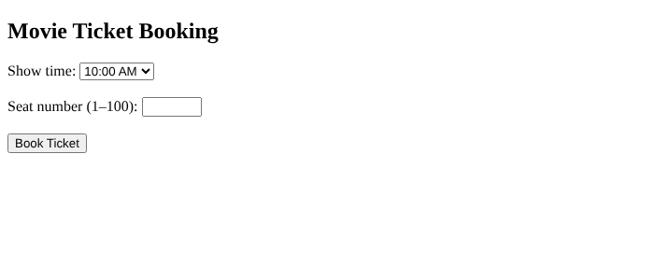
Output 1: Booking form on first load
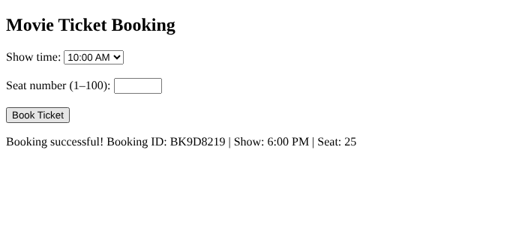
Output 2: Valid booking (6:00 PM, seat 25) generates a Booking ID
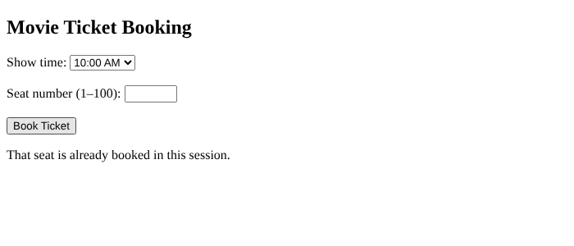
Output 3: Booking seat 25 again in the same session shows the duplicate-seat error
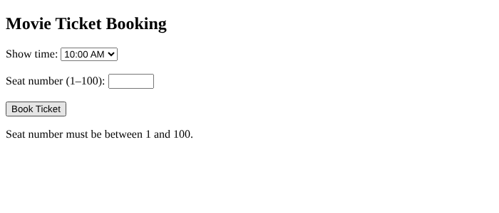
Output 4: Seat number 150 (outside 1-100) shows the range error

Result
A valid show time and seat generated a unique Booking ID. Re-booking the same seat in the same session and an out-of-range seat number were both rejected with error messages.

Scenario 5 – Flipkart-style Marketplace

Aim
To create a product catalog with product search and sorting by price or rating using JavaScript.

Algorithm
- Start the program and create the HTML elements for search, sorting, and product display.
- Prepare a JavaScript array containing product names, prices, and ratings.
- Create a search input that accepts part or all of a product name.
- Create a sorting drop-down with default order, price, and rating options.
- Write a display function that reads the current search and sorting values.
- Filter the product array so that only product names matching the search text remain.
- If price sorting is selected, arrange the filtered products from lowest price to highest price.
- If rating sorting is selected, arrange the filtered products from highest rating to lowest rating.
- Clear the previous product display before rendering new results.
- Display each matching product's name, price, and rating.
- Call the display function when the search input or sorting option changes.
- Test search terms and both sorting options to confirm the output updates correctly.

Source Code
<!DOCTYPE html>
<html><body>
<h2>Marketplace</h2>
<input id="search" placeholder="Search product">
<select id="sort"><option value="">Default order</option>
<option value="price">Price: low to high</option>
<option value="rating">Rating: high to low</option></select>
<div id="list"></div>
<script>
const products=[
{name:"Phone",price:20000,rating:4.5},
{name:"Laptop",price:55000,rating:4.8},
{name:"Headphone",price:2500,rating:4.2},
{name:"Watch",price:3500,rating:4.6}
];
function show(){
const s=document.getElementById("search").value.toLowerCase();
const sort=document.getElementById("sort").value;
let result=products.filter(p=>p.name.toLowerCase().includes(s));
if(sort==="price") result.sort((a,b)=>a.price-b.price);
if(sort==="rating") result.sort((a,b)=>b.rating-a.rating);
document.getElementById("list").innerHTML=result.map(p=>
`<div><h3>${p.name}</h3><p>Price: ₹${p.price} | Rating: ${p.rating}</p></div>`
).join("") || "No products found.";
}
document.getElementById("search").addEventListener("input",show);
document.getElementById("sort").addEventListener("change",show);
show();
</script></body></html>

Output
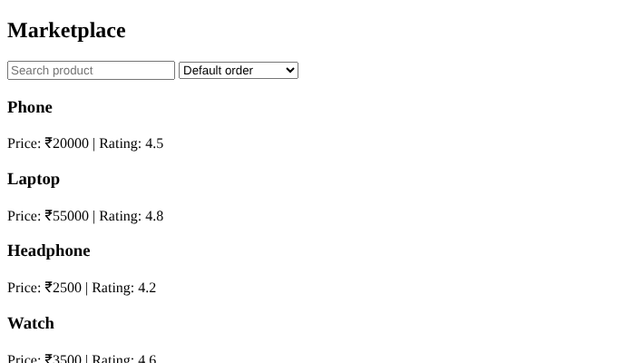
Output 1: Default order - all four products
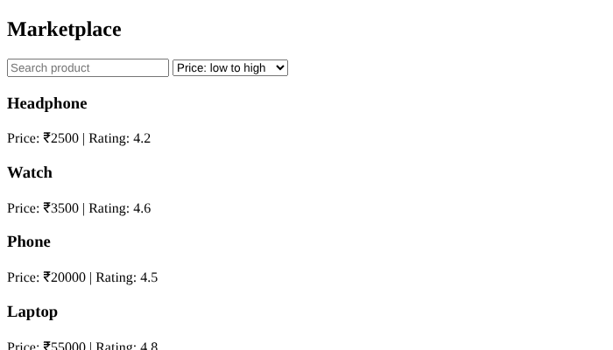
Output 2: Sorted by price (low to high)
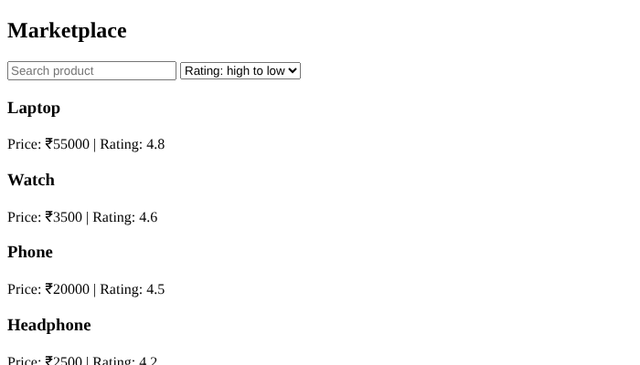
Output 3: Sorted by rating (high to low)
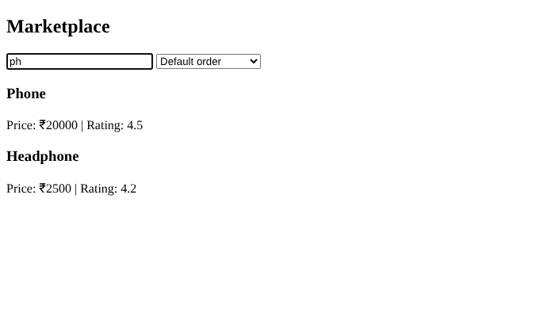
Output 4: Searching "ph" shows Phone and Headphone
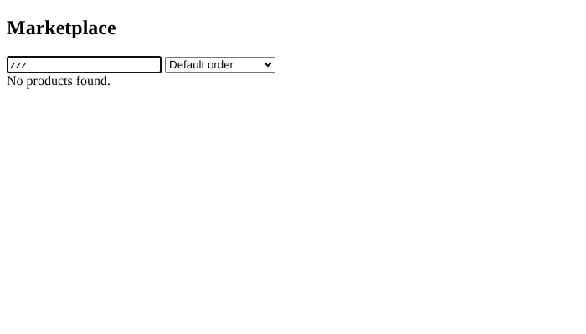
Output 5: No match shows "No products found."

Result
Search filtered products by name, and sorting worked correctly: price from lowest to highest and rating from highest to lowest. No match displayed 'No products found.'

Scenario 6 – Swiggy-style Grocery App

Aim
To develop a grocery search module that displays suggestions as the user types and provides Add to Cart functionality.

Algorithm
- Start the program and create a search input field.
- Prepare a list of grocery items with their prices.
- Create separate page areas for search suggestions and product results.
- Attach an input event listener to the search field.
- Whenever the user types, convert the entered text to lowercase.
- Compare the search text with each grocery item's name.
- Collect the items whose names contain the entered text.
- Display the matching item names as search suggestions.
- Display each matching item with its price and an Add to Cart button.
- When the button is clicked, show a message identifying the selected item.
- If no items match, display a suitable no-results message.
- Test with different terms, including a blank search and a term with no matches.

Source Code
<!DOCTYPE html>
<html><body>
<h2>Grocery Store</h2>
<input id="search" placeholder="Search grocery">
<div id="suggestions"></div><div id="products"></div>
<script>
const items=[["Apple",120],["Banana",60],["Milk",50],
["Rice",80],["Bread",45],["Tomato",40]];
function searchItems(){
const value=document.getElementById("search").value.toLowerCase();
const result=items.filter(x=>x[0].toLowerCase().includes(value));
document.getElementById("suggestions").innerHTML=
result.map(x=>`<p>${x[0]}</p>`).join("") || "No suggestions found.";
document.getElementById("products").innerHTML=result.map((x,i)=>`
<div><h3>${x[0]}</h3><p>₹${x[1]}</p>
<button onclick="addToCart('${x[0]}')">Add to Cart</button></div>`).join("");
}
function addToCart(name){alert(name+" added to cart");}
document.getElementById("search").addEventListener("input",searchItems);
searchItems();
</script></body></html>

Output
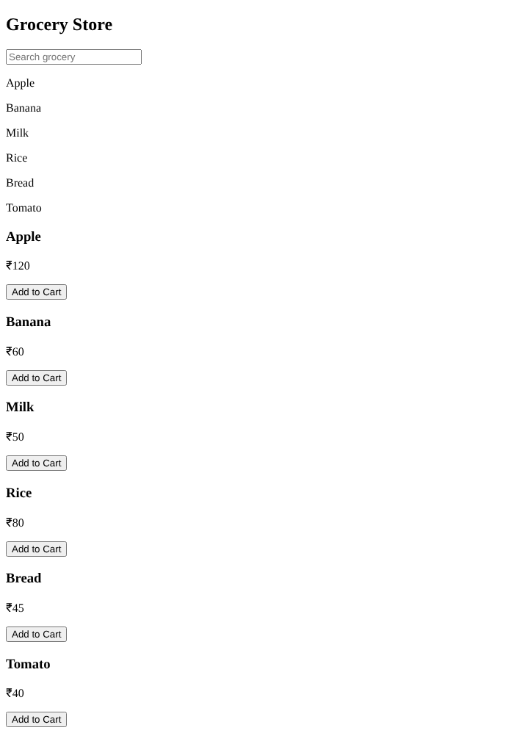
Output 1: Blank search shows all items as suggestions and products
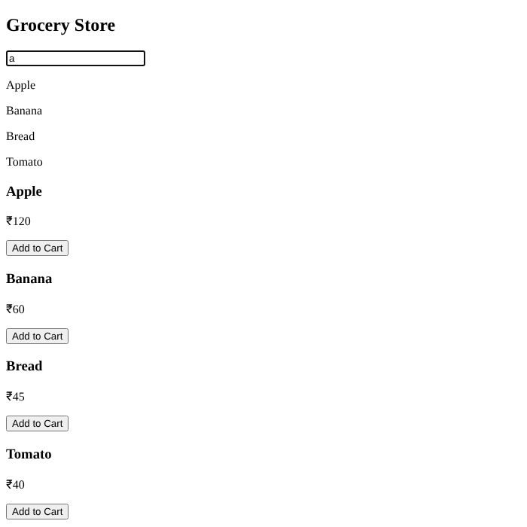
Output 2: Typing "a" shows matching suggestions (Apple, Banana, Rice, Bread, Tomato) and products
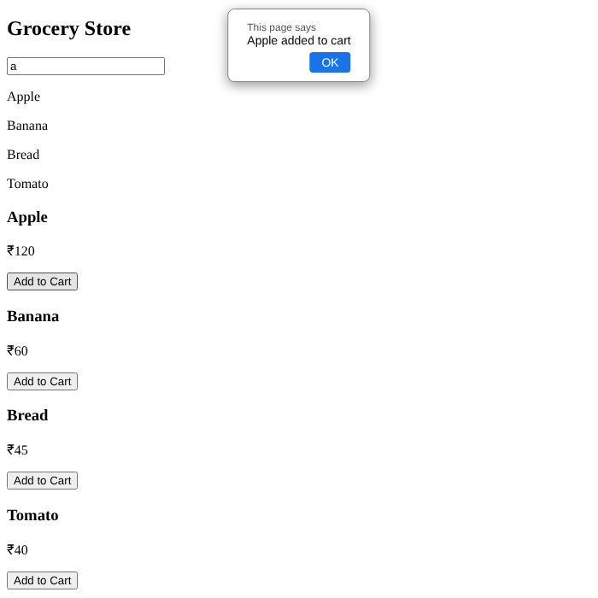
Output 3: Clicking Add to Cart shows which item was added
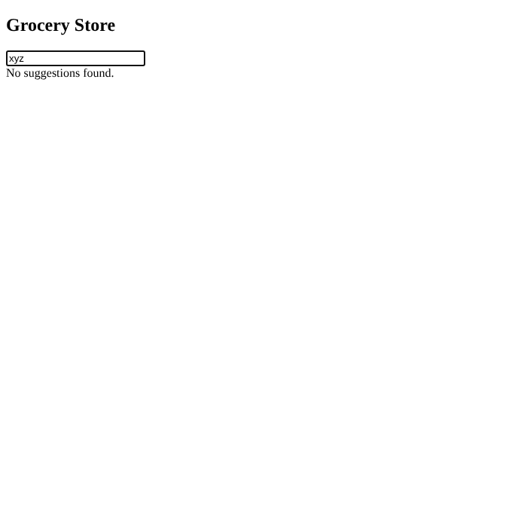
Output 4: No match shows "No suggestions found."

Result
Suggestions and product cards updated as the user typed. Add to Cart named the selected item, and a non-matching term showed the no-results message.

Scenario 7 – Netflix-style Subscription Platform

Aim
To create a subscription page offering Basic, Standard, and Premium plans and simulate payment using UPI, Card, or Net Banking.

Algorithm
- Start the program and create a heading for the subscription service.
- Define the available plans with their names, prices, and features.
- Create a drop-down list so the user can select a subscription plan.
- Create a second drop-down list for UPI, Card, and Net Banking.
- Add a Pay Now button and an area to display the result.
- When the button is clicked, call a JavaScript payment function.
- Read the selected subscription plan and payment method.
- Display a simulated payment-processing or confirmation message.
- Show the selected plan, payment method, and plan price in the result area.
- Clearly treat the result as a demonstration rather than a real transaction.
- Test the page using each subscription plan and payment method.

Source Code
<!DOCTYPE html>
<html><body>
<h2>Subscription Plans</h2>
<label>Choose plan:
<select id="plan">
<option value="199">Basic - ₹199</option>
<option value="499">Standard - ₹499</option>
<option value="799">Premium - ₹799</option>
</select></label>
<label>Payment method:
<select id="payment"><option>UPI</option><option>Card</option>
<option>Net Banking</option></select></label>
<br><br><button onclick="pay()">Pay Now</button>
<div id="result"></div>
<script>
function pay(){
const plan=document.getElementById("plan");
const payment=document.getElementById("payment");
const price=plan.value;
document.getElementById("result").innerHTML=
"<h3>Demo payment successful</h3>Plan: "+plan.options[plan.selectedIndex].text+
"<br>Amount: ₹"+price+"<br>Payment Method: "+payment.value+
"<br><small>This is a simulation; no money was charged.</small>";
}
</script></body></html>

Output
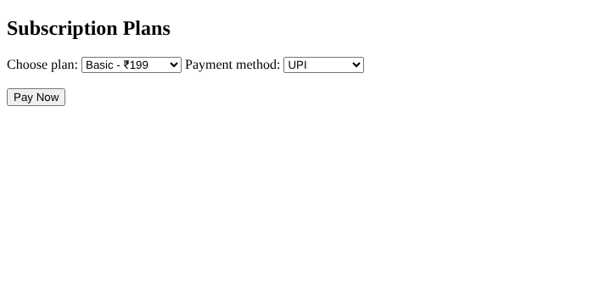
Output 1: Subscription page with plan and payment dropdowns
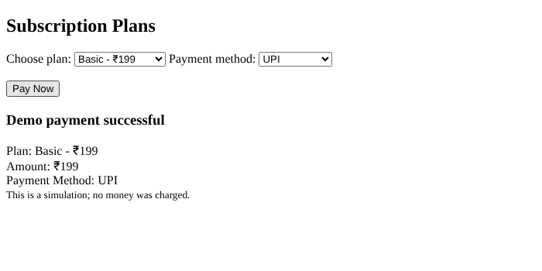
Output: Plan price Rs.199 with UPI - simulated payment result
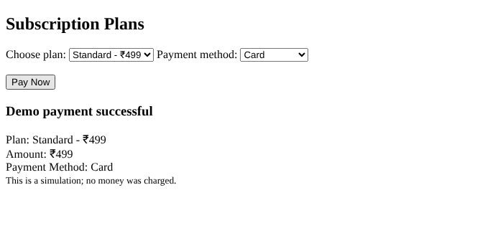
Output: Plan price Rs.499 with Card - simulated payment result
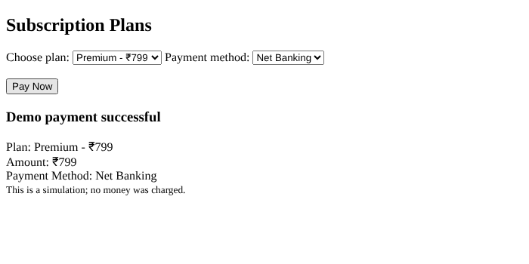
Output: Plan price Rs.799 with Net Banking - simulated payment result

Result
For each plan and payment method, the page displayed the selected plan, amount and payment method with a message that the payment is only a simulation.

Scenario 8 – IRCTC-style Ticket Portal

Aim
To implement a train-ticket payment demonstration that generates an order ID, records amount and date/time, and displays a simulated success or failure.

Algorithm
- Start the program and create a train-ticket payment page.
- Add a numeric input field for the ticket amount.
- Add a button that starts the payment simulation.
- When the button is clicked, read the amount entered by the user.
- Validate that the amount is present and greater than zero.
- Generate a unique-looking order ID using a prefix and a random number.
- Use the JavaScript Date object to obtain the current date and time.
- Simulate a payment result by selecting success or failure for demonstration purposes.
- If payment succeeds, display the order ID, amount, date/time, and success status.
- If payment fails, display a failure message and invite the user to try again.
- Test the program with valid amounts and invalid or empty input.
- Do not use this example for real payments; it does not connect to a payment gateway.

Source Code
<!DOCTYPE html>
<html><body>
<h2>Train Ticket Payment (Demo)</h2>
<input id="amount" type="number" min="1" placeholder="Amount in rupees">
<button onclick="pay()">Make Payment</button>
<div id="result"></div>
<script>
function pay(){
const amount=Number(document.getElementById("amount").value);
const result=document.getElementById("result");
if(!Number.isFinite(amount)||amount<=0){
result.textContent="Enter an amount greater than zero.";return;
}
const order="ORD"+Date.now().toString().slice(-8);
const date=new Date().toLocaleString();
if(Math.random()>0.3){
result.innerHTML="<h3>Demo Payment Successful</h3>Order ID: "+order+
"<br>Amount: ₹"+amount.toFixed(2)+"<br>Date/Time: "+date;
}else{
result.innerHTML="<h3>Demo Payment Failed</h3>Please try again.";
}
}
</script></body></html>

Output
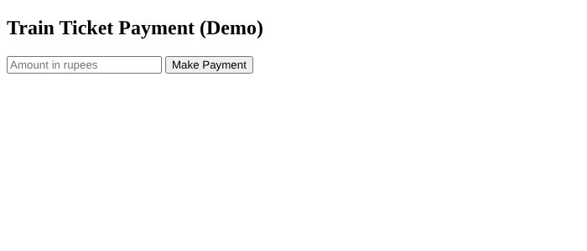
Output 1: Train ticket payment page
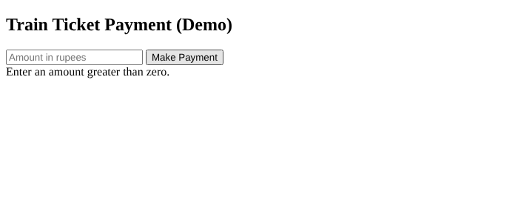
Output 2: Empty amount shows a validation message
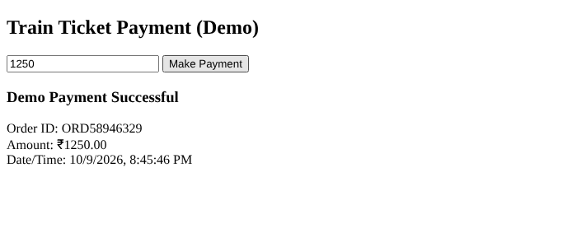
Output 3: Valid amount (1250) - simulated successful payment with Order ID and date/time
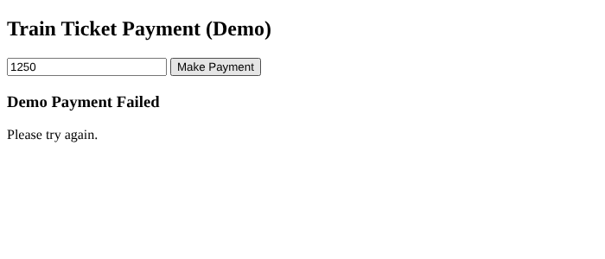
Output 4: Simulated failed payment asks the user to try again

Result
Empty input was rejected. A valid amount produced a simulated result: success showed order ID, amount and date/time; failure asked the user to try again. (Success/failure is random, forced here for demonstration.)

Scenario 9 – BigBasket-style Grocery Cart

Aim
To develop a grocery shopping cart that supports adding and removing products, updating quantities, calculating the total, and simulating checkout.

Algorithm
- Start the program and define grocery products with their names and prices.
- Create a product display area and show each product with an Add button.
- Create an empty cart array to store selected products and their quantities.
- When Add is clicked, check whether the product is already in the cart.
- If it exists, increase its quantity; otherwise, add it with quantity one.
- Create a cart display function that clears and redraws the current cart.
- For every cart item, display the name, unit price, quantity field, and Remove button.
- When the quantity changes, validate it and update the selected item's quantity.
- When Remove is clicked, delete the selected item from the cart.
- Calculate the total by adding each item's price multiplied by its quantity.
- Update the total amount whenever the cart changes.
- When Checkout is clicked, check whether the cart is empty and then display a mock payment confirmation.
- Test adding the same product multiple times, changing quantities, removing items, and checkout.

Source Code
<!DOCTYPE html>
<html><body>
<h2>Grocery Cart</h2>
<div id="products"></div><h2>Cart</h2>
<div id="cart"></div><h3>Total: ₹<span id="total">0.00</span></h3>
<button onclick="checkout()">Checkout</button>
<script>
const products=[["Rice",80],["Milk",50],["Apple",120],["Bread",45],["Sugar",55]];
let cart=[];
document.getElementById("products").innerHTML=products.map((p,i)=>
`<p>${p[0]} - ₹${p[1]} <button onclick="add(${i})">Add</button></p>`).join("");
function add(i){
const found=cart.find(x=>x.index===i);
if(found) found.qty++; else cart.push({index:i,name:products[i][0],price:products[i][1],qty:1});
show();
}
function changeQty(i,value){
const qty=parseInt(value,10);
if(!Number.isInteger(qty)||qty<1){cart[i].qty=1;}else{cart[i].qty=qty;}
show();
}
function removeItem(i){cart.splice(i,1);show();}
function show(){
document.getElementById("cart").innerHTML=cart.map((p,i)=>
`<p>${p.name} - ₹${p.price} each
<input type="number" min="1" value="${p.qty}" onchange="changeQty(${i},this.value)">
<button onclick="removeItem(${i})">Remove</button></p>`).join("") || "Your cart is empty.";
const total=cart.reduce((sum,p)=>sum+p.price*p.qty,0);
document.getElementById("total").textContent=total.toFixed(2);
}
function checkout(){
if(cart.length===0){alert("Your cart is empty.");return;}
alert("Demo checkout complete. Total: ₹"+document.getElementById("total").textContent);
}
show();
</script></body></html>

Output
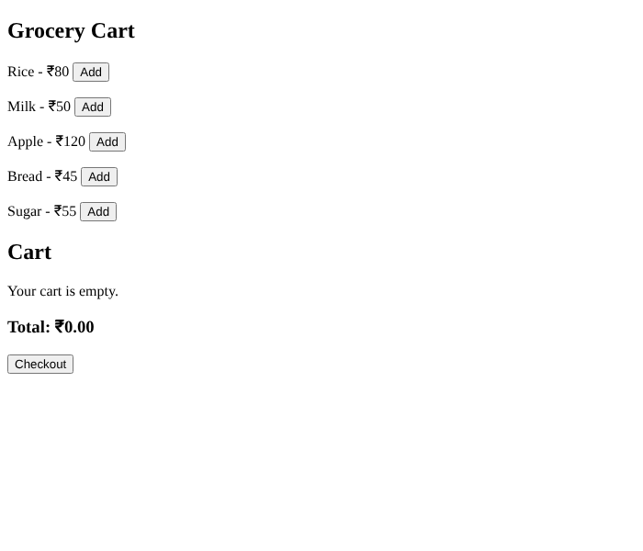
Output 1: Product list with empty cart (Total 0.00)
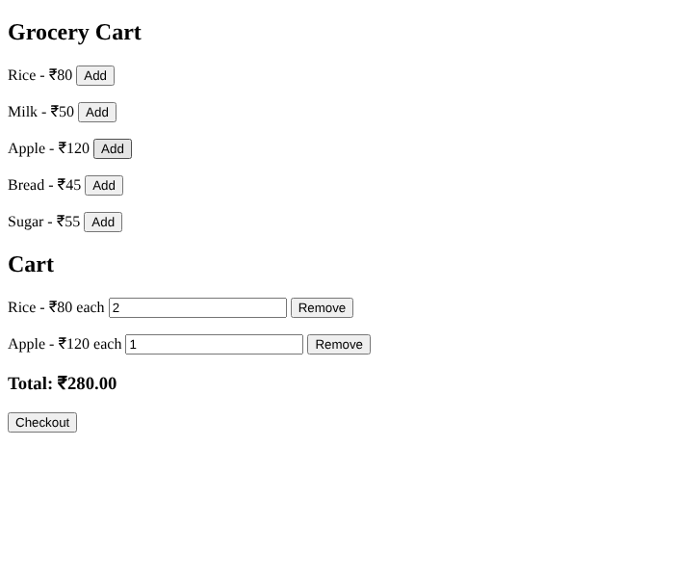
Output 2: Rice added twice (quantity 2) and Apple once - total Rs.280
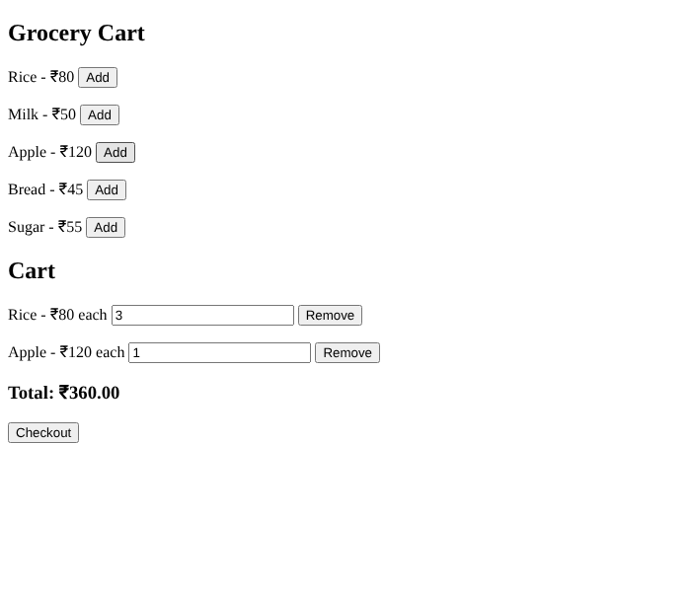
Output 3: Quantity of Rice changed to 3 - total updates to Rs.360
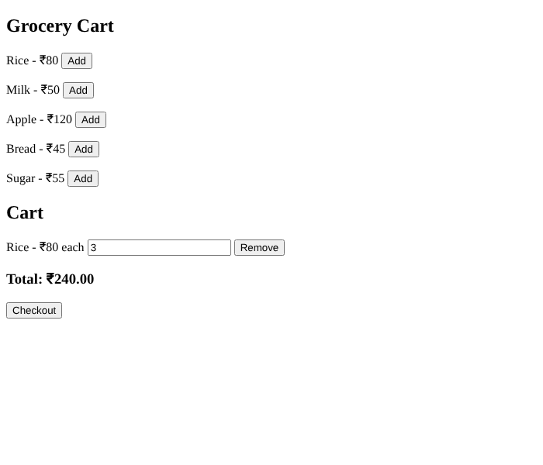
Output 4: Apple removed - total updates to Rs.240
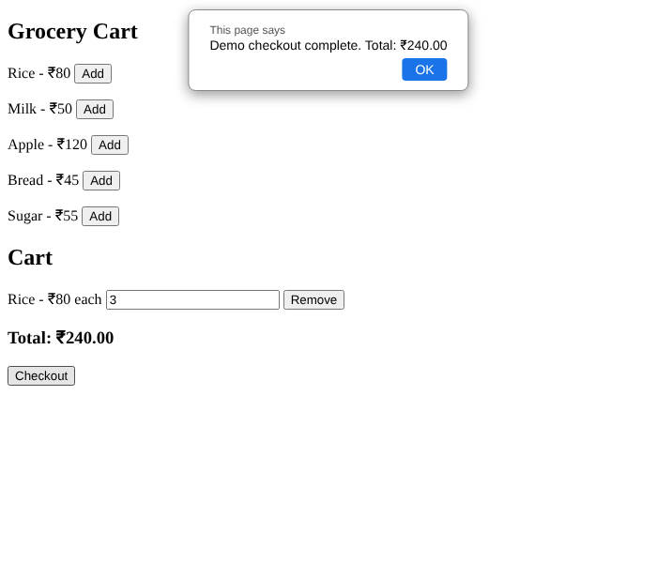
Output 5: Checkout shows the demo confirmation with total
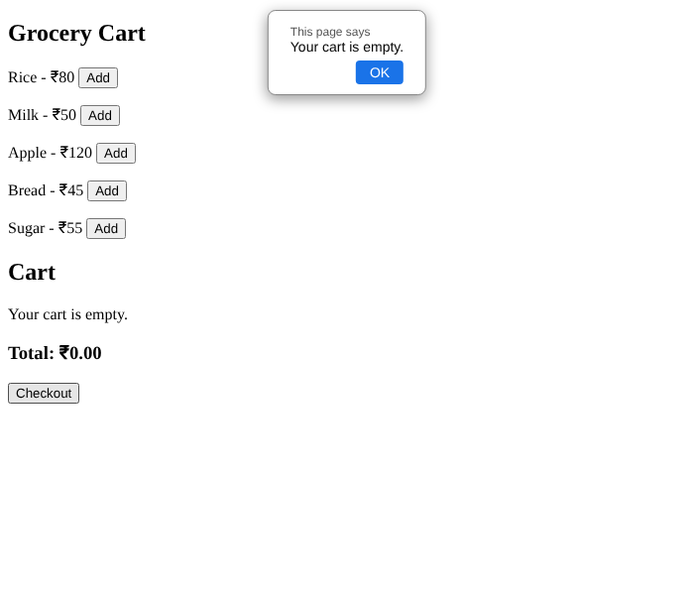
Output 6: Checkout with an empty cart shows "Your cart is empty."

Result
Adding the same product increased its quantity, quantity edits and removals updated the total, and checkout showed a demo confirmation or an empty-cart message.

Scenario 10 – Udemy-style E-Learning Platform

Aim
To create an online course catalog with at least five courses, enrollment functionality, and a course-progress tracker.

Algorithm
- Start the program and create an HTML page for the course catalog.
- Prepare course data containing each course title, instructor, and price.
- Display at least five course cards from the course data.
- Include an Enroll button on every course card.
- When a learner selects Enroll, store the selected course as the active course.
- Display the active course title and a list of course modules.
- Provide a completion control for each module.
- Track completed modules without counting the same module more than once.
- Calculate progress as completed modules divided by total modules multiplied by 100.
- Update the progress percentage and completion status whenever a module is marked complete.
- Test enrollment in different courses and completion of individual modules.

Source Code
<!DOCTYPE html>
<html><body>
<h2>Online Courses</h2><div id="courses"></div>
<div id="learning"></div>
<script>
const courses=[
["Python Programming","John","₹999"],
["Web Development","David","₹799"],
["Machine Learning","Priya","₹1299"],
["Java Programming","Arun","₹899"],
["UI/UX Design","Sara","₹699"]
];
let activeCourse="", completed=new Set();
document.getElementById("courses").innerHTML=courses.map((c,i)=>`
<div><h3>${c[0]}</h3><p>Instructor: ${c[1]}</p><p>Price: ${c[2]}</p>
<button onclick="enroll(${i})">Enroll</button></div>`).join("");
function enroll(i){
activeCourse=courses[i][0];completed=new Set();
document.getElementById("learning").innerHTML="<h2>"+activeCourse+"</h2>"+
[1,2,3,4].map(n=>`<p>Module ${n} <button onclick="complete(${n})">Mark Complete</button></p>`).join("")+
'<p id="progress">Progress: 0%</p>';
}
function complete(n){
completed.add(n);
document.getElementById("progress").textContent="Progress: "+(completed.size/4*100)+"%";
}
</script></body></html>

Output
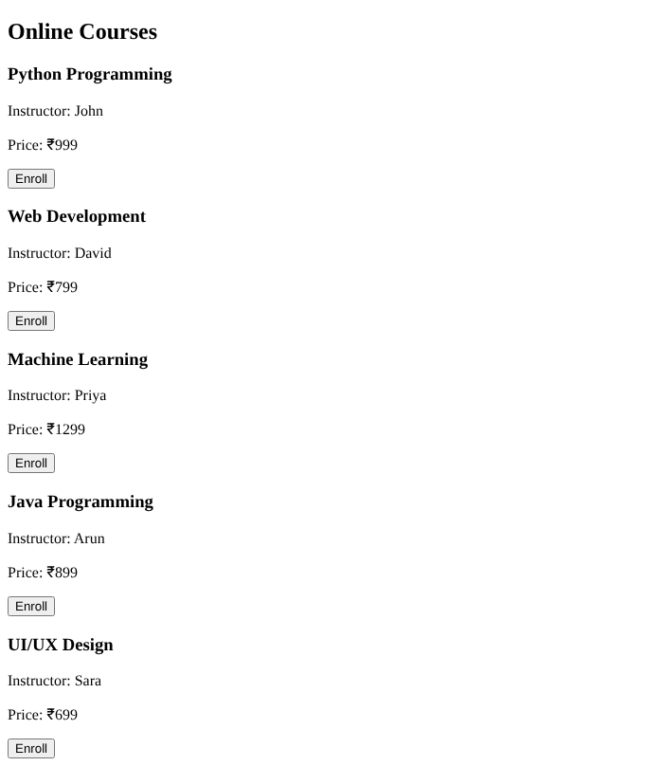
Output 1: Course catalog with five courses and Enroll buttons
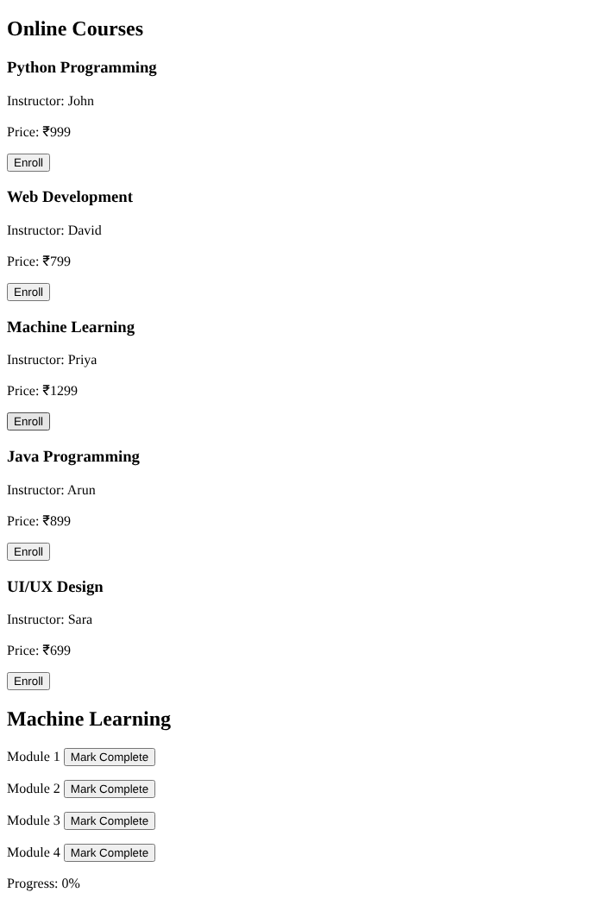
Output 2: Enrolled in Machine Learning - modules shown, progress 0%
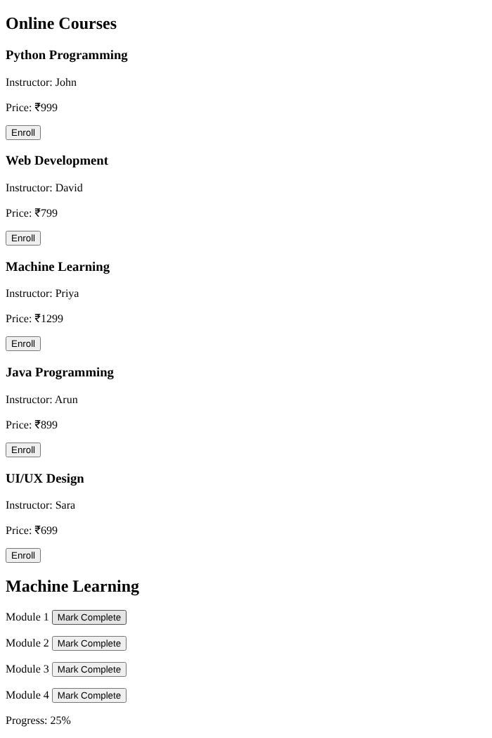
Output 3: Module 1 completed - progress 25%
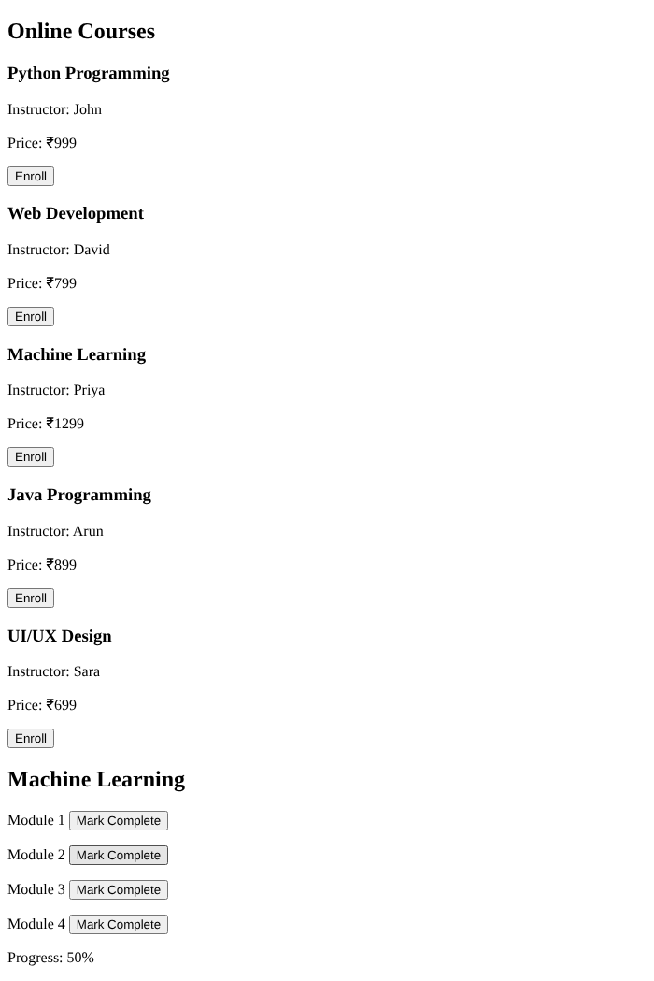
Output 4: Module 1 clicked again (not counted twice) and Module 2 completed - progress 50%
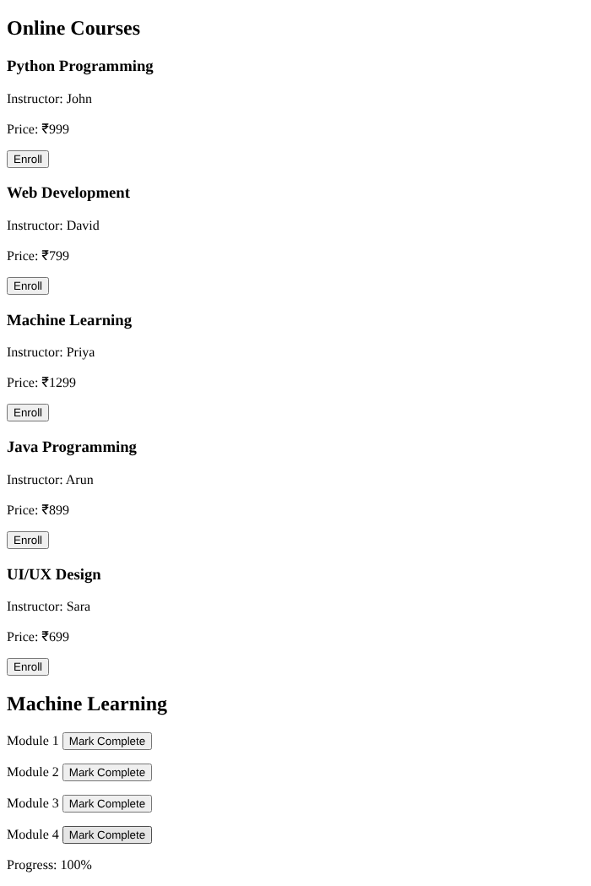
Output 5: All four modules completed - progress 100%

Result
Five courses were displayed; enrolling showed the course modules, and progress increased by 25% per module. Completing the same module twice was not counted twice, reaching 100%.

Scenario 11 – Nykaa-style Beauty Store

Aim
To create a product review form that validates a star rating and comment before displaying the submitted review.

Algorithm
- Start the program and create a product review form.
- Add a drop-down list containing ratings from one star to five stars.
- Add a text area where the user can enter a review comment.
- Add a Submit Review button and an area for validation or confirmation messages.
- When the form is submitted, prevent the browser from refreshing the page.
- Read the selected rating and comment text.
- Check that a rating has been selected.
- Check that the comment contains non-whitespace characters.
- If either field is invalid, display an error message and do not submit the review.
- If both fields are valid, display a confirmation and the review details.
- Test the form with no rating, an empty comment, and a valid review.

Source Code
<!DOCTYPE html>
<html><body>
<h2>Beauty Product Review</h2>
<form id="reviewForm">
<label>Rating:
<select id="rating" required>
<option value="">Select Rating</option>
<option value="1">⭐</option><option value="2">⭐⭐</option>
<option value="3">⭐⭐⭐</option><option value="4">⭐⭐⭐⭐</option>
<option value="5">⭐⭐⭐⭐⭐</option>
</select></label><br><br>
<textarea id="comment" placeholder="Write your review" required></textarea><br><br>
<button type="submit">Submit Review</button>
</form>
<div id="result"></div>
<script>
document.getElementById("reviewForm").addEventListener("submit",function(event){
event.preventDefault();
const rating=document.getElementById("rating").value;
const comment=document.getElementById("comment").value.trim();
const result=document.getElementById("result");
if(!rating){result.textContent="Please select a rating.";return;}
if(!comment){result.textContent="Comment cannot be empty.";return;}
result.innerHTML="<h3>Review submitted successfully!</h3>Rating: "+
"⭐".repeat(Number(rating))+"<p>"+comment.replace(/</g,"&lt;")+"</p>";
});
</script></body></html>

Output
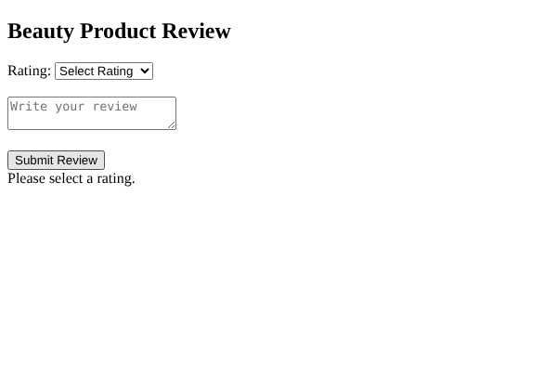
Output 1: Submitting with no rating shows "Please select a rating."
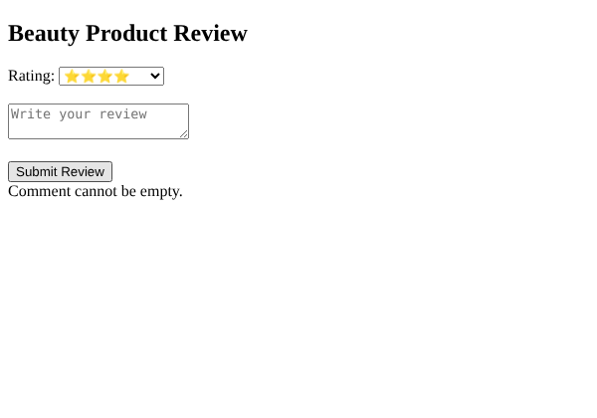
Output 2: Rating selected but empty comment shows "Comment cannot be empty."
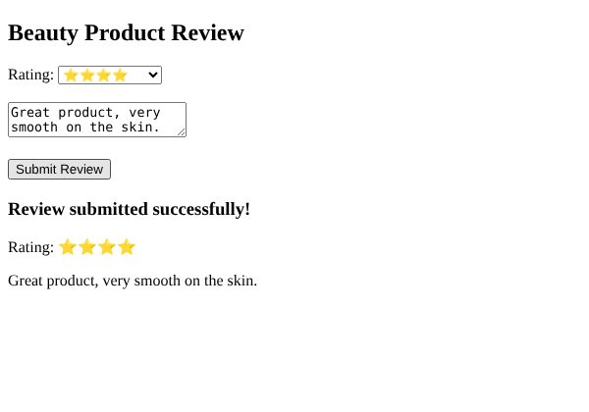
Output 3: Valid rating and comment - review submitted and displayed

Result
The form rejected a missing rating and an empty comment with error messages, and displayed the review with a confirmation when both were valid.

Scenario 12 – Airbnb-style Booking Site

Aim
To develop a property-booking webpage with location and price filters, date validation, booking cost calculation, and simulated payment confirmation.

Algorithm
- Start the program and create a property search and booking page.
- Prepare a property list containing the location and nightly price for each property.
- Create a location search field and maximum-price field.
- Create a container to display properties that match the filters.
- Whenever a filter changes, read the search location and maximum price.
- Filter properties by location text and ensure their price does not exceed the selected maximum.
- Display the matching properties with their nightly prices.
- Create check-in and check-out date inputs and a Book Now button.
- When booking is requested, verify that both dates have been entered.
- Convert the dates to date values and check that check-out occurs after check-in.
- Calculate the number of nights between the dates and calculate the booking amount using the selected property's nightly rate.
- Display booking details and a simulated payment confirmation; do not claim to process a real payment.
- Test location filters, price filters, valid dates, missing dates, and invalid date ranges.

Source Code
<!DOCTYPE html>
<html><body>
<h2>Property Booking</h2>
<input id="location" placeholder="Search location">
<input id="maxprice" type="number" min="0" placeholder="Maximum price per night">
<div id="properties"></div>
<h3>Booking</h3>
<label>Property:
<select id="property">
<option value="2000">Chennai - ₹2000/night</option>
<option value="2500">Pondicherry - ₹2500/night</option>
<option value="3000">Bangalore - ₹3000/night</option>
<option value="1800">Coimbatore - ₹1800/night</option>
</select></label><br><br>
<input id="checkin" type="date"><input id="checkout" type="date">
<button onclick="book()">Book Now</button><div id="result"></div>
<script>
const data=[["Chennai",2000],["Pondicherry",2500],["Bangalore",3000],["Coimbatore",1800]];
function show(){
const l=document.getElementById("location").value.toLowerCase();
const raw=document.getElementById("maxprice").value;
const max=raw===""?Infinity:Number(raw);
document.getElementById("properties").innerHTML=data.filter(x=>
x[0].toLowerCase().includes(l)&&x[1]<=max)
.map(x=>`<p>${x[0]} - ₹${x[1]} per night</p>`).join("") || "No properties found.";
}
document.getElementById("location").addEventListener("input",show);
document.getElementById("maxprice").addEventListener("input",show);
function book(){
const ci=document.getElementById("checkin").value;
const co=document.getElementById("checkout").value;
const result=document.getElementById("result");
if(!ci||!co){result.textContent="Enter both check-in and check-out dates.";return;}
const a=new Date(ci+"T00:00:00"), b=new Date(co+"T00:00:00");
if(Number.isNaN(a.getTime())||Number.isNaN(b.getTime())||b<=a){
result.textContent="Check-out must be after check-in.";return;}
const days=(b-a)/86400000;
const price=Number(document.getElementById("property").value);
result.innerHTML="<h3>Demo Booking Confirmed</h3>Nights: "+days+
"<br>Total: ₹"+(days*price)+"<br>Payment status: Simulated only.";
}
show();
</script></body></html>

Output
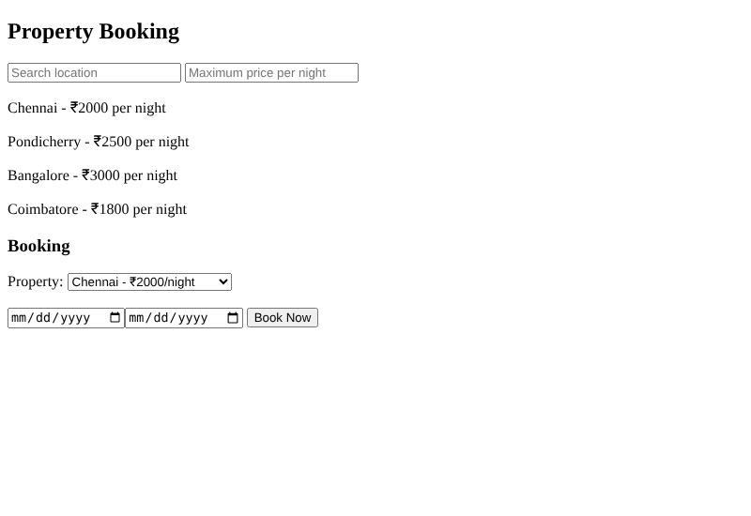
Output 1: Property list (no filters) and booking section
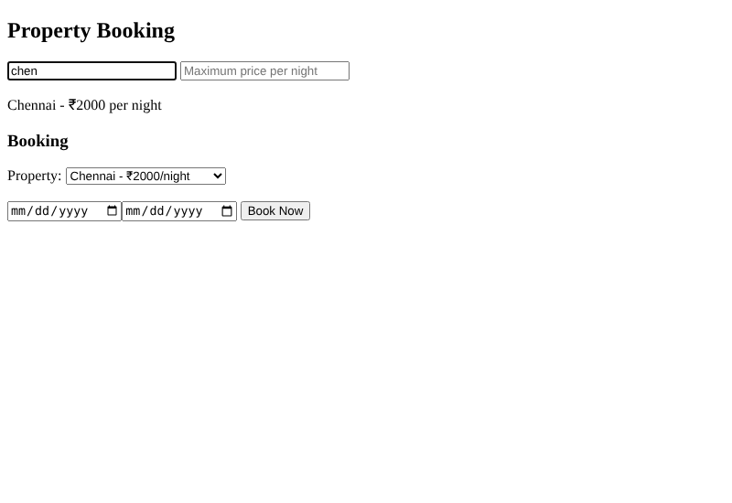
Output 2: Location filter "chen" shows only Chennai
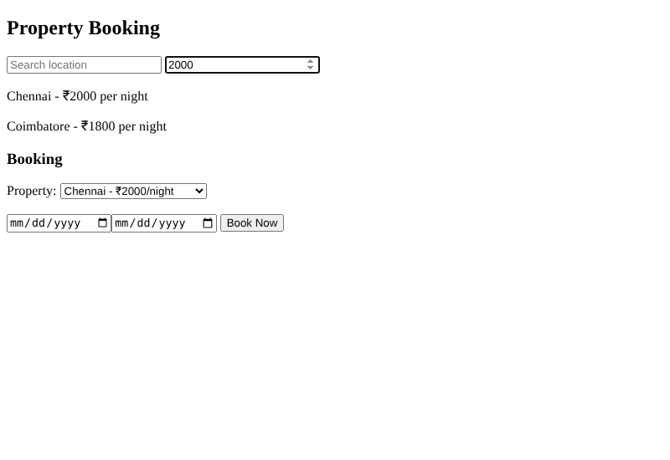
Output 3: Maximum price 2000 shows Chennai and Coimbatore
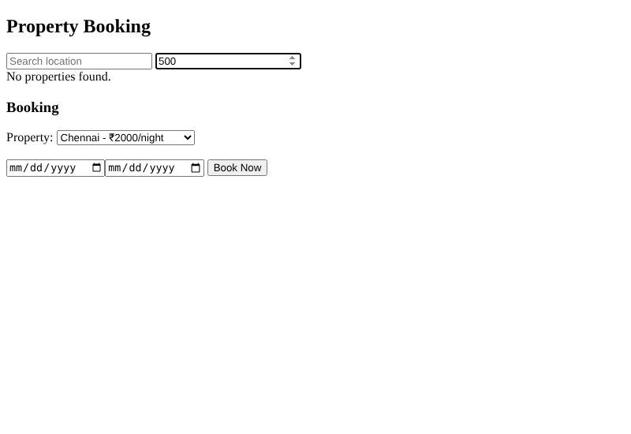
Output 4: Maximum price 500 shows "No properties found."
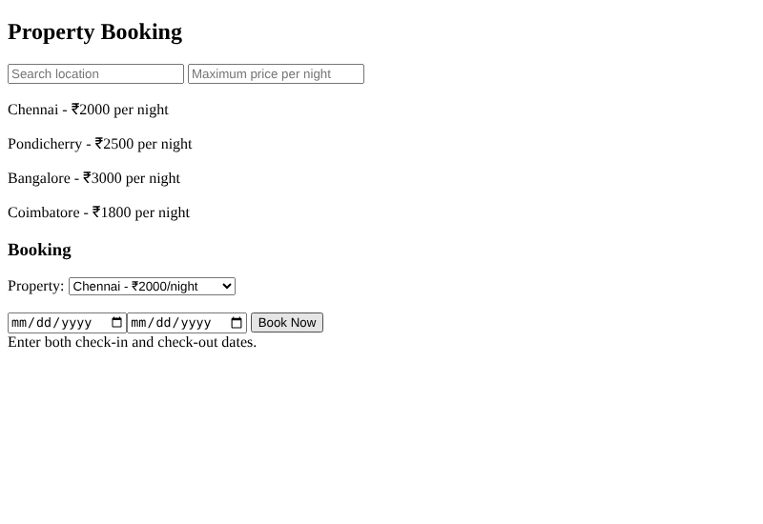
Output 5: Missing dates show an error message
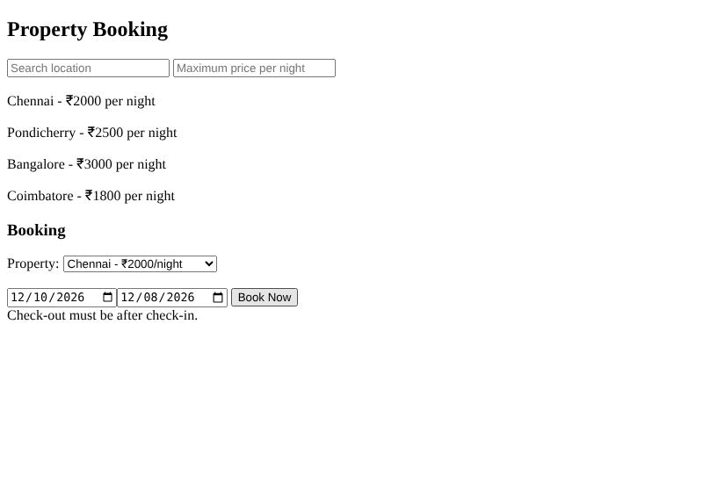
Output 6: Check-out before check-in shows an error message
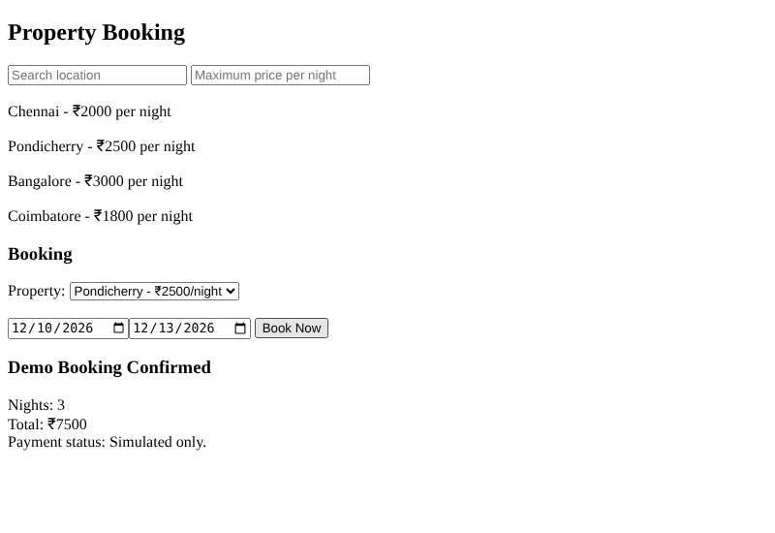
Output 7: Pondicherry, 3 nights x Rs.2500 = Rs.7500 - demo booking confirmed

Result
Location and price filters narrowed the property list. Missing dates and invalid date ranges were rejected; a valid booking calculated nights x rate (3 x 2500 = Rs.7500) with a simulated confirmation.

