Algorithm for classifying the time series data:

1)Load the data in excel sheets into arrays

2) initialize a neural network

3)Divide the data randomly into 3 sets – training, test and validation data sets

* This is done so as to avoid overfitting the data. The neural net parameters are evaluated over the 3 data sets and the minimum error for all the 3 data sets is chosen as the neural net configuration

4)Train the neural network using the backpropogation algorithm on the 3 sets

5)Test the neural network on the entire data set points and calculate the confusion matrix, the ROC curve

Results:

1)Accuracy on the entire data set is accuracy is 89.0052% .

* Accuracy = Correct classifications/ total elements to classify

2)ROC curve:

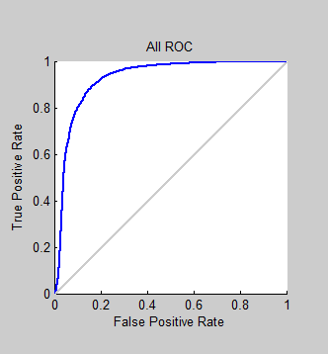

3) Confusion Matrix:

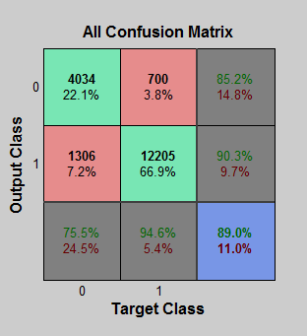

Problem2 : Detecting cancer regions in breast images

Algorithm:

1. Load images inside workspace
2. Eliminate the unnecessary part in those images( the left half of the images doesn’t contain much information):this is for faster data processing
3. Do intensity based image registration as the images look suitable for doing that
4. The metric for optimization is mean squares error which is basically a element wise difference between the 2 input images.
5. The optimization method is the gradient decent algorithm
6. Assume an affine transformation(preserves only straight lines)and calculate the elements of the affine transformation matrix which will map the input image to the fixed image.
7. Transform the input image using the affine transform to an output image
8. Take the difference of the output image and the fixed image to get the location of cancer regions: the high intensity regions denote cancer regions

Results:

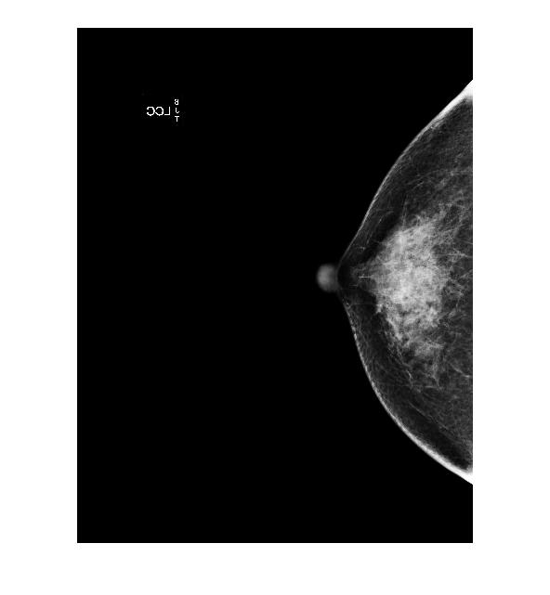

Fig1: Original image: left breast- fixed image

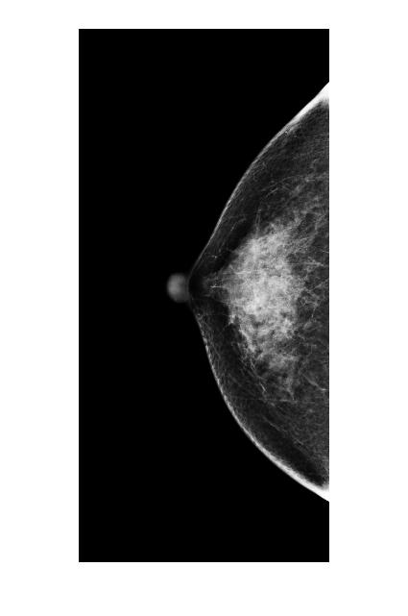

Figure 2: Original (Figure 1) cropped image :eliminating unnecessary data processing

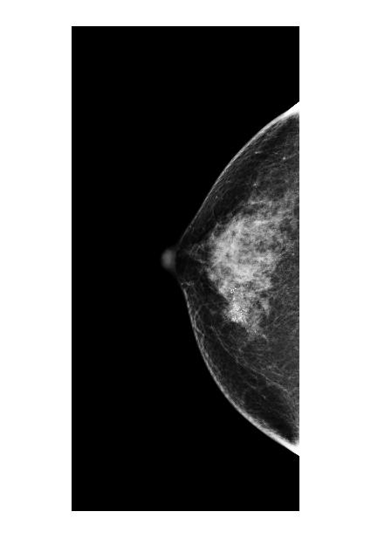

Figure 3: Image of the right breast

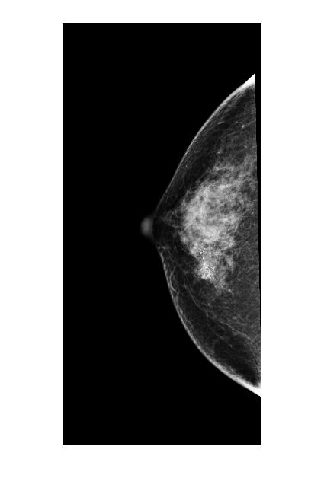

Figure 4: Image of the right breast transformed to align with the left breast

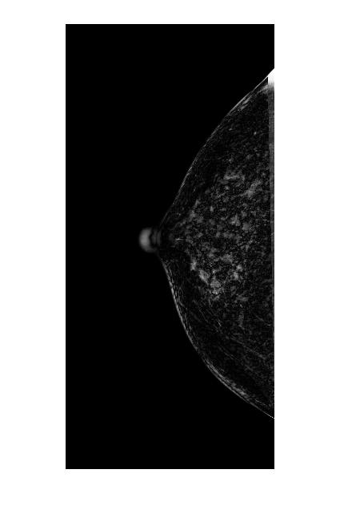

Figure 5: Difference image showing cancer regions

Second image set:

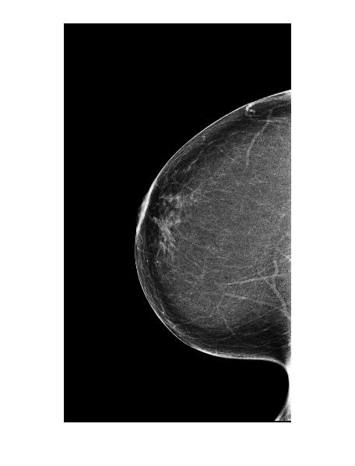

Figure 6: Left breast: original image: fixed

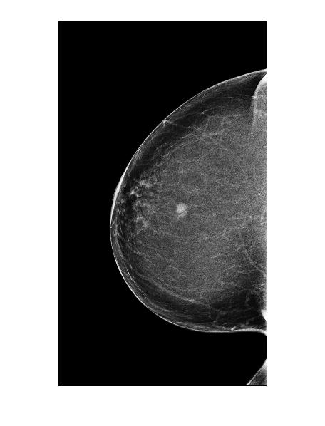

Figure 7: Right Breast image

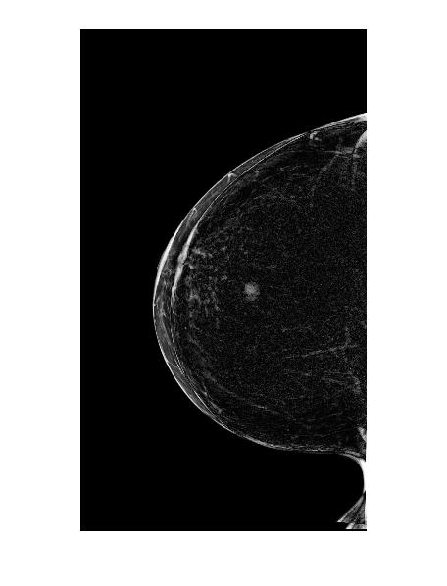

Figure8: Difference image showing cancer regions