COERCION

In some situations, the datatype of a Process Data element may be undefined. In these situations, you may know the datatype of the element, and you can coerce the element into a specific type. The Add / Edit Coercions context menu available in the Data Source tab allows you to create and manage your coercions.

The following example illustrates a schema with an element defined as the “any element” datatype. The schema is for a generic incoming message that can have any type of body. In the example, however, the any element is coerced into an Order type so that it can be mapped to a choice element.

In this example, the schemas are the following:

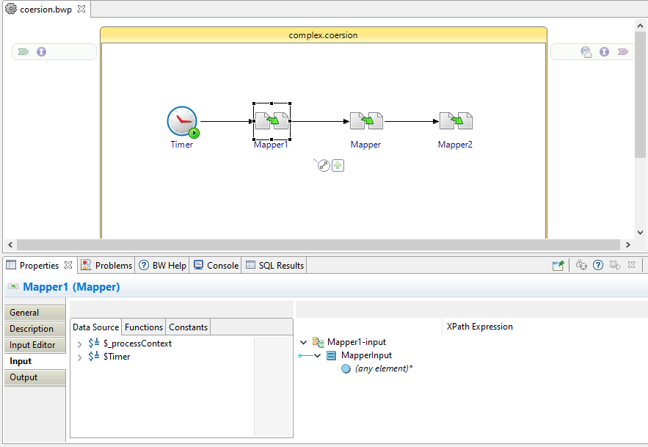

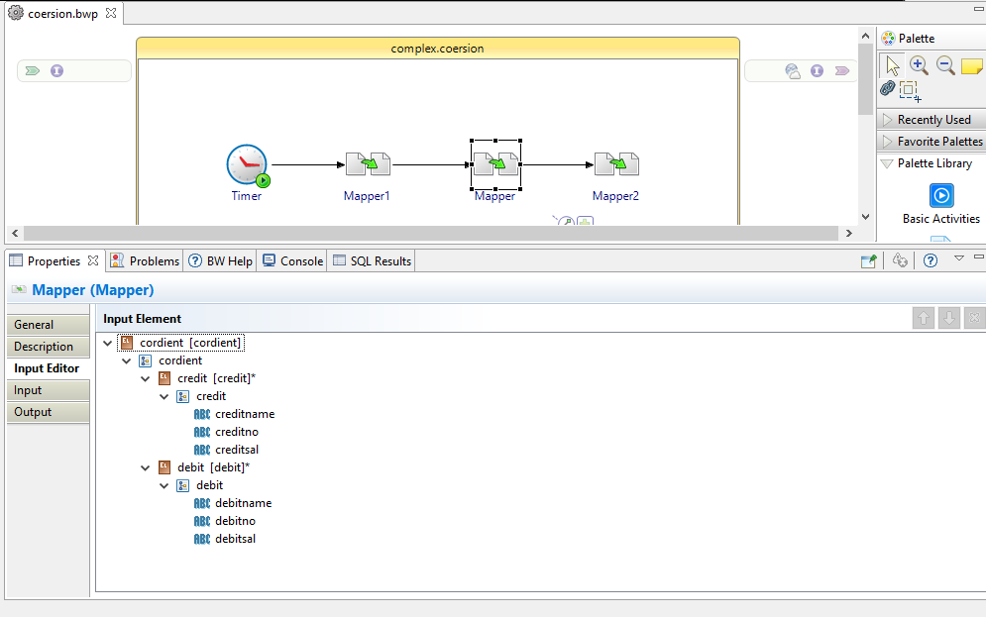

We can see the before coersion inputs as below.

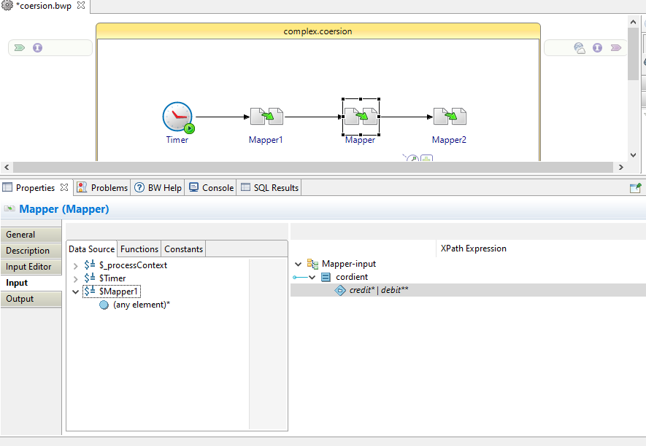

The following procedure describes how to coerce the Body element of the incoming message into a specific datatype and map it to a choice element.

There are different ways of accomplishing the same result as this example. This example attempts to illustrate the simplest method to achieve the desired result.

@1 Define the coercion to use for the element of type ‘Any’ using the Add/Edit Coercion… pop-up menu

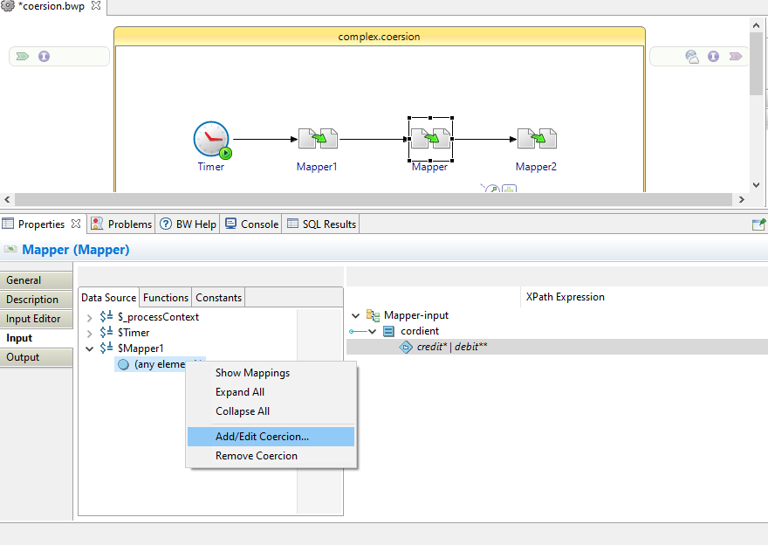

In the Coercions dialog, click the Insert button (+) to add a coercion for the currently selected element.

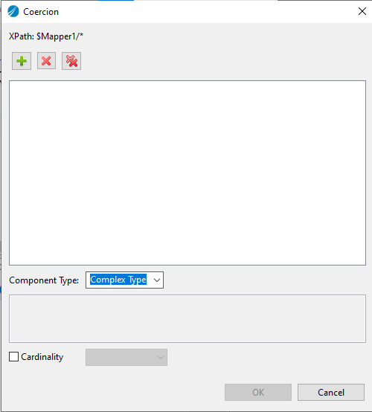

We can see the coersion as below.

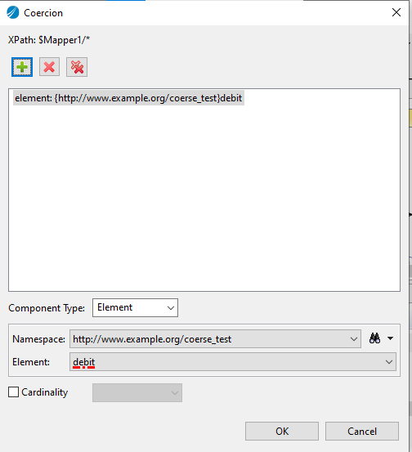

Click OK to coerce the element into the datatype of the selected schema element. The following would be the resulting schema where the element of the datatype any element has been replaced with the coerdient schema.

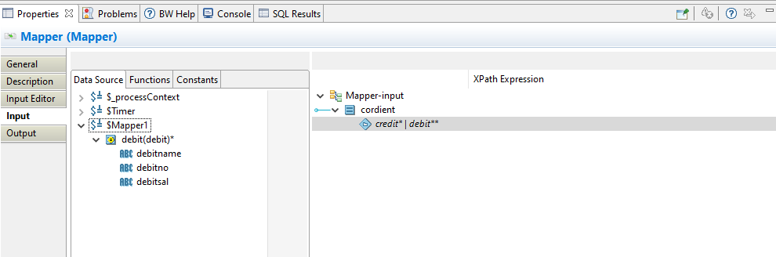

Map the Name element to the Name element in the Activity Input area. Then, map the coerced Order element to the choice element in the Activity Input area.

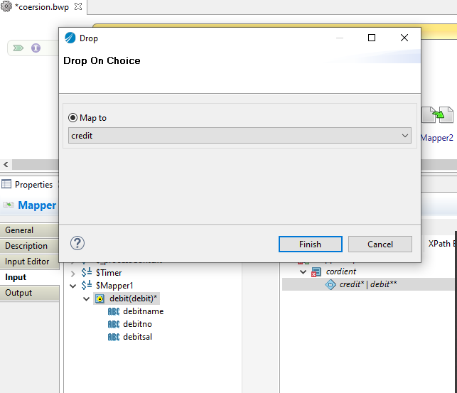

Next we can map details as below.

