CONNECTON FACORIES

**Uses:-**

A connection factory is the object a client uses to create a connection to a provider. A connection factory encapsulates a set of connection configuration parameters that has been defined by an administrator.

**Types of connections:-**

jms. Connection Factory(generic connection factory)

jmsQueueConnectionFactory.

jmsTopicConnectionFactory.

**Commands to create connection factories(ADMIN):GENERIC**

Generic Connection Factories Commands

**create factory niranjan generic URL=tcp://localhost:7222**



**If you want to give connection attempts count give below commandthe defaultvalue is betweeen 2 to 5**

**addprop factory niranjan connect_attempt_count=5**

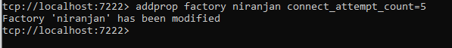

**Commands to create connection factories(ADMIN):QUEUE**

Queue Connection Factories Commands

**create factory Qniranjan queue URL=tcp://localhost:7222**

**addprop factory niranjan connect_attempt_count=5**

**Commands to create connection factories(ADMIN):TOPIC**

Topic Connection Factories Commands

**create factory topicniranjan queue URL=tcp://localhost:7222**

**addprop factory topicniranjan connect_attempt_count=5**

**Note:- show factories this command is use for show all factories**

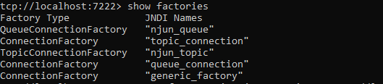

**I configured JNDI Connections as below(generic)**

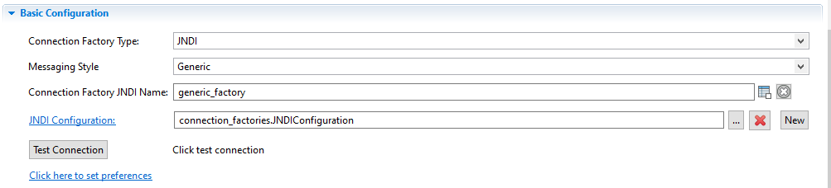

**I configured JNDI Connections as below(Queue/Topic)**

