REPEAT

The Repeat group activity is responsible for repeating the series of grouped activities until the specified condition evaluates to true. The activities are always executed once before checking whether the condition is true. After executing the series of activities, the initial evaluation of the condition is done, and it does not repeat when the condition evaluates as true. The Repeat activity evaluates the loop's conditional statement to determine whether or not more iterations of the loop are required.Scenario: im retrying the process while giving port number wrong in jdbc connections.

Take activities as below in Tibco bw6.x studio.

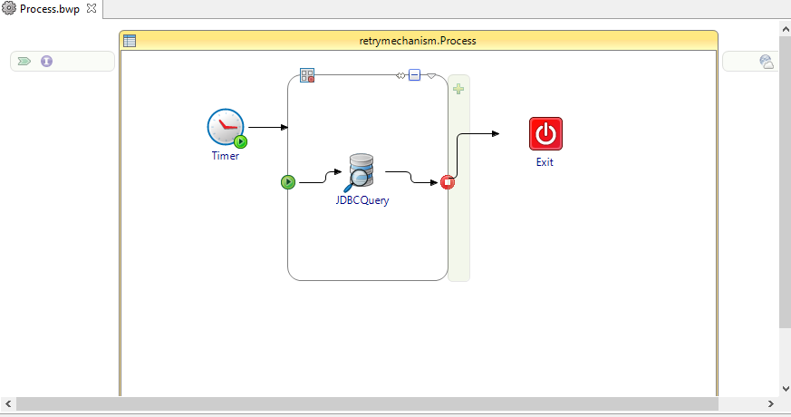

I Mentioned wrong jdbc port number like 5312 actual port number is 5432.

So we need to repeat on error until given index number value.

Mentioned repeat on error index value 4 so the loop will be not iterate because there is error in the loop.

The loop values mentioned as below.

After the debugging the loop will be run as below.

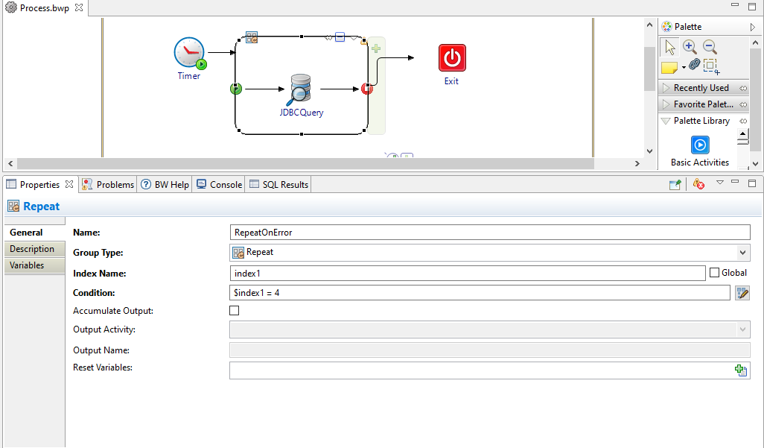

And the loop will be executed as below.

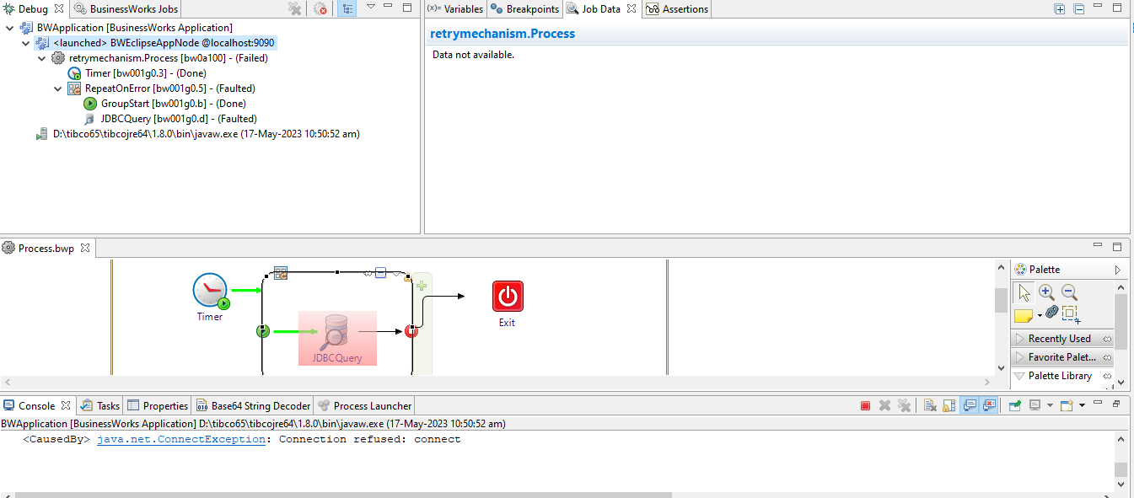

The loop will exicute when ever our port number change.

After change the port number the loop will be executes 4 times and terminated after completion of loop index value.

If we mention correct values the loop will be executes as below.

