LOGGING PROCESS BEFORE THE PROCESS

In Below Main process we need to log the jms message and parse data log on the start logs so we creating schema like below.

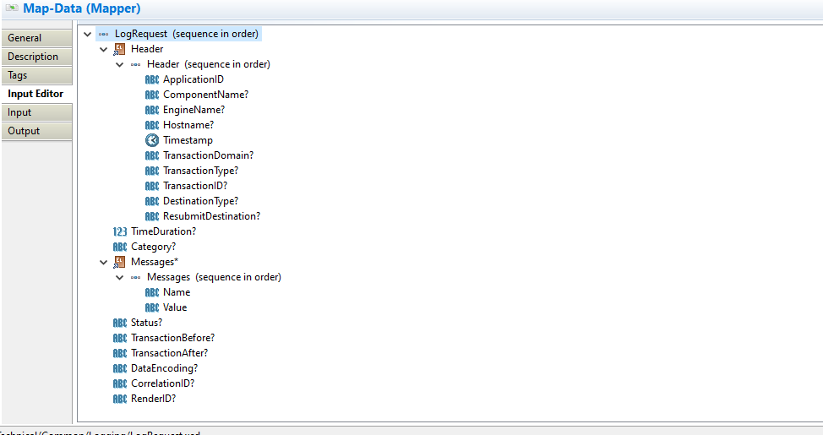

Process in below

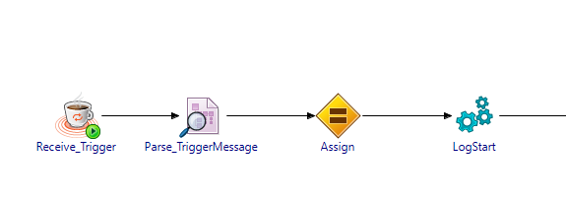

start log is in below

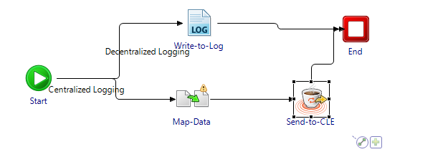

In The assign activity we need to configure the schema elements including the jms and parse data logs also as like Below.

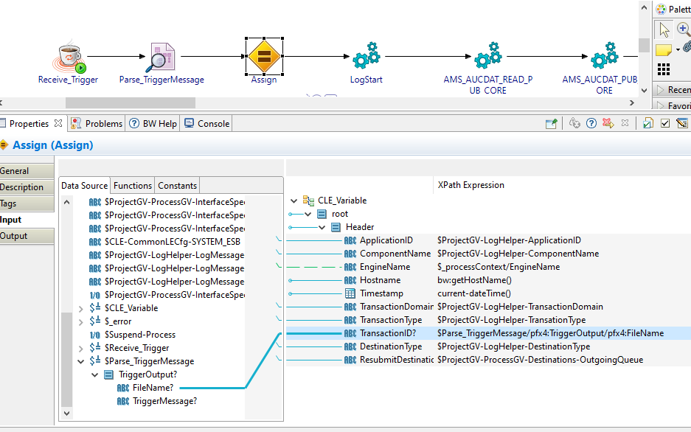

TransactionID in this process is triggered by the file name of the parse data element, Remaing all elements are process variables are mentioned erlier.

End logs are also same as start logs but we need to change the schema elemnts for what we need to log the process.