CineStream Backend Database Implementation Report
Name: Nirjara Jain
Technology: MySQL

Abstract
This project implements a relational database backend for the CineStream movie streaming platform. The system manages movies, users, and watch history through a normalized relational schema. CRUD operations, foreign key constraints, and analytical SQL JOIN queries were implemented to demonstrate practical database management and reporting.

Introduction
The objective of this project is to design and implement a relational database capable of managing movie catalogs, customer accounts, and viewing activity while maintaining data integrity and supporting business analytics.

Objectives
- Design a relational database
- Implement primary and foreign keys
- Perform CRUD operations
- Generate analytical reports using SQL JOINs

Database Design
Tables: Movies, Users, and WatchLog. WatchLog acts as a junction table connecting users and movies.

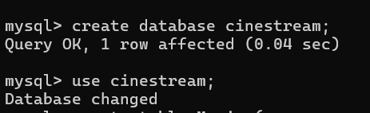
Database Creation and USE cinestream

Table Creation
Movies, Users, and WatchLog tables were created with primary and foreign key constraints.

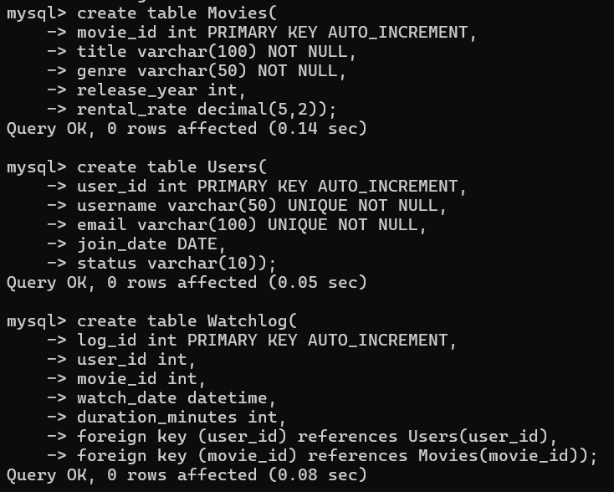
CREATE TABLE statements

Data Insertion
10 records were inserted into Movies, Users, and WatchLog tables.

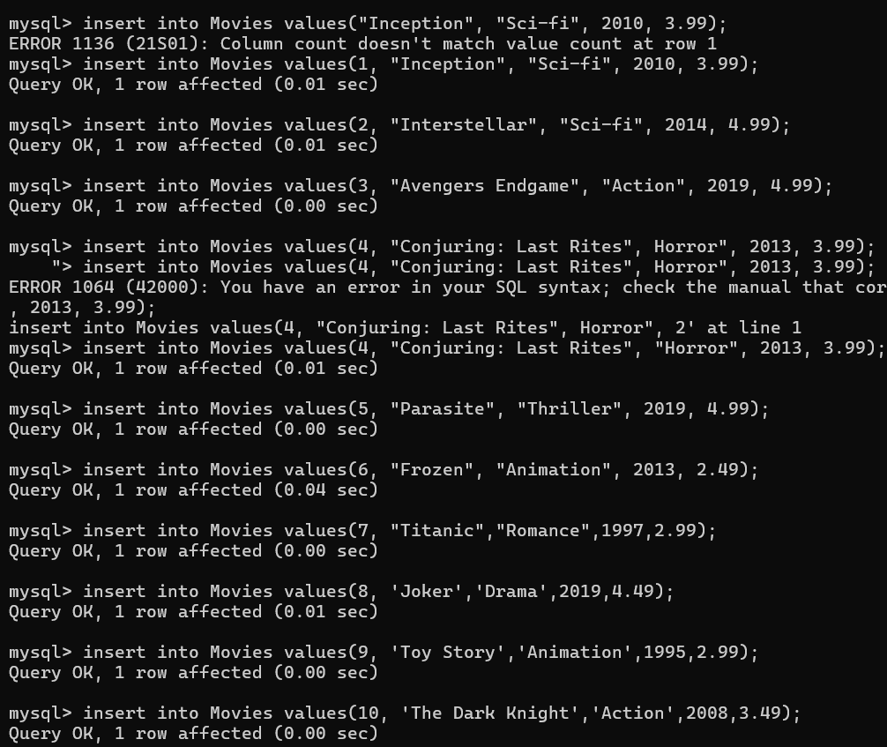
Movies Table Records

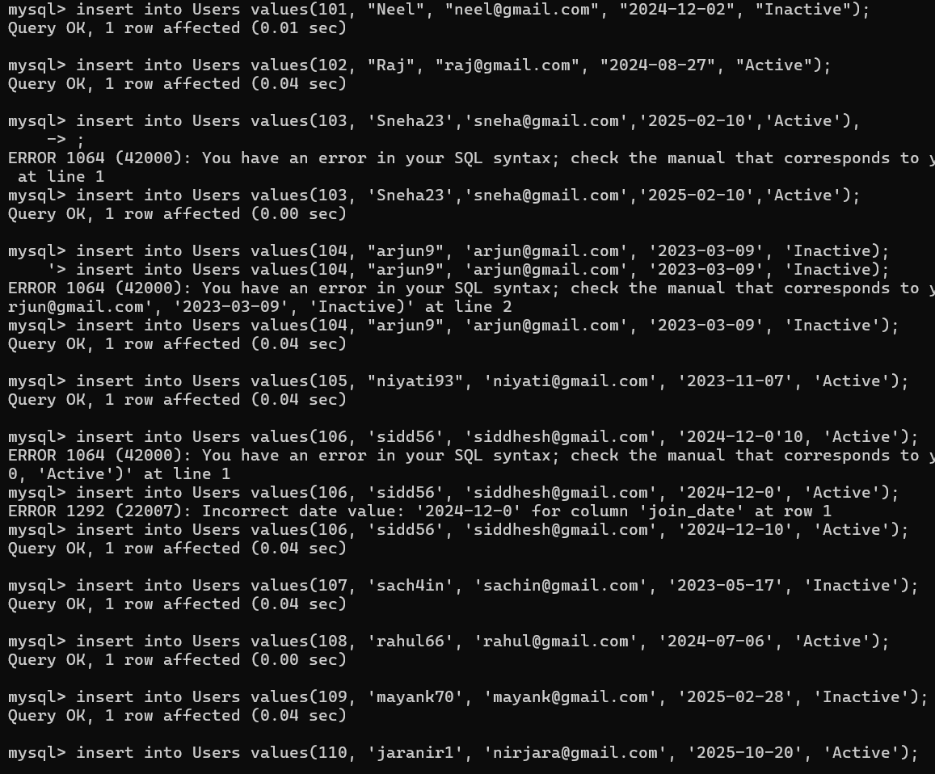
Users Table Records

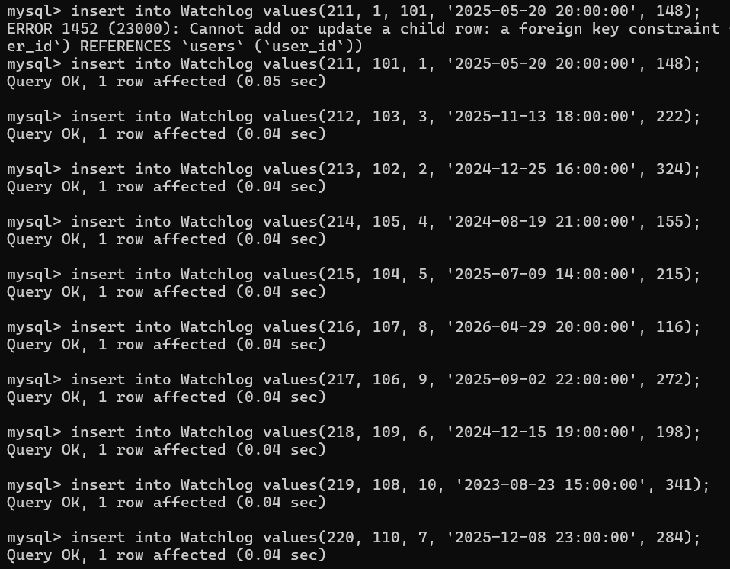
WatchLog Table Records

CRUD Operations
Create, Read, Update, and Delete operations were successfully executed.

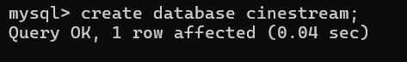
CREATE Operation

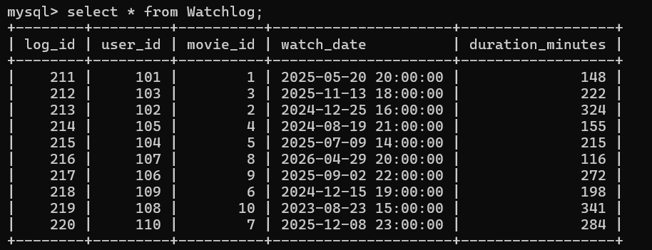
READ Operation

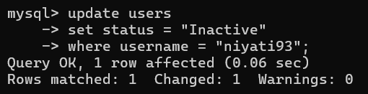
UPDATE Operation

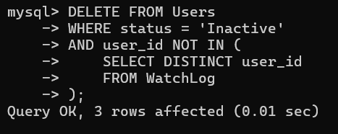
DELETE Operation

Error Handling
Several syntax and foreign-key errors were encountered and resolved during implementation.
Foreign Key Constraint Error

Analytical JOIN Query
Genre popularity was determined using INNER JOIN, GROUP BY, and ORDER BY clauses.

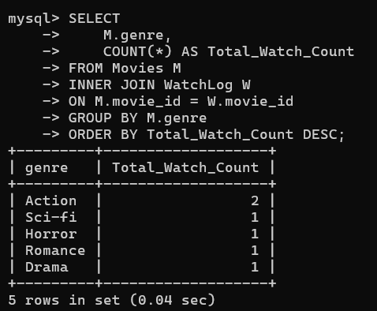
Genre Popularity Report

Important Concepts
Primary Keys, Foreign Keys, INNER JOIN, GROUP BY, ORDER BY, Referential Integrity.

Conclusion
The CineStream database successfully demonstrates relational database design, CRUD functionality, referential integrity, and analytical reporting using SQL.

