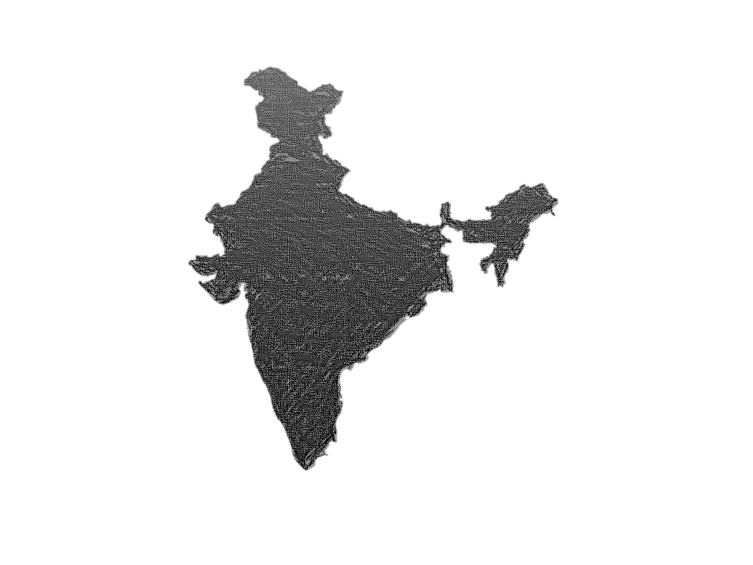
Suicide Trend in INDIA (2001-2012)
A state, demographic and casual analysis report
Nirav prajapati |  | 8/8/26

Problem Statement –
Suicide awareness and prevention efforts don't reach everyone equally. This project looks at which states, age groups, and other factors still need the most focus and awareness around suicide prevention in India.

Methodology –
The data of suicides records was imported into PostgreSQL, and cleaned to remove all records with zero totals, pre-aggregated “total” rows, and an overlapping aggregated age group category – reduced rows from 237,519 to 92,159.

The dataset reports suicides in five independent classification categories as Causes, Means Adopted, Professional Profile, Education Status, and Social Status, each of these categories are approximately same but all are independent. This dataset contains, state, year, gender, age group, total, and another two columns- one column for causes, professional profile etc and second column for their values.

Data cleaning was conducted with SQL; Exploratory and Statistical analysis was conducted with python (pandas, matplotlib, seaborn); interactive dashboard was created with Power BI desktop.

Key Findings –
- Rising Trend until 2011 – Across in India from 2001 to 2011 suicides rate is continuously increasing - suicides count was increased from 108506 to 134599 in 2001 to 2011 time period with 24.96% growth rate, after those major changes happened in 2012 – growth rate was decreased from 24.96 % to 11.04%.
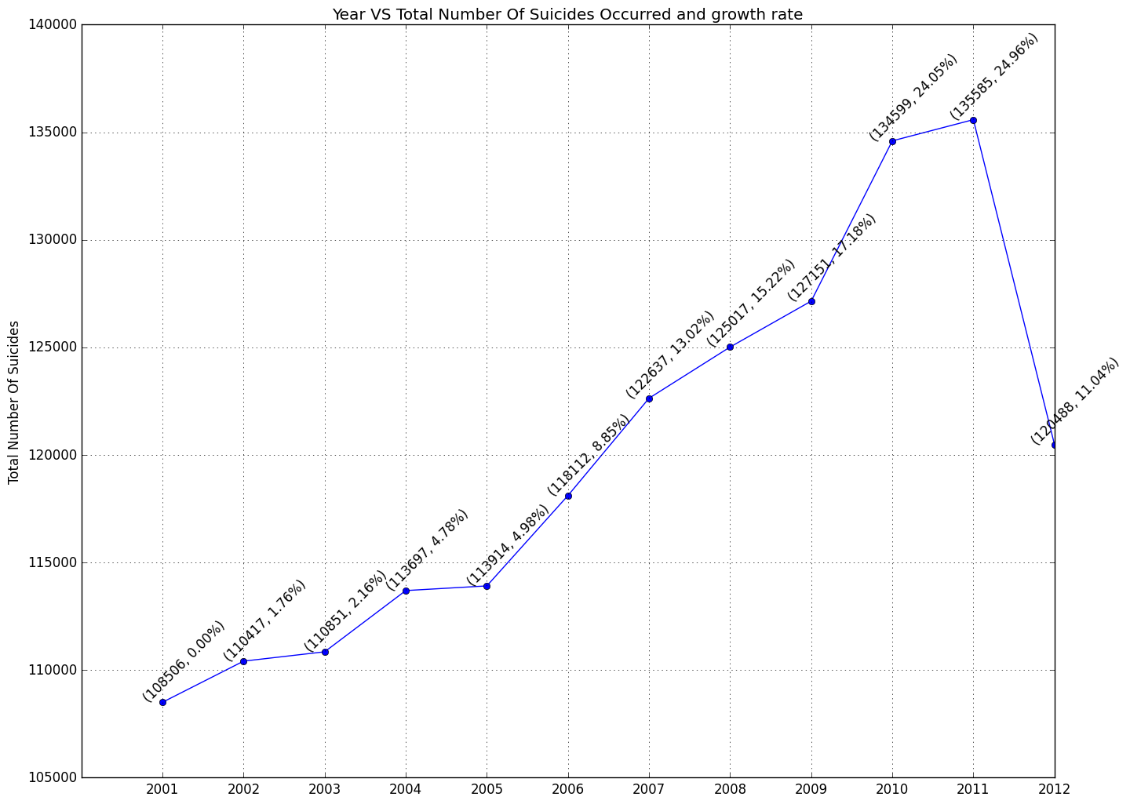
- Geographic concentration – Maharashtra has the highest suicides across all years.
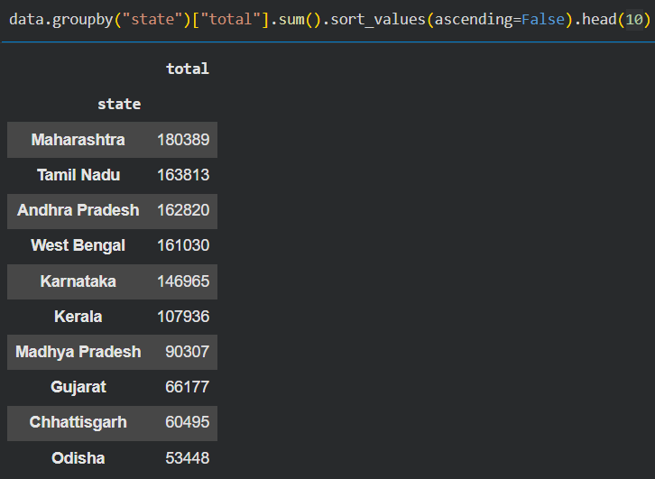
- Age is major factor – approximately 69% of people are being from 15-29 and 30-44 age group. Means most of peoples are from students and working area.
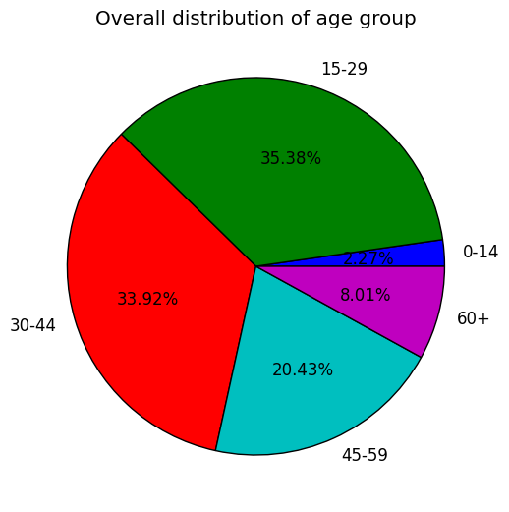

- Professional background – ignore others category, housewives and farmers are most affected from these time period
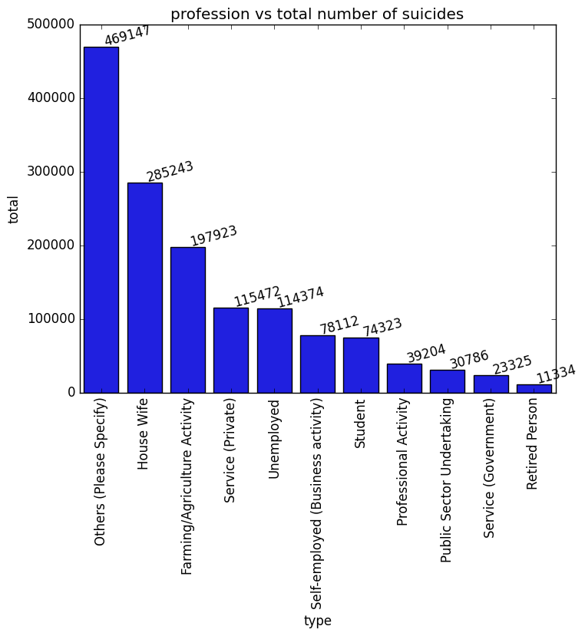
- Gender distribution – Around 64% of total suicide cases are male, and around 36 % are female.
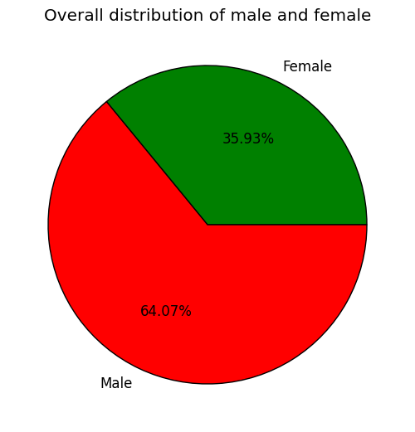
- Common methods of suicides – Most of people are did suicide by hanging, By Consuming Insecticides or poison.
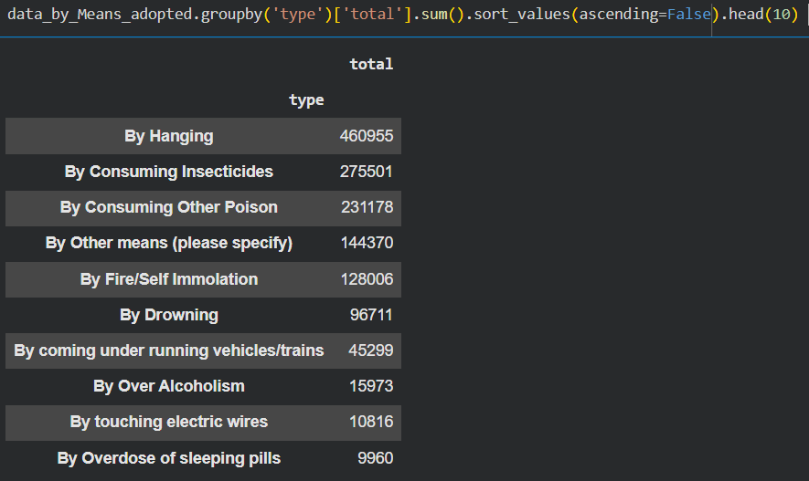
- Lead causes – Main cause for suicides is Family problem, even in children- male and females both.
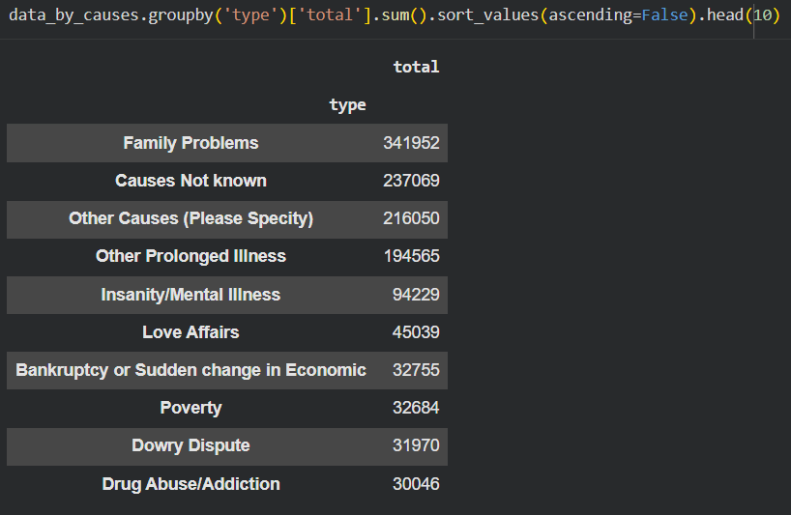

- Society’s wrong hypothesis on unemployment – one significant insight is that employed and unalloyed both have approximately same number of suicides.


- Child marriages – Almost every year on an average 50-60 house wives was did suicide whose age was under 14 years, this is strong indicator that child marriages were happened.
- Child suicides – Almost in every state child suicide was recorded but there is top 5 which has highest child suicides. And main reason of child suicide is also family problems,
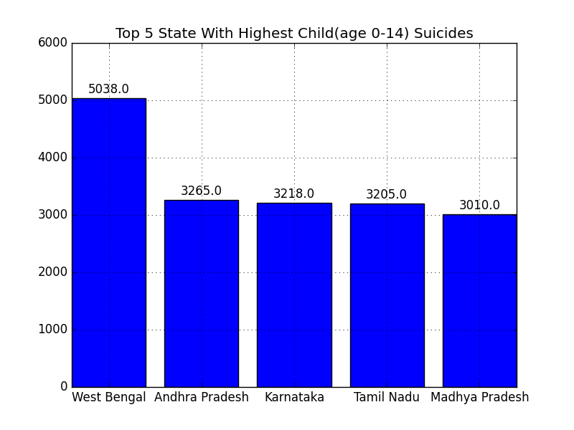
- Continuously declining trend – Keralam has continuously declining trend in across all states.
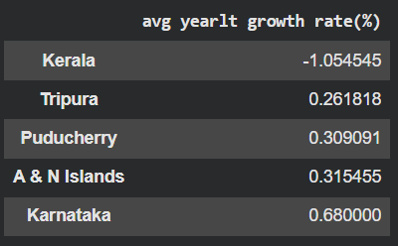
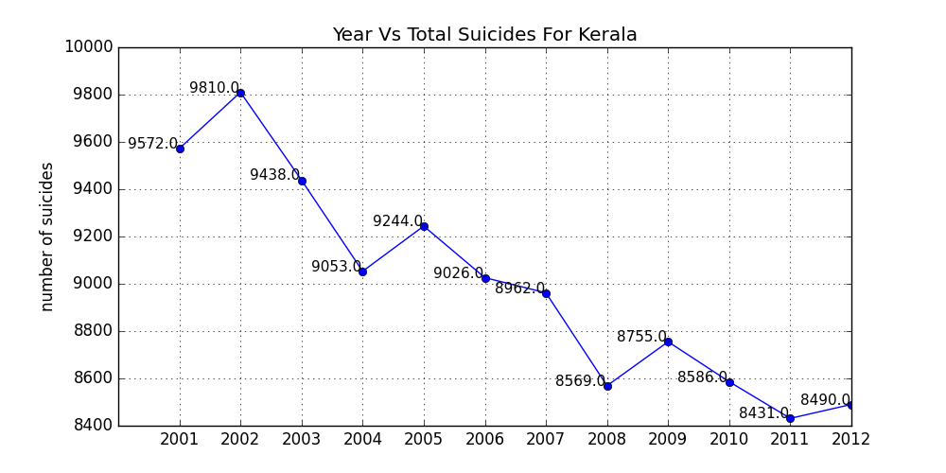
- Fastest growth rate – across all states Jharkhand has the fastest growth rate at the end of the time period.
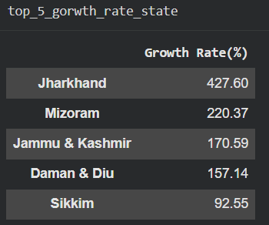

Dashboard Visuals –
There are three interactive dashboard – causes, profession, method – all are filtered with state, year, gender, age group and values of (causes, profession, methods) 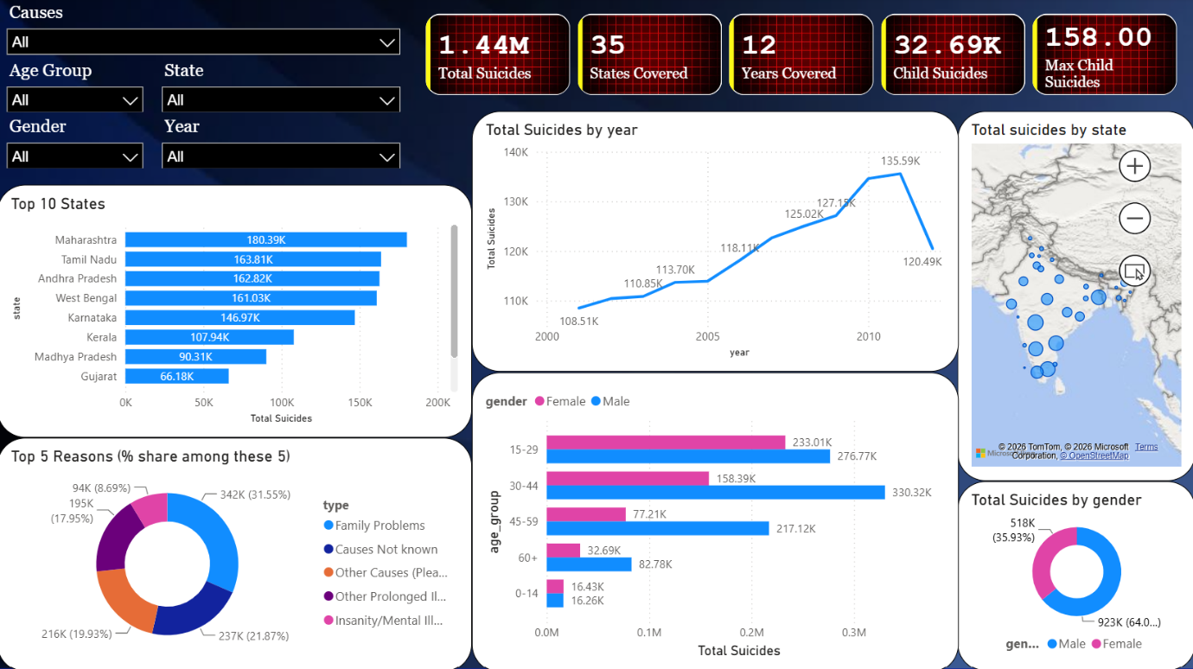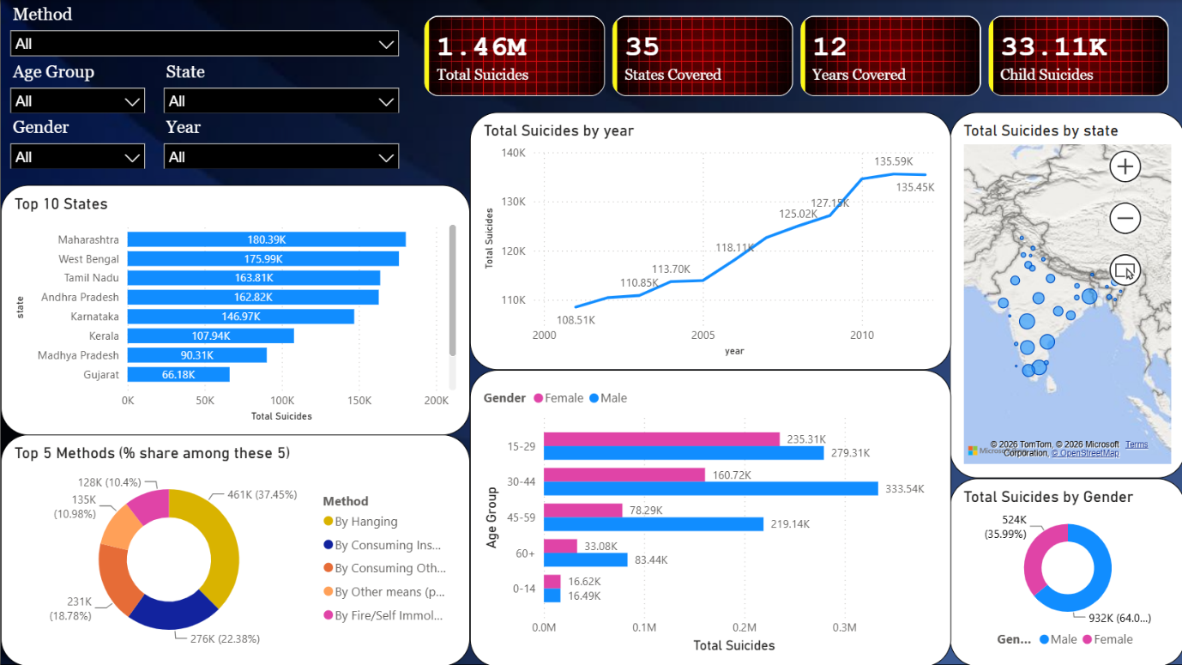
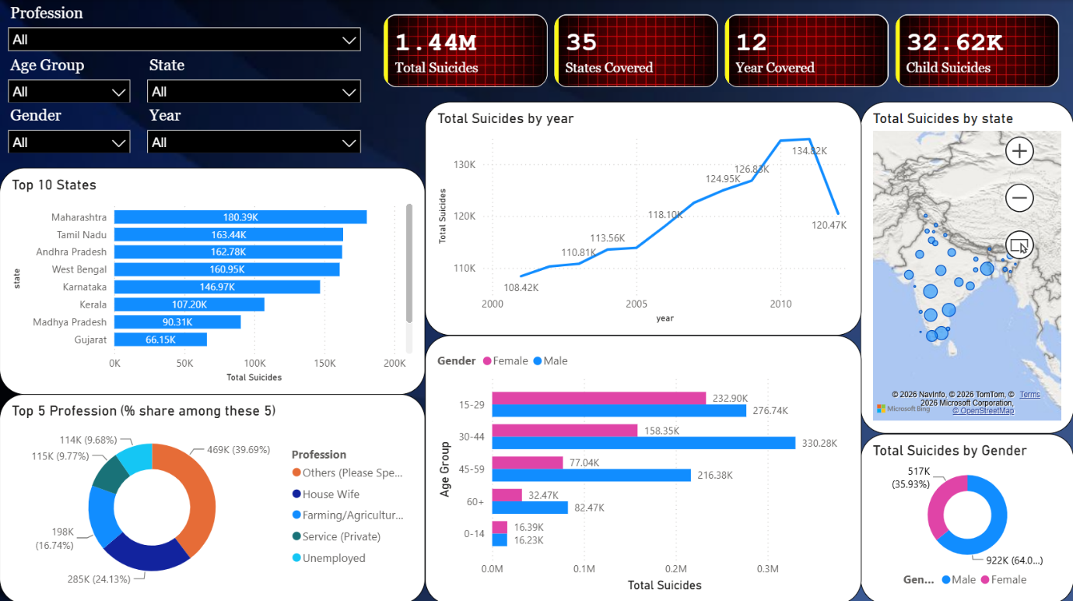

Note – Total suicides are slightly differed because this three categories’ data are not linked with each other as mention earlier.

Recommendation –
Given that family problems and unspecified/prolonged illness-related causes together account for the majority of reported cases, expanding accessible community and family counselling support — particularly in high-burden states like Maharashtra, Tamil Nadu, and West Bengal — could meaningfully reduce cases.
Family problem cause is major cause even in children so society should be think about It and counselling sessions should be happened in every area of the country it will be reduced child suicides.
The concentration of cases in the 15–29 and 30–44 age groups suggest school-, college-, and workplace-based mental health programs may reach the populations most at risk.
Given hanging and poisoning are the dominant methods, means-restriction strategies (such as regulated access to certain poisons, already piloted in some Indian states) remain a well-documented, evidence-based intervention worth further regional study.
Finally, the notably high share of housewives among affected professions suggests a need for gender-specific mental health outreach within domestic and family support settings.

Limitations –
NCRB-reported statistics are widely understood to undercount actual cases due to social stigma and inconsistent reporting standards across states; findings here should be read as directional trends in reported data, not absolute figures.
Education status and social status data could not be incorporated into age-based analysis, as the source data only reports these two categories at an aggregate age level rather than broken down by the five standard age brackets used elsewhere.
Additionally, causes, methods, and professional background cannot be cross-referenced against one another (for example, "which profession shows the highest rate of a specific cause") — the dataset reports these as independent aggregate breakdowns rather than linked, case-level records, so any such cross-analysis would not reflect real relationships in the underlying data.
Nirav Prajapati :-
Git-Hub :- https://github.com/nirav-258

