# **Assignment 3**

# **Building Scalable Distributed System**

Submitted by-

Nirav Aga

Praneeta Jhanwar

Architecture Design:

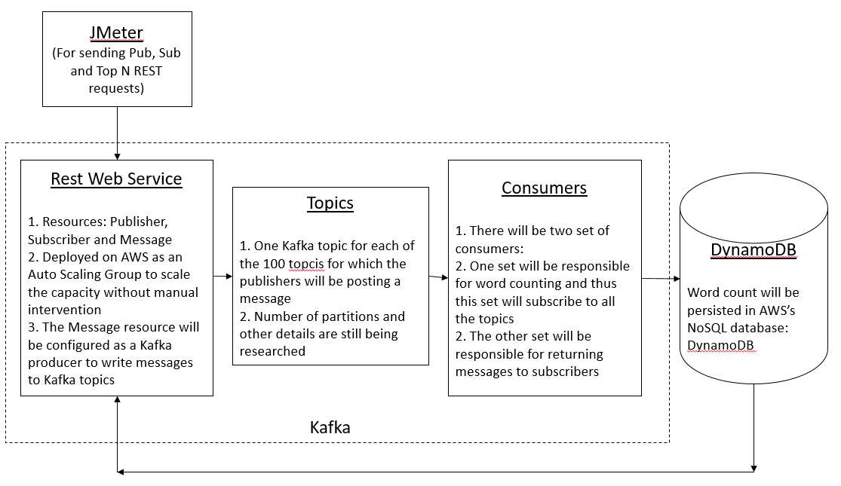

We plan to use Kafka for implementing the server. The deciding criteria is as follows:

1. Since Kafka is build up on Zookeeper, there will be very less efforts required for synchronization.
2. Kafka is ideal for applications where there are more reads than writes (10:1) and since in our application we have many subscribers reading the same message, Kafka serves as a good fit.

Additional Notes:

1. Kafka API will provides consumers to read from a offset, and thus we do not need to persist subscriber states in the database.