Docker

Install using below link
https://docs.docker.com/engine/install/ubuntu/

The contents of /var/lib/docker/, including images, containers, volumes, and networks, are preserved. The Docker Engine package is now called docker-ce.

Once installed , try below command

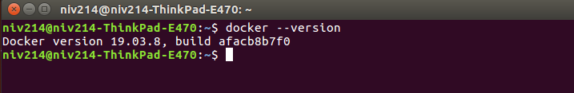

Docker Registory https://hub.docker.com/

Architecture

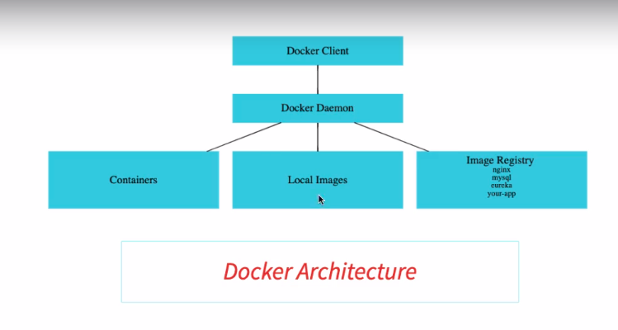
When you install docker in local system.
It install both docker client and docker deamon/engine .

Dcoker Deamon responsible for manging local contaiers and local images .
It also responsible to pull/push images to docker repository.

Few Useful Commands as below :

1) Docker image can be run bu below command

$ docker run -p 5000:5000 chhatrola/todo-rest-api:1.0.0.RELEASE

-p 5000:5000 -> -port {host port}:{contaner port}

chhatrola/todo-rest-api:1.0.0.RELEASE - > chhatrola/todo-rest-api is a repository of verius versions of applicaton. So structure is ,
{repository}:{version}

2) -d : to detach docker from container.

$ docker run -p 5000:5000 -d chhatrola/todo-rest-api:1.0.0.RELEASE

it will return container Id.

To see logs of that container

$ docker logs {container Id}

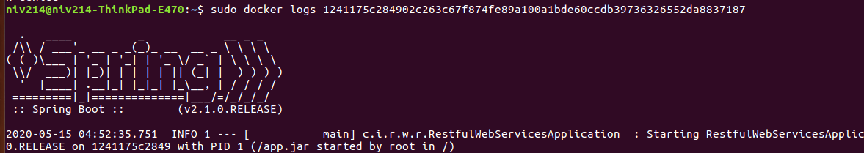

If you want to follow container logs you can tail it.

$ docker logs -f {container Id}

3) To list down all running containers

$ docker container ls

If you want to see all exited containers as well than use “-a”

$ docker container ls -a

4) To view all images downloaded in local

$ docker images

5) To stop running container

$ docker container stop {containerid}
stop command will send SIGTERM signal so it will be gracefully terminated.
One more option of kill contaner
$ docker container kill {containerid}
This command will kill container right away. Signal will be SIGKILL

6) To tag any image as latest

$ docker tag in28min/todo-rest-api-h2:1.0.0.RELEASE in28min/todo-rest-api-h2:latest
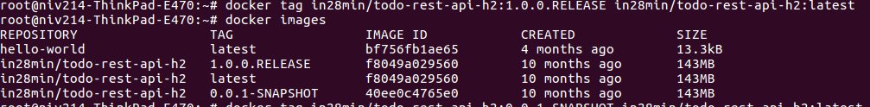
Here it will mark perticuler version of repository to latest. So when you deploy new version you should remember to tag that perticuler version as latest.

7) To untag any image
$ docker rmi in28min/todo-rest-api-h2:latet

8) To pull image to local image from docker hub

$ docker pull in28min/todo-rest-api-h2:0.0.1-SNAPSHOT
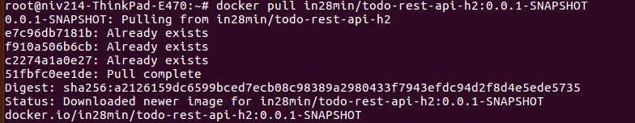

9) To Search image in docker hub

$ docker search mysql
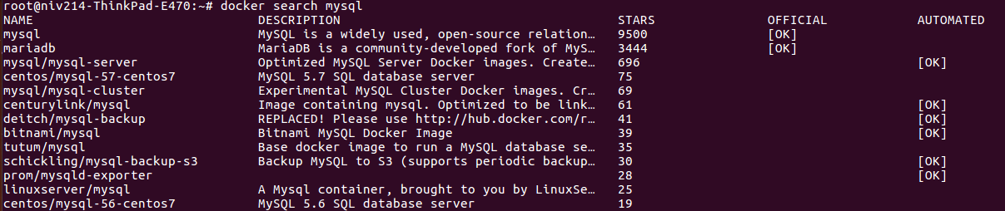
Where you can see some images are marked as official by Docker.

10) Docker image history : You can see what all steps involved in creation of image .

$ docker image history f8049a029560
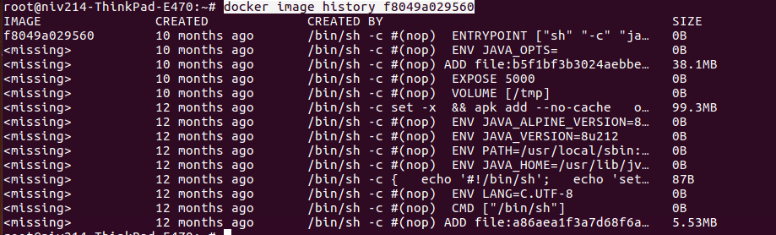

11) To get all details of image

$ docker image inspect f8049a029560
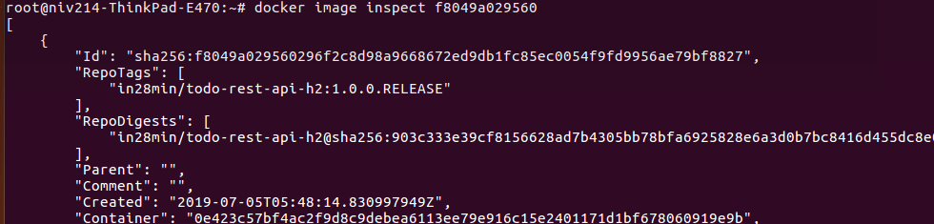

12) To remove image

$ docker image remove 40ee0c4765e0
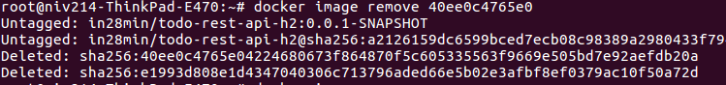

13) To pause and unpause container

$ docker container pause a0db1eb01f8c
$ docker container unpause a0db1eb01f8c

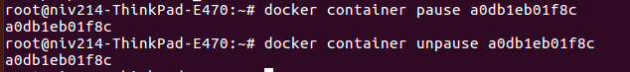

14) To inspect Docker container

$ docker container inspect a0db1eb01f8c
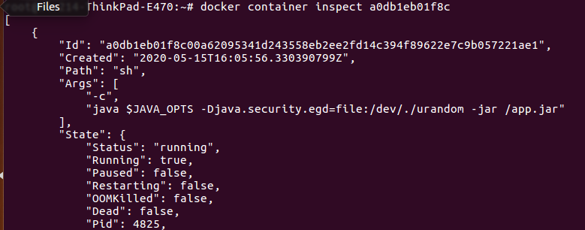

15) To remove all stopped container

$ docker container prune
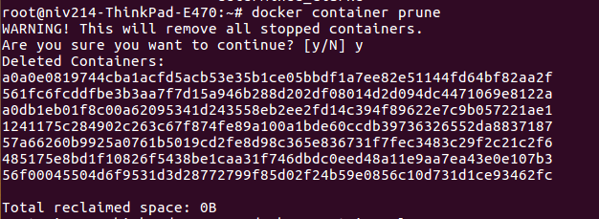

16) Restart policy

$ docker container run -p 8080:5000 -d --restart=always in28min/todo-rest-api-h2:1.0.0.RELEASE
Restart policy does have two values
no - by default that does not apply restart policy
always - It will start that perticuler container when docker service starts. Even if that container is stopped.
Its usefull when you need some service always up by default like database.
How to remove restart policy :
first stop that container and than prune all stopped container.

17) To see whats happening with your docker environment

$ docker events
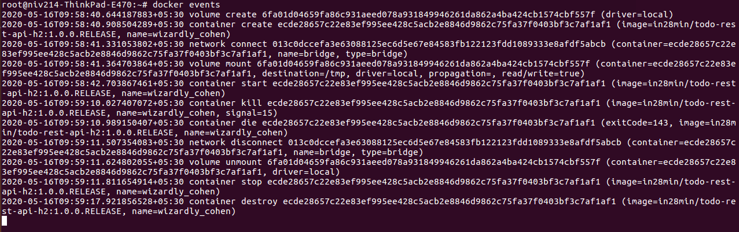

18) To view top docker container running processes

$ docker top {containerid}

19) To view stats of docker containers

$ docker stats
If you want to start container with specific memory and CPU usage
$ docker container run -p 8081:5000 -d -m 512m --cpu-quota 5000 in28min/todo-rest-api-h2:1.0.0.RELEASE

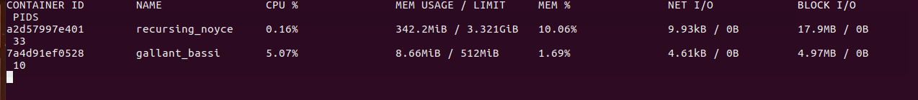

20) To view all docker image and continer realted info

$ docker system df
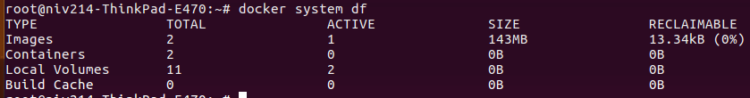

Docker image creation Manualy

Few steps to follow.

1) Build project to create jar
2) setup
$ docker run -dit openjdk:8-jdk-alpine

-d means in detach mode
-it means interactive so it allows you to run command on running continer

To run any command on container use below syntex
$ docker container exec {container_name} {command}

Now to see whats inside tmp dir of running continer, as of now its empty
$ docker container exec focused_booth ls /tmp

3) Copy jar using below simple command

$ docker conainer cp {source} {destination}

$ docker container cp 01-spring-boot-hello-world-rest-api-0.0.1-SNAPSHOT.jar focused_booth:/tmp

Can see jar in /tmp of continer
Now prepare image from this container + jar

Commit : user to create image from container
$ docker container commit {container name/id} {repository:tag}
$ docker container commit focused_booth chhatrola/hello-rest-world:manual

above command will create image with jar, but we have not told that what to do when we run the container.
For that –-change=’CMD []’ is used. Here between [] we have to give command.

$ docker container commit –-change=’CMD [“java”,”-jar”,”hello-world-rest-api.jar” ]’ focused_booth chhatrola/hello-rest-world:manual
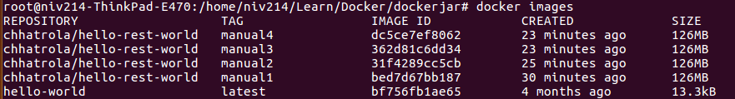
So our image is created.
Now to run that image

$ docker run -p 8080:5000 -d chhatrola/hello-rest-world:manual

here in short what we have done is
first we downloaded jdk image and run container.
Than we have copied our jar file to jdk container.
than we have created image from jdk container that containes jar file.
And than run newly created image.

Docker image Creation Using Script

Use below Script to create image using script

FROM openjdk:8-jdk-alpine
ADD 01-spring-boot-hello-world-rest-api-0.0.1-SNAPSHOT.jar 01-spring-boot-hello-world-rest-api-0.0.1-SNAPSHOT.jar
ENTRYPOINT ["sh", "-c", "java -jar /01-spring-boot-hello-world-rest-api-0.0.1-SNAPSHOT.jar"]

FROM - Host image
ADD – copy file from source to dest (Make sure everything is at same place)
ENTTRYPOINT – add command that we want to run while running container.

To build Image use below command
Goto the dir where docker file is created

$ docker build -t {repository:tag} .
$ docker build -t chhatrola/hello-rest-world:dockerfile1 .

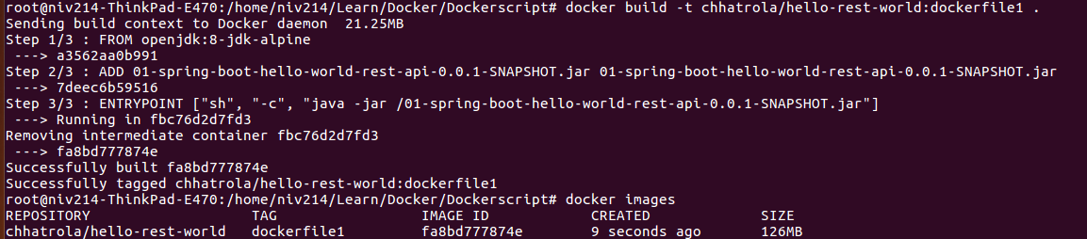

Now if you run the same command again it will used cached one.

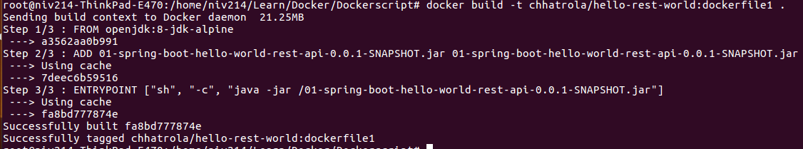

NOTE : You can easily integrate maven plugin to consume Dockerfile and create image in local repository.

To make this script more generic do below changes

FROM openjdk:8-jdk-alpine
ADD *.jar app.jar
ENTRYPOINT ["sh", "-c", "java -jar /app.jar"]

Docker image for web application

Make .war file handy.

Than use below dockerfile script.

FROM tomcat:8.0.51-jre8-alpine
RUN rm -rf /usr/local/tomcat/webapps/*
COPY *.war /usr/local/tomcat/webapps/ROOT.war
CMD ["catalina.sh","run"]

here we are using tomcat image as host image.
And copying our war file to tomcat webapps dir. Making sure its empty.
Than simple start tomcat server by calling catalina.sh.

Lets see main difference between few keywords.

FROM openjdk:8-jdk-alpine
ADD *.jar app.jar
ENTRYPOINT ["sh", "-c", "java -jar /app.jar"]

vs

FROM tomcat:8.0.51-jre8-alpine
RUN rm -rf /usr/local/tomcat/webapps/*
COPY *.war /usr/local/tomcat/webapps/ROOT.war
CMD ["catalina.sh","run"]

ADD command also provides features that we can pass any source like url and it will download it from there
but in COPY command it will only copy given file from source to dest.
But in normal schenario COPY is recommanded.

CMD command overrides startup command if anything proviced while running container.
Whereas ENTRYPOINT command does not directly override startup command.
If you want to override you can specify –entrypoint.
In normal schenario ENTRYPOINT is recommanded.

Docker setup

Create accound in docker hub.
Login through terminal.

$ docker login
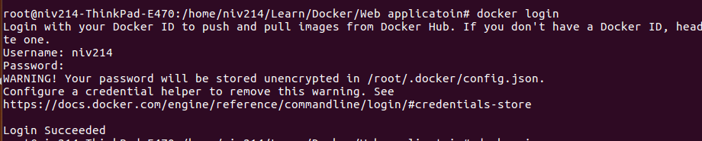

To push any repository to docker use below command.
$ docker push {dockerid}/{repo}:{tag}

$ docker push niv214/todo-webapp:1.0.0.RELEASE
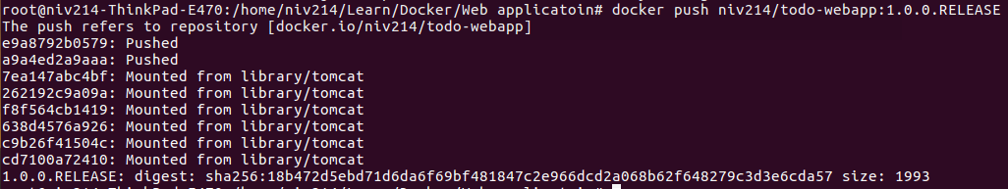
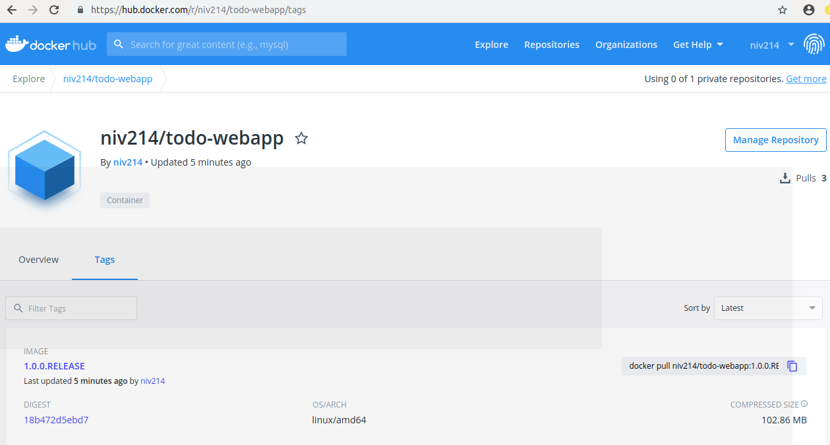

Network

Network is used to establish communication between containers.
By default 3 networks are there

$ docker network ls
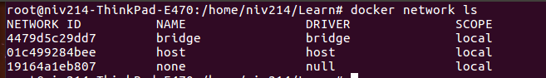
bridge network is by default. And to establish it we have to pass argyument
--link={container_name}

If want to use host you have to specify
--network=host
and in this network you dont have to specify link.

None is not a network. :)

Custom Network

One can create own network as below.

$ docker network create niv-network
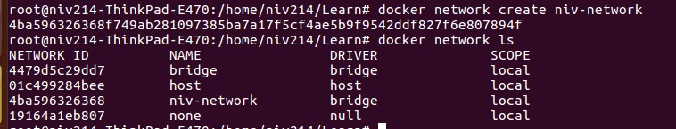

Now all the containers can be launched in to this network only.
So no need to establish link between them , even though its bridge network.

To run mysql container
$ docker run --network=niv-network -e MYSQL_ROOT_PASSWORD=dummypassword -e MYSQL_DATABASE=todos -e MYSQL_USER=todos-user -e MYSQL_PASSWORD=dummytodos -p 3308:3306 mysql:5.7

To run webapp container
$ docker run --network=niv-network -e RDS_PORT=3308 -p 8080:5000 niv214/todo-webapp-mysql:latest

Volume

To share data between host file system and container , volume is used.

It used in storing mysql kind of data to host system.

$ docker run –network=niv-network –-volume mysql-database-volume:/var/lib/mysql -e MYSQL_ROOT_PASSWORD=dummypassword -e MYSQL_DATABASE=todos -e MYSQL_USER=todos-user -e MYSQL_PASSWORD=dummytodos -p 3308:3306 mysql:5.7

Now even if we stop mysql container and remove it. And agin run image. Data will be there to read again.

Docker Compose

It used to handle multiple container from one place.

Below commands can be used with docker compose.

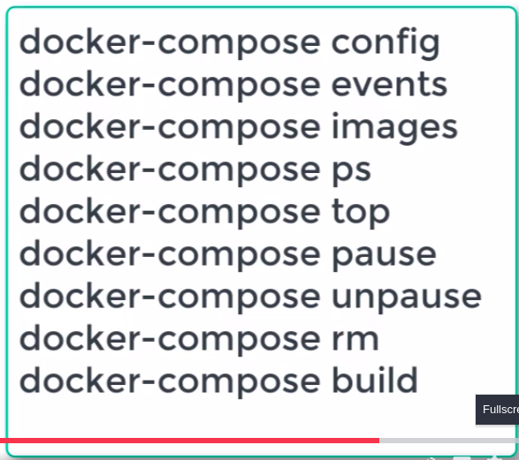

docker-compose.yml

version: '3.7'
# ERROR - Removed subprocess.CalledProcessError:
# Command '['/usr/local/bin/docker-credential-desktop', 'get']'
# returned non-zero exit status 1

# SOLUTION - Remove "credsStore":"desktop" from ~/.docker/config.json
# Original Content of ~/.docker/config.json
# {"auths":{},"credsStore":"", "credsStore":"desktop","stackOrchestrator":"swarm"}
# Update it to this
# {"auths":{},"credsStore":"","stackOrchestrator":"swarm"}
# OR
# {"auths":{},"stackOrchestrator":"swarm"}
services:
todo-frontend:
image: in28min/todo-front-end:0.0.1-SNAPSHOT
#build:
#context: frontend/todo-app
#dockerfile: Dockerfile
ports:
- "4200:80"
restart: always
depends_on: # Start the depends_on first
- todo-api
networks:
- fullstack-application-network

todo-api:
image: in28min/rest-api-full-stack:0.0.1-SNAPSHOT
ports:
- "8080:8080"
restart: always
networks:
- fullstack-application-network

# Networks to be created to facilitate communication between containers
networks:
fullstack-application-network:

