Welcome to MyBB AWS Infrastructure:

Observation/Assumptions:

1. MyBB Application is deployed under multitier architecture with single AWS region.
2. We assumed externally DNS Name has been registered using the Route 53 or migrated to route 53 under domain migration.
3. Before you launch this stack you must have SSH Key pair set either new one or existing one which should be there with you.
4. Most of configuration files are uploaded to My Git repository in order to make deployment more user friendly.( <https://github.com/niravhjoshi>)

**How to run this stack:-**

* Please follow video screen case as it recorded with voice.
* Login to the AWS console and browse to the CloudFormation section  
  Create an EC2 KeyPair (required for SSH access, can't be automated by CF) or you can use existing key pair provided you should have it.
* Click on "Create stack" and select "Upload a template to Amazon S3"  
  Select the "aws_cloudformation_stack_nirav.json" located in "Code\".
* Before clicking "Create", make sure that you give parameter like DBUserName/DBPassword  RDS DB should be MultiAZ or not and Admin email.
* Launch a stack from this template with CloudFormation ...drink ginger tea…
* Go to the LB URL in the output variable for the live MyBB application.( Login using this credential Username: admin Password : 1234)

**Overall architecture Design:**

C:\Users\nirav\AppData\Local\Temp\AWSEx2.png

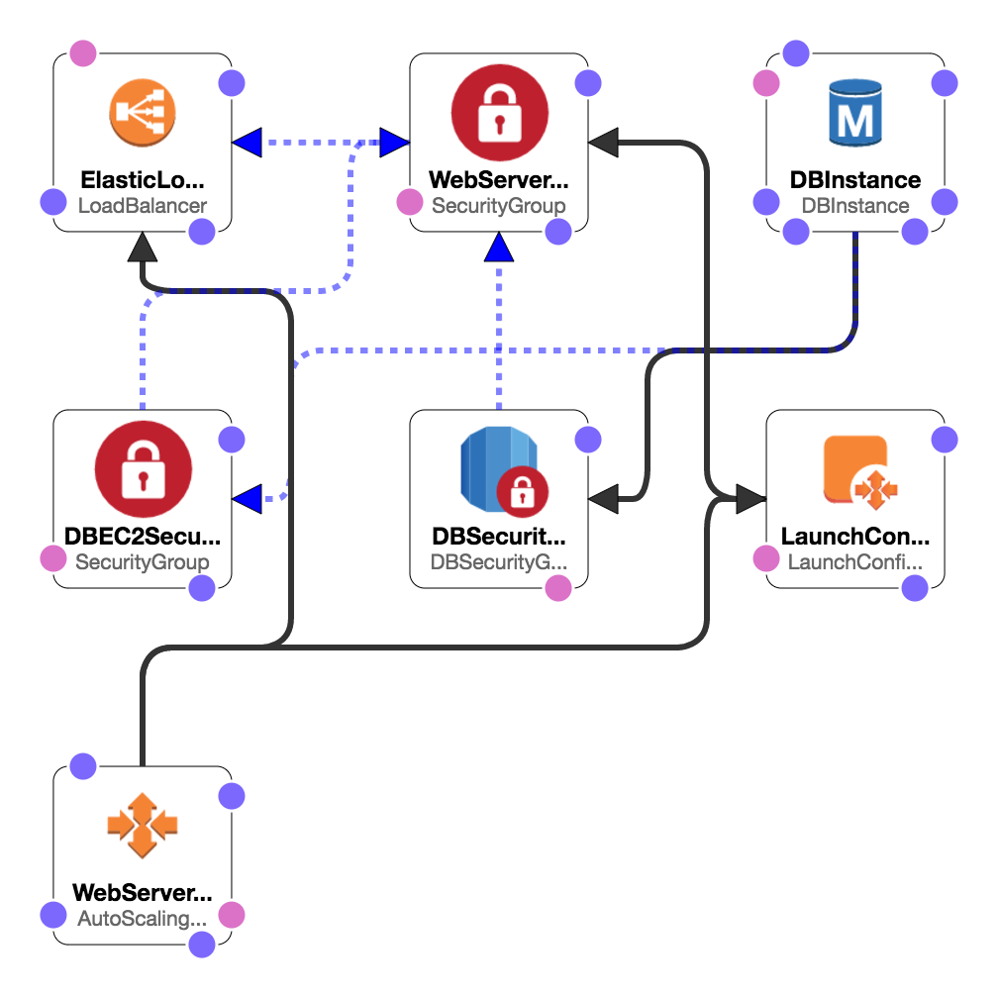

**Security Consideration:**  
1.Deployment are under single region of AWS.  
2. We have VPC in which we have created security groups (Webserver Security Group) which opens port 80 for inbound/outbound communication from ELB only we have not expose Webserver to internet.  
3.We have also created DB Security group which is only allowed to communicate from Webserver to RDS endpoint.

**Vertical/Horizontal Scaling:**  
1.For webserver we can vertical scale them without creating any downtime to website for CPU/Disk and RAM upgrade.

2. Using Auto scaling cloud init script in UserData can boot strap instance and allow them share load during peak hours.(Policy are set for CPU spike and cool Down).  
3. Database system are already on RDS which is Master/Slave configuration so reads and writes will be segregated.

**Improvement:**

1. For improvement you can have the s3 and CDN for better performance over EDGE location for caching contents.  
2. Notification emails for Auto Scale events like scale up or scale down.  
3. Cloudwatch alarms for latency of ELB /Abnormal B/W usage billing usage.  
4.Use Cloudtrail for cloud formation deployment further to investigate failure.  
5.Tag every resources in cloud so billing will get clear picture of who is costing what.  
6.Use Key/value pair for login related data in portal.  
7.Log ELB access log data and analyze it for patterns.  
8.Also cycle web logs and analyze it for patterns and errors.

Thank You.

## CREDITS

This project was built on top of **vpalos**'s stack, which is available here -> <https://github.com/vpalos/cloudformation-mybb>