GNotifier App

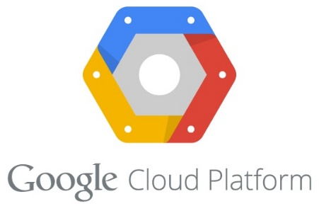

“Receive real-time SMS notifications for your Google cloud resources and the applications wherever you are”

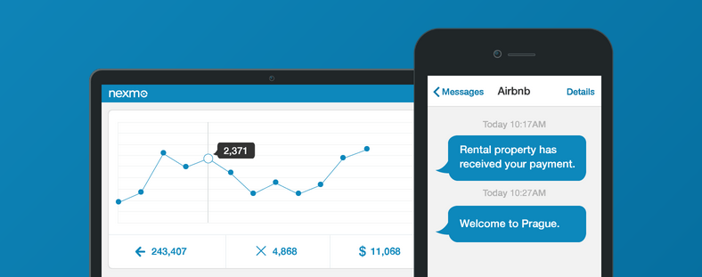

Contents

Introduction 3

Use Case 3

Prerequisites 3

Features 3

Steps to deploy the GNotifier App 3

Steps to use the GNotifier APP. 5

Steps to configure SNS on AWS 6

Configure Notification on AWS Cloudwatch 8

Appendix 9

Get Nexmo API Keys 9

# 

For system-wide visibility into Google cloud resources and applications, user can leverage google messaging and monitoring services such as Google Monitoring Service to get notification for critical events such as CPU usage, Disk usage, application performance etc. To receive such notifications as SMS on mobile, user can use the GNotifier app that makes it easy to set up, operate, and send notifications from the Google cloud. This app collect published messages from Google Monitor services or application and immediately deliver them to subscriber’s mobile as SMS to allow them to take proactive action.

GNotifiera wserviceMessaging sserviceGoogle Monitoringservice SMS to thedefined is true

# Use Case

For Google cloud resources and applications, enable Google compute engine Administrator to receive real-time SMS notifications wherever they are.

# Prerequisites

The following are prerequisite:

* Python 2.7.
* Compute Engine instance user with Administrative privileges.
* This app requires Nexmo subscription and corresponding Nexmo API keys (Keys and Secret). To access the API keys, see appendix section.

# Features

* Enable and disable SMS functionality.
* Send Compute Engine notifications as SMS.
* Easy integration and configuration with SNS.
* User friendly UI.
* Real time notification NO WAIT TIME on receive message.
* It can be use with any AWS service which is mapped to AWS SNS.
* Supported OS Fedora, CentOS 7, Redhat, Ubuntu and Debian.

# Steps to deploy the GNotifier App

To install the GNotifier app, follow the below OS specific steps:

**Ubuntu/Debian/Windwos**

1. Open the respective OS terminal
2. Clone the GNotifier repository to the desire directory. ***cd ~******git clone <https://github.com/nexmo-apps/GNotifier.git>***
3. Change the directory to the GNotifier .  
   ***cd GNotifier***
4. Run the following command to install and configure the Nexmo services.  
   ***sudo python install.py***

This will install following on AWS instance*:*

* Django 1.8.5
* Nexmo library
* Python 2.7

**Windows**

1. Download python from **https://www.python.org/ftp/python/2.7.10/python-2.7.10.msi** and install it in “C:/” drive.
2. Set the environment and system variables using below steps**:  
   Windows 8.x**
   * Open the explorer.
   * Right click on “**This PC**” -> Select the **property**.
   * Click on **Advanced System Settings**.
   * In System Property dialog box click on “**environment variable**” which located at right side corner bottom.
   * Goto the label **system variables** find the variable “**path**” append Python path **;C:/python27**
   * Click on “**Ok**”
   * Make directory **NexmoSetup,** Clone the **AWSNotifier** repository to the **NexmoSetup or** download as zip to the **NexmoSetup.**
   * ***git clone [https://github.com/nexmo-apps/GNotifier.git](https://github.com/nexmo-apps/AWSNotifier.git)***

***OR***

* + ***Extract*** the downloaded ZIP file
  + Change directory to GNotifier.  
    **cd GNotifier**

1. Run the following command to install and configure the Nexmo services.
   * ***python install.py***
2. Copy the system generated **aws_alert.bat** to Startup process. Following are the steps to make it start up process.
   * Start them run command using **Window+R**
   * Type shell:startup
3. Switch to the **GNotifier** folder copy the **aws_alert.bat** to the Start-up folder.
4. Double click on **aws_alert.bat** once.

# Google security settings

1. Login to the Google cloud console.
2. Select **Networks** under compute label from menu.
3. On Networks dashboard, select the **default** link.
4. Click on the **Add firewall rule** link as shown in the image below:  
    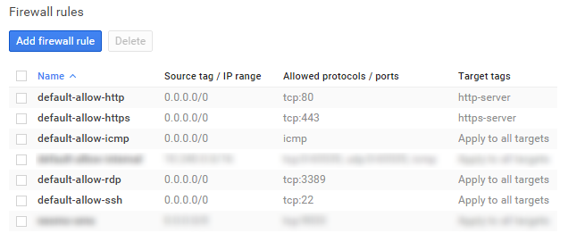
5. Set the firewall rule, allow port **9033** asshown in example screenshot.

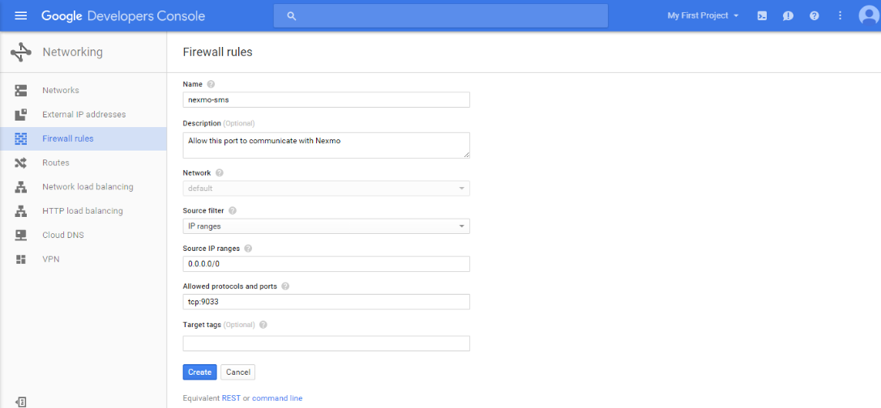

1. Click on **Create**.

# Steps to use the GNotifier APP.

1. Go to the browser and type **<<Compute Engine Instance IP:9033>>**. (Replace Compute Engine Instance IP with your instance public IP address)
2. Login with default credentials username: **admin** and password: **admin.**
3. Click on Login.  
     
   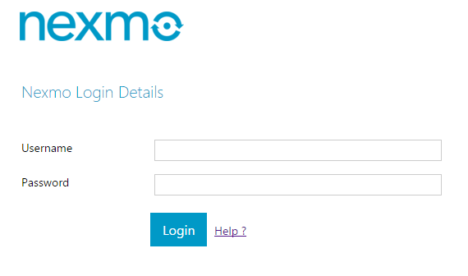
4. Set the value according to label shown. To get the Nexmo API key and secret key see the appendix. To receive SMS from the Nexmo enable it.  
   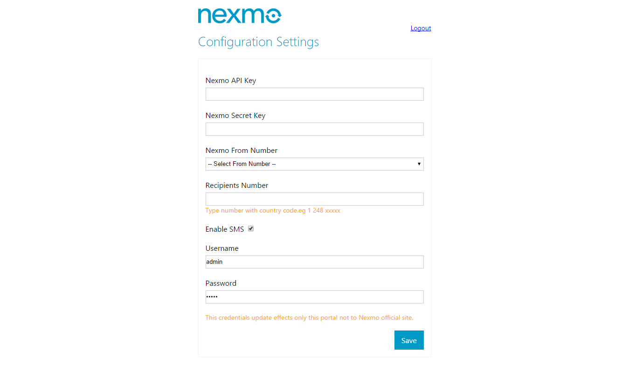
5. Click on the “**Save**”.

Steps to configure with Webhook

1. Login to the Google cloud console.
2. Click on the <https://app.google.stackdriver.com/settings/notifications/static-webhook/>
3. Click on “**Add**”  
   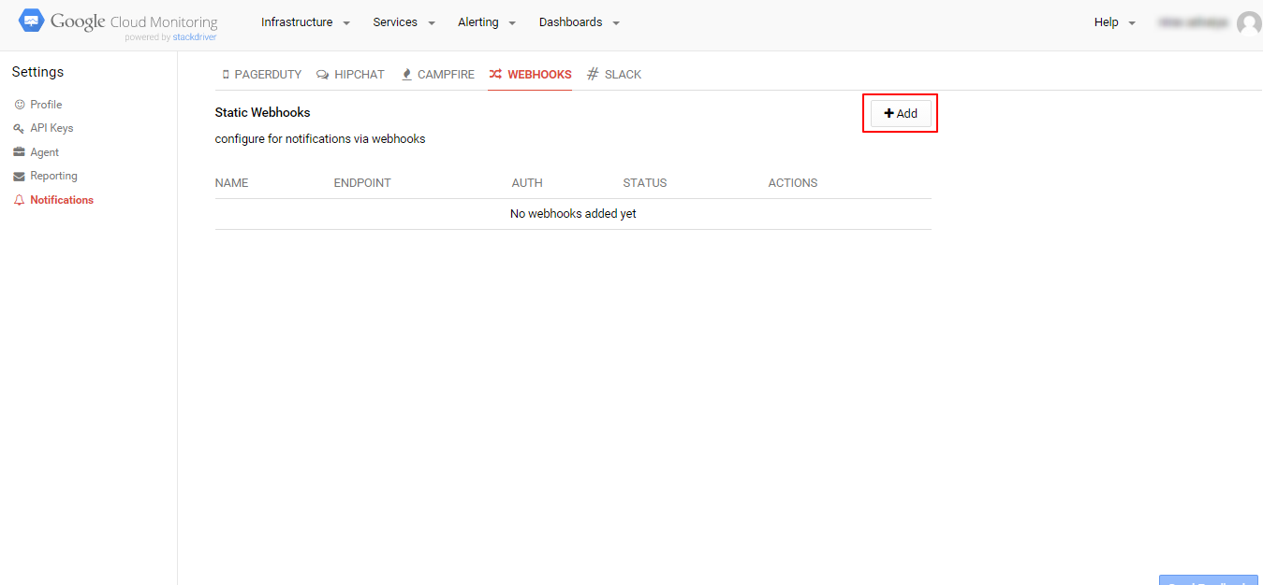
4. Set the ENDPOINT URL as your instance ID and WEBHOOK NAME that webhook identification.  
   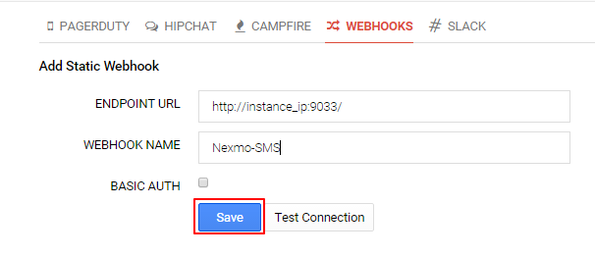
5. Click on **Save.**

Steps to configure with Google Monitoring

1. Login to the Google cloud console.
2. Click on “**Create Policy**”.   
   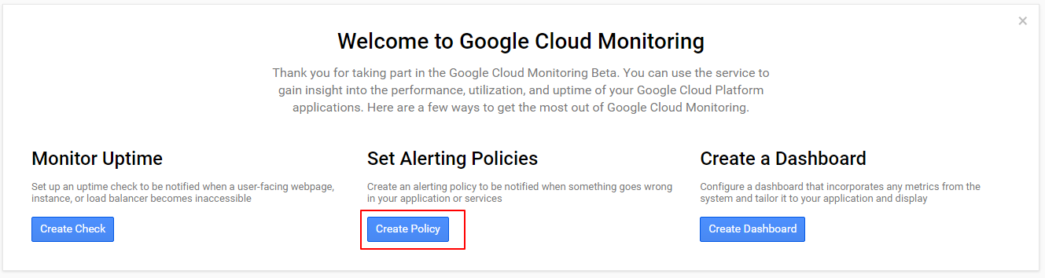
3. Type the policy name and click on **Next**.  
   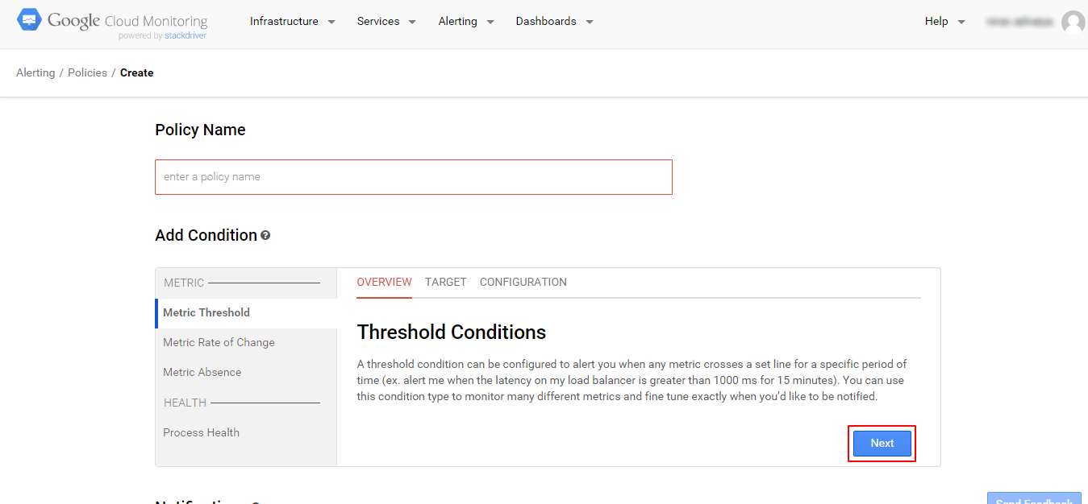
4. Select instance from the **Resource Type**. Also select this policy **applies to** from the drop down. Then Select **Next.**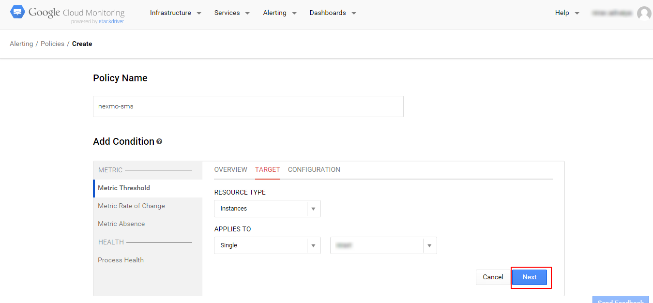
5. Set the configuration as per your requirements.  
    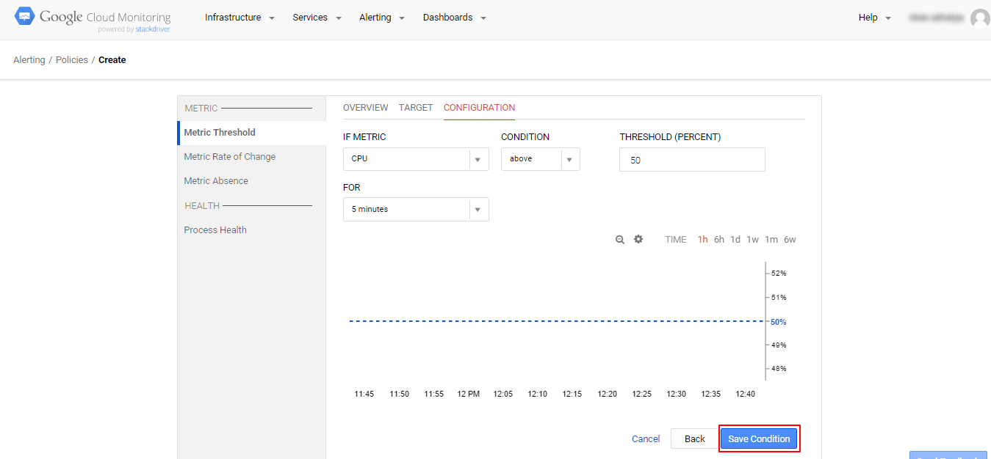
   1. To check the CPU Usage select CPU Usage (GCE Monitoring).
6. Click on “**Save Condition**”

# Configure Notification

1. Stay on same page.
2. Select webhook from the METHOD dropdown as shown in example.  
   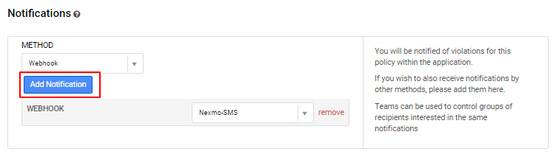  
   Click on “**Add Notification**”.
3. Optionally set the description and click on “**Save Policy**”. See in screenshot  
    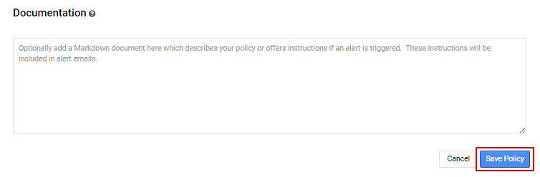
4. You will receive SMS when condition satisfy.

# Appendix

## Get Nexmo API Keys

1. Login to the Nexmo.
2. Click on click on the “**Api Settings**”

