Heroku Phone



“Deploy two-factor Authentication easy on Heroku”

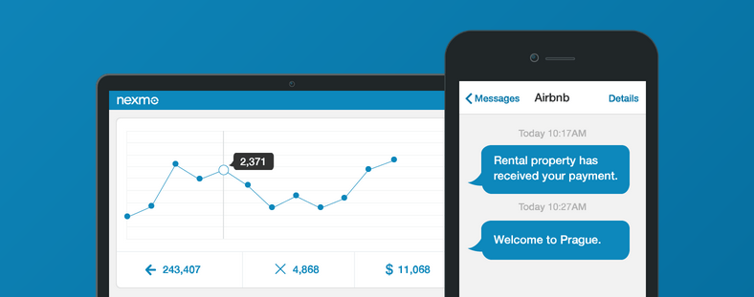

Contents

Introduction 3

Use Case 3

Prerequisites 3

Features 3

Steps to deploy the AWSNotifier App 3

Steps to use the AWSNotifier APP. 5

Steps to configure SNS on AWS 6

Configure Notification on AWS Cloudwatch 8

Appendix 9

Get Nexmo API Keys 9

# 

Heroku two-factor is application which can be integrated with any applications which could be created on C#, Python, Java, PHP and etc.

# Use Case

This app provide the two factor authentications using Heroku platform. Easy to deploy and integrate with any application.

# Prerequisites

The following are prerequisite:

* Heroku Account
* This app requires Nexmo subscription and corresponding Nexmo API keys (Keys and Secret). To access the API keys, see appendix section

# Features

* Simple integration with any Application.
* Less configuration required.
* Phone number verification using the SMS.
* Dynamic security key generate.

# Steps to deploy the Heroku Phone App

To install the Heroku Phone app, follow the below OS specific steps:

1. Open your browser and copy paste following URL.
   1. https://github.com/nexmo-apps/Heroku2factor
2. Click on Heroku Button having color Blue.
3. After click it navigate to the Heroku Deployment dashboard.

## Set up the application

1. Set application name which you like. Below is the example screenshot.  
   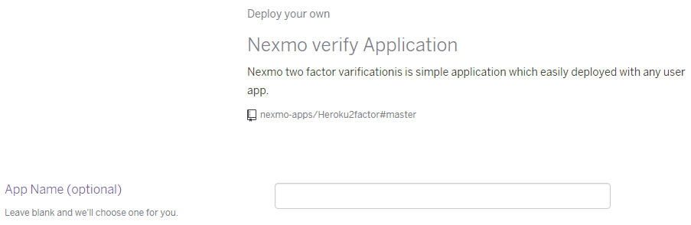
2. Select the region where the application will deploy. Default is United States.  
   C:\Users\nirav.trivedi\Desktop\Projects\Nexmo\Heroku\region.png
3. Set the Nexmo application variable to send the SMS, below is screenshot for configuration.  
   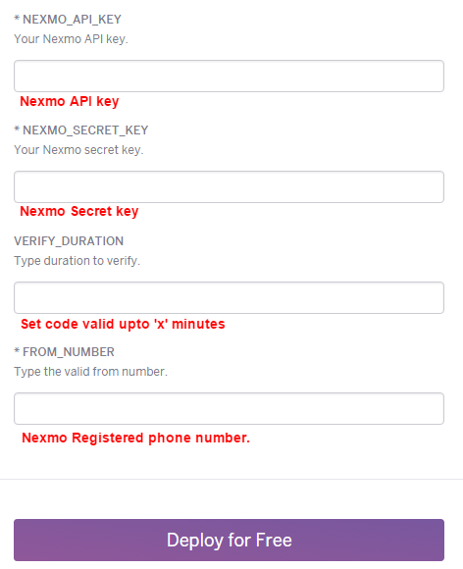
   1. Extract the API and SECRET key from the nexmo site. See the Appendix.
   2. VERIFY_DURATION: Sent code is valid upto minutes given in VERIFY_DURATION variable.
   3. FROM_NUMBER: Type here nexmo register number.
   4. Click on “Deploy for Free” button to start the application.
4. After successfully deploy it show two different button “Manage App” and “View” click on “View” copy the url for further use.
5. Use the following URI to send the verification code.
   1. Request URI : <http://<heroku-app-url>/verify?dst=<phone_with_country_code>>
   2. **dst** parameter is destination phone number with country code to send verification code.
   3. **Verify** will return you a security key in json format. Extract that security key and send back with code.
6. To validate user entered code request code and security key on following uri.
   1. Request URI : <http://<heroku-app-url>/validate?code=<code>&security_key=<secuiry_key>>
   2. Send request on **validate** end point with code and security key.
   3. Returns json if verify true or false parameter. If Verify is true, number is validated otherwise invalid phone number.
7. Sample application on:  
   http://<sample_app>

# Appendix

## Get Nexmo API Keys

1. Login to the Nexmo.
2. Click on click on the “**Api Settings**”

