- Draw a simple diagram showing the main components of a food delivery app like Zomato or Swiggy (such as user, restaurant, order, delivery partner, payment) and label how they interact in the software architecture.

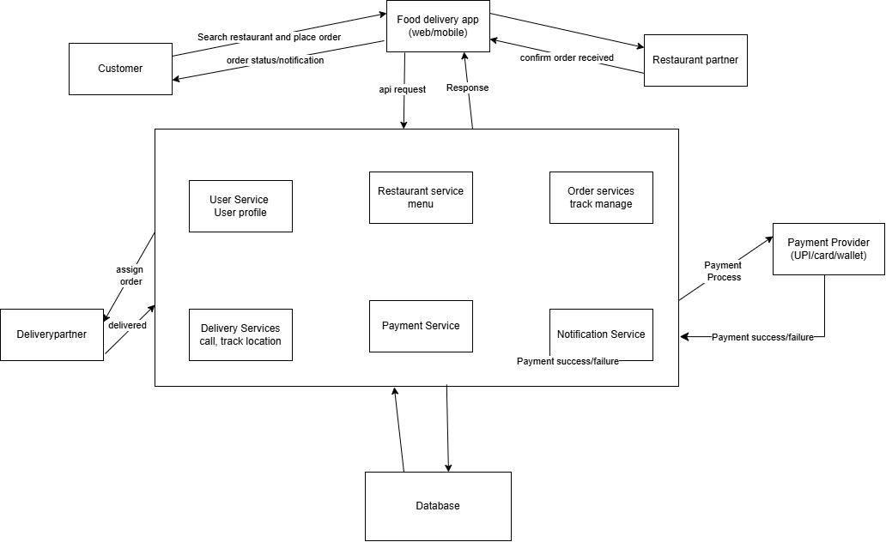

- Pick any app you use daily (Instagram, Paytm, Flipkart, etc.) and list 5 different testing activities that must be performed before the app is released to users.<br><br><em><strong>Hint:</strong> Think about things like login, payment, notifications, speed, and security.</em>

= Here is how those same 5 testing activities apply to Instagram:

- Test planing for login, feed scrolling, stories, reels, direct message and payment all these main features will be planned to work well on both android and iphone.
- Choosing test for to check login and send messages, to see if the app is running at speed, to see that hackers can steal data.
- Condition testing for true password, false password and forget password, internet can be superfast or very slow, millions of people watch live videos simultaneously, suddenly the phone switches off or the net goes down while sending a message.
- Test Cases & Checking Result for enter wrong password 5 times account should be lock. If account is locked, the test passes otherwise it as a bug, when a friend sends a message, a notification banner should immediately appear on the phone screen if the app is in the background, reels feed scrolling quickly videos should play without buffering and app should not hang.
- Evaluating completion criteria Ensuring that no critical bug remains, for after all the tests are done, check if the whole instagram is ready to launch to the public

- Explain in your own words why testing is important at each stage of the Software Development Life Cycle (SDLC), using an example from an app like BookMyShow or IRCTC.
= the 6 core stages of the Software Development Life Cycle (SDLC) using BookMyShow:
- Requirements Collection / Gathering for platform must allow users to browse movies, select specific seats, apply discount coupons, and make payments via UPI or credit cards.
- Analysis for Analyzing if the server infrastructure can handle massive traffic surges during major concert sales
- Design for check whether the design of the application is organized and easy to see and understandable.
- Implementation for to detect logical errors made by developers while writing code so that calculation errors can be corrected at the beginning.
- Testing for to test errors like if the payment fails while booking the ticket, to check whether the user’s deducted money is credited back to the account within the specified time, etc.
- Maintenance for checks that adding the new feature has not broken the old core feature of movie ticket booking.

- Write down the main objectives and purpose of testing by imagining you are part of a team launching a new music streaming feature in Spotify. List at least 3 objectives and explain each in one line.
= As part of the spotify team launching an exciting new music streaming feature, our main objectives and purpose for testing are:
- To guarantee that music playback starts instantly without buffering, even under poor or low network conditions.
- To ensure that spotify can be used on iOS, android and desktop and the app runs seamlessly on iOS, android, desktop and smart devices without crashing.
- To ensure that the user interface is easy to navigate, visually appealing and provides a free music and listening experience.

