SSAS (SQL SERVER ANALYSIS SERVICES) REPORT USING SP DATABASE

Contents

INTRODUCTION 2

Step 1: Creating the SSAS project 2

Step 2: Creating Data Source 3

Step 3: Creating the Data Source Views 6

Step 4: Creating the cube 9

Step 5: Editing Measures and Dimension attributes 13

Step 6: Deploying and processing cubes 14

Step 7: Browsing the information 15

Figure 1: Creating New SSAS project 3

Figure 2: Creating new data source 4

Figure 3: Data Source Connection selection wizard 4

Figure 4: Data Source connection manager wizard 5

Figure 5: Data Source Impersonation Information wizard 6

Figure 6: Data Source completion wizard 6

Figure 7: Data Source Views creation 7

Figure 8: Data Source selection wizard 7

Figure 9: Data Source name matching wizard 8

Figure 10: Data Source tables selection wizard 8

Figure 11: Data Source View completion wizard 9

Figure 12: Data Source Views tables 9

Figure 13: Cube Creation wizard 1 10

Figure 14: Cube creation wizard 2 10

Figure 15: Cube fact table selection 11

Figure 16: Cube measure selection 11

Figure 17: Cube dimension selection 12

Figure 18: Cube completion wizard 12

Figure 19: View of created cube 13

Figure 20: Editing measures and dimensions 13

Figure 21: Adding dimension attributes 14

Figure 22: Adding measures 14

Figure 23: Deploying cube 15

Figure 24: Processing cube 15

Figure 25: Browsing the data 16

## INTRODUCTION

SSAS or SQL Server Analysis Services, is an analytical, transactional processing and data mining tool provided for MS SQL SERVER which is commonly used for building data warehouse and perform analytics and mining.

This report is written to provide an example of SSAS using the SP database and below are the steps and screenshots as guide to use SSAS to create a data warehouse and run some analysis on the data.

## Step 1: Creating the SSAS project

The first step to create a data warehouse is to create the facts and dimension in the database where the fact table is the central table in a cube which contains the foreign keys of all other table which are also the dimension table. The fact table also work as a measure for the dimension tables when creating the cube in SSAS. Basically, the fact and the dimension table are a star schema or a snow flake schema in the database.

Now, to begin, open the visual studio with the SSDT installed (in this project, visual studio 2015 is used). In the context menu, go to the ‘File’, hover on ‘New’ and click on ‘Project’. This will bring the window as shown in figure 1. From the left-hand side, under ‘Business Intelligence’ select ‘Analysis Services’, then choose the first option in the middle pane i.e. ‘Analysis Services Multidimensional and Data Mining Project’, give a name to the project, chose the location to save the project, then click on ok to create the project.

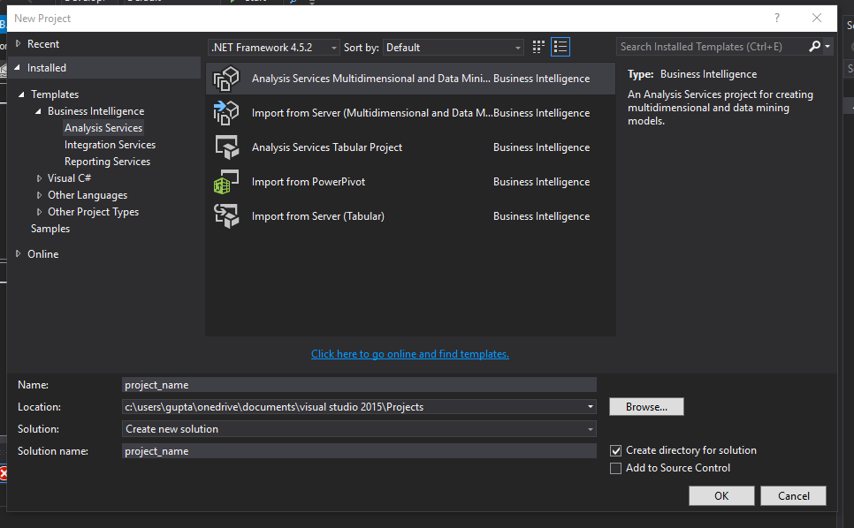

Figure 1: Creating New SSAS project

## 

## Step 2: Creating Data Source

Once the project is created, following options can be viewed in the solution explorer as shown in figure 2. These are the step by step process. So, the first thing that needs to be created here is the ‘Data Source’.

To create a data source, right-click on the ‘Data Source’ which will give ‘Add New Source’ as the option.

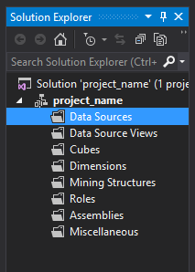

Figure 2: Creating new data source

Clicking on the option will bring the window as shown in figure 3. Here, click on the ‘New’ to create a new connection.

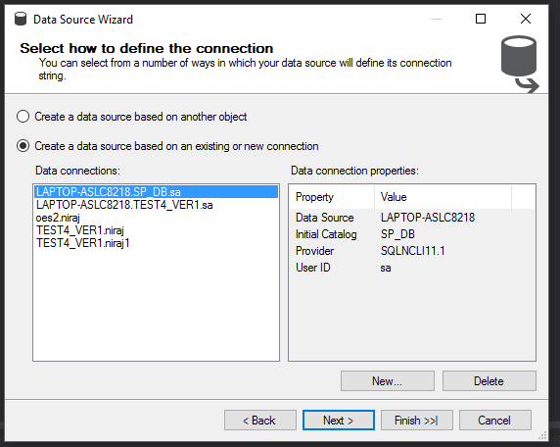

Figure 3: Data Source Connection selection wizard

This will bring a window for connection manager as shown in figure 4. Here, the middle ware for SQL Server is already provided. Now, choose the server name, choose the authentication type i.e. the sql server authentication or windows credentials, the sql server authentication is used in this case. Fill in the username and the password. Then, select the database to be used, the ‘SP_DB’ is selected in this case. Then test the connection which give the success message as in the figure below if nothing goes wrong.

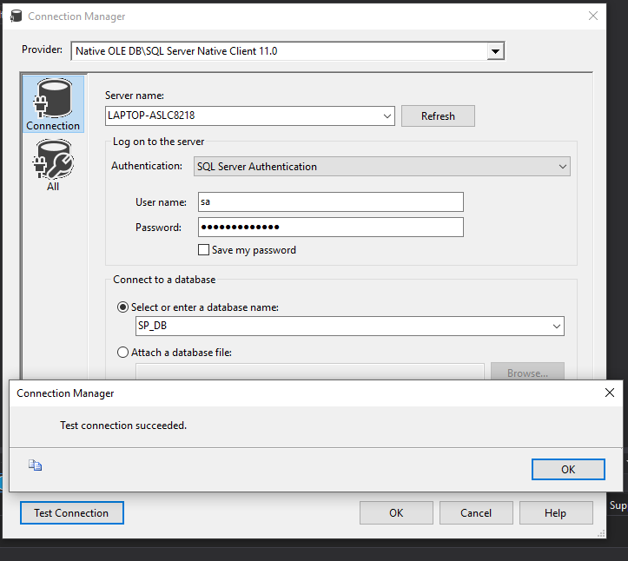

Figure 4: Data Source connection manager wizard

Now, for Impersonation Information, the recommended option would be to use the service account which is the credential used in the SQL Server Analysis Server. Choose this option and click on next.

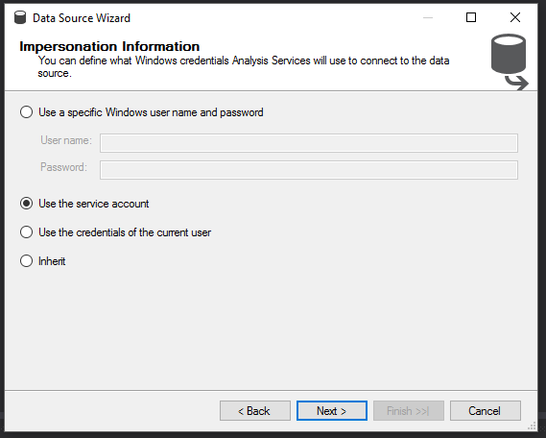

Figure 5: Data Source Impersonation Information wizard

In the ‘Completion wizard’, click on the ‘Finish’ to create the data source.

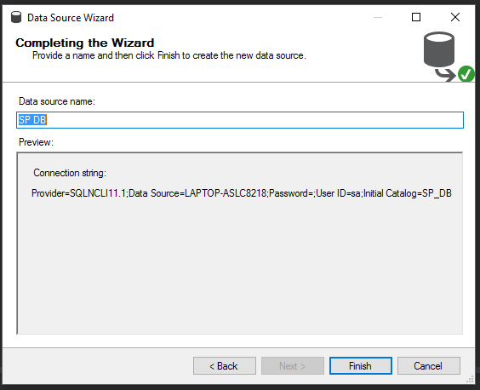

Figure 6: Data Source completion wizard

## Step 3: Creating the Data Source Views

The create data source i.e. the SP DB.ds can be viewed in the solution explorer. Now the next step is to create views from the created data source. To do that, right-click on the ‘Data Source Views’ which will show the option for ‘New Data Source View’, click on that which will bring a window as shown in figure 8.

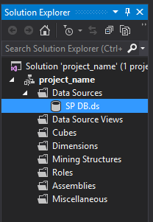

Figure 7: Data Source Views creation

In this part, select the database source, the SP DB is already selected here, now click on next.

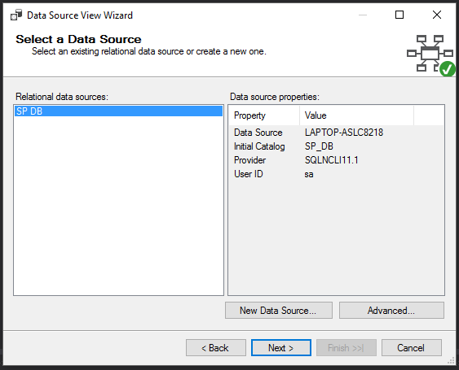

Figure 8: Data Source selection wizard

In the Data Source View Wizard, if your tables don’t have any foreign key relationships, it will say that no foreign keys were found but you can create logical relationships on matching columns and one option is using the matching primary keys. So, if this the case, check ‘Same name as primary key’ from the given options below and click on next to proceed.

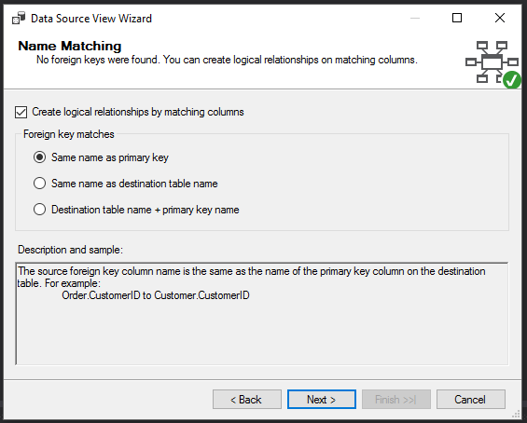

Figure 9: Data Source name matching wizard

Then, select include the tables from the available objects as shown in the figure below and click on next.

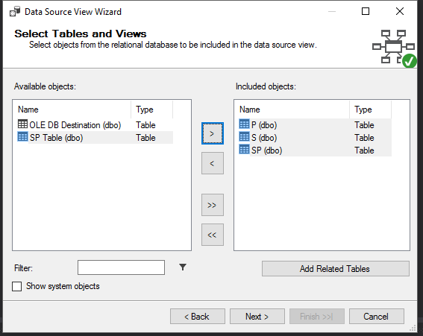

Figure 10: Data Source tables selection wizard

Once the tables are included (P, S and SP tables are selected in this case), click on the next to proceed.

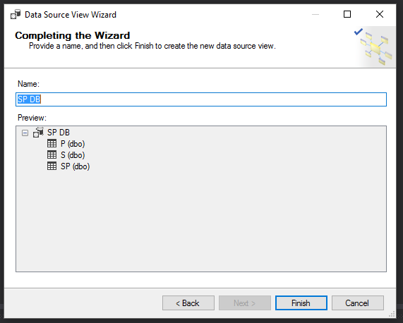

Figure 11: Data Source View completion wizard

The data source view is created now, and the tables and their relations can be seen in the middle pane as in the figure below.

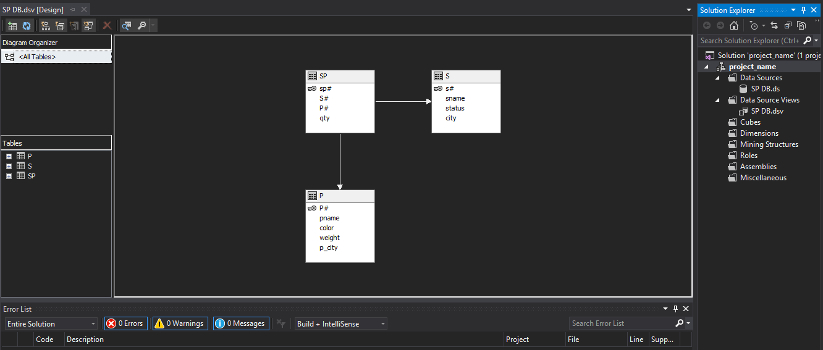

Figure 12: Data Source Views tables

## Step 4: Creating the cube

After the view is created, the next step is to create a cube from the view. To do this, right-click on the cubes from the solution explorer and click on the ‘New Cube’ which will bring the Cube Wizard. Then click on next to proceed.

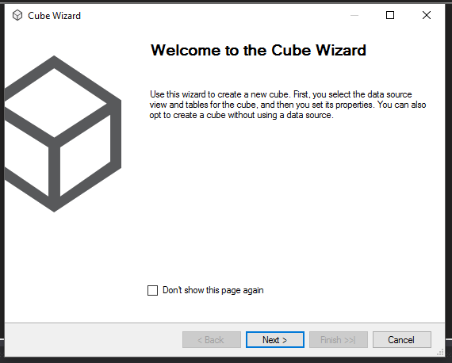

Figure 13: Cube Creation wizard 1

The cube wizard will give options as shown in the figure below. The ‘Use existing tables’ option is used in this case because we already have the tables to use for this purpose. Click on next.

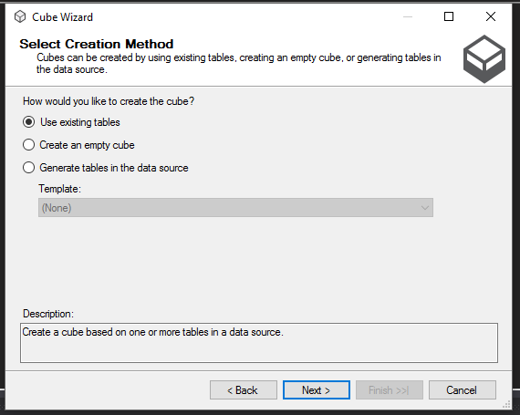

Figure 14: Cube creation wizard 2

Now, in this part, the fact table needs to be selected to create the measures and the SP table is the fact table here whereas the P and S are the dimension tables.

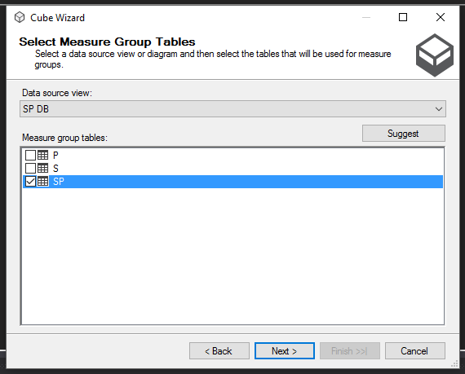

Figure 15: Cube fact table selection

The cube wizard will automatically choose the measures from the table, here, the selected measures are Qty, and SP Count. But the measures can also be added and removed after the cube is created which we will see later.

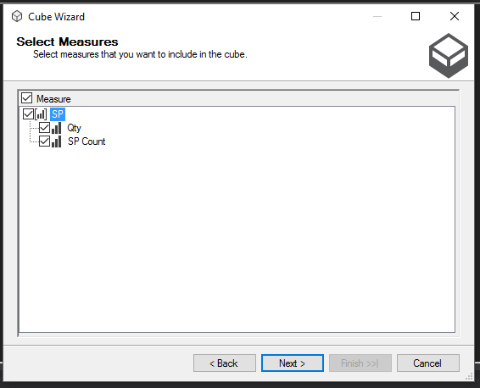

Figure 16: Cube measure selection

After the measures, the dimensions will be chosen to create the dimensions for cube. Here, S and P are selected as the dimensions.

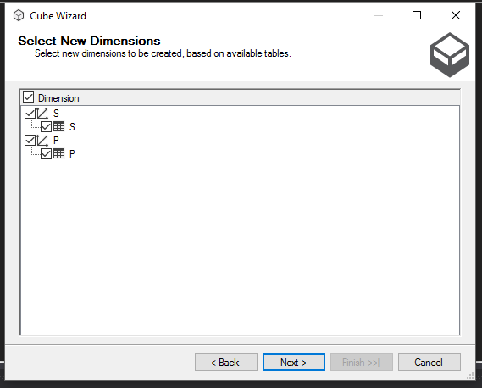

Figure 17: Cube dimension selection

Now, in the completion wizard, the preview of measures and dimensions will be shown. Click on finish to complete the process.

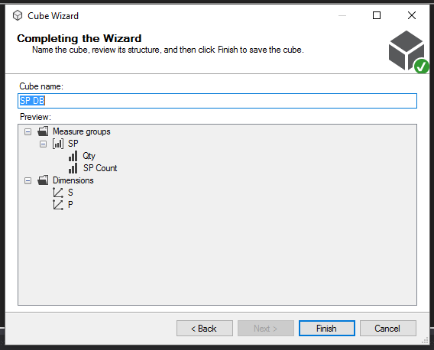

Figure 18: Cube completion wizard

Doing so will give the tables as shown in the figure below, here the yellow highlighted table is our fact table and the related tables are the dimensions. In the solution explorer we can see the cube and the dimensions created. On the left-hand side, we can see the dimensions and the measures which can be edited to add or remove dimension attributes or measures.

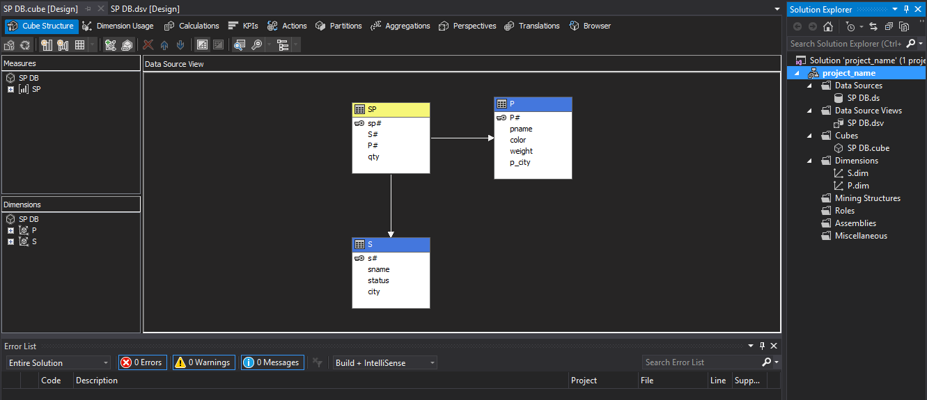

Figure 19: View of created cube

## Step 5: Editing Measures and Dimension attributes

To edit the dimension, expand the dimension, for example: expand P and click on edit P.

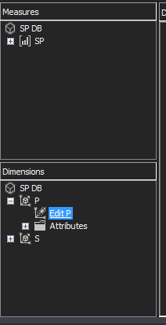

Figure 20: Editing measures and dimensions

Doing so, will show as figure given below, on the right-hand side, the attributes of P table are given, we can select them and drag and drop on left pane to add them to dimension. It is the same process for other dimensions.

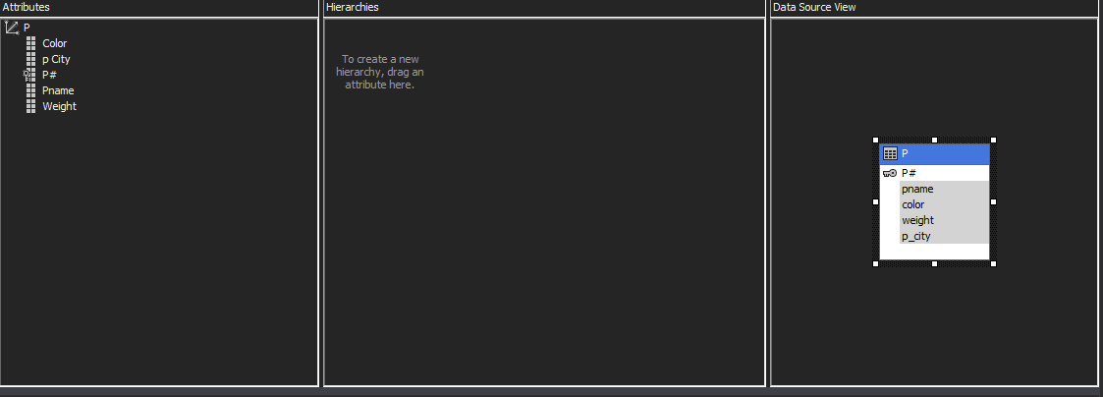

Figure 21: Adding dimension attributes

Similarly, to add new measures, we can expand the measures table on the left-hand side and right click on it to bring the new measure window. In the new measure window, check ‘show all columns’, select the usage (e.g. sum) and choose the column to add and click on ok. This will add the new measure to the cube.

Note: each time adding a new measure or dimension, it requires to process and deploy the cube again on the server and refresh the browser.

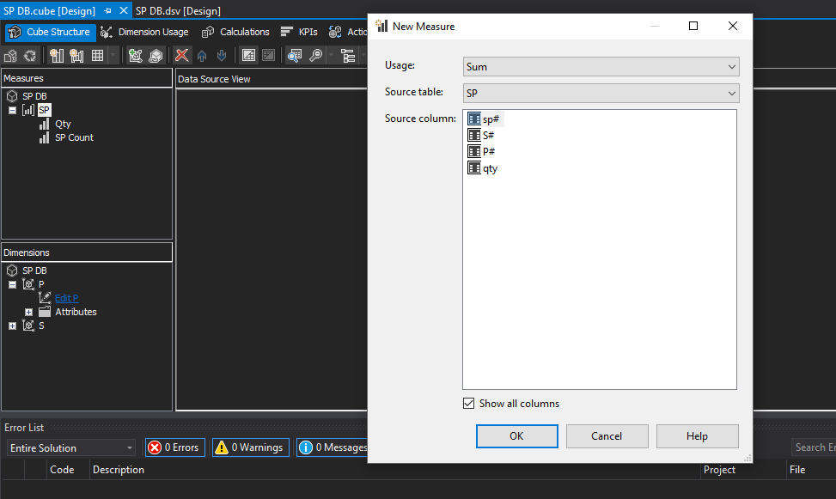

Figure 22: Adding measures

## Step 6: Deploying and processing cubes

To process and deploy the cube, first, from the solution explorer right-click on the project and click on the properties, from the new window click on deployment and choose the server on which you want to deploy. In this case, the deployment server is the ‘Localhost’. Then, right-click on the cube from the solution explorer and click on ‘process’. This will bring the window as shown in the figure below. Once the deployment is successful, click on run to process all dimensions and measures.

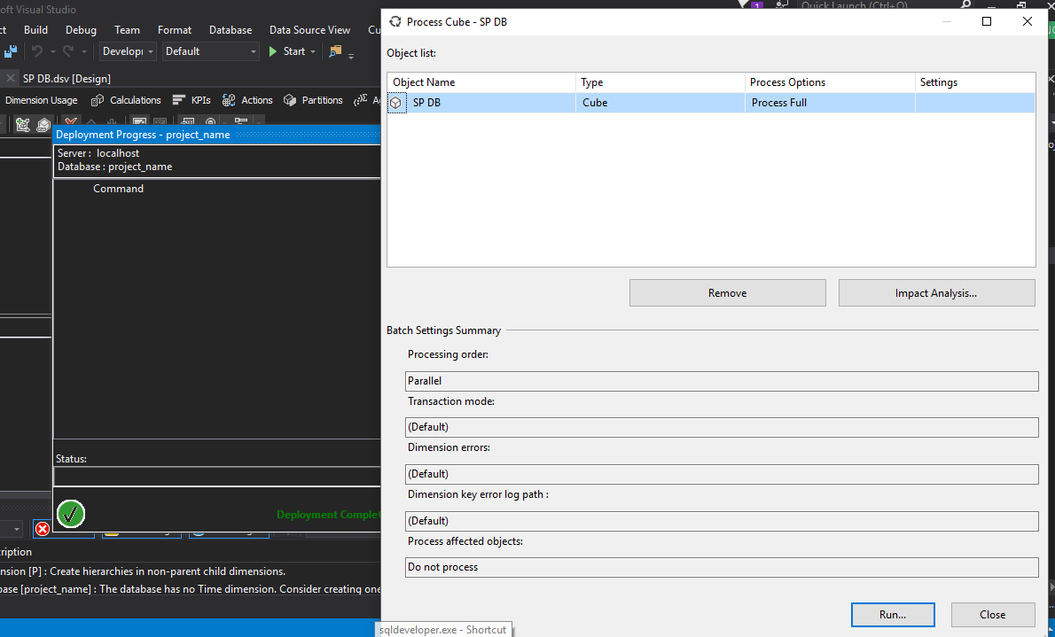

Figure 23: Deploying cube

Once the process is complete, click on close to proceed.

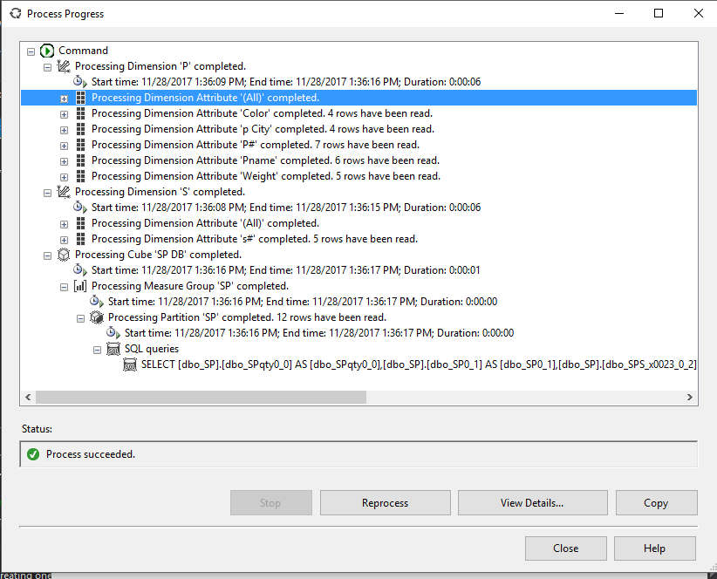

Figure 24: Processing cube

## Step 7: Browsing the information

Now, to browse the data, click on the browser from the page menu. On the left pane, we can see the measure, the dimension and their attributes. We can drag and drop these on the browser middle pane and click on execute query to view the information. So, for demonstration, I have selected the Pname (name of product), Sname (name of supplier), P City (city of product), Color (color of product) and Qty (the product quantity). And, as shown in the figure below, the quantity is our measure and will shown according to all included dimensions.

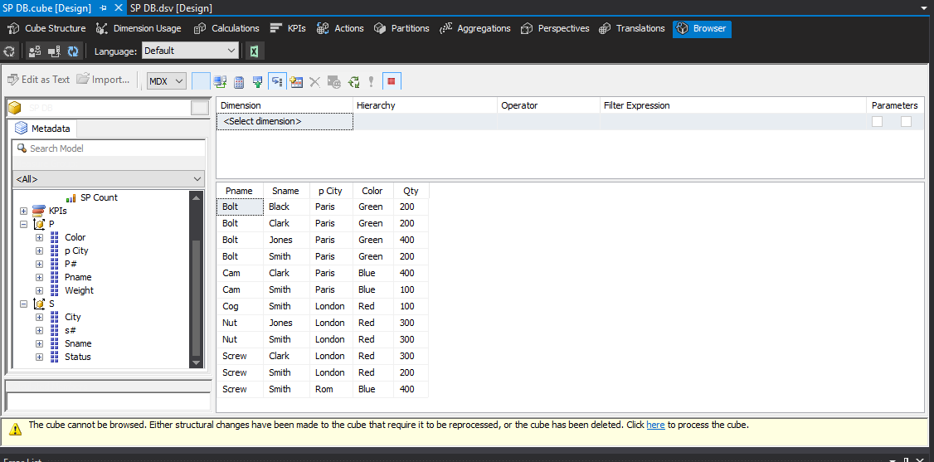

Figure 25: Browsing the data