Contents

INTRODUCTION 3

PHASE 1: Structure and model of Sales database 3

Phase 2: Structure of the data warehouse Sales_dw: 5

Phase 3: Creating the SSAS project 7

Step 1: Creating data source 7

Step 2: Creating Data Source Views 9

Step 3: Creating the Cube and dimensions 10

Step 4: Creating the time dimension 11

Phase 4: Analysis in the SSAS 13

Queries: 14

Link of the SSAS project video: 24

Figure 1: Table count of Sales database 3

Figure 2: Entity relationship diagram of Sales database 4

Figure 3: Sales data warehouse (Sales_dw) table count 5

Figure 4: Sales star schema 6

Figure 5: Vendor star schema 7

Figure 6: Data Source Connection wizard 8

Figure 7: Impersonation Information 8

Figure 8: SSAS Data Source selection wizard 9

Figure 9: SSAS Tables and Views selection wizard 9

Figure 10: SSAS Data Source View Structure 10

Figure 11: SSAS Cube creation 10

Figure 12: SSAS Cube Structure 11

Figure 13: SSAS Time Dimension creation wizard 12

Figure 14: SSAS Dimension usage interface 12

Figure 15: SSAS browser 13

Figure 16: SSAS output for query 1 14

Figure 17: SMSS output for query 1 14

Figure 18: SMSS output for query 2 15

Figure 19: SSAS output for query 2 15

Figure 20: SSMs output for query 3 16

Figure 21: SSAS output for query 3 16

Figure 22: SSMS output for query 4 17

Figure 23: SSAS output for query 4 17

Figure 24: SMSS output for query 5 18

Figure 25: SSAS output for query 5 18

Figure 26: SMSS output for query 6 19

Figure 27: SSAS output for query 6 19

Figure 28: SMSS output for query 7 20

Figure 29: SSAS output for query 7 20

Figure 30: SMSS output for query 8 21

Figure 31: SSAS output for query 8 21

Figure 32: SMSS output for total commission 22

Figure 33: SSAS output for total commission 22

Figure 34: SSAS output for monthly commission 23

Figure 35: SSAS output for yearly commission 23

# INTRODUCTION

This is paper is for the Test 5 SSAS project from IT 640 (Advanced Database Systems). The paper includes the explanation of creating data warehouse with facts and dimension tables from an existing database which is the updated Sales database with all the requirements from previous tests i.e. test 1, 2, 3 and 4 from the class. The star schemas which will be used in creating SSAS project. Analysis of the queries from the tests. The topics are explained in phases further in this this document.

## PHASE 1: Structure and model of Sales database

The sales database (which is named as v3b in sql server) is pre-existing database that was migrated from Oracle to SQL Server during test 4 and this will be used to create the data warehouse. To understand the schema and table counts consider the diagrams below.

The figure 1 and figure 2 below explains the table count and the structure of the sales database schema (using entity relationship diagram). The figure 2: Entity relationship diagram of Sales database is a jpg and it is large to fit into a single page of word document, so it is shrunk down from its original size but can be expanded to when there is need to have clear view of each entities and attributes.

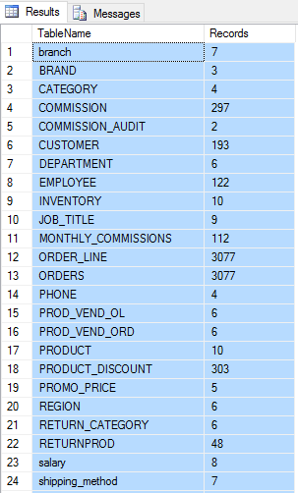

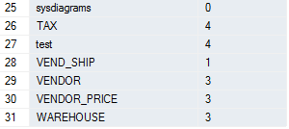

Figure : Table count of Sales database

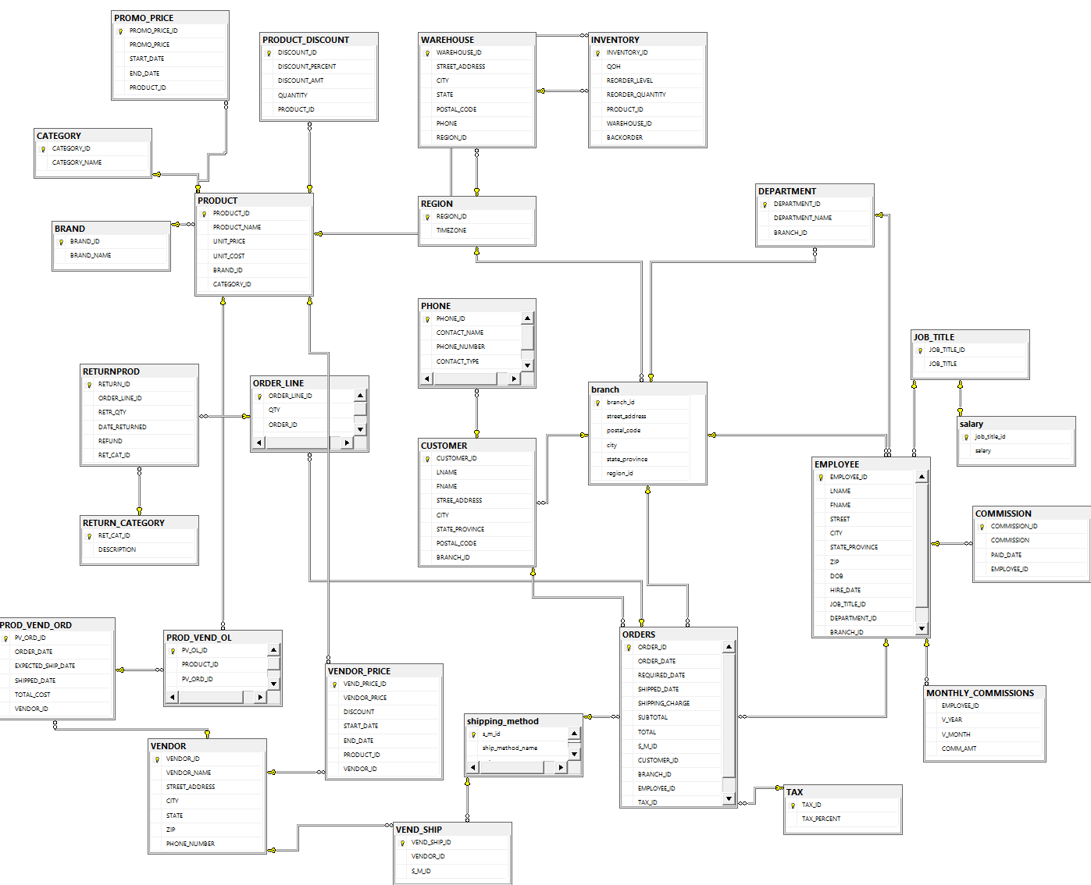

Figure : Entity relationship diagram of Sales database

## Phase 2: Structure of the data warehouse Sales_dw:

The sales_dw data warehouse is created from the sales (v3b) database and it contains the dimensions and the fact tables including the staging tables created during the table merges. Further, the sales_dw has two different star schemas, one for the Sales and other for the purchases from vendor.

Getting the data from sales database to sales data warehouse: To get the data from the database to the data warehouse, several sql queries were used. First, all the required dimension table tables were created including a surrogate key. Then a staging table was created by joining multiple relevant dimension table within the data warehouse. Then the fact table was created with importing the surrogate keys and measures from the staging table by matching the ID’s in staging and the dimensions to look up the surrogate keys.

To understand the structure of this data warehouse, consider the diagrams below.

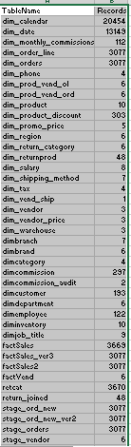

Figure : Sales data warehouse (Sales_dw) table count

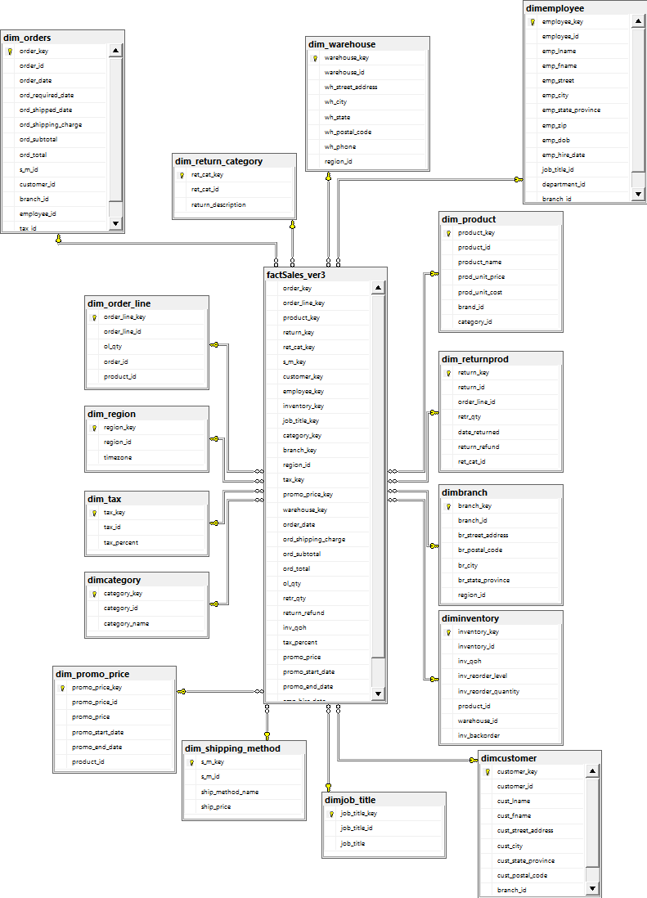

Figure : Sales star schema

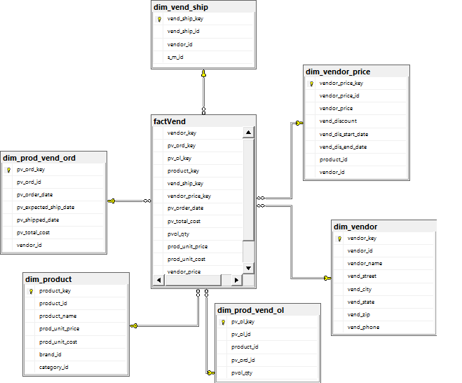

Figure : Vendor star schema

## Phase 3: Creating the SSAS project

Once the schemas were created including the fact and dimension table with data. The next step was to create the SSAS project. To create the SSAS project, tools like visual studio (VS 2015 is used for this project), SSDT (which can be download from Microsoft’s official website) and SQL Analysis Server (which is typically installed when you install the SQL Server) is required.

The steps for creating the SSAS project is explained in the SP DB SSAS project and explained in the video created for this project and I have attached the link of the video at end of this document. But, I will include the steps I carried to create the data source, data source view, cube and the dimensions.

### Step 1: Creating data source

After creating a new SSAS project in visual studio, from the solution explorer, right click on data sources which will bring the connection wizard as shown in figure 6. Select an already created connection or create new connection from connection manager.

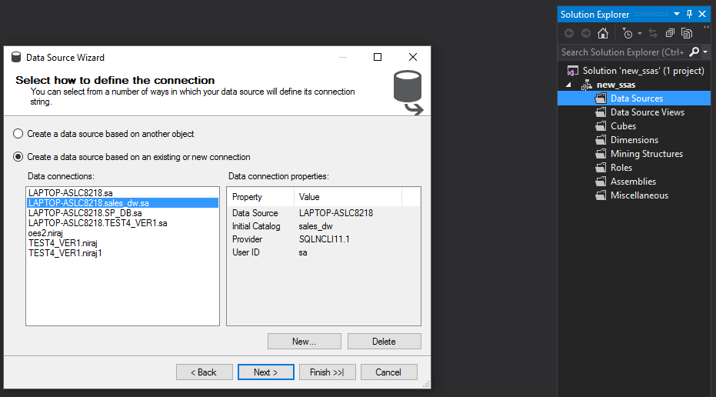

Figure : Data Source Connection wizard

Then choose the ‘User the service account’, else you can use the credential as Impersonation Information.

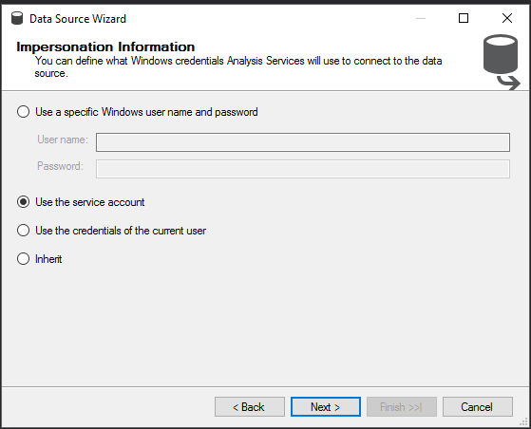

Figure : Impersonation Information

### Step 2: Creating Data Source Views

After forming the data source connection, now create the data source view. To do this, from the solution explorer, right click on the ‘Data Source Views’, click on add new data source. Then from the wizard, select the data source and click next. Give the name for DS and click on finish.

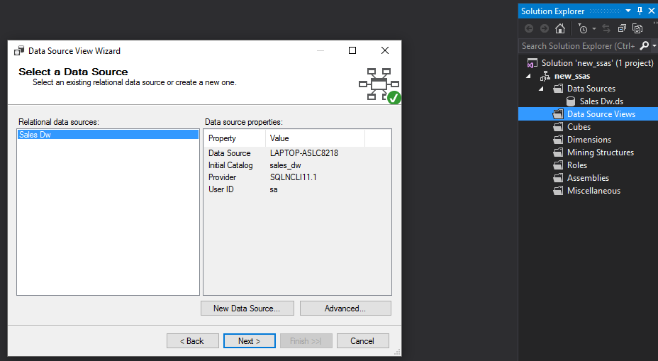

Figure : SSAS Data Source selection wizard

Select the tables and views and include them and add the related tables. factSales_ver3 and factVend is used for this project. Click on next, give a name and click on finish.

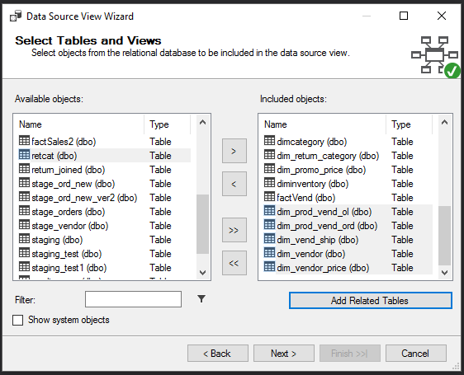

Figure : SSAS Tables and Views selection wizard

Following is the data source view created till this step. Where two different star schema’s can be seen for vendor and for sales. Product dimension is common for both schemas.

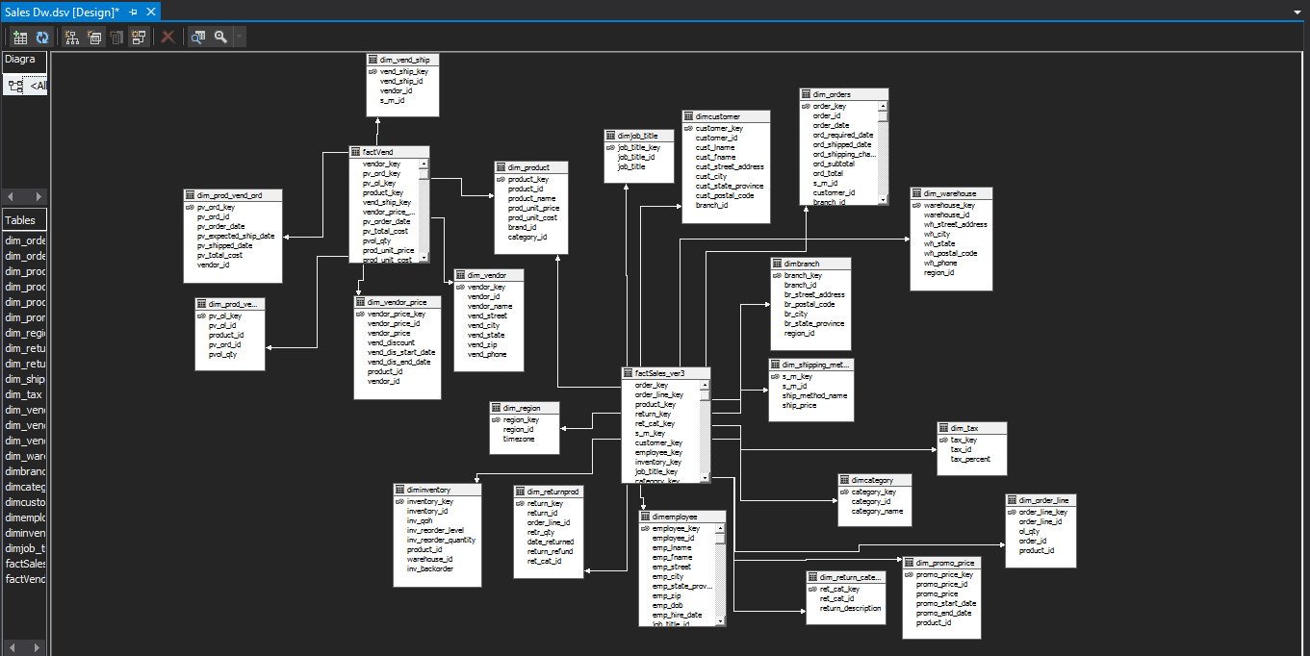

Figure : SSAS Data Source View Structure

### Step 3: Creating the Cube and dimensions

To create the cube, from solution explorer right click on the ‘Cubes’ and click on add new cube. Now, from the wizard, select the existing table option and click on next. Verify the measures and dimensions to be used. Then give a name to cube and click on finish.

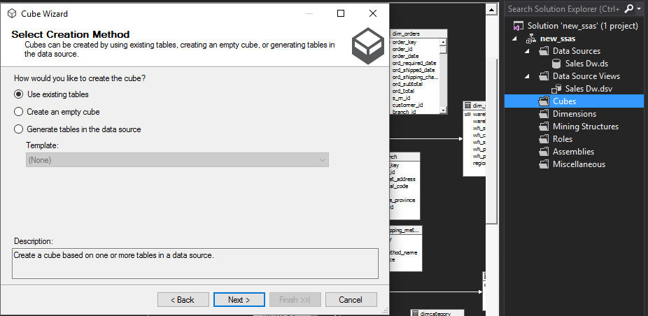

Figure : SSAS Cube creation

The following structure will be created where table in yellow is the fact table and tables in blue are the dimension tables. And in the solution explorer we can see the cube and the dimensions that are created.

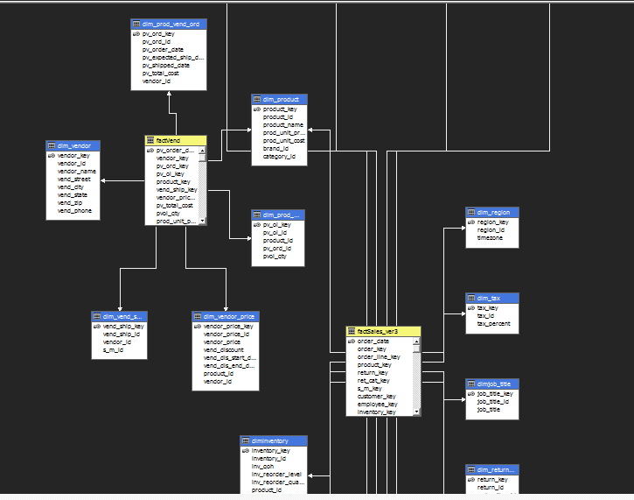

Figure : SSAS Cube Structure

### Step 4: Creating the time dimension

We need to create the time dimension because this dimension will be used to get results by periods. To create the time dimension, from the solution explorer, right click on the dimension, and click on add new dimension which will bring as following figure. There are options to use existing table, create time dimension in the data source, generate time dimension on the server, and use a template. The on the server option is used for this project. Click on next, from next window give the range of dates, 1920 to 2025 is used here. Then click on next, chose the type of calendar you want to use. Click on next then finish. This will create the dimension for time.

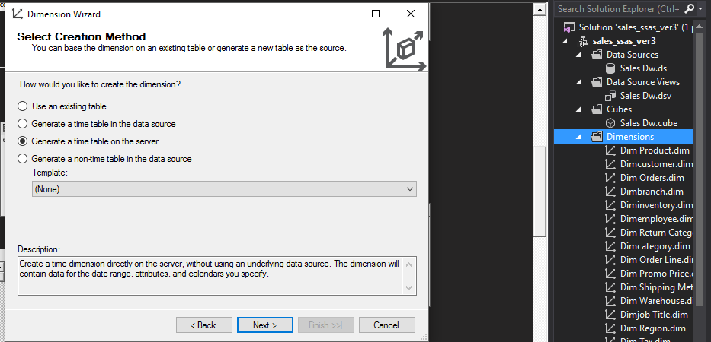

Figure : SSAS Time Dimension creation wizard

Now, from the dimension usage, for the measure group, form the relationship to use the granularity of time dimension. In this case, granularity is the data and measure is the order_date from the factSales.

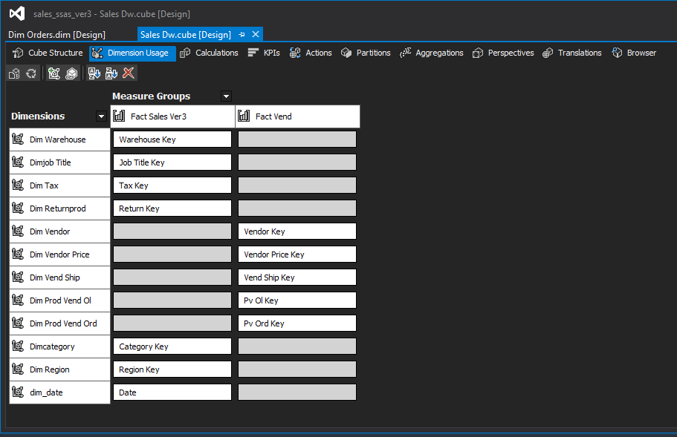

Figure : SSAS Dimension usage interface

## Phase 4: Analysis in the SSAS

Once the SSAS is setup for the analysis, i.e. after all the dimensions and cubes are created. The next step is to deploy and process the cube. To do this, right click on the cube and click on process. Before that, make sure you are using the correct server for deployment. The server is the SQL Analysis Server on the machine. If the server is on localhost, localhost can be given as the deployment server in the SSAS. After deploying the SSAS will process all the dimensions, the cube including the time dimension, the KPI’s (if created any), the calculation (if created any). Once this is done, the cube is ready for browsing and when we click on the browser on the cube interface we will se some like as in the figure below.

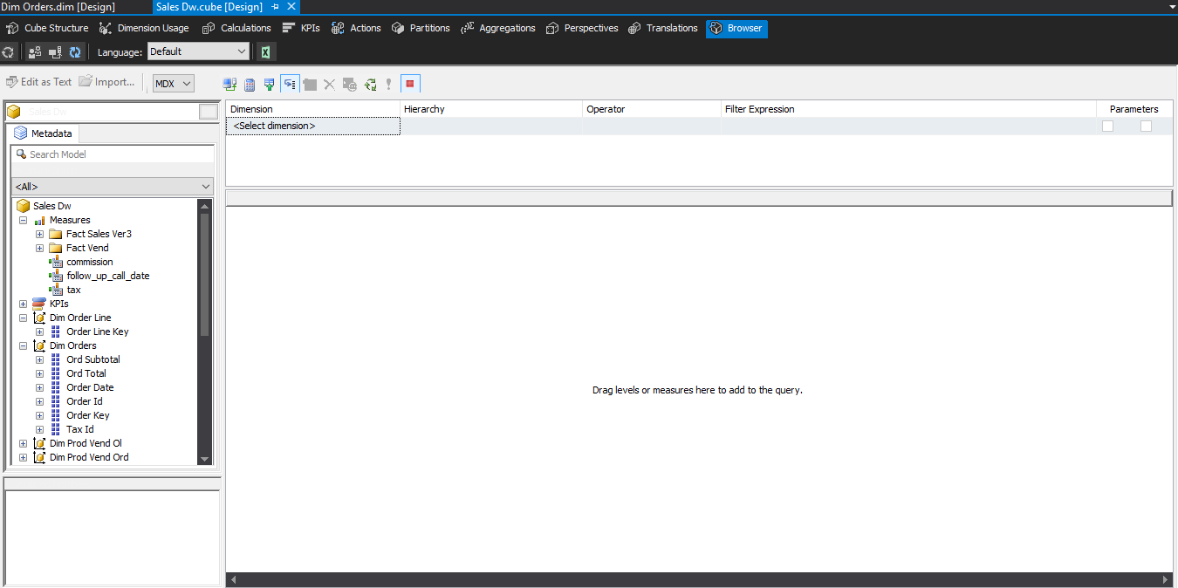

Figure : SSAS browser

In this image, the middle pane is where we will view our results, the left pane contains the measure groups, the dimensions and their attributes, from here, we can drag and drop the measures, and the attributes from the dimensions to produce the results. In the measure group, there are also some calculated measures to calculate tax, commission, and the follow_up_date.

### Queries:

Now, we will continue to do some queries include the results from SSAS below.

--Query 1 Using your database, list the position title and number of employees in each position title. You should get the following results

POSITION Title COUNT

Result of the query 1 from SSAS. It is showing similar result as from SMSS.

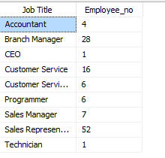

Figure : SSAS output for query 1

Result of query 1 from SMSS

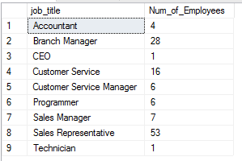

Figure : SMSS output for query 1

2. Using your database, for each customer list the following information.

CUSTOMER_NO LNAME TOTAL_ORDERS TOTAL_PRODUCTS GROSS_SALES TOTAL_SHIPPING_COST TOTAL_TAX

Let’s assume shipping charge is 2% of gross sales and tax is 7.5% of gross sale

Result of query 2 from SMSS.

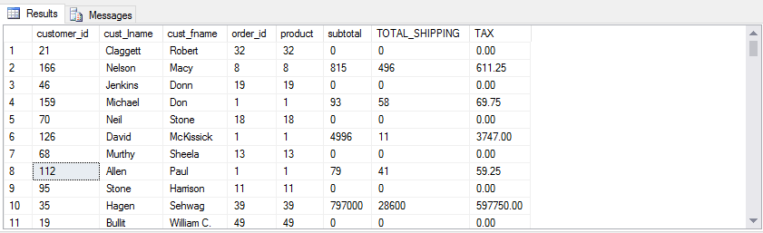

Figure : SMSS output for query 2

Result of query 2 from SSAS

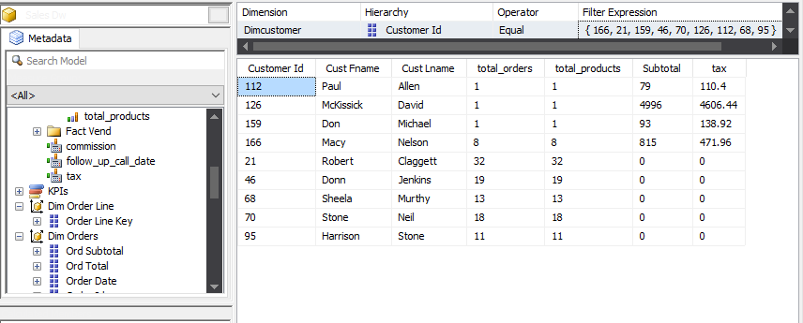

Figure : SSAS output for query 2

3. Using your database, List customer number and their orders based on days of the week. You should get the following results

CUSTOMER_NO ORDER_NO gross_Sale

Result of query 3 from SSMS

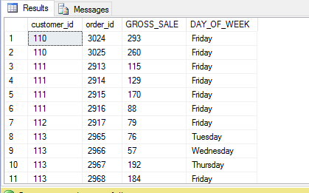

Figure : SSMs output for query 3

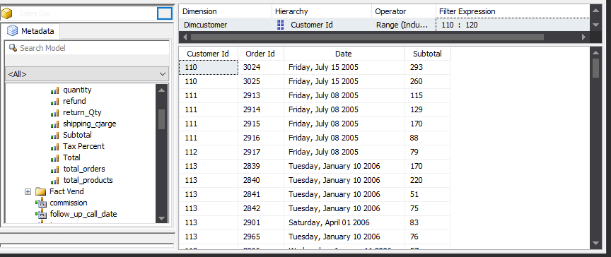

Figure : SSAS output for query 3

4. Using your database, for every employee (employee number, first name, last name)

list their total sales for each product that they have sold. You should get the following results

EMPLOYEE_NO FNAME LNAME PRODUCT_NO PRODUCT_SOLD

Result of query 4 from SMSS

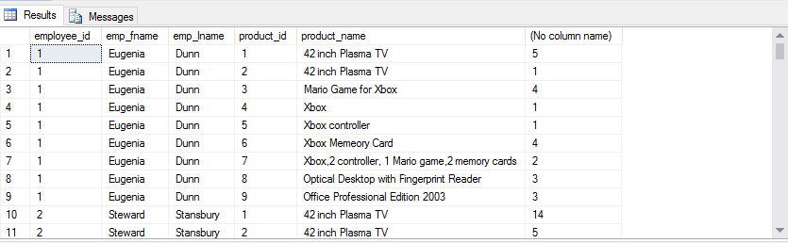

Figure : SSMS output for query 4

Result of query 4 from SSAS

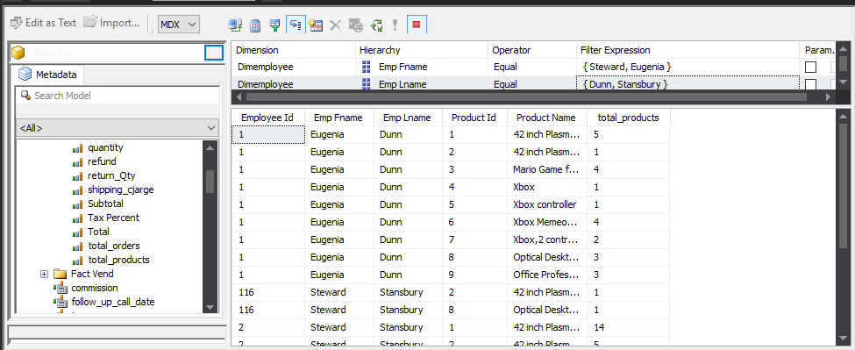

Figure : SSAS output for query 4

5. Using your database, for every state, select top customer

number with the highest number of orders. You should get the following results

CUSTOMER_NO COUNT_ORDERS State

Result of query 5 from SMSS

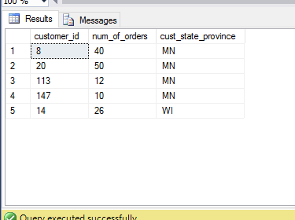

Figure : SMSS output for query 5

Result of query 5 from SSAS

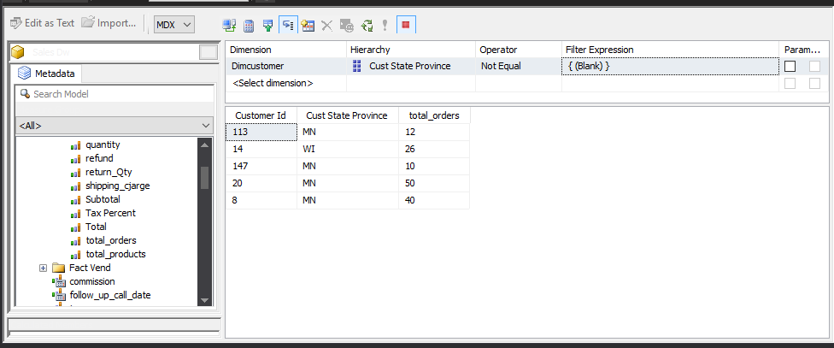

Figure : SSAS output for query 5

/* 6. for each state (based on state customer address) with more than one employee helping customers,

list state, number of orders,

number of products ordered, total number of quantity ordered, and total sales*/

Result of query 6 from SSMS

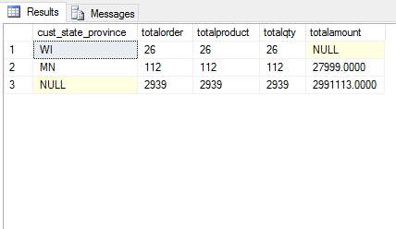

Figure : SMSS output for query 6

Result of query 6 from SSAS

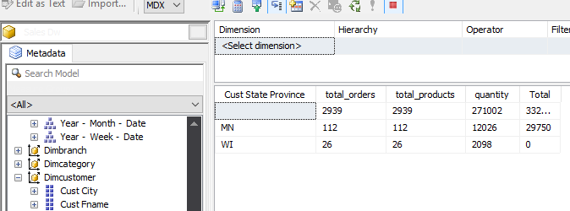

Figure : SSAS output for query 6

/* 7. for each month, List the customer number, customer last name,

with the highest total number of orders. Order your result from JAN to DEC.*/

Result of query 7 from SMSS

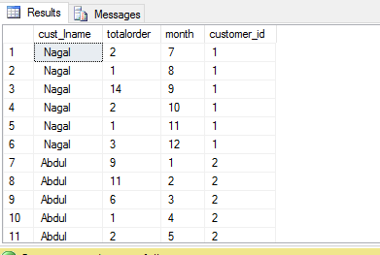

Figure : SMSS output for query 7

Result of query 7 from SSAS

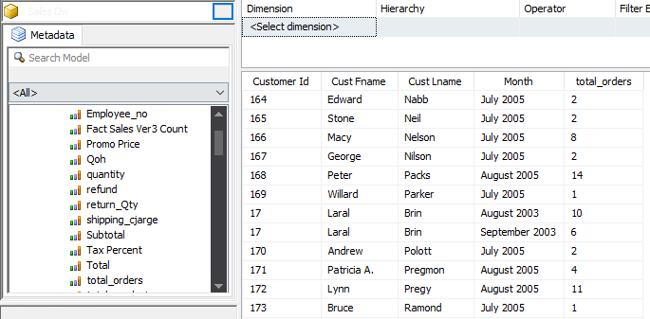

Figure : SSAS output for query 7

/* 8. for each state (based on customer state) list top three employees. Your list should include employee number, first name, last name, and total sales. */

Result of query 8 from SSMS

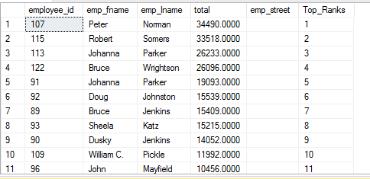

Figure : SMSS output for query 8

Result of query 8 from SSAS

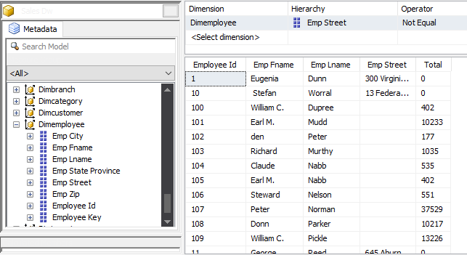

Figure : SSAS output for query 8

-- Query 9. Commission calculation by month and year

Result of query 9 from SSMS

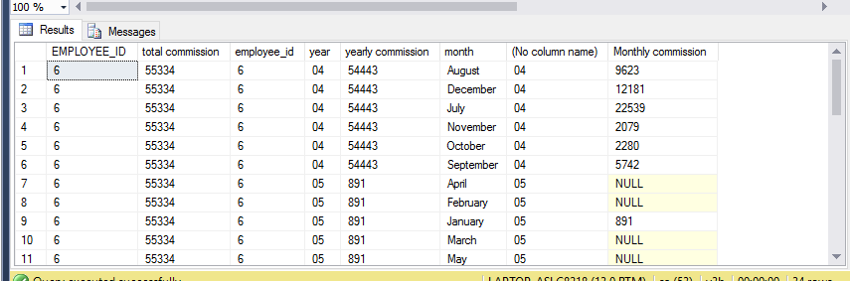

Figure : SMSS output for total commission

Result of query 9 from SSAS

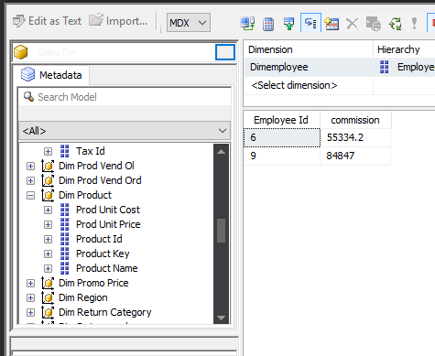

Figure : SSAS output for total commission

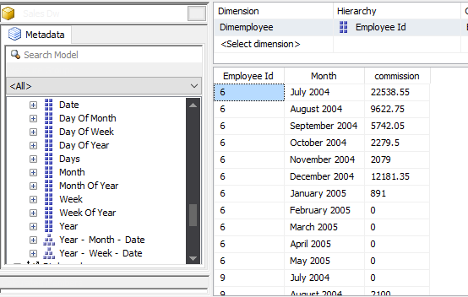

Figure : SSAS output for monthly commission

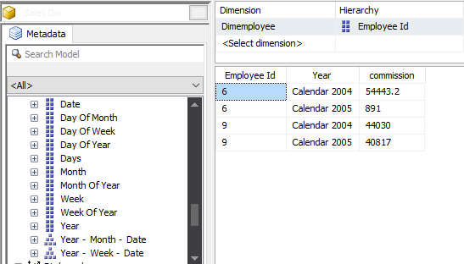

Figure : SSAS output for yearly commission

# Link of the SSAS project video:

https://youtu.be/3v5FVn7-7T8