**Project for the Degree of Bachelor of Computer Science and Engineering**

**Automatic Vaccum Cleaner Robot**

Nirban Mitra

ID: 182482546

Md. Nadim Hossain

ID: 182482543

Md. Jeshan

182482505

Md. Asaduzzaman

ID: 173462103

Habiba Sultana

182482547



**Department of Computer Science and Engineering**

**City University**

**Bangladesh**

**June, 2022**

**Automatic Vaccum Cleaner Robot By**

Nirban Mitra

ID: 182482546

Md. Nadim Hossain

ID: 182482543

Md. Jeshan

182482505

MD Asaduzzaman

ID: 173462103

Habiba Sultana

182482547

Supervised by

**Sharmin Akhter**

**Lecturer**

Department of Computer Science and Engineering

City University

Submitted to the Department of Computer Science and Engineering of City University in partial fulfillment of the requirements for the degree of B.Sc. in CSE.

Thesis Evaluation Committee:

Teacher Name 1.......................................................

Teacher Name 2.......................................................

Teacher Name 3.......................................................

**Automatic Vaccum Cleaner Robot**

Nirban Mitra

ID: 182482546

Md. Nadim Hossain

ID: 182482543

Md. Jeshan

182482505

Md. Asaduzzaman

ID: 173462103

Habiba Sultana

182482547

We the undersigned, recommend that the thesis completed by the students listed above, in partial fulfillment of B.Sc. in CSE degree requirements, be accepted by the dept. of Computer Science and Engineering, City University.

**Supervisor**

----------------------------------------------

**Sharmin Akhter**

Lecturer

Department of Computer Science and Engineering

City University

**Departmental Approval**

---------------------------------------------

**Md. Safaet Hossain**

Associate Professor and Head

Department of Computer Science and Engineering

City University, Bangladesh

**Table of Contents**

**Table of Contents** **Page**

1.1 Introduction ………………………………………………………… 05

2.1 Methodology ………………………………………………………… 05

2.2 Project Description ………………………………………………………… 06

2.3 System Analysis ………………………………………………………… 06

2.3.1 Circuit Diagram ………………………………………………………… 06

2.3.2 Real Image ……………………………………………………….... 07

2.3.3 Code ……………………………………………………….... 07

3.1 Result Analysis ………………………………………………………… 08

4.1 Conclusion ………………………………………………………… 08

5.1 Reference ………………………………………………………… 08

**Introduction [182482505]**

Robot vacuums are an autonomous device that is designed to clean carpet, tiles, and hardwood floors of all dirt and debris, much like other types of vacuum cleaners. The main difference between robotic versions is their ability to minimize the amount of work that homeowners need to do.

**Methodology [182482543]**

**Project Description**

**The suction motor creates vacuum pressure and suction by rotating a motor fan**. The impeller rotates at an incredibly high speed of about 30,000 to 35,000 RPM. A suction motor's power is measured by multiplying the rate of airflow and the vacuum pressure, which induces airflow from the brush through the hose.

**System Analysis:**

**Circuit Diagram: [182482543]**

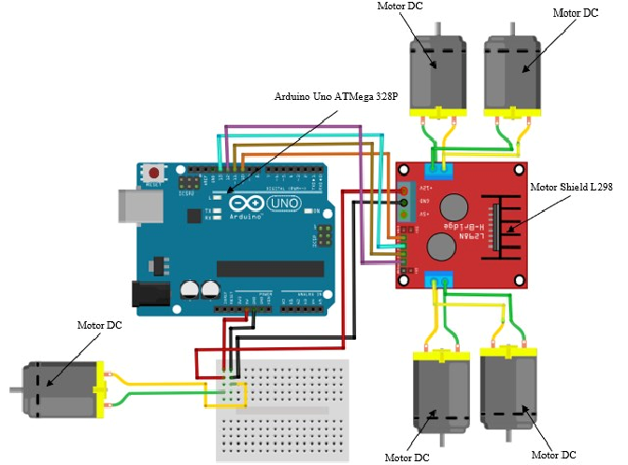

**Real Image:**

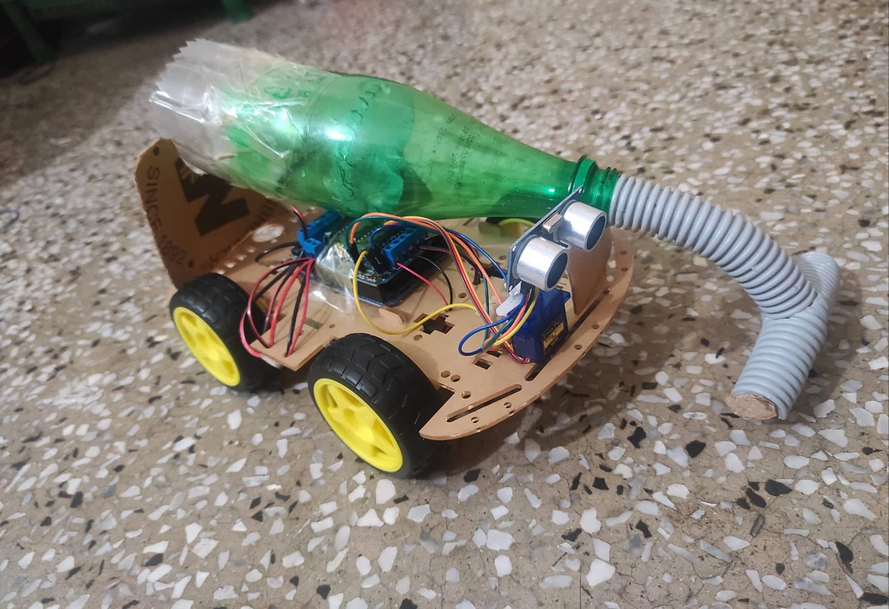

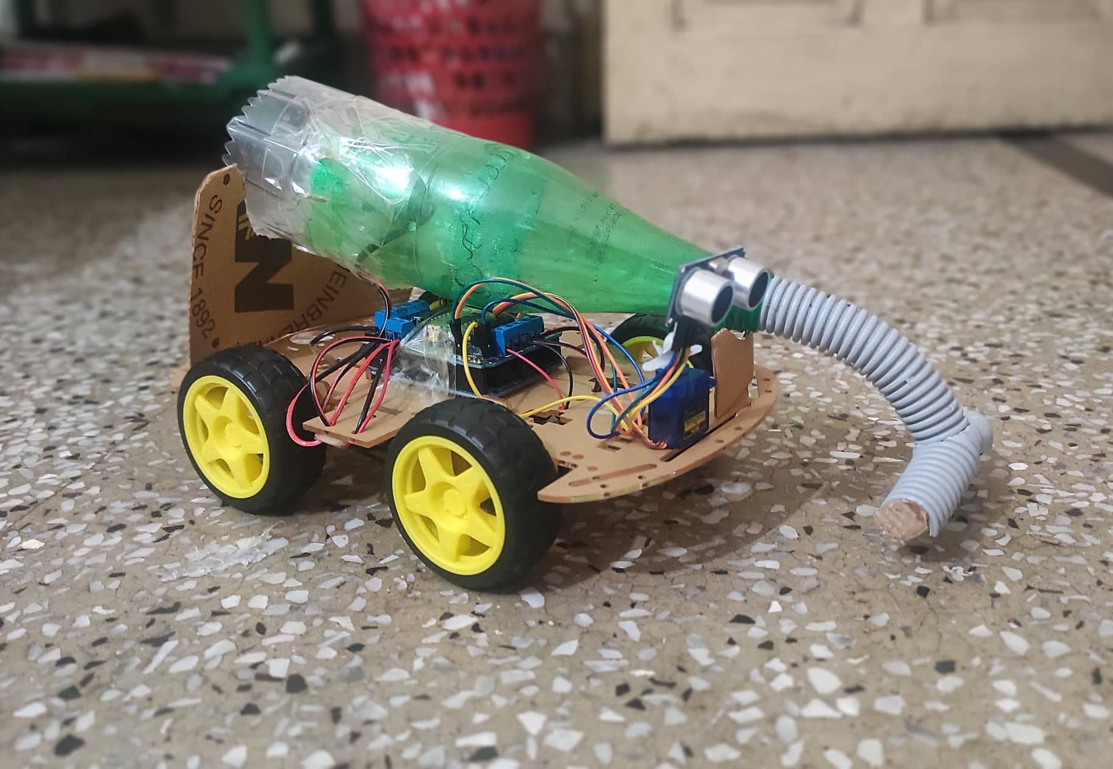

**Code: [182482546]**

#include <AFMotor.h>

#include <NewPing.h>

#include <Servo.h>

#define TRIG_PIN A0

#define ECHO_PIN A1

#define MAX_DISTANCE 200

#define MAX_SPEED 190 // sets speed of DC motors

#define MAX_SPEED_OFFSET 20

NewPing sonar(TRIG_PIN, ECHO_PIN, MAX_DISTANCE);

AF_DCMotor motor1(1, MOTOR12_1KHZ);

AF_DCMotor motor2(2, MOTOR12_1KHZ);

AF_DCMotor motor3(3, MOTOR34_1KHZ);

AF_DCMotor motor4(4, MOTOR34_1KHZ);

Servo myservo;

boolean goesForward=false;

int distance = 100;

int speedSet = 0;

void setup() {

myservo.attach(10);

myservo.write(115);

delay(2000);

distance = readPing();

delay(100);

distance = readPing();

delay(100);

distance = readPing();

delay(100);

distance = readPing();

delay(100);

}

void loop() {

int distanceR = 0;

int distanceL = 0;

delay(40);

if(distance<=15)

{

moveStop();

delay(100);

moveBackward();

delay(300);

moveStop();

delay(200);

distanceR = lookRight();

delay(200);

distanceL = lookLeft();

delay(200);

if(distanceR>=distanceL)

{

turnRight();

moveStop();

}else

{

turnLeft();

moveStop();

}

}else

{

moveForward();

}

distance = readPing();

}

int lookRight()

{

myservo.write(50);

delay(500);

int distance = readPing();

delay(100);

myservo.write(115);

return distance;

}

int lookLeft()

{

myservo.write(170);

delay(500);

int distance = readPing();

delay(100);

myservo.write(115);

return distance;

delay(100);

}

int readPing() {

delay(70);

int cm = sonar.ping_cm();

if(cm==0)

{

cm = 250;

}

return cm;

}

void moveStop() {

motor1.run(RELEASE);

motor2.run(RELEASE);

motor3.run(RELEASE);

motor4.run(RELEASE);

}

void moveForward() {

if(!goesForward)

{

goesForward=true;

motor1.run(FORWARD);

motor2.run(FORWARD);

motor3.run(FORWARD);

motor4.run(FORWARD);

for (speedSet = 0; speedSet < MAX_SPEED; speedSet +=2) // slowly bring the speed up to avoid loading down the batteries too quickly

{

motor1.setSpeed(speedSet);

motor2.setSpeed(speedSet);

motor3.setSpeed(speedSet);

motor4.setSpeed(speedSet);

delay(5);

}

}

}

void moveBackward() {

goesForward=false;

motor1.run(BACKWARD);

motor2.run(BACKWARD);

motor3.run(BACKWARD);

motor4.run(BACKWARD);

for (speedSet = 0; speedSet < MAX_SPEED; speedSet +=2) // slowly bring the speed up to avoid loading down the batteries too quickly

{

motor1.setSpeed(speedSet);

motor2.setSpeed(speedSet);

motor3.setSpeed(speedSet);

motor4.setSpeed(speedSet);

delay(5);

}

}

**Result Analysis: [173462103]**

The automatic Vaccum Cleaner Robot code is implemented successfully. Arduino Uno, ultrasonic sensor, servo motor, and power supply is also implemented successfully. The performance of the automatic Vaccum Cleaner system is fast, efficient, and accurate.

**Conclusion: [182482547]**

Conclusion. A robot vacuum cleaner is a great addition to your home and provides you with more time to do the things you enjoy most – that is unless your thing is vacuuming! Robot vacuums are compact and will not take up too much additional space in your home and are a great addition to your home cleaning arsenal.

**References:**

<https://www.thinkcrucial.com/blogs/blog/should-you-get-robot-vacuum-cleaner#:~:text=Conclusion,to%20your%20home%20cleaning%20arsenal>.