# **Getting Starting with Apache Kafka**

Apache Kafka is an open-source stream processing platform developed by the Apache Software Foundation written in Scala and Java. The project aims to provide a unified, high-throughput, low-latency platform for handling real-time data feeds.  
  
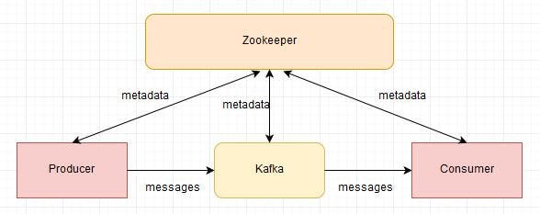  
The Advantages of using Apache Kafka are as follows-

* **High Throughput-**  
  The design of Kafka enables the platform to process messages at very fast speed. The processing rates in Kafka can exceed beyond 100k/seconds. The data is processed in a partitioned and ordered fashion.
* **Scalability-**  
  The scalability can be achieved in Kafka at various levels. Multiple producers can write to the same topic. Topics can be partitioned. Consumers can be grouped to consume individual partitions.
* **Fault Tolerance-**  
  Kafka is a distributed architecture which means there are several nodes running together to serve the cluster. Topics inside Kafka are replicated. Users can choose the number of replicas for each topic to be safe in case of a node failure. Node failure in cluster won’t impact. Integration with Zookeeper provides producers and consumers accurate information about the cluster. Internally each topic has its own leader which takes care of the writes. Failure of node ensures new leader election.
* **Durability-**  
  Kafka offers data durability as well. The message written in Kafka can be persisted. The persistence can be configured. This ensures re-processing, if required, can be performed.

download the [https://kafka.apache.org/download the **Scala 2.12 kafka\_2.12-0.10.2.1.tgz**](https://kafka.apache.org/download%20the Scala%202.12%20kafka_2.12-0.10.2.1.tgz)

We will now start Apache Kafka-

* This Kafka installation comes with an inbuilt zookeeper. Zookeeper is mainly used to track status of nodes present in Kafka cluster and also to keep track of Kafka topics, messages, etc.  
  Open a command prompt and **start the Zookeeper-**
* C:\kafka\_2.12-0.10.2.1>.\bin\windows\zookeeper-server-start.bat .\config\zookeeper.properties
* 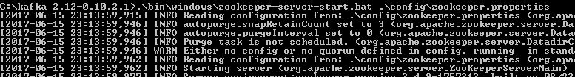
* Open a new command prompt and **start the Apache Kafka-**
* C:\kafka\_2.12-0.10.2.1>.\bin\windows\kafka-server-start.bat .\config\server.properties



* Open a new command prompt and **create a topic with name javainuse-topic, that has only one partition & one replica.**
* C:\kafka\_2.12-0.10.2.1>.\bin\windows\kafka-topics.bat --create --zookeeper localhost:2181 --replication-factor 1 --partitions 1 --topic javainuse-topic

boot21_5

* Next Open a new command prompt and **create a producer to send message to the above created javainuse-topic and send a message - Hello World Javainuse to it-**
* C:\kafka\_2.12-0.10.2.1>.\bin\windows\kafka-console-producer.bat --broker-list localhost:9092 --topic javainuse-topic
* Hello World Javainuse

boot21_6

* Finally Open a new command prompt and **start the consumer which listens to the topic javainuse-topic we just created above**. We will get the message we had sent using the producer
* C:\kafka\_2.12-0.10.2.1>.\bin\windows\kafka-console-consumer.bat --bootstrap-server localhost:9092 --topic javainuse-topic --from-beginning

boot21_7