**yml file for configuration:**

As an alternate to application.properties, one may use a .yaml file. YAML provides a JSON-like structured configuration compared to the flat properties file.To see this in action, simply replace application.properties with application.yaml and add the following property:



Rerun the application to see the port printed in the console.

**Using multiple configuration files(Profiles):**

**What is Profile?**

If we want to switch from one environment to another environment without re-build we have to use a seperate properties file for each environment. For instance, lets have dev, stage and prod environments, now we have to maintain three properties files seperately named application-dev.properties, application-stage.properties and application-prod.properties.

But using yml file only one file is enough to define all the environment specific configurations as below:

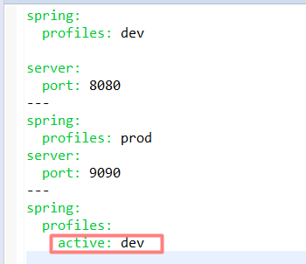

Now clean the application and build using mvn clean install.

And run the generated self contained jar file using profile setting as below:



Now in the console log we could see the profile activation as below:

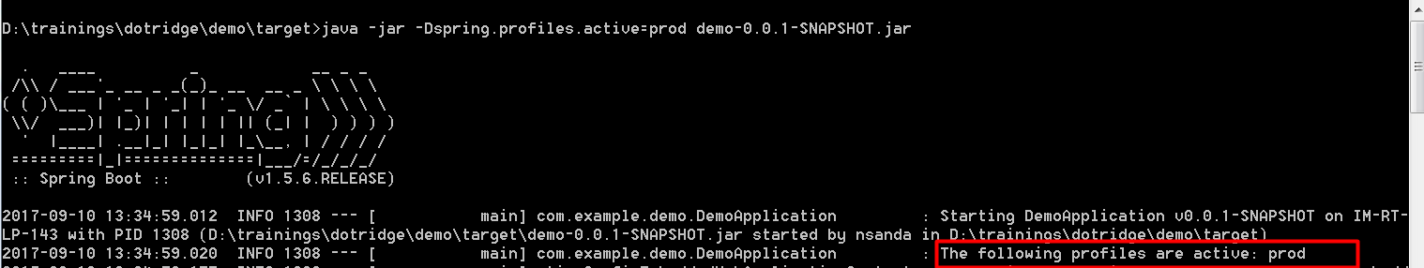

If we didn’t specify any profile setting like below:



Then by default profile will be settled to the “dev” environment as shown below:

