A PROJECT REPORT ON

AUTOMATED CAR parking system

**BIRLA VISHVAKARMA MAHAVIDYALAYA**

**VALLABH VIDYANAGAR**

**(ELECTRONICS AND COMMUNICATION DEPARTMENT)**



Nirbhay Chaplot (18EC446)

Aditya Shah (18EC412)

Amisha Singh (18EC411)

Arka Ghosh (18EC409)

Ashish Pandey (18EC440)

# TABLE OF CONTENTS

ABSTRACT 2

INTRODUCTION 3

PROBLEM STATEMENT 4

LITERATURE REVIEW 5

APPLICATION 6

BLOCK DIAGRAM 8

FLOW CHART 9

REFERENCES 10

# ABSTRACT

Population of the world is increasing at a very high rate and so is the number of vehicles on the road. It becomes very difficult to find places where you can park your vehicle and keep it safely. In recent times the concept of smart cities have gained great popularity. Thanks to the evolution of Internet of things the idea of smart city now seems to be achievable. Problems such as, traffic congestion, limited car parking facilities and road safety are being addressed by IoT. Here through this project we present a smart car parking system. This system consists of an on-site deployment module that is used to monitor and signalize the state of availability of each single parking space. In this module we have used a arduino, 4 Ultrasonic sensors for checking the availability of slots, 2 IR sensor with 2 servo motor for controlling the barricades and all the related data are send to the sever using Nodemcu i.e 8266 module. We have made a website which allows the end user to check the availability of parking space anywhere he wants to go and book a parking slot accordingly. The report also describes a view of the system architecture. Towards the end, the paper discusses the working of the system in form of a use case that proves the correctness of the proposed model.

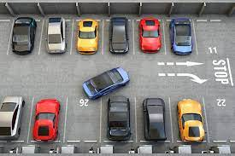

# INTRODUCTION

Over the last few decades our country has developed significantly, now we are in this state that we have a well-established network of roads and transportation, commercial parks and exponentially increasing number of automobiles but one problem still prevails, Parking. While other countries have adopted automated and supervision free parking method India seems far away from even introducing the same, we still use manual and rigid parking procedures. Which in most of the cases is unplanned and lacks discipline and due to this people park their cars anywhere they think it will fit which creates a mess as they do not follow the particular cue as observed in most scenarios. It also causes economical loss to commercial places like shopping malls and amusement parks as people are more likely not to visit these places due to this parking hazard. Here we are going to solve this problem by introducing Automated Car Parking System. This system will be low cost so that even smallest of the commercial buildings can purchase and apply this system in their parking lot which eliminates the first problem as to why such systems are not adapted by India yet. While being cheap it will be efficient and smooth enough to be used by huge shopping complexes and MNCs. This system will also have complete internet support so it can be monitored from anywhere in the world and booking your parking slot can be done with so much ease now. The proposed system is described in further parts of this report in detail.

# PROBLEM STATEMENT

The “Automated Car Parking System” provides a remote facility to users to find a parking slot for their vehicle. Finding a parking slot in most of the metro cities is a tedious job which consumes a lot of time and wastage of fuel.

# LITERATURE REVIEW

# APPLICATION

1. It can be applied in public places such as malls, stations etc. To accurately sense and predict spot/vehicle occupancy in real-time. This helps in decreasing the traffic at a large extent and hence decreasing the pollution caused as well.

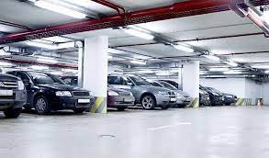

1. Guides residents and visitors to available parking spot and can be used to decrease the chaos caused in the societies especially in those where there are no allotted parking.
2. Simplifies the parking experience and adds value for Parking stakeholders, such as merchants and drivers.
3. Enables intelligent decisions using data, including real–time status applications and historical analytics reports.

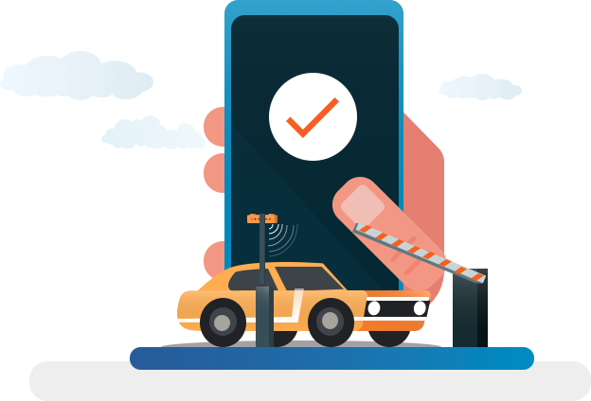

1. As discussed earlier Smart Parking plays an important role in creating better urban environment by reducing the emission of CO2 and other pollutants.

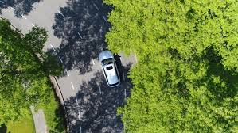

1. Smart Parking enables better and real time Monitoring and managing of available parking space which Results in significant revenue generation. Provides tools to optimize workforce management.

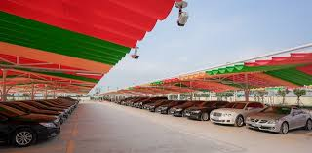

# BLOCK DIAGRAM

# FLOW CHART

# REFERENCES

|  |  |
| --- | --- |
| [1] | A. Khanna and R. Anand, "IoT based smart parking system", *2016 International Conference on Internet of Things and Applications (IOTA)*, 2016. |
|  |  |
| [2] | A. Raj, "Arduino with ESP8266 - Reading Data from Internet", *Circuit Digest*, 2018. [Online]. |
| [3] | G. Revathi and V. Dhulipala, "Smart parking systems and sensors: A survey", *2012 International Conference on Computing, Communication and Applications*, 2012. |
| [4] | K. Hassoune, W. Dachry, F. Moutaouakkil and H. Medromi, "Smart parking systems: A survey", *2016 11th International Conference on Intelligent Systems: Theories and Applications (SITA)*, 2016. |
| [5] | Mutinda Mutava Gabriel, "Arduino Uno, Ultrasonic Sensor HC-SR04 Motion Detector with Display of Distance in the LCD", *International Journal of Engineering Research and*, vol. 9, no. 05, 2020. |
| [6] | S. Team, "IR Sensor Interfacing with Arduino Code Step by Step Guide (2020)", *StudentsHeart.com*, 2020. [Online]. |
| [7] | W. Z. Al Qaidhi and M. Sohail, “Smart Parking System using IOT”, *J Stud Res*, Jul. 2020 |