Screen 1.

Header



Screen 2

formula_column1

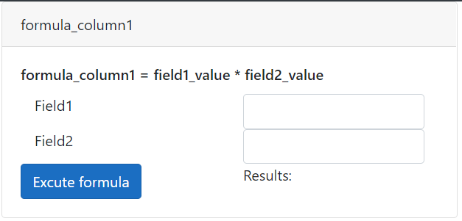

Screen 3

formula_column2

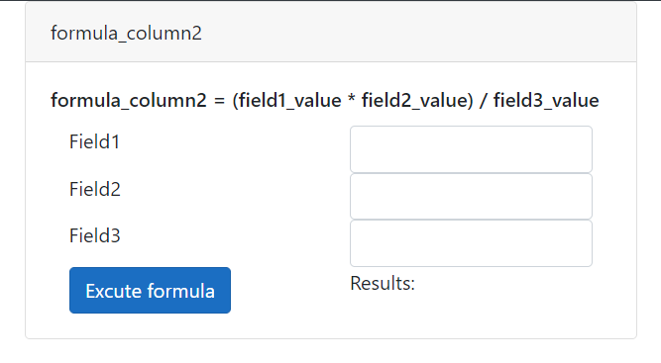

Screen 4.

With result formula_column1

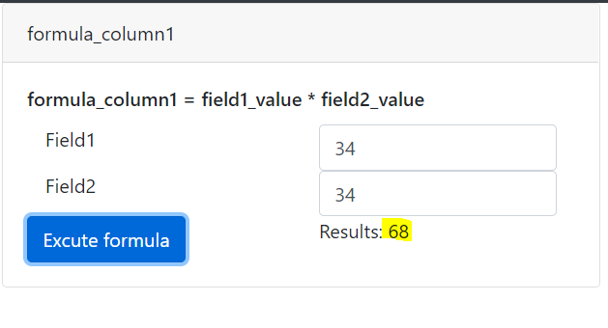

Screen 5:

With result formula_column2

