expariment param 1
Data 2
features 2
Model training 3
visualization 3
Pwelch 3
data visualization 4
features creation 6
histogram 6
feature selection 14
Train model with cross-validation 14
Validation precentage 15
Test 16
%MATLAB 2019a
%this code loads an EEG structure extarcts feature out of the data and trains an LDA model
%to predict between two classes
clear all; close all;

expariment param
load('motor_imagery_train_data.mat'); % trainig data
testFileName = 'motor_imagery_test_data.mat'; % test data
fs = P_C_S.samplingfrequency; %sampling frequency, Hz
nTrials = size(P_C_S.data,1); % num of trails
nSamples = size(P_C_S.data,2); % num of sample
times = 1/fs:1/fs:nSamples/fs; %create time vec according to parameters
f = 0.5:0.1:40; % relevant freq range
window = 1.2; %window length in secs
windOverlap = 1; %window overlap length in secs
numOfWindows = floor((size(P_C_S.data,2)-window*fs)/...
(window*fs-floor(windOverlap*fs)))+1; %number of windows
miStart = 2.25; %motor imagery start in sec
miPeriod = times(times >= miStart); %motor imagery period
edgePrct = 90; %spectral edge percentaile
null = 0; %in case of no input needed
chans = cell2mat(P_C_S.channelname(1:2)); %channels in use
chans = str2num(chans);
chansName = ["C3" "C4"]; %channels names should corresponds to chans
nchans = length(chans); % num of channels
sides = P_C_S.attributename(3:end); %extract classes assuming rows 1,2 are artifact and remove
numberSides = length(sides); %this project support two classes only
sides = string(sides);
ntrialsPerClass = [sum(P_C_S.attribute(3,:)==1),...
sum(P_C_S.attribute(4,:)==1)]; % Third and fouth rows contain left and right
% creating struct for all relevant parameters
technicalPar = struct('fs',fs,'time',times,'freq',f,'nTrials',nTrials,'winLen',floor(window*fs),...
'winOvlp',floor(windOverlap*fs),'miPeriod',miPeriod,'nclass',numberSides,'classes',sides, ...
'clasRow',cell2mat({3, 4}'),'ntrialsPerClass',ntrialsPerClass,...
'chans',chans,'chansName',chansName,'nchans',nchans,'edgePrct',edgePrct);
% isTrainMode = 0; % if set to 1 than the script will ran a loop in order to
%check the best num of features to select using analyzeNumOfFeat function
%when is set to 0 a normal run will occur

Data
creating struct for all relevant data and arrange it
Data.allData = P_C_S.data;
Data.combLables = cell(1,nchans*numberSides); %lables for channels*class combinations
Data.lables = strings(nTrials,1); %lable each trail for his class
k = 1;
for i = 1:numberSides
currClass = sides(i);
Data.indexes.(sides{i}) = find(P_C_S.attribute(technicalPar.clasRow(i),:)==1); %finding the indexes for each class
Data.lables(Data.indexes.(sides{i})) = currClass; %lable each trail for his class
for j = 1:nchans
sideName = char(currClass + chansName(j)); %creating combination name
Data.(sideName) = Data.allData(Data.indexes.(sides{i}),:,chans(j)); %arrange data by combination
Data.combLables{1,k} = sideName;
k = k+1;
end
end

features
%band power features 1st arr - band, 2nd arr - time range
Features.bandPower{1} = {[12,17],[3.5,6]}; % Low Beta
Features.bandPowerName{1} = "Low Beta";
Features.bandPower{2} = {[30,34],[4,6]}; % Gamma
Features.bandPowerName{2} = "Gamma";
Features.bandPower{3} = {[8,12],[5.5,6]}; % Alpha
Features.bandPowerName{3} = "Alpha";
Features.bandPower{4} = {[18,23],[1.2,2.7]}; % High Beta
Features.bandPowerName{4} = "High Beta";
nBandPowerFeat = length(Features.bandPower)*2; %bandpower and relative bandpower for each relevant range
Features.mVthrshld = 4; %threshold feature in muV
Features.diffBetween = ["C3","C4"]; % choose two elctrode to calc diff
generalFeat = 8; %number of general features
nDifFeat = 1; %number of diffs between channel features
Features.nFeat = ((nBandPowerFeat+generalFeat)*numberSides)+ nDifFeat; %num of total features feature selection method
Features.nFeatSelect = 8 ; %number of features to select for classification
Features.distPrecision = 5; %only in case you run ks for feature selection

Model training
k = 5; %k fold parameter
results = cell(k,1);
trainErr = cell(k,1);
acc = zeros(k,1);

visualization
Set the figure
paper_width = 0.8; %cm
figure_ratio = 0.8; % Figure's height/width ratio
figPosition = [0.2, 0.1, paper_width, figure_ratio*paper_width]; %cm main screen, upper right side
titlePosition = [0.45,0.999]; %global title position
%first visualization
signalPerFig = 20; %signals per figuer
plotPerRow = 4; %plots per row
plotPerCol = signalPerFig/plotPerRow; %make sure signalPerFig divisible with plotPerRow
%histogram
xLim = [-4 4]; %x axis lims in sd
binWid = 0.2;
trnsp = 0.5; %bars transparency
binEdges = xLim(1):binWid:xLim(2);
technicalPar.Vis = struct('globalPos', figPosition,'globTtlPos',titlePosition,...
'signalPerFig',signalPerFig,'plotPerRow',plotPerRow,'plotPerCol',plotPerCol,...
'xLim',xLim,'binEdges',binEdges,'trnsp',trnsp);

Pwelch
for i = 1:numberSides
for j = 1:length(technicalPar.chans)
currClass = technicalPar.classes(i);
sideName = char(currClass + chansName(j));
Data.PWelch.(sideName) = pwelch(Data.(sideName)(:,(technicalPar.miPeriod*fs))',...
technicalPar.winLen,technicalPar.winOvlp,technicalPar.freq,technicalPar.fs);
end
end
%visualization PWelch
plots('Pwelch',Data,technicalPar)
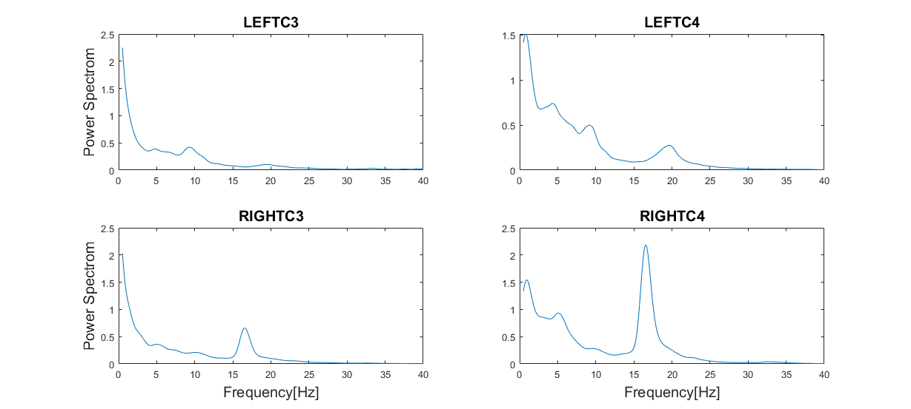
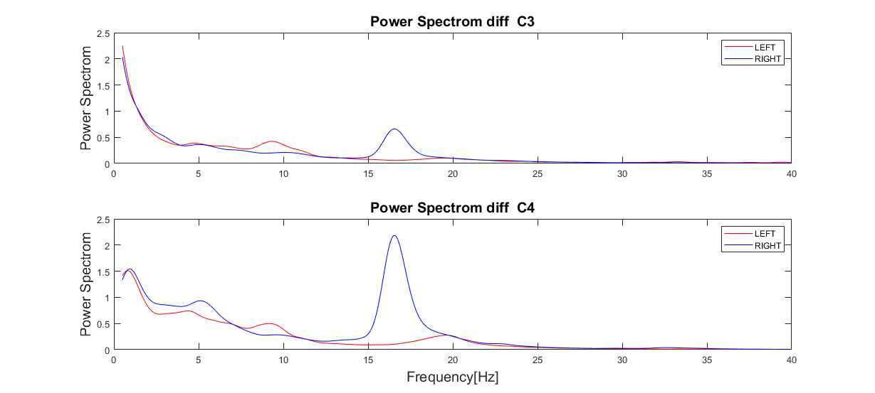

data visualization
%visualization of the signal in Voltage[muV] for rand co-responding trails
plots('dataviz',Data,technicalPar)
% calculating PWelch for all condition
%calculating spectrogram for all conditions
for i =1:length(Data.combLables) %looping all condition
for j = 1:size(Data.(Data.combLables{i}),1)
Data.spect.(Data.combLables{i})(j,:,:) = spectrogram(Data.(Data.combLables{i})(j,:)',...
technicalPar.winLen,technicalPar.winOvlp,technicalPar.freq,technicalPar.fs,'yaxis');
end
% convert the units to dB and average all spect for each cindition
Data.spect.(Data.combLables{i}) = squeeze(mean(10*log10(abs(Data.spect.(Data.combLables{i}))).^2));
end
%visualization spectogram
plots('Spectogram',Data,technicalPar)
plots('SpectDiff',Data,technicalPar)
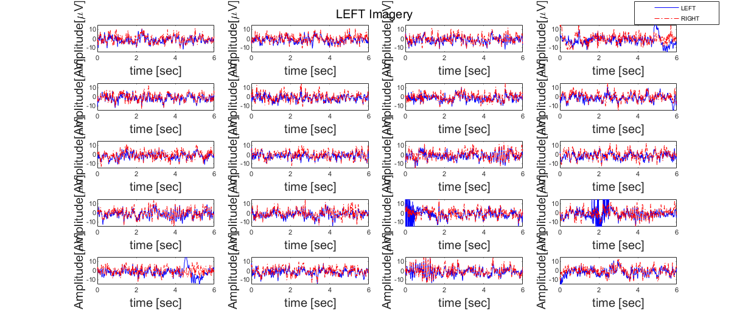
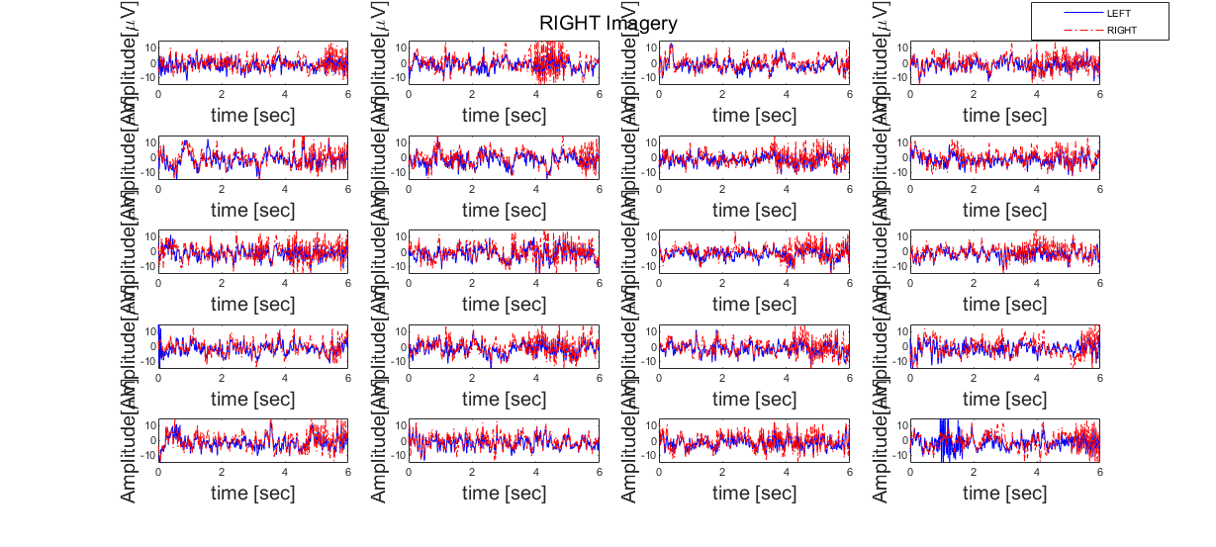
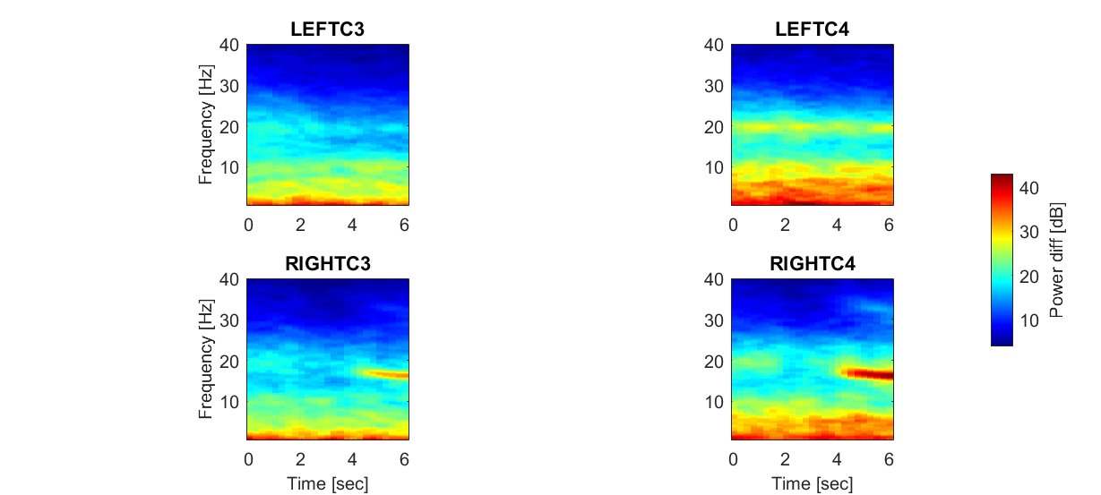

features creation
Features.featMat = zeros(nTrials,Features.nFeat); %allocate space
Features.featLables = cell(1,Features.nFeat); %allocate space to features name
Features = featureCreate(Data.allData,technicalPar,Features,'featMat'); %calc and extract all features
[Features.featMat,meanTrain,SdTrain] = zscore(Features.featMat); % scale all features

histogram
plots('FeaturesHist',Data,technicalPar,Features);
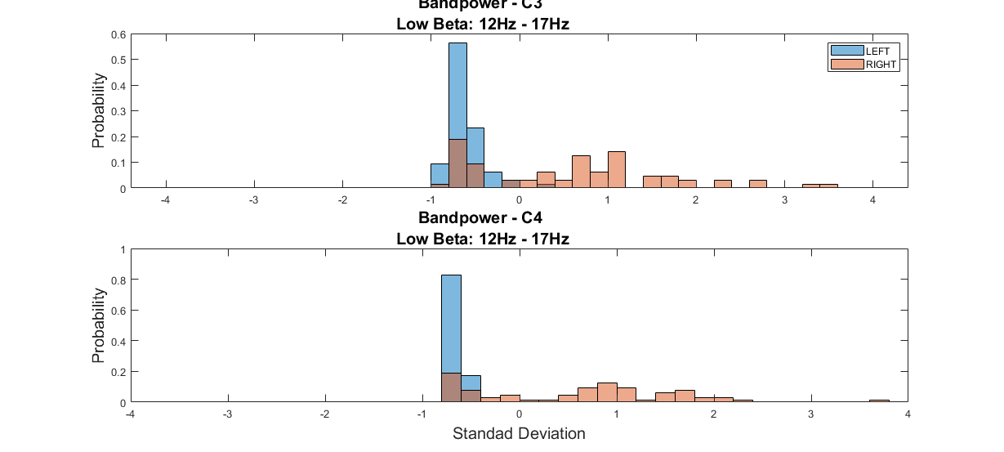
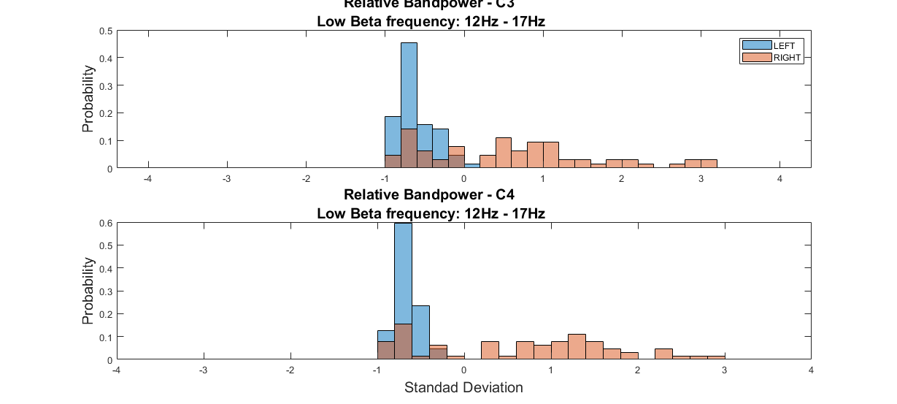
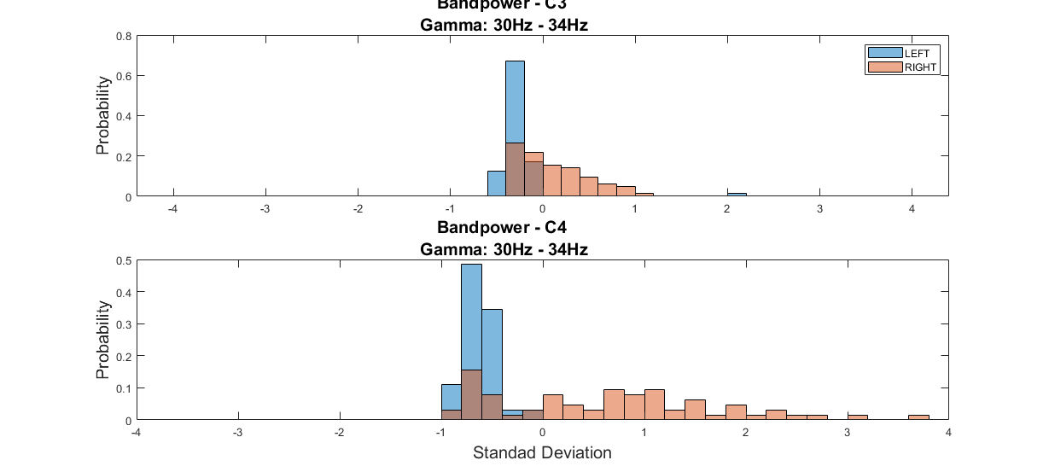
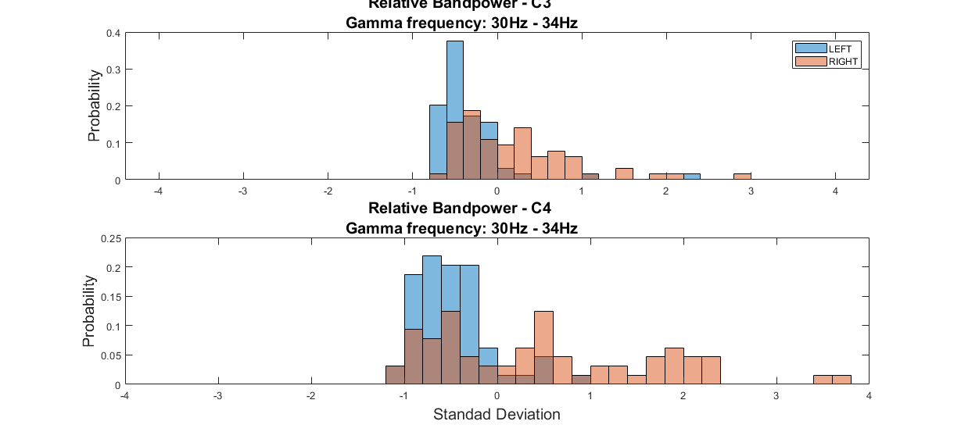
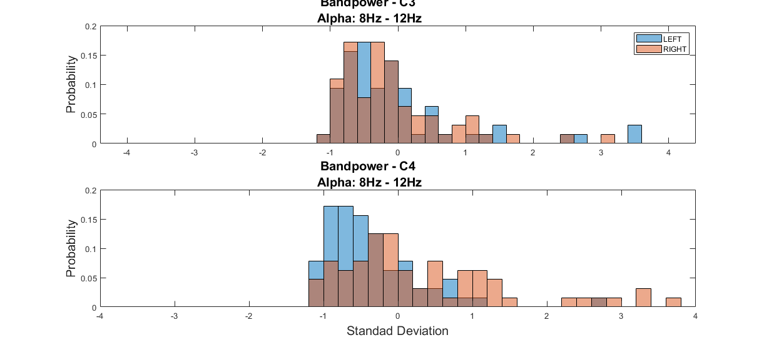
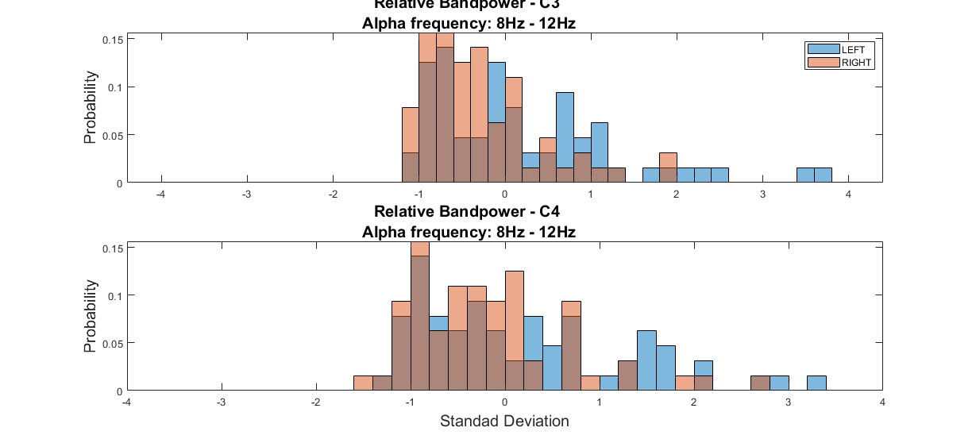
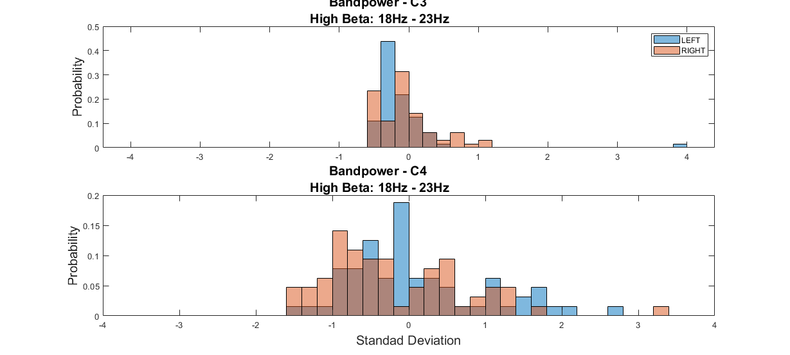
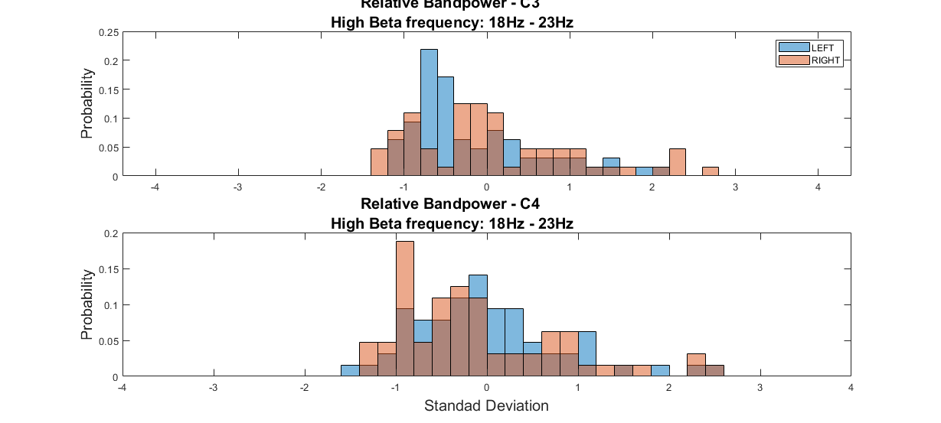
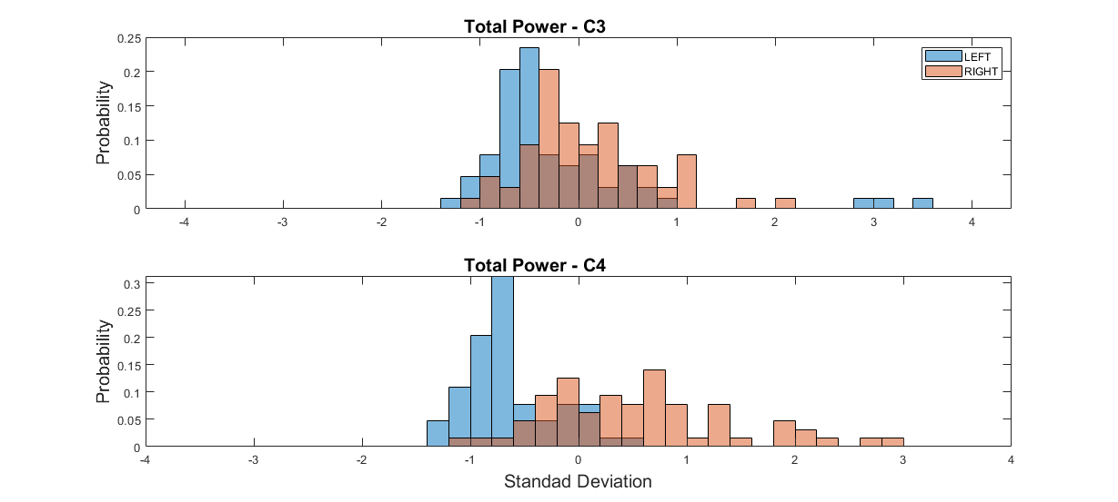
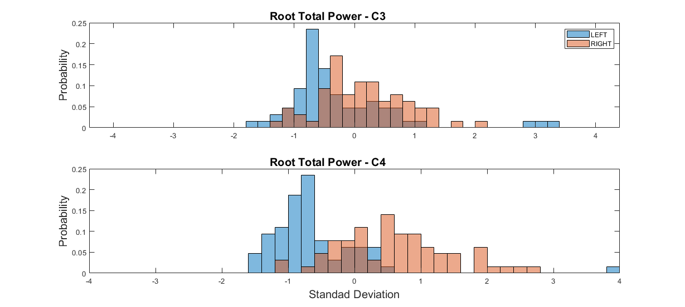
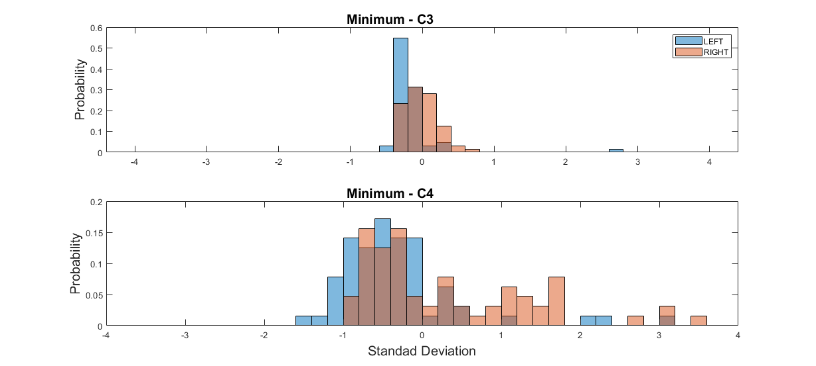
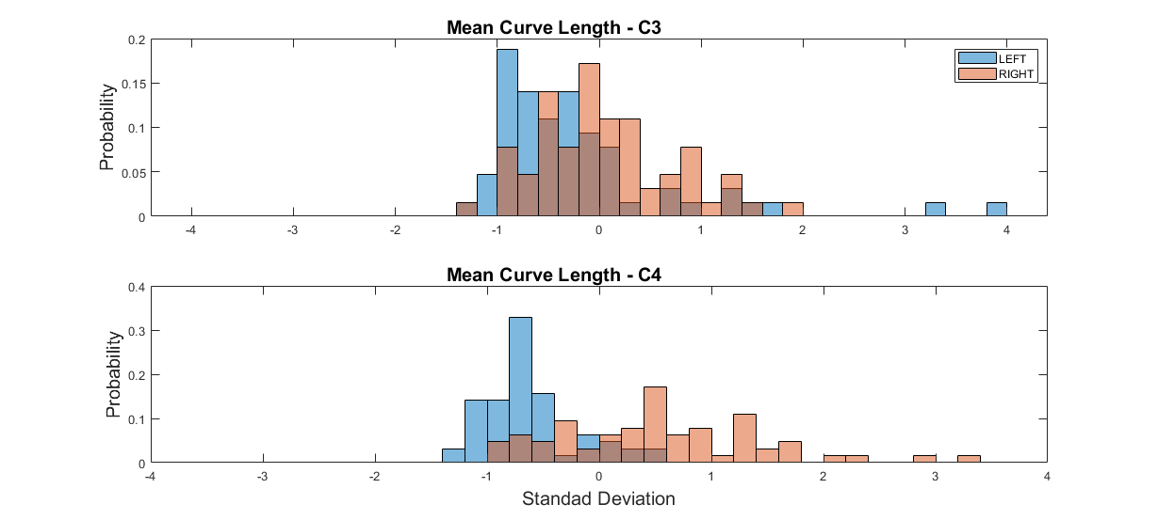
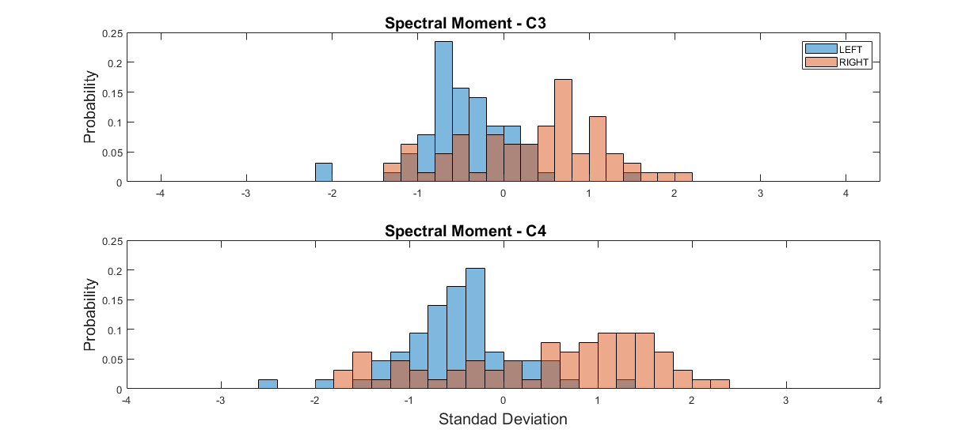
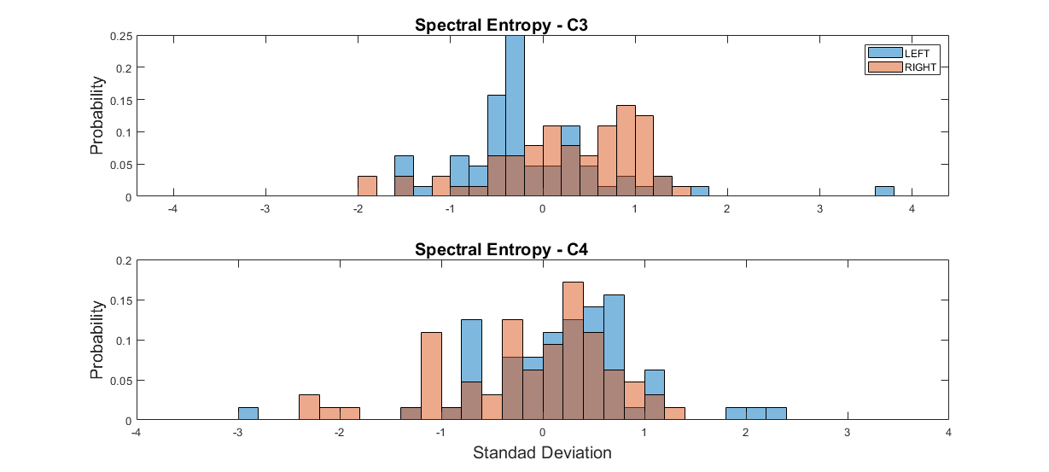
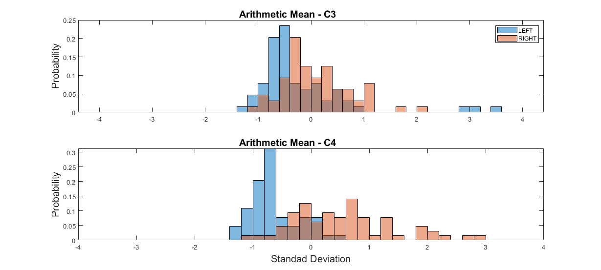
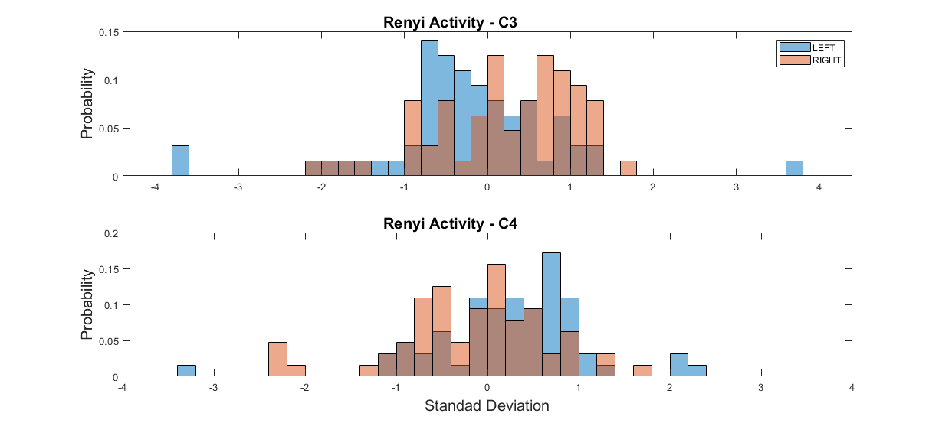
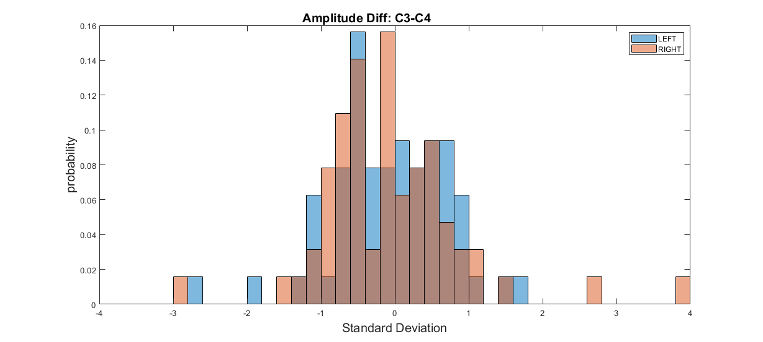

feature selection
Selection = fscnca(Features.featMat,Data.lables); % Feature selection using neighborhood component analysis for classification
weights = Selection.FeatureWeights;
%Decsending order of importence
[~ , featOrder] = sort(weights, 'descend');
%Taking the most importent features
featIdx = featOrder(1:Features.nFeatSelect);
selectMat = Features.featMat(:,(featIdx));

Train model with cross-validation
idxSegments = mod(randperm(nTrials),k)+1; %randomly split trails in to k groups
cmT = zeros(numberSides,numberSides); % allocate space for confusion matrix
for i = 1:k
% each test on 1 group and train on the else
validSet = logical(idxSegments == i)';
trainSet = logical(idxSegments ~= i)';
[results{i},trainErr{i}] =...
classify(selectMat(validSet,:),selectMat(trainSet,:),Data.lables(trainSet),'linear');
acc(i) = sum(results{i} == Data.lables(validSet)); %sum num of correct results
acc(i) = acc(i)/length(results{i})*100;
%build the confusion matrix
cm = confusionmat(Data.lables(validSet),results{i});
cmT = cmT + cm;
end

Validation precentage
trainAcc = (1-cell2mat(trainErr))*100;
printAcc(mean(acc),std(acc),1);
printAcc( mean(trainAcc),std(trainAcc),0);
% plot confusionchart
figure('Units','normalized','Position',figPosition)
cmChart = confusionchart(cmT,[sides(1) sides(2)],'FontSize',15,'DiagonalColor','g','OffDiagonalColor','r');
cmChart.Title = char(sides(1)+" "+sides(2)+" classification");
% plot PCA
plots('pca',Data,technicalPar,null,Features.featMat)
The validation accuracy is: 87.4462±3.516%
The train accuracy is: 89.6442±2.2037%
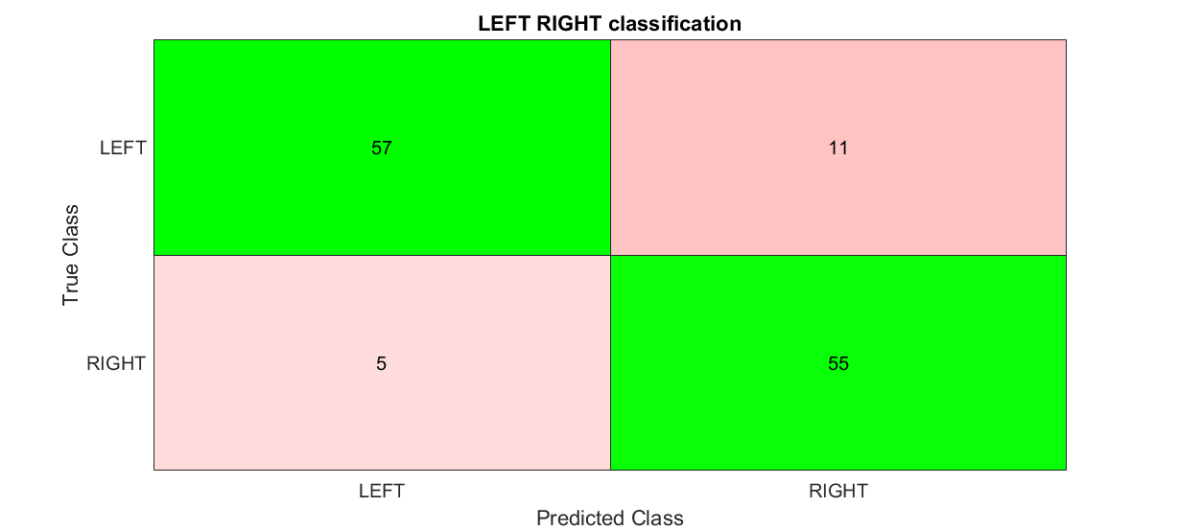
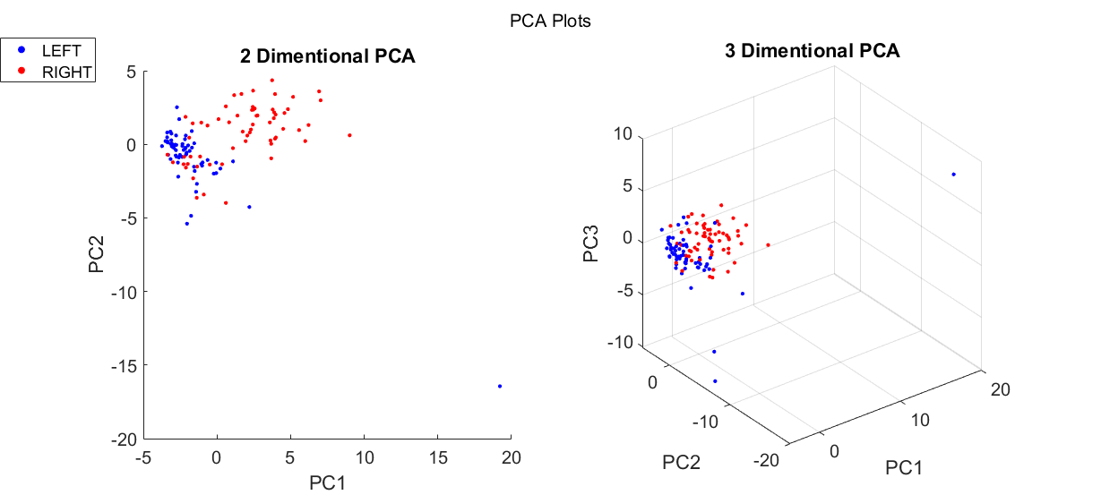

Test
%Load test data
load(testFileName)
testData = data(:,:,1:length(technicalPar.chans));
%Test feature extraction
Features.TestFeatMat = zeros(size(testData,1),Features.nFeat); %allocate space
Features = featureCreate(testData,technicalPar,Features,'TestFeatMat'); %calc and extract all features
%Test feature selection
Features.TestFeatMat = Features.TestFeatMat(:,featIdx); %choosing the same features
Features.TestFeatMat = (Features.TestFeatMat - meanTrain(:,featIdx))./SdTrain(:,featIdx); % scale according to train data
%Test classifier - output is the classifier predictions for test data.
testPredict = classify(Features.TestFeatMat,selectMat,Data.lables,'linear');
Published with MATLAB® R2019b

