**Assignment 2:**

[Hello World Docker Image](https://hub.docker.com/_/hello-world) Run Hello World Docker Image Locally.

* Pulling the docker image

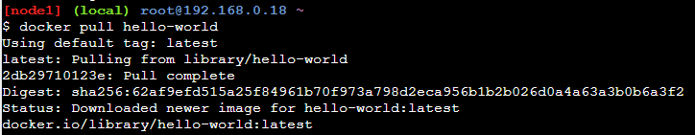

* Running the image

