**Assignment 3:**

Create a hello world fastapi application. Create a Dockerfile for your fastapi hello world application. Build Docker image using Docker file. Run docker image build in previous step. Push your Docker image to Docker Hub.

* main.py hello world

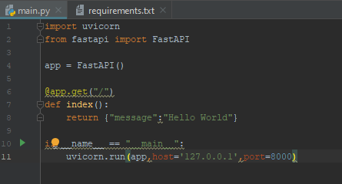

* Dockerfile

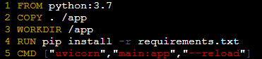

* Building docker image

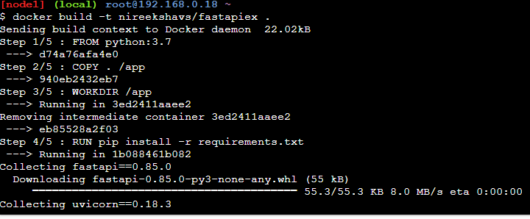

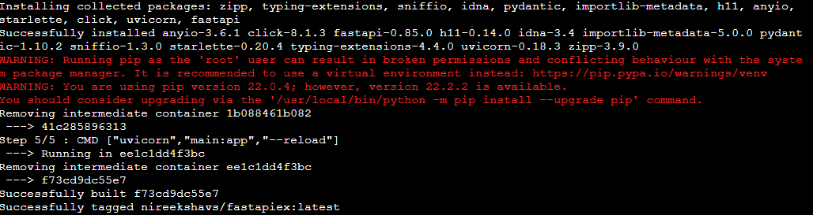

* Running docker image

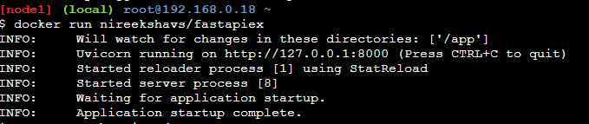

* Application o/p

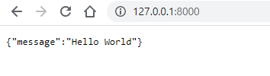

* Pushing docker image

