Docker basic commands

1. **docker –version** – It tells the current version installed in the system

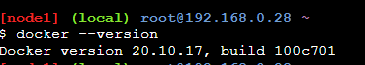

1. **docker pull <image-name>** -- It pulls the images from the docker repository

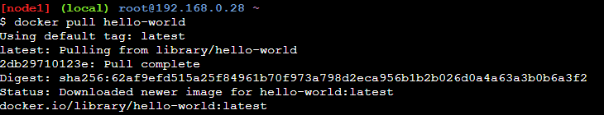

1. **docker run** – It is used to create container from the image (i.e pulled from docker repository)



1. **docker ps** – It displays the list of running containers



1. **docker ps -a** -- It’s used to list all the running and exited containers



1. **docker images** – It’s used to list all the locally stored docker images

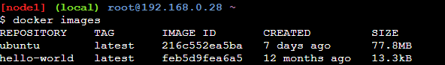

1. **docker exec** – It’s used to access the running container



1. **docker commit <container-id> <usrname/imagename>** – It’s used to create a new image of an edited container on the local system



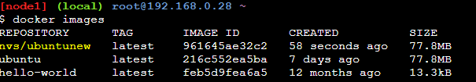

1. **docker login** – It’s used to login to docker hub repository

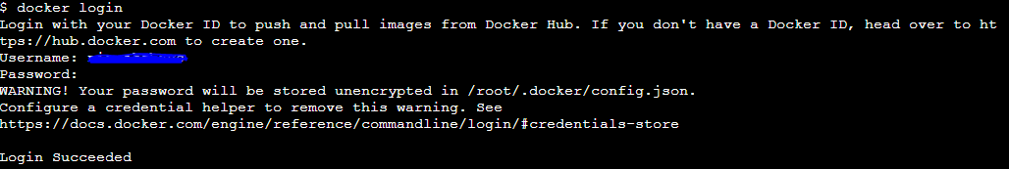

1. **docker push <username/imagename>** : It’s used to push an image to docker hub repository

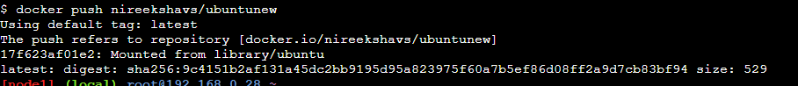

1. **docker stop <container-id>** – It’s used to stop the running container

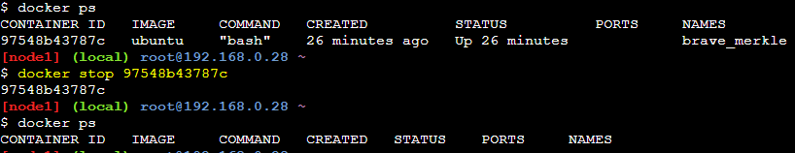

1. **docker rm <container-id>** -- It’s used to delete stopped container



1. **docker rmi <username/imagename>** : It’s used to delete an image from local storage

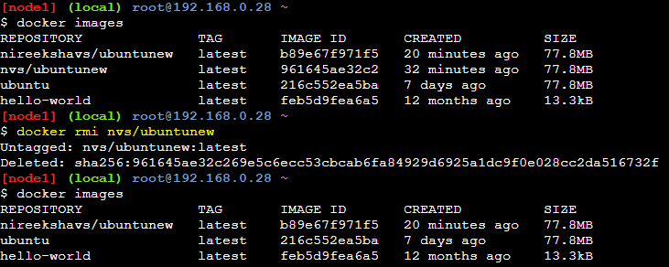

1. docker kill <container-id> -- It’s used to kill container by stopping its execution immediately



1. **docker build <path to docker file>** -- It’s used to build an image from a specified docker file.

