**Task 1**

* Demonstrate minimum 15 basic Git command with explanation and screenshot.

1. **git init:**

It’s used to initialize git repository . It will create .git directory used to keep track of multiple versions of files in folder

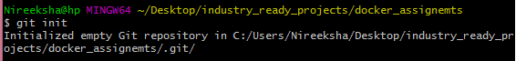

1. **git add**

It’s used to add specific file/all files into git repo



1. **git status**

It’s tells us whether we have any files modified/added/deleted

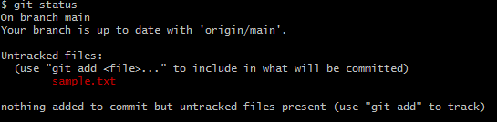

1. **git config –global user.name <username>**

Before our first commit, it’s good to tell git who you are.



1. **git config –list** : It lists out the configuration set to git

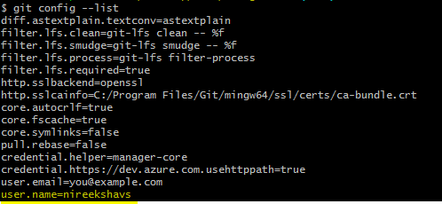

1. **git commit –m <message>**

It’s used to commit the changes with meaningful message on pushing the data to git repository

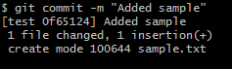

1. **git log**

It’s used pull up a repository’s commit history

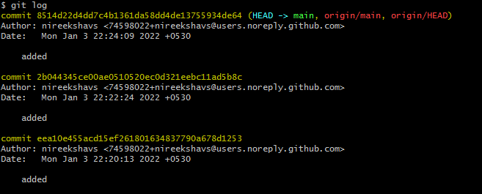

1. **git remote add origin <url>**

It’s used to push our code to remote repository



1. **git push** : It’s used to push our local files to git repository

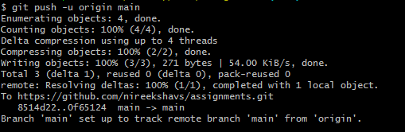

1. **git clone**: It’s used to clone the git repository to our local system

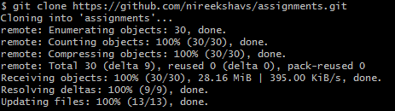

1. **git pull** : When the latest commit in the *local repo* is older than the latest commit in the *remote repo,* you can use git pull to update the working directory so that it has the same files as the latest commit

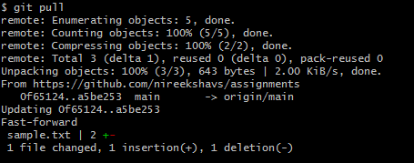

1. **git branch <branch_name>**: It allows user to create new branch for a particular repo





1. **git branch –d <branch_name>** : It’s used to delete a branch

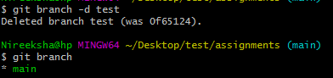

1. **git checkout <branch_name>** : It’s used to switch to the new branch from current branch

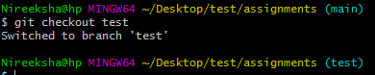

1. **git merge** : It’s used to combine two branches

