SMARTBRIDGE 8-PHASE PROJECT DOCUMENTATION
PocketSmart AI
Your Smart Budget & Recommendation Assistant
A GenAI-powered, budget-aware recommendation platform for home interiors, party planning and jewelry selection.
Contents
Project Overview & Team Members
Phase 1 – Brainstorming & Ideation
Phase 2 – Requirement Analysis
Phase 3 – Project Design
Phase 4 – Project Planning
Phase 5 – Project Development
Phase 6 – Project Testing
Phase 7 – Project Documentation
Phase 8 – Project Demonstration

Project Overview

PocketSmart AI: Your Smart Budget & Recommendation Assistant
PocketSmart AI is a GenAI-powered, cross-platform recommendation system that delivers personalized, budget-based suggestions for everyday planning needs.
What it is. PocketSmart AI is a web application with three smart planners: the Home Interior Budget Planner, the Party Budget Planner and the Jewelry Budget Planner. Each planner collects the user's budget and preferences and returns curated recommendations.
Problem addressed. Managing budgets across different life needs, such as home decor, event planning or jewelry shopping, is overwhelming because of the wide variety of products, platforms and price ranges.
How it works. A registered user selects a planner and submits a form (budget, quantities, room types, event details, occasion, or an optional outfit image). The FastAPI backend builds a structured prompt and sends it to Google's Gemini 1.5 Flash Pro model, which returns a budget breakdown as structured JSON. The backend then attaches shopping links (Amazon, Flipkart, IKEA, Myntra, Ajio) to each recommended item, stores the result in the user's history and renders it in the web interface.
Major technologies. Python, FastAPI, Jinja2 templates, HTML/CSS/JavaScript, Google Gemini 1.5 Flash Pro (google-generativeai SDK), Pydantic, passlib (bcrypt), python-jose (JWT), Pillow and python-dotenv.
Major features. Budget-aware AI recommendations across three domains; multimodal input (text plus optional outfit image); user registration, login and token-based session management; a user dashboard; and a recommendation history with per-recommendation detail view.
Intended users. Individuals who want to plan a home interior, organize a party or choose matching jewelry for an occasion within a defined budget.

Detail | Information
Team ID | SWTID-2026-4353
Class | II B.Sc Computer Science
Shift | 1

Team Members

Name | Email | NM ID
Vignesh.K | nireshkalai81@gmail.com | 89A9B98FC9BE1BE965642BAB763601EC
Manikandan S | mmanikandan32386 | 5AA6C2BE4652F668CEA4998769D528D3
Manikandan J | manikandan09042010@gmail.com | AC22140D3526B3388154CAC236C4C6F1
Santhosh M | santhosh52342008@gmail.com | ED493104CD90BE5A3D346D1392C3AA2D

Phase 1 – Brainstorming & Ideation Phase

1. Background
Planning a purchase or an event usually spans many online platforms such as Amazon, Flipkart, IKEA, Swiggy, Zomato and OYO. Each platform lists a different range of products and services at different prices. Users who have a fixed budget must compare options manually across these platforms and decide how to split the budget between categories, for example lighting versus furniture for a home, or catering versus decoration for a party. Generative AI can interpret a budget together with user preferences and produce a structured, category-wise plan, which is the context that led to PocketSmart AI.

2. Problem
- Managing budgets across home decor, event planning and jewelry shopping is overwhelming.
- The variety of products, platforms and price ranges makes comparison time-consuming.
- Users lack guidance on how to allocate a total budget proportionally across categories.
- Recommendations are rarely tailored to context, such as the event type or the outfit a piece of jewelry must match.

3. Proposed Solution
PocketSmart AI is a GenAI-powered, cross-platform recommendation system built on Google's Gemini 1.5 Flash Pro. The system analyzes user preferences, budgets and contextual needs, and generates curated recommendations for products and services. Smart planners, adaptive forms and a recommendation engine bridge multiple categories and e-commerce ecosystems, so users can plan interiors, parties and jewelry selection within a defined budget.

4. Objectives
- Provide personalized, budget-aware recommendations across home interiors, party planning and jewelry.
- Use Gemini 1.5 Flash Pro to interpret budgets, analyze images and generate structured suggestions.
- Link recommended items to popular shopping platforms so that users can act on the suggestions.
- Provide secure user registration, login and session handling.
- Offer a lightweight, responsive and intuitive web interface with a clear display of AI output.
- Keep a per-user history of recommendations for later review and reuse.

5. Usage
All planners are used by a registered, logged-in user. The three usage scenarios described in the project are:
Scenario 1: Home Interior Planning. The user selects the Home Budget Planner, enters the budget, specifies room types (Living Room, Kitchen, Bedroom) and quantities for lights, ceiling fans, furniture and dining tables. Gemini recommends cost-effective options for each category, balanced across functionality, style and price.
Scenario 2: Party Budget Planning. In the Party Planner the user enters the total budget, guest count, event type and venue details. The AI allocates the budget across catering, decoration and entertainment, tailoring suggestions to the event type (for example birthday, corporate or wedding), with options sourced from vendors on Swiggy, Zomato and accommodation services such as OYO.
Scenario 3: Jewelry Recommendations. In the Jewelry Budget Planner the user enters a budget, selects the occasion and defines style preferences. An outfit image can optionally be uploaded so that the AI can consider color coordination and aesthetics. Options are suggested from platforms such as Amazon and Flipkart.

6. Expected Outcome
- Users receive category-wise recommendations that are designed to stay within their stated budget.
- Time and effort spent on comparing products and vendors across platforms is reduced.
- Users obtain context-aware suggestions (event type, occasion, outfit image) instead of generic lists.
- Previous plans remain available in the history for review and reuse.

Phase 2 – Requirement Analysis Phase

1. Software Requirements
Category | Requirement | Purpose
Programming language | Python | Backend logic, AI integration and utilities
Web framework | FastAPI (served with Uvicorn) | Routing, request handling, session control, dependency-based authentication
Templating | Jinja2Templates | Server-side rendering of the HTML pages
Frontend | HTML, CSS (styles.css), JavaScript | Forms, navigation and dynamic display of recommendations
AI model | Google Gemini 1.5 Flash Pro via google-generativeai | Budget interpretation, image analysis and structured recommendation generation
Data validation | Pydantic (BaseModel, EmailStr) | Structured input/output models
Authentication | passlib (bcrypt), python-jose (JWT), OAuth2PasswordBearer | Password hashing and token-based access
Image handling | Pillow (PIL), base64, io | Processing of uploaded outfit images
Configuration | python-dotenv (.env file) | Loading the Gemini API key from environment variables
Environment | Python virtual environment (venv) | Isolated dependency management
IDE / editor | Visual Studio Code (as shown in project screenshots) | Development
External service | Google Cloud / Google AI Studio account | Creating and managing the Gemini API key
Operating system | [Information not available in the provided project] | -
Browser | A web browser (specific browser not specified) | Accessing the web interface

2. Hardware Requirements
Component | Requirement
Processor | [Not specified in the provided project]
RAM | [Not specified in the provided project]
Storage | [Not specified in the provided project]. Uploaded images are stored in the static/uploads folder.
GPU | No GPU requirement is stated; AI processing is performed by the Gemini API.
Network | Internet connectivity is required to reach the Gemini API and the shopping platforms.

3. Functional Requirements
- Register a new user account and authenticate existing users (/register, /login, /token).
- Maintain and terminate user sessions (/session-info, /session-data, /logout).
- Accept home planning inputs: total budget, number of lights, fans, furniture pieces and dining tables, and room selection (living room, kitchen, bedroom).
- Accept party planning inputs: total budget, guest count, event type and venue details.
- Accept jewelry planning inputs: budget, occasion, style preferences and an optional outfit image.
- Generate AI recommendations with a category-wise budget breakdown using Gemini 1.5 Flash Pro.
- Attach shopping links for each recommended item.
- Store each recommendation in the user's history and provide a detail view for a selected recommendation.
- Display a dashboard, a recommendation history page, a home page with testimonials and a footer.

4. Non-Functional Requirements
Attribute | Requirement (as supported by the project)
Security | Passwords hashed with bcrypt; JWT access tokens with an expiry time; HttpOnly cookie; protected routes; API key kept in an environment variable.
Usability | Lightweight, responsive, intuitive interface with card-like result layouts.
Reliability | Input validations for edge cases and fallback/default recommendations when the AI returns insufficient results (Milestone 5 activities).
Performance | Asynchronous FastAPI endpoints. No benchmark figures are provided in the project.
Maintainability | Modular design separating routing, AI prompt logic, models and templates.
Scalability | Modular planner design allows further categories to be added. No load-testing data is provided.

5. User Requirements
- Create an account and log in securely.
- Enter a budget and preferences through simple forms for the home, party or jewelry planner.
- Optionally upload an outfit image to obtain style-matched jewelry suggestions.
- Receive clear, structured recommendations with estimated prices and links to shopping platforms.
- Review past recommendations from the history page.

Phase 3 – Project Design Phase

1. System Architecture
PocketSmart AI is an intelligent, modular platform that integrates a lightweight Python web backend with Google's Gemini 1.5 Flash Pro, a multimodal AI model that processes text, numbers and images. The architecture diagram supplied with the project is shown below. It depicts the request path from the user through the content delivery and API layers to the orchestration logic, which sends the budget, preferences and context to Gemini as a prompt, receives curated recommendations, and consults external e-commerce platforms for product details.
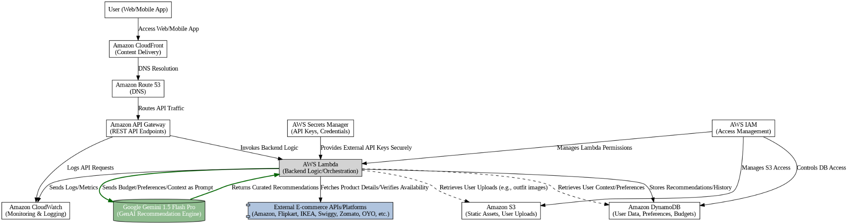
Figure 1: System Architecture (as provided in the project)
Note. The diagram shows a cloud deployment view (CloudFront, Route 53, API Gateway, Lambda, S3, DynamoDB, Secrets Manager, IAM, CloudWatch). The implementation documented in Phase 5 is a FastAPI application (app.py) with the Gemini SDK integrated directly.

2. Components Definition

Frontend UI
Purpose: collect budgets, preferences and images and present recommendations. Responsibility: HTML/CSS/JavaScript pages rendered through Jinja2 (index, login, register, dashboard, home_planner, party_planner, jewelry_planner, history). Interaction: submits forms to the FastAPI routes and displays the returned recommendations in card-like layouts.

FastAPI Backend
Purpose: central request handler. Responsibility: routing, input models, CORS configuration, static file mounting, authentication and session management. Interaction: receives requests from the UI, calls the recommendation functions, and returns rendered pages or JSON.

Gemini AI Layer
Purpose: generate recommendations. Responsibility: builds prompts from user input, calls Gemini 1.5 Flash Pro, and extracts the JSON payload from the model response (extract_json_from_response). Interaction: called by the planner functions; for jewelry it also receives the uploaded outfit image.

Shopping Link Generator
Purpose: connect recommendations to shopping platforms. Responsibility: for each item that has search terms, builds search URLs for Amazon, Flipkart, IKEA, Myntra and Ajio using urllib.parse.quote_plus. Interaction: runs after the Gemini response is parsed and adds a shopping_links object to each item.

Authentication & Session Manager
Purpose: protect the planners. Responsibility: password hashing, JWT creation, cookie handling, active session tracking, token blacklisting and expired-session cleanup. Interaction: protected routes depend on get_current_active_user.

Recommendation Store
Purpose: keep each user's generated recommendations. Responsibility: stores an ID, timestamp, recommendation type, input summary and full result per recommendation. Interaction: read by the /history and recommendation-details routes.

3. Data Flow
- The user submits a planner form (and optionally an image) from the browser.
- The FastAPI route validates the input using Pydantic models and confirms the user's session.
- The planner function builds a structured prompt containing the budget and preferences.
- The prompt (and image, for jewelry) is sent to Gemini 1.5 Flash Pro.
- The JSON in the model response is extracted, and shopping links are added for every item.
- The result is saved in the user's recommendation history and returned to the UI.
- The UI renders the budget breakdown, item details and shopping links.
[INSERT DATA FLOW DIAGRAM HERE]
Figure 2: Data Flow Diagram (diagram not provided in the project file)

4. User Flow
- Open the home page and register a new account, or log in.
- Land on the dashboard showing recent recommendations and saved queries.
- Choose a planner: Home, Party or Jewelry.
- Fill in the planner form (optionally upload an outfit image for jewelry) and submit.
- View the AI-generated recommendations with prices and shopping links.
- Revisit earlier results from the history page, then log out.
[INSERT USER FLOW DIAGRAM HERE]
Figure 3: User Flow (diagram not provided in the project file)

5. Database Design
The provided project does not include a database schema, database connection code or an ER diagram. The code screenshots show user records, active sessions, blacklisted tokens and per-user recommendations being handled through in-memory structures (users_db, active_sessions, blacklisted_tokens, user_recommendations). Only uploaded images are written to disk (static/uploads). The architecture diagram lists Amazon DynamoDB as a data store in the cloud view, but no corresponding implementation is documented.
Recommendation records contain the following fields, as read by the recommendation-details route:
Field | Description
id | Unique identifier of the recommendation
timestamp | Time the recommendation was created
recommendation_type | Planner type (home, party or jewelry)
input_summary | Summary of the user input used for the request
full_result | Complete AI-generated result
[ER DIAGRAM NOT APPLICABLE: NO DATABASE SCHEMA PROVIDED]
Figure 4: Entity-Relationship Diagram (not available in the project file)

6. Module Design
Module | Design summary
Home Interior Planner | Inputs: total budget, number of lights/fans/furniture/dining tables, room flags, additional requirements. Output: budget breakdown by category, calculation table, remaining budget and additional suggestions, in INR for the Indian market.
Party Planner | Inputs: budget, guest count, event type, venue details. Output: catering, venue and decoration options, categorized by the type of event.
Jewelry Planner | Inputs: budget, occasion, style preferences, optional outfit image. Output: style-matched jewelry options.
Authentication & Sessions | Register, login, logout, token issue, session information and session data update.
Recommendations & History | Stores results, lists past queries and returns details of one recommendation.
Dashboard & Home | Landing page with testimonials and footer; dashboard with recent recommendations and saved queries.

7. Security Design
- Password hashing: bcrypt through passlib CryptContext.
- Authentication: OAuth2 password flow; the /token endpoint returns a signed JWT with an expiry time for valid credentials and HTTP 401 for invalid credentials.
- Cookie handling: the access token is set as an HttpOnly cookie with samesite="lax" and a maximum age.
- Session control: one active session per user; a previous token is blacklisted on a new login; sessions inactive for more than 30 minutes are removed by a background task.
- Access control: planner, dashboard, history and session routes depend on get_current_active_user.
- Input validation: Pydantic models (including EmailStr) validate registration and planner input.
- Secret management: the Gemini API key is read from environment variables (GOOGLE_API_KEY or GEMINI_API_KEY) loaded from .env.

Phase 4 – Project Planning Phase

1. Project Modules
- Gemini AI Setup & Initialization
- Core Functionality Development (planner logic and Gemini prompts)
- Backend Implementation (FastAPI routes, sessions, CORS, static routing)
- UI Development (HTML/CSS/Jinja2 templates)
- Testing & Optimization

2. Entity / Data Structure

Home planner input
total_budget, num_lights, num_fans, num_furniture, num_dining_tables, has_living_room, has_kitchen, has_bedroom, additional_requirements.

Home planner output (JSON)
total_budget; budget_breakdown (list of categories, each with category, allocation and items); each item has name, description, estimated_price, quantity, search_terms and, after post-processing, shopping_links; calculation_table (category, items_count, total_cost, percentage_of_budget); remaining_budget; additional_suggestions.

User registration
username, email, full_name (optional), password.

Party and jewelry inputs
Party: budget, guest count, event type, venue details. Jewelry: budget, occasion, style preferences, optional outfit image. Field names for these models are [not visible in the provided project].

3. Key Features
Feature | Description
Budget-aware recommendations | Gemini generates category-wise plans intended to stay within the budget.
Three smart planners | Home Interior, Party and Jewelry planners with dedicated forms.
Multimodal input | Optional outfit image analysis for jewelry recommendations.
Platform links | Shopping search links for Amazon, Flipkart, IKEA, Myntra and Ajio on each item.
User accounts & sessions | Registration, login, logout, JWT tokens and session tracking.
Dashboard & history | Recent recommendations, saved queries and a reviewable history.
Responsive UI | Card-like layouts for results and forms for each planner.

4. User Roles and Responsibilities

Registered User
The only role evidenced in the project. A registered user can register, log in and log out, use the Home, Party and Jewelry planners, view the dashboard, and review recommendation history and details. No administrator role is described in the project.

5. Team Responsibilities
Team Member | Responsibility
[Team member details not available in the provided project] | [Responsibilities not available in the provided project]

6. Development Timeline
[Development timeline not provided in the project file]. The project defines the following development sequence (no dates or durations are provided):
Order | Milestone | Activities
1 | Gemini AI Initialization | Create Google Cloud/AI Studio access, generate API key, validate text and image + text calls
2 | Core Functionalities Development | Imports, app initialization, .env, planner routes, login/register, session routes
3 | Backend – FastAPI Integration | Route definitions, modular setup, CORS and static routing, startup and main function
4 | UI Development | HTML frontend, forms for each planner, result display
5 | Testing & Optimization | Real-world budget tests, prompt tuning, validations, fallback recommendations

Phase 5 – Project Development Phase

1. Development Environment Setup
The project is developed in Python inside a virtual environment (venv) using Visual Studio Code. The Gemini API is enabled through Google Cloud / Google AI Studio.
- Sign in to (or create) a Google account at the Google Cloud / AI Studio console and accept the terms and conditions.
- Select Get API key, then Create API key, and copy the key.
- Choose the required Gemini model in the console or through the API documentation.
- Test the integration by running a sample prompt from Python, first text-only and then image + text, to confirm multimodal support.
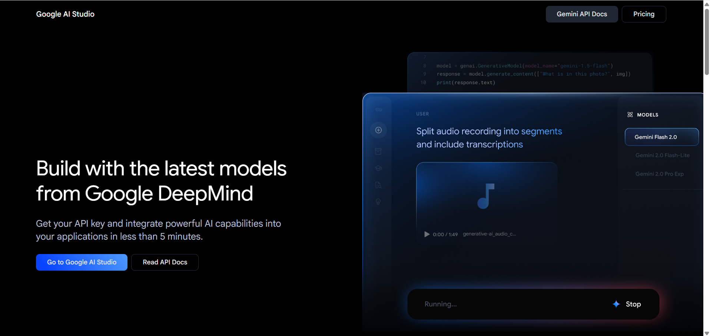
Figure 5: Signing in to the Google console
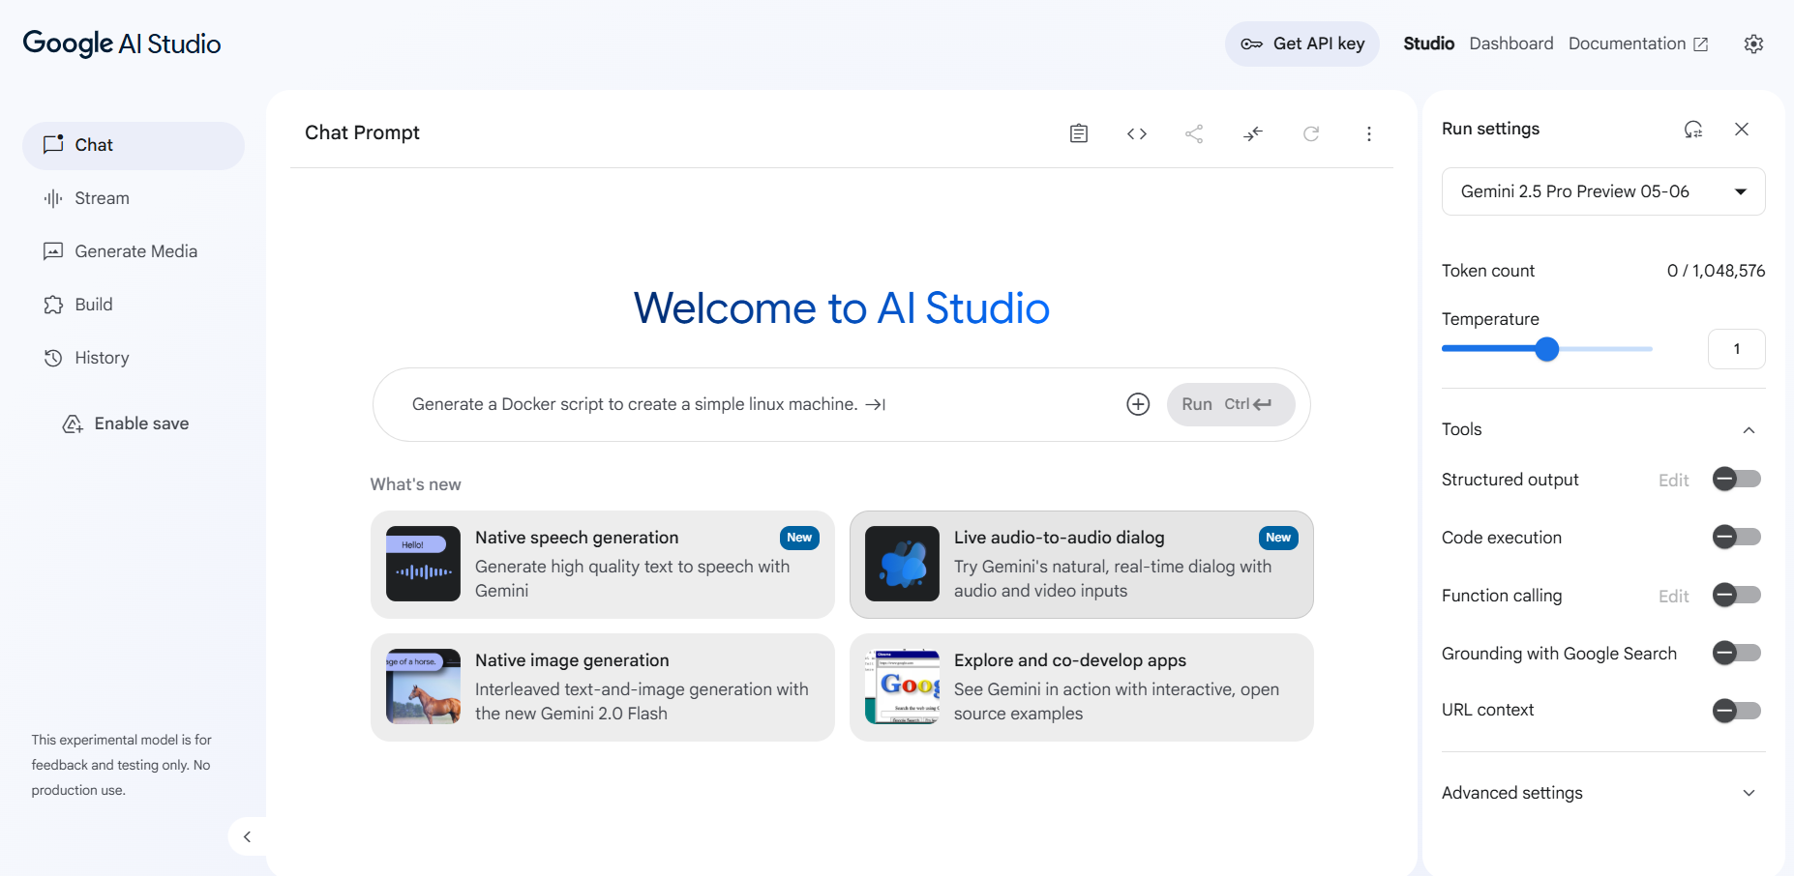
Figure 6: Accepting the terms and selecting Get API key
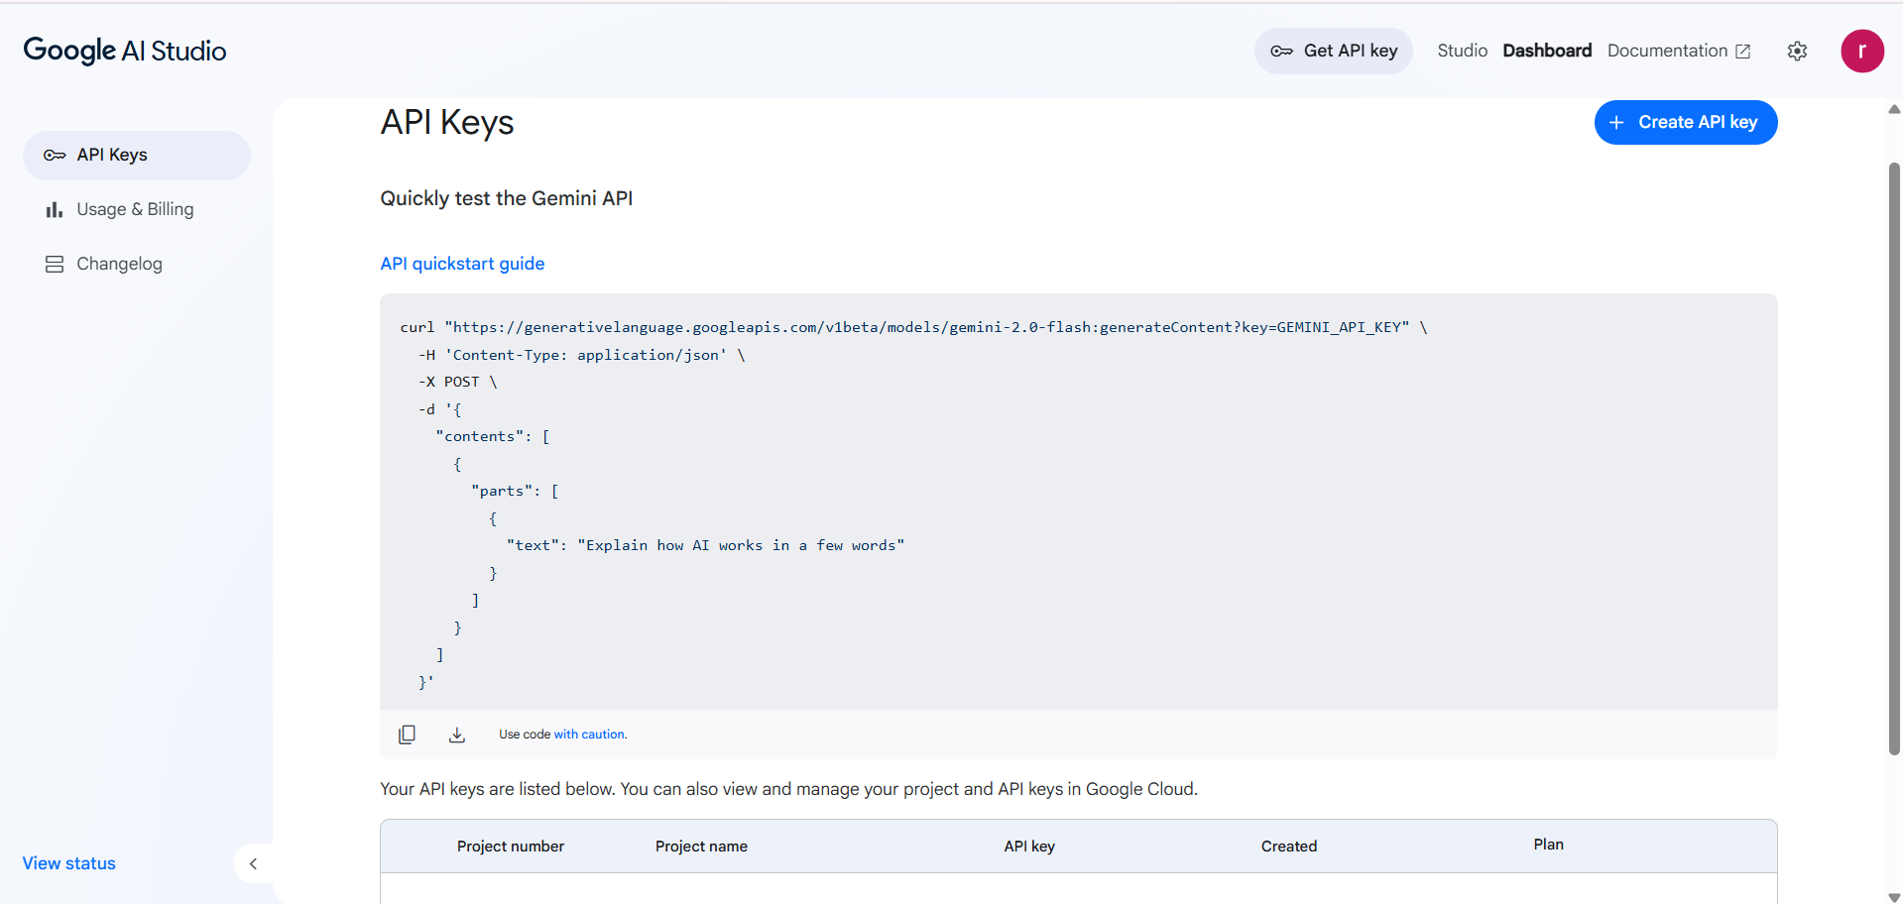
Figure 7: Create API key interface

2. Project Folder Structure
PocketSmart/
├── __pycache__/
├── static/
│ ├── uploads/ (uploaded outfit images)
│ └── styles.css
├── templates/
│ ├── dashboard.html
│ ├── history.html
│ ├── home_planner.html
│ ├── index.html
│ ├── jewelry_planner.html
│ ├── login.html
│ ├── party_planner.html
│ └── register.html
├── venv/
├── .env
└── app.py

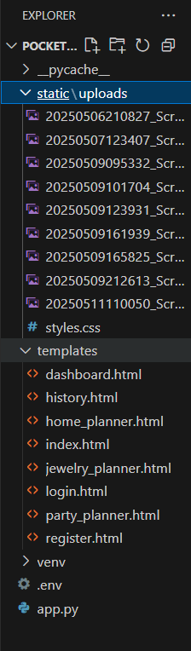
Figure 8: File Explorer structure
The project workflow also describes a modular layout (routes/, services/, models/) and a utility file gemini_utils.py. The file explorer in the project shows the application code in the single file app.py, and the structure above reflects the explorer.

3. Installation and Configuration
Create and activate a virtual environment, then install the libraries imported by the project:
python -m venv venv
pip install fastapi uvicorn jinja2 "pydantic[email]" "passlib[bcrypt]" python-jose \
google-generativeai python-dotenv pillow python-multipart

python-multipart is required by FastAPI for form and file-upload endpoints; it is not named in the source project, so it is listed here as an inferred dependency. Create a .env file in the project root with the Gemini key:
GOOGLE_API_KEY=<your-gemini-api-key>

The application reads GOOGLE_API_KEY and, if it is missing, falls back to GEMINI_API_KEY; if neither is found it raises a ValueError. The following screenshots show the imports and the configuration block (environment loading, Gemini configuration, password hashing context, CORS and static files).
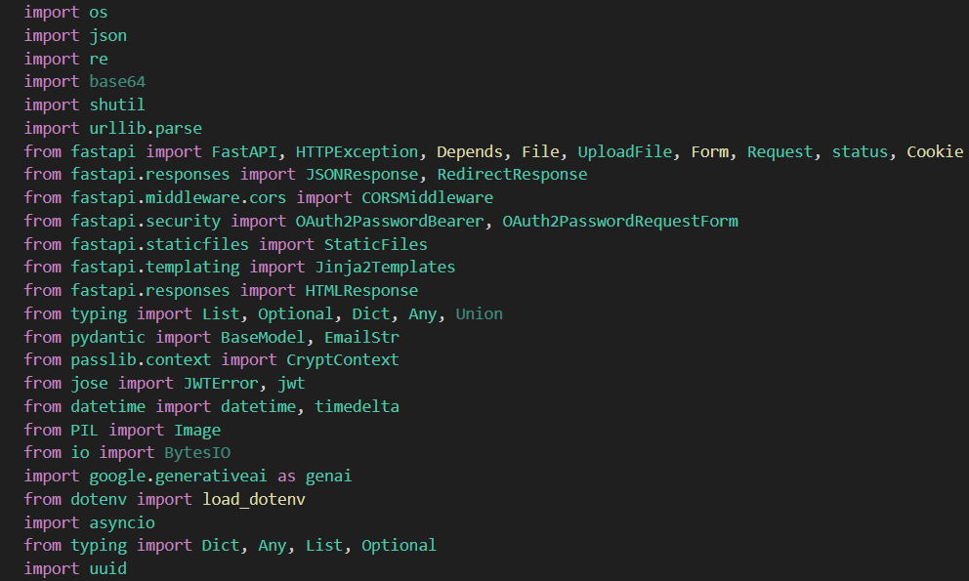
Figure 9: Imported libraries
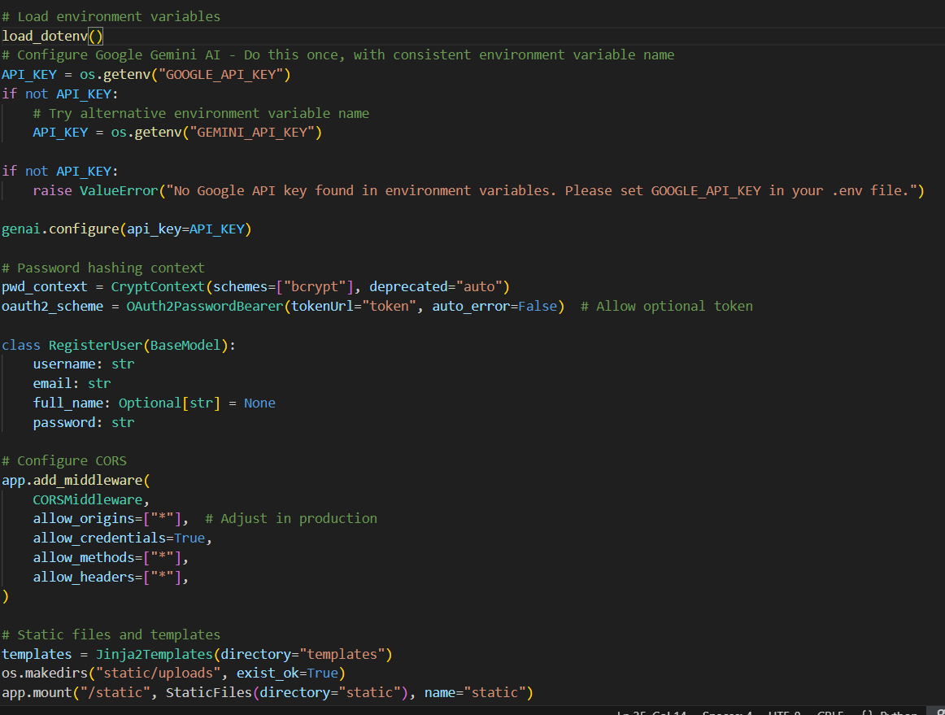
Figure 10: Environment loading, Gemini configuration, CORS and static files

4. Database Implementation
No database connection, schema or table creation is present in the provided project. Data is handled with in-memory structures: users (users_db), sessions (active_sessions), blacklisted tokens (blacklisted_tokens) and per-user recommendations (user_recommendations). Uploaded images are saved to static/uploads, which is created at startup with os.makedirs("static/uploads", exist_ok=True).

5. Module Implementation

Module 1: Gemini AI Initialization
The google.generativeai SDK is configured once with the API key. Prompts are sent with model.generate_content(prompt) and the returned text is parsed by extract_json_from_response. Connectivity is validated with sample text-only and image + text prompts.

Module 2: Home Interior Planner
/generate-home accepts a HomeBudgetInput. get_home_recommendations builds a prompt that asks for an INR budget breakdown for the Indian market with Indian brands and pricing, and requests JSON in a fixed structure (category, allocation, items, calculation table, remaining budget). The prompt instructs the model to keep total costs within budget and to supply search terms for each item.
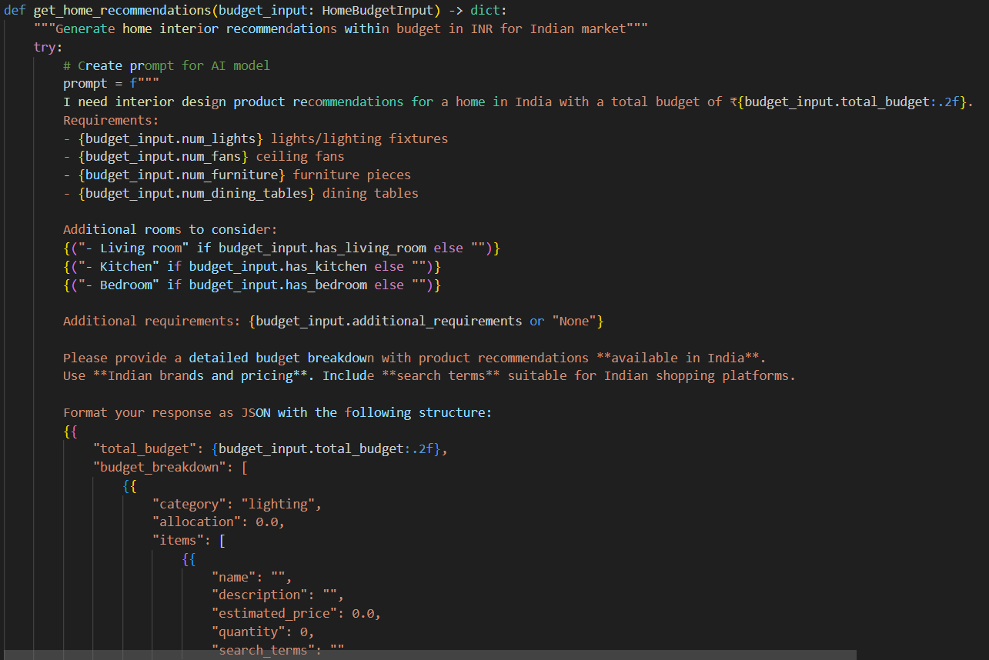
Figure 11: Home recommendation prompt (get_home_recommendations)

Module 3: Shopping Link Generation
After the JSON is parsed, every item with search terms receives a shopping_links dictionary of search URLs for Amazon India, Flipkart, IKEA India, Myntra and Ajio. Search terms are URL-encoded with urllib.parse.quote_plus.
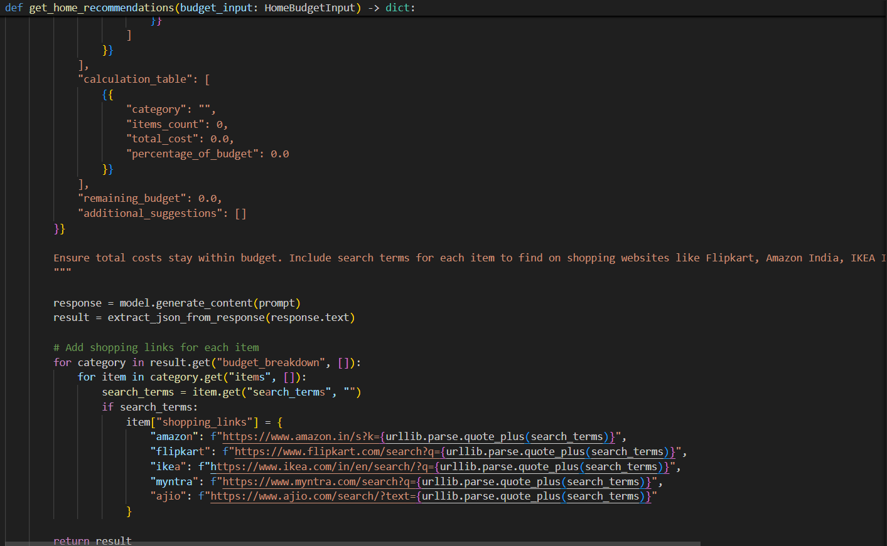
Figure 12: JSON structure, model call and shopping link generation

Module 4: Party Planner
/generate-party processes the party budget, guest count, event type and venue details, and returns catering, venue and decoration suggestions. Conditional (if) logic categorizes the suggestions by the type of situation or event, and platform links are attached in the same way as for the home planner.

Module 5: Jewelry Planner
/generate-jewelry accepts text input and an optional outfit image (Pillow and base64 are used for image handling; uploads are saved under static/uploads) and returns style-matched jewelry options based on budget, occasion and outfit. The planner page jewelry_planner.html is served only to an authenticated user.

Module 6: Authentication and Session Management
Routes: /register and /login (pages that redirect logged-in users to /dashboard), /token (issues the JWT), /logout, /session-info (username, login time, last activity, session duration in minutes, user data) and /session-data (updates session data and last activity). A startup background task removes sessions that have been inactive for more than 30 minutes, checking every 5 minutes.
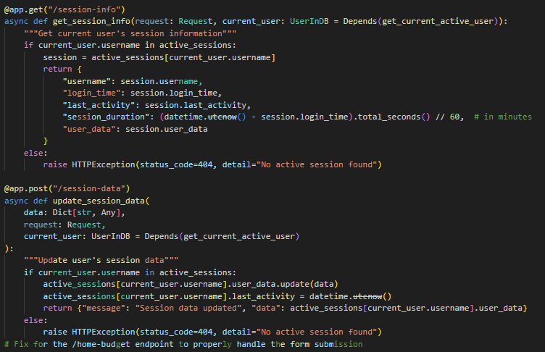
Figure 13: Session information and session data routes
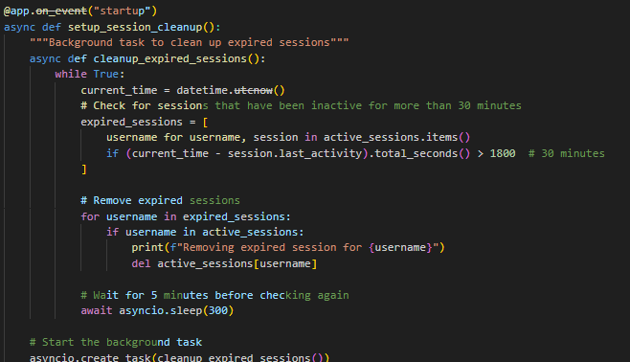
Figure 14: Startup task that cleans up expired sessions

Module 7: Recommendation History and Details
Each generated recommendation is stored per user. /history lists earlier queries and results; /recommendation-details/{recommendation_id} returns the id, timestamp, type, input summary and full result, and responds with HTTP 404 if the recommendation is not found.
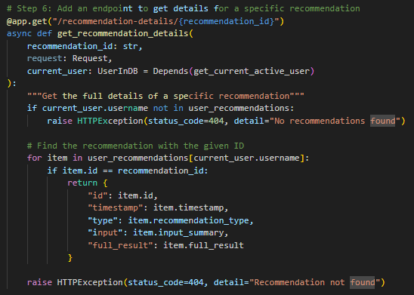
Figure 15: Recommendation details route

6. Core Functionality
The core function of the system is the pipeline: validated user input, prompt construction, Gemini call, JSON extraction, shopping-link enrichment, storage in history, and rendering. The home planner is fully visible in the project screenshots; the party and jewelry planners follow the same pattern with their own prompts and inputs. The route table below lists the endpoints named in the project.
Route | Purpose
/generate-home | Home interior recommendations (furniture, decor, lighting)
/generate-party | Catering, venue and decoration options for events
/generate-jewelry | Style-matched jewelry options from text and optional image
/register, /login, /logout, /token | User registration, authentication and session control
/session-info, /session-data | Read and update session information
/recommendation-details/{id} | Full details of a saved recommendation
/history | Past recommendation queries and results
/dashboard | User dashboard

7. Authentication / Security Implementation
At login, authenticate_user verifies the credentials; on failure the route raises HTTP 401 ("Incorrect username or password"). On success it creates a JWT (sub = username) valid for ACCESS_TOKEN_EXPIRE_MINUTES, blacklists any previous token for the same user, records a new UserSession, and returns the token in the JSON body and in an HttpOnly cookie.
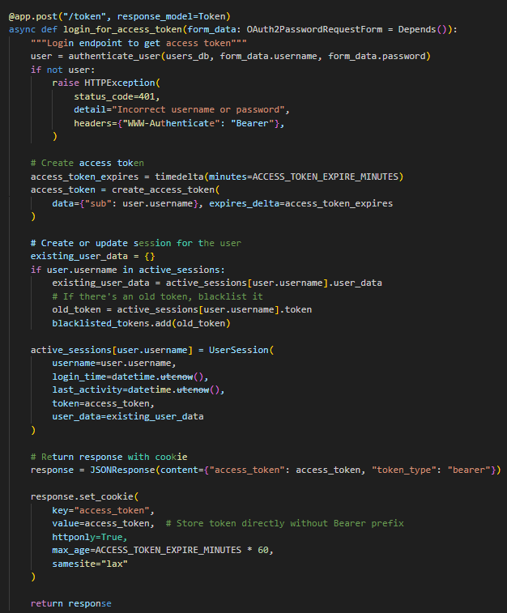
Figure 16: Token endpoint (/token)

8. User Interface Implementation
The interface is built with HTML, CSS and Jinja2 templates and connects to the FastAPI routes. It provides a home page with budget and category entry points, separate forms for each planner, and card-like result layouts. The templates directory contains one template per page.
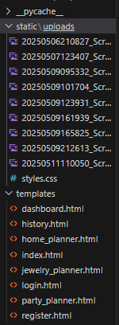
Figure 17: Templates directory structure

Home Page, Testimonials and Footer
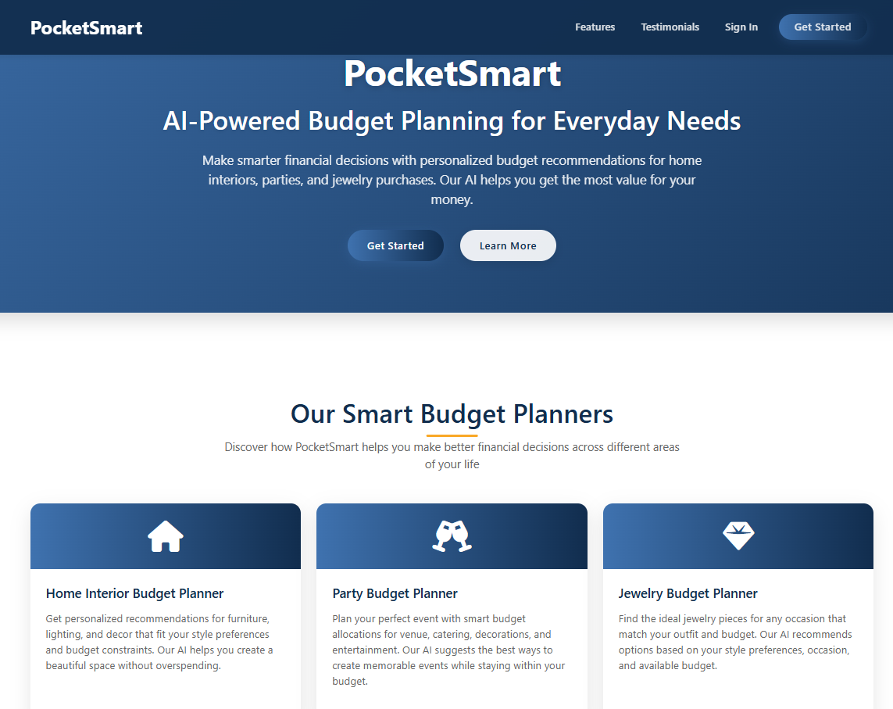
Figure 18: Home page: introduces PocketSmart AI with links to the planners and user actions
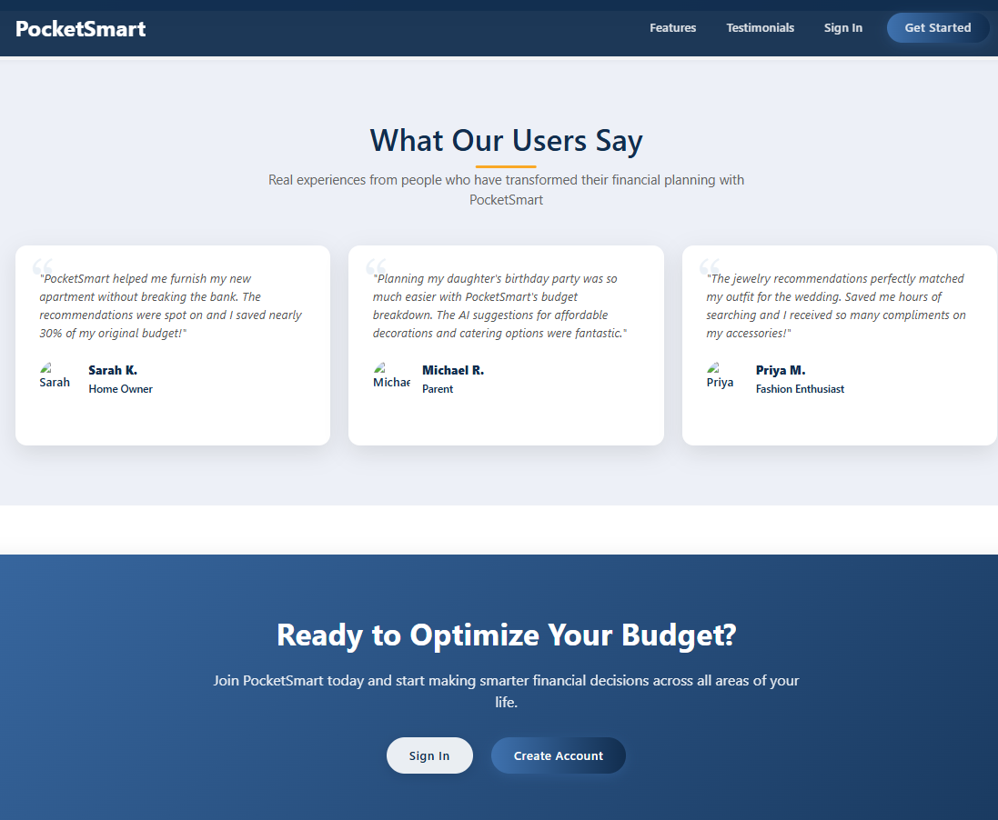
Figure 19: Testimonials section

Figure 20: Footer

Registration and Login
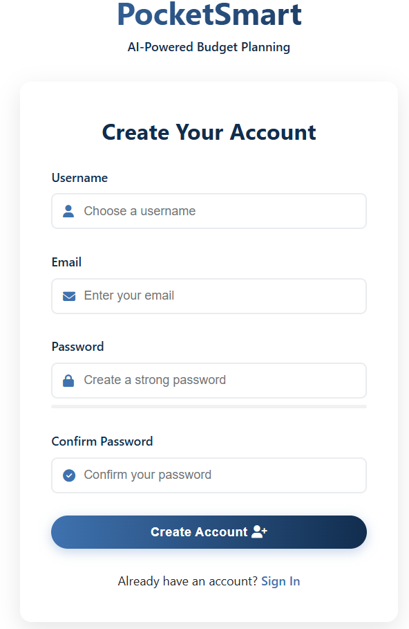
Figure 21: Register page: create an account
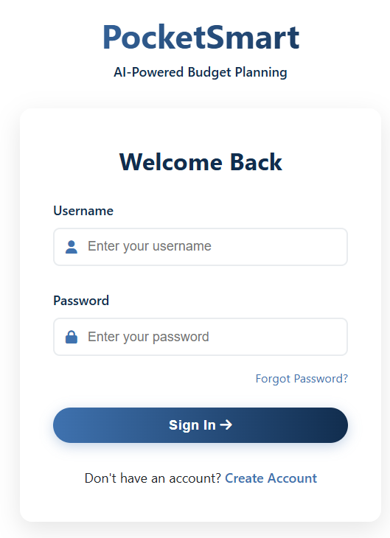
Figure 22: Login page: authenticate an existing user

Dashboard
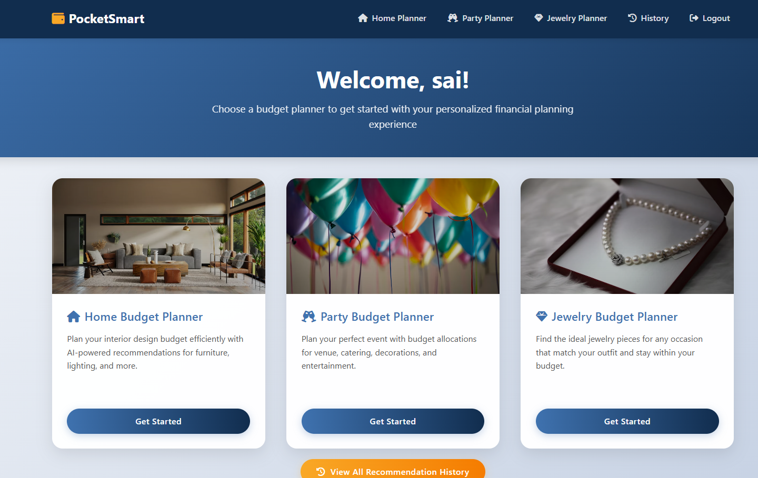
Figure 23: User dashboard: recent recommendations, saved queries and insights
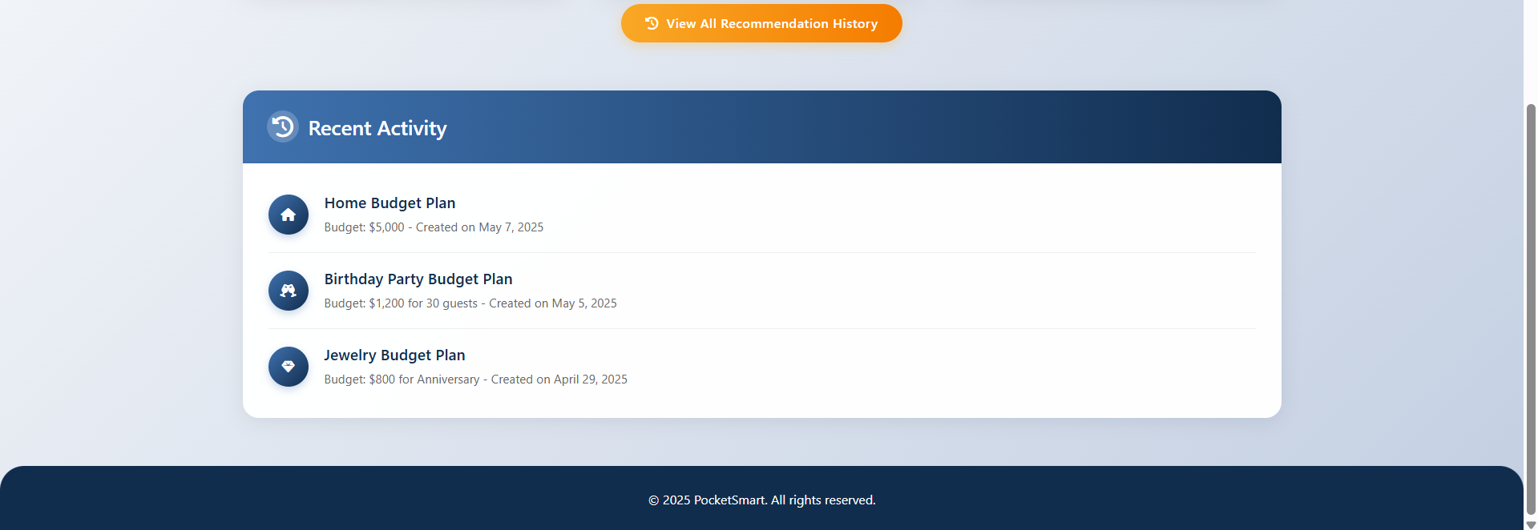
Figure 24: Dashboard (continued)

Home Interior Budget Planner
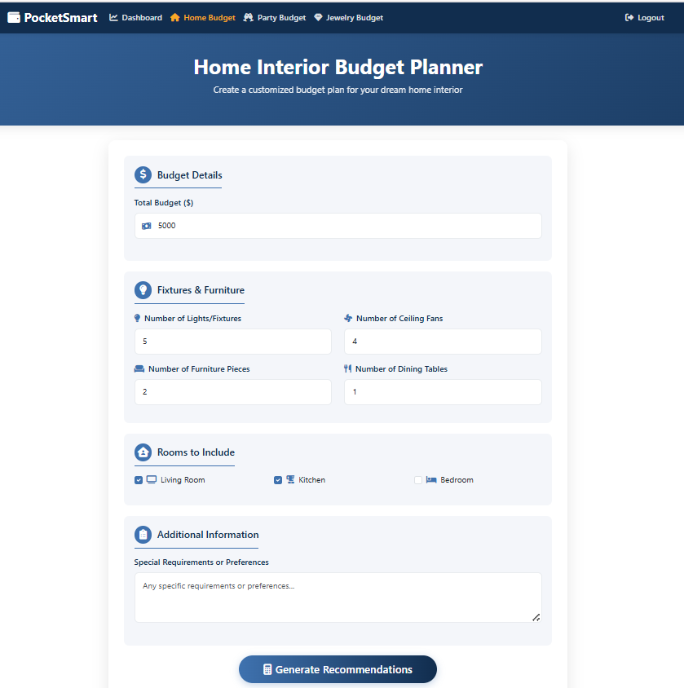
Figure 25: Home Interior Budget Planner page
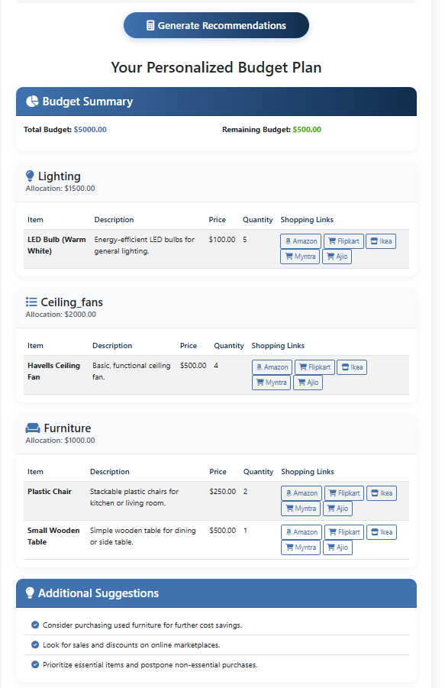
Figure 26: Home Interior Recommendations page

Party Budget Planner
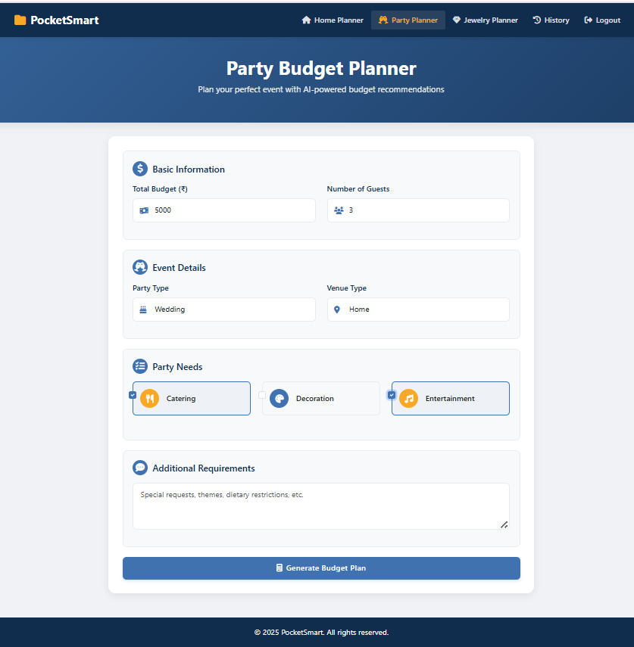
Figure 27: Party Budget Planner page
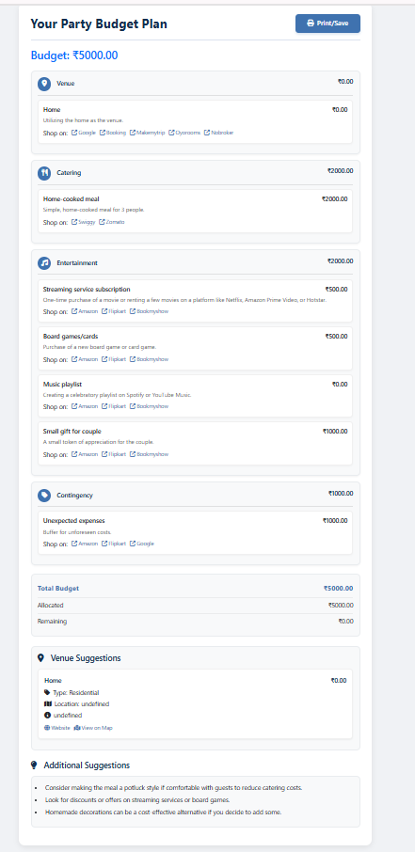
Figure 28: Party Budget Recommendations page

Jewelry Budget Planner
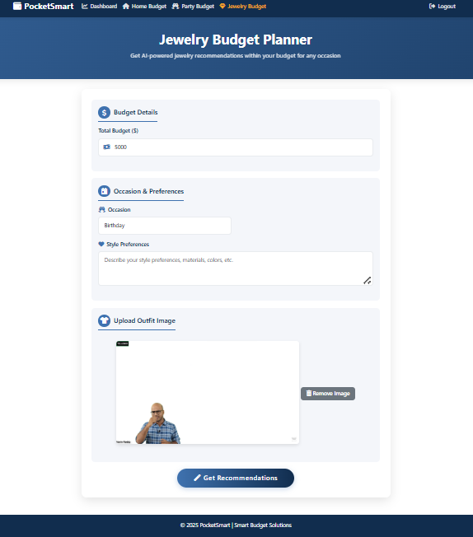
Figure 29: Jewelry Budget Planner page
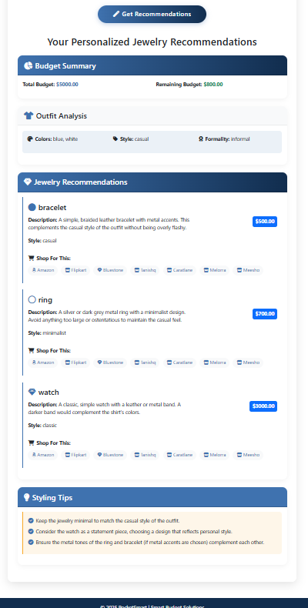
Figure 30: Jewelry Budget Recommendations page

Recommendation History
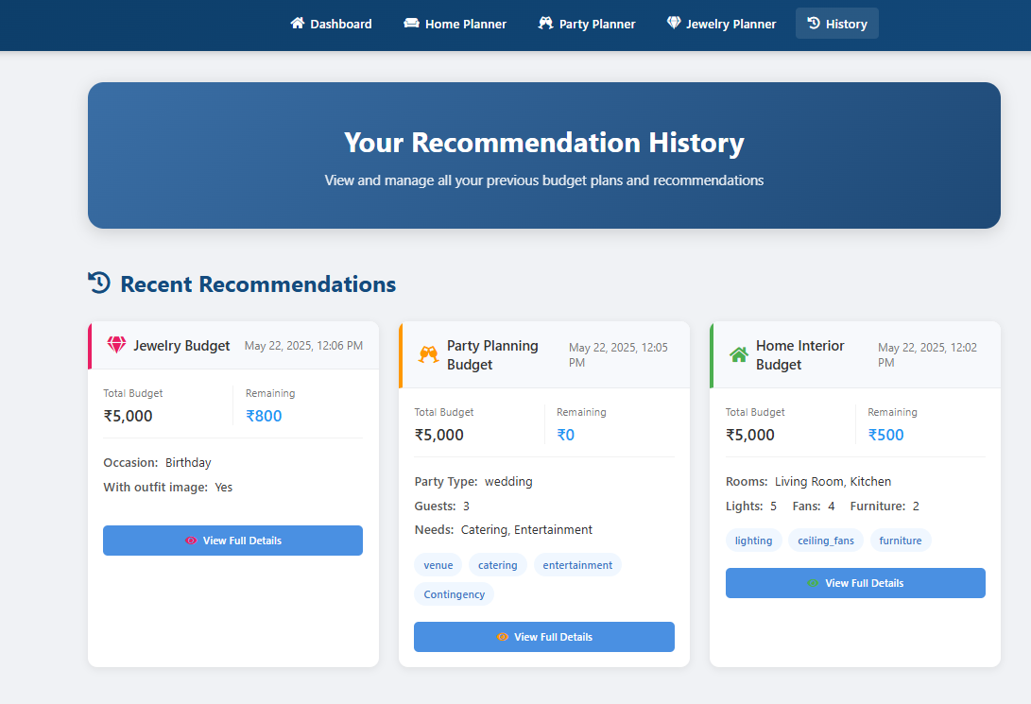
Figure 31: Recommendation History page

9. Integration
- Frontend and backend: HTML forms post to FastAPI routes; Jinja2 renders pages; CORS middleware is configured for cross-origin requests.
- Backend and AI service: the google.generativeai SDK sends prompts (and images for jewelry) to Gemini 1.5 Flash Pro and receives JSON text.
- Backend and e-commerce platforms: generated search-URL links to Amazon, Flipkart, IKEA, Myntra and Ajio. The project also lists Swiggy, Zomato and OYO as sources for party planning, and includes "mock API calls or simulated scraping" as a development activity. No live third-party API integration is shown in the code.
- Backend and storage: in-memory structures for users, sessions and recommendations; local disk for uploaded images.

10. Project Execution
# 1. activate the virtual environment
# 2. make sure .env contains GOOGLE_API_KEY
python app.py

The __main__ block starts the server with Uvicorn. Open the address shown in the console (host and port are [not visible in the provided project]), register an account and log in to reach the dashboard and planners.

11. GitHub Repository
GitHub Repository:
[PUBLIC GITHUB REPOSITORY LINK]

Phase 6 – Project Testing Phase
The project describes its testing activities (Milestone 5) but does not record individual test outcomes. Wherever a result is not documented it is marked accordingly and is not reported as passed.

1. Testing Objectives
- Verify that each planner returns relevant, structured recommendations for real-world budgets.
- Evaluate Gemini response quality, budget adherence and platform accuracy.
- Verify registration, login, logout and session behavior.
- Verify that input edge cases are handled and that fallback recommendations are shown when the AI output is insufficient.
- Verify a smooth UI/UX across devices.

2. Testing Environment
Item | Details
Hardware | [Information not available in the provided project]
Operating system | [Information not available in the provided project]
Browser | [Information not available in the provided project]
Runtime / IDE | Python virtual environment; Visual Studio Code
AI service | Google Gemini API (Gemini 1.5 Flash Pro)
Database | None documented (in-memory data structures)

3. Testing Methods
- Functional testing of the three planners with varied budgets and preferences.
- Integration testing between the forms, FastAPI routes and the Gemini API.
- UI testing of pages and forms.
- Security testing of authentication and session behavior.
- System (end-to-end) testing with real-world scenarios.

4. Test Cases
Scenarios are derived from the behavior described in the project. Actual outputs and statuses are not recorded in the source.
Test ID | Test Scenario | Input | Expected Output | Actual Output | Status
TC-01 | Register a new user | Username, email, password | Account created; user can log in | [Testing result not provided] | [Not recorded]
TC-02 | Login with valid credentials | Registered username and password | Token issued; redirect to dashboard | [Testing result not provided] | [Not recorded]
TC-03 | Login with invalid credentials | Wrong password | HTTP 401 "Incorrect username or password" | [Testing result not provided] | [Not recorded]
TC-04 | Logout | Click logout | Session ended; redirect to login page | [Testing result not provided] | [Not recorded]
TC-05 | Home planner | Budget, quantities, rooms | Budget breakdown, items and shopping links | [Testing result not provided] | [Not recorded]
TC-06 | Party planner | Budget, guests, event type, venue | Catering, venue and decoration options | [Testing result not provided] | [Not recorded]
TC-07 | Jewelry planner (text only) | Budget, occasion, style | Jewelry options matching occasion | [Testing result not provided] | [Not recorded]
TC-08 | Jewelry planner (with image) | Budget, occasion, outfit image | Options considering outfit colors | [Testing result not provided] | [Not recorded]
TC-09 | View history and details | Open history, select an item | Past queries and full result shown | [Testing result not provided] | [Not recorded]
TC-10 | Session expiry | 30+ minutes of inactivity | Session removed by cleanup task | [Testing result not provided] | [Not recorded]
TC-11 | Gemini connectivity | Text-only and image + text prompts | Model responds to both prompt types | [Testing result not provided] | [Not recorded]

5. Functional Testing
Each planner is tested end to end with varied budgets and preferences: home decor setups from IKEA and Amazon; party packages including food (Swiggy/Zomato), venues (OYO) and decoration; and jewelry suggestions matched with outfit styles, occasions and image inputs. Recorded outcomes: [Testing result not provided].

6. UI Testing
The UI is verified page by page: home, testimonials, footer, register, login, dashboard, the three planner pages, the three recommendation pages and the history page. Checks cover navigation, form fields and buttons, input validation, layout on different devices and the display of results. Recorded outcomes: [Testing result not provided].

7. Integration Testing
Integration testing verifies that form data reaches the FastAPI route, that the prompt is delivered to Gemini, that the JSON response is parsed and enriched with shopping links, and that the result appears in the UI and in the history. Recorded outcomes: [Testing result not provided].

8. Error Handling Testing
- Invalid credentials return HTTP 401 at /token.
- A missing session returns HTTP 404 at /session-info and /session-data.
- A missing recommendation returns HTTP 404 at the details route.
- Missing API key raises a ValueError at startup.
- Input edge cases and insufficient AI results are addressed through validations and fallback recommendations (Activities 5.3 and 5.4). Test outcomes: [Testing result not provided].

9. Performance Testing
[No performance test data provided in the project]

10. Security Testing
Areas to verify: bcrypt password hashing, token expiry, HttpOnly cookie, blacklisting of previous tokens on re-login, access to protected routes without a valid token, and session cleanup. Recorded outcomes: [Testing result not provided].

11. Testing Results
The project documents the testing approach and the areas covered but does not include pass/fail results or measured values. [Testing result not provided].

12. Bug Fixes
Bug ID | Issue | Resolution | Status
BUG-01 | [No bugs documented in the provided project] | [Not available] | [Not available]

13. Final Testing Result
Testing activities were planned across all three planners, authentication and the UI. Because the source does not record outcomes, no claim is made that the system is error-free. Actual results should be filled in before final submission.

Phase 7 – Project Documentation Phase

1. Project Introduction
PocketSmart AI is a GenAI-powered, cross-platform recommendation system that delivers personalized, budget-based suggestions for home interiors, party planning and jewelry selection using Gemini 1.5 Flash Pro.

2. Problem Statement
Managing budgets across different life needs is overwhelming because of the variety of products, platforms and price ranges available.

3. Objectives
- Budget-aware, personalized recommendations in three domains.
- Multimodal AI input, including outfit images.
- Secure accounts and sessions.
- A simple web interface with reviewable history.

4. Technologies Used
Python, FastAPI, Uvicorn, Jinja2, HTML/CSS/JavaScript, Google Gemini 1.5 Flash Pro (google-generativeai), Pydantic, passlib (bcrypt), python-jose (JWT), Pillow, python-dotenv.

5. System Requirements
Python with the libraries listed in Phase 2, a Gemini API key supplied via .env, a web browser and an internet connection. Hardware and OS specifications are not stated in the project.

6. System Design
- Architecture: browser UI, FastAPI backend, Gemini AI layer, shopping link generator and session/recommendation stores. The supplied architecture diagram presents a cloud deployment view.
- Database: no database schema is provided; data is held in in-memory structures and uploaded images on disk.
- Modules: Home, Party and Jewelry planners; authentication and sessions; recommendations and history; dashboard.
- User flow: register/login, dashboard, choose planner, submit form, view recommendations, review history, logout.

7. Implementation
The backend is implemented in app.py with FastAPI and the Gemini SDK. Prompts request JSON output; results are enriched with shopping links, stored per user and rendered through Jinja2 templates. Authentication uses bcrypt hashing and JWT tokens with HttpOnly cookies, and an asynchronous task expires inactive sessions.

8. Features
- Home, Party and Jewelry budget planners.
- Optional outfit-image input.
- Shopping links for Amazon, Flipkart, IKEA, Myntra and Ajio.
- Registration, login, logout and session information.
- Dashboard, testimonials and recommendation history.

9. User Roles
Registered User: uses all planners, dashboard and history after logging in. No other role is defined in the project.

10. Testing Summary
Testing covered real-world scenarios for all planners, authentication and UI pages. Pass/fail results are not documented in the source ([Testing result not provided]).

11. Screenshots
Figure 32: Home page
Figure 33: User dashboard
Figure 34: Home interior recommendations
Figure 35: Party budget recommendations
Figure 36: Jewelry budget recommendations

12. Advantages
- Saves time compared with manual multi-platform comparison.
- Context-aware suggestions through event type, occasion and image input.
- Clear budget breakdown with a calculation table and remaining budget (home planner).
- Direct links to shopping platforms.
- Secure, session-based access.

13. Limitations
- Recommendations and prices are AI estimates; shopping links are platform search URLs, and live price or stock availability is not verified by the application.
- Data (users, sessions, history) appears to be held in memory, so persistence across server restarts is not evidenced.
- CORS is configured with allow_origins=["*"], which the code comments mark as something to adjust for production.
- Testing results, performance data and a data-model diagram are not documented.

14. Future Enhancements
The following are proposed extensions and are not part of the current implementation:
- Store users, sessions and recommendations in a persistent database.
- Integrate official product/vendor APIs for live prices and availability.
- Restrict CORS origins for production deployment.
- Add further planner categories following the same modular pattern.

15. Conclusion
PocketSmart AI combines FastAPI with Gemini 1.5 Flash Pro to turn budget planning into an AI-assisted experience across home interiors, party planning and jewelry selection. It processes budgets, preferences and images to produce structured recommendations with links to popular platforms, and provides secure accounts, a dashboard and a history for repeat use.

16. GitHub Repository
GitHub Repository:
[PUBLIC GITHUB LINK]

Phase 8 – Project Demonstration Phase
This is the structure for the final demonstration video. It presents the working application.

1. Project Introduction
- Project name: PocketSmart AI: Your Smart Budget & Recommendation Assistant.
- Team members: [Not available in the provided project].
- Problem statement: overwhelming budget planning across many products, platforms and price ranges.
- Purpose: personalized, budget-based AI recommendations.

2. Project Overview
Briefly explain that PocketSmart AI provides Home, Party and Jewelry planners powered by Gemini 1.5 Flash Pro, with shopping links, user accounts and history.

3. Project File / Code Structure
Show the folder structure (app.py, templates/, static/, .env) and explain: app.py (routes, Gemini prompts, authentication, sessions), templates/ (one page per screen), static/styles.css (styling) and static/uploads (uploaded images).

4. Project Execution
Activate the virtual environment, confirm that .env holds the API key, run python app.py, and open the application in the browser.

5. Feature Demonstration
- User registration and login.
- Dashboard.
- Home Interior Budget Planner and its recommendations.
- Party Budget Planner and its recommendations.
- Jewelry Budget Planner with an outfit image and its recommendations.
- Shopping links on recommended items.
- Recommendation history and detail view.

6. Complete User Workflow
Register, log in, open the dashboard, choose a planner, submit budget and preferences, review the AI recommendations, follow a shopping link, open the history, and log out.

7. Final Output & Code Folder Link
Show the final recommendation page for each planner, with the budget breakdown, estimated prices and shopping links. Click Here TO open the Project Code Files

8. Benefits / Use of the Project
The project helps users plan a home interior, a party or a jewelry purchase within a defined budget, without comparing platforms manually.

9. Conclusion
Summarize how Gemini 1.5 Flash Pro and FastAPI together provide personalized, budget-aware recommendations.

10. Demo Video
Google Drive Demo Video: Click Here TO Open The Demo Video
Sharing must be set to Anyone with the link → Viewer.

