TK1104 Digital teknologi – Arbeidskrav 2
Linux, e-mail (SMTP), FTP and packet analysis
Group assignment — hands-on work in a Linux virtual machine: Terminal, SMTP and FTP, analysed in Wireshark and documented with screenshots.
Published: Tuesday 6 October 2026 | Deadline: Friday 23 October 2026
Group and submission details
Field | Fill in
Group name / number | Apetor / 7
Member 1 (name, student no.)
Member 2 (name, student no.)
Member 3 (name, student no.)
Member 4 (name, student no.)
Date

How this assignment is approved (two steps)
- Submit this completed document as a PDF on Canvas (one upload per group). The TA registers it as delivered — this qualifies your group for step 2.
- Question round in the øving on Tuesday 27 October 2026. Your group answers questions about what you did and why, another group gives feedback, and the TA registers the assignment as godkjent.
Note: a solution that does not fully work can still be submitted. The point is to try it yourself, show your steps, and be able to answer questions about them.

This is your group’s own work. All screenshots must come from your own machine, so the answers cannot simply be generated by an AI tool. Show your method, not only the final answers. Submissions are checked for plagiarism. If you have questions, contact your veileder through the Canvas Inbox.

Before you start
- You need a virtual machine with Linux, as described on the Canvas page “Virtuell maskin og Linux”. Ask your veileder if the installation gives you trouble.
- Work together, but make sure every member can explain every step — each of you may get questions in the øving.
- For each task, take a screenshot that shows both what you typed in the Terminal and the result.

Part 1 — Commands in the Linux Terminal
Open Linux in your virtual machine, then open a Terminal and carry out the following.

Task 1. Create a folder called arbeidskrav2.
Answer / command:

mkdir arbeidskrav 2
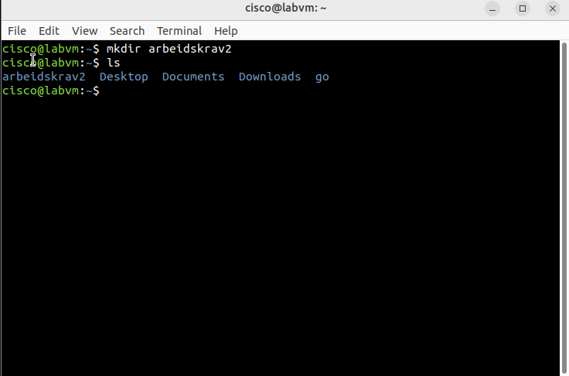

Task 2. Navigate into the folder arbeidskrav2.
Answer / command:
cd arbeidskrav2

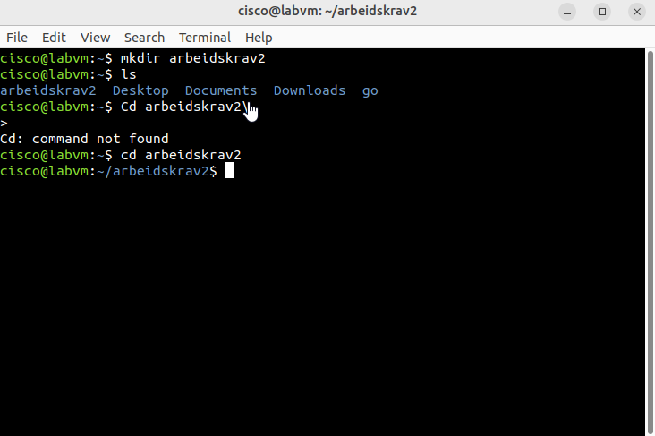

Task 3. Create two folders inside it called mappe1 and mappe2.
Answer / command:
mkdir mappe1 mappe2

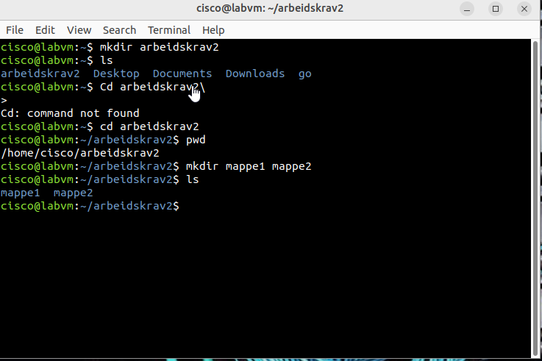

Task 4. Write the contents of the current folder into a new file called innhold.txt (hint: ls > innhold.txt ).
Answer / command:
ls > innhold.txt
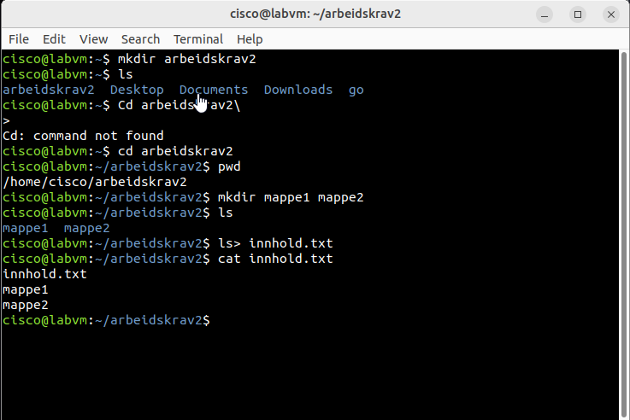

Task 5. Append the sentence Dette er siste linje. to the end of innhold.txt.
Answer / command:

echo "Dette er siste linje." >> innhold.txt
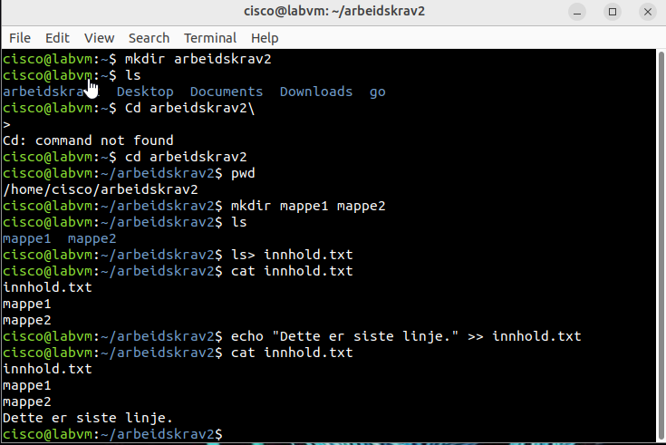

Task 6. Print the contents of innhold.txt in the Terminal. Take a screenshot of the output.
Answer / command:
cat Innhold.txt
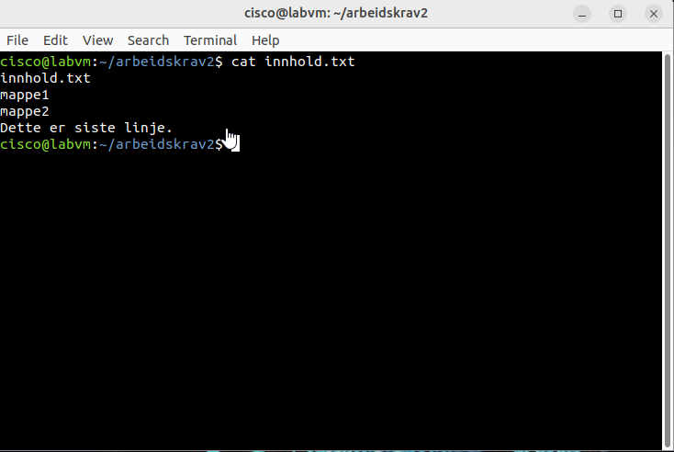

Task 7. Copy innhold.txt into the folder mappe1.
Answer / command:

cp innhold.txt mappe1/
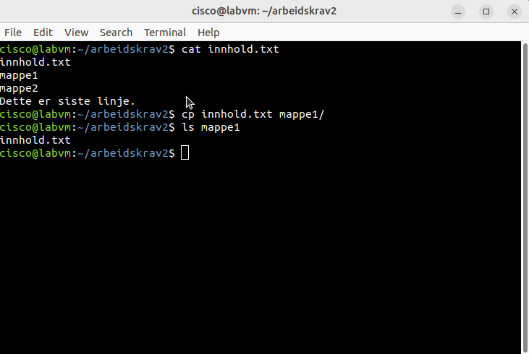

Part 2 — Wireshark, MailHog and an SMTP conversation
Here you send a small e-mail “by hand” over SMTP to a local test mail server (MailHog) and watch the packets in Wireshark.
Install MailHog first (once per VM). MailHog is not in Ubuntu’s package list, so you install it with Go. Run these commands in the Terminal:
sudo apt update
sudo apt install -y golang-go netcat-openbsd
go install github.com/mailhog/MailHog@latest
Then start it with ~/go/bin/MailHog. It receives SMTP on port 1025 and shows the received mails in the browser at http://localhost:8025. This works in VirtualBox and in UTM.

Task 1. Open Wireshark and start a capture on Loopback: lo (localhost).

Task 2. In a Terminal, start MailHog with ~/go/bin/MailHog and leave this Terminal open.
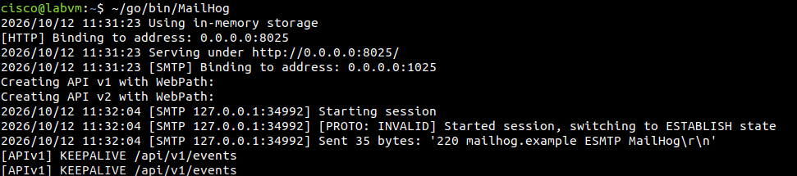

Task 3. Open a second Terminal and connect to the SMTP service on localhost port 1025 (for example with nc localhost 1025 ).
Answer / command:
nc localhost 1025
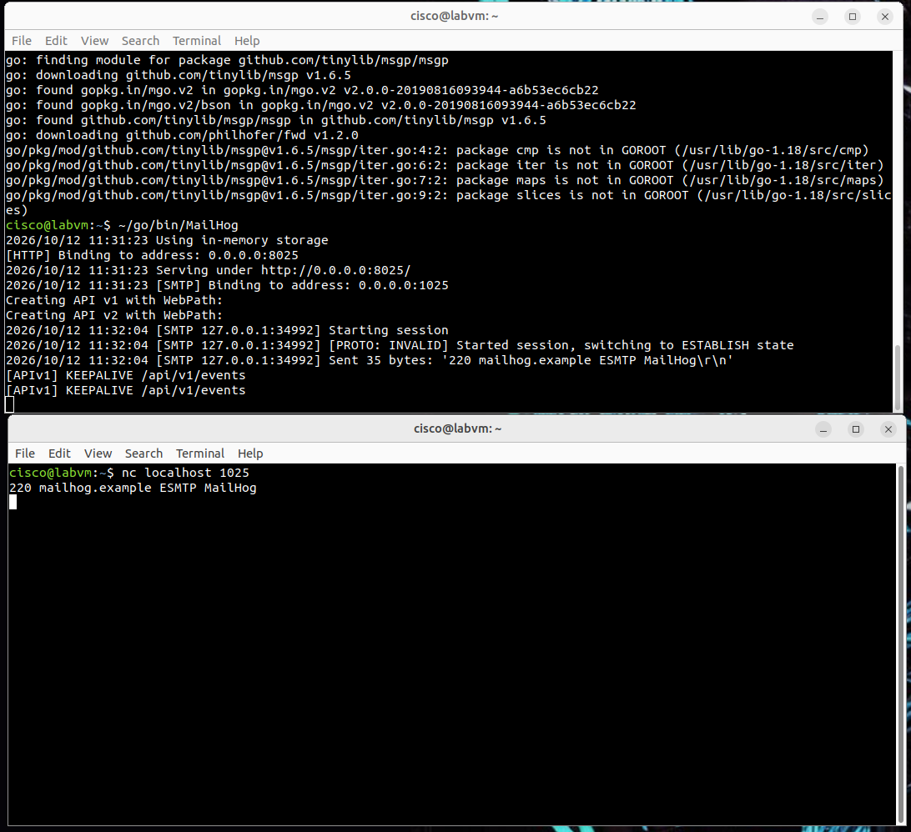
Task 4. Type the SMTP commands to send an e-mail to mottaker@testpost.no from noreply@soppelpost.no. The body shall be: “Dette er linje 1. Dette er linje 2.”
Use HELO/EHLO, MAIL FROM, RCPT TO, DATA … then a single dot to end the message.
Answer / command:
HELO labvm
MAIL FROM:<noreply@soppelpost.no>
RCPT TO:<mottaker@testpost.no>
DATA
Dette er linje 1.
Dette er linje 2.
.
QUIT
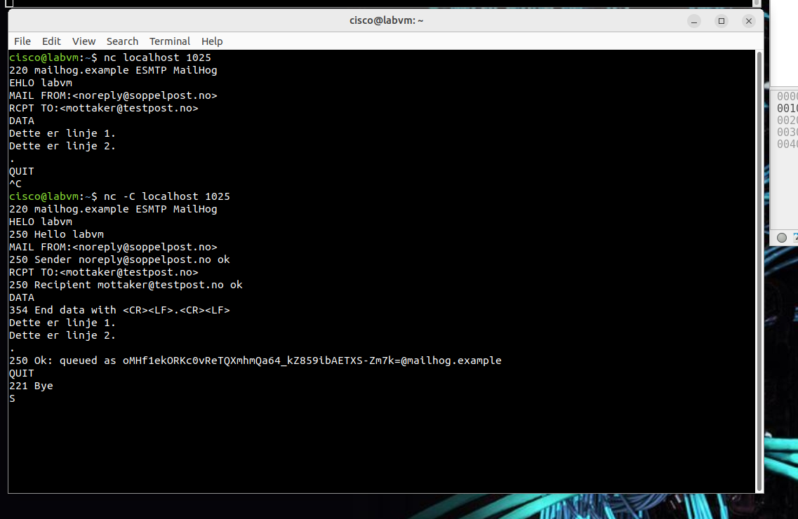 første gang fungerte ikke

Task 5. End the SMTP session and close the connection (command QUIT ).
Bildet er i oppgave 4 med quit command.

Task 6. Stop the capture in Wireshark. Find the three packets that open the connection to port 1025 — the ones with flags SYN, SYN, ACK, ACK. Screenshot them and draw a box around the three.

Task 7. Open the next packet after the handshake that goes from port 1025. Open Transmission Control Protocol → Flags and screenshot which flags are set.
Answer / command:

Pakke 4 (1025 > 34992): flaggene PSH og ACK er satt Flags: 0x018
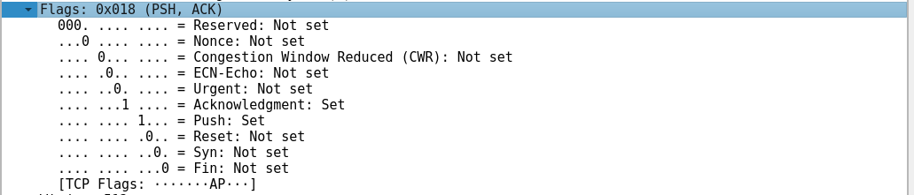

Task 8. Find a packet whose Data field carries the text you sent. Mark the text. What does it say?
Answer / command:

Dette er linje 1.
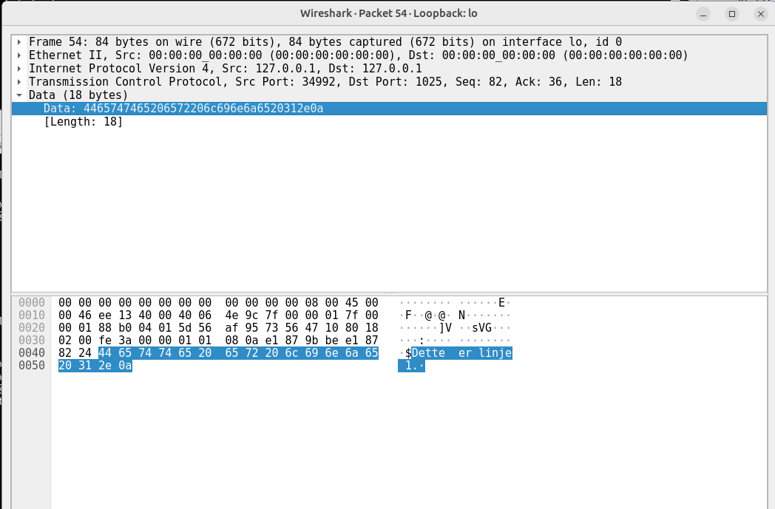

Task 9. Find the packet that contains the command QUIT in its Data (near the end of the capture). Look at the reply from port 1025. What does the SMTP server write back?
Answer / command:

221 Bye
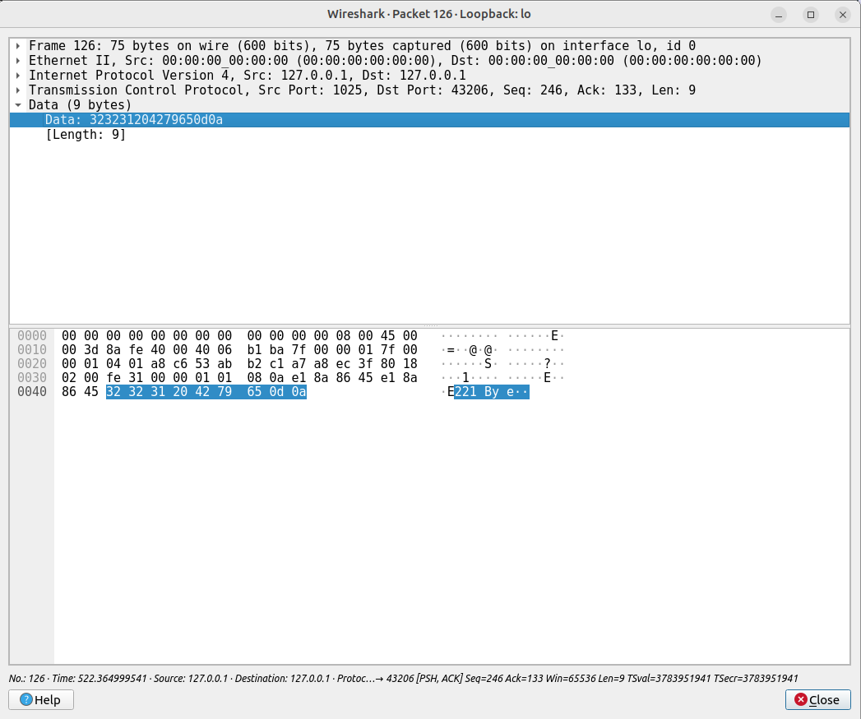

Task 10. Write down the numeric SMTP reply codes the server returns: after MAIL FROM / RCPT TO, after DATA, and after QUIT. (Hint: 2xx = accepted, 3xx = waiting for more input.)
Answer / command:
MAIL FROM:<noreply@soppelpost.no> 250
RCPT TO:<mottaker@testpost.no> 250
DATA 354
QUIT 221

Task 11. Which flags are sent in the three last packets that close the connection?
Answer / command:
127 = ACK 1025 > 43206
128 = FIN, ACK 1025 > 43206
129 = ACK 43206 > 1025

Command reference (Parts 3–5)
Terminal (Mac / Linux)
Command | What it does
ls | List the files and folders where you are
cd .. | Go one level out
cd mappe1 | Go into mappe1
cd / | Go back to the root
mkdir ftp-filer | Create the folder ftp-filer
rmdir ftp-filer | Delete the folder ftp-filer if it is empty
rm -rf ftp-filer | Delete ftp-filer and everything in it
ftp test.rebex.net | Open an FTP connection to test.rebex.net on port 21 (user demo, password password)

FTP commands
Command | What it does
ls | List files/folders on the FTP server
cd mappe1 / cd .. / cdup | Move into / out of folders on the server
get readme.txt | Download readme.txt to your machine
put bilde.png | Upload a file to the server
pwd | Show the current folder on the server
! | Switch to your local machine without closing the connection
exit / quit | Close the FTP connection

Part 3 — Transfer a file with FTP
Open Linux in your virtual machine and open a Terminal.
Task 1. Use a command to create a folder called ftp-filer.
Answer / command:
mkdir ftp-filer

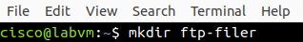

Task 2. Navigate into ftp-filer.

Task 3. Open Wireshark and start a capture on your network interface (for example enp0s3 ).

Task 4. Back in the Terminal, connect with ftp test.rebex.net, user demo, password password.
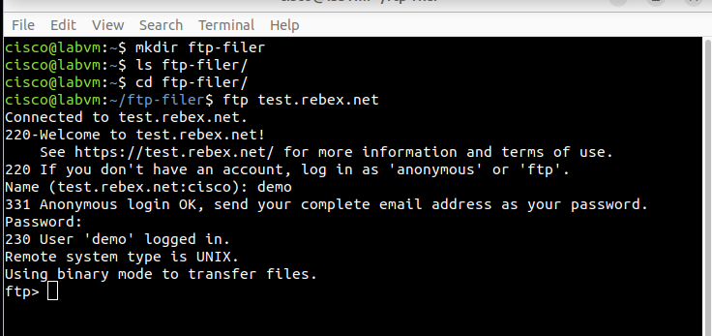

Task 5. Navigate to pub/example (ls, cd pub, ls, cd example, ls ).
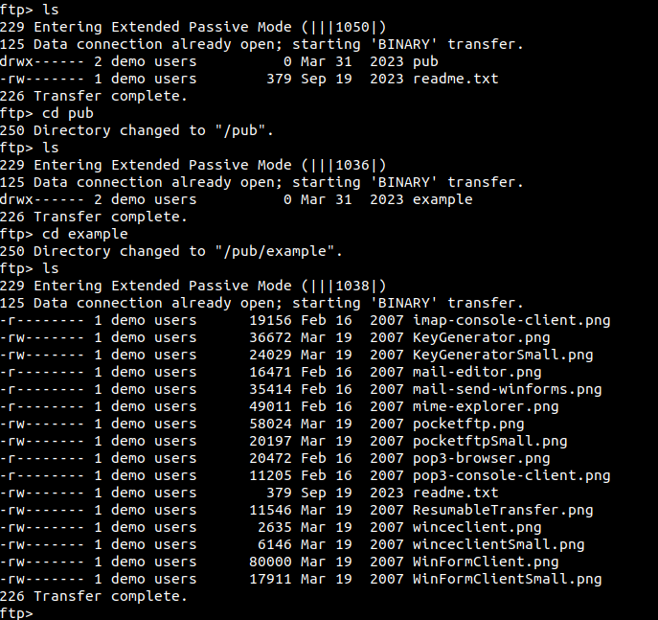
Task 6. Download the file with get readme.txt.

Task 7. Switch to your local file system with !, run ls, and check that readme.txt arrived in ftp-filer.
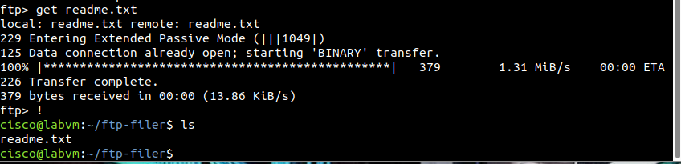

Task 8. Go back with exit, then close the connection with quit. Stop the capture in Wireshark.

Task 9. In Wireshark, search for packets containing the text readme.txt. Choose the first packet with Info Request: SIZE readme.txt.
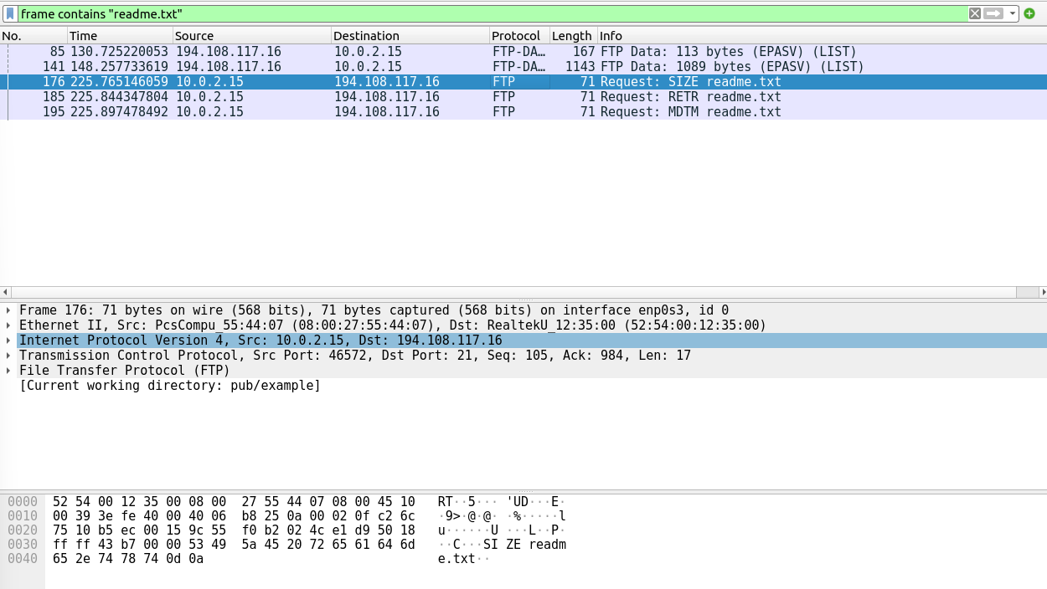

Part 4 — Read the layers in that packet
Using the packet you selected in Part 3, answer the questions for the application, transport and network layer. Give the value and say where you read it.
Application layer (the message / data)
• Which application-layer protocol is in this packet?
Answer / command:
FTP is the protocol that is used. I read it in the Protocol column and in the “File Transfer Protocol (FTP)” section in Wireshark.
• Which Request command and which Request argument are run as a result of your get readme.txt?
Answer / command:
The request command is Size, and the request argument is readme.txt. I read it in the FTP section, under “Request command” and “Request arg”.
Transport layer (the segment)
• Which transport-layer protocol is used?
Answer / command:
The protocol used is TCP. I read it in the “Transmission Control Protocol” section.
• Which port numbers are used to reach the right client and service?
Answer / command:
The source port is 46572, and the destination port is 21. I read it in the TCP header, under “Source Port” and “Destination Port”.
• Which flags are set on this packet?
Answer / command:
The flags that are set on this packet is PSH and ACK (0x018). I read it in the TCP header, under “Flags”.

Network layer (the datagram)
• Which network-layer protocol is used?
Answer / command:
IPv4 is used for the network-layer protocol. I read it in the “Internet Protocol Version 4” section.
• What is the source IP and the destination IP?
Answer / command:
The source IP is 10.0.2.15, while the destination IP is 194.108.117.16. I read it in the IPv4 header, under “Source Address” and “Destination Address”.
• What is the header length of this datagram?
Answer / command:
The header length of this datagram is 20 bytes (5). I read it in the IPv4 header, under “Header Length”.

Part 5 — Fill in the TCP header
Click “Transmission Control Protocol” in the same packet and fill in the header fields below.
TCP header field | Value from your packet
Source port | 46572
Destination port | 21
Sequence number | 105 (2622877874)
Acknowledgement number | 984 (38592985)
Header length | 20 bytes (5)
Flags (URG/ACK/PSH/RST/SYN/FIN) | PSH, ACK
Receive window | 65535
Checksum | 0x43b7
Urgent pointer | 0
Options (if any) | None

What to hand in
- One PDF per group with this document filled in: the commands you used, the Terminal results, the answers in Part 4, the TCP-header table, and all the annotated screenshots asked for.
- Be ready to answer questions about your steps in the øving on 27 October, including one layer in Wireshark.
Form: PDF document that shows what you typed in the Terminal and the annotated screenshots requested above.

