CourtSync - Use Case Diagram
This document outlines the primary use cases for the CourtSync Futsal Management System, specifically derived from the actual backend architecture (Booking, Payment, Review, Chat, Court, and Auth routes).

Use Case Diagram
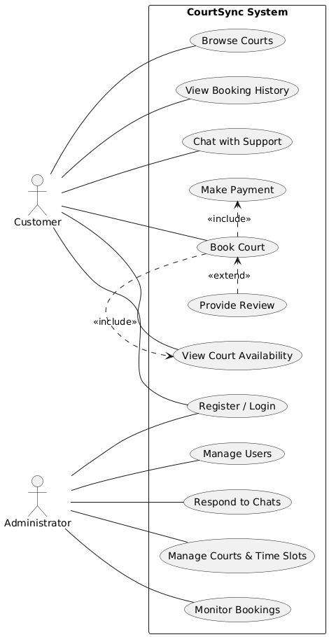

Actor Descriptions
Customer: The general user who interacts with the system to browse futsal courts, check real-time availability, book courts, make payments securely, provide reviews, and chat with support.
Administrator: The manager of the facility who holds privileges to manage court listings, time slots, monitor all bookings and user records, and respond to incoming support chats.

Inclusive and Exclusive Relationships
The diagram incorporates strict UML include (inclusive) and extend (exclusive) logic to model mandatory and optional system flows:
- Book Court <<include>> Make Payment: An inclusive relationship. The booking process mandates that a payment transaction must be processed as part of the booking.
- Book Court <<include>> View Court Availability: An inclusive relationship. In order to successfully book a court, checking available time slots is a mandatory subroutine enforced by the system.
- Provide Review <<extend>> Book Court: An exclusive/extending relationship. After a booking is completed, a customer has the optional capability to leave a review for the court.

