

Project Name : IELTS and GRE exams Problem
Course Title : Operating System
Course Code : CSE 325
Section : 05
Group No : 05
Submitted To: Shatabdi Roy Moon
Lecturer
Department of Computer Science & Engineering
Submitted By:
1. Farhana Hasin (2023-2-60-303)
2. Ratul Hasan Nirjon(2023-3-60-498)
3. Fahim Shaharear (2023-3-60-077)

Submission Date : 23.04.2026

Table Of Contents:
- Introduction
- Objectives
- Software and Tools Used
- Methodology
- Workflow
- Result Analysis
- Conclusion
- Appendix

IELTS and GRE exams Problem

Introduction
Many students face confusion when choosing between the IELTS and GRE exams, especially when planning to study abroad. Both tests serve different purposes, yet they often get mixed up. The IELTS mainly checks English language skills for study, work, or migration, while the GRE is used for admission into graduate programs and focuses on verbal, quantitative, and analytical skills. The problem begins when students are unsure which exam they actually need, leading to wasted time, money, and effort. Understanding the difference early can make the path much clearer and more efficient.
Employing this problem in C programming language provides us with practical skills like array and makes us concerned with synchronization and resource management algorithm design. Since C is a system-level language, it also allows us to understand where and how data are stored and manipulated at a lower level.

Objectives
- To simulate a real-life exam system using multithreading.
- To demonstrate thread synchronization techniques.
- To control limited resources using semaphores.
- To prevent race conditions in shared data
- To coordinate simultaneous start and end of execution

Software and Tools Used
 Programming Language: C
 Compiler/IDE Used:
Code::Blocks – for local development and testing
Libraries:
stdio.h (Input/Output) stdlib.h (Memory allocation) unistd.h (Sleep handling) pthread.h (Thread management) semaphore.h (Semaphore synchronization)

Methodology
Problem Analysis: Understand requirements for managing IELTS and GRE exam problems and concurrent operations.
System Design: This code use system designs like concurrent processing, resources management using semaphore, synchronization with mutex and condition variables, load balancing like round-robin allocation.
Implementation:
- Student threads are created to simulate concurrent exam participants.
- Mutex locks are used to protect shared data such as room occupancy and attendance.
- Condition variables are used to synchronize exam start and end for all threads.
- Semaphores are used to control room capacity (maximum 30 students per room).
- Round-robin logic (student_id % NUM_ROOMS) is used to assign students to rooms.
- Thread synchronization ensures safe entry, execution, and exit of students during the exam.
Testing: Validate correctness and synchronization through multiple runs.
Evaluation & Refinement: The system was evaluated as successfully simulating a real-time exam using threads, mutex, condition variables, and semaphores for safe synchronization and room capacity control. Refinement may include improving scalability and reducing thread overhead for better performance in larger systems.

Workflow
The workflow illustrates how the system operates from start to finish:
Program starts and setup
- Initializes mutex, condition variables, and semaphores
- Creates arrays to track rooms and students
Create student threads
- 300 student threads are created
- Each student is assigned a room using student_id % 10
Students wait for exam start
- All threads stop and wait using a condition variable
- They cannot enter rooms yet
Exam starts (main thread control)
- After 2 seconds, main thread signals start
- All students wake up together
Students enter rooms
- Each student uses semaphore to enter a room
- If room is full (30 students), they wait
- Room occupancy is updated safely using mutex
Exam runs for 3 seconds
- Students stay inside the rooms
- They wait until exam ends signal
Exam ends
- Main thread signals exam end
- All students are notified
Students leave rooms
- Each student exits
- Semaphore is released (room space becomes free)
- Occupancy is updated
Final step
- Main thread waits for all students to finish
- Displays attendance summary of each room

Result Analysis:

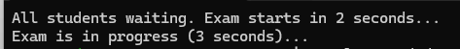

This is the first phrase before exam starts. The Students are waiting. The exam will start in 2 seconds.
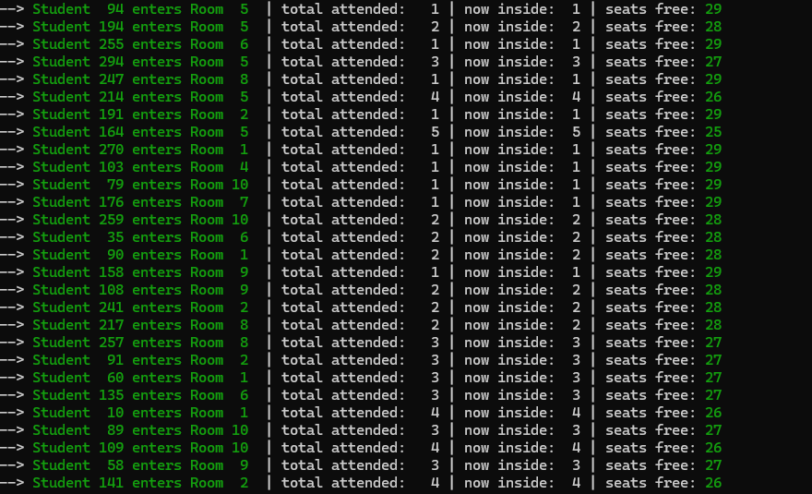

In this phrase the students who have different id’s entering to their exam room. Here room number is allocated and also in this output we can see the attendance. After that here is also showing currently how many students are inside and how many seats are free. The arrow and the green color indicates that the students are entering to the room.
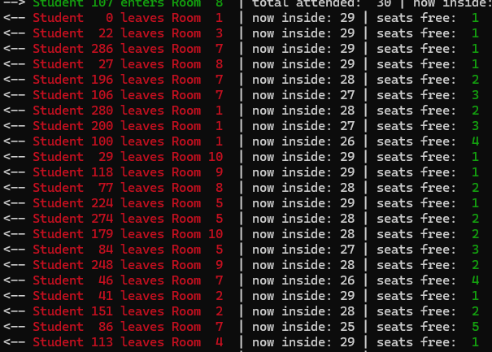
In this picture of output, the arrow indicates that the students are leaving from the exam room, the red color is highlighting that the students are leaving. We every single students leave the count of inside room and the seats are change. It is updating after every single students leave form this room.

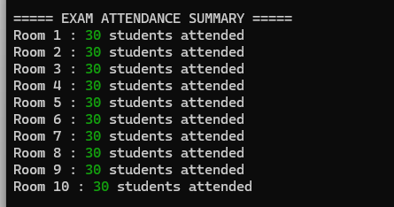

Here is the total summary. In this output it shows the room number and how many students are attended the exam on that room.
Conclusion:
The project demonstrates a thread-safe IELTS and GRE exam problem with proper concurrency control. It highlights practical use of threads, mutexes, and semaphores in C programming.

Appendix:

#include <stdio.h>
#include <stdlib.h>
#include <pthread.h>
#include <semaphore.h>
#include <unistd.h>

#define NUM_STUDENTS 300
#define ROOM_CAPACITY 30
#define NUM_ROOMS 10

pthread_mutex_t global_mutex = PTHREAD_MUTEX_INITIALIZER;
pthread_cond_t start_cond = PTHREAD_COND_INITIALIZER;
pthread_cond_t end_cond = PTHREAD_COND_INITIALIZER;
int exam_started = 0;
int exam_ended = 0;

sem_t room_sem[NUM_ROOMS];
int room_attendance[NUM_ROOMS] = {0};
int room_occupancy[NUM_ROOMS] = {0};
typedef struct {
int student_id;
int room;
} student_args;

void* student_thread(void* arg) {
student_args* args = (student_args*)arg;
int id = args->student_id;
int room = args->room;

pthread_mutex_lock(&global_mutex);
while (!exam_started) {
pthread_cond_wait(&start_cond, &global_mutex);
}
pthread_mutex_unlock(&global_mutex);
sem_wait(&room_sem[room]);
pthread_mutex_lock(&global_mutex);
room_occupancy[room]++;
room_attendance[room]++;
int current_occ = room_occupancy[room];
int available = ROOM_CAPACITY - current_occ;
printf("--> \033[32mStudent %3d enters Room %2d \033[0m | total attended: %3d | now inside: %2d | seats free: \033[32m%2d\033[0m\n",
id, room+1, room_attendance[room], current_occ, available);
pthread_mutex_unlock(&global_mutex);
pthread_mutex_lock(&global_mutex);
while (!exam_ended) {
pthread_cond_wait(&end_cond, &global_mutex);
}
pthread_mutex_unlock(&global_mutex);
pthread_mutex_lock(&global_mutex);
room_occupancy[room]--;
int after_leave_occ = room_occupancy[room];
int available_after = ROOM_CAPACITY - after_leave_occ;
printf("<-- \033[31mStudent %3d leaves Room %2d \033[0m | now inside: %2d | seats free: \033[32m%2d\033[0m\n",
id, room+1, after_leave_occ, available_after);
pthread_mutex_unlock(&global_mutex);
sem_post(&room_sem[room]);
free(args);
return NULL;
}

int main() {
pthread_t students[NUM_STUDENTS]; // array to hold thread IDs

for (int i = 0; i < NUM_ROOMS; i++) {
sem_init(&room_sem[i], 0, ROOM_CAPACITY);
}

for (int i = 0; i < NUM_STUDENTS; i++) {
student_args* args = (student_args*)malloc(sizeof(student_args));
args->student_id = i;
args->room = i % NUM_ROOMS; // simple assignment: room0 gets 0,10,20,... ; room1 gets 1,11,21,...
pthread_create(&students[i], NULL, student_thread, args);
}

printf("All students waiting. Exam starts in 2 seconds...\n");
sleep(2);

pthread_mutex_lock(&global_mutex);
exam_started = 1;
pthread_cond_broadcast(&start_cond); // wake up every thread waiting on start_cond
pthread_mutex_unlock(&global_mutex);

printf("Exam is in progress (3 seconds)...\n");
sleep(3);

pthread_mutex_lock(&global_mutex);
exam_ended = 1;
pthread_cond_broadcast(&end_cond);
pthread_mutex_unlock(&global_mutex);

// Wait for all student threads to finish (they will all leave and then terminate)
for (int i = 0; i < NUM_STUDENTS; i++) {
pthread_join(students[i], NULL);
}
printf("\n===== EXAM ATTENDANCE SUMMARY =====\n");
for (int r = 0; r < NUM_ROOMS; r++) {
printf("Room %d : \033[32m%d\033[0m students attended\n", r+1, room_attendance[r]);
}
for (int i = 0; i < NUM_ROOMS; i++) {
sem_destroy(&room_sem[i]);
}

return 0;
}

