**Main Server.js File:**

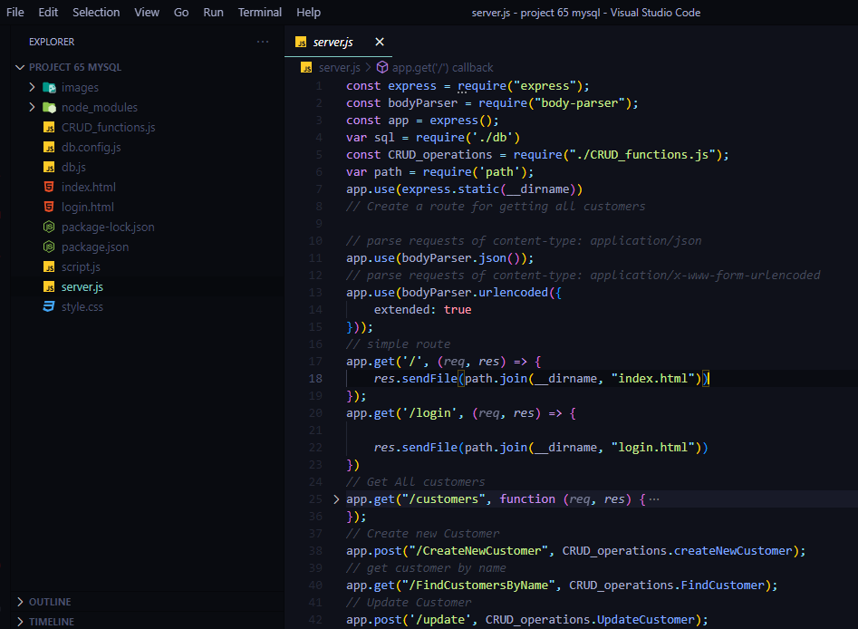

* Imports all required modules and setup the static directory as root folder to pickup styles and scripts from css and js file.
* Sets up app instance of express to enable to work with get,post,put,delete and patch methods.
* Sets up multiple middlewares such as url encoded and json of express to evaluate json data coming from frontend.
* Finally make the app to listen at particular PORT of localhost.

**Database Connection:**

**Database Configuration:**

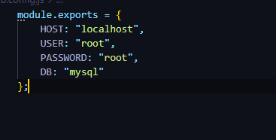

* This object has information about host,password,database name and user and this is exported for use in other files

**Database Connection:**

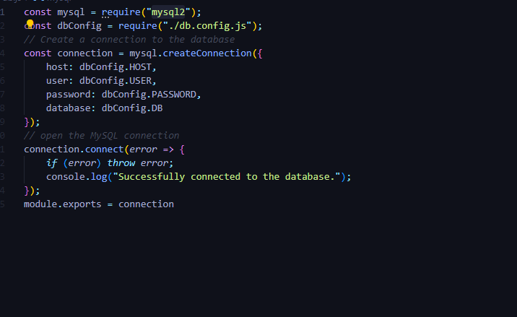

* Using config information mentioned above the app is finally connected to database using mysql2 module and upon successful connection message is displayed as “Successfully connected to database.”

**Routes to frontend:**

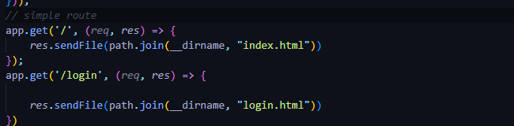

* Get Route to ‘/’ serves the index.html file from root directory.
* Get Route to ‘/login’ serves the login.html file from root directory.

**API’s Code:**

**Create Functionality:**



* This post route creates new customer in database and use function createNewCustomer that is defined in CRUD_functions.js file.

**Read:**

* This function is used to select a record from database using customerName property so it accomplish read function.

**Update:**

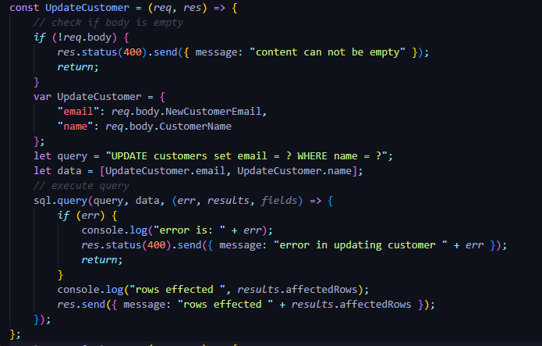

* This function updates the email of customer or name using customerName and customerEmail property passed as body.

**Delete:**

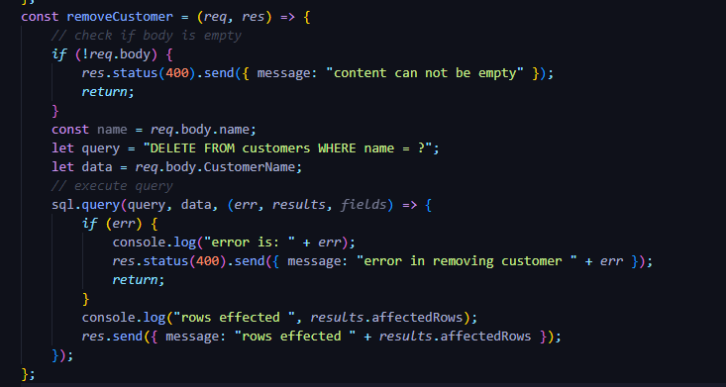

* This function removes a row from database based on customerName passed in body.
* Similarly removeAll function is used to remove all rows from database.

**Output Verifications:**



