02 — The Mobile App

The main product: what buyers and suppliers see and do on their phones
For non-technical readers: this is the app your customers actually hold in their hands. It's built once and runs on both Android and iPhone. Android ships first because that's where most of our users are. Below, every screen is described in plain language, followed by the buyer's and supplier's complete journeys.

1. Why the mobile app is the "primary surface"
The phone app is where the real product lives. People in construction are on-site, on their phones — not at a desk. Everything is designed for one-handed, quick, "I need this material now" use. The website (document 03) exists mainly to capture Google traffic; the app is where engaged users live.
Built with React Native: one codebase produces both the Android and iPhone apps, roughly halving the cost and time versus building each separately. Android is released and QA'd first; iPhone follows.

2. How you move around the app
In plain English: After logging in, the app has four tabs along the bottom — Home, Categories, My Truck, and Profile — exactly like Instagram or WhatsApp's bottom bar. You spend your whole time moving between these four.
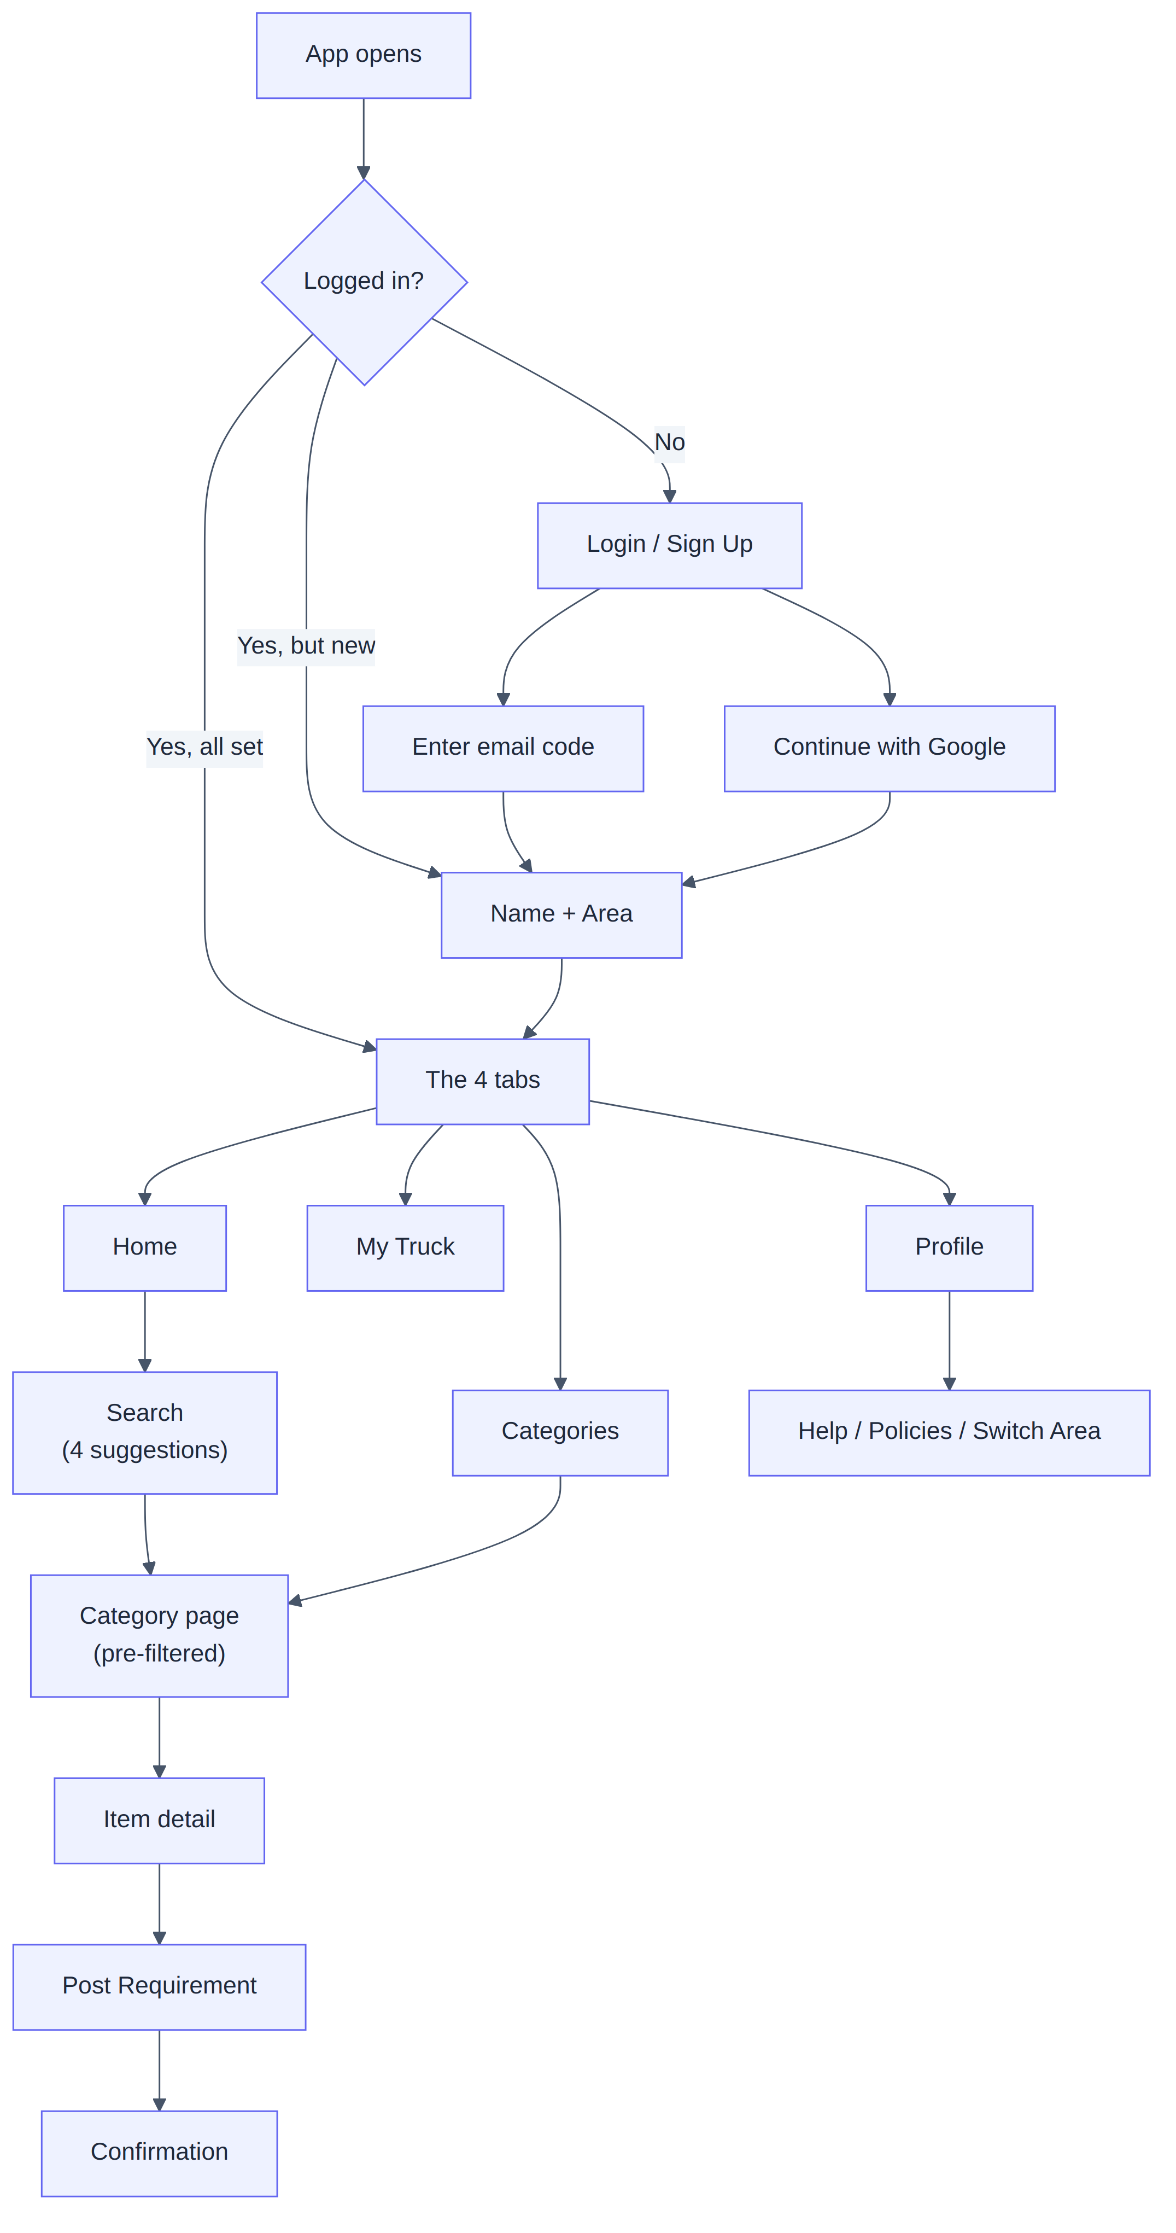

3. Every screen, in plain language

3.1 Login / Sign Up — one screen, no friction
A single screen. Type your email and tap "Send Code," or tap "Continue with Google." We deliberately do not ask "are you new or returning?" — the system figures that out. New users flow into onboarding; returning users go straight in. The 6-digit code auto-fills where the phone allows, with a 30-second resend timer. A wrong code shows quiet red text under the boxes, not an alarming popup — keeping you in the flow.

3.2 Onboarding — only for brand-new users
Just two fields on one screen: Name and Area (pincode). The area field is the exact same picker used in the header later — built once, reused everywhere. This is also the natural moment to offer the English/Hindi toggle.

3.3 The header — always visible
Across the top of every tab: the Nirmaan logo, your current area (e.g. "📍 Dehradun ▾" — tap to switch neighbourhoods), and your name (tap to jump to Profile). Switching your area instantly re-filters everything you see to that pincode.
┌─────────────────────────────────────────────┐
│ [Logo] Nirmaan 📍 Dehradun ▾ 👤 Rohit │
└─────────────────────────────────────────────┘

3.4 Home tab
The search bar sits at the top and opens with 4 suggestions the moment you tap it — before you type a thing (recent or trending choices), then live results as you type. Below it: a quick grid of category icons, then "Popular near you" products filtered to your area.
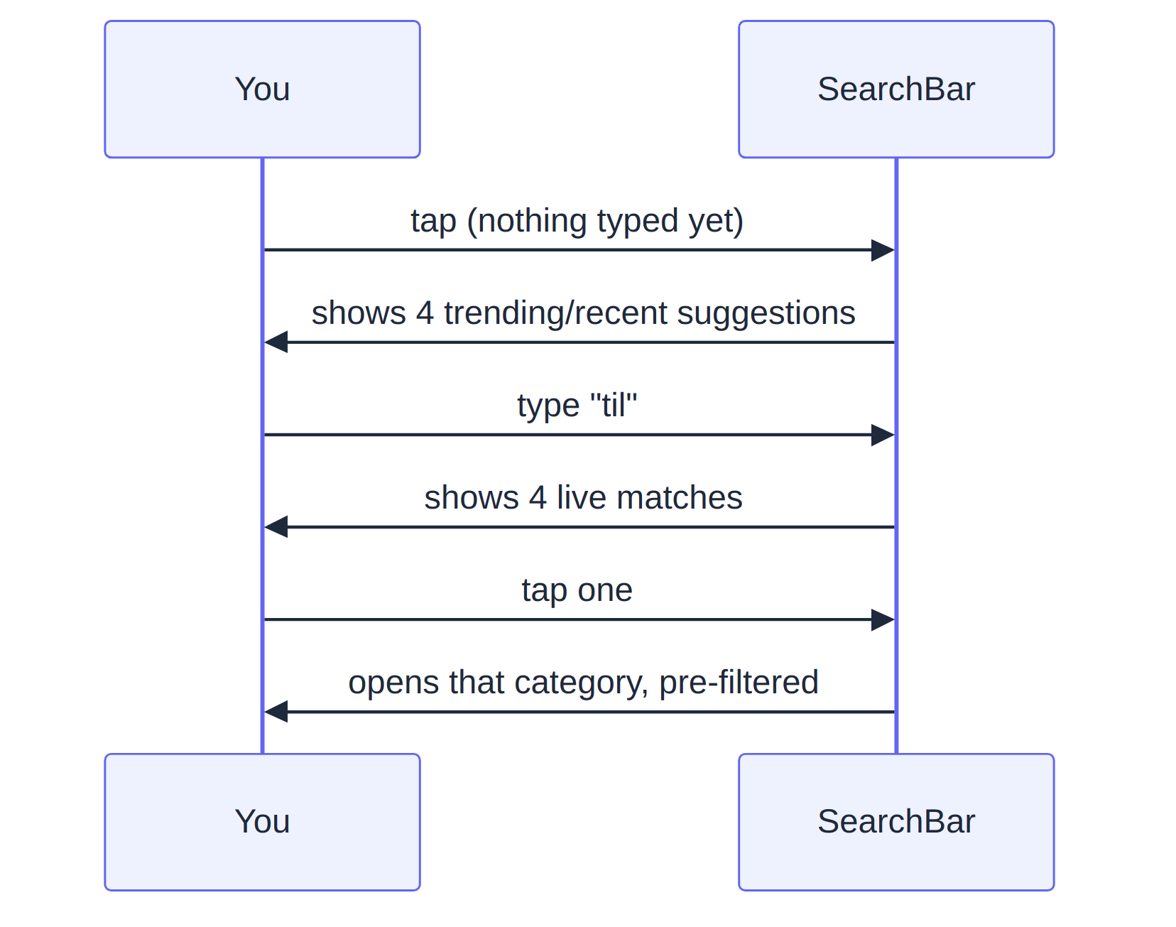

3.5 Categories tab
This screen is a search bar at the top, plus a scrollable grid of all categories below for browsing without typing. Tapping any category opens its page.

3.6 Category page
A filtered list of products in that category and your area. Each card shows: title, unit, price estimate, supplier name, and two actions — "Add to Truck" and "Post Requirement instead." A persistent banner at the top — "Can't find it? Post a Requirement" — is never buried, because posting a requirement is our core demand engine.

3.7 Post Requirement (the demand engine entry)
A short form, four fields maximum: Category (pre-filled if you came from a category), Description, Quantity + Unit, and confirm your Area. Submit and you get an honest confirmation — "We've notified suppliers near you" — never a false promise of instant delivery.

3.8 My Truck tab (the playful cart)
Your cart, with the signature touch: the icon grows with the load, while the label always stays "My Truck."
Items in cart | Icon shown
0 | empty cart outline ("My Truck is empty")
1–5 | 🛺 hand-cart / "Bailgadi"
6–15 | 🛻 pickup
16+ | 🚛 full truck

Each item has a quantity stepper and a line estimate (never "total price" — these are negotiated materials, so we always say "estimated value" to avoid implying a fixed checkout). The main button, "Send as Requirement," turns your cart into requirements (grouped by category).
🆕 v2.1: for fixed-price items, the cart can also lead into a real checkout — choose an address, place the order, and pay.

3.9 Profile tab
Your name and contact at the top, then: Become a Supplier (if you aren't one), My Requirements (your history), My Truck history, Help & Support, Privacy Policy, Terms of Service, Switch Area, and Logout.
🆕 v2.1: also My Orders (with live status tracking) and saved Addresses.

4. The complete BUYER journey
In plain English: here's everything a buyer does, start to finish, combining v1 and v2.1.
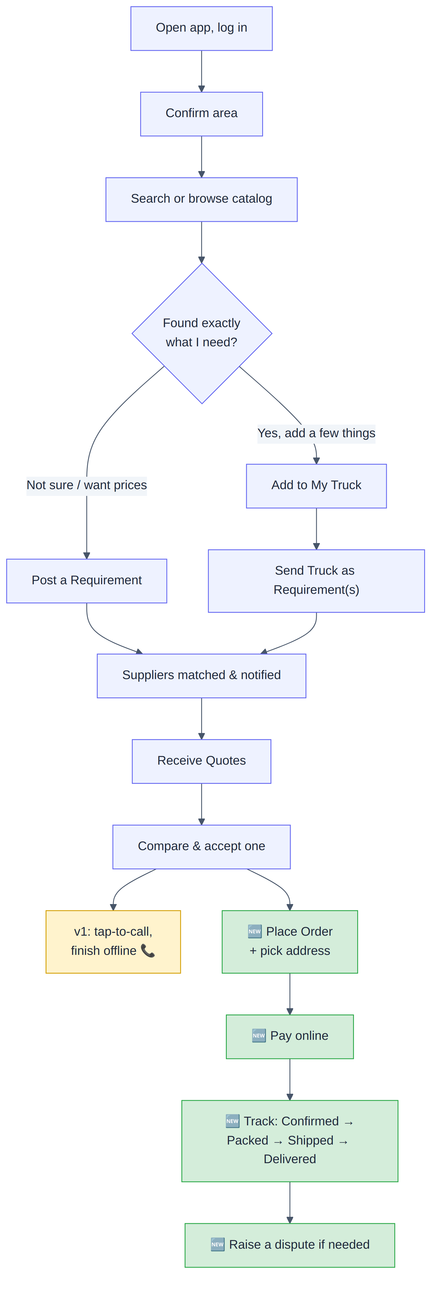

5. The complete SUPPLIER journey
In plain English: a supplier is just a user who tapped "Become a Supplier." Once verified by you (the admin), they list products, receive leads, quote, and — in v2.1 — fulfil orders.
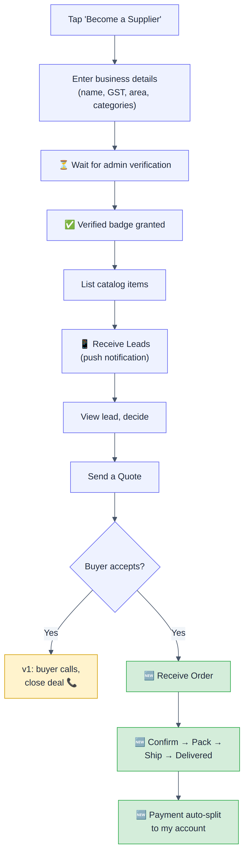

6. Things that make the app feel good (cross-cutting decisions)
In plain English: a few deliberate choices that separate a "cheap-feeling" MVP from a "smooth" one.
Decision | Why it matters
Skeleton loaders, not spinners | Showing a grey outline of content that's loading *feels* faster than a spinning wheel
One shared component library | Buttons, inputs, and cards look identical on every tab — inconsistency is the #1 way apps feel cheap
Push notifications deep-link | Tapping a "new lead" notification jumps straight to that lead, not the home screen
Tap-to-call, not in-app calling | Opens the normal phone dialer — building voice calling into the app was needless complexity
Honest expectation-setting | Requirement confirmations never imply instant magic; trust matters in construction

7. What the app deliberately leaves out
- iPhone-only features or design differences (parity with Android instead)
- Fingerprint/face login
- In-app voice calling
- Quick-reply directly from a notification (open the app instead)

8. The technical bits worth knowing (for engineers)
- React Native with React Navigation (bottom tabs + a stack per tab).
- State: React Query for data from the backend, lightweight Zustand for on-screen UI state.
- Push: Firebase Cloud Messaging.
- 🆕 Payments: the Razorpay React Native component (needs installing and native-linking on a dev machine before the payment screen activates — until then it shows "payment not available in this build").
- 🆕 Deep links: nirmaan://pay/... links are configured; the OS-level registration is a remaining native setup step, with the website's pay page as a working fallback in the meantime.

9. Summary for a co-founder
The mobile app is four simple tabs — Home, Categories, My Truck, Profile — wrapped around one core action: post a requirement and get quotes. A buyer browses or searches, posts what they need, and picks a quote. A supplier gets leads and responds. In v2.1, that extends all the way to placing orders, paying, and tracking delivery. The whole thing is engineered to feel *smooth and trustworthy*, because in construction, trust is the product.

