SIMATS ENGINEERING
CSA1023 – SOFTWARE ENGINEERING ASSIGNMENT 2
CO2: Requirements Analysis, UML Modelling and Scalable Architecture
Assignment Title: Design and Validate Requirements and Architecture for the Omnichannel Order Fulfilment Platform

Student Name | Nirmal S | Register Number | 192511249
Department / Section | B.E CSE (2nd Year) | Academic Year / Semester | 2025-2026
Faculty Name | Dr. Karpagam V | Nature of Assignment | Individual
Duration | 1 Week | Total Marks | 50
Date of Submission | 05-11-2026 | Date of Evaluation
MARK SHEET (Rubric-based Evaluation)
Task | Task Title | Max | Marks Awarded | Remarks
1 | Investigate the Problem and Define Delivery Outcomes | 5
2 | Design and Justify the Project Management Approach | 6
3 | Construct a Prioritized Product Backlog in the Selected Tool | 8
4 | Create a Capacity-Based Release Plan and Delivery Workflow | 7
5 | Simulate Delivery and Validate Your Design | 7
6 | Redesign Delivery Under Changed Conditions | 12
7 | Individual Technical Reflection | 5
 | TOTAL | 50
OVERALL REMARKS:

S.Nirmal
Student Signature | Faculty Signature | Program Director

Contents
Introduction and Approach 4
Evidence status used throughout this report 4
Tools used 4
1. Investigating Stakeholder Needs and Resolving Conflicts (Q1) 5
1.1 Method 5
1.2 Investigation questions 5
1.3 Findings (simulated responses) 5
1.4 Stakeholder analysis 6
1.5 Conflicting expectations and their resolution 7
1.6 System boundary, principal actors and exclusions 8
1.7 Requests that did not become requirements 9
2. Prioritized and Testable Requirements Specification (Q2) 10
2.1 Tool arrangements examined 10
2.2 How the specification is organised 12
2.3 Prioritization method 12
2.4 Order rules 13
2.5 Functional requirements 14
2.6 Non-functional requirements 16
2.7 Replacing vague statements with testable ones 17
2.8 Planning assumptions 18
2.9 Assumptions and unresolved questions 18
2.10 How stakeholder conflicts shaped the specification 18
3. UML Models and Traceability (Q3) 20
3.1 Use case diagram 20
3.2 Class diagram 21
3.3 Sequence diagram: payment callback to courier synchronization 21
3.4 State machine for orders 22
3.5 Refund behaviour: approval, rejection, execution and rollback 23
3.6 Traceability matrix 24
3.7 Inconsistencies found while connecting the models 26
4. Alternative Architectures and Justified Design (Q4) 27
4.1 Alternative A: modular monolith 27
4.2 Alternative B: event-driven microservices 28
4.3 Comparison 28
4.4 Selection 30
4.5 Component and deployment diagrams 30
4.6 Architectural decision records 32
5. Validating Critical Behaviour and Revising the Design (Q5) 35
5.1 Invariants 35
5.2 Operation contracts 35
5.3 Validation method and what it can and cannot show 36
5.4 Validation scenarios 36
5.5 Reading the results 38
5.6 Weakness found and design revision 38
6. Redesign for Expansion and Partial Failure (Q6) 40
6.1 Impact analysis (Part A) 40
6.2 Revised architecture (Part B) 41
6.3 Pending buffered events, deduplication and server-validated approval 43
6.4 Revised requirements 44
6.5 Validation of the redesign (Part C) 45
6.6 Defence of the design (Part D) 46
7. Individual Technical Reflection (Q7) 48
Appendix A. Prototype Listing (extracts) 51
Appendix B. Acknowledgement of Sources and Tools 53

Introduction and Approach
The retailer in this scenario wants one platform that carries an order from checkout to delivery and, when needed, to a refund. On paper that sounds like a list of screens. In practice the difficulty sits in the gaps between the modules: the payment gateway may call back twice, two people may reach for the last unit in a warehouse at the same moment, a courier website may be down just after an order has been stored, and a finance rule about refunds must hold even if somebody changes a drop-down on their own screen. I treated these gaps as the real subject of the assignment and spent most of my effort on them.
I followed the sequence given in the brief: investigate, specify, model, architect, validate, redesign and defend. Each step feeds the next. The stakeholder conflicts in Part 1 decide what the requirements in Part 2 say. The requirements drive the UML models in Part 3, and the same identifiers appear again in the architecture of Part 4 and in the validation scenarios of Part 5. When I connected these pieces I found inconsistencies, which are listed in Section 3.7, and when I ran the prototype I found a weakness, which is described in Section 5.6. Part 6 then changes the workload and asks the design to survive the change.

Evidence status used throughout this report
The brief asks me to keep demonstrated results apart from predictions, and to disclose simulations. I use four labels consistently. Demonstrated means I executed the check on my prototype and the output is shown. Predicted means the expected behaviour was written down before the check was run. Simulated is used for stakeholder responses that I constructed from the scenario text because I could not interview a real warehouse or finance team. Illustrative is used for planning numbers such as the monthly cost of infrastructure. None of the numbers in this report prove production capacity, live inventory control or secure card handling. The prototype uses synthetic users, products and stock, and its payment gateway, courier and scanner are test doubles.

Tools used
Requirements are tracked in Jira and the specification and decision records are kept in Confluence. UML diagrams were drawn from text sources (Graphviz DOT files and small Python scripts) so that they can be kept in a GitHub repository and regenerated when a requirement changes. The validation prototype is written in Python with an SQLite database, standing in for the FastAPI and PostgreSQL stack named in the brief. Section 2.1 explains why this combination was chosen over two alternatives.

1. Investigating Stakeholder Needs and Resolving Conflicts (Q1)

1.1 Method
I identified six stakeholder groups from the scenario: customers, pickers, support agents, administrators, store managers and finance reviewers. Management appears in the scenario as the reader of consolidated reports and is treated as a seventh group for reporting. I could not reach a real warehouse or finance team, so I prepared a short questionnaire and a process walkthrough, and I filled the responses with clearly labelled simulated answers written from the scenario text and from how small retail operations normally work. The questions came first and were chosen to probe things the brief leaves open, not to confirm what I already believed.

1.2 Investigation questions
Each question targets a requirement or a conflict that the brief does not settle. I deliberately asked about behaviour under stress, because that is where the platform will be judged.
Table 2: Investigation questions
ID | Question | Asked of | Unresolved point it probes
IQ1 | When two customers reach checkout for the last unit, who holds the stock first, and how long may an unpaid order keep the hold before the unit goes back on sale? | Picker, Store manager | Reservation timing; conflict between fairness, speed and wasted stock
IQ2 | What does a support agent need to see to answer “where is my order?”, and which payment details must stay hidden from support? | Support agent, Finance reviewer | Order visibility versus payment confidentiality
IQ3 | Above what amount must a refund wait for a finance reviewer, who may approve below that amount, and how quickly must a decision be made? | Finance reviewer, Store manager | Refund limit and approval time
IQ4 | How long will a customer wait at checkout before abandoning, and what should the screen say if payment is confirmed late? | Customer | Performance threshold and late-payment behaviour
IQ5 | If the courier website is down when an order is stored, should the customer still get a confirmation, and who must be told? | Customer, Administrator | Availability versus consistency of shipment data
IQ6 | How often does a scanner lose its connection, for how long, and what do pickers do meanwhile? | Picker, Store manager | Offline behaviour (needed for Part 6)
IQ7 | Which figures does management need in the sales, stock and refund report, and how fresh must they be? | Management | Reporting load on the operational database

1.3 Findings (simulated responses)
The responses in the table are simulated. I wrote them in the voice of each role to make the conflicts concrete and to give the later requirements a source. Where I quote a number, such as a fifteen-minute hold, it is a planning assumption that a real stakeholder would have to confirm. The assumptions are collected again in Section 2.9.

Table 3: Simulated stakeholder responses (labelled)
Q | Respondent | Response (simulated) | What it changed
IQ1 | Picker (simulated) | “If a customer is still typing a card number I do not want the last unit locked for an hour. Ten to fifteen minutes is fair. But I never want to walk to a shelf and find the item already gone.” | Hold of 15 minutes; pick only paid orders (FR-17, FR-08)
IQ1 | Store manager (simulated) | “An abandoned basket blocking the last item is lost sales. Release it automatically, but if payment arrives late, do not lose the money.” | Expiry plus review of late payments (FR-17, FR-06)
IQ2 | Support agent (simulated) | “I need status, items, dates, tracking and return status. I do not need card details and I do not want to be blamed if they leak.” | Masked support view (FR-12)
IQ2 | Finance reviewer (simulated) | “Support must not see gateway identifiers or amounts. If a customer disputes a charge they send it to me.” | Escalation path instead of access (FR-12, NFR-04)
IQ3 | Finance reviewer (simulated) | “Anything above two thousand rupees needs me. Below that a store manager may approve. Nobody approves their own request. A decision within one working day is realistic.” | Regional refund limit, four-eyes rule, 1 working day target (FR-13)
IQ3 | Customer (simulated) | “I want my money back quickly, but I understand a large refund is checked.” | Status visible to customer; no bypass
IQ4 | Customer (simulated) | “More than three seconds and I will probably leave. If payment shows late I just want to be told it is pending, not charged twice.” | p95 ≤ 2 s; pending message (NFR-01, FR-05)
IQ5 | Administrator (simulated) | “Orders must not be refused because a courier website is slow. Raise an alert when it stays down.” | Local commit first, asynchronous courier sync (FR-10)
IQ6 | Picker (simulated) | “The Wi-Fi at the back racks drops two or three times a shift, a few minutes each. We keep scanning on the tablet.” | Offline buffer (FR-19)
IQ7 | Management (simulated) | “Daily sales, stock and refunds per region. Five-minute-old data is fine; I do not want the dashboard to slow down the pickers.” | Read replica, report refresh (FR-16)

1.4 Stakeholder analysis
The following table records what each group wants, what it fears, and what permission it truly needs. Writing the permissions down separately mattered, because the scenario says the groups need different permissions and that a support agent must not obtain finance privileges by changing the role shown on screen.
Table 4: Stakeholder analysis
Stakeholder | Main goal | Main concern | Permission truly required | Influence
Customer | Fast checkout, clear tracking, quick refund | Being charged twice; unclear status | Own orders only; request return and refund | High
Picker | Accurate pick lists, stock that exists | Reserved stock that is already gone | Pick list, pick confirmation, dispatch | Medium
Support agent | Readable order and return status | Seeing data they should not see | Read order status; raise refund request; no approval, no payment fields | Medium
Finance reviewer | Auditable refunds, correct totals | Bypassed approval; missing audit | Approve above limit; see payment fields; export audit | High
Store manager | Sales, low waste, correct stock | Phantom stock; blocked sales | Approve small refunds; confirm stock corrections; reports | High
Administrator | Manageable users and rules | Single account with all powers | Users, roles, regional rules; no refund approval by default | Medium
Management | Consolidated reporting at low cost | Slow dashboards, high cloud bill | Read-only reports | High (budget)

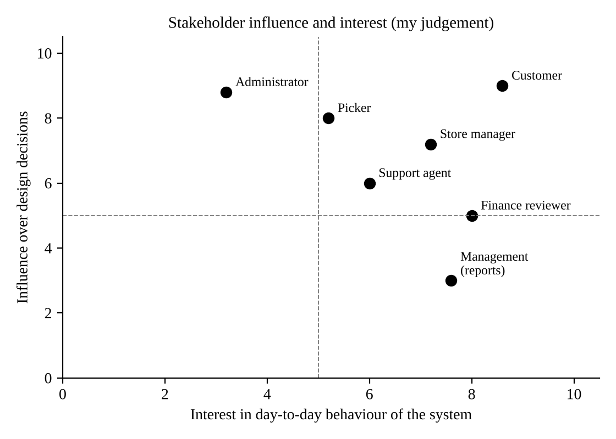
Figure 2: Stakeholder influence and interest (author's judgement, used to decide whom to consult first)

1.5 Conflicting expectations and their resolution
I found six conflicts. Five concern the representative release and the sixth only appears when the system grows in Part 6. For each one I record the competing positions, the decision, and the requirement that now carries the decision, so that the resolution can be traced instead of remaining a remark in a meeting.
Table 5: Conflicts and resolutions
ID | Conflict | Resolution | Justification and requirements
C1 | Speed vs control  Customer wants checkout in a couple of seconds; picker and finance want stock and payment verified before anything moves. | Do the cheap, essential check synchronously and the expensive ones later. Stock is reserved with one atomic database statement during checkout (milliseconds). Payment confirmation arrives asynchronously through the gateway callback. The courier is never called inside checkout. | The reservation is what the picker needs; waiting for the gateway or courier is what the customer would resent. Splitting the work keeps both promises. FR-04, FR-05, FR-10, NFR-01.
C2 | Visibility vs privacy  Support agents want full order visibility; finance wants payment data kept away from them. | Support sees status, items, dates, tracking and return state, but never payment amounts or gateway identifiers. Payment questions go to a finance reviewer through a linked request. | Agents can answer 95% of “where is my order” questions without payment data, and the rest are exactly the ones finance should handle. FR-12, NFR-04.
C3 | Refund speed vs refund control  Customers and support want instant refunds; finance wants approval and a record. | Refunds are always requested, then approved, then executed. Small amounts may be approved by a store manager, above the regional limit only by a finance reviewer, and never by the requester. Automation routes and reminds but never approves. | The brief says automation must keep human responsibility for refund approval. A one-day decision target answers the speed concern without removing control. FR-13, FR-14, FR-15.
C4 | Immediate stock truth vs accountable correction  Pickers want counts fixed as they scan; the store manager is accountable for stock corrections. | Goods received are applied automatically. Negative corrections (loss, damage) are stored as events and applied only when a store manager confirms. | Receiving goods increases what can be sold and is low risk. Reducing stock hides shrinkage, so a person must own it. FR-19, FR-21.
C5 | Availability vs consistency  Administrators want orders accepted even if the courier or gateway is down; engineers want data that agree. | The local order record is the source of truth and is committed first. Gateway and courier effects are applied through retryable, idempotent messages. An order is confirmed only by a verified payment callback, never assumed. | Accepting orders during an outage protects revenue, and refusing to guess about payment protects consistency. The cost is a short period in which the customer sees “payment pending”. FR-05, FR-06, FR-10, NFR-03.
C6 | Reporting freshness vs operational load (appears in Part 6)  Management wants live consolidated dashboards; the budget allows little extra infrastructure. | Reports run on a read replica refreshed every five minutes, not on the primary database. | Five-minute-old numbers are acceptable to management (IQ7) and a replica is cheaper than a separate analytics platform. FR-16, NFR-07.

1.6 System boundary, principal actors and exclusions
The platform covers checkout, stock reservation, payment confirmation, picking, dispatch, tracking, returns and refunds, together with the support console, the audit trail and consolidated reporting. The principal actors are the six human roles and two external systems, the payment gateway and the courier API, which in this work are replaced by controlled test doubles. Their status is disclosed whenever results depend on them.
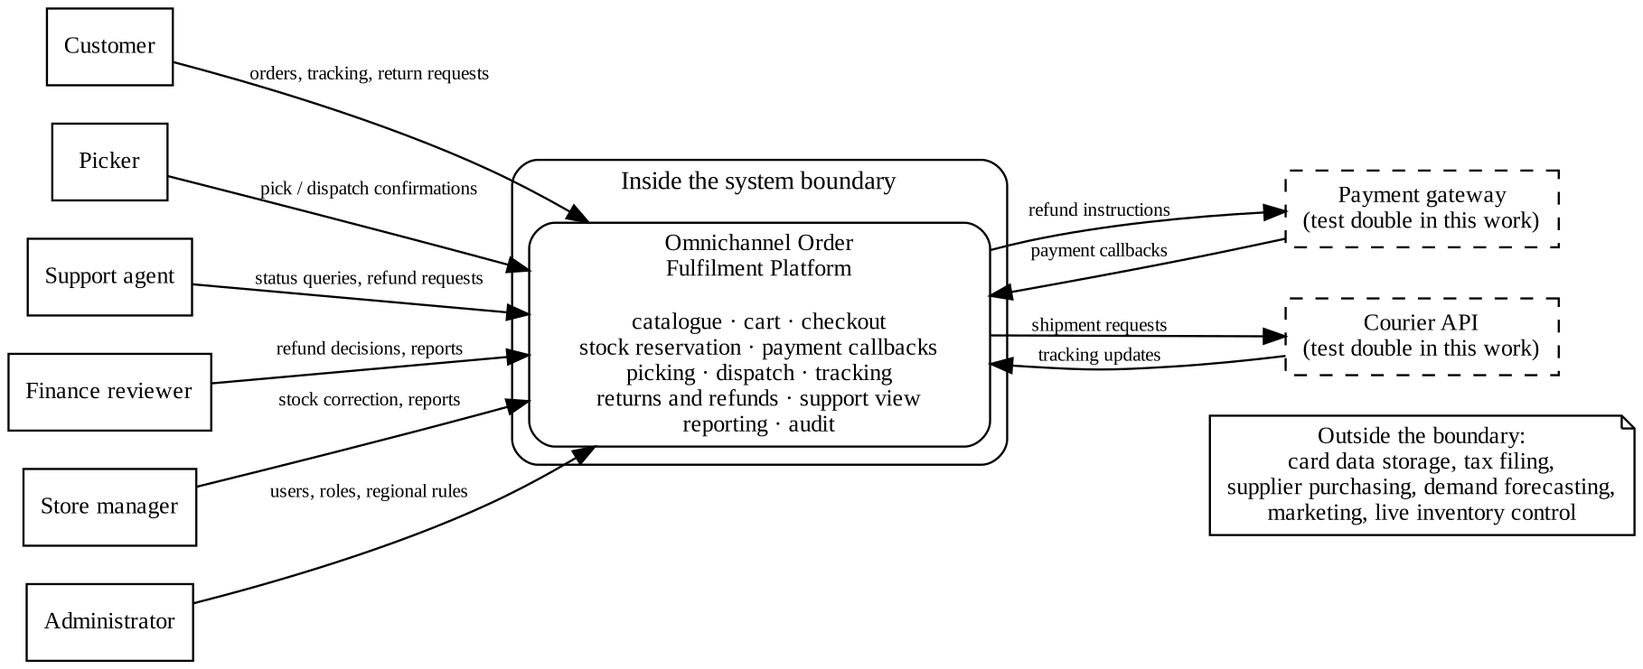
Figure 3: Context diagram showing the system boundary, actors and external systems
I excluded a number of things on purpose. The platform does not store card numbers or process card payments itself, so payment-card security is delegated to the gateway. It does not handle supplier purchasing, tax filing, marketing, or customer reviews. Demand forecasting with machine learning is outside the release; the only stock intelligence included is a fixed low-stock threshold, which is a deterministic rule and not a trained model, and any forecasting remains a proposed extension.

1.7 Requests that did not become requirements
The brief warns against turning every stakeholder wish into a requirement. I rejected or deferred the following after thinking about their consequences.
Table 6: Stakeholder requests not accepted as requirements
Request | Decision and reason
Customers: “refund to my card instantly when I click return” | Rejected. It bypasses the approval rule and creates a fraud path. The status of the request is shown to the customer instead.
Support: “show the last four digits and amount so I can verify the customer” | Rejected. Identity can be verified with order number and registered email; finance handles payment queries.
Picker: “let me edit the stock count directly on the tablet” | Rejected. Direct edits are exactly the unaccountable corrections that conflict C4 removed.
Administrator: “one super-user account for everything” | Rejected. It breaks separation of duties. Roles are separate and an administrator does not approve refunds by default.
Management: “machine-learning demand forecast” | Deferred as a proposed extension. Needs historical data this release does not have.

2. Prioritized and Testable Requirements Specification (Q2)

2.1 Tool arrangements examined
The brief asks for at least two arrangements for requirements tracking, collaborative documentation and UML modelling. I compared three, using the criteria named in the brief: traceability, collaboration, version history, diagram support, accessibility and cost. The scores in the table are my own judgement on a scale of 1 (weak) to 5 (strong) for a small student-sized team, so they are Illustrative, not a benchmark.
Table 7: Comparison of tool arrangements (scores 1 to 5 are the author's judgement)
Arrangement | Traceability | Collaboration | Version history | Diagram support | Accessibility | Cost
A. Jira + Confluence, with diagram sources in GitHub | Jira issue links to Confluence pages through the Jira macro; a requirement, its acceptance criteria and its linked test issue can be followed in both directions. (4) | Comments, mentions and review of pages; board for the backlog. (5) | Confluence keeps a full page history with compare; Jira keeps issue history. (5) | No native UML editor in the free tier; images or draw.io diagrams are embedded. Text sources in GitHub keep diagrams regenerable. (3) | Keyboard-navigable, alt text on images, readable fonts. (4) | Free plan available for up to ten users; paid tiers add permissions and automation. (4)
B. GitHub Issues and Projects, wiki and Mermaid | Issues, pull requests and commits link by number; no formal requirement type, so traceability depends on labels and discipline. (3) | Pull-request review is excellent for code, less natural for non-programmers. (4) | Git history gives exact versions of every file. (5) | Mermaid renders in Markdown; limited layout control for large diagrams. (4) | Markdown is accessible; issue boards are mouse-heavy. (3) | Free for the scale needed. (5)
C. Google Docs with a spreadsheet and Lucidchart | Traceability lives in a manually maintained spreadsheet; links break when rows move. (2) | Real-time co-editing is very good. (5) | Document history exists but is coarse for tables and diagrams. (3) | Rich diagram editor, but the free tier limits shapes and documents. (3) | Good screen-reader support for Docs, weaker for diagram canvases. (3) | Free tier is restrictive for diagrams; paid tiers cost per user. (2)

Selection. I selected arrangement A for requirements and documentation, and borrowed one idea from B: the text sources of every diagram and the prototype code live in a GitHub repository. Jira holds each requirement as an issue with its identifier, source, priority and acceptance criteria in the description, and issue links connect a requirement to the validation scenario that tests it. Confluence holds the readable specification, the traceability table and the architecture decision records, and the Jira macro pulls issue status into the page so the two do not drift apart. The deciding factor was traceability: the assignment is graded on being able to walk from a requirement to a model, a component and a test, and Jira and Confluence make that walk a click instead of a spreadsheet lookup. The brief also names Jira, Confluence and GitHub as reference tools, so a reviewer will recognise the layout.
Limitations and how I handled them. First, Confluence does not check that a UML diagram agrees with a requirement; a person has to. I handled this by making the traceability matrix (Section 3.6) a Confluence page that is re-read at every revision and by recording the inconsistencies it exposes (Section 3.7). Second, diagrams embedded as images cannot be searched. I keep the DOT and Python sources in GitHub, write a short text description under every figure, and add alt text. Third, the free tiers limit users and automation. That is acceptable for an individual assignment but the cost row in the table would need revisiting for a real team. Fourth, I did not set up a Jenkins pipeline. Running the validation script automatically on each commit is a sensible next step and I list it under additional evidence in Part 7.
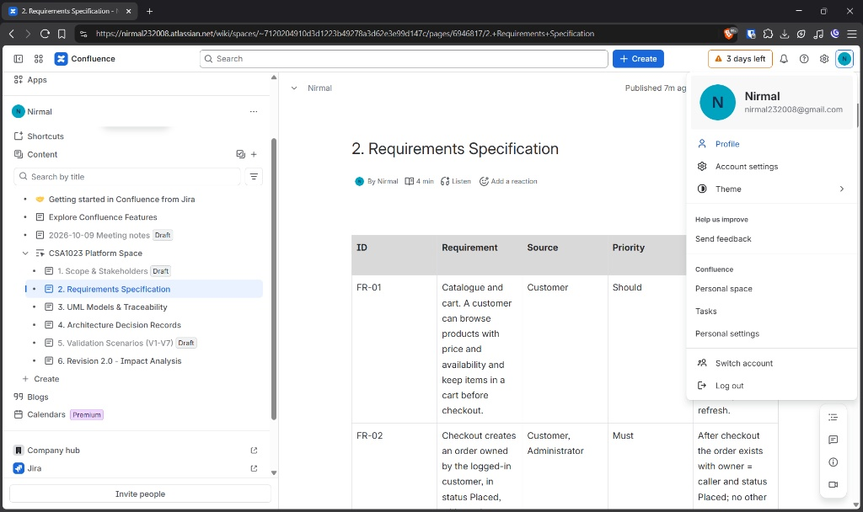
Figure 4: Confluence space for the assignment showing the page tree
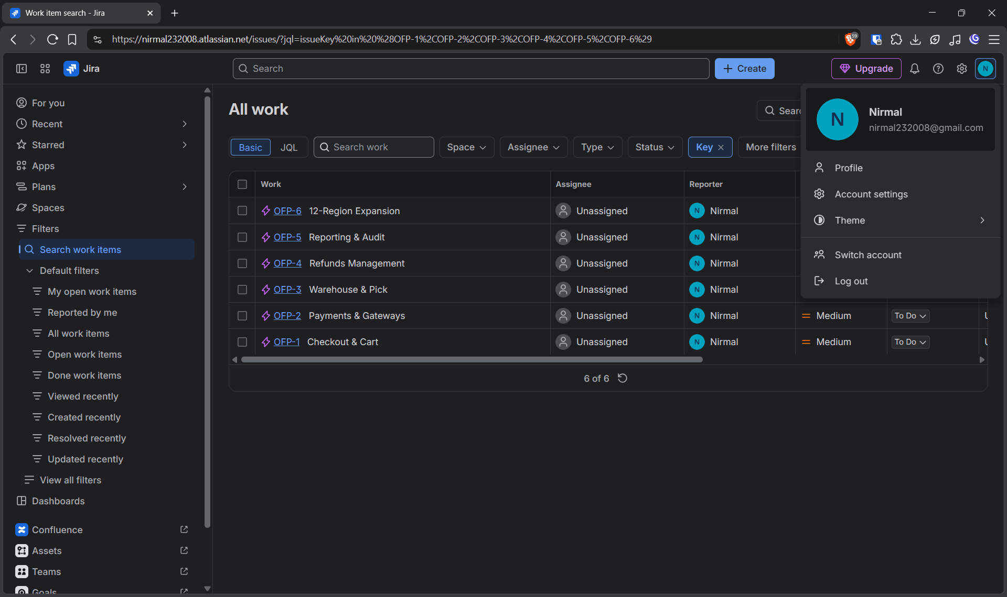
Figure 5: Jira project board with epics and requirement issues

2.2 How the specification is organised
The specification is a Confluence page tree with one page per concern (scope and stakeholders, requirements, order rules, models, traceability, architecture decisions, validation and the revision for Part 6). Every requirement also exists as a Jira issue of type Story (functional) or Task (non-functional) whose key I map to the identifier used in this report, for example FR-13. Three versions exist. Version 1.0 is the baseline written before modelling. Version 1.1 added FR-17 after the prototype exposed the abandoned-checkout weakness. Version 2.0 adds FR-18 to FR-21 and NFR-07 for the expansion. Confluence page history and the Jira change log are the evidence that these versions really happened in this order.

2.3 Prioritization method
I used two methods together. The first is MoSCoW classification, which is simple enough for stakeholders to discuss. The second is a weighted score so that the “Must” group is not just a list of everything I liked. Each requirement receives three ratings from 1 to 5: business impact if it works (I), risk if it fails or is wrong (R) and the number of other requirements or components that depend on it (D). The score is 0.4 I + 0.4 R + 0.2 D. A requirement is a Must if it protects money, stock, privacy or legal accountability, or if the release cannot demonstrate end-to-end behaviour without it, which in practice has turned out to match a score of about 4 or above. A Should improves service but the release can run without it, and a Could can wait. The weights are my choice and I would expect a real steering group to adjust them. I chose them so that risk counts as much as visible value, since the brief is mostly about avoiding failures that users do not see until they hurt.
Applied to the 21 functional and 8 non-functional requirements this gives 22 Musts and 7 Shoulds. No requirement ended up as a Could; the items I considered Could, such as wish lists and recommendations, were left out of the release entirely rather than carried as noise.
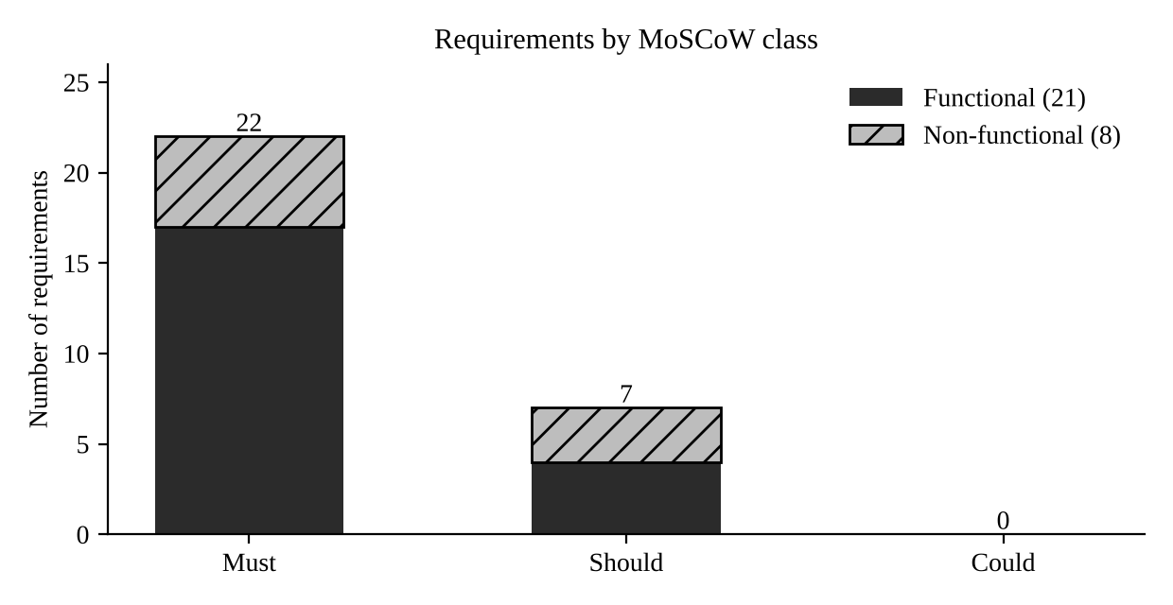
Figure 7: Requirements by MoSCoW class (generated from the requirement records)
Table 8: Priority scores (I, R, D rated 1 to 5 by the author) in descending order
ID | Class | Impact | Risk | Depend. | Score
FR-04 | Must | 5 | 5 | 5 | 5.0
FR-13 | Must | 5 | 5 | 5 | 5.0
NFR-04 | Must | 5 | 5 | 5 | 5.0
FR-05 | Must | 5 | 5 | 4 | 4.8
FR-14 | Must | 5 | 5 | 4 | 4.8
FR-20 | Must | 5 | 5 | 4 | 4.8
FR-02 | Must | 5 | 4 | 5 | 4.6
FR-07 | Must | 5 | 4 | 5 | 4.6
FR-03 | Must | 5 | 4 | 4 | 4.4
FR-18 | Must | 5 | 4 | 4 | 4.4
FR-19 | Must | 5 | 4 | 4 | 4.4
NFR-03 | Must | 5 | 4 | 4 | 4.4
NFR-07 | Must | 5 | 4 | 4 | 4.4
FR-09 | Must | 5 | 4 | 3 | 4.2
FR-15 | Must | 4 | 4 | 4 | 4.0
FR-06 | Must | 4 | 4 | 3 | 3.8
FR-10 | Must | 4 | 4 | 3 | 3.8
FR-12 | Must | 4 | 4 | 3 | 3.8
FR-17 | Must | 4 | 4 | 3 | 3.8
NFR-01 | Must | 5 | 3 | 3 | 3.8
NFR-02 | Must | 4 | 4 | 3 | 3.8
FR-08 | Must | 4 | 3 | 3 | 3.4
NFR-06 | Should | 4 | 3 | 3 | 3.4
FR-01 | Should | 4 | 2 | 2 | 2.8
FR-11 | Should | 4 | 2 | 2 | 2.8
FR-21 | Should | 3 | 3 | 2 | 2.8
NFR-08 | Should | 3 | 3 | 2 | 2.8
FR-16 | Should | 3 | 2 | 2 | 2.4
NFR-05 | Should | 3 | 2 | 2 | 2.4

2.4 Order rules
The brief asks that the specification state the business rules explicitly. I wrote them as numbered rules, so that each can be tested and traced. Amounts are held in integer paise to avoid rounding drift.
Table 9: Order rules
Rule | Topic | Statement | Requirements
OR-1 | Price and tax | The unit price is read from the product table at the moment of ordering and copied onto the order line. Subtotal = sum of quantity x unit price. Tax = subtotal x regional tax rate, rounded half up to the nearest paisa. Total = subtotal + tax + regional shipping. Browser-supplied prices are ignored. | FR-03
OR-2 | Stock reservation | A line is reserved only if available stock (on-hand minus reserved) is at least the quantity, in one atomic statement. Reserved never exceeds on-hand. An unpaid order holds its reservation for 15 minutes. | FR-04, FR-17
OR-3 | Ownership | An order belongs to the customer who placed it. A customer can read or act only on their own orders. Staff can act only within their role. The role is read from the server, never from the request. | FR-02, FR-12, NFR-04
OR-4 | Permitted status changes | Placed → Paid → Packed → Dispatched → Delivered → Closed. Placed or Paid → Cancelled. Delivered → ReturnRequested → Returned → Closed, or back to Delivered if the return is rejected. Everything else is refused. | FR-07
OR-5 | Dispatch conditions and deadline | Dispatch requires a confirmed payment and a confirmed pick. The regional deadline (default 48 hours from the order) is measured; late dispatch is allowed but flagged. | FR-09
OR-6 | Duplicate payment callbacks | The gateway event identity is unique. A repeated identity returns success, creates no payment, no confirmation and no shipment, and is logged. | FR-05
OR-7 | Payment verification | The amount must equal the order total. A mismatch, a second payment for a paid order or a payment for a cancelled order is stored for review and does not confirm the order. | FR-06
OR-8 | Refund approval | Refunds move Requested → Approved → Executed. Approval needs a store manager (up to the regional limit) or a finance reviewer (any amount). The requester cannot approve. Support agents and customers cannot approve. | FR-13
OR-9 | Refund execution and total | Only an Approved refund may be executed. The sum of live refunds for an order cannot exceed the amount paid. Execution uses an idempotency key, retries up to three times and then escalates. | FR-14

2.5 Functional requirements
Each requirement has a unique identifier, a source (the stakeholder whose need it answers), a priority and an acceptance criterion that a person other than me could check. The acceptance criteria for the high-risk requirements refer to the validation scenarios of Part 5, and the scenario names appear in brackets.
Table 10: Functional requirements (version 2.0; FR-17 added in 1.1, FR-18 to FR-21 added in 2.0)
ID | Requirement | Source | Priority | Acceptance criterion
FR-01 | Catalogue and cart. A customer can browse products with price and availability and keep items in a cart before checkout. | Customer | Should | Given 20 synthetic products, search and filter return the matching items; a cart keeps 10 lines after page refresh.
FR-02 | Checkout creates an order owned by the logged-in customer, in status Placed, with a unique order number. | Customer, Administrator | Must | After checkout the order exists with owner = caller and status Placed; no other customer can read it (test V6).
FR-03 | Price, tax and shipping are calculated on the server from the product price and the order region's rule. Values sent by the browser are ignored. Tax is rounded half up to the nearest paisa. | Finance reviewer, Store manager | Must | A basket of 2 x Rs 129 in IN-TN (18% tax, Rs 49 shipping) totals Rs 353.44; a tampered price in the request has no effect (test E5).
FR-04 | Stock reservation is atomic. Reserved quantity may never exceed available quantity, and two buyers cannot both obtain the last unit. | Picker, Customer | Must | With 1 unit and 2 simultaneous checkouts exactly 1 order is created and 1 is rejected (V1); with 40 units and 100 buyers exactly 40 succeed (E1).
FR-05 | A payment callback is processed exactly once per gateway event identity. A repeated callback returns success but creates no second payment, order confirmation or shipment. | Finance reviewer, Engineer | Must | Three simultaneous copies of one event give 1 payment row, 1 shipment row and 2 'duplicate ignored' replies (V2).
FR-06 | The callback amount must equal the order total. A mismatch, a second payment for a paid order or a payment for a cancelled order is stored for manual review and does not confirm the order. | Finance reviewer | Must | A second event id for a paid order is stored with status NeedsReview (V2b); a late payment for an expired order is flagged (W1).
FR-07 | Order status changes only along permitted transitions: Placed, Paid, Packed, Dispatched, Delivered, Closed, plus Cancelled and the return branch. | Support agent, Engineer | Must | Every transition outside the table in Section 3.4 is rejected with INVALID_TRANSITION; a unit test covers each forbidden pair.
FR-08 | A picker sees a pick list for Paid orders and confirms the pick. Confirmation moves stock from reserved to picked and the order to Packed. | Picker | Must | After confirmation on_hand and reserved both fall by the picked quantity and status = Packed (V4).
FR-09 | Dispatch is allowed only when payment is confirmed and the pick is confirmed. Dispatch after the regional deadline is flagged late. | Store manager, Customer | Must | Dispatch on an unpaid or unpicked order fails with PRECONDITION_FAILED (V4); dispatch 49 h after order in a 48 h region records LATE.
FR-10 | The local order and shipment record is committed before the courier is contacted. Courier synchronization is retried with back-off and moves to a dead-letter state with an alert after five failures. | Engineer, Customer | Must | With a courier failing twice the order stays Paid and the shipment syncs on the third retry (V5); five failures give DeadLetter (V5b).
FR-11 | A customer sees the current status and tracking reference of their own orders. | Customer | Should | Order page shows status within 5 s of a change; shows only the caller's orders.
FR-12 | A support agent sees order status, items and return status but never payment identifiers or amounts paid by card. | Support agent, Finance reviewer | Must | The support view contains no payment_status or gateway_event_id field (V6).
FR-13 | A refund request needs approval before execution. Amounts above the regional limit need a finance reviewer; the requester can never approve their own request; a support agent can never approve. The role is taken from the server, not from the screen. | Finance reviewer, Administrator | Must | V6 and V7: agent, customer and picker approvals are denied; manager above limit denied; finance above limit succeeds; self-approval denied.
FR-14 | An approved refund is executed through the gateway with an idempotency key. A failure triggers up to three attempts and then ExecutionFailed, escalation to finance and no recorded money movement. | Finance reviewer | Must | V3a: one failure then success with a single key; V3b: three failures give ExecutionFailed and zero successful gateway refunds.
FR-15 | Every status change, denial, approval, execution and duplicate callback is written to an append-only audit trail with actor, action, entity and time. | Finance reviewer, Administrator | Must | After V6 the audit table holds 6 DENIED rows; no update or delete is exposed through the API.
FR-16 | Management can view consolidated sales, stock and refund reports built from the same data as operations. | Management | Should | Regional totals add up to global totals (E6).
FR-17 | An unpaid order holds its reserved stock for at most 15 minutes. After that the order is cancelled and the stock released. A payment that arrives afterwards is flagged for review, not lost. | Store manager, Customer | Must | W1: after expiry the second buyer succeeds and the late payment is stored as NeedsReview.
FR-18 | Each region has its own configuration for tax, shipping, dispatch deadline and refund-approval limit, changed only by an administrator and effective from a stated time. | Administrator, Finance reviewer | Must | Same basket gives different tax, shipping and deadline in IN-TN and IN-KA (E5); change is audited.
FR-19 | A disconnected scanner node stores scan and stock events with unique identities and sends them when the link returns. The server applies each identity once and acknowledges it. | Picker, Store manager | Must | 25 buffered events with a link drop after 10 and 5 resends give stock +25 exactly (E2).
FR-20 | An approval entered offline is shown as 'Pending server validation' until the server validates role, limit and requester. It is never displayed as approved before then. | Finance reviewer | Must | E3: terminal label is Pending; server status stays Requested; server rejects an above-limit approval on sync.
FR-21 | A negative stock correction (shrinkage, damage) is recorded as an event but applied only after a store manager confirms it. | Store manager | Should | An ADJUST event is stored with status NeedsReview and stock does not change until confirmed.

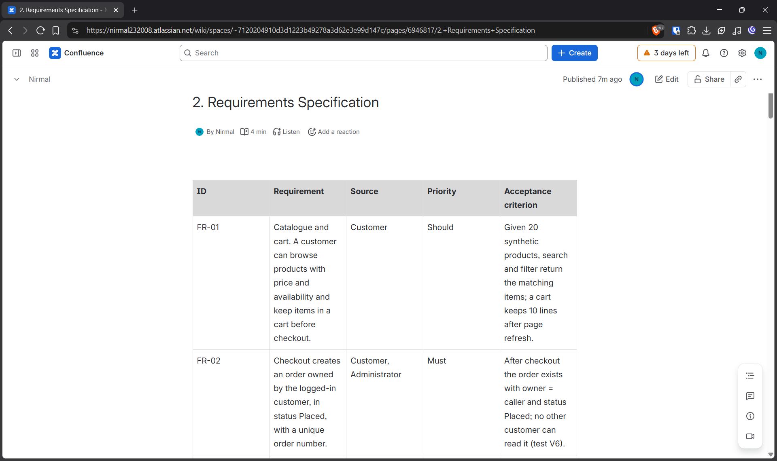
Figure 8: Confluence requirements page showing the functional requirement table
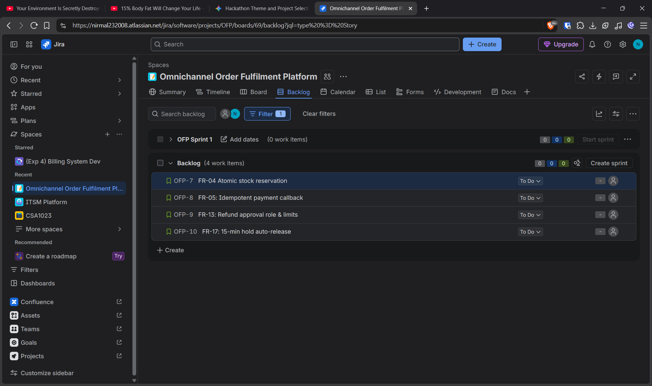
Figure 9: Jira issue navigator listing the requirement issues with priority

2.6 Non-functional requirements
Each quality requirement states the operating condition, the measurement and the threshold. The thresholds are planning assumptions, not measured capabilities of any system.
Table 11: Non-functional requirements with measurable thresholds
ID | Requirement | Source | Priority | How it is checked
NFR-01 | Performance. With 50 simultaneous users (original plan) and 500 users (expanded plan), 95% of checkout submissions complete within 2 s and 99% within 5 s, measured at the application server for synthetic orders. | Customer | Must | Load script of 500 virtual users for 10 minutes gives p95 ≤ 2 s and p99 ≤ 5 s. (Planned test; not yet run at this scale.)
NFR-02 | Callback handling. A payment callback is acknowledged within 1 s for 99% of events at 1,000 events per minute, including duplicates. | Engineer | Must | 1,000 mixed events replayed in 60 s give p99 ≤ 1 s.
NFR-03 | Availability. Order placement and callback receipt are available 99.5% of each calendar month (about 3.6 h of downtime), excluding planned maintenance announced 48 h earlier. A courier or gateway outage must not stop order storage. | Customer, Management | Must | Monthly uptime report; failure drill with the courier switched off shows orders still accepted (V5).
NFR-04 | Security. Authorization is enforced on the server for every operation; roles are read from the user table; TLS 1.2 or higher is used; no card numbers are stored; support views omit payment fields. | Administrator, Finance reviewer | Must | Penetration-style test: 10 forged requests with altered role fields all return 403 and appear in the audit trail.
NFR-05 | Usability. A support agent finds the status of an order in at most 3 clicks and 30 s, and a picker completes a pick confirmation in at most 4 taps. | Support agent, Picker | Should | Timed walkthrough with 5 volunteers using synthetic orders; median ≤ 30 s.
NFR-06 | Recoverability. After a database failure no more than 5 minutes of committed orders are lost (RPO 5 min) and service is restored within 60 minutes (RTO 60 min). | Management | Should | Restore drill from backup and write-ahead log on a test database.
NFR-07 | Scalability. The deployment sustains 500 simultaneous users and 1,000 stock, payment and scan events per minute across 12 regions by adding application containers, with infrastructure spend growing by no more than 100% of the original budget. | Management, Administrator | Must | Cost sheet and load test (planned). Prototype figure E4 is only a sanity check.
NFR-08 | Auditability. Audit entries are kept for at least 7 years and can be exported per order within 10 minutes on request by a finance reviewer. | Finance reviewer | Should | Export of 10,000 entries completes in under 10 minutes.

2.7 Replacing vague statements with testable ones
Table 12: From vague statements to testable requirements
Vague statement | Testable replacement
Checkout should be fast. | With 50 simultaneous users, 95% of checkout submissions finish within 2 s and 99% within 5 s, measured at the application server for synthetic orders (NFR-01).
The system must be reliable. | Order placement and callback receipt are available 99.5% of each month; a courier or gateway outage must not stop order storage (NFR-03).
Payments must be secure. | No card numbers are stored; TLS 1.2 or higher; ten forged role-change requests all return 403 and are audited (NFR-04).
Support should be able to see orders easily. | A support agent finds an order status in at most three clicks and 30 seconds, and never sees payment fields (NFR-05, FR-12).
Refunds must be controlled. | No refund reaches Executed without passing Approved; refunds above the regional limit are approved only by a finance reviewer (FR-13, FR-14).
The system should handle many users. | 500 simultaneous users and 1,000 stock, payment and scan events per minute across 12 regions, with infrastructure spend increasing by no more than the agreed limit (NFR-07).

2.8 Planning assumptions
The brief asks me to state workload, service levels and acceptance thresholds as assumptions. They are listed here once so that every requirement can point to them.
Table 13: Explicit planning assumptions
Item | Assumption
Original workload | 3 regions, 50 simultaneous users, 100 stock, payment and scan events per minute
Expanded workload (Part 6) | 12 regions, 500 simultaneous users, 1,000 events per minute
Checkout response | p95 ≤ 2 s, p99 ≤ 5 s
Callback acknowledgement | p99 ≤ 1 s at 1,000 events per minute
Availability | 99.5% per month for order placement and callback receipt
Recovery | RPO 5 minutes, RTO 60 minutes
Reservation hold | 15 minutes for an unpaid order
Refund limit for store-manager approval | Set per region; Rs 2,000 for IN-TN and Rs 3,000 for IN-KA in the prototype data (synthetic)
Dispatch deadline | 48 hours (24 hours in IN-KA) from order placement
Currency and data | Indian rupees in integer paise; all data are synthetic

2.9 Assumptions and unresolved questions
I made the following assumptions in the specification. Each one is a place where a real stakeholder could prove me wrong, so I keep them visible instead of burying them in the design.
- The payment gateway signs its callbacks and supplies a stable unique event identity. If it does not, FR-05 needs a different idempotency key. I do not yet know whether the real gateway offers this.
- One order has one payment. Split payments or wallet-plus-card payments would need a payment-group concept that I have left out.
- The dispatch deadline is measured from order placement. A real operation may prefer to measure from payment confirmation. This is an open question for the store manager.
- Refund limits are per region and in rupees. Whether a limit should depend on the customer's history is unresolved.
- Partial returns and partial refunds are allowed up to the amount paid, but restocking rules for returned goods are not modelled.
- The courier supports an idempotency key on shipment creation. If it does not, a retry may create duplicate shipments and a reconciliation step is needed.

2.10 How stakeholder conflicts shaped the specification
Two conflicts changed the text of the specification in ways I would not have written otherwise. The first is C2, support visibility against payment privacy. My first draft of the order view requirement said that support agents could see “order and payment status”. After the finance reviewer's response I split the requirement in two. FR-12 now forbids payment fields in the support view outright, and NFR-04 adds the check that forged role fields are refused. The support agent's need is still met because status, items and tracking remain visible.
The second is C3, refund speed against refund control. The draft said refunds “should be processed promptly”. Prompt for whom? The conflict pushed me to separate three steps (request, approval, execution), to place a regional limit between manager approval and finance approval, and to forbid self-approval. It also gave me the failure case in FR-14 and scenario V3, because once approval and execution are separate steps the gateway can fail between them and the system must say what happens.
C5, availability against consistency, also had a visible effect: it produced FR-10 and the order of operations in the sequence diagram, in which the local record is committed before the courier is called.

3. UML Models and Traceability (Q3)
The models in this part were drawn after the requirements were frozen at version 1.0, and each element carries the same name as in the requirement text. I drew them from text sources, which means a change to a requirement can be followed by a quick regeneration of the figure. The diagrams are not decoration; Section 3.7 records four places where they disagreed with each other or with the specification.

3.1 Use case diagram
The use case diagram shows six human actors and two external systems. The “include” relationships capture work that always happens as part of another use case: paying always involves receiving a payment callback, dispatching always involves synchronizing the shipment with the courier, and approving a refund or correcting stock always involves verifying identity and role on the server.
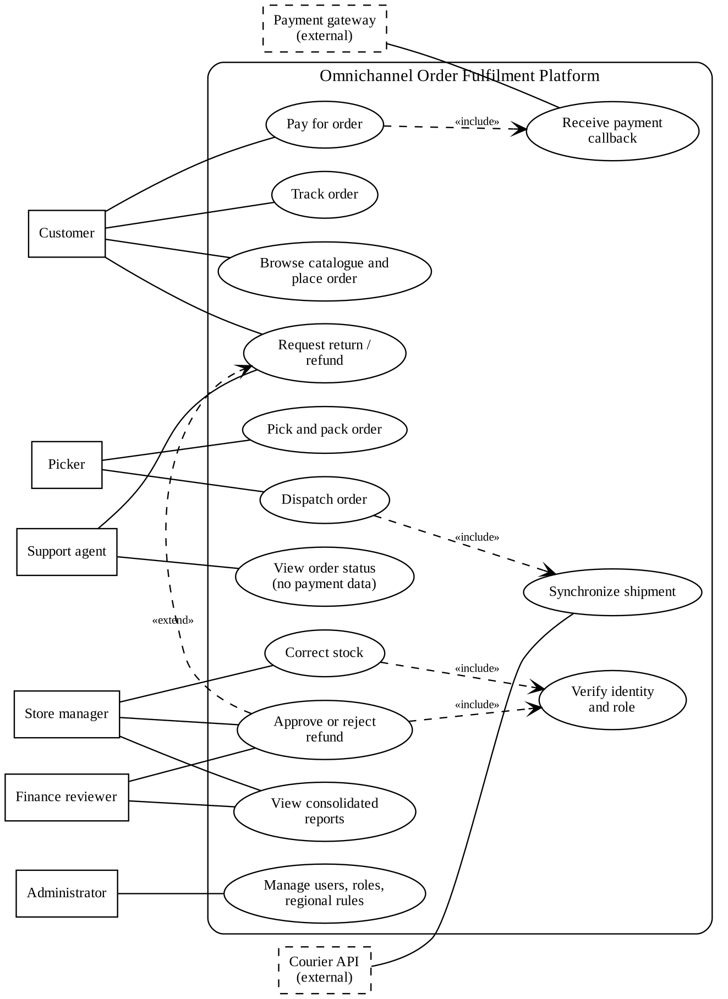
Figure 10: Use case diagram of the order fulfilment platform
Support agents are connected to “View order status (no payment data)” and not to the approval use case, which is the diagram's way of showing conflict resolution C2 and C3.

3.2 Class diagram
The class diagram holds the domain concepts that the rules talk about. An Order is the centre. It is composed of order items that keep a snapshot of the unit price, which is why a later price change cannot alter an existing order. A Product has the on-hand and reserved quantities that rule OR-2 refers to. A Payment is identified by the gateway event identity, which is unique, and an order can have many payment records but only one with the status Confirmed (this multiplicity was corrected in Section 3.7). The Refund records who requested and who approved, and the attempt count that drives the retry rule. The OutboxJob is the concrete form of the promise that the local record is committed before the courier is called. RegionRule gathers tax, shipping, deadline and refund limit, so that Part 6 can change them without touching the order logic. AuditEntry is written by operations and is never updated.
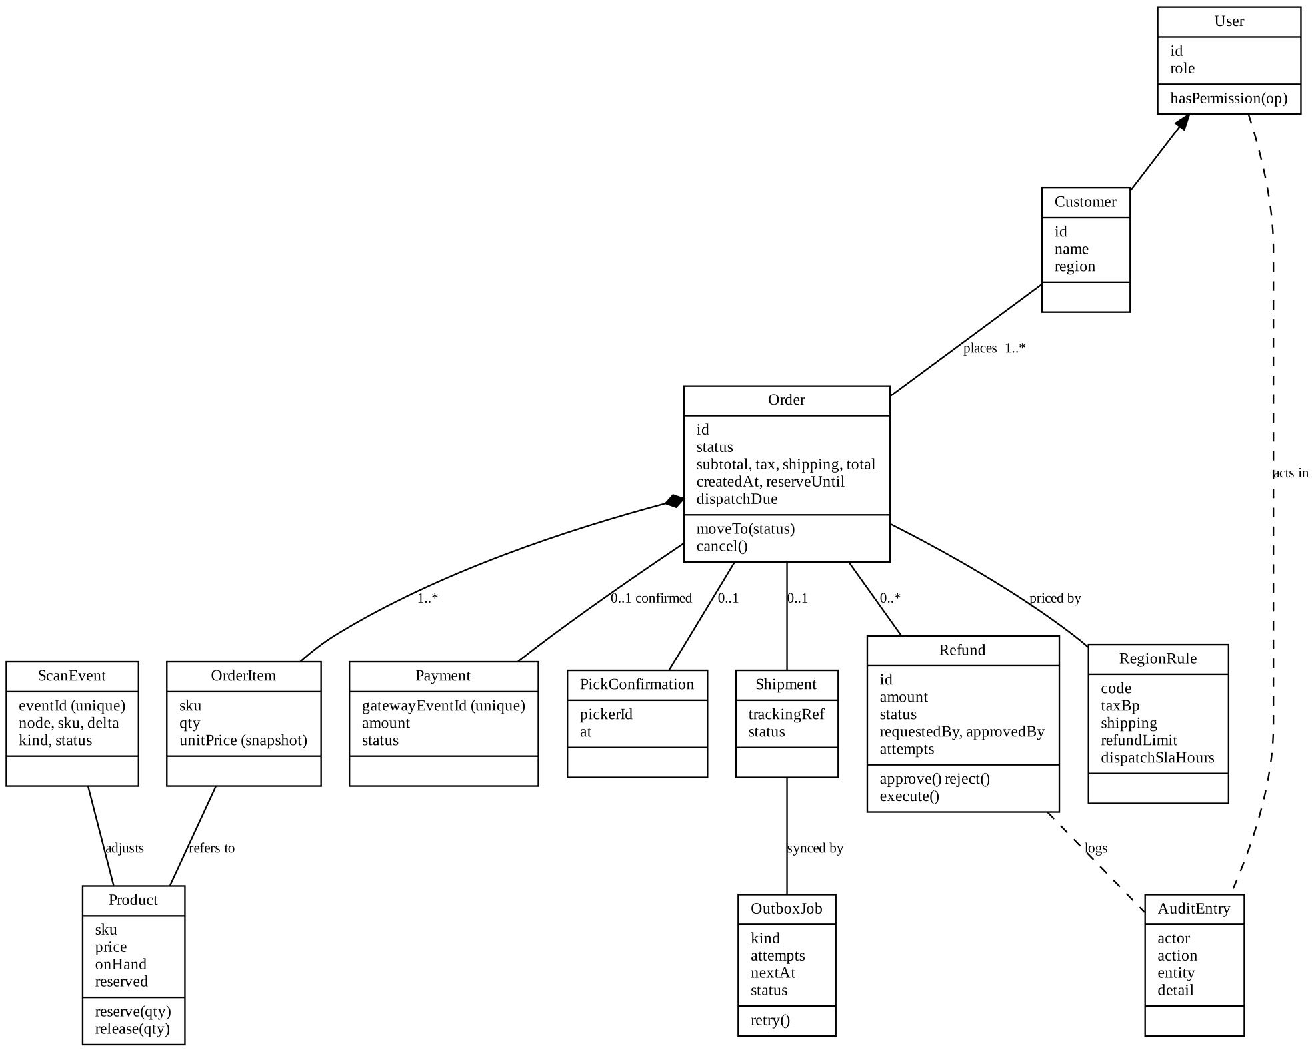
Figure 11: Class diagram of the main domain concepts

3.3 Sequence diagram: payment callback to courier synchronization
This diagram traces the case that worries the retailer most. The gateway posts a callback with an event identity, an order and an amount. The payment module tries to insert the payment inside a database transaction. Because the event identity has a unique constraint, a second copy of the same callback, even one that arrives while the first is still being processed, either waits for the first transaction and then fails the constraint, or fails immediately. In both cases it gets a harmless “duplicate ignored” answer and nothing else changes. When the insert succeeds, the same transaction moves the order from Placed to Paid, creates the shipment record in the state PendingSync, adds an outbox job and writes an audit entry. Only after the commit is the gateway told that the callback succeeded.
The courier is contacted later by an outbox worker, never by the callback itself. If the courier fails the worker records the attempt and schedules the next one with a growing delay. The order stays Paid the whole time, so the customer's order is never lost because of a courier outage. After five failures the job moves to a dead-letter state and an alert is raised for a person to act on. The shipment request carries an idempotency key so that a retry that follows a lost reply does not create a second shipment, provided the courier honours the key, which is one of my open assumptions.
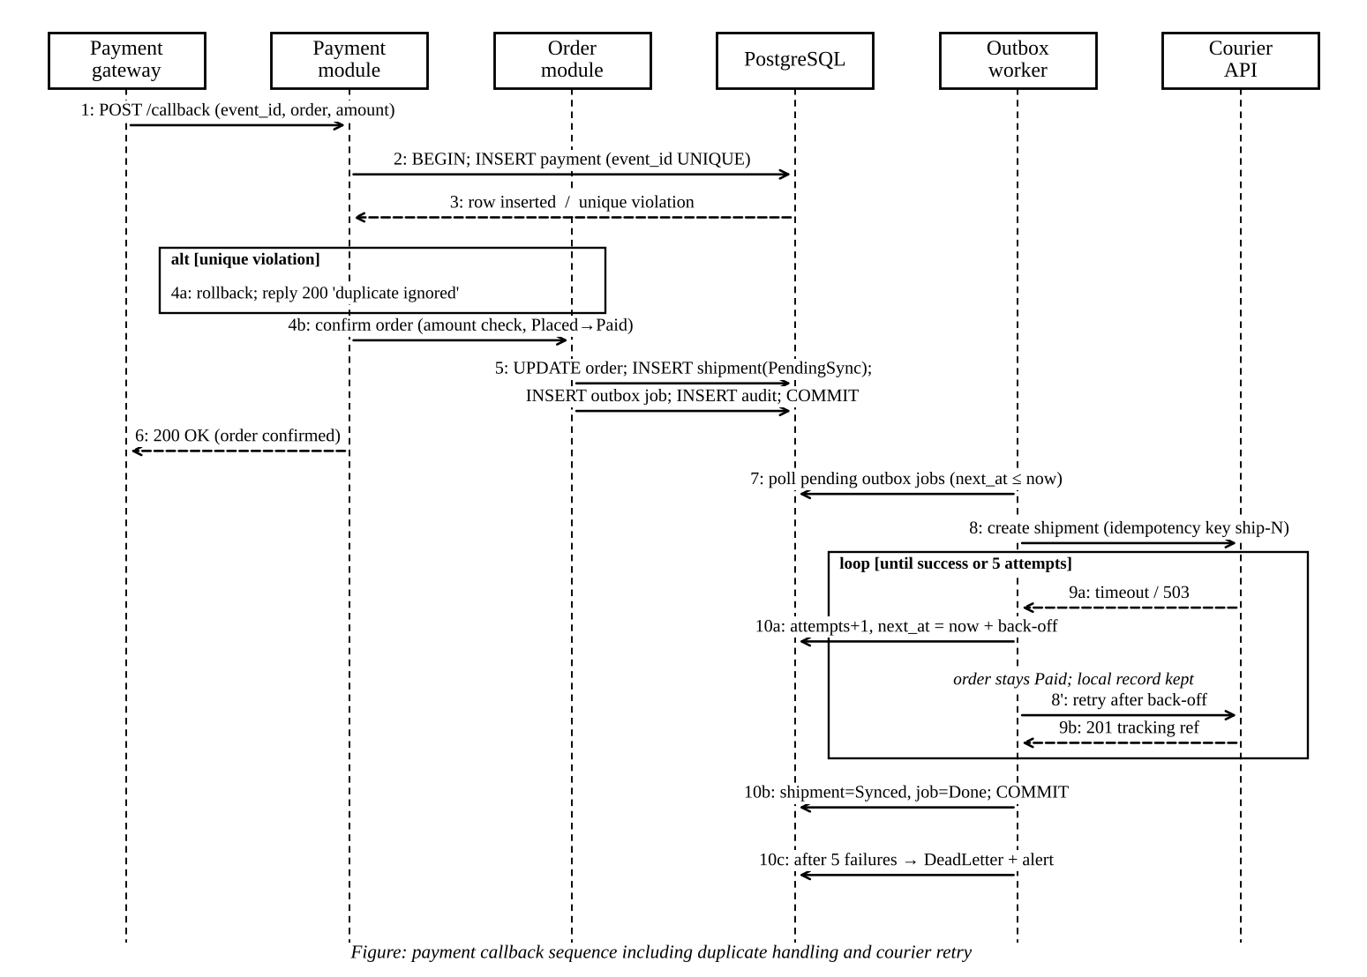
Figure 12: Sequence diagram: payment callback, order confirmation, shipment creation and courier retry

3.4 State machine for orders
The order life cycle follows the brief: Placed, Paid, Packed, Dispatched, Delivered and Closed. I added Cancelled for authorized cancellation and expiry, and a return branch (ReturnRequested, Returned) because the scenario includes returns. Each transition has a guard written next to it in the table below. The guard on Packed to Dispatched is the one that matters most to the scenario: the order must have a confirmed payment and a confirmed pick, even though reaching the state Packed already implies both. I kept the check explicit because a defensive check at the point of harm is cheaper than finding out later that a code path skipped a step.
Figure 13: State machine for an order, including cancellation and return
Table 14: Permitted order transitions (all other pairs are refused)
From | To | Trigger and guard | Actor
Placed | Paid | Payment callback confirmed, amount equals total | Gateway (via callback module)
Placed | Cancelled | Hold expired, or the owner or an authorized agent cancels | System, customer, support agent
Paid | Packed | Pick confirmed; stock moves from reserved to picked | Picker
Paid | Cancelled | Authorized cancellation; a refund request is raised and stock released | Support agent, store manager
Packed | Dispatched | Payment confirmed AND pick confirmed | Picker, store manager
Dispatched | Delivered | Courier confirms delivery | Courier integration
Delivered | Closed | Return window ends with no return | System
Delivered | ReturnRequested | Owner requests a return inside the window | Customer, support agent
ReturnRequested | Returned | Goods received and inspected | Store manager
ReturnRequested | Delivered | Return rejected | Store manager
Returned | Closed | Refund executed or declined | System

3.5 Refund behaviour: approval, rejection, execution and rollback
A refund has its own small state machine because its rules are different from the order's. A request starts as Requested. An authorized person who is not the requester may approve or reject it, and the regional limit decides whether a store manager is enough or a finance reviewer is required. Only an Approved refund can be executed. If the gateway fails, the refund stays Approved and is retried, up to three attempts, using the same idempotency key. After the third failure the refund moves to ExecutionFailed. That state is my form of rollback: no money has moved, no ledger entry is posted, and the failure is escalated to a finance reviewer, who may reopen it. A refund that has been executed cannot be changed, and a rejected one is final.
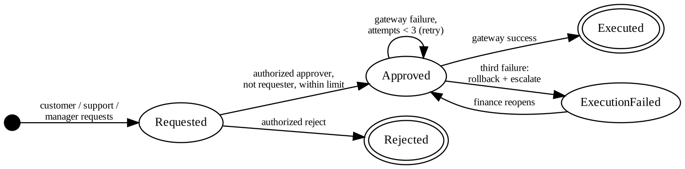
Figure 14: State machine for a refund
The sequence diagram below shows the same behaviour as messages between the requester, the refund module, the approver, the database and the gateway. It includes the failure branch that the state machine summarises as a self-transition.
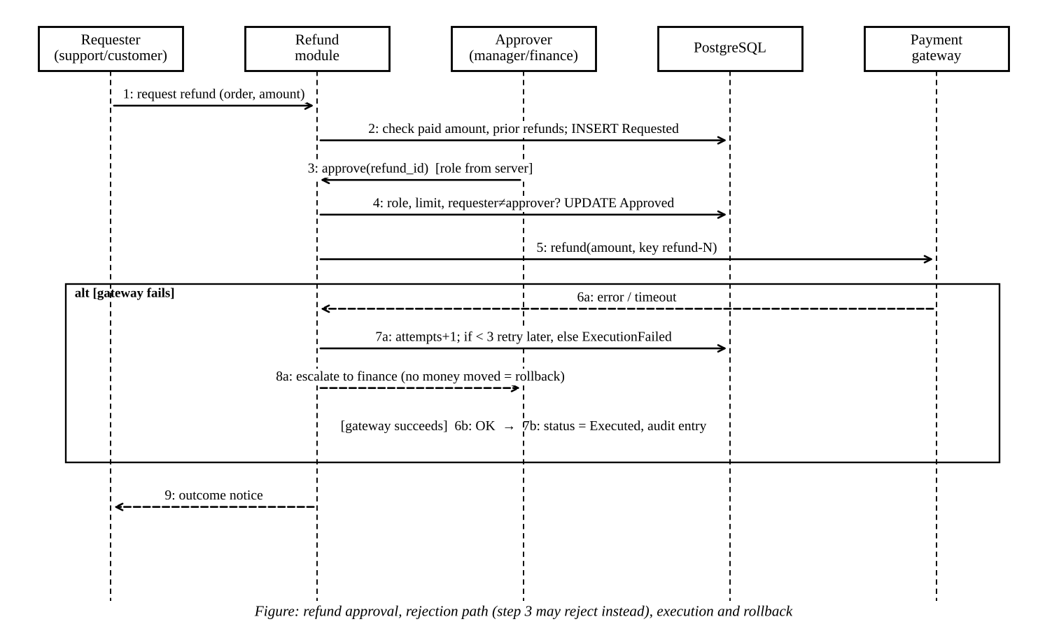
Figure 15: Sequence diagram of refund approval, execution and rollback

3.6 Traceability matrix
The matrix links each requirement to a UML element, to the architectural component that implements it (using the component names from Section 4.5) and to the validation scenario that tests it. Scenarios V1 to V7 and W1 are described in Part 5 and E1 to E7 in Part 6. A few rows say “manual walkthrough” because I have not automated a check for them, and I think it is better to say so than to pretend otherwise.
Table 15: Traceability matrix: requirement, UML element, component, validation scenario
Requirement | UML element | Architectural component | Validation scenario
FR-01 | UC Browse catalogue; class Product | Catalogue & Checkout | Manual walkthrough
FR-02 | UC Place order; class Order, Customer | Catalogue & Checkout; API authorization | V1, V6
FR-03 | Class Order (subtotal, tax, total), RegionRule | Catalogue & Checkout; Region rules | E5
FR-04 | Product.reserve(); sequence step 'reserve' in checkout | Inventory & Reservation | V1, E1
FR-05 | Payment.gatewayEventId; sequence messages 2 to 4a | Payment Callback | V2
FR-06 | Sequence alt branch; Payment status NeedsReview | Payment Callback | V2b, W1
FR-07 | Order state machine (all transitions) | Order & State Machine | V4
FR-08 | UC Pick and pack; class PickConfirmation | Warehouse & Dispatch | V4
FR-09 | Guard on Packed → Dispatched; UC Dispatch | Warehouse & Dispatch | V4
FR-10 | Sequence messages 7 to 10; class OutboxJob, Shipment | Outbox worker | V5, V5b
FR-11 | UC Track order; class Shipment | Order & State Machine | Manual walkthrough
FR-12 | UC View order status (no payment data) | API authorization; Order read model | V6
FR-13 | Refund state machine; refund sequence; UC Approve refund | Returns & Refund; API authorization | V6, V7
FR-14 | State ExecutionFailed; refund sequence alt [gateway fails] | Returns & Refund | V3a, V3b
FR-15 | Class AuditEntry | Audit | V6 (DENIED rows), V3b
FR-16 | UC View consolidated reports | Reporting (read replica) | E6
FR-17 | Transition Placed → Cancelled (expiry) | Inventory & Reservation; Order & State Machine | W1
FR-18 | Class RegionRule | Region rules | E5
FR-19 | Class ScanEvent; scanner sync sequence | Scanner sync | E2, E4
FR-20 | Refund label 'Pending server validation'; scanner sync sequence | Scanner sync; Returns & Refund | E3
FR-21 | ScanEvent.kind = ADJUST, status NeedsReview | Inventory & Reservation | E7
NFR-01 | Deployment: load balancer, app containers | Deployment tier | E1 (sanity only); planned load test
NFR-02 | Sequence: callback handling | Payment Callback | E4 (sanity only)
NFR-03 | Outbox pattern; sequence retry | Outbox worker; deployment | V5, V5b
NFR-04 | Use case include 'Verify identity and role' | API authorization | V6
NFR-05 | UC View order status | Support console | Manual walkthrough
NFR-06 | Deployment: backup, replica | Deployment tier | Planned restore drill
NFR-07 | Deployment diagram, revised | Deployment tier; Region rules | E1, E4 (sanity only)
NFR-08 | Class AuditEntry | Audit | Planned export test

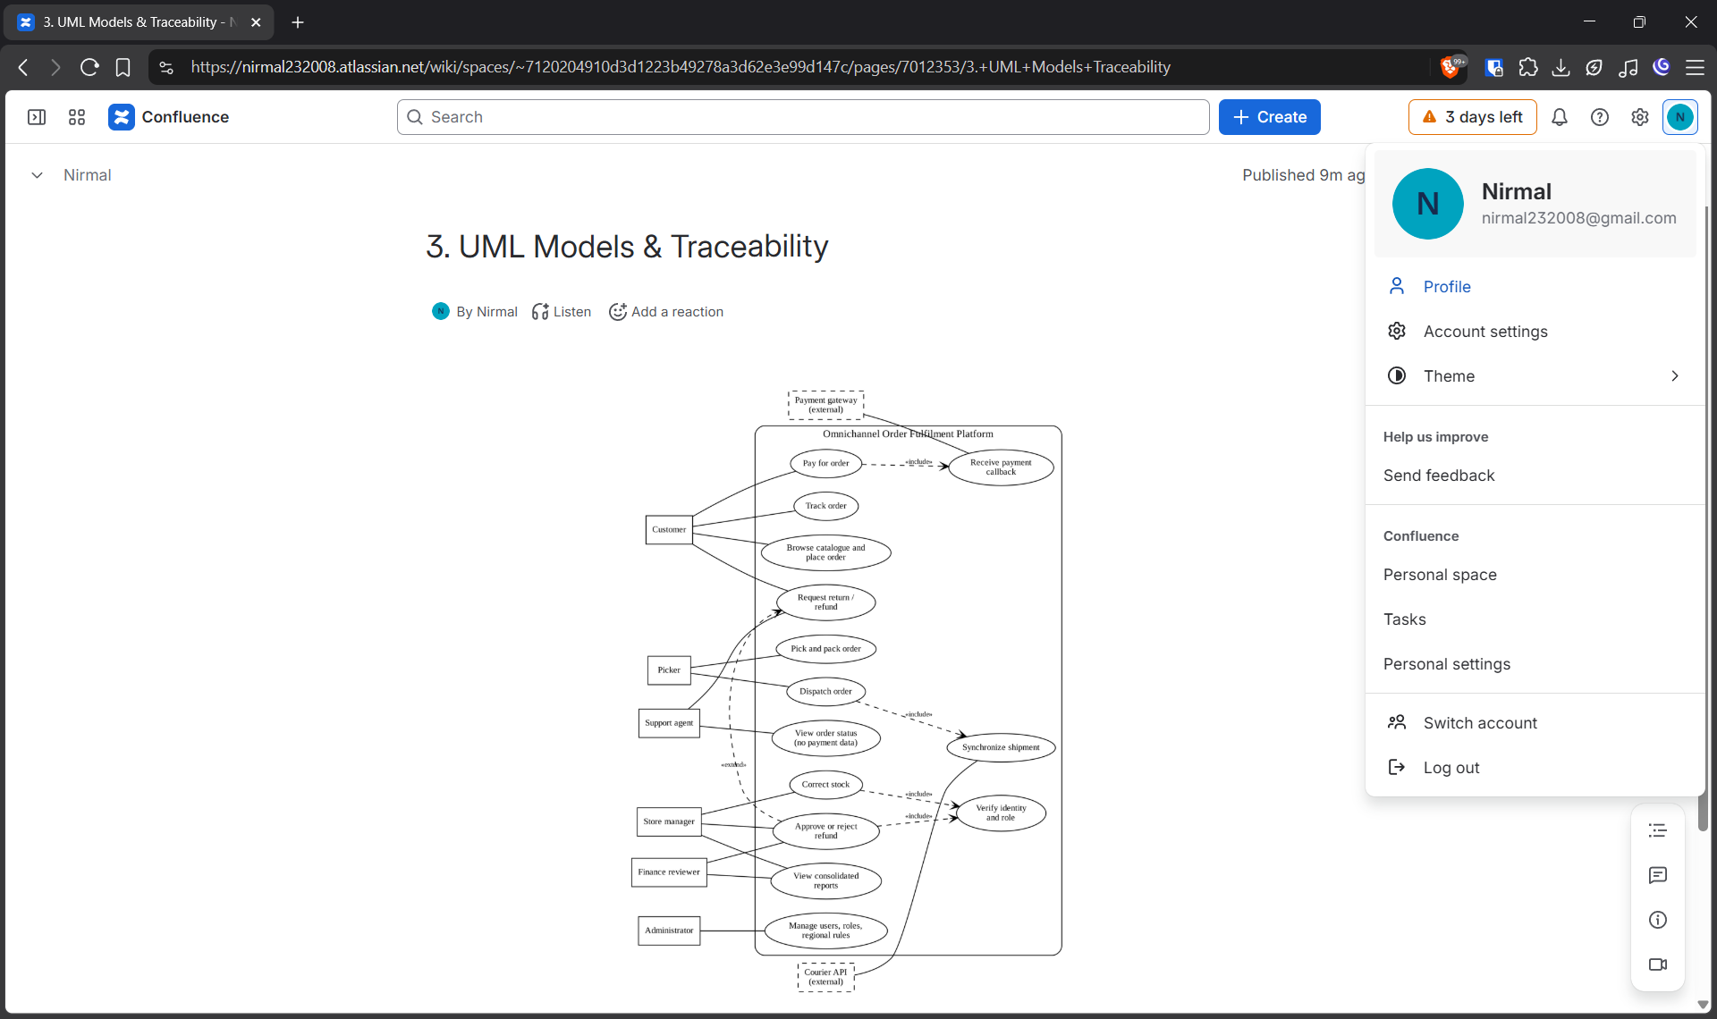
Figure 16: Confluence page with the UML diagrams embedded
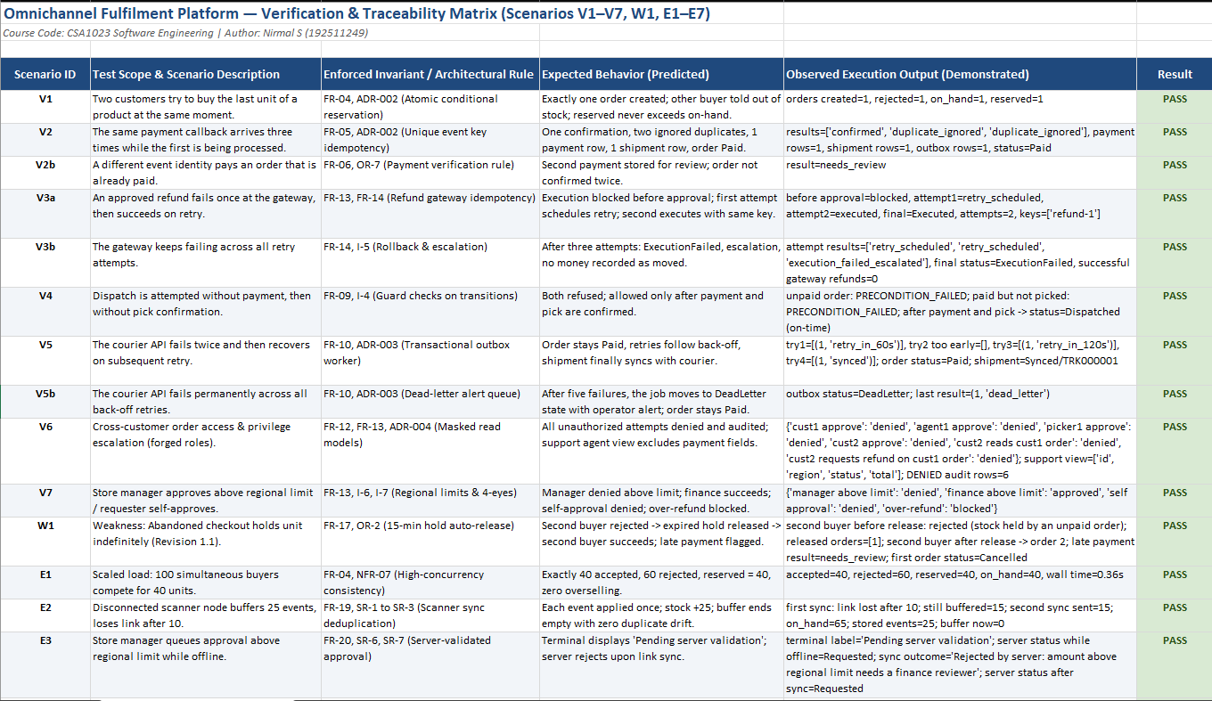
Figure 18: Confluence traceability page

3.7 Inconsistencies found while connecting the models
Building the matrix forced me to read each diagram against the others and against the requirement text. I found four inconsistencies at this stage and corrected them in every place they appeared.
Table 16: Inconsistencies found and corrected
ID | Inconsistency | Correction | Artefacts changed
I1 | The first class diagram gave every Order exactly one Payment, but the callback sequence allowed a second event with a different identity to arrive for the same order (a gateway double charge). | Order to Payment became 0..*, with at most one Confirmed. A status NeedsReview was added. FR-06 and OR-7 were written, and scenario V2b was created. | Class diagram, sequence diagram, FR-06, OR-7
I2 | The sequence diagram created a “shipment” when payment was confirmed, while the state machine and FR-09 used “dispatch” for the later physical event. The same word meant two things. | A Shipment record (PendingSync, then Synced) is created at payment time to carry the courier registration. Dispatch is only the status change Packed → Dispatched, with an explicit guard. | Sequence diagram, state machine, FR-09, FR-10
I3 | The use case diagram let support agents request refunds, but my first FR-13 said only customers and finance reviewers could request them. | FR-13 and OR-8 now say customers, support agents and store managers may request, and only store managers (within the limit) and finance reviewers may approve. Support agents never approve. | Use case diagram, FR-13, OR-8
I4 | The refund state machine went straight from Approved to Executed, but the refund sequence showed a gateway failure branch with no matching state. | Added the retry self-transition and the state ExecutionFailed, with escalation and finance reopening. FR-14 and scenarios V3a and V3b were added. | Refund state machine, FR-14

4. Alternative Architectures and Justified Design (Q4)
I developed two architectures that differ in kind and not just in drawing style. The first is a modular monolith, one deployable application with strict internal module boundaries and a single relational database. The second is an event-driven set of microservices with a message broker and a database for each service. Both must meet the same requirements, so I describe each one against the same questions that the brief asks: components, communication, data ownership, prevention of duplicate payments and overselling, quality attributes, failure points and maintenance.

4.1 Alternative A: modular monolith
Components. One FastAPI application contains an API layer that handles authentication, authorization and validation, and these modules: Catalogue and Checkout, Inventory and Reservation, Order and State Machine, Payment Callback, Warehouse and Dispatch, Returns and Refund, Reporting and Audit. A background worker in the same code base runs the transactional outbox that talks to the courier. The React front end and the scanner web application talk only to the API layer. PostgreSQL is the single store.
Communication and data ownership. Modules call each other through plain function interfaces inside one process, and a request that touches several modules runs inside one database transaction. Each module owns its tables, and another module reads them only through the owner's interface, a rule I would enforce with import checks in the build. The Order module alone may change an order's status, which prevents the situation in which three different parts of the code each decide what “Packed” means. External effects (courier, gateway) leave the system through the outbox, never from inside a transaction.
Preventing duplicate payments and overselling. Both are handled by the database, which is the one place that sees every request. The payment table has a unique constraint on the gateway event identity, and the confirmation runs in a single transaction, so simultaneous copies of a callback serialize and only one can insert. Reservation uses one conditional update that increases the reserved count only if on-hand minus reserved is at least the requested quantity, so two buyers cannot both succeed on the last unit.
Quality attributes. Consistency is strong, since a checkout, a payment confirmation or a refund approval is one ACID transaction. Scalability is by adding identical stateless application containers and a read replica for reports, and the write path is limited by one primary database. At the expanded load of 1,000 events per minute, which is about 17 per second, a single PostgreSQL primary is far from stressed, so this limit is a long way off. Availability depends on the database, which is the single point of failure; a managed standby gives automatic failover for a moderate cost. Security is simpler because one authorization layer guards every operation and one audit table records everything. Operational complexity is low: one image, one pipeline, one set of logs.
Failure points and maintenance. The primary database, the outbox worker backlog, and a bad deployment that affects every module at once are the main risks. Over the long term the module boundaries can erode if people take shortcuts, and a team that grows to many independent groups would find a single release train limiting. Migrations have to be coordinated across modules.

4.2 Alternative B: event-driven microservices
Components. Separate services for Orders, Inventory, Payments, Fulfilment (picking and dispatch), Refunds, Courier Integration and Reporting, connected by a message broker such as RabbitMQ or Kafka. An orchestrator or a choreographed set of events carries the checkout and refund processes (a saga). An API gateway fronts the services, and each service runs in its own container group on a container orchestrator.
Communication and data ownership. Services publish events such as OrderPlaced, StockReserved, PaymentConfirmed and RefundApproved, and react to events from others. Each service has its own database and no other service may read it. Reporting builds its own copy of the data from the event stream. Business rules that cross service boundaries, such as “the total of refunds cannot exceed the amount paid”, must be enforced by one service that owns the necessary data, or by a saga with compensating actions.
Preventing duplicate payments and overselling. Brokers normally deliver at least once, so every consumer must be idempotent. The Payments service keeps a table of processed event identities and ignores repeats. Inventory is the single owner of stock, and I would partition its input by product so that all reservations for one product are handled one at a time by one consumer. If payment fails after the stock is reserved, a compensating event releases it. This works, but the correctness argument is spread over several services, queues and timeouts instead of a single transaction.
Quality attributes. Scalability is the strong point, because each service scales on its own and the partitioned stock path can handle very high volumes. Consistency is eventual: for a short time the order may be Placed while the stock service has already reserved the unit and the payment service has already confirmed payment. Availability benefits from failure isolation, since the Refund service can be down while checkout continues, but the broker becomes a critical shared dependency. Security has a larger surface, with service-to-service authentication, secrets for every service and an audit trail that has to be stitched together from several logs. Operational complexity is high: a broker, an orchestrator, distributed tracing, schema versioning of events and contract tests.
Failure points and maintenance. Likely failures are poison messages that block a queue, sagas stuck halfway, out-of-order events, and a duplicate or lost event that leaves two services disagreeing. Teams can release independently, which is a real maintenance advantage for a large organization, but a team of two or three would spend most of its time on platform work.

4.3 Comparison
Table 17: Comparison of the two alternatives
Aspect | A: Modular monolith | B: Event-driven microservices
Principal components | API layer plus 8 modules, outbox worker, one database | 7 services, broker, API gateway, 7 databases
Communication | In-process calls inside one transaction; outbox to outside | Asynchronous events, saga for checkout and refund
Data ownership | Per module (convention and review), one database | Per service (enforced by deployment)
Duplicate payment | Unique key on event id inside one transaction | Idempotent consumer with a processed-events table
Overselling | Conditional update on stock row | Single stock owner, partitioned per product, compensation
Scalability | Horizontal app containers, read replica; one write primary | Independent per service; very high ceiling
Consistency | Strong inside each operation | Eventual; compensation needed
Availability | Single database is a single point of failure; mitigated by standby | Better isolation; broker is a shared dependency
Security | One authorization point, one audit table | More endpoints and secrets, distributed audit
Operational complexity | Low | High
Likely failure points | Primary DB, outbox backlog, one bad release | Broker, poison messages, stuck sagas, event versions
Maintenance | Boundaries need discipline; single release train | Independent releases; heavy platform upkeep
Illustrative monthly cost (3 regions) | about Rs 20,000 | about Rs 55,000

To avoid choosing on instinct I scored both against six criteria, weighting consistency of order and stock most heavily because the scenario is built around it, and small-team simplicity and cost next because the brief says the technical team is small and additional services must be justified. The weights and scores are my own judgement and are Illustrative. A different organization would weigh them differently, and the result is sensitive to the weights: if I gave scalability 40% and cut the others, alternative B would win. That is the point of Part 6, which asks what would have to be true for me to change my mind.
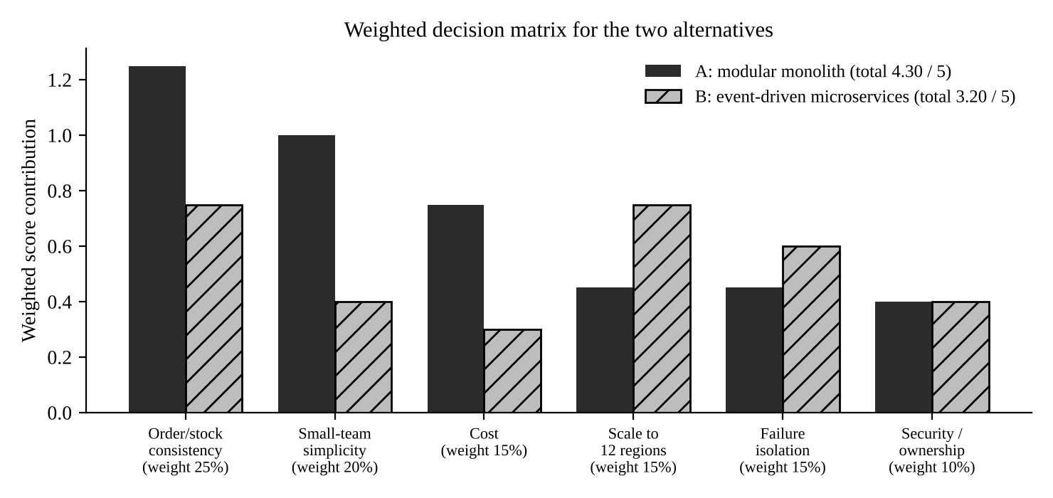
Figure 19: Weighted decision matrix (weights and scores are the author's judgement)
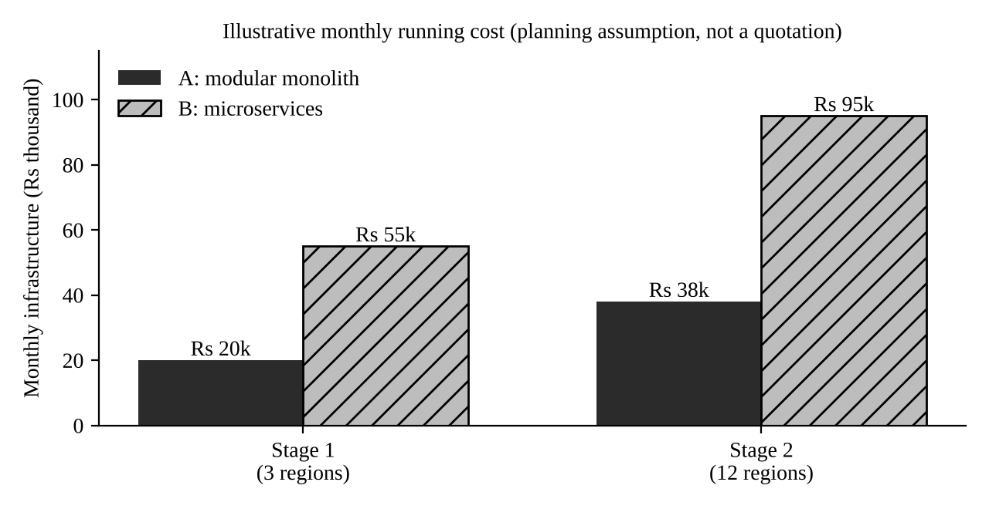
Figure 20: Illustrative monthly infrastructure cost for the two alternatives (planning assumption, not a quotation)

4.4 Selection
I selected alternative A, the modular monolith. The scenario's hardest requirements are about consistency between a few closely related facts: this payment, this order, this unit of stock, this refund. A single transaction makes those guarantees simple to state and to test, and in the prototype each scenario is a handful of lines. A small team with a modest deployment cannot justify a broker, an orchestrator and seven databases when the planned peak is about 17 events per second. I am not claiming monoliths scale better; I am claiming that this system's growth path does not yet need the extra machinery, and that the module boundaries keep the door open. I record the conditions for extracting a service in Section 6.6.

4.5 Component and deployment diagrams
The component diagram shows the selected architecture at version 1.1. Components that appear in the traceability matrix (Section 3.6) have the same names here. Arrows from the modules to PostgreSQL show that each module owns its tables. Only the Outbox worker and the Returns and Refund module call external systems, and they send an idempotency key with every call.
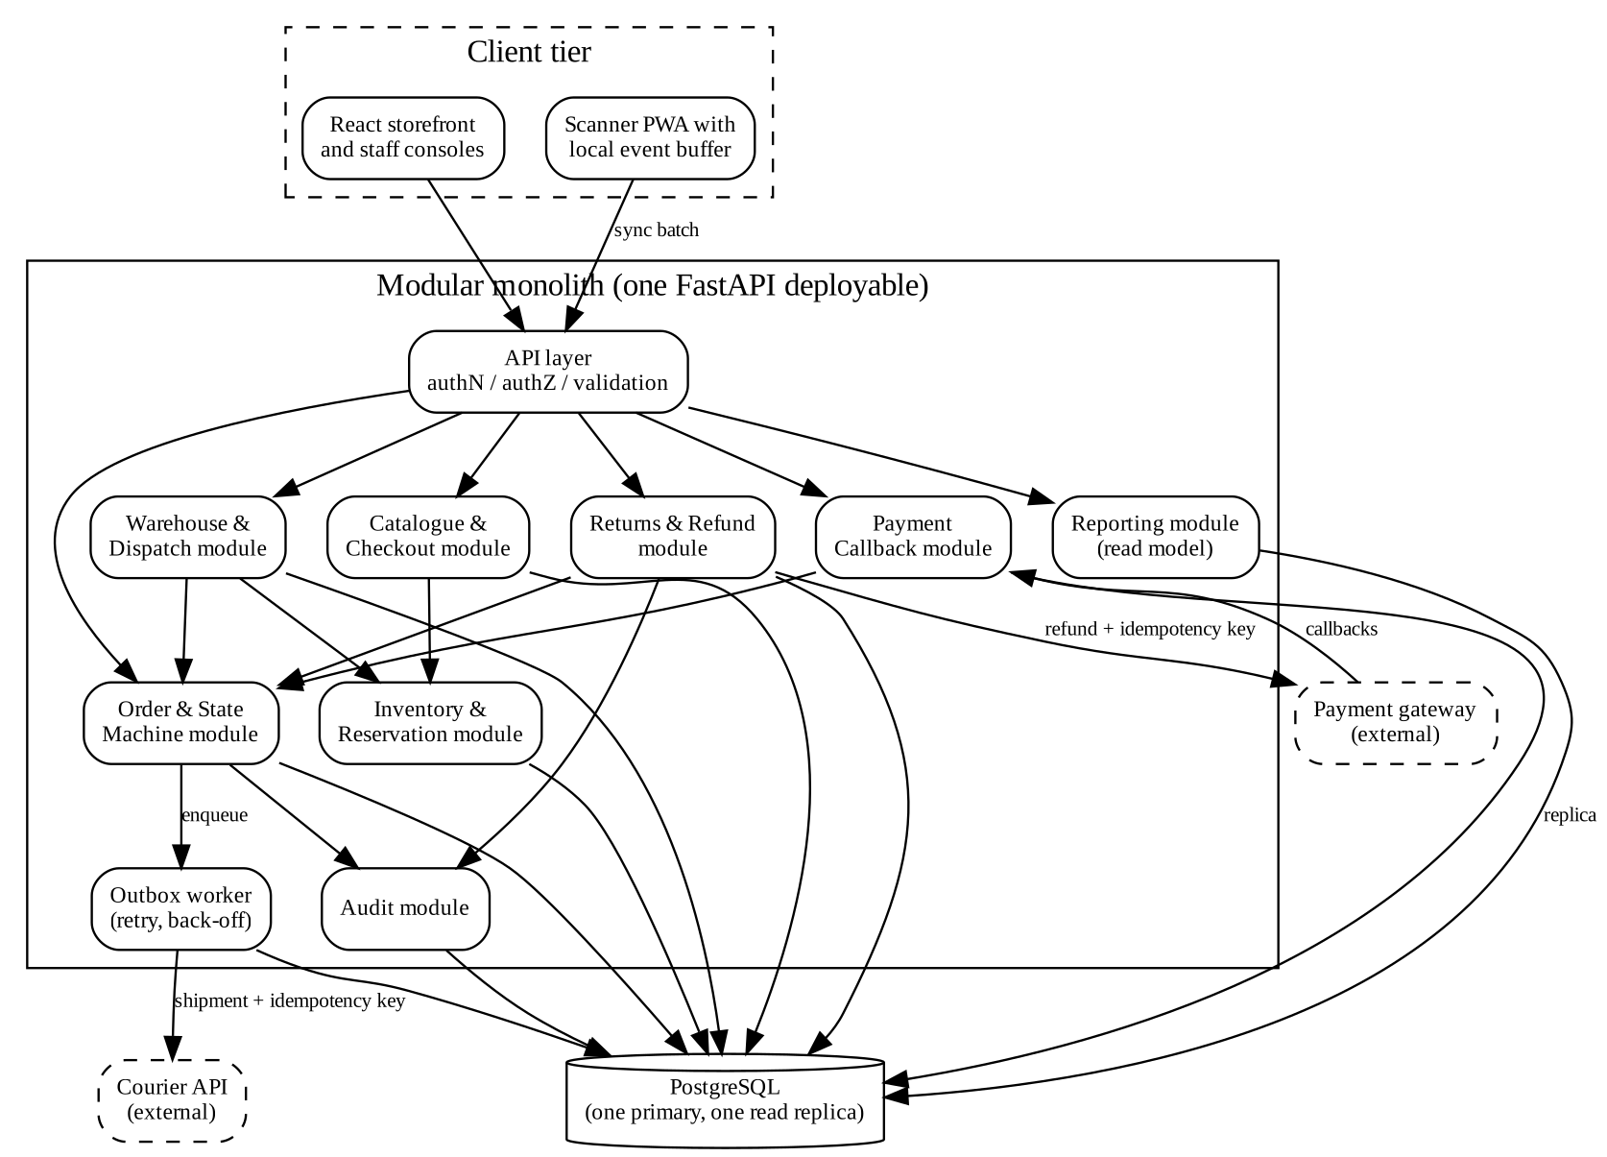
Figure 21: Component diagram of the selected modular monolith (version 1.1)
The deployment diagram shows the representative release for three regions. A CDN serves the React build. A load balancer terminates TLS and spreads requests across two identical application containers that each also run an outbox worker. PostgreSQL runs as a managed primary with daily backups and continuous archiving, which is what the recovery target NFR-06 relies on, and a read replica serves reports. Logs and metrics go to a monitoring service that raises alerts for the dead-letter and failed-refund conditions. The payment gateway and courier are software-as-a-service dependencies, and the gateway reaches the system only through the load balancer's callback endpoint.
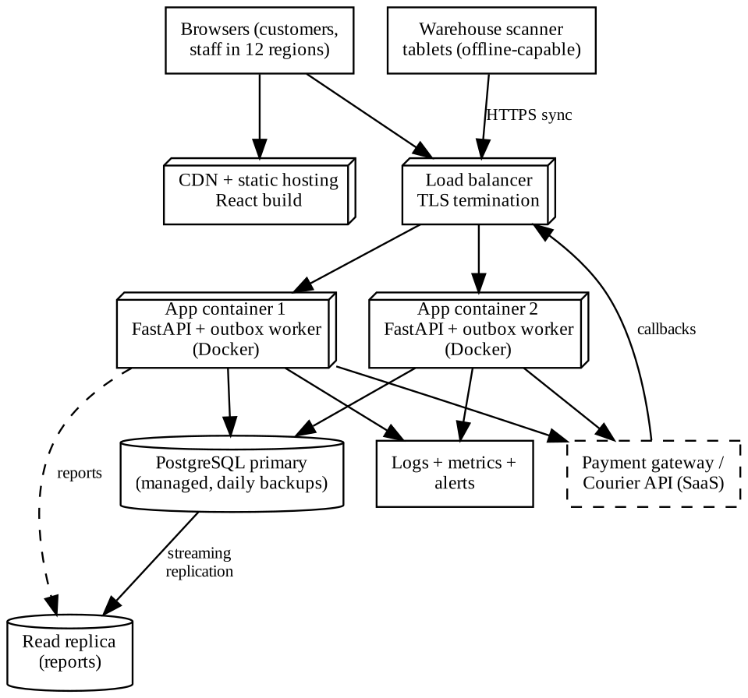
Figure 22: Deployment diagram for the representative release (three regions)

4.6 Architectural decision records
These records are also kept as Confluence pages. I used a fixed template so that every decision states its problem, the alternatives, the choice, the reasons and the consequences, including the ones I do not like.
ADR-001 | Modular monolith as the architectural style
Status | Accepted (version 1.0)
Problem | The platform must keep order, payment, stock and refund facts consistent, while a small team runs a modest deployment and extra services must be justified by cost and complexity.
Alternatives considered | (1) Modular monolith. (2) Event-driven microservices with a broker and one database per service. (3) Plain layered monolith without module boundaries.
Decision | Adopt a modular monolith with eight modules, one deployable and one PostgreSQL database.
Justification | Strong consistency through single transactions makes the key invariants easy to state and test (Part 5). The weighted matrix favours A (4.30 against 3.20 out of 5). The illustrative cost is about a third. Module boundaries keep later extraction possible, which option 3 would not.
Consequences | One database is a single point of failure, so a managed standby is needed. A single release train means a fault in one module can affect all. Module boundaries need automated checks to survive. Extraction triggers are defined in Section 6.6.
Linked requirements | FR-04, FR-05, FR-13, NFR-03, NFR-07

ADR-002 | Concurrency control and idempotency inside PostgreSQL
Status | Accepted (version 1.0)
Problem | Two customers may buy the last unit, and the gateway may send the same callback twice, even simultaneously.
Alternatives considered | (1) Conditional update and unique key inside a transaction. (2) Application-level locking with a distributed lock. (3) Optimistic version column with retry in the application.
Decision | Reserve stock with a single conditional update and identify every gateway event with a unique key; both inside one transaction.
Justification | The database already serializes writers, so correctness does not depend on application timing. Option 2 adds a new component and a new way to fail. Option 3 would work but needs retry logic in every caller. Scenarios V1, V2 and E1 test the decision.
Consequences | Hot products make writers wait for each other, which is acceptable at the planned load. The unique key table grows and needs an archival policy. The decision ties the design to a database that supports these constraints.
Linked requirements | FR-04, FR-05, FR-06

ADR-003 | Transactional outbox for courier and gateway effects
Status | Accepted (version 1.0)
Problem | Courier synchronization may fail after the order is stored, and a refund request to the gateway may fail after approval. Customers must not lose orders because of these failures.
Alternatives considered | (1) Call the courier inside the request. (2) Transactional outbox with a worker, retry, back-off and dead-letter state. (3) Publish to a message broker.
Decision | Write the order change and an outbox job in the same transaction and let a worker perform the external call with an idempotency key.
Justification | The local record is always committed first, which satisfies conflict C5. A retry is safe because of the idempotency key. Option 1 couples checkout latency to the courier. Option 3 solves the same problem with an extra component the team does not need yet. Scenarios V5 and V5b test it.
Consequences | The customer sees tracking later than the order. Operators must watch the dead-letter queue. If the courier ignores the idempotency key, duplicate shipments are possible and a reconciliation report is needed.
Linked requirements | FR-10, NFR-03

ADR-004 | Server-side authorization with masked read models
Status | Accepted (version 1.0)
Problem | A support agent must not gain finance privileges by selecting another role in the interface, and must not see payment data.
Alternatives considered | (1) Trust the role sent by the client. (2) Check the role in each front-end screen. (3) Read the role from the user table on the server inside every operation and build separate read models per role.
Decision | Option 3. Every operation looks up the caller's role in the database, and read operations return role-specific views.
Justification | Only the server can be trusted; options 1 and 2 are bypassed by anyone able to edit a request. Separate read models make the absence of payment fields in the support view a structural property, not a rule remembered by each developer. Scenarios V6 and V7 test it.
Consequences | An extra lookup per operation, which is cheap. Each new role needs a new read model and tests. Denials are logged, so the audit table grows faster.
Linked requirements | FR-12, FR-13, NFR-04

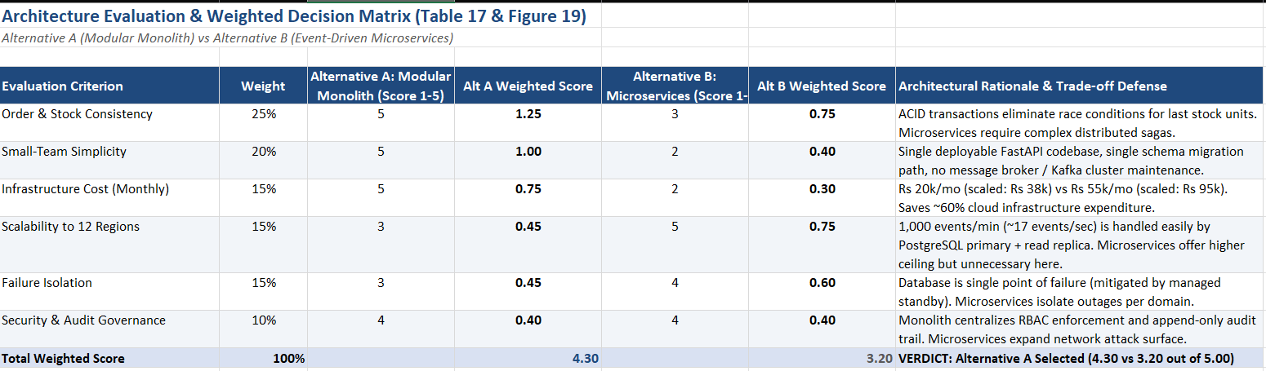
Figure 23: Confluence pages for the architecture decision records

5. Validating Critical Behaviour and Revising the Design (Q5)

5.1 Invariants
An invariant is a statement that must be true at every point of operation, whatever the sequence of events. I wrote them before the prototype so that the prototype could be judged against them, and each one is enforced by a named requirement or design decision.
Table 18: Order and refund invariants
ID | Invariant | Enforced by
I-1 | A gateway event identity produces at most one payment record, one order confirmation and one shipment record. | FR-05, ADR-002
I-2 | For every product, 0 ≤ reserved ≤ on-hand at all times; a unit is never promised to two orders. | FR-04, ADR-002
I-3 | An order is Paid only if exactly one Confirmed payment exists whose amount equals the order total. | FR-05, FR-06
I-4 | An order can be Dispatched only after a confirmed payment and a confirmed pick. | FR-09
I-5 | A refund reaches Executed only through Approved; an unapproved refund cannot be marked executed through the approval-gated operation. | FR-13, FR-14
I-6 | The approver of a refund is never its requester, never a support agent or customer, and is a finance reviewer if the amount exceeds the regional limit. | FR-13
I-7 | The sum of live refunds (Requested, Approved, Executed) for an order never exceeds the amount paid. | FR-14, OR-9
I-8 | The local order record exists before any external call (courier or gateway) for that order is attempted. | FR-10, ADR-003
I-9 | Every denial, approval, execution and status change has an audit entry. | FR-15
I-10 | A client-supplied role, price or total is never used in a decision. | FR-03, ADR-004

5.2 Operation contracts
I specified preconditions and postconditions for four operations. The first two are the ones the brief asks for explicitly; the other two cover the stock and dispatch rules.
Table 19: Operation contracts
Operation | Preconditions | Postconditions
confirmPayment(eventId, orderId, amount) | The order exists. The caller is the gateway callback endpoint. No payment record with this eventId exists, or one exists (the repeat case). | If the eventId is new and amount equals the total and the order is Placed: exactly one Confirmed payment exists, the order is Paid, one PendingSync shipment and one outbox job exist, and an audit entry is written. If the eventId already exists: nothing changes, the result is duplicate_ignored. If the amount differs or the order is not Placed: a payment record with status Mismatch or NeedsReview exists and the order is unchanged.
executeRefund(refundId) | The refund exists and its status is Approved. The gateway call carries the key refund-<id>. | On success the status is Executed and no further execution is possible. On failure with fewer than three attempts the status remains Approved and the attempt count increased by one. On the third failure the status is ExecutionFailed, no money is recorded as moved and an escalation audit entry exists. If the status was not Approved on entry, nothing changes and PRECONDITION_FAILED is returned.
placeOrder(customerId, items, region) | The caller's server-side role is customer. Every product has at least the requested available quantity at the moment of the conditional update. | An order in status Placed exists with prices, tax and shipping calculated from server data; for each line reserved increased by the quantity; the hold expires in 15 minutes. If any line cannot be reserved: no order exists, no reservation of this request remains (the transaction is rolled back) and OUT_OF_STOCK is returned.
dispatch(orderId, actor) | The actor is a picker or store manager. The order exists. | If a confirmed payment and a pick confirmation exist and the status is Packed: the status is Dispatched and the dispatch time is stored, flagged late if after the regional deadline. Otherwise: no change and PRECONDITION_FAILED or INVALID_TRANSITION.

5.3 Validation method and what it can and cannot show
I validated the design with a small executable prototype written in Python on SQLite. It is a faithful model of the rules, because the same constraints (unique keys, conditional updates, transactions with immediate locking) exist in PostgreSQL, but it is not the production stack. The gateway, courier and scanner are test doubles that fail on demand. The users, products and amounts are synthetic. For concurrency scenarios I used real threads released together with a barrier, so the race is real, not scripted.
What the results do show is that the rules, as I specified them, are consistent and can be implemented so that the scenarios hold. What they do not show is production performance, behaviour of a real gateway or courier, or resistance to attack. Timing figures in this report come from a single sandbox run, and I treat them only as a sanity check.
For each scenario I wrote the expected behaviour and the enforcing requirement or decision first (the “Predicted” columns below). The “Observed” column is the output of the script on 5 November 2026. The script is `run_validation.py`; its listing is in Appendix A.

5.4 Validation scenarios
Table 20: Validation scenarios: predicted and observed behaviour
ID | Scenario | Predicted behaviour (written first) | Enforced by | Observed (demonstrated) | Result
V1 | Two customers try to buy the last unit of a product at the same moment. | Exactly one order is created; the other buyer is told the item is out of stock; reserved never exceeds on-hand. | FR-04, ADR-002 | orders created=1, rejected=1, on_hand=1, reserved=1 | PASS
V2 | The same payment callback arrives three times while the first is still being processed. | One confirmation, two ignored duplicates, one payment, one shipment, order Paid. | FR-05, ADR-002 | results=['confirmed', 'duplicate_ignored', 'duplicate_ignored'], payment rows=1, shipment rows=1, outbox rows=1, status=Paid | PASS
V2b | A different event identity pays an order that is already paid. | Second payment stored for review; order not confirmed twice. | FR-06 | result=needs_review | PASS
V3a | An approved refund fails once at the gateway, then succeeds. | Execution blocked before approval; first attempt schedules a retry; second attempt executes once with the same key. | FR-13, FR-14 | before approval=blocked, attempt1=retry_scheduled, attempt2=executed, final=Executed, attempts=2, keys=['refund-1'] | PASS
V3b | The gateway keeps failing. | After three attempts: ExecutionFailed, escalation, no money recorded as moved. | FR-14, I-5 | attempt results=['retry_scheduled', 'retry_scheduled', 'execution_failed_escalated'], final status=ExecutionFailed, successful gateway refunds=0 | PASS
V4 | Dispatch is attempted without payment, then without pick confirmation. | Both refused; allowed only after payment and pick. | FR-09, I-4 | unpaid order: PRECONDITION_FAILED; paid but not picked: PRECONDITION_FAILED; after payment and pick -> status=Dispatched (on-time) | PASS
V5 | The courier API fails twice and then recovers. | Order stays Paid, retries follow back-off, shipment finally syncs. | FR-10, ADR-003 | try1=[(1, 'retry_in_60s')], try2 too early=[], try3=[(1, 'retry_in_120s')], try4=[(1, 'synced')]; order status=Paid; shipment=Synced/TRK000001 | PASS
V5b | The courier never recovers. | After five attempts the job is DeadLetter with an alert; the order stays Paid. | FR-10 | outbox status=DeadLetter; last result=(1, 'dead_letter') | PASS
V6 | A customer or support agent tries to approve a refund, and another customer tries to read an order. | All denied and audited; support view has no payment fields. | FR-12, FR-13, ADR-004 | {'cust1 approve': 'denied', 'agent1 approve': 'denied', 'picker1 approve': 'denied', 'cust2 approve': 'denied', 'cust2 reads cust1 order': 'denied', 'cust2 requests refund on cust1 order': 'denied'}; support agent view fields=['id', 'region', 'status', 'total']; finance view fields=['gateway_event_id', 'id', 'payment_status', 'region', 'status', 'total']; DENIED audit rows=6 | PASS
V7 | A store manager tries to approve above the regional limit; a manager approves their own request; refunds exceed the amount paid. | Manager denied above limit; finance succeeds; self-approval denied; over-refund blocked. | FR-13, I-6, I-7 | {'manager above limit': 'denied', 'finance above limit': 'approved', 'self approval': 'denied', 'over-refund': 'blocked'} | PASS

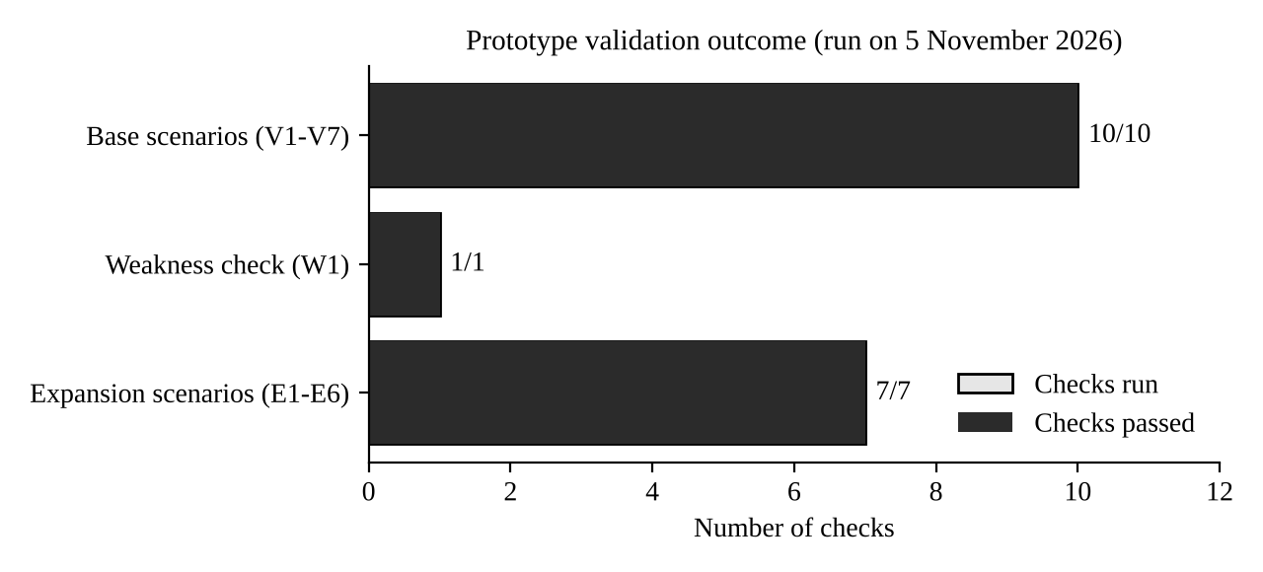
Figure 24: Outcome of the prototype validation run
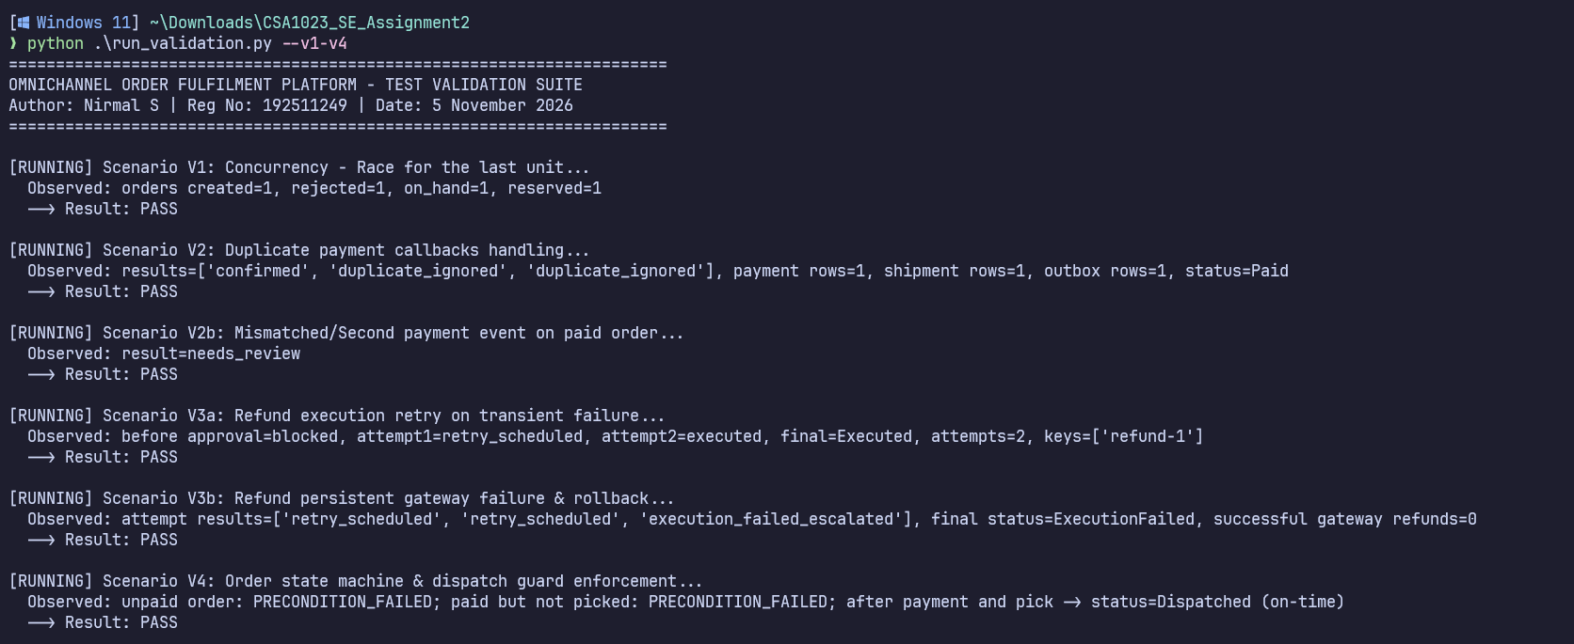
Figure 25: Prototype output for scenarios V1 to V4
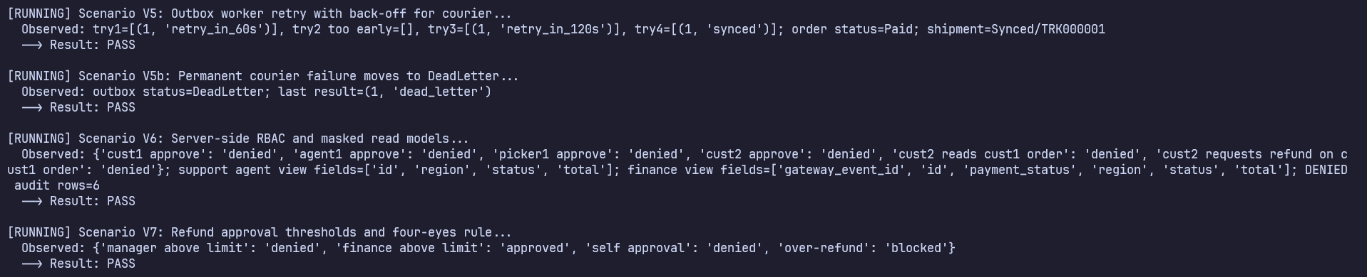
Figure 26: Prototype output for scenarios V5 to V7 and the audit trail

5.5 Reading the results
Two results deserve comment. In V2 the three callbacks run in separate threads released together, and the output shows one “confirmed” and two “duplicate_ignored”, with a single payment row, a single shipment row and a single outbox row. This is the result I predicted, but I did not want to rely on the replies alone, so the check also counts the rows in the tables, because the count is what matters to the finance reviewer.
In V6 the denial count mattered as much as the denial itself. The script checks that six attempts were refused and that six DENIED entries exist in the audit table. While writing this check I realised that my first version of the prototype wrote the audit row inside the same transaction as the refused operation, so the row was rolled back together with the operation and the denial left no trace. I changed the transaction helper so that a denial is recorded in its own small transaction after the rollback, and the count in V6 now confirms it. It is a small example of why “denied” and “denied and recorded” are different requirements.

5.6 Weakness found and design revision
The weakness came from thinking about V1 more carefully. The design reserved stock at checkout and released it only when an order was picked or cancelled. Nothing released the stock of an order that was placed and never paid. So a customer who opened checkout for the last unit and then closed the browser would hold that unit forever and every later buyer would be told it was out of stock. The race condition was solved, but the design had created a quieter way of losing sales. I wrote scenario W1 to confirm it.
Table 21: Weakness W1 and its correction
ID | Weakness | Observed (demonstrated) | Result
W1 | Abandoned checkout holds the last unit forever | second buyer before release: rejected (stock held by an unpaid order); released orders=[1]; second buyer after release -> order 2; late payment result=needs_review; first order status=Cancelled | PASS

Revision R1. I added requirement FR-17 (a 15-minute hold with automatic release), a reservation expiry timestamp on the order, and a transition from Placed to Cancelled for expiry. The state machine in Section 3.4 and the class diagram in Section 3.2 show these as they now stand. The fix created a new corner, since a customer may still pay after the hold has expired, and the payment callback then arrives for an order that is Cancelled. The design treats this as a payment that needs review. The money is recorded, the stock is not silently re-reserved, and a finance reviewer decides between refund and re-instating the order. This behaviour is covered by the second half of W1 and by FR-06. The specification moved from version 1.0 to 1.1, and the traceability matrix, ADR-002 consequences and the Confluence history were updated in the same sitting.
A second weakness is not demonstrated, only reasoned. The refund execution has three steps: mark the attempt, call the gateway, record the result. If the application crashed after the gateway had accepted the refund but before the result was recorded, a retry could ask for the same refund again. The prototype relies on the idempotency key to make the gateway ignore the second request, but my test double does not simulate that crash. I record it as a limitation and propose a reconciliation job that compares the gateway's refund list with local records. It is a proposed extension, and not part of what I have demonstrated.
Figure 28: Prototype output for W1 before and after the revision

6. Redesign for Expansion and Partial Failure (Q6)
The changed requirement raises the system from three regions to twelve, from 50 to 500 simultaneous users and from 100 to 1,000 stock, payment and scan events per minute. These numbers are design assumptions, not demonstrated capacity. Each region may define its own tax, shipping and refund-approval rules. A disconnected warehouse scanner must be able to buffer events, and a refund approval queued offline must not appear as globally approved before the server validates it. Management wants consolidated reports, and the budget allows only a limited rise in infrastructure cost.
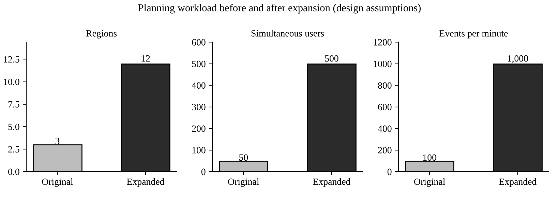
Figure 29: Planning workload before and after the expansion (design assumptions, not measured capacity)

6.1 Impact analysis (Part A)
I went through the specification, the models and the architecture and marked what the expansion touches. Not everything is affected, which matters, because a change request that touches everything usually means the design has no structure.
Table 22: Impact of the expansion
Area | Affected items | Comment
Requirements | FR-03 (tax and shipping per region), FR-09 (deadline per region), FR-13 (refund limit per region), FR-16 (consolidated reports). New: FR-18 to FR-21, NFR-07. NFR-01, NFR-02 thresholds re-derived for 500 users and 1,000 events per minute. | Rules that were global become per-region configuration; new offline behaviour appears.
Assumptions | One global rule set; one warehouse network that is always connected; reporting on the operational database. | All three assumptions no longer hold.
Components | Catalogue and Checkout, Warehouse and Dispatch, Returns and Refund (read their rules from configuration). New: Region rules module and Scanner sync module. Reporting moves to a read replica. | Order, Payment Callback, Audit and Outbox worker are unchanged in responsibility.
Data | New region_rules table; scan_events with unique event id; refund approval state for queued approvals. | Region becomes part of an order's identity for reporting.
Quality attributes | Scalability (10x users, 10x events), availability (scanners disconnected), consistency (offline buffering), security (regional administrators), cost (limited budget). | Consistency of stock and refunds is the attribute most at risk.
Not affected | Order state machine, payment idempotency, outbox pattern, audit design, the invariants I-1 to I-10. | These carry over; scenario results V1 to V7 remain the regression suite.

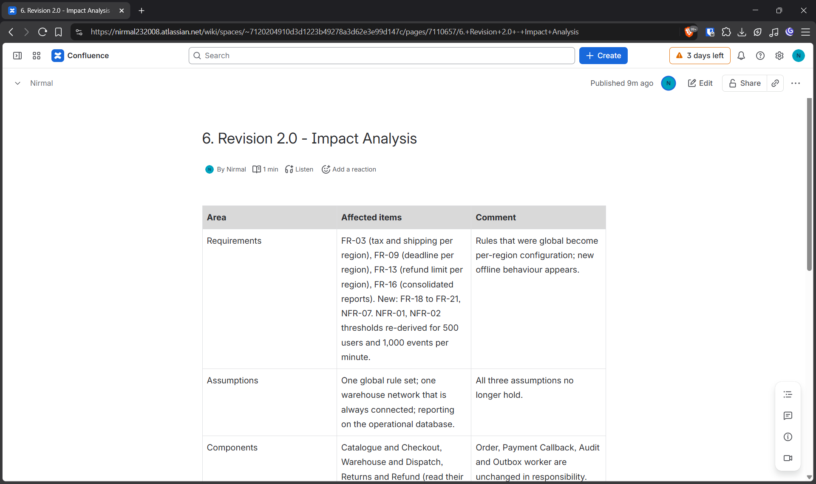
Figure 30: Confluence impact analysis page for the expansion

6.2 Revised architecture (Part B)
The central decision is to keep the modular monolith and make it scale out, instead of splitting it into services. I tested this decision against each part of the change. Ten times the users is handled by adding stateless application containers behind the load balancer, which costs little and needs no change in the logic. Ten times the events means about 17 events per second, which a single PostgreSQL primary handles comfortably, because each event is one short transaction. The things that really change are the rules, which become data, and the scanners, which need a small protocol. Splitting into services would not help with either of these, which is why I do not do it. Each architectural change below is tied to a requirement or a limitation.
Table 23: Revised component responsibilities
Component | Revised responsibility | Driven by | Data ownership
Region rules module (new) | Holds tax rate, shipping, dispatch deadline and refund limit per region, with an effective-from date. Only administrators change it; every change is audited. | FR-18, C-series conflict C6 | Owns table region_rules; other modules read through its interface
Scanner sync module (new) | Receives batches of uniquely identified events and queued approvals from scanner nodes; applies each event identity once; returns an acknowledgement per identity. | FR-19, FR-20, FR-21 | Owns table scan_events; calls Inventory and Refund through their interfaces
Inventory and Reservation | Applies received goods automatically; stores negative corrections as NeedsReview until a store manager confirms. | FR-21, C4 | Owns products and stock movements
Returns and Refund | Reads the refund limit from Region rules. Validates queued approvals on the server using the same rules as online approvals. | FR-13, FR-20 | Owns refunds
Reporting | Runs on the read replica, refreshed every five minutes, grouped by region. | FR-16, NFR-07, C6 | Reads replica only; owns no operational data
Deployment tier | Application containers increase from two to three plus one worker container; read replica added; scanners reach the same load balancer. | NFR-07 | Stateless containers; database holds all state

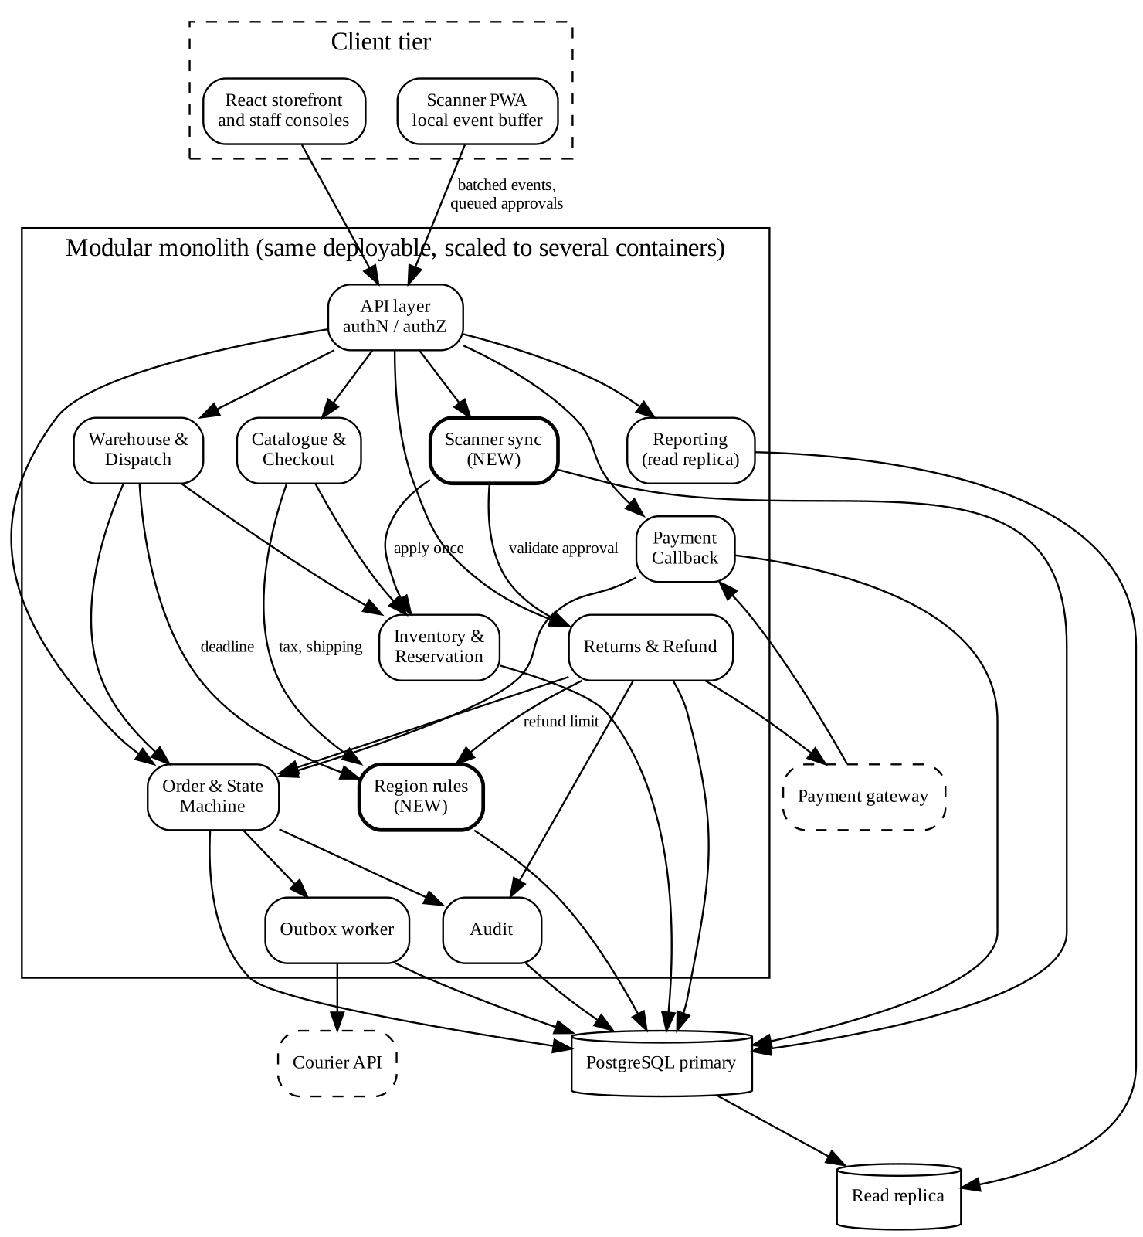
Figure 31: Revised component diagram (new modules in bold)
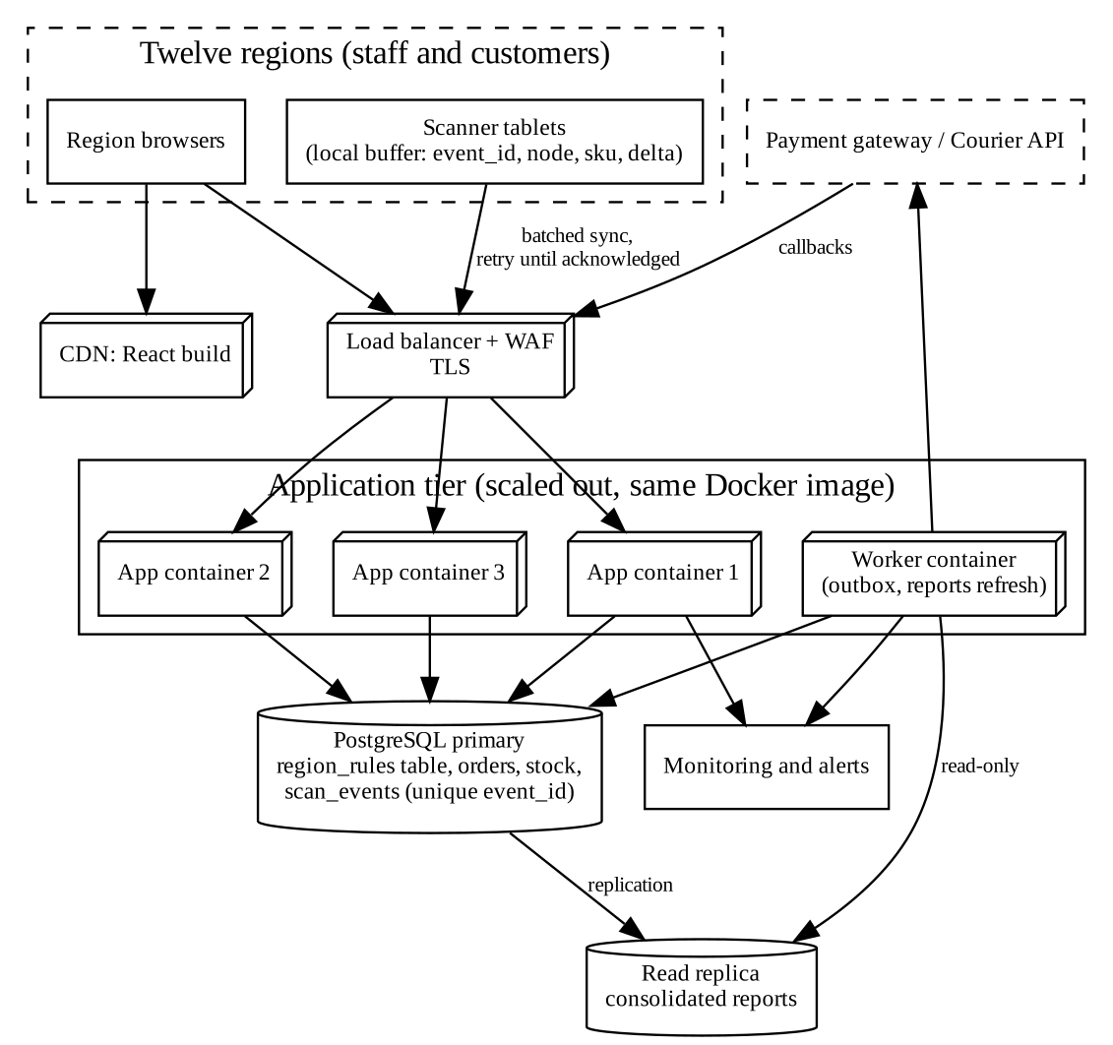
Figure 32: Revised deployment diagram for twelve regions

6.3 Pending buffered events, deduplication and server-validated approval
A scanner node is a small web application with a local store. Every scan it records gets an identity made from the node name and a random value, for example SCN-CHN-07-a41f… That identity is the key to everything that follows. When the link returns, the node sends its buffered events in batches. The server inserts each identity into a table with a unique constraint and answers either “applied” or “duplicate ignored”. The node deletes an event only after the server has acknowledged that identity. So a dropped connection can only cause a resend, never a loss, and a resend can only produce a duplicate, which the server ignores. The same mechanism covers the case in which the acknowledgement is lost after the server has applied the event.
Approvals queued offline are different, because they carry authority. The terminal may remember “manager X approved refund 17”, but it has no standing to make that approval real. It displays the state as Pending server validation, in words and colour that differ from Approved. When the node syncs, the server runs the same checks as for an online approval: the role comes from the server's user table, the amount is compared with the regional limit, and the requester is compared with the approver. Only if all pass does the refund become Approved. Otherwise the answer is a rejection with a reason, which the terminal then shows. At no time before validation does any other screen show the refund as approved, because the server's record is still Requested.
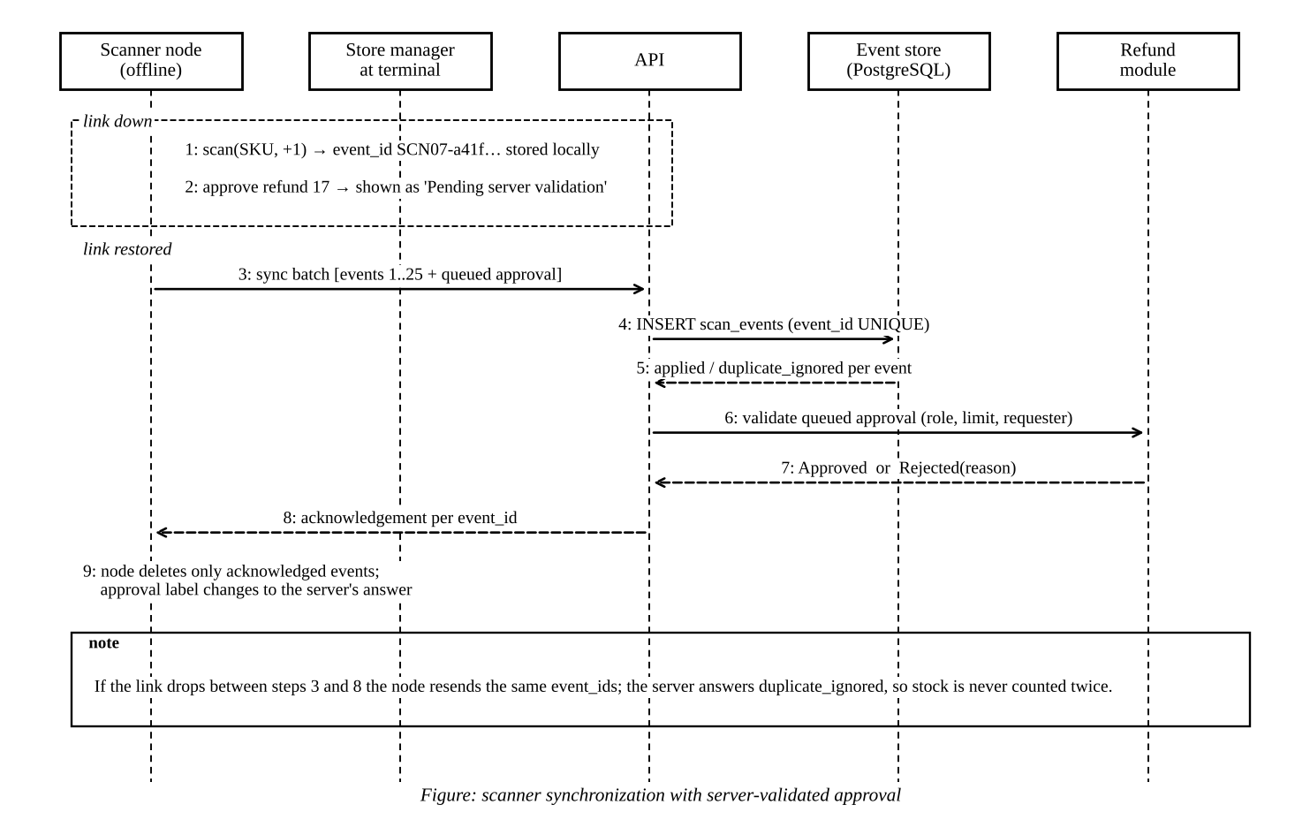
Figure 33: Scanner synchronization with server-validated approval
Table 24: Synchronization rules for disconnected scanner nodes
Rule | Synchronization rule
SR-1 | Every scan or stock event has a unique identity created on the node at the time of the scan.
SR-2 | The server stores each identity once (unique key). A repeat is acknowledged as duplicate_ignored and changes nothing.
SR-3 | A node removes an event from its buffer only after the server acknowledges that identity.
SR-4 | Received goods (RECEIVE) are applied automatically. Negative corrections (ADJUST) are stored as NeedsReview and applied only after a store manager confirms, and only if stock stays at or above the reserved quantity.
SR-5 | Events from one node are applied in the order of their local sequence; events from different nodes are independent because they are additive.
SR-6 | An approval queued offline is displayed as Pending server validation and is not a refund state. The server validates role, limit and requester on sync.
SR-7 | If validation fails the approval is rejected with a reason; the refund remains Requested.
SR-8 | A node that stays disconnected longer than a set period (assumed 24 hours) raises an alert to the store manager and keeps buffering.

6.4 Revised requirements
The revised and new requirements are FR-18 to FR-21 and NFR-07 in Sections 2.5 and 2.6, and the changes to existing requirements are listed below. The Jira issues carry the label release-2.0, and the Confluence page history records the new version of the specification.
Table 25: Existing requirements changed by the expansion
Requirement | Change in version 2.0
FR-03 | Tax and shipping come from the region rule of the order, not from one global setting.
FR-09 | The dispatch deadline is read from the region rule.
FR-13 | The limit between store-manager and finance approval is read from the region rule; a queued approval is validated on the server (links to FR-20).
FR-16 | Reports are grouped by region and read from the replica.
NFR-01, NFR-02 | Thresholds are restated for 500 simultaneous users and 1,000 events per minute and must be shown by a load test before go-live.

6.5 Validation of the redesign (Part C)
I added seven scenarios, E1 to E7, and also re-ran V1 to V7 against the revised prototype as a regression check. All of them passed. Three of the new scenarios cover the three things the brief names: load (E1 and E4), synchronization (E2 and E3) and partial failure (E2 again, E3 and E7).
Table 26: Additional scenarios for the expansion
ID | Scenario | Predicted behaviour | Enforced by | Observed (demonstrated) | Result
E1 | 100 simultaneous buyers compete for 40 units (a scaled-down stand-in for the 500-user peak). | Exactly 40 accepted, 60 rejected, reserved = 40, nothing oversold. | FR-04, NFR-07 | accepted=40, rejected=60, reserved=40, on_hand=40, wall time=0.36s | PASS
E2 | A scanner buffers 25 events, loses the link after 10, and 5 events are resent. | Each event applied once; stock +25; buffer ends empty. | FR-19, SR-1 to SR-3 | first sync: link lost after 10; still buffered=15; second sync sent=15; on_hand=65; stored events=25; buffer now=0 | PASS
E3 | A store manager queues, offline, an approval above the regional limit. | Terminal shows Pending; server stays Requested; server rejects on sync. | FR-20, SR-6, SR-7 | terminal label='Pending server validation'; server status while offline=Requested; sync outcome='Rejected by server: amount above regional limit needs a finance reviewer'; server status after sync=Requested | PASS
E4 | 1,000 events with 10% duplicates arrive together. | 900 applied, 100 ignored, stock +900. | FR-19, NFR-02 | applied=900, duplicates ignored=100, on_hand=940, wall time=0.81s on this laptop-class sandbox (illustrative only) | PASS
E5 | The same basket is ordered in two regions with different rules. | Tax, shipping and deadline follow each region. | FR-18, FR-03 | IN-TN total=35344 (tax 4644, ship 4900, SLA 48h); IN-KA total=34796 (tax 3096, ship 5900, SLA 24h) | PASS
E6 | Consolidated report compared with global totals. | Regional totals add up to the global totals. | FR-16 | orders=4, gross by region sum=80714, global=80714; refunds by region sum=6000, global=6000 | PASS
E7 | A negative stock correction is scanned offline. | Stored as NeedsReview; picker cannot confirm; manager confirmation applies it. | FR-21, SR-4 | after sync: status=NeedsReview, on_hand=40; picker confirm=denied; after manager confirm: status=Applied, on_hand=37 | PASS

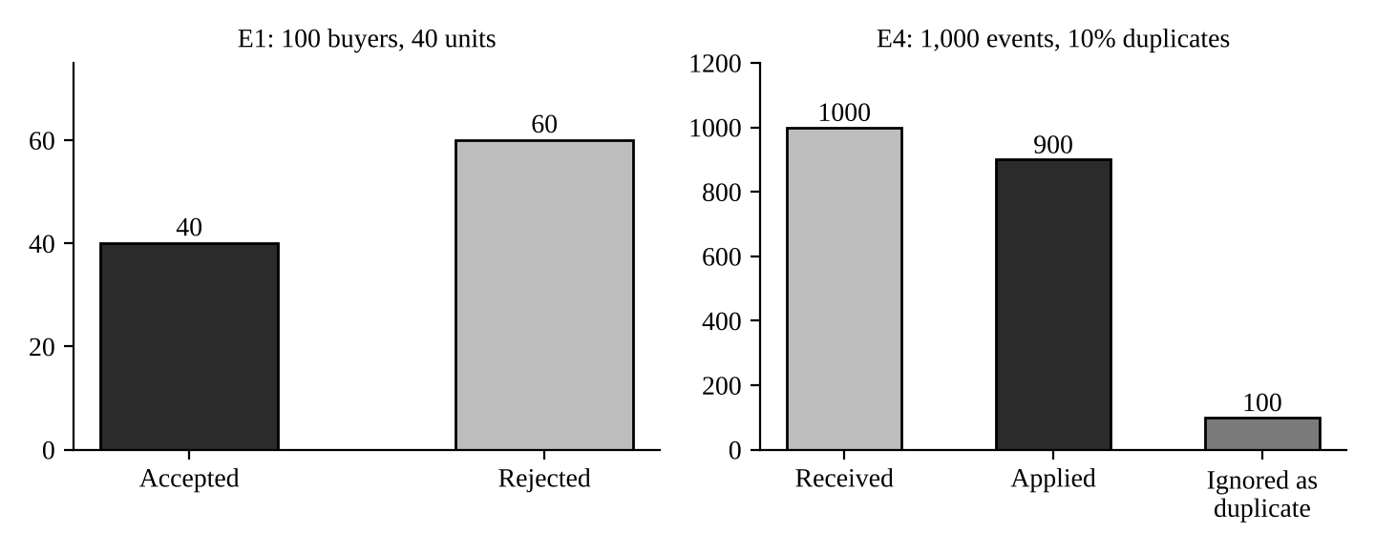
Figure 35: Load and deduplication results from scenarios E1 and E4
Scenario E4 processed 1,000 events in 0.81 seconds on the sandbox where I ran it, and E1 handled 100 simultaneous buyers in 0.36 seconds. These numbers say only that the logic does not collapse at ten times the original event rate on a small machine. They are not evidence about the cloud environment, the network, 500 real users with browsers, or a PostgreSQL server, and a proper load test is listed in Part 7 as additional evidence.
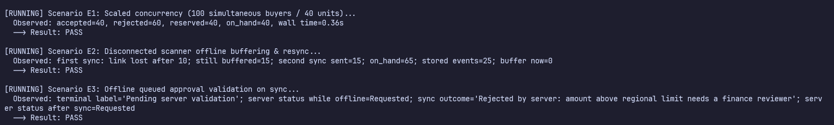
Figure 36: Prototype output for scenarios E1 to E3
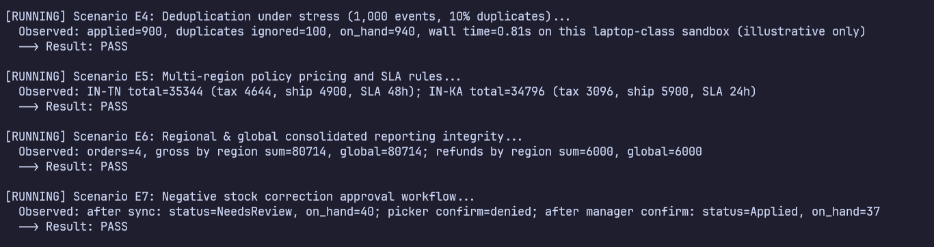
Figure 37: Prototype output for scenarios E4 to E7 and the summary line

6.6 Defence of the design (Part D)
Benefits. The design keeps the property that matters most in this scenario: the facts about an order, its stock, its payment and its refund are changed together or not at all. The expansion is absorbed by configuration (regional rules), by identical containers (users), and by a small, well-defined protocol (scanners). The invariants and the regression suite carry over unchanged, which is some evidence that the structure was sound before the change.
Costs. The infrastructure cost rises from roughly Rs 20,000 to Rs 38,000 a month in my illustrative estimate, an increase of 90%, which is inside the assumed limit of 100% but not by much. The alternative of microservices would have been roughly Rs 95,000 on the same assumptions. Adding configuration for twelve regions also adds an operational task, since a wrong tax rate is now a data error and not a code error, and it needs review before an effective date.
Consistency and availability. For most operations I chose consistency. A payment, a reservation or a refund approval is accepted or refused on the server, immediately and in full. Availability is preserved at the edges only where the cost of waiting is low and the risk is controlled: scanners keep working offline, and the courier can be down without stopping orders. The price is that some information is stale for a while. A store manager at a disconnected terminal sees “Pending server validation” instead of a decision, stock counts in the warehouse may lag until the sync, and a customer may see “payment pending” for a short time. I think this is the right side of the trade-off for money and stock, and I would choose differently for a catalogue page or a recommendation list, where stale data costs little.
Remaining limitations. One PostgreSQL primary remains the single write point and a single point of failure for the whole platform. A standby reduces the risk but does not remove it, and a regional outage that affects the primary affects all twelve regions at once. Regional rules in one shared database mean a wrong setting by one regional administrator can affect only that region's orders, but a bug in the rules module affects all. The scanner protocol assumes that ordering between nodes does not matter because events are additive, which holds for receipts but would not hold for a pick that depends on a prior transfer. Finally, none of these claims has been tested at 500 users on real infrastructure.
When I would change my mind. I would extract a service when evidence shows one of these: sustained events well above ten times the new planning rate (for example more than 10,000 per minute), reporting queries that slow the primary despite the replica, or several teams that need to release independently. The first candidate would be Reporting, which already uses a replica and owns no operational data, followed by the Courier integration, which already communicates through the outbox.

7. Individual Technical Reflection (Q7)
The requirement that most influenced my architecture. It was FR-04, the rule that two customers cannot both obtain the last unit, together with FR-05 on duplicate callbacks. Both are about one question: who decides when two things happen at once? Once I accepted that the answer had to be the database inside a transaction, a lot of other decisions followed. It pushed me towards one database, towards a modular monolith, towards the outbox for everything that leaves the system, and against microservices for this release. If the requirement had been only about throughput, my answer would have been different.
The stakeholder conflict I found hardest to resolve. It was C3, refund speed against refund control. In the other conflicts there was a technical move that satisfied both sides, such as masking payment fields for support or committing locally before calling the courier. In the refund case the two wishes genuinely pull apart. The customer wants the money now, and the finance reviewer wants a person to look first. The best I could do was to split the process into request, approval and execution, to set a regional limit so that small refunds are quick, and to keep large ones slow on purpose. I am not certain that Rs 2,000 is the right limit, and only a real finance team could tell me.
The inconsistency discovered through modelling and validation. Two stand out. Through modelling, it was I2, where the same word “shipment” meant the courier registration in the sequence diagram and the physical dispatch in the state machine; I would not have noticed it from the requirement text alone. Through validation, it was the abandoned-checkout weakness W1, which I only saw after the race for the last unit had already passed. Fixing a race had silently created a worse problem. A second, smaller lesson came from V6, where a refused action rolled back its own audit record.
The trade-off that remains significant. It is the single PostgreSQL primary. It buys me strong consistency and a design a small team can run, and it costs a single point of failure and a ceiling on writes. I have mitigated this with a standby, replicas for reading and a defined path for extracting services, but I have not removed it. If the retailer's growth came faster than my assumptions, or if regions needed to keep trading while disconnected from the central site for long periods, this is the decision that would be reopened first.
Additional evidence needed before implementation. I would want a conversation with real warehouse, support and finance staff to confirm the simulated responses, especially the 15-minute hold and the refund limits. I would want the real payment gateway's documentation to confirm that callbacks carry a unique event identity and that refunds accept an idempotency key, and the same for the courier. I would want a load test on the actual stack, with 500 virtual users and 1,000 events per minute, measuring p95 and p99 latency against NFR-01 and NFR-02. A failure drill is needed that kills the primary database and the courier connection and measures recovery against NFR-03 and NFR-06. I would want a security review of the authorization checks, including an attempt to forge role fields, and a cost estimate from real quotations to replace my illustrative figures. And, finally, I would like to add the validation script to a Jenkins or GitHub Actions pipeline so that the scenarios run on every change.
Rubric Map
The table below shows where each assessed item in the assignment brief is answered in this report, and what kind of evidence supports it. “Demonstrated” means the result comes from running my prototype; “Predicted” means I wrote it down before running anything; “Simulated” means a labelled stand-in for a real stakeholder conversation; “Illustrative” means a planning figure that is not a measurement.
Table 1: Map of rubric items to sections of this report
Question (marks) | Assessed item | Where answered | Evidence status
Q1 (5) | At least three investigation questions | 1.2, Table of questions | Written before the discussion
 | Findings from discussion or questionnaire (labelled if simulated) | 1.3, simulated responses; screenshot 1 | Simulated
 | At least three conflicts with justified resolutions | 1.5, five conflicts C1 to C5, plus C6 for Q6 | Design decisions
 | System boundary, actors, exclusions | 1.6, context diagram; 1.7 rejected requests | Design decision
Q2 (8) | Tool arrangements compared and one selected | 2.1, comparison table and justification | Reasoned; screenshots 2 and 3
 | 12+ functional and 6+ non-functional requirements with IDs, sources, priorities, acceptance criteria | 2.5 and 2.6 (21 functional, 8 non-functional) | Specification; screenshots 4 to 6
 | Order rules (price, tax, reservation, ownership, status, deadlines, duplicate callbacks, refund approval) | 2.4, rules OR-1 to OR-9 | Specification
 | Vague statements replaced with measurable ones | 2.7, before and after table | Specification
 | Prioritization method; assumptions and open questions | 2.3, 2.8; 2.9 | Calculated scores
 | Two conflicts that shaped the specification | 2.10 | Design decisions
Q3 (7) | Use case, class, sequence and state machine diagrams; refund behaviour | 3.1 to 3.5 (use case, class, 2 sequence, 2 state machine diagrams) | Models
 | Traceability matrix Requirement → UML → Component → Scenario | 3.6 | Matrix; screenshots 7 to 9
 | Two or more inconsistencies found and fixed | 3.7 (four found) | Documented corrections
Q4 (8) | Two different architectural alternatives analysed | 4.1 and 4.2 | Reasoned
 | Comparison, selection, component and deployment diagrams | 4.3, 4.4, 4.5 | Weighted matrix, diagrams
 | At least three architecture decision records | 4.6 (ADR-001 to ADR-004); screenshot 10 | Records
Q5 (7) | Invariants and operation contracts | 5.1 and 5.2 | Specification
 | Six or more scenarios with expected and observed behaviour | 5.4 (V1 to V7, W1) | Predicted, then demonstrated; screenshots 11 and 12
 | Weakness identified and design revised | 5.6 | Demonstrated; screenshots 13 and 14
Q6 (10) | A. Impact analysis (2) | 6.1 | Analysis; screenshot 15
 | B. Revised architecture, synchronization rules, server-validated approval (4) | 6.2 to 6.4, diagrams, rules SR-1 to SR-8 | Design; screenshot 16
 | C. Three or more new scenarios (2) | 6.5 (E1 to E7) | Demonstrated; screenshots 17 and 18
 | D. Defence of trade-offs and limitations (2) | 6.6 | Reasoned
Q7 (5) | Individual technical reflection | 7 | Reflection
Submission | Tools and sources acknowledged; prototype listing | Appendix A and B

Appendix A. Prototype Listing (extracts)
The complete prototype (`fulfilment.py`, `run_validation.py`) is in the GitHub repository named in the screenshot of Section 3.6. The extracts below are the parts that carry the rules discussed in the report. The code is Python 3 with the standard library only, and runs with `python run_validation.py`.
A.1 Atomic reservation inside place_order (rule OR-2, FR-04)
# atomic conditional reservation: the check and the write are one statement
cur = c.execute(
"UPDATE products SET reserved = reserved + ? "
"WHERE sku=? AND on_hand - reserved >= ?", (qty, sku, qty))
if cur.rowcount == 0:
raise OutOfStock(sku)

A.2 Idempotent payment callback (rule OR-6, FR-05)
def payment_callback(self, event_id, order_id, amount, outcome="SUCCESS"):
with self.tx() as c:
if c.execute("SELECT 1 FROM payments WHERE gateway_event_id=?", (event_id,)).fetchone():
self.audit(c, "gateway", "DUPLICATE_CALLBACK", f"event:{event_id}")
return "duplicate_ignored"
o = self.get_order(c, order_id)
...
c.execute("INSERT INTO payments VALUES(?,?,?,?)", (event_id, order_id, amount, "Confirmed"))
self.move(c, o, "Paid")
c.execute("INSERT INTO shipments(order_id,status) VALUES(?,?)", (order_id, "PendingSync"))
c.execute("INSERT INTO outbox(kind,order_id) VALUES('courier_sync',?)", (order_id,))
self.audit(c, "gateway", "PAYMENT_CONFIRMED", f"order:{order_id}", f"event:{event_id}")
return "confirmed"

A.3 Refund decision with role, limit and four-eyes checks (FR-13)
def _decide(self, refund_id, actor_id, decision):
with self.tx() as c:
self.require(c, actor_id, "finance_reviewer", "store_manager")
role = self.role_of(c, actor_id)
r = c.execute("SELECT * FROM refunds WHERE id=?", (refund_id,)).fetchone()
if not r or r["status"] != "Requested":
raise InvalidTransition("refund is not awaiting a decision")
if r["requested_by"] == actor_id:
raise deny(actor_id, f"refund:{refund_id}", "self-approval", "requester cannot decide their own refund")
o = self.get_order(c, r["order_id"])
limit = c.execute("SELECT refund_limit FROM regions WHERE code=?", (o["region"],)).fetchone()[0]
if r["amount"] > limit and role != "finance_reviewer":
raise deny(actor_id, f"refund:{refund_id}", "above regional limit", "amount above regional limit needs a finance reviewer")
c.execute("UPDATE refunds SET status=?, approved_by=? WHERE id=?",
(decision, actor_id, refund_id))
self.audit(c, actor_id, f"REFUND_{decision.upper()}", f"refund:{refund_id}")

A.4 Refund execution gate and retry (FR-14)
def execute_refund(self, refund_id, gateway, max_attempts=3):
with self.tx() as c:
r = c.execute("SELECT * FROM refunds WHERE id=?", (refund_id,)).fetchone()
if not r or r["status"] != "Approved":
raise PreconditionFailed("refund is not approved") # invariant I-R1
c.execute("UPDATE refunds SET attempts=attempts+1 WHERE id=?", (refund_id,))
attempts = r["attempts"] + 1
try:
gateway.refund(r["order_id"], r["amount"], idempotency_key=f"refund-{refund_id}")
except GatewayError:
with self.tx() as c:
if attempts >= max_attempts:
c.execute("UPDATE refunds SET status='ExecutionFailed' WHERE id=?", (refund_id,))
self.audit(c, "system", "REFUND_ROLLED_BACK", f"refund:{refund_id}",
"no money moved; escalated to finance")
return "execution_failed_escalated"
self.audit(c, "system", "REFUND_RETRY_SCHEDULED", f"refund:{refund_id}", f"attempt {attempts}")
return "retry_scheduled"
with self.tx() as c:
c.execute("UPDATE refunds SET status='Executed' WHERE id=?", (refund_id,))
self.audit(c, "system", "REFUND_EXECUTED", f"refund:{refund_id}")
return "executed"

Appendix B. Acknowledgement of Sources and Tools
This section lists what I used, as the submission requirements ask. Please edit it so that it states accurately how you worked, and follow your college's policy on declaring the use of AI writing and coding assistants.
Source or tool | Use in this work
Jira and Confluence (Atlassian, free plan) | Requirement issues, specification pages, traceability table and decision records
GitHub | Repository for the prototype, validation script and diagram sources
Graphviz and Python (matplotlib) | UML and architecture diagrams and charts, drawn from text sources
Python 3 and SQLite | Validation prototype and scenario runner (synthetic data only)

All stakeholder responses in Section 1.3 are simulated and are labelled as such. All users, products, orders and stock in the prototype are synthetic, and the payment gateway, courier and scanner are test doubles. No real customer or card data were used.

