**TABLEAU**

# NOTE

* **AGGREGATION - Top, Bottom, Non-Null**
* **ANALYSIS – Highlighter**
* **ANALYTICS PANE - Custom | Model - Lines – Drag to View -SELECT CORRECT OPTION**
* **AXIS – Double Click – Format**
* **AXIS - Edit X Y Axes**
* **AXIS – Right Click – Hide Field Labels**
* **AXIS - X | Y Labels | Marks cards | Filters | Special - DO NOT MATCH ALWAYS AUTOMATICALLY**
* **CALCULATED FIELD - Drop down carat - Top of Data Pane**
* **CALCULATED FIELD - Right Click measure – Create Calculated Field**
* **CALCULATED FILED – DATEPART - SUNDAY = 1 SATURDAY = 7**
* **DASHBOARD - Right Click – Use as Filter**
* **DASHBOARD – Right Click Visual – Filters – Choose Filters**
* **DATA - Convert between dimensions and measures / discrete and continuous**
* **DATA - discrete dimensions and continuous measures are most common combinations of data roles**
* **DATA - Measure Names | Measure Values ARE AUTOMATICALLY GENERATED ALL FIELDS ABOVE**
* **DATA - Tableau assigns data roles to fields automatically. Good practice to review and adapt**
* **FILETR - Measure Names | Measure Values TO ADD MORE FILEDS (INCLUDING CALCULATED)**
* **FILTER – Customize – Show Apply Button**
* **FILTER - Drag to Filter Card or Filter Directly (gets added to Filter card)**
* **FILTER - Fields in Marks Cards can be used as conditions for Filters – BUT CHECK**
* **FILTER – More than one filter – Right Click – Show Relevant Values**
* **FILTER - Order - Extract | Data source | Context | Dimension | Measure**
* **FILTER – Right Click Measure or Dimension – Show Filter**
* **FILTER – Single Value Dropdown**
* **MARKS - Adding to Marks Cards adds to Row or Column**
* **MARKS - Cards – Edit type – Separate for each measure**
* **MARKS – Change chart type in dropdown**
* **MARKS – Edit Label | Change Format | Alignment**
* **MARKS - Show Mark Labels button**
* **QUICK TABLE CALCULATIONS - Triangle**
* **TABLE The field that is listed first in the rows shelf will appear first**
* **VISUAL - Can Drag directly to View**
* **DATA – Create Bins**
* **VISUAL – Exclude Null**
* **VISUAL – Lasso Select – Drag to Bottom**
* **VISUAL – Right Click value – Edit Alias**
* **VISUAL - Show Me button – Ctrl + 1**
* **VISUAL – Tableau will not show if too crowded**
* **WORKSHEET – Right Click – Duplicate as Crosstab**
* **FILTER – Exclude Null**
* **TOOLTIPS - Edit format**
* **TOOLTIPS - Add Visualization**
* **VISUALIZATION - Drag pills to the chart area for quick colour**
* **DATA - Use CTRL key to multi-select pills to drag on and off the canvas**
* **DATA - CTRL + F - Search field name**
* **DATA - Type field names on inline formula**
* **DATA - Right-click (OPTION) and drag a field to Rows, Columns, or the Marks card**
* **DATA - CTRL (CMD) -drag to quickly duplicate fields**
* **DATA - Hide fields not being used/show hidden fields - Data Pane - Dropdown carat**
* **DATA - Create fast hierarchy - Drag one pill on top of another pill - drag other pills**
* **VISUALIZATION - Drag x or y axis to chart area for colour**
* **KPIs - Right Click Measure values and add to sheet**

# How to create and format visualizations in Tableau

* Dragging and dropping dimensions and measures on the canvas, shelves and cards.
* Canvas - where your visualizations will appear.
* Columns - correspond to the x axis of your view.
* Rows - correspond to the y axis.
* Pages shelf lets you break a visualization into several pages, e.g. one page for each neighbourhood.
* Filters shelf lets you filter your data, and you will learn more about this in a next chapter.
* Marks field contains marks cards and marks types.
* Marks cards encompass color, size, and shape: these let you add context and detail to your view.
* Marks types - You can change the type of marks displayed in the view to fit your analysis better.
* Informative titles
* Colours and large fonts
* Legends
* Adjust axes and titles
* Create tooltips
* Can format at both Workbook and Sheet level
* **Dual Axes – Drag to top and right | Right click and choose Dual Axes**
* **Right Click on Y Axis – Choose Synchronise Axes**
* **Hide axes**
* **Centre title**
* **Edit Axes names**
* **Add colours to dimension**

# Workbook vs Sheet

| **WORKBOOK** | **SHEET** |
| --- | --- |
| .twbx | Similar to Excel tab |
| Organise, save share and publish | Displayed along workbook bottom |
| Multiple sheets | 1. Worksheet |
| Similar to whole Excel file | 1. Dashboard |
|  | 1. Story |

# Dashboard vs Story

| **DASHBOARD** | **STORY** |
| --- | --- |
| **Worksheet can be placed in a Dashboard** | **Dashboard can be placed in a Story** |
| Collection of several views | Dashboards can be bookmarked to create stories |
| Easy to compare data | Sequence of visualizations to tell a narrative |
| Uncovers key insights | Each individual visualization is called a Story Point |
| Automatically connected to worksheets | 1. Dashboard |
| Drill down and do advanced | 1. Story |
| Views can be connected – 1 view is interactive filter |  |

* Drag different Worksheets to Dashboards overlay
* Can move | float legend and filters
* Use visualisations | dashboards as interactive filters
* **Add Filter - Click visualisation | dashboard – Analysis toolbar – Filters**
* Drag different Dashboards to Story

# Continuous

* Green fields are continuous fields, treated as an infinite range.
* Examples are the number of reviews per month, room price, or the longitude of the location.
* **Continuous means "forming an unbroken whole, without interruption".**

# Discrete

* Blue fields are discrete, or categorical fields, they have individually separate and distinct values.
* Examples include room type, neighbourhood, and the ID number of the listing.
* **Discrete means "individually separate and distinct."**

# Dimensions

* Dimensions, positioned at the top, contain qualitative values, such as names or dates.
* E.g. in dataset: Neighbourhood, Room Type, or number of reviews per month.

# Measures

* Measures, positioned under the dimensions, contain numeric quantitative values that you can measure, and aggregate.
* E.g. in dataset: Price, Number of minimum nights, and Total number of reviews.

# Attribute (ATTR)

* ATTR() can indicate that there are multiple values from the secondary data source.
* Dimensions added to Tooltip on the Marks card are automatically wrapped in ATTR() because dimensions on Tooltip must be aggregated.
* ATTR() will display * as there is more than 1 value and the view or the values need to be adjusted.
* Like other aggregations, ATTR() can be used to change a non-aggregate value to an aggregate value to resolve aggregation errors in the calculation.
* When a calculation that returns numeric data contains ATTR(), if there are multiple values in the ATTR(), the calculation will return NULL rather than an asterisk.

# Data roles in Tableau

* Discrete dimensions and continuous measures are the more common combinations of data roles.
* E.g. eye color and sex, and height and weight, respectively.
* Less common E.g. discrete measures (shoe size and age) and continuous dimensions (date).

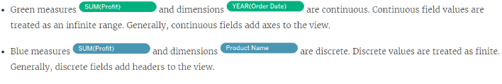

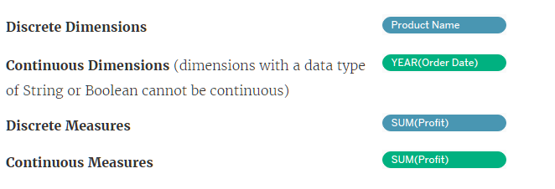

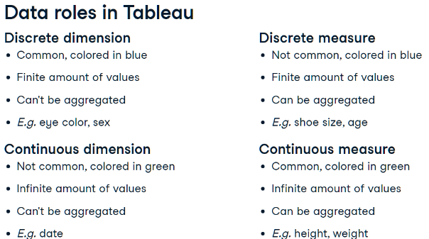

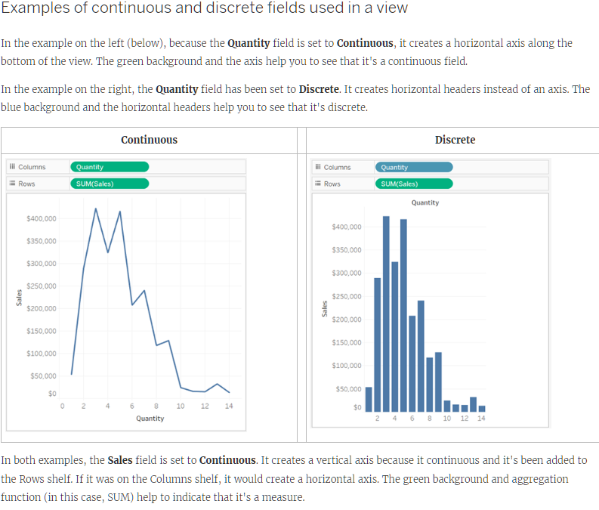

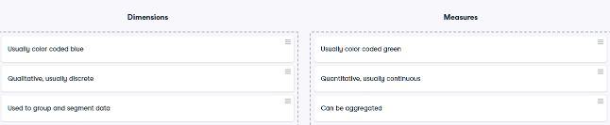

# Segmenting with dimensions

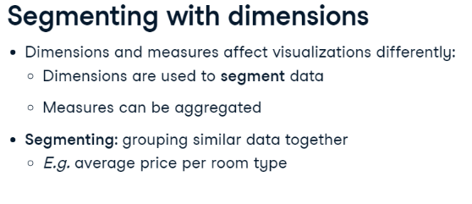

# Filters

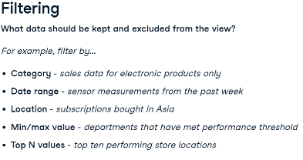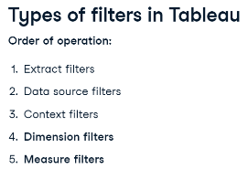

# Dimension filters (in blue)

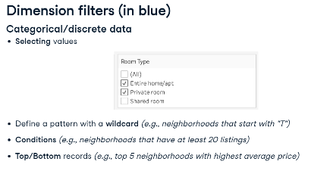

# Measure filters (in green)

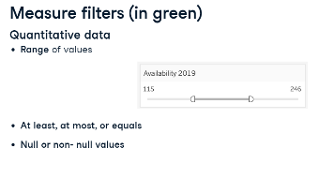

# Sorting

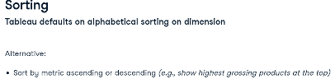

# Aggregation

* Default aggregation for Measures is SUM
* Can only aggregate Dimensions with MIN, MAX, COUNT and COUNT DISTINCT
* Aggregating a Dimension creates a temporary Measure
* All Dimension aggregations can be applied to Measures but not vice-versa

# Calculated Fields

* Create new Field - Measure or Dimension
* Analysis Tab – Create Calculated Field
* Use Functions
* Enter name of Field and add Formula
* Can be edited in dropdown
* Right click Measure and Choose Calculated Field

# Geographical Data

* Filled Map | Symbol map
* Geocoding – Globe icon
* Drag Country (globe icon) to View
  + Automatically creates map and geo data
  + Automatically adds Country to Marks Cards
* Edit Map layers in Map tab

# Date Data

* Calendar Icon
* Date hierarchy
* Top is Dimension – Discrete – Blue – Aggregates
* Bottom is Measure – Continuous – Green – Timeline
* DATEDIFF
* 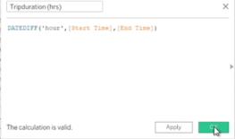
* DATEPART SUNDAY = 1 SATURDAY = 7
* 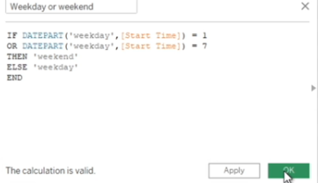

# Reference Lines, Trend Lines, Forecasting

* Reference line drawn on a chart representing another measure or point of reference E.g. AVG
* Reference line – Analytics pane - Custom
* Trend line - used to predict the continuation of a certain trend
* Trend line – Analytics pane - Model
* Forecasting - predicting the future value of a measure using mathematical models
* Forecasting – needs a time dimension and a measure
* Forecast – Analytics pane – Model

# Data Preparation

* When a numeric value is brought into Tableau, it's placed by default in the Measures section
* Move numeric fields that shouldn’t be aggregated to the Dimensions section
* Check Default Properties – Number Format - Custom
* Fit Width
* Edit Alias
* Add Highlighter - Analysis tab
* Show Filter – Customize – Show Apply Button
* Create Calculated Field – Drop Down Carat at top of Data Pane

# Discrete vs Continuous Time Analysis

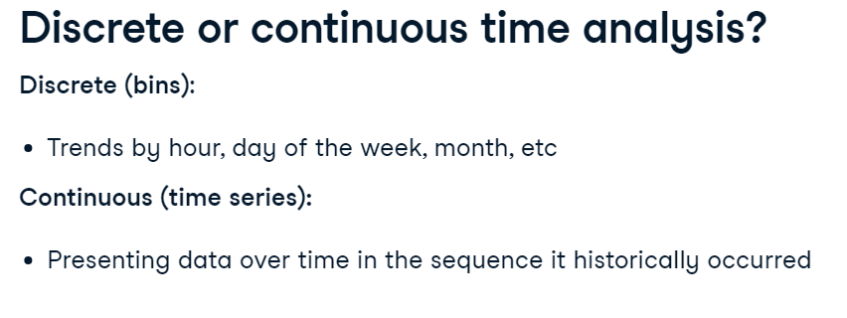

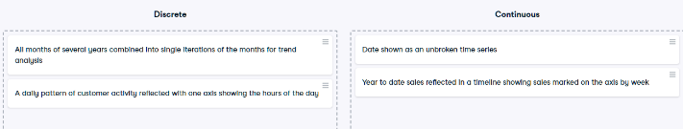

# KPI Dashboard

* Key Performance Indicators are measurable values that track a company's key business objectives.
* Turn off the field label for the columns by right clicking on it and then selecting Hide Field Labels for Column.
* Add KPI charts to pre-formatted dashboard.
* Worksheets - fit the entire view - charts will fill up whatever space is available in the dashboard.
* Turn off the title by clicking down arrow and then unchecking the title.
* When adding sheets to the dashboards, filters are automatically brought in - Remove duplicate.
* Bring in new filters - clicking the down arrow in grey menu upper right corner - Filters, select the one you want.
* Each filter drop-down - Apply to Worksheets - All Using this Data Source – when a filter is applied, every sheet using this data source will filter its content accordingly.
* Select visualization - grey menu - Select Use as Filter - Click the funnel to make it solid so it's used as a filter.

# Mapping

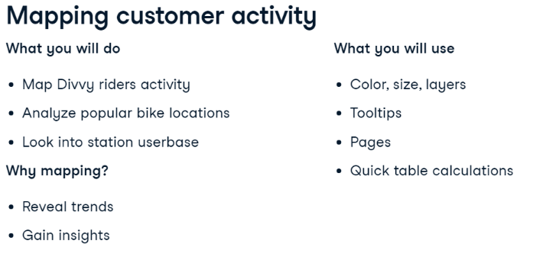

* Colour Palettes
* Opacity
* Size
* Maps – Background – Dark
* Add time filter – Add to Pages shelf
* Marks type – Density
* Density Colour
* Density Intensity
* Dual Axis
* Layering – Multiple Rows
* Multiple Marks for each map
* Overlay – Right Click Rows and select Dual Axis

# Quick table calculations

* A table calculation is a calculation that you can apply to the values in a visualization.
* Examples include running total, difference, percent of total, and many more.
* These predefined calculations are calculated based on what is currently in the visualization.
* They do not consider any measures or dimensions that are filtered out of the view.
* Table calculations are defined by their scope and direction.
* The scope defines the group on which the calculation is performed.
* The direction defines how the table calculation moves within the scope.
* Options are across, down, down then across and so on.
* Quick table calculations are table calculations that you can apply quickly to your visualization.
* They are applied to the visualization with the most typical scope and direction settings.
* When the menu is accessed, only calculations that are possible with your data are available

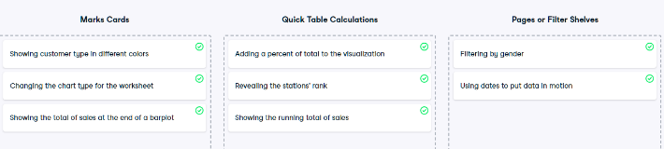

# Ranking

* FILTER - QUICK TABLE CALCULATION - Rank
* Tableau applies Competition Ranking - Data with same value will get same rank