# INTRODUCTION TO TABLEAU

## Note

* **ANALYSIS – Highlighter**
* **Analytics pane – Custom | Model = Lines – Drag to View -SELECT CORRECT OPTION**
* **CALCULATED FIELD - Drop down carat = Top of Data Pane**
* **CALCULATED FIELD - Right Click measure – Create Calculated Field**
* **CALCULATED FILED – DATEPART - Sunday = 1 saturday = 7**
* **FILTER – Highlighter Filter – Right Hand pane**
* **Can Drag directly to View**
* **Change between Measure, Dimension, Discrete, Continuous**
* **Check Default Properties**
  + **Colour - Edit borders, colours, etc**
* **Dashboard - Right Click – Use as Filter**
* **Edit X Y Axes**
* **Fields in Marks Cards can be used as conditions for Filters – BUT CHECK**
* **FILTER – Customize Legend (Right hand Pane) – Right Click – Show Apply button**
* **FILTER - Drag to Filter Card or Filter Directly (gets added to Filter card)**
* **FILTER – Right Click Measure or Dimension – Show Filter**
* **Filter Measure Names | Measure Values TO ADD MORE FILEDS (INCLUDING CALCULATED)**
* **Group data**
* **MARKS - Adding to Marks Cards adds to Row or Column**
* **MARKS - Cards – Edit type – Separate for each measure**
* **MARKS - Show Mark Labels button**
* **MARKS – Change chart type in dropdown**
* **Measure Names | Measure Values ARE AUTOMATICALLY GENERATED ALL FIELDS ABOVE**
* **Order of Filters Extract | Data source | Context | Dimension | Measure**
* **QUICK TABLE CALCULATIONS - Triangle**
* **Right Click element – Remove**
* **Show Filter on Filter Shelf**
  + **Size – Edit size**
* **TABLE - Add Measure Names to Columns**
  + **Text**
  + **Tooltip**
* **Use Top, Bottom, Non-Null – Check Aggregation**
* **VISUAL - Show Me button – Ctrl + 1**
* **VISUAL - Tooltip appears as you hover over elements on the canvas**
* **X Y Labels | Marks cards | Filters | Special DO NOT MATCH ALWAYS AUTOMATICALLY**
* **FORMAT – Right Click on Axis**

## Continuous

* Green fields are continuous fields, treated as an infinite range.
* Examples are the number of reviews per month, room price, or the longitude of the location.
* **Continuous means "forming an unbroken whole, without interruption".**

## Discrete

* Blue fields are discrete, or categorical fields, which means they have individually separate and distinct values.
* Examples include room type, neighbourhood, and the ID number of the listing.
* **Discrete means "individually separate and distinct."**

## Dimensions

* The position of the fields in the data pane indicate whether fields are treated as dimensions or measures.
* Dimensions, positioned at the top, contain qualitative values, such as names or dates.
* Our dimensions include Neighbourhood, Room Type, or number of reviews per month.

## Measures

* Measures (positioned under the dimensions) contain numeric quantitative values that you can measure, and aggregate.
* Examples of measures in this dataset include price, the number of minimum nights, and the total number of reviews.
* Tableau assigns these so-called data roles to fields automatically.
* It is good practice to review these and adapt where necessary.

## Converting between dimensions and measures / discrete and continuous

* You can convert fields between measures and dimensions.
* Or between discrete and continuous.
* As any combination of data roles is possible in theory.

## Data roles in Tableau

* Discrete dimensions and continuous measures are the more common combinations of data roles.
* They include the classic examples of eye color and sex, and height and weight, respectively.
* Less common combinations are discrete measures (for example, shoe size and age) and continuous dimensions (for example, date).

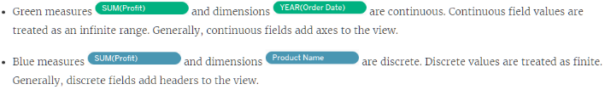

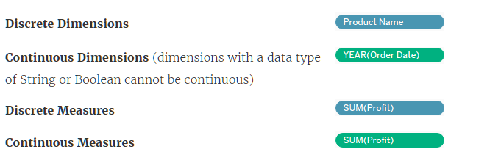

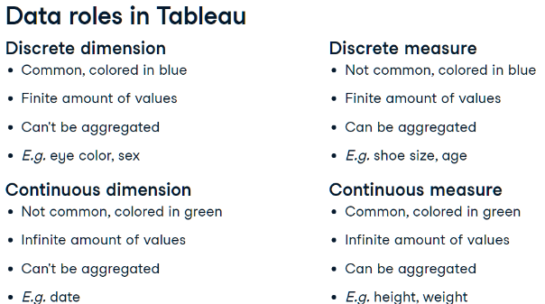

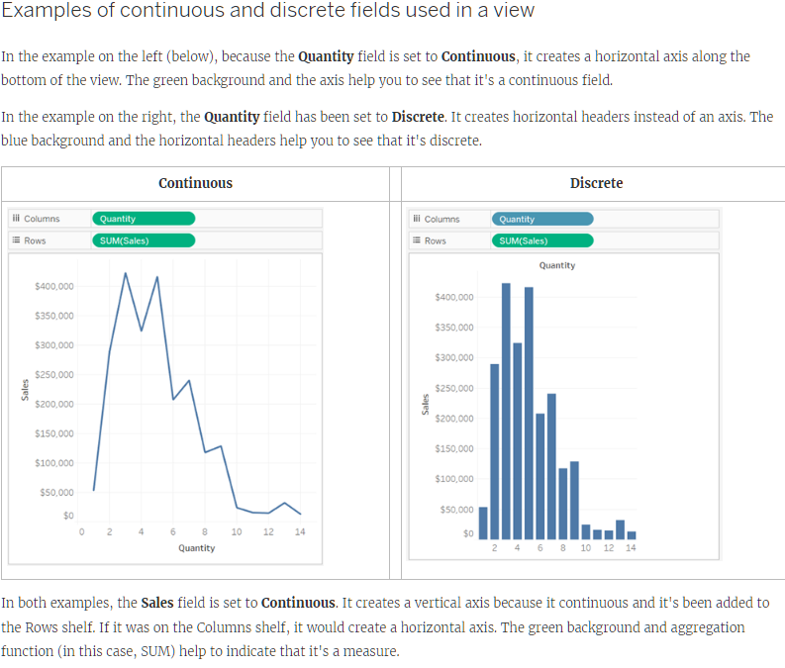

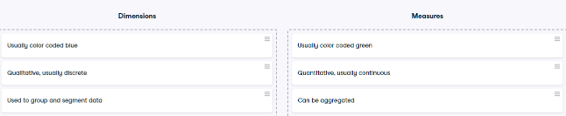

## Segmenting with dimensions

* Note that changing the data role of a field will affect your visualization possibilities.
* Dimensions allow you to group and segment data
* Measures can be aggregated and add quantitative values to dimensions.
* Segmenting means grouping similar data for each category, for example calculating the average price for each room type.

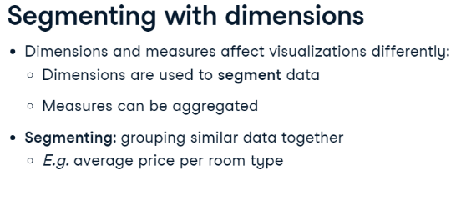

## How to create visualizations in Tableau

* Creating visualizations is done by dragging and dropping dimensions and measures on the canvas, shelves and cards.
* Canvas - where your visualizations will appear.
* Columns - correspond to the x axis of your view.
* Rows - correspond to the y axis.
* Pages shelf lets you break a visualization into several pages, e.g. one page for each neighbourhood.
* Filters shelf lets you filter your data, and you will learn more about this in a next chapter.
* Marks field contains marks cards and marks types.
* Marks cards encompass color, size, and shape: these let you add context and detail to your view.
* Marks types - You can change the type of marks displayed in the view to fit your analysis better.

## Filters

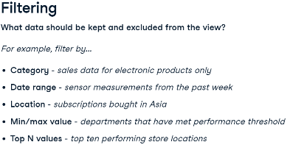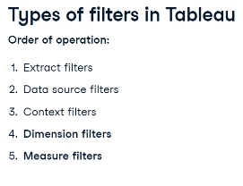

## Dimension filters (in blue)

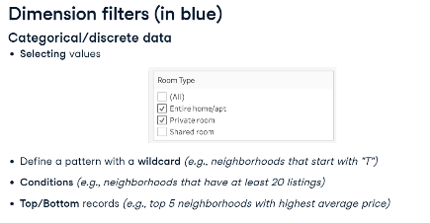

## Measure filters (in green)

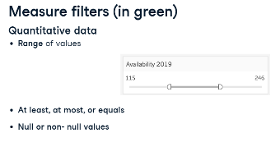

## Sorting

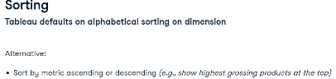

## Aggregation

* Default aggregation for Measures is SUM
* Can only aggregate Dimensions with MIN, MAX, COUNT and COUNT DISTINCT
* Aggregating a Dimension creates a temporary Measure
* All Dimension aggregations can be applied to Measures but not vice-versa

## Calculated Fields

* Create new Field - Measure or Dimension
* Analysis Tab – Create Calculated Field
* Use Functions
* Enter name of Field and add Formula
* Can be edited in dropdown
* Right click Measure and Choose Calculated Field

## Geographical Data

* Filled Map | Symbol map
* Geocoding – Globe icon
* Drag Country (globe icon) to View
  + Automatically creates map and geo data
  + Automatically adds Country to Marks Cards
* Edit Map layers in Map tab

## Date Data

* Calendar Icon
* Date hierarchy
* Top is Dimension – Discrete – Blue – Aggregates
* Bottom is Measure – Continuous – Green – Timeline
* DATEDIFF
* 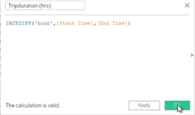
* DATEPART Sunday = 1 saturday = 7
* 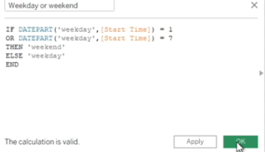

## Reference Lines, Trend Lines, Forecasting

* Reference line drawn on a chart representing another measure or point of reference E.g. AVG
* Reference line – Analytics pane - Custom
* Trend line - used to predict the continuation of a certain trend
* Trend line – Analytics pane - Model
* Forecasting - predicting the future value of a measure using mathematical models
* Forecasting – needs a time dimension and a measure
* Forecast – Analytics pane – Model

## Formatting Visuals

* Informative titles
* Colours and large fonts
* Legends
* Adjust axes and titles
* Create tooltips
* Can format at both Workbook and Sheet level
* **Dual Axes – Drag to top and right | Right click and choose Dual Axes**
* **Right Click on Y Axis – Choose Synchronise Axes**
* **Hide axes**
* **Centre title**
* **Edit Axes names**
* **Add colours to dimension**

## Workbook vs Sheet

|  |  |
| --- | --- |
| **WORKBOOK** | **SHEET** |
| .twbx | Similar to Excel tab |
| Organise, save share and publish | Displayed along workbook bottom |
| Multiple sheets | 1. Worksheet |
| Similar to whole Excel file | 1. Dashboard |
|  | 1. Story |

## Dashboard vs Sstory

|  |  |
| --- | --- |
| **DASHBOARD** | **STORY** |
| **Worksheet can be placed in a Dashboard** | **Dashboard can be placed in a Story** |
| Collection of several views | Dashboards can be bookmarked to create stories |
| Easy to compare data | Sequence of visualizations to tell a narrative |
| Uncovers key insights | Each individual visualization is called a Story Point |
| Automatically connected to worksheets | 1. Dashboard |
| Drill down and do advanced | 1. Story |
| Views can be connected – 1 view is interactive filter |  |

* Drag different Worksheets to Dashboards overlay
* Can move | float legend and filters
* Use visualisations | dashboards as interactive filters
* **Add Filter - Click visualisation | dashboard – Analysis toolbar – Filters**
* Drag different Dashboards to Story

# ANALYZING DATA IN TABLEAU

## Data Preparation

* When a numeric value is brought into Tableau, it's placed by default in the Measures section
* Move numeric fields that shouldn’t be aggregated to the Dimensions section
* Check Default Properties – Number Format - Custom
* Fit Width
* Edit Alias
* Add Highlighter - Analysis tab
* Show Filter – Customize – Show Apply Button
* Create Calculated Field – Drop Down Carat at top of Data Pane

## Discrete vs Continuous Time Analysis

