**Create an S3 Bucket**

When you first create an S3 bucket, you select the AWS Region in which the files will be geographically stored.

* Click on "Create Bucket" button.
* Provide a globally unique name for bucket and select Region.
* Leave blank this field "Copy Settings from an existing bucket

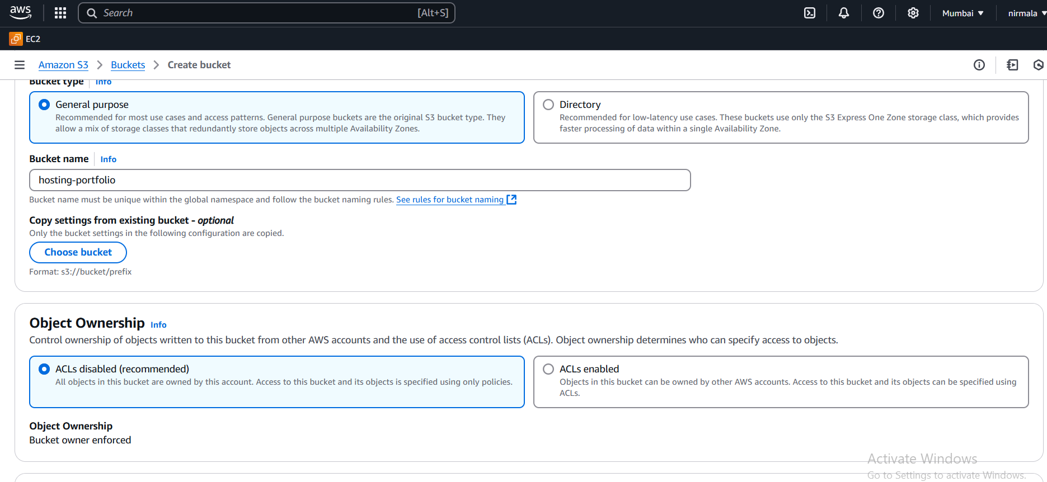

### Upload Content of your Website

Upload the website contents to your S3 bucket including sub-folders.

For Example: You can use sample Website "Website" folder contents (provided in this repository).

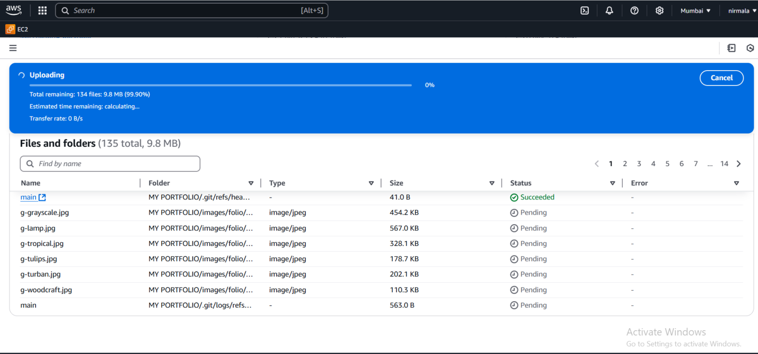

### Add a Bucket Policy to allow Public Read Access

Go to Permissions Tab and update Public Access Setting:

Uncheck Manage public bucket policies:

* Uncheck - Block new public bucket policies (Recommended)
* Uncheck - Block public and cross-account access if bucket has public policies (Recommended)

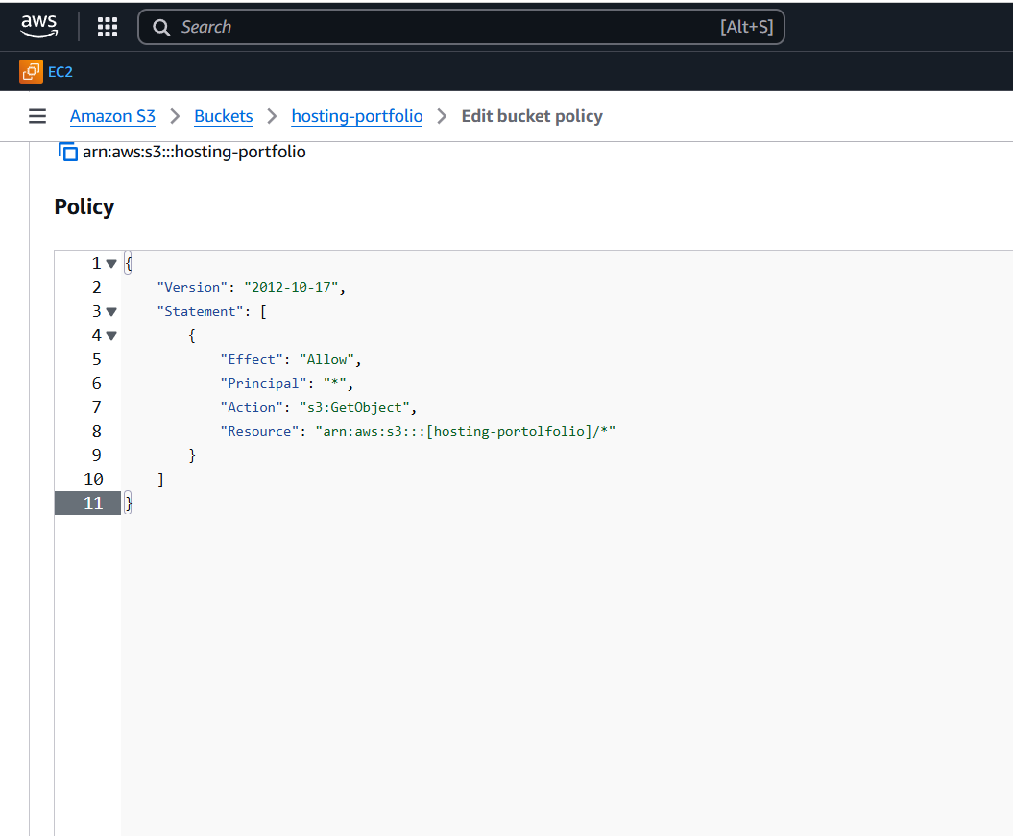

### Enable Website Hosting

In order to serve assets via url, you need to enable Website Hosting

Go to Properties and enable "Static Website Hosting" option

Note the endpoint. http://{bucket-name}.s3-website-{AWS-Region}.amazonaws.com

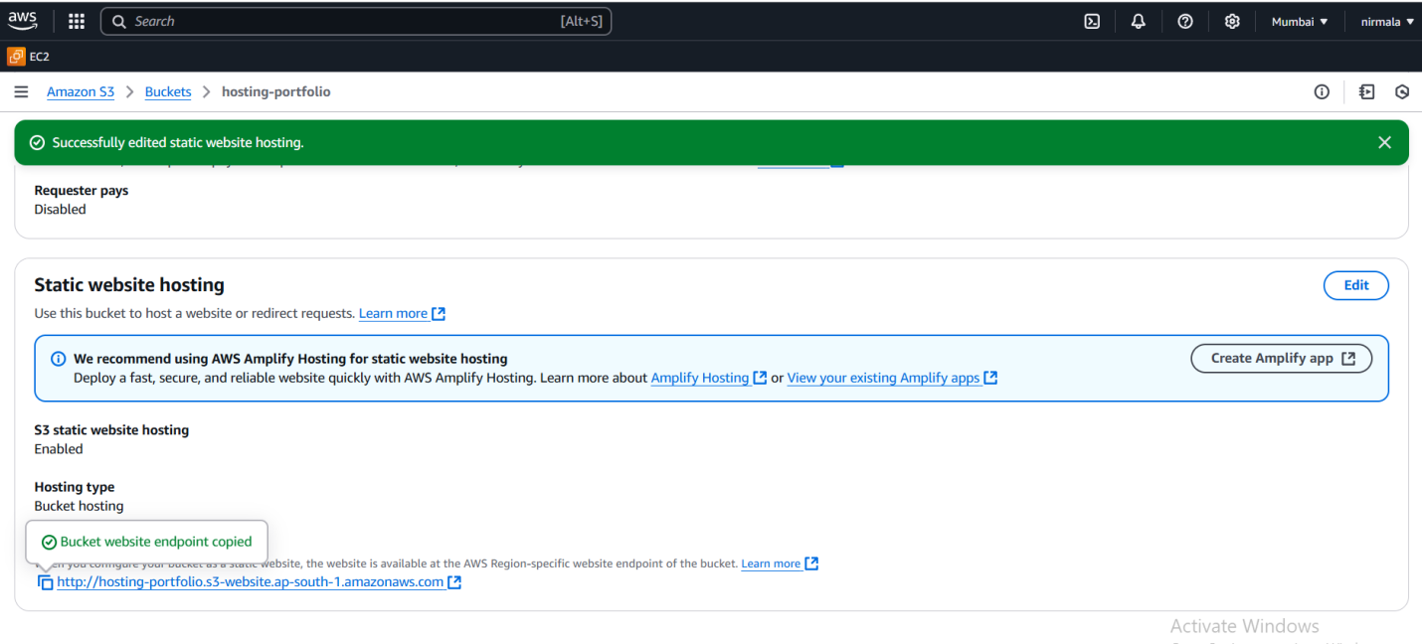

### Access Your Website (Testing/Validation)

Access the site in browser: http://{bucket-name}.s3-website-{AWS-Region}.amazonaws.com

For Example: <http://hosting-portfolio.s3-website.ap-south-1.amazonaws.com/>

